
POWER BI PORTFOLIO PROJECT · RETAIL ANALYTICS
RetailPulse
One interactive report for the whole retail story: sales, customers, products and returns.
12 report pages · 104 data visuals · 14 DAX measures · 3 model tables
Prepared by
Sanket Udaykumar Sutar
Project documentation · 20 October 2026

1. Project Overview

Vision & objectives
RetailPulse is a multi-page Power BI report that turns invoice-level retail transactions into a single, consistent view of how the business is performing. The vision is simple: anyone in the business should be able to open one report and answer "what is selling, to whom, where, when, and what is coming back?" without writing a query.
- Objective 1 – Visibility. Surface headline KPIs (gross sales, orders, unique customers, average order value) on an executive landing page.
- Objective 2 – Diagnosis. Provide dedicated drill-down pages for trends, products, customers, geography, seasonality, returns, inventory demand and order status.
- Objective 3 – Segmentation. Rank and segment customers with a Recency–Frequency–Monetary (RFM) model so marketing can target the right people.
- Objective 4 – Self-service. Give users slicers (date, country, product, customer, order status, quarter) so they can explore without asking an analyst.
- Objective 5 – Trust. Separate gross sales, returns and net sales, and track cancelled invoices, so revenue is never overstated.

Target users & use cases
User | Typical question | Where in the report
Sales leadership | Are we growing? Which months, quarters and countries drive revenue? | Executive Summary, Sales Trends, Country & Region
Marketing / CRM | Who are our best customers and who is about to lapse? | Customer Analysis, Customer Behaviour & RFM
Merchandising & inventory | Which products and categories move, and when does demand peak? | Product Performance, Inventory & Demand, Advanced Analytics
Finance & operations | How much revenue is lost to returns and cancellations? | Revenue & Returns, Orders & Transactions
Analysts | Can I slice everything my own way? | Interactive Analysis

Business value delivered
- One version of the truth: every page reads the same model and the same 14 measures, so numbers agree across pages.
- Faster decisions: the Pareto view, RFM scoring and Top-N visuals point straight to the products and customers that matter most.
- Margin protection: returns, net sales and cancelled-invoice tracking highlight where revenue leaks.
- Scheduling insight: sales by hour, weekday and month support staffing, promotion and stock-timing decisions.

Non-functional goals
Area | Goal | How the design supports it
Accuracy | KPIs reconcile across pages and to source totals | Centralised DAX measures; single fact table; gross / returns / net separated
Performance | Page interactions feel instant (target: visuals render in under ~3 s) | Star-style model, few visuals per page (7–10 on most pages), Top-N filters on long-tail visuals
Scalability | Handle further months/years of transactions without redesign | Dedicated Calendar table and measure-based logic, so new data flows through unchanged
Usability | New users orient within a minute | Consistent page titles, KPI strip, slicer placement and a shared Fluent 2 visual theme
Maintainability | Easy to extend and audit | Descriptive measure names; report stored in the modern PBIR folder-based format that diffs cleanly in Git

2. Key Features
Each feature corresponds to a report page or a cross-cutting capability. Acceptance criteria are written so they can be checked directly in the report.
ID | Feature | Description | Acceptance criteria
F-01 | Executive Summary | Four KPI cards (Gross Sales, Total Orders, Unique Customers, Average Order Value), monthly sales trend, top 5 products, sales by country and by customer type, date slicer. | All visuals respond to the date slicer; KPI totals match the detail pages for the same period.
F-02 | Sales Trends | Month-on-month and year-on-year change cards; monthly, quarterly and yearly column/line charts; year and date slicers. | Changing the year slicer recalculates MoM/YoY; quarterly totals add up to the yearly total.
F-03 | Product Performance | Treemap of sales by category, top 10 products by sales and by quantity, product matrix with units, average selling price and sales; product slicer. | Top-N visuals respect the product slicer; matrix lists units, ASP and gross sales per product.
F-04 | Customer Analysis | Customer table (orders, sales, AOV), orders-vs-sales scatter, customer-type donut, top customers. | Selecting a customer type cross-filters all visuals; scatter exposes outliers via tooltip.
F-05 | Country & Region Sales | Filled map, country ranking, top-10 country share, matrix with sales, orders and AOV. | Map, ranking and matrix agree on country totals; clicking a country filters the page.
F-06 | Monthly & Seasonal Sales | Sales by hour of day, weekday and month; month × year matrix. | Hour, weekday and month charts sum to the same Gross Sales total.
F-07 | Customer Behaviour & RFM | Customer summary with Recency Days, Order Count, Customer Sales, R/F/M scores and a composite RFM Score; recency-vs-sales scatter; top 10 customers. | Every customer in the table has all three R/F/M scores and a composite score; top-10 list is sorted by sales.
F-08 | Revenue & Returns | Gross, Net and Return Value KPIs; gross vs return by month; net sales by country; returns by quarter; quarterly matrix. | Net Sales = Gross Sales minus Return Value for any filter selection.
F-09 | Inventory & Demand | Units sold KPI, top products by units, units trend by month, category × quarter treemap, product table; category slicer. | Category slicer filters every visual; units trend aligns with the units KPI.
F-10 | Orders & Transactions | Total orders, cancelled invoices and cancelled lines KPIs; orders and cancellations by month; order-status donut; invoice-level table; date, status and country slicers. | Cancelled counts change with the order-status slicer; the invoice table drills to individual invoices.
F-11 | Advanced Analytics | Pareto chart (sales by stock code with cumulative %), top customers, most-returned products, category treemap, YoY and return KPIs. | Cumulative % reaches 100% on the last item; Pareto items are sorted by sales descending.
F-12 | Interactive Analysis | Six slicers (date, country, product, customer, order status, quarter) driving KPIs, quarterly and prior-year comparison, country ASP table and chart. | Any combination of slicers updates every visual on the page with no errors or blanks.
F-13 | Branded, consistent experience | Fluent 2 base theme, 12 custom full-page backgrounds, uniform page headings and KPI strip. | Every page uses the same title position, card style and colour palette.

3. Technology Stack
Category | Technology | Rationale / alternatives
BI authoring | Power BI Desktop (report saved in the PBIR folder format, report schema 3.x) | Rich native visuals, DAX engine, and a direct path to sharing. Alternatives: Tableau, Qlik Sense, Looker Studio.
Data preparation | Power Query (M) | The fact table is named online_retail_cleaned, showing that cleaning happened before modelling. Alternatives: Python/pandas, SQL views.
Data model | Three tables: online_retail_cleaned (fact), Calendar (date), Customer summary (customer grain) | Separates transactions, time and customers so measures stay simple. Alternative: a single flat table (harder to maintain).
Calculations | DAX measures (14) and derived columns | Measures recalculate with every slicer; alternatives such as pre-aggregated SQL lose that flexibility.
Time intelligence | Dedicated Calendar table (Date, Year, Quarter, Month Name, YearMonth, Day Name) | Required for YoY, MoM and prior-year logic and correct month sorting.
Customer segmentation | RFM scoring (Recency Days, Order Count, Customer Sales → R/F/M scores → RFM Score) | Transparent and explainable to marketers. Alternative: k-means clustering in Python.
Visualisation | 17 native visual types: cards, slicers, bar/column/line, donut, treemap, scatter, filled map, matrix, table, Pareto combo | Native visuals are fast and cross-filter automatically. Alternative: AppSource custom visuals.
Design system | Fluent 2 base theme plus 12 custom page backgrounds | Gives a polished, consistent look. Alternative: corporate theme JSON.
Publishing | Power BI Service (dataset and report published to a workspace) | Sharing, scheduled refresh, usage metrics. Alternatives: Power BI Report Server, PDF/PowerPoint export.

4. Architecture Overview
Data moves left-to-right through seven stages, from raw transaction lines to business users. There is no machine-learning pipeline in this project: it is a descriptive analytics solution, so the "MLOps" part of the flow is replaced by the BI lifecycle (model, measures, publish, refresh).
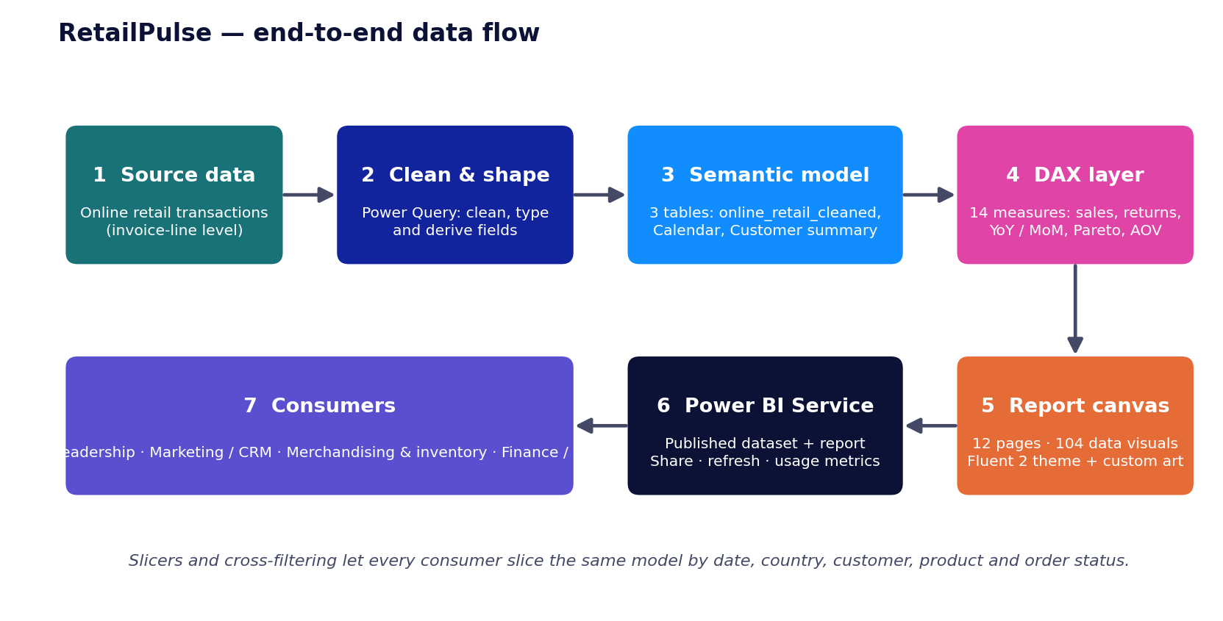

Semantic model
The report reads from three tables. The fact table holds one row per invoice line; the Calendar table provides every time attribute used by the trend pages; the Customer summary table aggregates the fact table to one row per customer and carries the RFM scores.
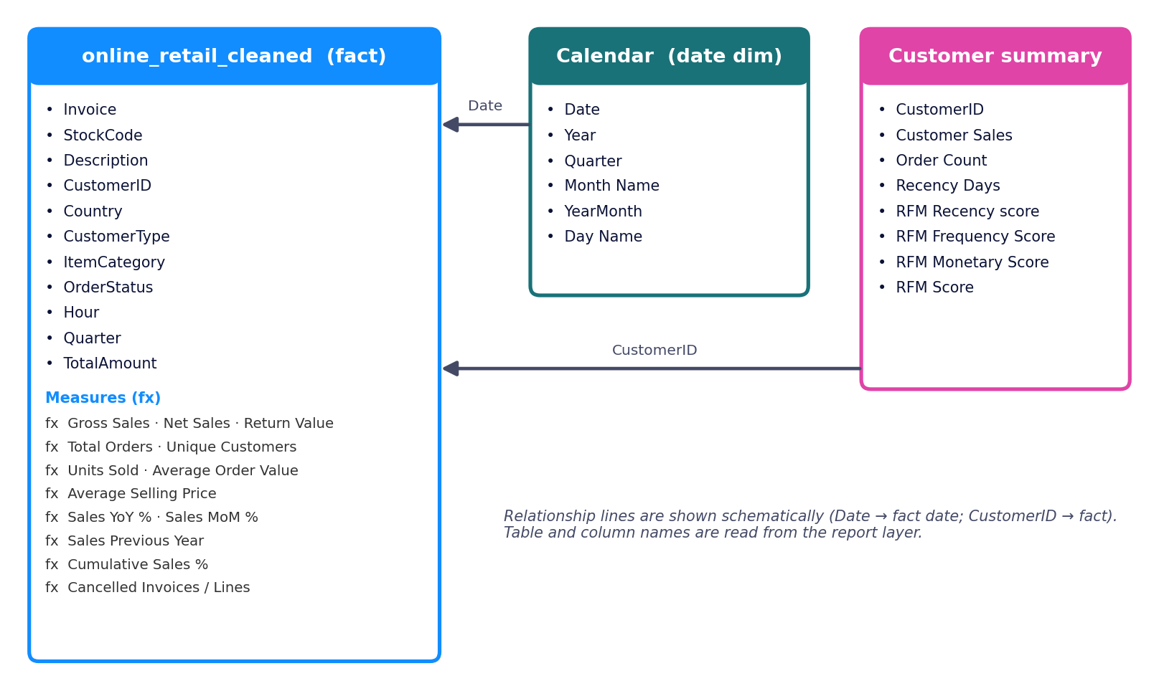

5. Detailed Execution Timeline
Week | Phase | Major deliverables | Milestone / checkpoint
Week 1 | Discovery & data audit | Review the raw transaction file; define the KPI list (gross sales, orders, customers, AOV, returns); sketch page wireframes; choose theme and backgrounds. | M1 – KPI dictionary and page list agreed.
Week 2 | Data preparation & modelling | Clean and type the transaction data (online_retail_cleaned); derive CustomerType, ItemCategory, OrderStatus, Hour, Quarter, TotalAmount; build the Calendar table and the Customer summary table; relate tables. | M2 – Model validated: row counts and totals reconcile with the source.
Week 3 | Core measures & first five pages | Write the base measures (Gross Sales, Total Orders, Unique Customers, AOV, Units Sold, ASP) and time-intelligence measures (Previous Year, YoY %, MoM %); build Executive Summary, Sales Trends, Product Performance, Customer Analysis and Country & Region pages. | M3 – Five pages reviewed with a stakeholder.
Week 4 | Deep-dive pages | Build Monthly & Seasonal, Customer Behaviour & RFM, Revenue & Returns (Return Value, Net Sales), Inventory & Demand and Orders & Transactions (cancelled invoices and lines). | M4 – All 10 analytical pages functionally complete.
Week 5 | Advanced analytics, polish & publish | Pareto (Cumulative Sales %), Interactive Analysis workbench, Top-N filters, tooltips and alignment; QA of every slicer combination; publish to Power BI Service; write documentation. | M5 – Report published; documentation signed off.

Checkpoints applied throughout
- After modelling: tie out total sales, order count and customer count to the cleaned source data.
- After each page: test every slicer, cross-filter and Top-N filter for blanks or errors.
- Before publishing: check page names, titles, alignment, colour contrast and the tab order.

6. Technical Highlights

Report build statistics
The metrics for this project are about analytical coverage and model design rather than predictive accuracy
Metric | Value
Report pages | 12 (6 at 1920 × 1080, 6 at 1920 × 1190)
Visual containers | 124 = 104 data visuals + 12 page headings + 8 visual groups
KPI cards / slicers | 36 / 15
Charts / tables and matrices | 44 / 9
Visuals with Top-N or other filters | 13
DAX measures used in the report | 14
Model tables / columns surfaced in visuals | 3 / 25
Visual theme | Fluent 2 base theme plus 12 custom page backgrounds

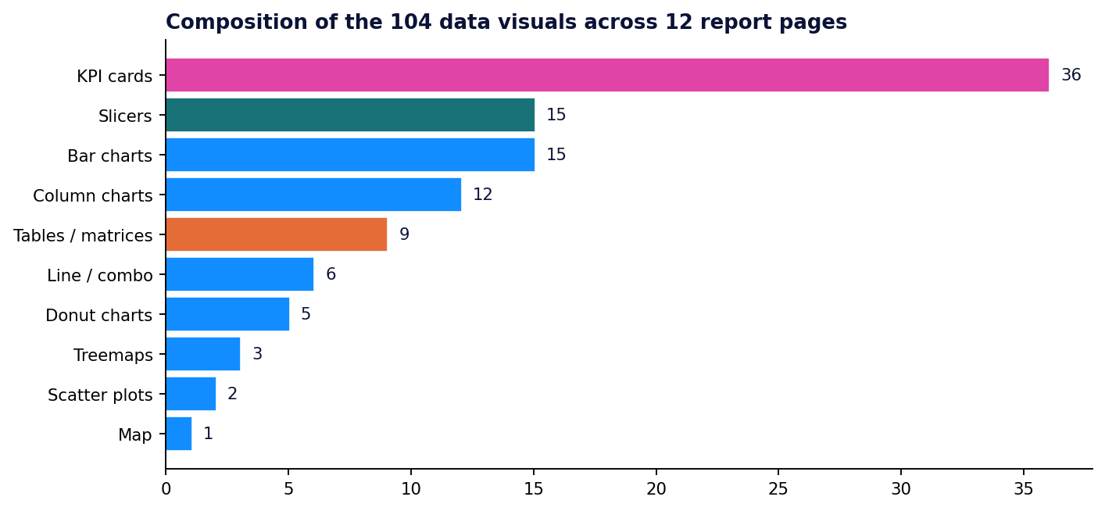
Figure 3 – What the 104 data visuals are made of

Model metrics: MAPE, AUC and F1
RetailPulse is descriptive analytics, so no predictive model is trained and error metrics such as MAPE, AUC or F1 do not apply. The quality bar here is reconciliation accuracy: KPIs must agree across pages and with the source. If a forecasting layer is added later (see the roadmap), MAPE on a hold-out period would become the headline model metric.

Measure catalogue
Measure names are read from the report; the business question column describes each measure's role on the pages where it appears. Page numbers refer to the order in Figure 4 onwards (1 = Executive Summary … 12 = Interactive Analysis).
Measure | Business question it answers | Used on pages
Gross Sales | What is total sales value before returns? | 1, 2, 3, 4, 5, 6, 8, 9, 11, 12
Net Sales | What revenue remains after returns? | 8
Return Value | How much value is returned? | 8, 11
Total Orders | How many orders were placed? | 1, 4, 5, 6, 8, 10, 12
Unique Customers | How many distinct customers bought? | 1, 4, 5, 8, 12
Average Order Value | How much does a typical order bring in? | 1, 4, 5
Units Sold | How many items were sold? | 3, 6, 8, 9, 11
Average Selling Price | At what price are items actually sold? | 3, 8, 12
Sales Previous Year | What did the same period earn last year? | 12
Sales YoY Change % | Are we growing versus last year? | 2, 11
Sales MoM Change % | Are we growing versus last month? | 2
Cumulative Sales % | How concentrated is revenue in a few products (Pareto)? | 11
Cancelled Invoices | How many invoices were cancelled? | 10
Cancelled Invoice Lines | How many invoice lines were cancelled? | 10

Feature engineering
Field | Table | Purpose
CustomerType | online_retail_cleaned | Splits customers into types so sales can be compared by segment (customer-type donut on Executive Summary and Customer Analysis).
ItemCategory | online_retail_cleaned | Groups products into categories for treemaps and the category slicer.
OrderStatus | online_retail_cleaned | Flags order state (for example completed vs cancelled) and drives the Orders & Transactions page.
Hour | online_retail_cleaned | Hour of the transaction, used for the sales-by-hour chart.
Quarter, TotalAmount | online_retail_cleaned | Quarter supports quarterly returns; TotalAmount is the line or invoice value shown in tables and distribution charts.
Year, Quarter, Month Name, YearMonth, Day Name | Calendar | Time attributes for trend, seasonal and weekday analysis; YearMonth sorts months chronologically.
Recency Days, Order Count, Customer Sales | Customer summary | Raw R, F and M inputs per customer.
RFM Recency / Frequency / Monetary score, RFM Score | Customer summary | Scored versions of R, F and M combined into one composite RFM Score for ranking customers.

Field purposes are inferred from names and where they are used. Add the exact derivation logic and RFM binning rules (for example quintile cut-offs) once confirmed in Power Query / DAX.

BI practices
ML practice | BI equivalent in this project
Data validation | Cleaned fact table; cancelled and returned lines modelled explicitly instead of ignored
Feature store | Reusable derived columns and a dedicated Customer summary table
Experiment tracking / versioning | PBIR folder format is Git-friendly (recommended in Section 7)
Drift detection | Trend measures (YoY, MoM, return value, AOV) reveal shifts in demand and returns over time
Retraining | Scheduled dataset refresh re-evaluates every measure and RFM score on new data

Challenges faced & how they were solved
Challenge | Solution in the report
Returns and cancellations distort revenue | Separate Gross Sales, Return Value and Net Sales measures; OrderStatus plus Cancelled Invoices and Cancelled Invoice Lines on a dedicated page.
Long tails of products and customers make charts unreadable | Top-N filters on 13 visuals and a Pareto chart with Cumulative Sales % to focus on the vital few.
Period comparisons are hard with raw dates | A dedicated Calendar table and Sales Previous Year, YoY % and MoM % measures.
Defining "best customer" objectively | RFM scoring combines recency, frequency and monetary value into one composite score.
Twelve pages risk looking inconsistent | Shared theme, identical heading style, a KPI strip on each page and one background image per page.
Different users need different slices | A dedicated Interactive Analysis page with six slicers, plus page-level slicers where needed.

7. Deployment & Operations
This section separates what the file shows is already in place from what is recommended as the next step, so the documentation stays honest.
Area | In place | Recommended next step
Platform | Report is linked to a published dataset and report in the Power BI Service | Place in a dedicated workspace and share through a Power BI app for read-only consumers
Refresh | Not determinable from the file | Configure scheduled refresh (daily); add a gateway if the source is on-premises; consider incremental refresh as history grows
CI/CD | No pipeline configuration inside the file | Store the PBIR project in Git (GitHub or Azure DevOps) and promote Dev → Test → Prod with Fabric / Power BI deployment pipelines
Quality gates | Manual testing | Run Tabular Editor Best Practice Analyzer and DAX query tests on each pull request
Security | Default workspace permissions | Add row-level security by country if regional managers should see only their own data
Monitoring | None embedded | Use the built-in Usage Metrics report; set refresh-failure alerts; track data-quality checks (row count, blank CustomerID share, negative quantities)

Proposed CI/CD flow
Developer (Power BI Desktop, PBIR project)
│ git push / pull request
▼
Automated checks: Best Practice Analyzer, DAX tests
▼
Deployment pipeline: Dev ──► Test ──► Prod
▼

Monitoring and "drift" for BI
- Data quality: alert when row counts, null CustomerID rate or negative-price rows move outside normal ranges.
- Business drift: watch AOV, return rate and cancelled-invoice share month over month; sudden shifts usually mean a data or process change.
- Adoption: review usage metrics monthly and retire or merge pages nobody opens.

8. Visuals
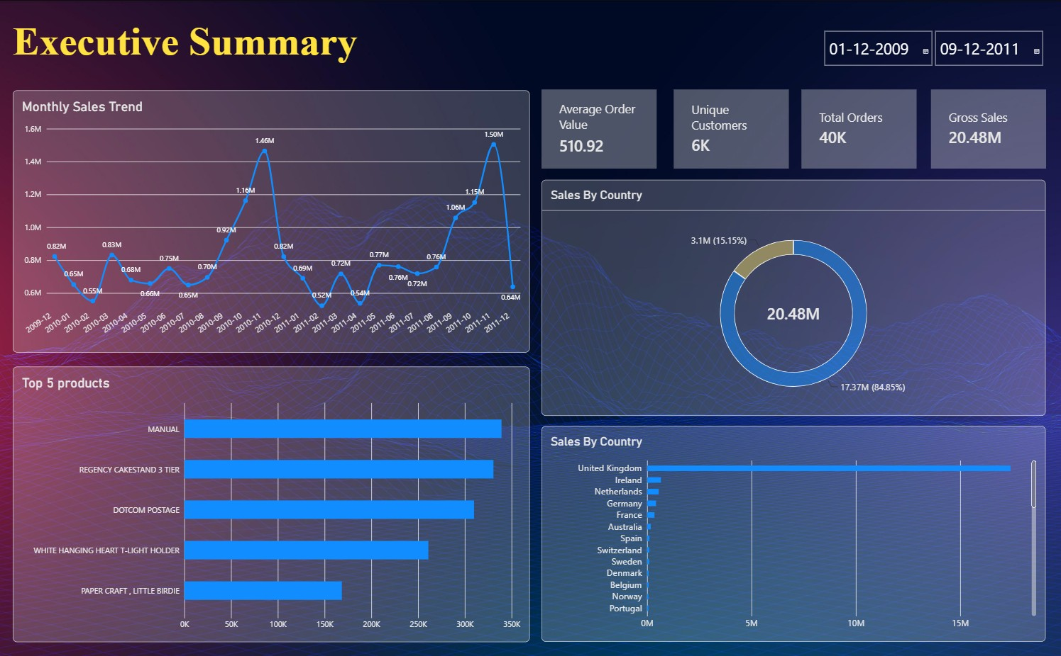
Headline KPIs, monthly sales trend, top 5 products, sales by country and by customer type.

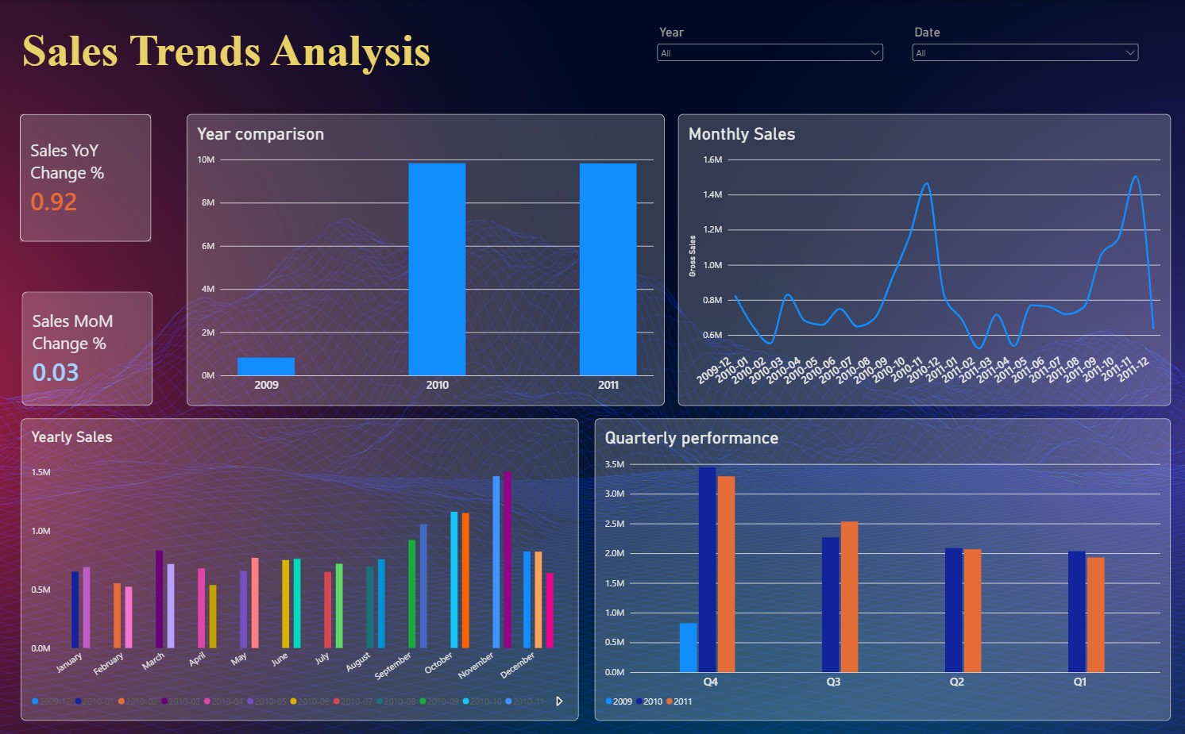
MoM and YoY change cards with monthly, quarterly and yearly sales comparisons.
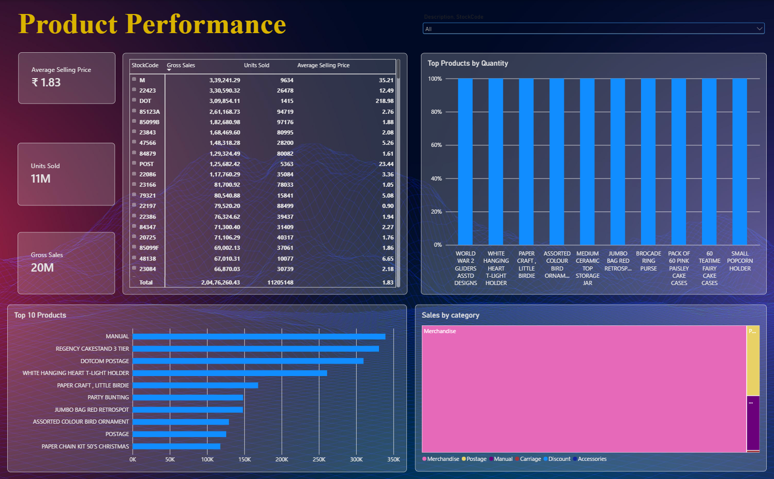
Category treemap, top products by sales and quantity, and a product matrix with ASP.

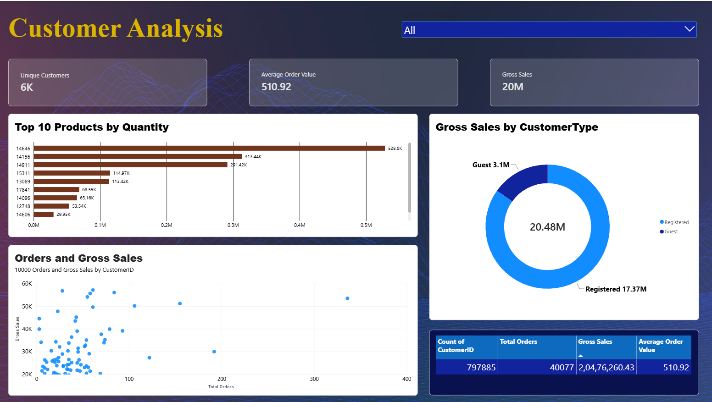
Customer table, orders-vs-sales scatter, customer-type donut and top customers.
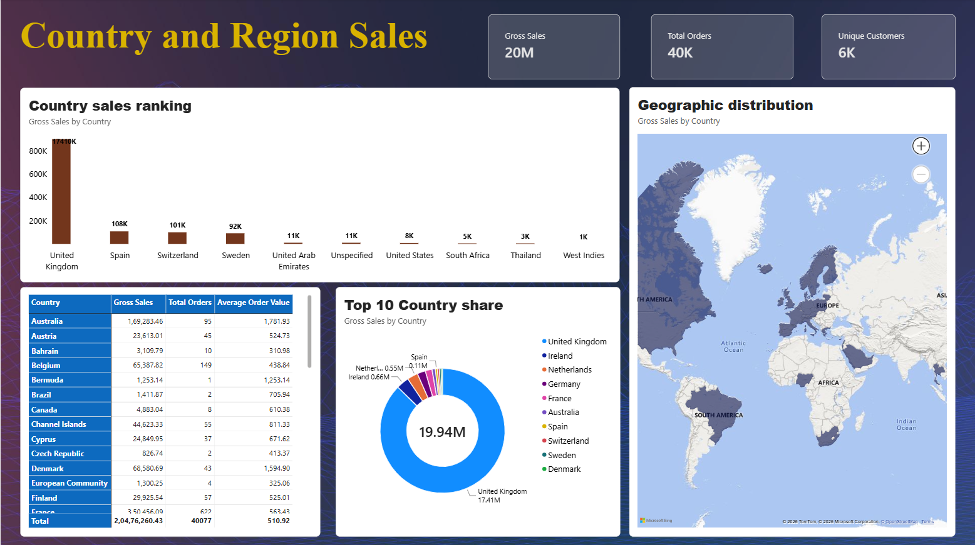
Geographic distribution map, country ranking, top-10 share and country matrix.

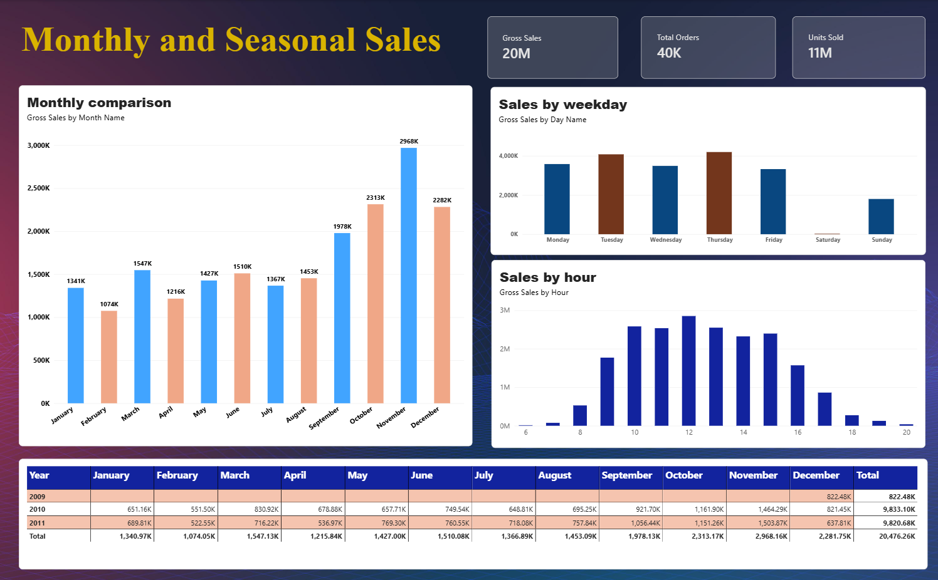
Sales by hour of day, weekday and month, with a month × year matrix.
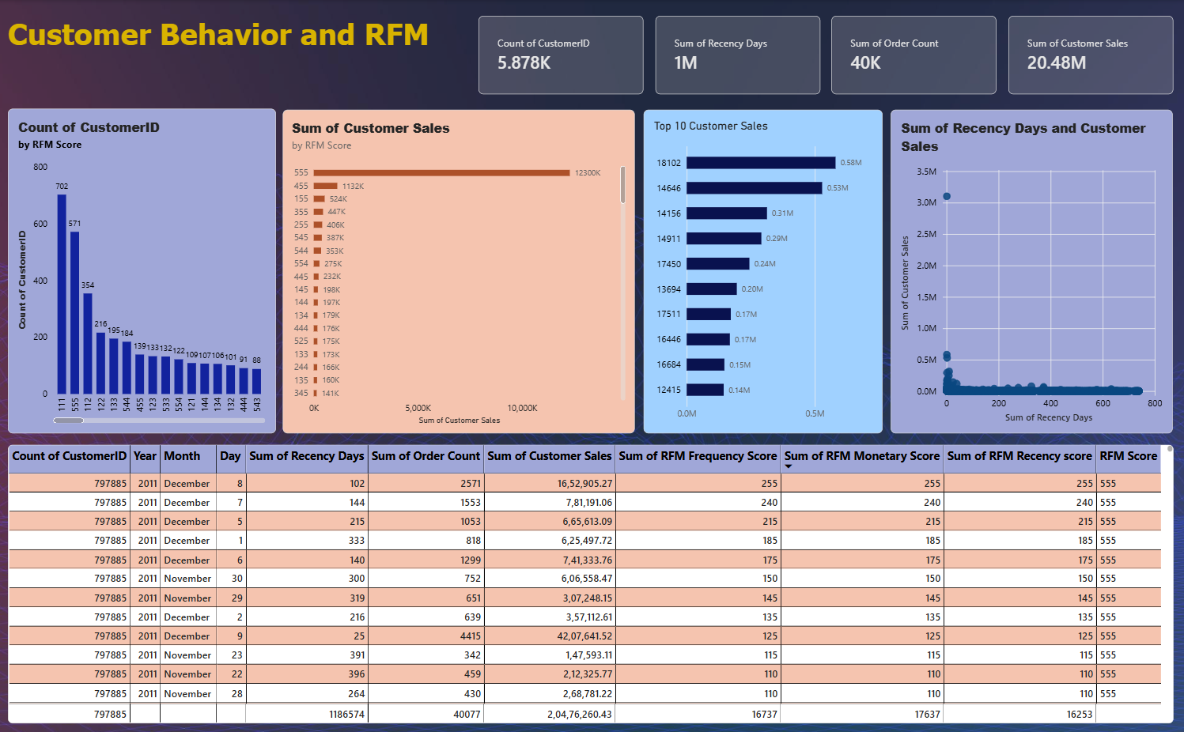
RFM scores, recency-vs-sales scatter and top customers by sales.

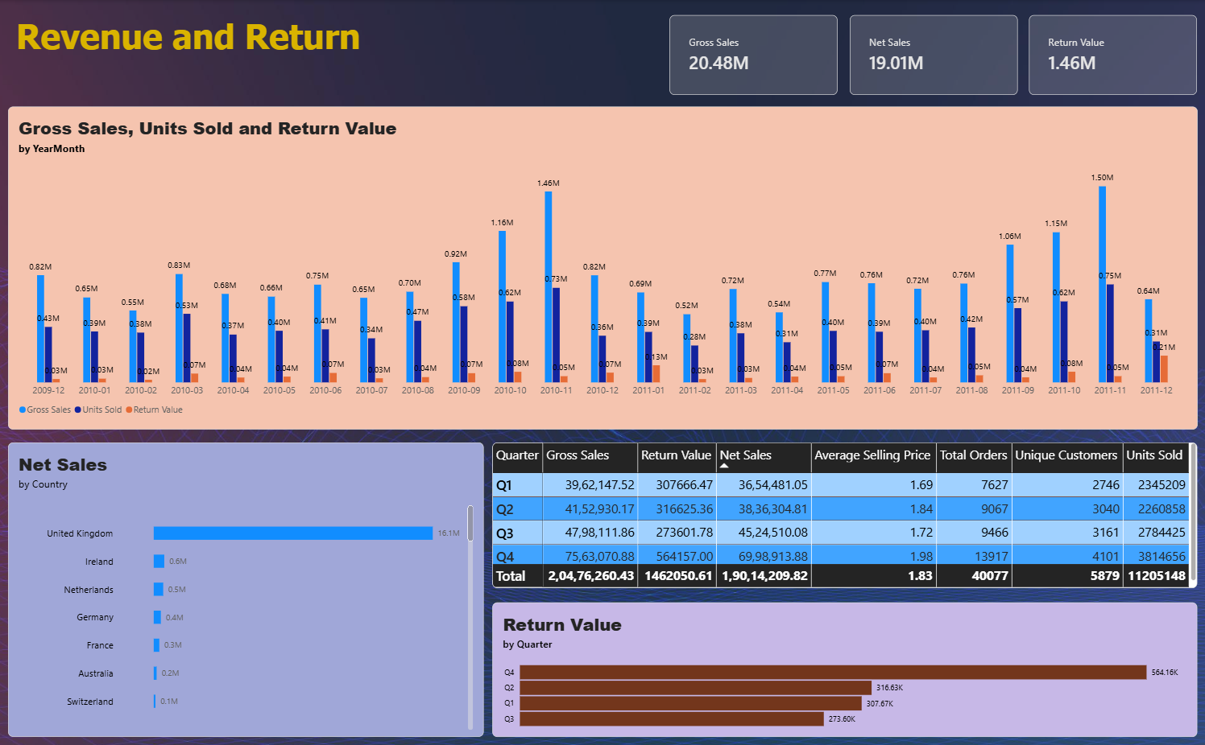
Gross vs net sales, return value by month, quarter and country.
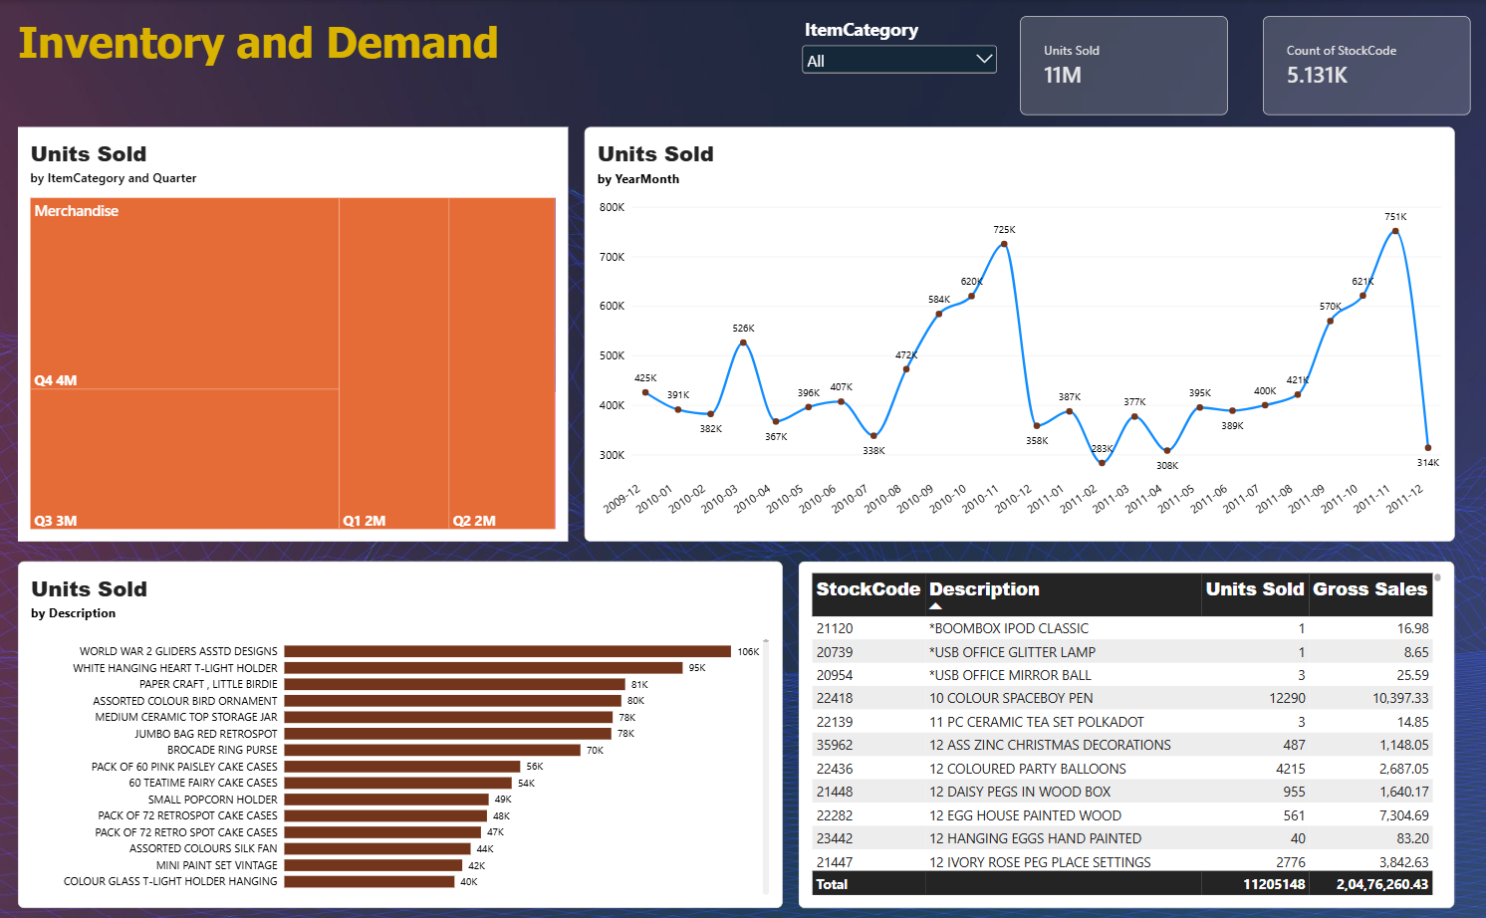
Units sold by product, units trend, category × quarter treemap and a category slicer.

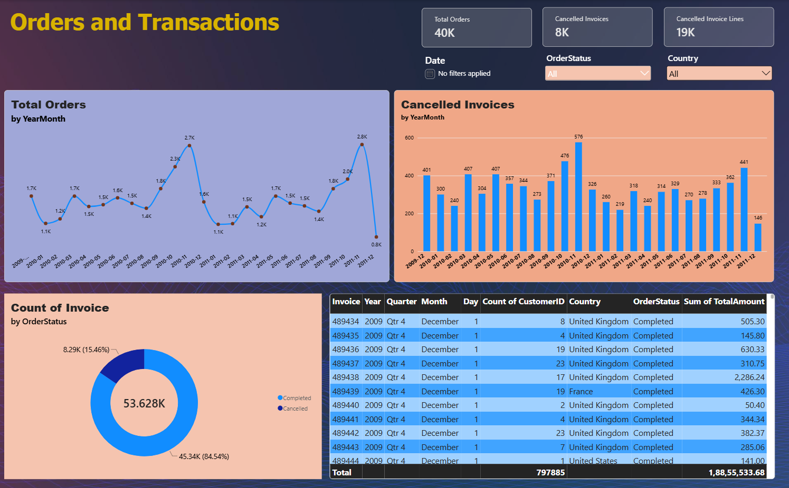
Order volume, cancelled invoices and lines, order-status split and invoice drill table.
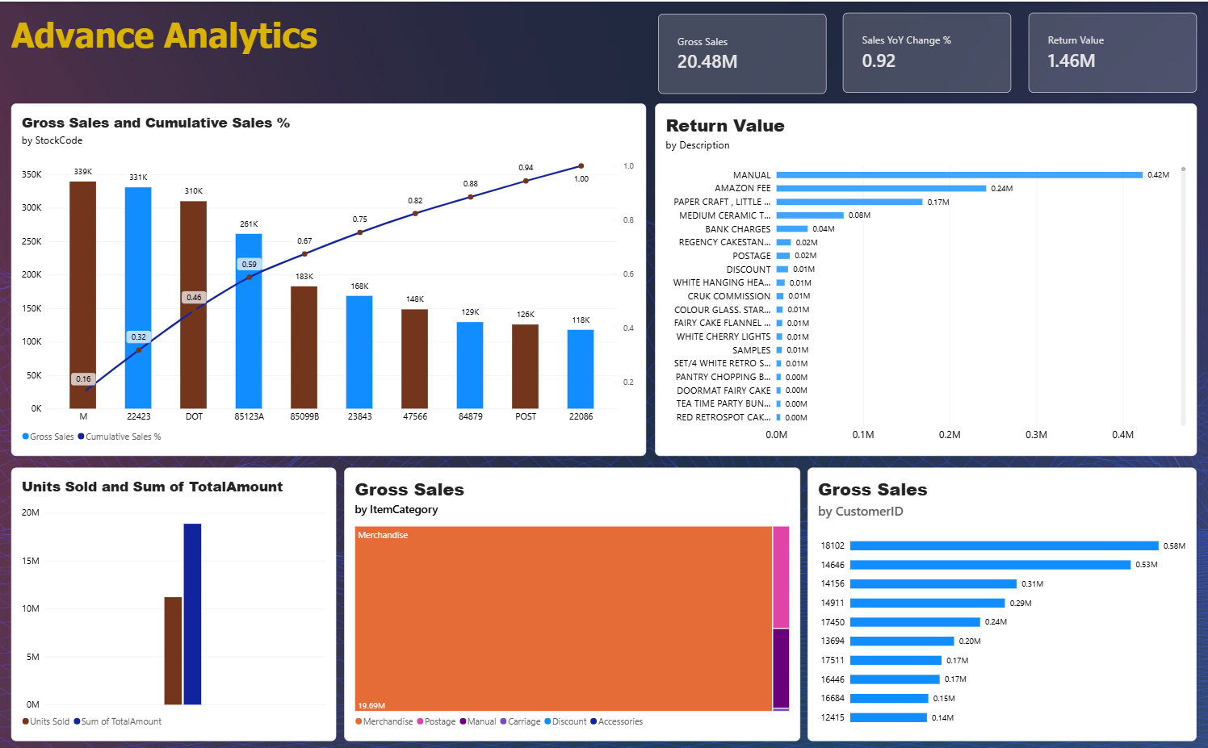
Pareto of sales by stock code, most-returned products, top customers and category mix.

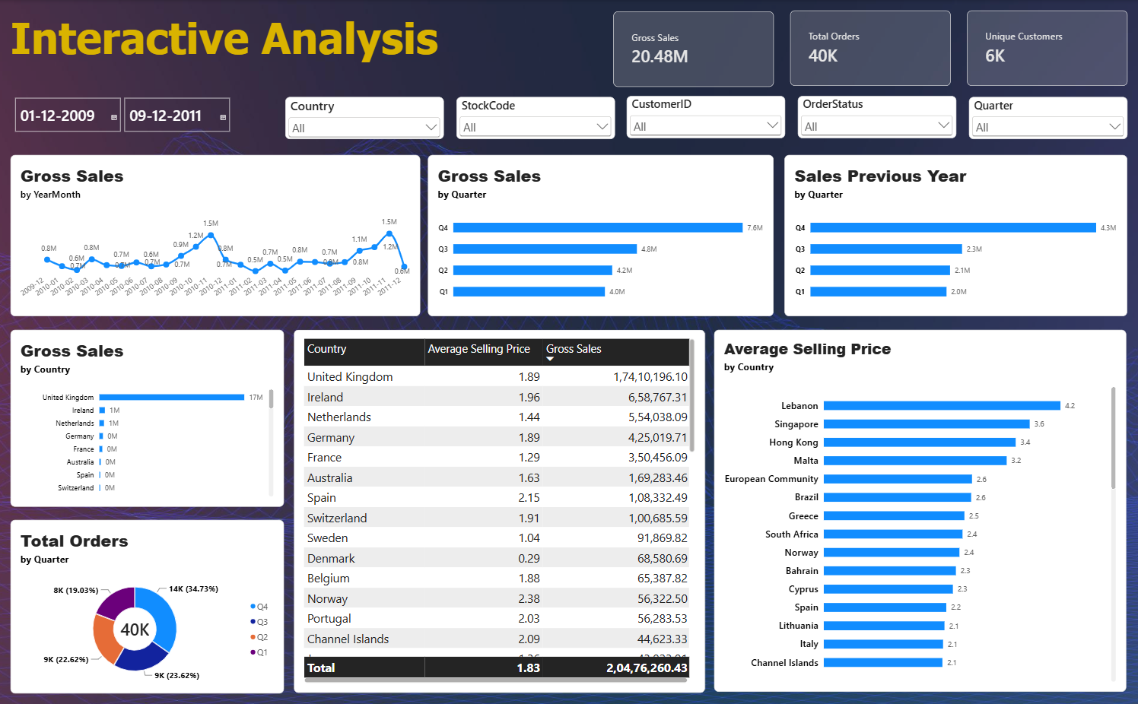
Six-slicer workbench with prior-year, quarterly and country price comparisons.

9. Personal Reflection
Draft in first person. Edit freely so it reflects your own experience.

Key learnings
- A clean model makes everything downstream easier. Separating the fact, date and customer tables meant measures stayed short and pages stayed consistent.
- Design is part of analytics. A shared theme, a consistent KPI strip and restrained visuals per page made twelve pages feel like one product.
- Revenue is not one number. Distinguishing gross sales, returns and net sales changed how I read every chart.
- RFM is simple but powerful. Three transparent scores gave marketing a ranking they could explain to anyone.
- Interactivity needs testing. Slicer combinations create edge cases (blanks, empty selections) that only careful testing reveals.

Industry best practices applied
- One shared set of measures instead of ad-hoc calculations on visuals.
- A dedicated Calendar table for time intelligence.
- Top-N filters and Pareto analysis to focus attention on what matters.
- Consistent page layout: title top-left, KPIs in a strip, slicers grouped together.
- Folder-based PBIR report format that supports source control and code review.

Future roadmap
Idea | Why it matters | Possible tools
Sales forecasting | Move from "what happened" to "what next"; report MAPE on a hold-out period | DAX forecast line, or Python/Prophet
Cohort and retention analysis | Show whether newly acquired customers come back | DAX, matrix visual
Market-basket analysis | Find products frequently bought together for cross-sell | Python (apriori) or DAX
Drill-through and tooltip pages | Let users jump from a country or product to a detail page | Native drill-through, report-page tooltips
Row-level security | Regional managers see only their markets | Power BI RLS roles
Incremental refresh and scheduled refresh | Keep data current as history grows | Power BI Service
Mobile layouts | Executive access on phones | Mobile layout view
Housekeeping | Rename pages "Page 1/2/3" to descriptive names, fix the "Inventory & Demand." trailing period and the Calendar table name, add alt text and a data dictionary | Power BI Desktop, Tabular Editor

Appendix A – Report Page Inventory
# | Page | Data visuals | Key fields and measures
1 | Executive Summary | 9 | Gross Sales, Total Orders, Unique Customers, AOV, Monthly trend, Top 5 products, Country, CustomerType
2 | Sales Trends | 8 | Sales MoM %, Sales YoY %, Year, Quarter, YearMonth, Date
3 | Product Performance | 8 | Units Sold, Average Selling Price, Gross Sales, ItemCategory, Description, StockCode
4 | Customer Analysis | 8 | CustomerID, Total Orders, Gross Sales, AOV, CustomerType
5 | Country & Region Sales | 7 | Country, Gross Sales, Total Orders, Unique Customers, AOV
6 | Monthly & Seasonal Sales | 7 | Hour, Day Name, Month Name, Year, Gross Sales, Units Sold
7 | Customer Behaviour & RFM | 9 | Recency Days, Order Count, Customer Sales, R/F/M scores, RFM Score
8 | Revenue & Returns | 7 | Gross Sales, Net Sales, Return Value, Country, Quarter, YearMonth
9 | Inventory & Demand | 7 | Units Sold, ItemCategory, Description, StockCode, YearMonth
10 | Orders & Transactions | 10 | Total Orders, Cancelled Invoices, Cancelled Invoice Lines, OrderStatus, Invoice
11 | Advanced Analytics | 8 | Cumulative Sales %, StockCode, Return Value, Sales YoY %, ItemCategory
12 | Interactive Analysis | 16 | Sales Previous Year, Average Selling Price, Country, Quarter, 6 slicers

