Skill Lab - Ist Year – Simulation using LT Spice Software - 2024

# Experiment-1:- )Simulation of basic circuits finding voltage across resistors and currents (N1 and N2).

P3

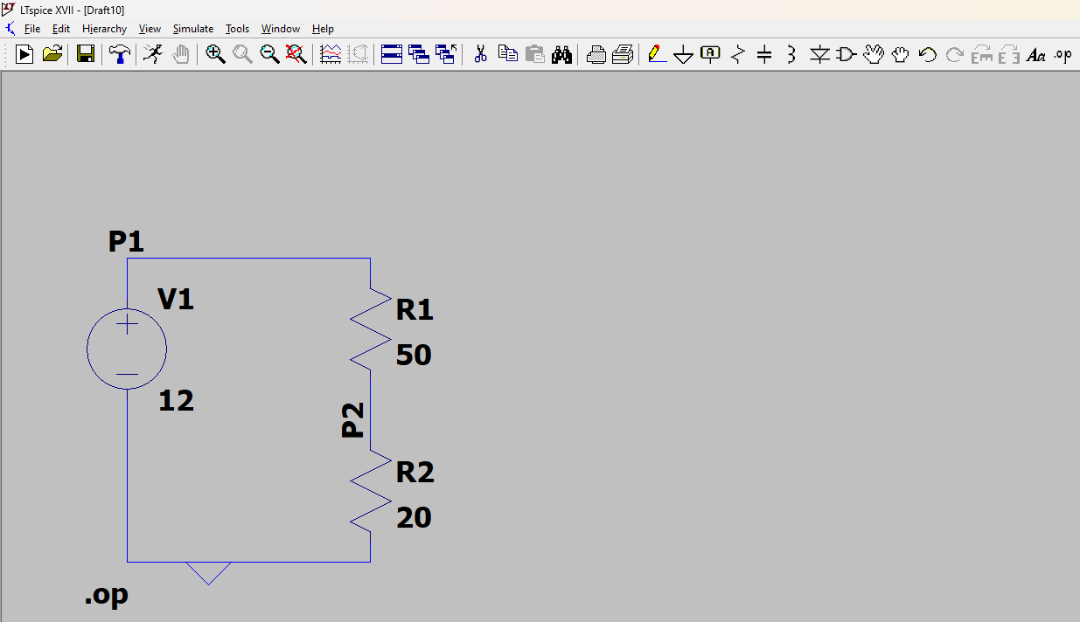

Components used

1 Resistor

2 Battery

3 wire

**Circuit Analysis**

The circuit consists of:

1. A 12V DC voltage source
2. Two resistors in series:

**R1** = 50 ohm

**R2** = 20 ohm

**Step 1: Calculate the Total Resistance**

Since the resistors are in series

R total=R1+R2= 50 ohm+20 ohm=70 ohm

**Step 2: Calculate the Total Current**

I=V/R

Where:

* V = 12V
* R total​ = 70Ω
* I=12/70 = 0.17A

**Step 3: Calculate the Voltage Drop Across Each Resistor**

1. **Voltage drop across R1: V=IR V=0.17 X 50=8.5V**
2. **Voltage drop across R2: V=0.17 X 20=3.4V**

**--- Operating Point ---**

**V(p1): 12 voltage**

**V(p2): 3.42857 voltage**

**V(P3): 8 . 58566 voltage**

**I(R2): 0.171429 device_current**

**I(R1): 0.171429 device_current**

**I(V1): -0.171429 device_current**