Skill Lab - Ist Year – Simulation using LT Spice Software - 2024

# Experiment-1:- )Simulation of basic circuits finding voltage across resistors and currents (N1 and N2). 2

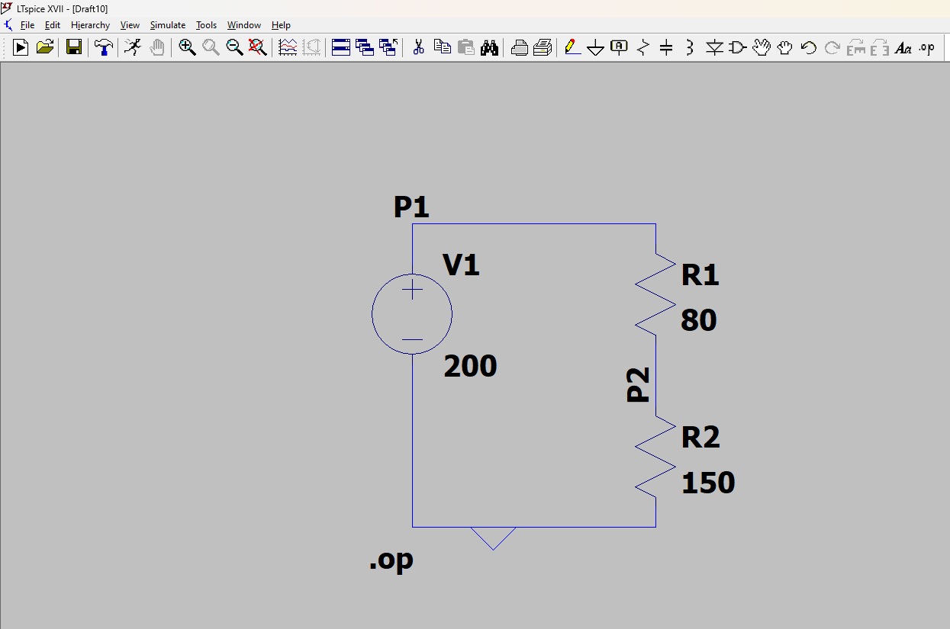

# Components used

# 1 Resistor

# 2 Battery

# 3 wire

**circuit Analysis**

The circuit consists of:

1. A 200V battery
2. Two resistors in series:
   * **R1** = 80 ohm
   * **R2** = 150 ohm

**Step 1: Calculate the Total Resistance**

For resistors in series

R=R1+R2 ​=80 ohm+150 ohm=230 ohm

**Step 2: Calculate the Total Current**

I=V/R

Where:

* V = 200V
* Rtotal​ = 230ohm

I=200/230=0.86A

**Step 3: Calculate the Voltage Drop Across Each Resistor**

1. **Voltage drop across R1: V=IR=0.86X80=68.8V**
2. **Voltage drop across R2: V=IR=0.86X150=129V**

**Total Current through R1 and R2**: 0.86A

**--- Operating Point ---**

**V(p1): 200 voltage**

**V(p2): 130.435 voltage**

**I(R2): 0.869565 device_current**

**I(R1): 0.869565 device_current**

**I(V1): -0.869565 device_current**