Skill Lab - Ist Year – Simulation using LT Spice Software - 2024

Experiment-2 ;- Mesh and node analysis of simple circuit

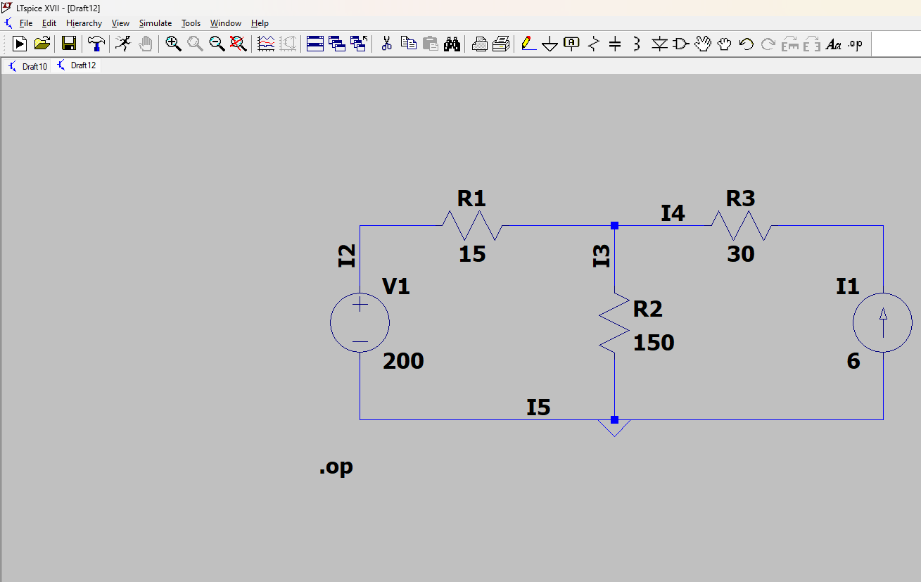

Components used

1 Resistor

2 Battery

3 wire

4 current source

**Circuit Overview:**

* **V1**: 200 V (Voltage source)
* **I1**: 6 A (Current source)
* **R1**: 15 Ω
* **R2**: 150 Ω
* **R3**: 30 Ω

**by junction law and taking the junction voltage as x**

**I1+I2+I3=0 I=V/R**

**X-200/15 -6 +X/150=0**

**X=263.6 VOLTAGE AT JUNCTION**

**AND Current through**

**R1=v/r=263.63-200/15=4.24A**

**R2=263.63-0/150=1.75A**

**R3=6A**

**--- Operating Point ---**

**V(i2): 200 voltage**

**V(i3): 263.636 voltage**

**V(n001): 443.636 voltage**

**I(I1): 6 device_current**

**I(R3): 6 device_current**

**I(R2): 1.75758 device_current**

**I(R1): 4.24242 device_current**

**I(V1): 4.24242 device_current**