Skill Lab - Ist Year – Simulation using LT Spice Software - 2024

Experiment-2 ;- Mesh and node analysis of simple circuit 2

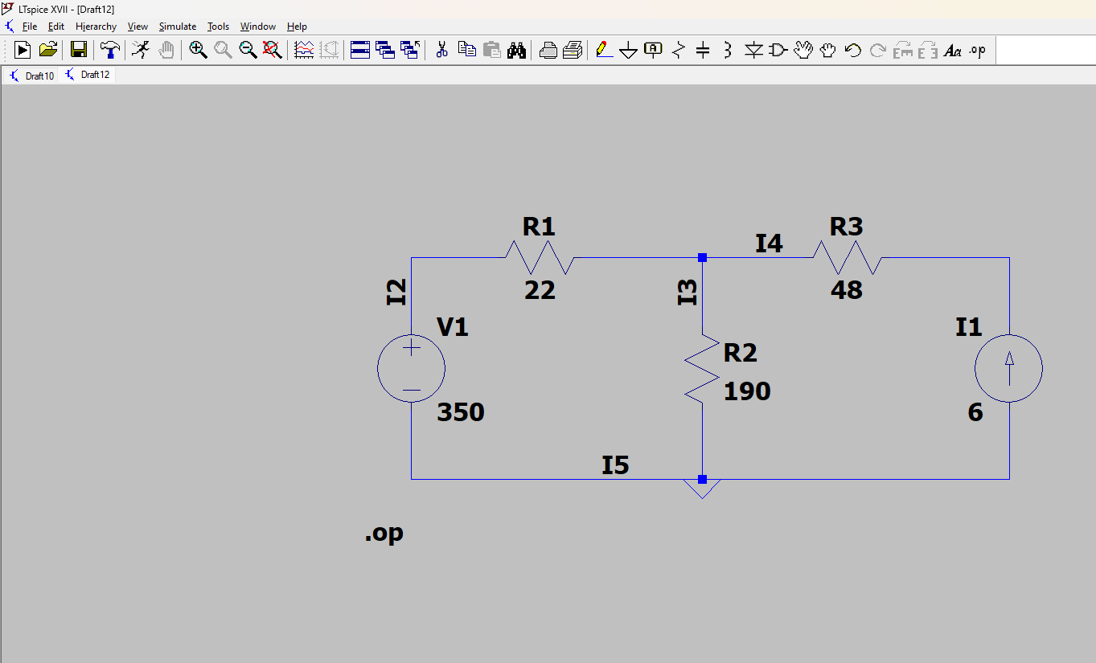

Components used

1 Resistor

2 Battery

3 wire

4 current source

**Circuit Overview:**

* **V1**: 350 V (Voltage source)
* **I1**: 6 A (Current source)
* **R1**: 22 OHM
* **R2**: 190 OHM
* **R3**: 48 OHM

**by junction law and taking the junction voltage as x**

**I1+I2+I3=0 I=V/R**

x-350/22+x/190-6=0

x=431.98V

**VOLTAGE AT JUNCTION 431.98V**

**AND Current through**

**R1=V/R=431.98-350/22=3.726A**

**R2=V/R=431.98/190=2.27A**

**R3=V/R=6A**

**--- Operating Point ---**

**V(i2): 350 voltage**

**V(i3): 431.981 voltage**

**V(n001): 719.981 voltage**

**I(I1): 6 device_current**

**I(R3): 6 device_current**

**I(R2): 2.27358 device_current**

**I(R1): 3.72642 device_current**

**I(V1): 3.72642 device_current**