Skill Lab - Ist Year – Simulation using LT Spice Software - 2024

## Experiment-3;- Simulation of half wave rectifier circuit without filter using LT spice.

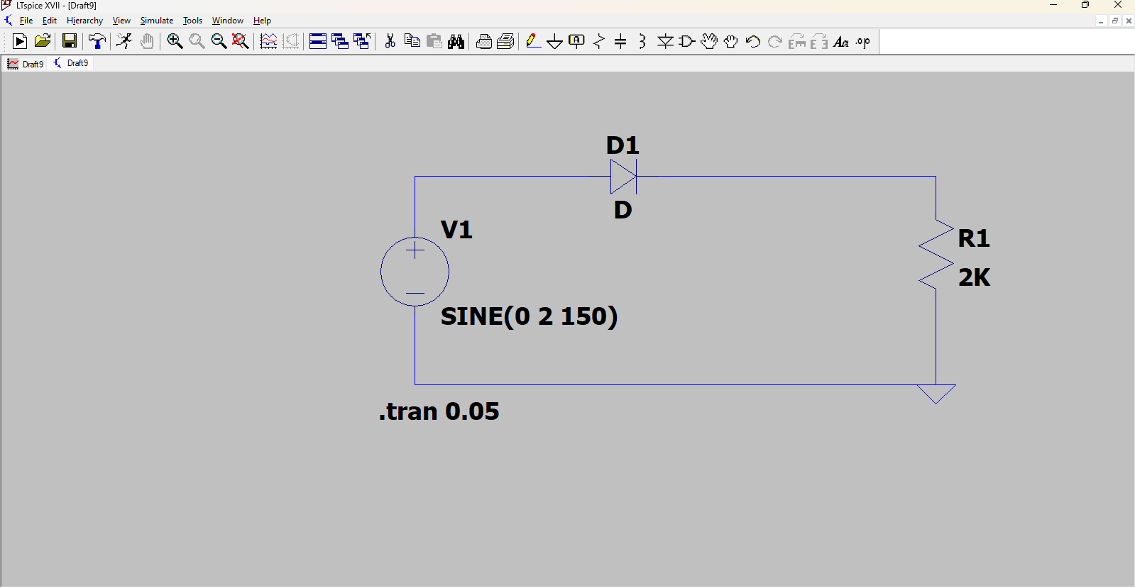

Components used

1 Resistor

2 Battery

3 wire

4 Diod

WORKING ;- A half-wave rectifier converts an AC signal to DC by passing either the negative or positive half-cycle of the waveform and blocking the other.

Graph

Input=blue

Output=green

