Skill Lab - Ist Year – Simulation using LT Spice Software – 2024

# Experiment-4;- Simulation of Zener diode voltage Regulator

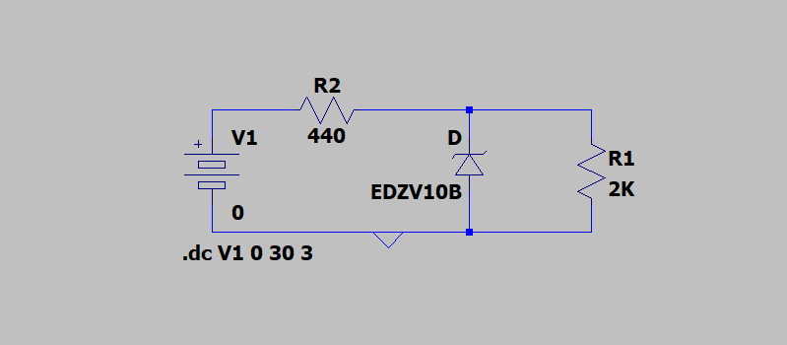

Components used

1 Resistor

2 Battery

3 wire

4 zener Diod

WORKING;- The zener diode is used as a Shunt voltage regulator for regulating voltage across small loads. The Zener diode is connected parallel to the load to make it reverse bias, and once the Zener diode exceeds knee voltage, the voltage across the load will become constant.

Graph

Output=green

