A PROJECT REPORT ON

VIDEO EDITING APPLICATION ON MOBILE

SUBMITTED TO THE UNIVERSITY OF PUNE, PUNE
IN PARTIAL FULFILLMENT OF THE REQUIREMENTS
FOR THE AWARD OF THE DEGREE

BACHELOR OF ENGINEERING (Computer Engineering)

BY

Vaibhav Mahajan Exam No: B8054279
Manish Motwani Exam No: B8054282
Sanket Tandulwadkar Exam No: B8054326
Vivek Teke Exam No: B8054328

Under the guidance of

Prof Dr. S. A. Joshi Prof. P.R.Patil
(Internal Guide) (Internal Co-Guide)


DEPARTMENT OF COMPUTER ENGINEERING

PUNE INSTITUTE OF COMPUTER TECHNOLOGY
Sr. No. 27, Pune Satara Road, Dhanakawadi
PUNE 411043

DEPARTMENT OF COMPUTER ENGINEERING

PUNE INSTITUTE OF COMPUTER TECHNOLOGY
Sr. No. 27, Pune Satara Road, Dhanakawadi
PUNE 411043

CERTIFICATE

This is to certify that the project report entitled

“VIDEO EDITING APPLICATION ON MOBILE”

Submitted by

Vaibhav Mahajan Exam No: B8054279
Manish Motwani Exam No: B8054282
Sanket Tandulwadkar Exam No: B8054326
Vivek Teke Exam No: B8054328

is a bonafide work carried out by them under the supervision of Prof. Dr S.A.joshi and it is submitted for the partial fulfillment of the requirement of University of Pune, Pune for the award of the degree of Bachelor of Engineering (Computer Engineering)

(Prof. S.A.Joshi ) (Prof. Pravin R. Patil)
Internal Guide Internal Co-Guide
Head, Department of Computer
Engineering PICT, Pune

Head,
Place: PICT, Pune. Department of Computer Engineering,
Date: PICT, Pune.
INDEX

1. SYNOPSIS 6
1.1 Group ID: 7
1.2 Project Group Members: 7
1.3 Project Title: 7
1.4 Title of the project: 7
1.7 Problem Statement: 7
1.8 Technical Key Words (Ref ACM Keywords): 7
1.9 Relevant mathematics 7
1.10 Names of at least two conferences where papers can be published 7
2. Technical Key Words 8
3. INTRODUCTION 10
3.1 Project Idea 11
3.2 Mobile 11
3.3 Video 12
4. PROBLEM DEFINITION AND SCOPE 13
4.1 Problem Statement 14
4.1.1 Goals and objectives 14
4.1.2 Statement of scope 14
4.1.3 Software context 15
4.1.4 SWOT Analysis 15
4.1.5 Technology and associated platform 16
4.1.6 Area of Project 17
5. SOFTWARE PROJECT PLAN 18
5.1 Introduction 19
5.1.1Problem Definition 19
5.1.2 Management and technical constraints [using SWOT Analysis] 20
5.1.3 Purpose of the Document 21
5.2 Project Estimates 21
5.2.1 Estimation techniques applied and results 21
5.2.3 Reconciled Estimate 22
5.2.4 Project Resources 22
5.3 Risk Management 23
5.3.1 Risk Table 23
5.3.2 Overview of Risk Mitigation, Monitoring, Management 24
5.4 Project Schedule 25
5.4.1 Project task set 26
5.4.2 Task network 29
5.4.3 Timeline chart 29
5.5 Staff Organization 30
5.5.1 Team structure 31
5.5.2 Management reporting and communication 31
5.6 Tracking and Control Mechanisms 32
5.6.1 Quality assurance and control 32
5.6.2 Change management and control 34
6. SOFTWARE REQUIREMENTS SPECIFICATION 35
6.1. Introduction 36
6.1.1 Purpose and Scope of Document 36
6.1.2 Overview of responsibilities of Developer 37
6.2 Product Overview 37
6.3 Usage scenario 40
6.3.1 User profiles 40
6.3.2 Use-cases 40
6.3.3 Use Case View 43
6.4 Data Model and Description 44
6.4.1 Data Description 44
6.4 Functional Model and Description 45
6.4.1 Flow diagram 45
6.5 Description for (Function/Module/Subsystem) 46
6.5.3 Non Functional Requirements 46
6.5.4 Design Constraints 46
6.5.5 Software Interface Description 49
6.6 Behavioral Model and Description 48
6.6.1 Description for software behavior 48
6.6.2 State Transition Diagrams 48
6.7 Restrictions, Limitations, and Constraints 49
7. SOFTWARE DESIGN SPECIFICATION 50
7.1 Introduction 51
7.1.1 Purpose of Document 51
7.1.2 Scope of Document 51
7.2 Overview of Product 52
7.3 Architectural design 54
7.4 Data design 55
7.4.1 Internal software data structure 55
7.4.2 Global data structure 56
7.4.3 Temporary data structure 57
7.4.4 Database description 60
7.5 Component design 61
7.5.1 Algorithms 63
7.5.2 Program Structure 65
7.5.3 Software Interface Description 66
7.6 Restrictions, limitations, and constraints 68
8. FUTURE ENHANCEMENT……………………………………………………...69

9. SUMMARY AND CONCLUSION 71
10. LIST OF DIAGRAMS 73
11. LIST OF TABLES………………………………………………………………. 75

12.ANNEXURES 77
ANNEXURE A 77
ANNEXURE B 79
ANNEXURE C 85
ANNEXURE D 90
ANNEXURE E……………………………………………………………………. 94
ANNEXURE F……………………………………………………………………. 99

ANNEXURE G………………………………………………………………… 100

ANNEXURE H …………………………………………………………………. 104

13. REFERENCES………………………………………………………………….105

SYNOPSIS

Group Id: 29

Group Members:
Vaibhav Mahajan Exam No: B8054279
Manish Motwani Exam No: B8054282
Sanket Tandulwadkar Exam No: B8054326
Vivek Teke Exam No: B8054328

Project Title : Video editing application for mobile.

Internal Guide: Prof. Dr. Sarang A. Joshi.

Title of the project: Video editing application for mobile.

Problem Statement: Design a mobile application for editing videos.

Technical Key Words (Ref ACM Keywords):
I.4.0.a Image displays
I.4.1Digitization and Image Capture
I.4.2Compression (Coding)
V. Information Interfaces and Representation (HCI)
I. Multimedia Information Systems
VII. Video
IX. Mobile Applications
3. Multimedia applications and multimedia signal processing
XIII. Miscellaneous
VI. IT Applications

Relevant mathematics associated with the Project:
- Set theory.
- Derivation.
- Integration.
- Functions.

Names of at least two conferences where papers can be published:
Conferences:
- International Conference on Advanced Computer Theory and Engineering (ICACTE 2011).
- Information System Computer Engineering & Application (ICISCEA 2011 )

TECHNICAL KEYWORDS

Project Title : Video editing application for mobile.

Project Area: Image processing, mobile computing.

Technical Keywords (Refer ACM Keywords):
I.4.0.a Image displays
I.4.1Digitization and Image Capture
I.4.2Compression (Coding)
V. Information Interfaces and Representation (HCI)
I. Multimedia Information Systems
VII. Video

IX. Mobile Applications
3. Multimedia applications and multimedia signal processing

XIII. Miscellaneous
VI. IT Applications

INTRODUCTION

Idea:

With the camera being an integral part of mobiles, these days capturing and exchanging videos has become banal. Hence video editing has become necessary and moreover famous since people usually want to trim the unwanted part of the video or edit the unwanted noise. Multimedia Messaging Services (MMS) has changed the way video transfers took place. With the development of technology there have been many video editing platforms. Editing videos on PCs is fairly easy. However, there has been minimal research for video editing on mobile systems. With mobiles, there are a few limitations like decrease in the display screen, lesser storage area and RAM. We aim at designing an application for editing videos on mobile. This will reduce the need of a studio for editing videos making the process portable and flexible.
Today, in the era of technology, mobiles and its different application are very vital in day to day life. Multimedia mobiles are the fundamental need of living. Cameras are embedded in mobiles and motion pictures can be captured and stored in devices. As we can store and capture video there is need to modify it. Images are considered as the frames of the video. We should be able to edit that frames and create a video file.

Keywords:
Video editing, mobiles, videos, images, image processing.

Mobile:
Video editing can be done much faster on the android phones. Android based mobile phones are the suitors for this application.

Video:

Images are the most fundamental elements of any video file format. Videos are object based i.e. data is stored in boxes called objects. The container box contains the movie atom. The movie atom (moov) contains all the metadata such as video duration, size of the file in a sequential manner.
The color and luminance information is stored in this data structure. Manipulating this container is equal to manipulating the video content.

PROBLEM DEFINITION AND SCOPE

- Problem Statement

Design a mobile application for editing videos in mobile.

1.1 Goals and objectives
1] To grab images from the playing video.

2] To change the black and white pigmentation of video.

1.2 Statement of scope
Size of input:-
Video editor is an application which is being run onto mobile. In video we are extracting images by grabbing. We recognized the problem of providing video editing capabilities on memory- and power-constrained portable devices, such as mobile phones with integrated video cameras. In order to avoid the computationally demanding decode-edit-encode cycle for a typical video editing session, we proposed a viable alternative for video editing on mobile phones — by developing a highly optimized, cutting and splicing algorithm. This system supports most of the common video editing features, such splicing, frame insertion, special effects (such as black & white). As the mobile technology expands its focus more towards the multimedia market, it is imperative that efficient and viable solutions are provided for mobile devices for managing the growing multimedia content. Mobile video editor is one such step in this direction.

1.3 Software context
As mobile devices are becoming the basic fundamental needs of living, this software is going to be very essential for those people who are working in video technologies.
Following are the major applications of our software:-
1] In video film making industries.
2] In animation industries.
3] In mobile business presentations
4] In advertizing field.
5] Image processing field.

1.4 Major constraints based on SWOT Analysis
Strength-
1] Adoption of video in mobile is speeding up and consumption content is growing.
2] The experience of using videos in mobile is getting more agreeable all the time due to better technology including video quality improvements.
3] The video quality can be improved drastically by this app.
4] This application can make a better video sequence from a raw frames.
Weakness-
1] Mobile video technology is not yet the feasible technology for video processing as well as image processing.

Opportunities-
1] As videos are the big domain in our software, there is a tremendous opportunities in digital video field.
2] Through mobile video processing there will be a fast and easy video editing facility in the hand.
Threats-
1] It continues to get more difficult for mobile to provide a consistence experience across different video files and even expanding mobile handsets.
2] Abuse of mobile video frames damage the social life. It could get worse if the offenders are not punished properly.
  - Technology and associated platform
Our project is mainly developed for the mobile device technologies. Following are the main platforms we are using in our software.
Android SDK:
For java application, we chose android SDK as the platform. Android SDK provides support for developing android mobile applications.

Requirements:-
1] PC with at least 1.8GHz processor.
2] 2GB RAM.
3] 700 MB of free disk space [excluding SDK].
4] Windows OS/Linux OS.

1.6 Area of Project [as per ACM keywords]
1] Mobile devices
2] images/Frames
3] Video editing

SOFTWARE PROJECT PLAN

- Introduction
Video editing is the process of editing segments of motion video production footage, special effects and sound recordings in the post-production process. Motion picture film editing is a predecessor to video editing and, in several ways, video editing simulates motion picture film editing, in theory and the use of linear video editing and video editing software on non-linear editing systems (NLE). Using video, a director can communicate non-fictional and fictional events. The goals of editing are to manipulate these events to bring the communication closer to the original goal or target. It is a visual art.
There are several PC-based commercial products available providing such video editing functionalities. It is not very practical solution, however, to transfer files from a phone to PC for editing and then transfer the edited videos back to the phone for sharing. Editing capabilities on the mobile phone, therefore would provide significant advantage.

  - Problem Definition
We are supposed to grab the images from video and create an edited video file. Images are basic fundamental ingredients of any video. We have to process on images to edit video. Processed images are spliced to form video sequence. Specific images should be selected to get expected video file.

Our video editing system for mobile devices offers an extensive set of features for editing video clips on mobile terminals. The application enables users to create edited movies out of their captured video content for instant sharing and playback, as well as for storing the movies in finalized shape.

Management and technical constraints [using SWOT Analysis]
The main constraint is to use Mobile having Android O.S. during the development and testing period.
Strength:
- Java is very useful for creating any application for the Mobile.
- Android is becoming very popular O.S. which can be used by many Mobile companies so it is our pleasure to create an application in Android O.S
Weakness:
- Weakness of our system is that we are doing that application only for android mobiles not for others.
- We are doing only Cutting and Splicing with Color changing and Motion compression in this project rather than various IP applications are applied for video.
Opportunities:
There are various Opportunities for editing a video in mobile in future.
- Various Image Processing Applications are apply on the frame like face detection, eye tracking, transformation, filtering etc.
- This application will be created for various other O.S. used in mobiles and also for other series of mobiles.

Threats:
- It continuous to get more difficult for mobiles to provides consistence experience across different video files and even expanding variety of handsets and personal devices.
- Abuse of mobile video frames damage the social life. It could get worse if offenders are not punished properly.
  - Purpose of the Document
This document seeks to provide the Project Plan for the project. ‘Video Editing Application on Mobile’ to be developed as a part of Final Year Engineering Project at Pune Institute of Computer Technology with purpose of obtaining a degree in Computer Science at the Pune University. This document will be used by faculty of Computer Engineering department and the guides.
2.0 Project Estimates
Use Waterfall model and associated streams derived from assignments 1, 2, 3 and 4 (Annex A and B) for estimation.

  - Historical data used for estimates
The historical data used is large number of memory for storing images and understand the cutting and splicing the images from video for the modification.
2.2 Estimation techniques applied and results
Estimation Technique m
LOC Technique of Estimation:
It is technique which lets us define an estimate depending on Lines of Code.

Estimate Technique m
Estimate generated for LOC:
As we are dealing with Java and Android O.S. with use of Mobile, our project will be finished around 1500 to 2000 lines.
2.3 Reconciled Estimate
Estimated Cost:
As we are working on open source software, and partly hardware independent software there is hardly any finance needed.

Estimated Time:
The project will be completed in estimated time of 8 to 10 months split as 2 months on review, 3 months of design and 3 months for actual implementation.
2.4 Project Resources
2.4.1Human Resources Required
1. Manish Motwani
2. Vaibhav Mahajan
3. Vivek Teke
4. Sanket Tandulwadkar

2.4.2Hardware Resources Required
1. Any android compatible device
2. Computer
3. 20GB HDD
4. RAM 2GB

2.4.3Software Resources Required
1. Android SDK
2. Java along with eclipse
3. Operating System (Window XP/Linux)

Risk Management [using SWOT Analysis]
We have classified the risks into different categories as:
1. Development Risks
2. Business Risks
3. Project Risks
4. Requirements Risks

No | Risks | Category | Probability | Impact
1 | Lack of training on tools | Development | 20% | Critical
2 | Delivery deadline will be tightened | Business | 20% | Critical
3 | Technology will not meet expectations | Technical | 5% | Critical
4 | Requirement will change | Project | 10% | Marginal
5 | Ambiguity in data structures written by developers | Development | 5% | Catastrophic
6 | Lack of experience with web services | Development | 10% | Marginal
Table 1 Risk Table

3.1 Risk Table
Catastrophic: Failure to meet the requirement would result in mission failure
Critical: Failure would degrade performance, mission success is Questionable
Marginal: Failure would result in degradation of secondary mission.
Negligible: Failure would have slight impact
3.2 Overview of Risk Mitigation, Monitoring, Management
It will help the team to study the major risks in the initial stages. The requirement specification and software specification will be reviewed and studied. All the risks though making negligible impact will be taken into consideration. A proactive approach will be practiced. The risks will be recorded and a best course of action will be planned to avoid the risks. As all risks cannot be avoided, performing risk management, we can attempt to ensure that the right risks are taken at right time.
No. | Risks | Mitigation | Monitoring | Management
1 | Lack of training on tools | The tool manuals and tutorials are frequently practiced | Done by members of team | Assure foolproof understanding each time.
2 | Technology will not meet expectations | Study technology features for requirement’s fulfillment | Done by administrator and members | Discuss with technical experts and search online for newer versions.
3 | Ambiguity in data structures written by developers | Carry out unit tests on minimal set of rules | By members | Change the rule as and when required if ambiguity occurs
4 | Poor Documentation | The code is documented to reflect meaning to observer. | Done by team members | Any change in the document is corrected and doc. Properly

Table 2 Risk Mitigation, Monitoring and Management

4.4 Project Schedule:

This section presents an overview of project tasks and the output of a project scheduling tool. (SDLC paradigm used)

Sr. No. | Deliverables | Submission Date | Review Date
1 | Requirement Gathering | 2nd Week of January | 3rd Week of January
2 | Study And Platform Installation | 3rd Week of January | 4th Week of January  (22th Jan – 1st Feb.)
3 | Primary GUI development | 4th Week of January. | 2nd week of Feb.
4 | Module development | February-March, 1st  & 2nd week of April | 3rd week of April.
5 | Module review and verification | 3rd week of April | 3rd week of April
6 | Testing | 4th week of April. | 4th week of April
7 | Submission for Term II  Report consisting of(2,4,5,6) | 4th week of April. | 4th week of April

4.4.1 Project Task Set

Serial No | Task ID | Name Of Task
1 | T-1 | Deciding the Input for the Project & the Required Output.
2 | T-2 | Acquiring information about Android OS, Android SDK and Java along with eclipse.
3 | T-3 | Video file Path on mobile SD card.
4 | T-4 | Tools required for the Project.
5 | T-5 | Deciding the required algorithms
6 | T-6 | Creating new Algorithms if not available for Particular task.
7 | T-7 | Preparing Version 1
8 | T-8 | Testing Version 1
9 | T-9 | Deploying Version 1
10 | T-10 | With Feedback improving the Application.
Information of Task

Functional Decomposition
The ten functions may basically be viewed as follows. The new system requirements are defined in as much detail as possible. This usually involves interviewing a number of users representing all the external or internal users and other aspects of the existing system.

T-1 Task: Deciding the I/P for the project & the required o/p
Task ID: T-1
Purpose: The Input and output of the project is discussed.

T-2 Task: Installation of Android SDK .
Task ID: T-2
Purpose: The technologies and software resources used in project are installed.

T-3 Task: Searching Videos on Mobile SD card
Task ID: T-3
Purpose: Searching the existing videos on mobile.

T-4 Task: Tools required for Project
Task ID: T-4
Purpose: The tools required for project are studied and sample
Examples are implemented.

T-5 Task: Deciding the Algorithms Required for Project
Task ID: T-5
Purpose: The Algorithms uses in the Project are decided.

T-6 Task: Creating NEW algorithms if not available
Task ID: T-6
Purpose: A new Algorithm is design for implementing given task and represents an approximation of the characteristic of application.

T-7 Task: Preparing First Version
Task ID: T-7
Purpose: A first prototype of the application is evaluated on
Following factors:
(1) Evaluating the first prototype in terms of its
Strengths, weaknesses, and risks;
(2) Defining the requirements of the second prototype;
(3) Planning and designing the second prototype;
(4) Constructing and testing the second prototype

T-8 Task: Testing First Version
Task ID: T-8
Purpose: The final system (Application) is thoroughly evaluated and tested. Routine maintenance is carried out on a continuing basis

T-9 Task: Deploying First Version
Task ID: T-9
Purpose: The Application is give to the person of college for using this application and he/she given us a feedback for the working of the application.
T-10 Task: Improving Application on Feedback
Task ID: T-10
Purpose: If any problem is occurring for using this application when use by the person and he/she give us a feedback then this problem is solved and repeat the tasks from T8-T10.
Note: For More Detail of Tasks see the Annexure C.

4.4.2 Task Network:

T1
T2
T3
T4
T5
T7
T8
T9
T6
T10

4.3 Timeline Chart:

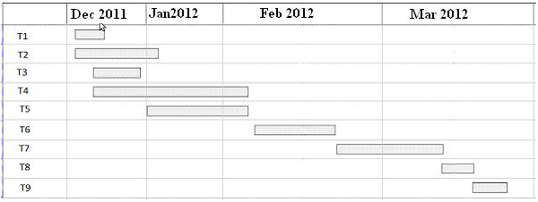

5.0 Staff Organization [with Justification LOC excluding comments, working hours, No of Functions derived from Appendices]
The manner in which staff is organized and the mechanisms for reporting are noted.

5.1 Team structure
Role | Responsibilities | Participant(s)
Project Guide | 1.Manages project in accordance to the project plan  2.Provide overall project direction  3.Direct/lead team members toward project objectives  4.Handle problem resolution | Prof. Dr. S. A. Joshi  Prof. P. R. Patil  (Co-guide)
Project Participants | 1.Communicate project goals, status and progress throughout the project to personnel in their area  2.Review and approve project deliverables  3.Coordinates participation of work groups, individuals and stakeholders  4.Assure quality of products that will meet the project goals and objectives  5. Identify risks and issues. | Group members
Table 3 Team Structure

Prof. P. R. Patil
Co-Guide
Prof. Dr. S. A. Joshi
PICT, Pune

Manish Motwani
Vaibhav Mahajan
Sanket Tandulwadkar
Vivek
Teke

5.2 Management reporting and communication
The communication began in august with initial study of the basic concepts of Video, Frames and few editing functions. Each assignment was checked and accordingly reviewed and corrected by the guide.
The team reported to guide mentors on weekly basis for project discussions. The developers being in the same institute and all pursuing final year of computer engineering met on daily basis depending on need and task to be done.

6.0 Tracking and Control Mechanisms
Techniques to be used for project tracking and control are identified. Mention Software goals and software stages as per planner.
6.1 Quality assurance and control
Software quality is defined as conformance to explicitly state functional and performance requirements, explicitly documented development standards, and implicit characteristics that are expected of all professionally developed seawares. Software quality assurance (SQA) is an activity that is applied throughout the software process.

It involves various steps like:
- Create a set of activities that will help ensure that every software engineering work product exhibits high quality.
- Perform quality assurance activities on every software products.
- Use matrix to develop strategies for improving your software process and as a consequence the quality of the product.
- Everyone involved in the software engineering process is responsible for the quality of product.

6.1.1 Documentation
As a part of ensuring software, project following documents should be prepared
1. Software Requirement Specification 2. Software Design Specification
3. Risk Mitigation, Monitoring and Management Plan

6.1.2 Standards, Practices and Conversions
6.1.2.1 Document Standard
All documents are written in Microsoft Word in Font Arial and size 12. The headings are bold with font size ranging from 12 to 14. The documents are fully justified.
6.1.2.2 Review Guidelines
The team will update the documents on regular basis and send the updated documents to team members as well as internal guide for critical reviews and assessment. Suggested improvements and changes will be incorporated promptly.
6.1.2.3 Metrics Following metrics will be used to ensure software quality:
1) Team meeting every day to discuss progress.
2) Meeting with internal guide every week to analyze the progress over the week
3) Meeting with external guide once in a week to discuss the progress till date, Suggestion of changes for improvement and deciding the future course of Action.
4) Logging of daily work by every team member.
5) Use of group mailing list to manage work done by every team member.
6) Periodic analysis of the man-hours being put in by each team member.

6.1.2.4 Quality Control through Testing
Test cases will be design to test each module thoroughly. Each test consists of requirements for performing the test; the exact procedure to be carried out, the correct results of the test and the errors, which the test might expose.

6.2 Change management and control (if applied)
Any change in designing and the plan is immediately discussed with the guide and the appropriate decision is made.

SOFTWARE REQUIREMENTS SPECIFICATION

Introduction
Purpose and Scope of Document:
Purpose:
With the camera being an integral part of mobiles, these days capturing and exchanging videos has become banal. Hence making of video from specific frames has become necessary and moreover famous since people usually want to trim the unwanted part of the video or edit the unwanted noise. MMS has changed the way video transfers took place. With the development of technology there have been many video editing platforms. Editing videos on PCs is fairly easy. However, there has been minimal research for video editing on mobile systems. With mobiles, there are a few limitations like decrease in the display screen, lesser storage area and RAM. In this paper, we discuss the basic idea behind editing a video.
Scope:
Video editor is an application which is being run onto mobile. In video editing, we modifying the extracted images or frames from a video and dropped unwanted frames or visual objects. We recognized the problem of providing video editing capabilities on memory- and power-constrained portable devices, such as mobile phones with integrated video cameras. In order to avoid the computationally demanding decode-edit-encode cycle for a typical video editing session, we proposed a viable alternative for video editing on mobile phones — by developing a highly optimized, cutting and splicing algorithm. This system supports most of the common video editing features, such as splicing, frame insertion, special effects (such as slow motion and black & white), and supporting audio editing capabilities. As the mobile technology expands its focus more towards the multimedia market, it is imperative that efficient and viable solutions are provided for mobile devices for managing the growing multimedia content. Mobile video editor is one such step in this direction.

Overview of responsibilities of Developer
What all activities carried out by developer?
Product Overview
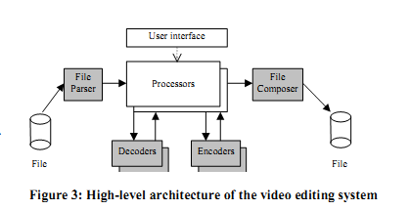

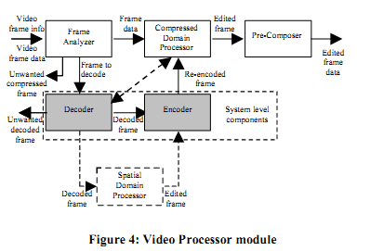

We present a complete editing system that can be built based on the proposed editing operations. Our video editing system employs both system components and internal editing components, as illustrated in Figure 3. The input and output to the system are files while the user controls the operations. The heart of the editing system consists of two key modules: Video Processor and Audio Processor. All the components of the video editing system are discussed below. 4.1. System-Level Components The system-level components are not specific to the editing system but can be standard components.

4.1.2 Video and Still Image Codecs
Video decoder is used to decode compressed video to spatial domain, whereas video encoder encodes spatial domain video to compressed signal. While this editing system does most of the processing in compressed domain, there are instances when full decoding of a video frame is needed, for example when seeking for a cutting point or when applying a transition effect. Similarly, the video encoder is needed only in some cases, for example when applying transition effect, inserting still images, or converting P frame to I in cutting. Both of them are needed in full transcoding as well. In the still image insertion case, still image decoder is used instead of video decoder. In cases where data is modified in compressed domain, the editor must also be capable of doing partial decoding and encoding operations, such as VLC coding, since typically hardware accelerators do not provide access to such individual operations.

4.1.3. Audio Codecs
Audio encoder and decoder are used in our system only when transcoding audio.

4.2 Video Processor
Video Processor provides the core of the editing system. It consists of several components, as illustrated in Figure 4 and listed below, and it interfaces with the introduced system level components.
4.2.1. Frame Analyzer
Frame Analyzer takes in the information about the video frame, and in conjunction with the editing parameters, decides the kind of operations to be performed on the frame. It may remove the frame altogether, or it may feed the frame to the decoder for full decoding. Alternatively, it may send the frame to the compressed domain processor for editing the frame in compressed domain.
4.2.2. Spatial Domain Processor
The Spatial Domain Processor is used to perform some spatial domain processing on the raw video frame, e.g. for the transitional effect, or for scaling in transcoding case.

4.2.3. Compressed Domain Processor
Compressed Domain Processor performs compressed domain editing operations on the video frame, based on the information provided by the Frame Analyzer. The operations include, for example, Black and White effect and time stamp alignment.

4.2.4. Pre-Composer
Once the compressed video frame data is ready after editing, Pre-Composer collects and updates the file format information. This information consists of video frame size and type, timestamp, etc.

4.3. Audio Processor
Audio Processor provides simple audio editing features to support the video editing system. It processes the audio data in the input clips in accordance with the editing parameters to generate the desired audio track in the output movie, keeping the timing information synchronized with the video. The processed audio frames are sent to the Composer for inclusion in the output movie.

3.0 Usage scenario
3.1 User profiles
Actors:
- Name: user.
Description:
A person which uses the mobile with integrated camera and want to grab images from the video.

2. Name: database.
Description: memory for storing the video clips and images.

The profiles of all user categories are described here.(Actors and their Description)

3.2 Use-cases

All use-cases for the software are presented. Description of all main Use cases using use case template is to be provided.

- Name: Video selection
Actor: user.
Description: User wants to modify the video in mobile.

Precondition: there should be video file exist in database.
Flow of events:
1. User unlocks the mobile.
2. User starts the application.
3. User brings the video from memory into application.
4. User selects the frames he wants to grab.
5. Application stores these images.
6. User can see the modified video.
7. Use case end.
Alternative Flow of Event:
1. There is no input video into memory.
2. Use case ends.

2. Name: spliced video
Actor: user.
Description: User can splice the video existing in the memory and generating streaming video in mobile.
Precondition: there should be one or more input video file exists in database.
Flow of events:
1. User unlocks the mobile.
2. User starts the application.
3. User brings the input video from memory into application.
4. User selects the frames that want to splice.
5. User joins the images and form a video.
6. User sees the modified video.
7. Use case end.
Alternative Flow of Event:
1. There is no input video into memory.
2. Use case ends.

Name: Color transformation
Actor: User.
Description: User wants to change the existing color video into black and white mode.
Precondition: there should be input videos that exist in database.
Flow of events:
1. User unlocks the mobile.
2. User starts the application.
3. User brings the input video from memory into application.
4. Giving brightness/darkness to frames.
5. User sees the modified video.
6. Use case end.

Alternative Flow of Event:
1. There is no input video into memory.
2. Use case ends.

3.3 Use Case View
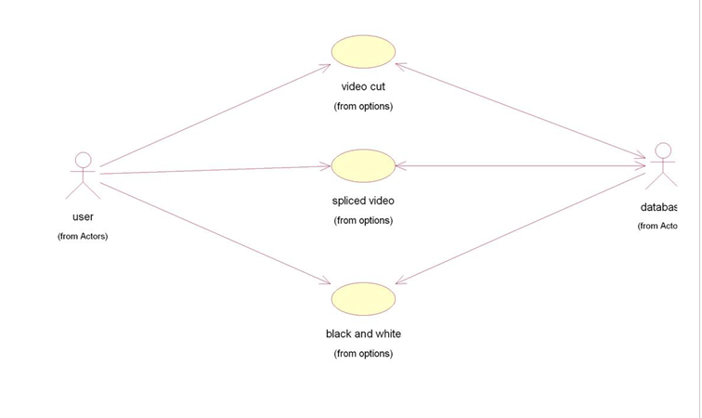

3.4 Special usage considerations (if any)
- Mobile with integrated camera.
2. Special requirements associated with the use of the software are presented.

4.0 Data Model and Description

4.1 Data Description
Data objects that will be managed/manipulated by the software are described in this section. The database entities or files or data structures required are described. For data objects details can be given as below
4.1.1 Data objects and Relationships
Data objects and their major attributes and relationships among data objects are described using an ERD- like form.
Macroblocks in a frame contain Variable Length Codes(VLCs) that contain the information about the chroma and lumina of the frame. Considering frame as a class, the macroblocks are the data objects which contain the data about the frame.
Video

Video
Pictures
Slices

Video
Macroblocks
YC_{b}C_{r} data

Variable Length Code

Video

4.1.4 Data dictionary (if required)
A reference to the data dictionary is provided. The dictionary is maintained in electronic form.

5.0 Functional Model and Description
5.1 Flow diagram
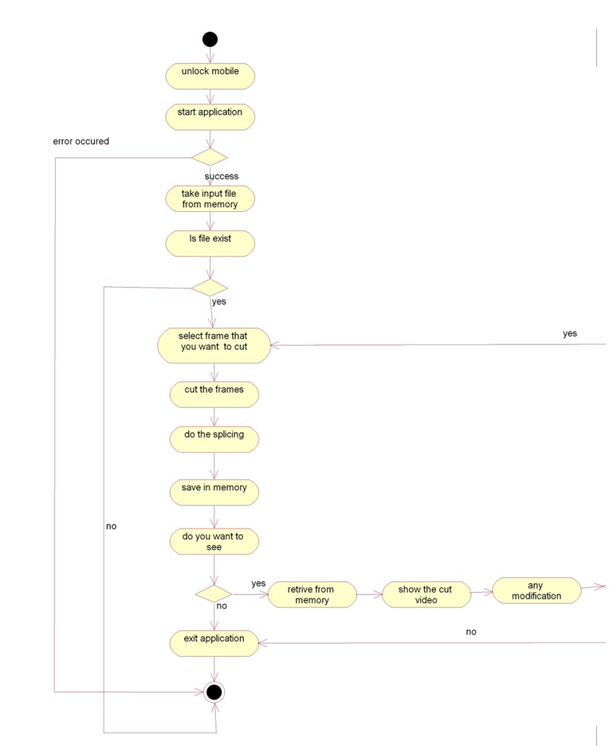
Fig. A diagram showing the flow of information through the function and the transformation it undergoes is presented

5.2 Description for (Function/Module/Subsystem)
A description of each software function is presented. A processing narrative for function n is presented.(Steps)/ Activity Diagrams
5.3 Non Functional Requirements
Performance requirements:
The performance of this system can be measured by considering the ability of the system to correct/ edit the images from a video. The time taken for the video to edit determines the performance of the system. The system requires at least 256MB memory in the mobile devices since memory is essential to store the video until editing process is completed.
Safety requirements:
The safety requirements are that the process of editing the video should not taken a lot of time thus using the mobile memory a lot and hence heating up the battery of the mobile. This may result in permanent damage to the mobile.
Security requirements:
The system is based on Android Operating System (OS). The security of the system is under the security of Android since as this application is Android based it will support mobiles on android platforms only.

5.4 Design Constraints
• Performance

• Dependability

• Maintenance

• End User Criteria

5.4.1 Performance Criteria

The part of the application to be used for the video editing should have a fast response time (real time) with maximum throughput. Furthermore, the application should not be taking up too much space in memory. The user has chosen fast response time over throughput and hence the application should try to be more interactive. In the case of the video editing system, the system should be more reliable in order to satisfy the constraints than fast response time.

5.4.2 Dependability

The video editing application needs the system to be highly dependable as it is expected to be used by all mobile user. The application should be robust and fault tolerant. Furthermore, as the application is handling sensitive data of the video, high emphasis should be given with regards to security.

5.4.3 Maintenance

The application should be easily extensible to add new functionalities at a later stage. It should also be easily modifiable to make changes to the features and functionalities.

5.4.4 End User Criteria

From the end users’ perspective the system should be designed in such a way that it is easy to learn and use, efficient and having few errors if any.
Trade-off is inevitable in trying to achieve a particular design goal. One best case is the issue of security versus response time. Checking User-Id and Password before a member can enter to the video editing application. creates response time problem/overhead. The other case is the issue of response time versus quality. There is some amount of time taken by the system to generate the modified video. So the user has to wait a little after telling the system to generate the modified video and getting the result to get a quality modified video.

5.5 Software Interface Description
The software interface to the outside world is described.
The video is divided into frames and for each frame the functionality of the software is applied. The software at the user end has a tool box with functionalities: Grab Video, Trim, Black and white color.
The requirements for interfaces to other devices/systems/networks/human are stated.
6.0 Behavioral Model and Description
6.1 Description for software behavior
6.1.1 Events
A listing of events (control, items) that will cause behavioral change within the system is presented.
6.1.2 States
A listing of states (modes of behavior) that will result as a consequence of events is presented.
6.2 State Transition Diagrams
Depict the overall behavior of the system.
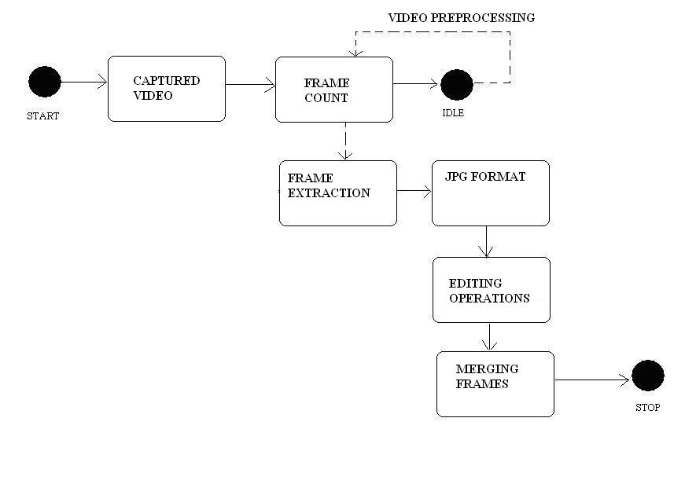

7.0 Restrictions, Limitations, and Constraints
Special issues which impact the specification, design, or implementation of the software are noted here.
- The biggest limitation of the application is that it is based on only Android OS.
- Storage media limitations.
- Resolution must be in-sync with the resolution of mobile.
- Since the availability of storage is limited, the number of images should not be more.
- The resolution also matters in image processing application.

SOFTWARE DESIGN SPECIFICATION
(HIGH LEVEL DESIGN DOCUMENT)

- Introduction
This document seeks to provide the Project Plan for the project. ‘Creation of Video Editing Application on Mobile’ to be developed as a part of Final Year Engineering Project at Pune Institute of Computer Technology with purpose of obtaining a degree in Computer Science at the Pune University. This document will be used by faculty of Computer Engineering department and the guides.

Video coding is to represent a sequence of images in a form suitable for storage and transmission.

0010110011101001110

We are going to edit a existing videos and give the menu for editing video through the use of mobile. For that purpose we are using existing images or frames because it is widely used in videos.
We provide interactive GUI to create a video by grabbing the frames in mobile which is very useful for the user to edit a Frame after capturing video and publish the modified video after removing unwanted frames to create video.
We also provide facility to personalize the existing images to form video by inserting new image or frame in that sequence.
We also provide color changing of existing video by applying gray scale effects on video which is useful for user to change the color of existing video.

Overview of Product
With the camera being an integral part of mobiles, these days capturing and exchanging images has become banal. Hence video capturing and editing has become necessary and moreover famous since people usually want to trim the unwanted part of the video. MMS has changed the way video transfers took place. With the development of technology there have been many video editing platforms. Editing videos on PCs is fairly easy. However, there has been minimal research for video editing on mobile systems. With mobiles, there are a few limitations like decrease in the display screen, lesser storage area and RAM. In this paper, we discuss the basic idea behind editing a video. We discuss the movie atom container in detail and the method of locating a track in a video file using functions. The process of editing a video by joining the frames and performing similar tasks with limitations of size and resolution is discussed in brief.
We provide trimming and splicing applications for editing the video in frames. Firstly we browse the existing videos in the mobile and select video.
We can grab frames from that video.
After that we can provide menu of techniques apply on to frames (Applications like Color Change).
1.1 Goals and objectives
We provide various types of functions for editing frames and creating a video in mobile. We will be providing user friendly interactions between different components at the design level.

1.2 Statement of scope
Video editor is an application which is being run onto mobile. In video editing we modifying the available video and dropped unwanted frames or visual objects. We recognized the problem of providing video editing capabilities on memory- and power-constrained portable devices, such as mobile phones with integrated video cameras. In order to avoid the computationally demanding decode-edit-encode cycle for a typical video editing session, we proposed a viable alternative for video editing on mobile phones - by developing a highly optimized, cutting and splicing algorithm. This system supports most of the common video editing features, such as video cutting and splicing, frame insertion, special effects (such as slow motion and black & white), transitional effects (such as wipe and fade), and supporting audio editing capabilities. As the mobile technology expands its focus more towards the multimedia market, it is imperative that efficient and viable solutions are provided for mobile devices for managing the growing multimedia content. Mobile video editor is one such step in this direction.
This document provides detailed description of software context, its usage scenario, data model and description, data object and their relationships, functional model and description, performance issues, software design constraints, software interfacing description, limitations and validation criteria.

1.3 Software context
There are several PC-based commercial products available providing such video editing functionalities. It is not very practical solution, however, to transfer files from a phone to PC for editing and then transfer the edited videos back to the phone for sharing. Editing capabilities on the mobile phones, therefore would provide significant advantage.
1.4 Major constraints
The main constraint is to use Mobile having Android O.S. during the development and testing period.

- Arcitectural design

Input Output
Video
Editing Algorithms
Modified Video

Present for Editing Present for Editing
Cutting Algorithm
Splicing Algorithm

The above diagram is showing what we do in our project.
The Video is the Input of the system which can be provided to the various editing algorithms like cutting and splicing the video from number of frames.
Then after applying these techniques, the output is the modified Edited Video file.

3.0 Data design
3.1 Internal software data structure
Cut
Color (B/W)
Trim

Cut

Cut block describing the grabbing Process use for the video. Cutting process is used for grabbing the frames from video and saved into Gallery.
Color (B/W)
In this Process we change the color of a Video but we provide only Black/White color process means we convert the frame from color to gray scale.
Trim

In this Process we trim the existing video at particular level and make small useful video.
We provides menu to user when user can open this application and do various things after choosing one of the option from the menu.
We also provide menu after selecting the frames to create the video and provide various IP processes for applying on the frames.

3.2 Global data structure
Sequence

GOP
Pictures
Slice

Macroblock

The above blocks show the contents of the Video file.
Sequence contain the SH and GOP.
SH -> it is a sequence header.
GOP -> It is a Group of Pictures.

SH | GOP | SH | GOP | SH | GOP
GOP contain the Frames Types
I Frame -> Intra Frame
P Frame -> Predicted Frame
B Frame -> Bi-directional Frame
The sequence of frames in each GOP is:

I | B | B | P | B | B | P | B | B | P | ----------- | B | P
From above diagram it is clear that each GOP contain only one I frame and number of P and B frames.

Picture contains the position of Slice present into frame.

Slice
Slice

The above figure contains the information about only one B frame.

Slice contains the Number of Macroblocks.

Macroblock contains the detail about the matrix and the color of the frames.
Splicing and Cutting of the Frame can be the Global Data Structure of our project.

3.3 Temporary data structure

Frame
Macroblock

Macroblock contain tables and the information about the color values of each frame present in the video.

Table
Y1
Cb
Cr
Y3
Y4
Y2

Above table contains the value of color Model in the matrix of 8X8.
YCbCr contain the values of the color model of each frame.
Temporary menu driven example of the system:
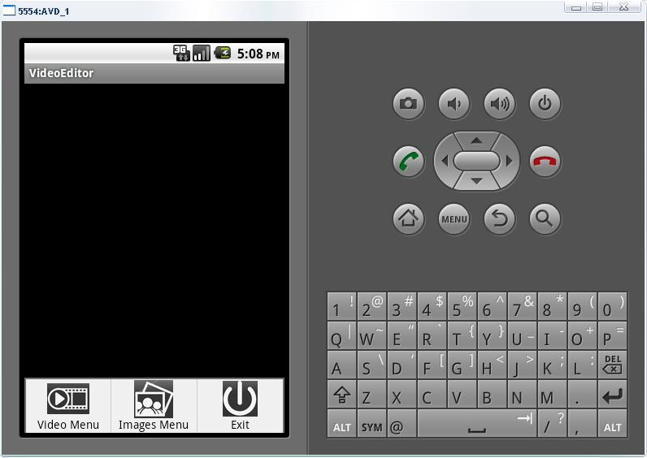

3.4 Database description

Storing all selected Frames

Memory storing unwanted Frames

Editing Processes
Memory Storing Modified Frames

We can use database for storing the all frames for the video into Memory (Image Gallery of Mobile) which we provide to the Editing Processes one by one.
User decide which frame is to be modified and then those frame is stored in Memory finalize (Modified) frames after providing various application on frames and those frames which are not wanted i.e. unwanted frames are stored in unwanted frame table and this frames are deleted before creating modified video.

4.0 Component design
Class diagram

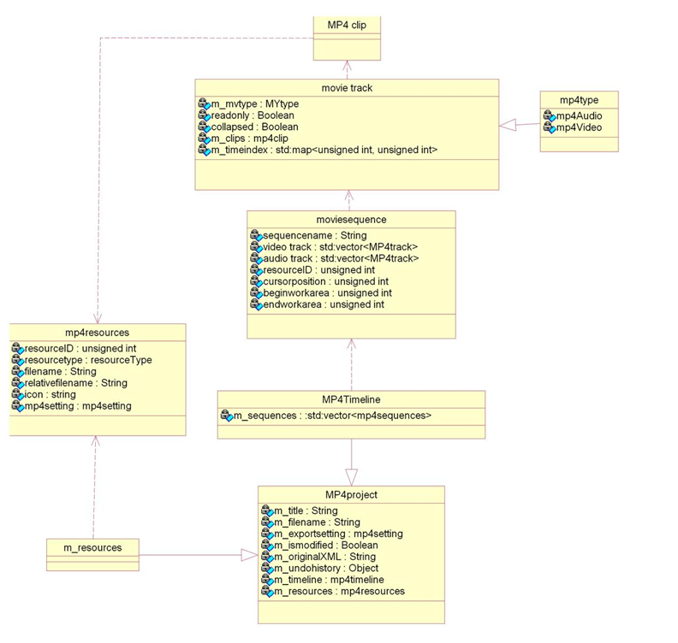

Interaction Diagram

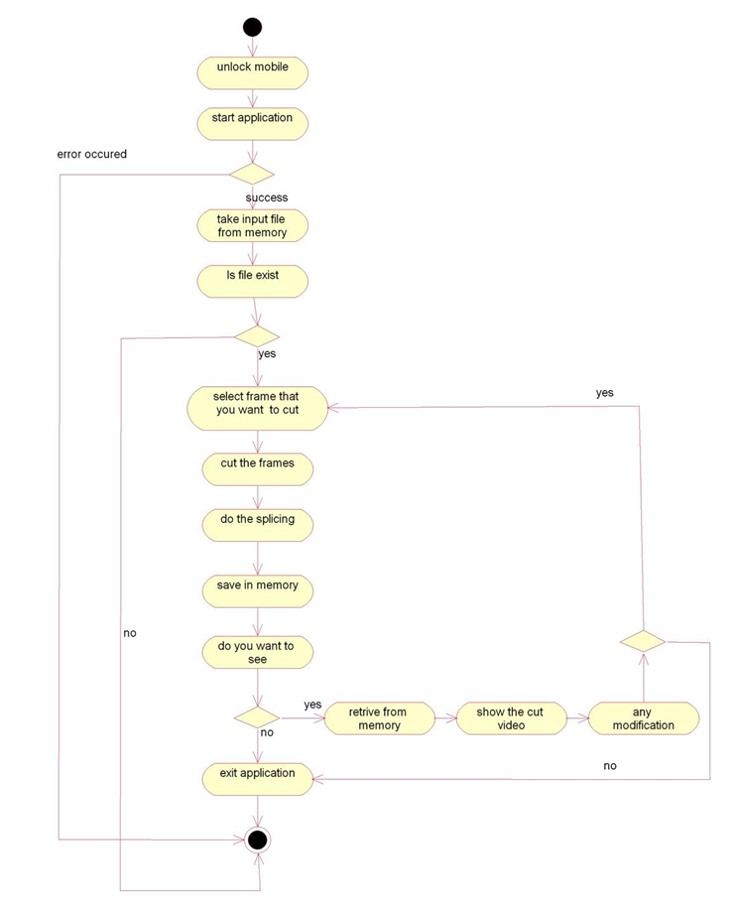

Algorithms:
- Cutting algorithm:

While selecting frames for a video, sometimes unwanted frames are captured because of the movement of camera. These unwanted images must be removed. For removing this, a cutting algorithm is used. In this algorithm, the image to be cut is selected. The duration of the frame to be deleted is calculated. Now this part to be deleted is cut thus dividing the video into two parts. A splicing algorithm is used on these parts to form one video with the help of the time-stamp of the deleted part and the total length of the video.
T_{t}

T_{m} Ʈ_{m}
m

F1’ F1”
F1
Input: Frame of a video from which a part is to be removed.
Let
T_{t} = time duration of K frame.
T₀ = time stamp for first frame.
T_{m} = time stamp for mth frame.
T_{m} = duration of mth frame.
F1’ = Formed frame 1.
F1” =Formed frame 2

Translation factor:
m-1
T_{m} = ∑ T_{i}
i=0
Output: Two frames are formed after the removal of the part to be cut.

- Splicing algorithm:
On removing the unwanted images for the video, two parts are formed. Hence the need of joining them arises. For joining two videos, both of the images must be of the same format and resolution. The duration of both the videos is needed. The time-stamp of the last frame in the first video and the first frame in the second video is calculated. The duration of the last frame of the first video is calculated. The time-stamp of the first frame of the second video is the duration of the first video. Using this, the two videos are joined.

Tv1 = T_{n}
V1 m n V2

T_{m} T_{m}

Input: Two videos of same format and resolution.
Let
V1 = Video 1
V2 = video 2
T_{m} = time stamp of last frame in V1
T_{n} = timestamp for first frame in V2
Tv1= duration of V1
T_{m} = duration of mth frame

Therefore,
T_{m} = Tv1 – T_{m}

After splicing,
T’_{n} = T_{m} + T_{m}
T’_{n} = Tv1
Therefore timestamp of remaining part of video

T’_{k} = T’_{n} + T_{k}
Where T_{k} =timestamp of the rest k frames.
T’_{n} = T’_{n} – T_{n}

Output: Spliced video.

4.1 Program Structure
A description of the program structure/Design Model chosen for the application is presented.
4.2 Description for Component n
4.2.1 Processing narrative (PSPEC) for component n
4.2.1.1. Processing narrative (PSPEC) for component User Management
In case of user management we will be providing different facilities to the user along with interactive GUI.
In this GUI user can select different operations such as Grabbing, Trimming, coloring to modify the selected frames.
4.2.1.2. Processing narrative (PSEPC) for component Notification System
In the notification system, we will make sure that which frames to be selected according to the user need. The Operations will be applied on those frames which are selected by the user.
4.2.1.3. Processing narrative (PSEPC) for Frame Maintaining
This module of the project will consist of maintaining the tables which includes various frames which are wanted or unwanted.
4.2.1.4. Processing narrative (PSEPC) for Mobile Background Processing
The background processing system will continuously do routine background tasks that need to be done automatically without any user interaction. E.g. Mobiles other activities are not interrupted during running of this application.

4.3 Software Interface Description
4.3.1 External machine interfaces
There are no other external machine interfaces in our application.
4.3.2 External system interfaces
4.3.3 Human interface
An overview of any human interfaces to be designed for the software is presented. See Section 4.0 for additional detail.

  - User interface design (if detail user design is to be provided)

USER
Editing Algorithm
Mobile

User has mobile which contain Video Editing Algorithms which we provides.
Mobile Provides only menu but which task is to be doing on that video is decide by the User. A description of the user interface design of the software is presented.

5.1 Description of the user interface
User is the one who can use mobile and want to edit video present in his mobile so he open our application and doing various different task on video from menu.
User is interface with this application through Mobile device.
User is the one who can decide which Frame can be modified or which is unwanted.

5.2 Interface design rules
Interface of this application with user is through Mobile device which he/she used.
1. Enable frequent users to use shortcuts.
2. Design dialog to yield closure.
3. Offer simple error handling.
4. Permit easy reversal of actions.
5. Support internal locus of control.
6. Strive for consistency.
This application is directly interface with mobile and indirectly with User.
5.3 Components available
1. Android compatible Mobile
2. Video Player
3. Images/ frames which user wants to edit.
4. Memory for storing frames.

6.0 Restrictions, limitations, and constraints
Restriction:
User has Restrict on edit video other than Android Based device.
Video file can be edit only which is supported by mobile.

Limitations:
User only does those functions which we provide.
Unwanted Frames can be deleted which is not retrieve in future so it is the loss of data of the user.
We can not make video from grabbed frames.
Constraints:
During the running process of our application the device can be switched off due to the low battery power.
Application cannot be seen if the mobile display is not working properly.
Problems may occur if there is no enough memory present in mobile for storing the frames.
It takes few second to load existing video in our video player.

FUTURE ENHANCEMENT

Future Work

- In our project we are providing some basic functions like color changing . But there are various types of function are available in the Image Processing domain so this will be the future work and we will continue the study on that topic and try to provide various types of Image Processing applications like noise reduction, filtering, transformation etc.
- We are doing work on this project for providing video editing application only to the jpg image format. There are various image formats available in the market. So there will be a great opportunity for developing this project for other image formats also.
- This software is mainly developed for the Android Operating System. Hence this will run only on those devices having Android operating system. So in the future we can expand our work for other operating system such as Symbian, meego etc.
- This application works for grabbing of frames from video only, this can expand to splice different image to create a new modifiable video in the future.

SUMMARY AND CONCLUSION

Summary:

The following document gives detailed information about the mobile video editor system. It explains the design specifications and the project plan of the work on this project. The functionality of the system, its working and its behavior is mentioned in the following document with the help of various UML diagrams. Various testing techniques are used for testing the modules. Software requirements and specification is done in the report.

Conclusion:

This document is a description of the work done on the mobile video editor software. It states the functionality of the software with the help of UML diagrams. It states the work done on the project and the needed information for understanding the basis behind editing a video.

LIST OF DIAGRAMS

Figure | Name | Document | Page No
Block diagram (whole system) | 1)High Level Architecture  2)Video processor module | Chapter 3- Software Requirement Specification | 55
Use case | Use Case Diagram | Chapter 3- Software Requirement Specification | 43
Class-diagram | Class Diagram | Chapter 5-High Level Design Documentation | 61
Activity diagram | Interaction diagram | Chapter 5-High Level Design Documentation | 62
State transition diagram | Data Flow Diagram | Chapter 3- Software Requirement Specification | 45

LIST OF TABLES

No. | Name | Page No
1 | Risk Table | 27
2 | Risk Mitigation, Monitoring and Management. | 28
3 | Project Schedule | 29
4 | Project Task Set | 30
5 | Timeline chart | 33
6 | Team structure | 33

ANNEXURE

Annexure A
Input:-

For a video editor system S, the input is a video of any format.
The input for the software is the Variable Length Code (VLC). The VLC contains pixel details like the color, luminance.
The manipulation of these details will converge into a modified video.

Sr. No. | Description | X | F(x) | Y
1 | Search for an mp4 file in the mobile | All the mp4 files from the mobile | Select the file to be edited | <filename>.mp4 is selected and now can be used for editing
2. | Color editing | Movie or an image that is chosen | Change the color of the movie or the image using color transformation to make the required file into a black and white picture | Edited image is saved in the same location.
3. | Trim | Movie selected from the mobile | The length of the video will be cut. The video is cut from the desired point by using the timestamp method. The cut video is then stored in the same location as that of the mp4 file | Trimmed video is created.
4 | Grab | Movie selected from the mobile | Select the required frame from the movie file. | Grabbed frames are saved.

Output:-
The output is an edited video. On locating the frame and changing the details according to the user’s specification a corrected video is obtained.
NP HARD/NP COMPLETENESS

Guessing stage:- choosing a random frame from video object which is to be modified.
Verification stage:-It takes input as frame which is to be edited, if it returns ‘yes’ then the edited frames will give the actual solution.
Video is composed of video objects. Video objects consist of a sequence of frames.
We have to select a frame from this sequence which is to be edited.

Algorithm:
A[1:n] is a set of frames. We have to determine the index i of A at which frame x is located which is to be modified.
For i=1 to n do
A[i]:=choose(i); // non deterministic stage
if A[i]=x then //deterministic stage
{
Edit(i);
Success();
}
Edit(0);
Fail();
Single frame can be edited by polynomial time.
After integrating all the edited frames a modified video file is obtained as an output.
So the original video file can be edited by polynomial time.
Hence problem is NP complete.

ANNEXURE B

ANNEXURE B
Assignment 2:

The objects for the system are the macroblock contents. They are variable length codes(VLCs) which contain information about the color and the luminance of the pixel. Each macroblock is an object, considering the video editor system as a class and the variables being YC_{b}C_{r}.

Searching a track in a file is done with the help of data within the sample table atom.

- f(s,T) -> S
Where ‘f’ is the function to locate the track that contains the sample at time T and S is the set of samples at time T.

- f(SS_{i} ,T)-> Sy_{j}
where ‘f’ is the function to summate the shadow sync atoms(SS) which are nearly equal to the sync sample atoms(Sy).

- Stc(Sy_{i}) U sco(c_{i}) U ssz(Sy_{i}) = S_{i}
Find the sample with the help of sample to chunk(stc), chunk offset(sco) and sample size(ssz).

Venn Diagrams:

Video Images

Video Frame

color

Image Color

Assignment 3: Functional dependency graphs and relevant UML diagrams or other necessities

Images
1

2

3

4

5

6

Video
1

2

3

Color image Black Image
1

2

3

1

2

3

Original video Trimmed video

1
2
3
4
5

1

2

3

Sequence diagram:

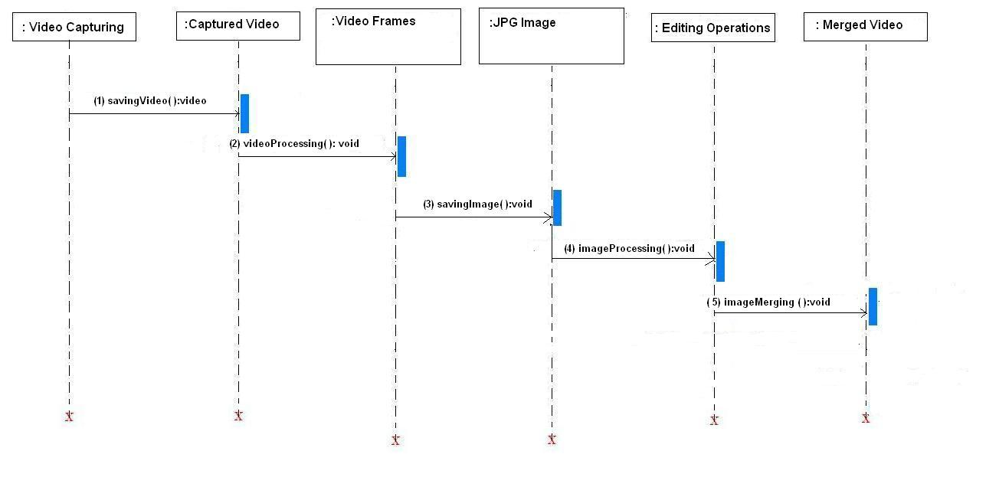

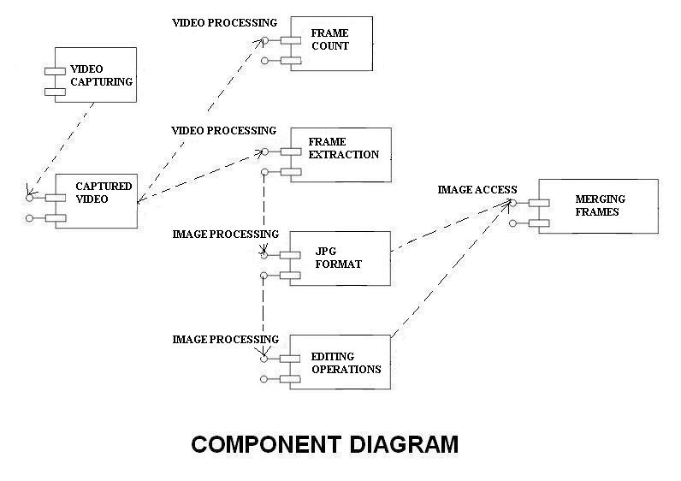

State transition diagram

ANNEXURE C

Task Network:
T1
T2
T3
T4
T5
T7
T8
T9
T6
T10

Serial No | Task ID | Name Of Task
1 | T-1 | Deciding the Input for the Project & the Required Output.
2 | T-2 | Acquiring information about Android OS, Android SDK and Java.
3 | T-3 | Video Path on mobile.
4 | T-4 | Tools required for the Project.
5 | T-5 | Deciding the required algorithms
6 | T-6 | Creating new Algorithms if not available for Particular task.
7 | T-7 | Preparing Version 1
8 | T-8 | Testing Version 1
9 | T-9 | Deploying Version 1
10 | T-10 | With Feedback improving the Application.

Information of Tasks

Functional Decomposition
The ten functions may basically be viewed as follows. The new system requirements are defined in as much detail as possible. This usually involves interviewing a number of users representing all the external or internal users and other aspects of the existing system.

Task-1 (T1):
In this we decided the input for our application and the required output for the application.
Input:
      - The input of our application is video of any format.
      - Videos available in device are considered.
      - Frames contain the information about Video Objects (VO),
Video Object Plane (VOP), Macroblocks, Color Information (YCbCr) etc.
Output:
- The output is the Modified frames i.e. it is editing video file which is produced by Application through images for editing.
Task-2 (T2):
This Task gives the information about the Android O.S. and Java like requirements and the setup.
System Requirements:
- Microsoft window 2000 professional with Service pack 3 or Microsoft XP Service Pack 2.
- At least 512 MB of RAM (1.5 GB Recommended).
- 1-GHz or faster Pentium-class processor (2GHz Pentium class Processor Recommended).
- At least 1GB of free disk space (5 GB recommended).
- Java Runtime Environment (JRE) 1.4.1_02 or later (available from java.sun.com).

Task-3 (T3):
Searching the videos on the mobile using the functions:
- In android Default path for storing the captured videos in phone Memory is c:\data\videos, while on the memory card it is e:\videos.
- The paths are:
  - PathInfo::PhoneMemoryPath()
  - PathInfo::MemoryCardPath()
  - PathInfo::VideoPath()
  - PathInfo::ImagesPath()
  - PathInfo::SoundsPath()
ImagePath() return ‘Images\’. Backslash character at the end of the returned path.
Task-4 (T4):
Tools:
- Android Mobile Device.
- Android SDK.
- Java.
- Java Runtime Environment 1.4.1 or later.

Task-5 (T5):
Required Algorithm:
- Editing a video Frames.
- Color changing.
Task-6 (T6):
New Algorithms:
If the available algorithms for video editing are not feasible to use in our application, then there may be a need to come up with a new algorithm. If need be, it should be possible to create a new algorithm or make the existing one more efficient

BLACK-BOX TESTING:

Black-box testing is a method of software testing that tests the functionality of an application as opposed to its internal structures or working. Specific knowledge of the application's code/internal structure and programming knowledge in general is not required. The tester is only aware of what the software is supposed to do, but not how i.e. when he enters a certain input, he gets a certain output; without being aware of how the output was produced in the first place.

Modules to be tested—
1] Login
2] Video selection
3] Grey Scale
4] Grabbing
5] Image store

Frames Editing

Input Output

Video Frames

Select video

Mobile Video

Login
Password Open application

Annexure D

Review of Design, Black box testing and corrective action in design

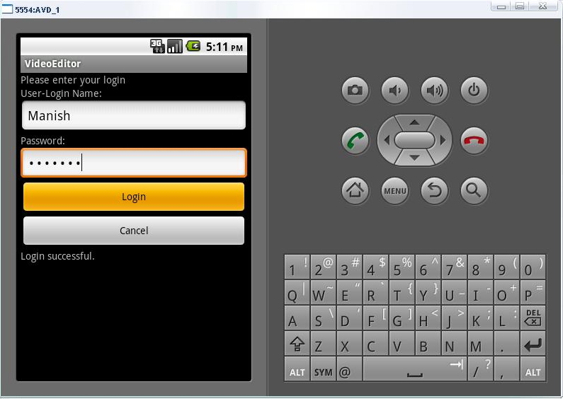

Review Form of ICICA 2012

February 17-18, 2012, Hong Kong
http://www.icica.org/
Paper ID : | A0004 .
Paper Title : | Mobile Video Editor

Evaluation:
 | Poor | Fair | Good | Very Good | Outstanding
Originality | ○ | ○ | ● | ○ | ○
Innovation | ○ | ● | ○ | ○ | ○
technical merit | ○ | ○ | ● | ○ | ○
Applicability | ○ | ○ | ○ | ● | ○
Presentation and English | ○ | ○ | ● | ○ | ○
Match to Conference Topic | ○ | ○ | ● | ○ | ○
Recommendation to Editors
 | Strongly Reject | Reject | Marginally Accept | Accept | Strong Accept
Recommendation | ○ | ○ | ○ | ● | ○
Comments:
Instructions for Composition of Final Paper:
The author should prepare the final version of the paper as per review instructions:
-the format should be according to ASME template.
-it is expected to present sufficient technical contents on authors’ contributions.
-all figures and tables should be clear and in good quality for publication.
- More references are expected to be referred in the manuscript so as to give a solid background of authors’ work.

Review Form of ISEM-PSR Centre Conferences, Bangkok (Dec. 23-24, 2011)

www.psrcentre.org & http://www.isems.org

Paper ID : | 1211353
Paper Title : | Mobile Video Editor

Evaluation:
 | Poor | Fair | Good | Very Good | Outstanding
Originality | ○ | ○ | √ | ○ | ○
Innovation | ○ | ○ | √ | ○ | ○
technical merit | ○ | ○ | √ | ○ | ○
Applicability | ○ | ○ | ○ | √ | ○
Presentation and English | ○ | √ | ○ | ○ | ○
Match to Conference Topic | ○ | ○ | √ | ○ | ○
Recommendation to Editors
 | Strongly Reject | Reject | Marginally Accept | Accept with corrections as per comments | Strong Accept
Recommendation | ○ | ○ | ○ | √ | ○
Comments:
- In this paper, the author has discussed the basic idea behind editing a video.
- Every Figure needs to be numbered and caption is required below each figure.
- Figure captions are to be written below the figure and Table captions are to be written above the table.
- The final paper is required as .doc file for the formatting.
- In the reference section every reference should have details: authors, paper title, conference/journal name, date & Place of the conference/Journal Volume& Issue Number, page numbers.
- In case of Book: “Author name, Book Title, Publication, Edition, Pages referred” are required.
- References are to be written according to the conference format, it means the references should be numbered at the end of the paper and every reference should be called at least once in the main body of the paper as numbers e.g. [2]. (Please see the template in the download section of the conference website). In this paper no reference is called in the main body. Kindly ensure that all the reference should be called in the main body of the paper.
- The topic is very useful for the audience so the paper may be accepted.

Annexure E

Project Workstation selection, installation and setup report

Hardware, software resource required, Steps for installing software,
Configurations required

Workstation Selection:
Android SDK and Eclipse are chosen as the platform for Video Editing Application on Mobile.

Installation of Android (On Windows)
System Requirements :
- Operating Systems
- Windows XP (32-bit) / Vista (32 or 64 bit) / Windows 7 (32 or 64 bit).
- Linux Ubuntu 8.04 LTS - 10.04
- Mac OS X 10.5.8 or later (x86 only).
- Supporting Development Environments:
Note:
1. before installing any of the version of Eclipse on your machine, You need to Install JDK.
2. Also go through Eclipse IDE - Android Development Tools plugin (Recommended)
Download any of the version (Latest recommended)
- Eclipse Indigo (3.7)
- Eclipse Helios (3.6)
- Eclipse Galileo (3.5)
Download All versions from here: http://www.eclipse.org/downloads/

Hardware requirements:
The Android SDK requires disk storage for all of the components that you choose to install. The table below provides a rough idea of the disk-space requirements to expect, based on the components that you plan to use.
Component type | Approximate size | Comments
SDK Tools | 35 MB | Required.
SDK Platform-tools | 6 MB | Required.
Android platform (each) | 150 MB | At least one platform is required.
SDK Add-on (each) | 100 MB | Optional.
USB Driver for Windows | 10 MB | Optional. For Windows only.
Samples (per platform) | 10M | Optional.
Offline documentation | 250 MB | Optional.

Download the ADT Plugin:
Following steps are necessary and can be carried out in any version of Eclipse.
- Start Eclipse, then select Help > Install New Software....
- Click Add, in the top-right corner.
- In the Add Repository dialog that appears, enter "ADT Plugin" for the Name and the following URL for the Location: https://dl-ssl.google.com/android/eclipse/
- Click OK
- Note: If you have trouble acquiring the plugin, try using "http" in the Location URL, instead of "https" (https is preferred for security reasons).
- In the Available Software dialog, select the checkbox next to Developer Tools and click Next.
- In the next window, you'll see a list of the tools to be downloaded. Click Next.
- Read and accept the license agreements, then click Finish.

Note: If you get a security warning saying that the authenticity or validity of the
software can't be established, click OK.
- When the installation completes, restart Eclipse.

Configuring the ADT Plugin:

To modify your ADT preferences in Eclipse to point to the Android SDK directory follow steps:
- Select Window > Preferences... to open the Preferences panel (Mac OS X: Eclipse > Preferences).
- Select Android from the left panel.
You may see a dialog asking whether you want to send usage statistics to Google. If so, make your choice and click Proceed.
For the SDK Location in the main panel, click Browse... and locate your downloaded SDK directory.
- Click Apply, then OK.

API Levels:
The following table specifies the API Level supported by each version of the Android platform.

Platform Version | API Level | VERSION_CODE | Notes
Android 3.2 | 13 | HONEYCOMB_MR2
Android 3.1.x | 12 | HONEYCOMB_MR1 | Platform Highlights
Android 3.0.x | 11 | HONEYCOMB | Platform Highlights
Android 2.3.4  Android 2.3.3 | 10 | GINGERBREAD_MR1 | Platform Highlights
Android 2.3.2  Android 2.3.1  Android 2.3 | 9 | GINGERBREAD
Android 2.2.x | 8 | FROYO | Platform Highlights
Android 2.1.x | 7 | ECLAIR_MR1 | Platform Highlights
Android 2.0.1 | 6 | ECLAIR_0_1
Android 2.0 | 5 | ECLAIR
Android 1.6 | 4 | DONUT | Platform Highlights
Android 1.5 | 3 | CUPCAKE | Platform Highlights
Android 1.1 | 2 | BASE_1_1
Android 1.0 | 1 | BASE

Creating an AVD:
An Android Virtual Device (AVD) is a device configuration for the emulator that allows you to model real world devices. In order to run an instance of the emulator, you must create an AVD.
To create an AVD from Eclipse:
  - Select Window > Android SDK and AVD Manager.
  - In the Virtual Devices panel, you'll see a list of existing AVDs. Click New to create a new AVD.
  - Give name, Android platform target, an SD card size, and a skin.
Note: AVD platform target must have an API Level greater than or equal to the API Level that your application compiles against.
  - Click Create AVD.

Annexure F
Module Development plan:

MODULE DESIGN PLAN

Sr. No | Module | Date | Input | Output
1 | Log-in screen |  | Password | A log-in screen is created for the application. On correct password entry, login is provided else error is thrown.
2 | Video selection |  | Memory | Video to be edited is selected.
3 | Frame editing | ` | Selected video | The video is divided into frames by getting snapshots.
4 | Image store |  | Images | Images are stored in phone memory.
5 | Grey scale |  | Images | Images are converted into grey scale mode.
6 | Frames merging |  | Frames | Video is generated by merging the selected frames.

1] Log-in screen:- In this module login screen is displayed. User must have to enter the valid password to log in. If the invalid password is entered by the user the error message will be displayed on the screen.
2] Video selection:- In this module memory of the device is accessed and the video is selected and played.
3] Frame extraction:- The function of this module is to extract frames from the selected or captured video file in the memory.
4] Image store:- Images are stored in phone memory with the help of this module.
5] Grey scale:- This module is developed for converting selected images into grey scale mode.

Annexure G

White Box Test Plan, Testing and Test report

White-box testing (also known as clear box testing, glass box testing, transparent box testing, and structural testing) is a method of testing software that tests internal structures or workings of an application, as opposed to its functionality (i.e. black-box testing). In white-box testing an internal perspective of the system, as well as programming skills, are used to design test cases. The tester chooses inputs to exercise paths through the code and determine the appropriate outputs. This is analogous to testing nodes in a circuit, e.g. in-circuit testing (ICT).
While white-box testing can be applied at the unit, integration and system levels of the software testing process, it is usually done at the unit level. It can test paths within a unit, paths between units during integration, and between subsystems during a system–level test. Though this method of test design can uncover many errors or problems, it might not detect unimplemented parts of the specification or missing requirements.
White-box test design techniques include:
- Control flow testing
- Data flow testing
- Branch testing
- Path testing
White-box testing is the verification technique software engineers can use to examine if their code works as expected. In this chapter, we will explain the following:
• A method for writing a set of white-box test cases that exercise the paths in code.
• The use of equivalence partitioning and boundary value analysis to manage the number of the
test cases that need to be written and to examine error-prone/extreme “corner” test cases
• How to measure how thoroughly the test cases exercise the code

White-box testing is testing that takes into account the internal mechanism of a system or component (IEEE, 1990).

White-box testing is also known as structural testing, clear box
testing, and glass box testing (Beizer, 1995). The connotations of “clear box” and “glass
box” appropriately indicate that you have full visibility of the internal workings of the
software product, specifically, the logic and the structure of the code.
Using the white-box testing techniques outlined in this chapter, a software engineer can design test cases that (1) exercise independent paths within a module or unit; (2) exercise logical decisions on both their true and false side; (3) execute loops at their boundaries and within their operational bounds; and (4) exercise internal data structures to ensure their validity (Pressman, 2001).
There are six basic types of testing: unit, integration, function/system, acceptance, regression, and beta. White-box testing is used for three of these six types:

• Unit testing, which is testing of individual hardware or software units or groups of
related units (IEEE, 1990). A unit is a software component that cannot be subdivided
into other components (IEEE, 1990). Software engineers write white-box test cases to
examine whether the unit is coded correctly. Unit testing is important for ensuring the
code is solid before it is integrated with other code. Once the code is integrated into the code base, the cause of an observed failure is more difficult to find. Also, since the software engineer writes and runs unit tests him or herself, companies often do not track the unit test failures that are observed– making these types of defects the most “private” to the software engineer. We all prefer to find our own mistakes and to have the opportunity to fix them without others knowing. Approximately 65% of all bugs can be caught in unit testing (Beizer, 1990).
• Integration testing, which is testing in which software components, hardware
components, or both are combined and tested to evaluate the interaction between them (IEEE, 1990). Test cases are written which explicitly examine the interfaces between the various units. These test cases can be black box test cases, whereby the tester understands that a test case requires multiple program units to interact. Alternatively, white-box test cases are written which explicitly exercise the interfaces that are known to the tester.

• Regression testing, which is selective retesting of a system or component to verify that modifications have not caused unintended effects and that the system or component still complies with its specified requirements (IEEE, 1990). As with integration testing, regression testing can be done via black-box test cases, white-box test cases, or a combination of the two. White-box unit and integration test cases can be saved and rerun as part of regression testing

Deriving Test Cases

In the following sections, we will discuss various methods for devising a thorough set of
white-box test cases. We will refer to the Monopoly example to illustrate the methods under discussion. These methods can serve as guidelines for you as you design test cases. Even though it may seem like a lot of work to use these methods, statistics show [1] that the act of careful, complete, systematic test design will catch as many bugs as the act of testing. The test design process, at all levels, is at least as effective at catching bugs as is running the test case designed by that process.
Each time you write a code module, you should write test cases for it based on the guidelines.
A possible exception to this recommendation is the accessor methods (i.e., getters and setters) of your projects. You should concentrate your testing effort on code that could easily be broken. Generally, accessor methods will be written error-free.

Control-flow/Coverage Testing
Another way to devise a good set of white-box test cases is to consider the control flow of the program. The control flow of the program is represented in a flow graph.
  - We consider various aspects of this flow graph in order to ensure that we have an adequate set of test cases. The adequacy of the test cases is often measured with a metric called coverage. Coverage is a measure of the completeness of the set of test cases.

Keeping with a proper testing technique, we write methods to ensure they are testable – most simply by having the method return a value. Additionally, we predetermine the “answer” that is returned when the method is called with certain parameters so that our testing returns that predetermined value. Another good testing technique is to use the simplest set of input that could possibly test your situation – it’s better not to input values that cause complex,

White-Box Testing
Error-prone calculations when you are predetermining the values. We’ll illustrate these
principles as we go through the next items.

Data Flow Testing
In data flow-based testing, the control flow graph is annotated with information about how the program variables are defined and used. Different criteria exercise with varying degrees of precision how a value assigned to a variable is used along different control flow paths. A reference notation is a definition-use pair, which is a triple of (d, u, V) such that V is a variable, d is a note in which V is defined, and us is a node in which V is used. There exists a path between d and u in which the definition of V in d is used in u.

Failure (“Dirty”) Test Cases
As with black-box test cases, you must think diabolically about the kinds of things users
may do with your program. Look at the structure of your code and think about every
possible way a user might break it. These devious ways may not be uncovered by the
previously mentioned methods for forming test cases. You need to be smart enough to think of your particular code and how people might outsmart it (accidentally or intentionally).
Augment your test cases to handle these cases. Some suggestions follow:
• Look at every input into the code you are testing. Do you handle each input if it
is incorrect, the wrong font, or too large (or too small)?
• Look at code from a security point of view. Can a user overflow a buffer, causing
a security problem?
• Look at every calculation. Could it possible create an overflow? Have you
protected from possible division by zero?

Properly planned with explicit input/output combinations, white-box testing is a controlled V&V technique. You run a test case, you know what lines of code you execute, and you know what the “answer” should be. If you don’t get the right answer, the test case reveals a problem (a fault). Fortunately, you know which lines of code to look at based upon the test case that fails. Because of this control, removing defects in unit test is more economical than later phases in the development cycle. Later testing phases that involve block-box testing can be more chaotic. In those phases, a test case no longer reveals a problem (and an approximate location of where the problem needs to be fixed). Instead, a failed black-box test case reveals a symptom of a problem (a failure). It can be difficult, time consuming, and take an unpredictable amount of time to find the root cause of the symptom (the fault that caused the failure) so that the software engineer knows what to change in the code.
Therefore, unit testing is a more economical defect removal technique when compared with black box testing. Therefore, as much as possible should be tested at the unit level (IEEE, 1987).

Annexure H

- Paper Title: Mobile Video Editor

- Name of the conference/journal where paper submitted :

  - ISEM-PSR Centre Conferences, Bangkok
  - ICICA, hongkong

- Backward references of the paper:

- David Singer, William Belknap, “International Organisation For Standardisation Organisation Internationale De Normalisation”,Iso/Iec Jtc1/Sc29/Wg11,Coding Of Moving Pictures And Audio,Iso/Iec Jtc1/Sc29/Wg11,Mpeg98/N2612p4
Dec 1998

2. Ari Hourunranta, Asad Islam, Fehmi Chebil, Nokia, "Video And Audio Editing For Mobile Applications”, ©2006 Ieee

- Forward references of the paper:

- Jianping Chen, Dajun Wu, Hai Gao And Jo Yew Tham, ”A Novel Scheme Of Generating Streamable Mp4 Files For Scalable Video Coding”, Institute For Infocomm Research, Fusionopolis, Singapore 138632 ©2009 Ieee.

- Zhaoxin-Bo, Xiao-Chun, Fengyan,Xi'an, China, An Efficient Video Segmentation Algorithm, 2010 2nd International Conference On Industrial And Information Systems ©201o Ieee..

- Paper accepted/rejected: Accepted

- Review comments by reviewer if any

REFERENCES

Backward References:

1. David Singer, William Belknap, “International Organisation For Standardisation Organisation Internationale De Normalisation”,Iso/Iec Jtc1/Sc29/Wg11,Coding Of Moving Pictures And Audio,Iso/Iec Jtc1/Sc29/Wg11,Mpeg98/N2612p4
Dec 1998

2. Ari Hourunranta, Asad Islam, Fehmi Chebil, Nokia, "Video And Audio Editing For Mobile Applications”, ©2006 Ieee

3. Angel R. Kanchev, Antoaneta A. Popova, ”Development System For Video And Audio Algorithms”
2007 Ieee International Symposium On Signal Processing And Information Technology.

Forward References:

6. Jianping Chen, Dajun Wu, Hai Gao And Jo Yew Tham, ”A Novel Scheme Of Generating Streamable Mp4 Files For Scalable Video Coding”, Institute For Infocomm Research, Fusionopolis, Singapore 138632 ©2009 Ieee.

7. Zhaoxin-Bo, Xiao-Chun, Fengyan,Xi'an, China, An Efficient Video Segmentation Algorithm, 2010 2nd International Conference On Industrial And Information Systems ©201o Ieee..

8.Vaishnavi Rajgopalan, Ananth Ranganathan, Ramgopal Rajagopalan,Sudhir P. Mudur, “Keyframe-Guided Automatic Non-Linear Video Editing”, 2010 International Conference On Pattern Recognition © 2010 Ieee.

9. Dingming Liu,Jieyu Zhao, “Spatio-Temporal Video Object Segmentation Using Moving Detection And Graph Cut Methods” 2011 Seventh International Conference On Natural Computation ©2011 Ieee.

