Configuring MINIKUBE
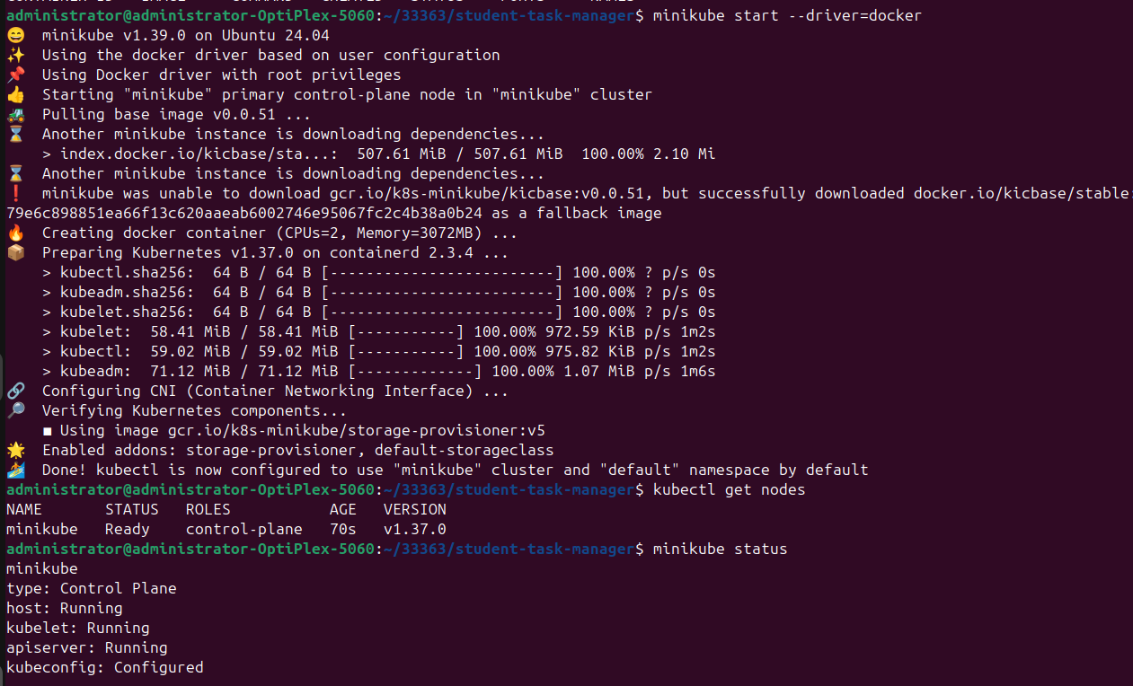
Application on server
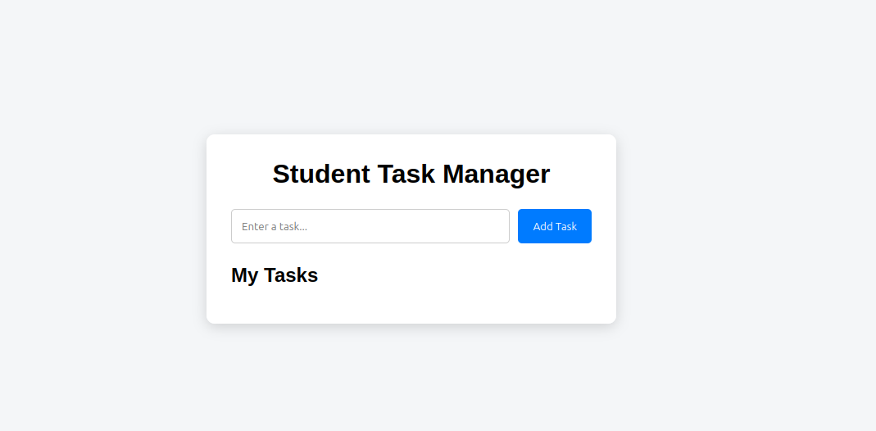

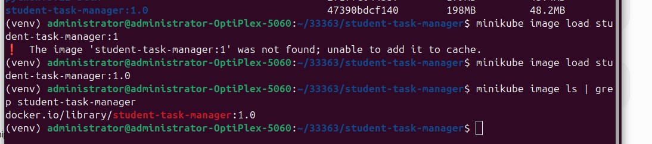
Loading image into minikube
Creating and deploying pods using kubectl
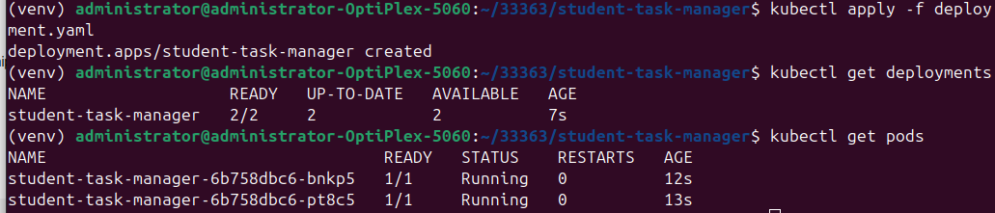
Final Service Deployment
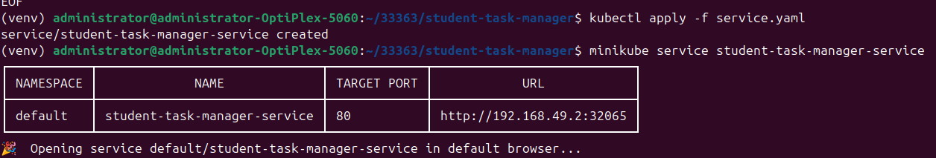
Kube TOPs
KubeCTL Pod Details
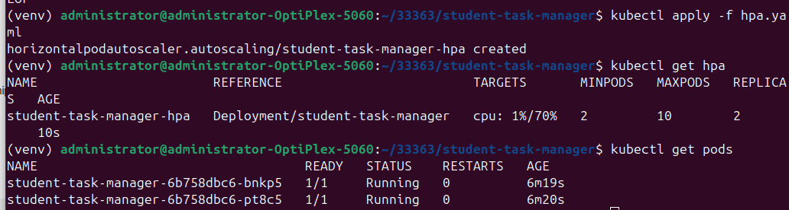
Verification Commands
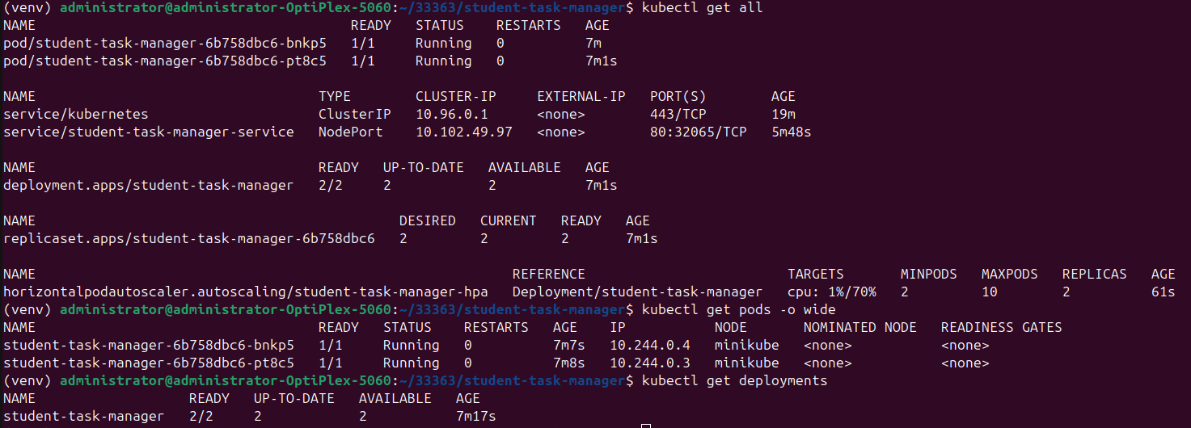
DEMO Commands
cd ~/33363/student-task-manager

docker --version
docker ps

minikube start --driver=docker
kubectl get nodes

docker build -t student-task-manager:1.0 .

minikube image load student-task-manager:1.0

kubectl apply -f deployment.yaml
kubectl get pods

kubectl apply -f service.yaml
kubectl get services

minikube service student-task-manager-service

minikube addons enable metrics-server
kubectl top pods

kubectl apply -f hpa.yaml
kubectl get hpa

kubectl get all

