SE2

**Software Requirement Specification**

**for**

Service Request Management

**Version 1.0**

Contents

1. Executive Summary 3

2. Purpose and Scope 3

2.1 Purpose 3

2.2 Product Scope 3

3. Goals 3

4. Target Market Overview 3

5. Overall Description 3

5.1 Product Perspective 3

5.2 Product Functions 3

5.3 User Classes and Fields 4

5.3.1 Login Fields 4

5.3.2 Registration Fields 4

5.4 Operating Environment 4

5.4.1 Hardware 4

5.4.2 Software 4

5.5 Design and Implementation Constraints 4

5.6 Assumptions and Dependencies 4

6. System Features 5

6.1 Forget Password 5

6.1.1 Description and Priority 5

6.1.2 Functional Requirements 5

6.2 Login 5

6.2.1 Description and Priority 5

6.2.2 Functional Requirements 5

6.3 Register 5

6.3.1 Description and Priority 5

6.3.2 Functional Requirements 6

6.4 Profile 6

6.4.1 Description and Priority 6

6.4.2 Functional Requirements 6

7. Other Nonfunctional Requirements 7

7.1 Performance Requirements 7

7.2 Security Requirements 7

7.3 Software Quality Attributes 7

7.4 Reliability 7

7.5 Availability 7

7.6 Usability 7

8. Evaluation Plan and Performance Metrics 7

8.1 Metrices 7

9. Future Work 8

# Executive Summary

This system will allow all the users to securely login and logout of Service Management System and each user will see different dashboards according to their roles. Users can also see their profile.

# Purpose and Scope

## Purpose

This SRS document contains the description and behavior for Login/ Registration Module System. It includes interactions that the user will make with software at the time of Login/ Registration. It also contains use cases, functional, non-functional requirements, constraints and design.

## Product Scope

It’s main purpose is to create a Login/ Registration Module for different users to login and logout of the system. The main goal is to add authentication and show different dashboards to different users.

# Goals

The goal of the system is to allow the user to get successfully login by providing credentials and register if the user is new to the system by entering the required information.

# Target Market Overview

The target end users are the employees of the enterprise and this system will be used by them to request services in the enterprise.

# Overall Description

## Product Perspective

This module is the part of the project Service Request Management and mainly focuses on Login/ Registration functionality. Once user gets registered a confirmation will be sent to their email.

## Product Functions

|  |  |  |
| --- | --- | --- |
| 1 | Login | This process allows authorized users to access the system |
| 2 | Register | This process it used to register new users in the system |
| 3 | Forget Password | This process will allow to reset the password |
| 4 | Profile | User profile will be displayed |

## User Classes and Fields

### Login Fields

1. User Email
2. Password

### Registration Fields

1. First Name
2. Middle Name
3. Last Name
4. Gender
5. Email
6. Phone
7. Password

## Operating Environment

### Hardware

### Software

#### Frontend

1. AngularJs framework is used for frontend to make Single Page Application
2. Bootstrap and Angular Material for CSS

#### Backend

1. .Net Web API is used as backend
2. JWT token based authentication will be used
3. Microsoft SQL is used as databse

## Design and Implementation Constraints

1. Password must be alphanumeric with special sign

2. Password must be at least 6 characters long

3. User name must be at least 2 characters long

4. All fields in registration form are required

## Assumptions and Dependencies

1. User is employee of SE2
2. User has valid email account
3. User understands login and registration procedure

# System Features

## Forget Password

### Description and Priority

Description: This process will allow the user to create a new password in case they forget the password

### Functional Requirements

System will provide forget password module and this will allow the user to recover his password in case he has forgotten his password

## Login

### Description and Priority

Description: This process will allow the user to login to the system

### Functional Requirements

System will allow the user to login to the system by using login credentials

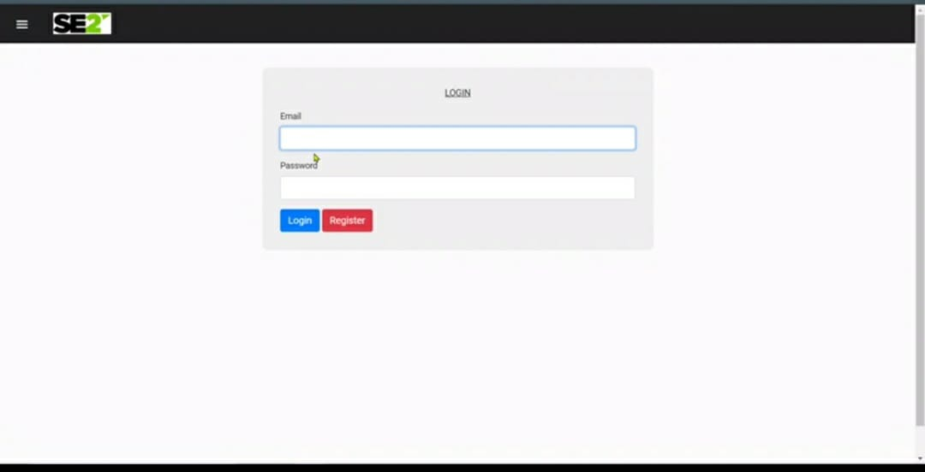

## Register

### Description and Priority

Description: This process will allow the new user to register

### Functional Requirements

System will allow new user to register in the system by filling required fields

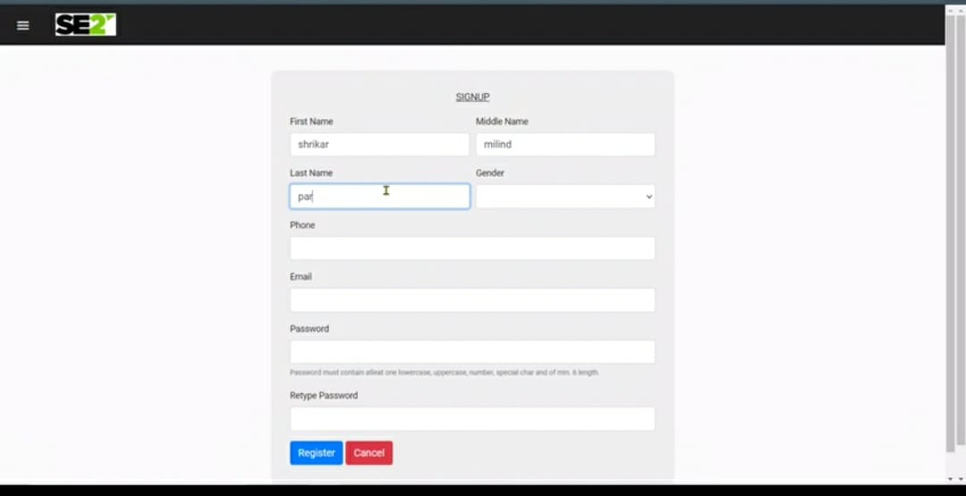

## Profile

### Description and Priority

Description: Allow the user to see user profile

### Functional Requirements

System must allow user to see the user profile

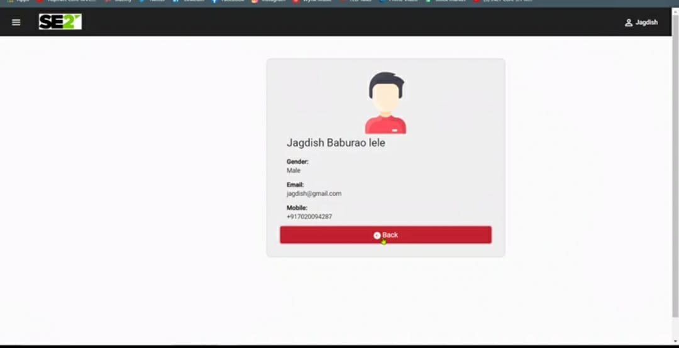

# Other Nonfunctional Requirements

## Performance Requirements

Response time must be as low as possible

## Security Requirements

1. Access to the data must be controlled
2. Physical security of data will be monitored by the administrator

## Software Quality Attributes

1. System should support concurrent logins
2. Proper popups must be displayed to the user
3. User Interface must help the user understand the state of the system

## Reliability

The system must highly reliable.

## Availability

The user can access the system any point of time.

## Usability

The system must be easy to use for the end users and the user interface must give some hint and idea about the current state.

# Evaluation Plan and Performance Metrics

The system can be evaluated on the basis of following metrices.

## Metrices

1. The response time to login and register.
2. How many users are handled at a time.
3. Application and server CPU usage.
4. Application availability.
5. Garbage Collection.
6. Errors generated in the system.

# Future Work

1. Adding OTP security to the system.
2. Adding mobile approval to add double security.
3. Allowing users to use mobile number, employee number to login instead of just email.
4. Able to allow user access the same account from multiple devices.