Name : Sanket Wadekar.

Roll No : TECOB266.

**Website Description :**

My website is business website named “SEO Experts”. The business is about the SEO services to the clients to rank their websites on top in search engines. It have three pages in it. First page is home page containing the information about the business and short description of services. Second page is Services page where detailed information about the services to the client is given. Third page is about the contact to the business. It contains form with various fields and messages.

**Screenshots :**

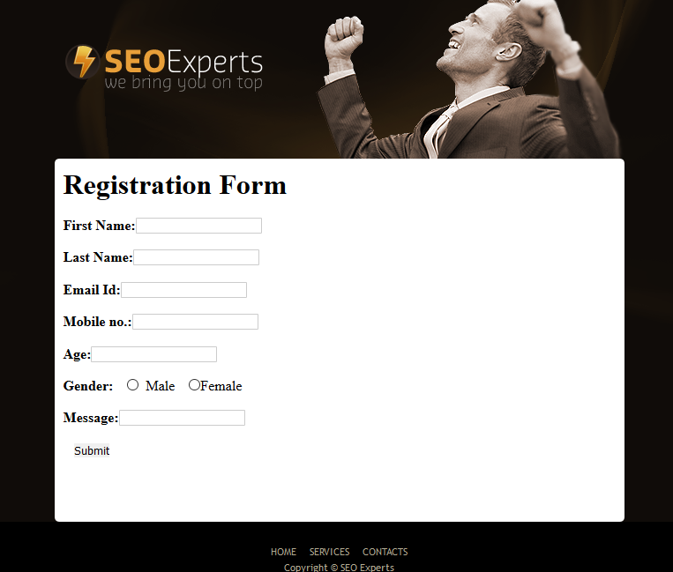

**Technologies Used :**

1. HTML
2. CSS
3. JavaScript
4. XML
5. Servlet
6. MySQL

**Complete Code :**

<!doctype html>

<html>

<head>

<meta charset="utf-8" />

<meta name="viewport" content="width=device-width" />

<meta name="description" content=""/>

<meta name="keywords" content="" />

<link href="CSS/index.css" rel="stylesheet" type="text/css">

</head>

<body>

<div id="MainWrapper">

<nav id="nav">

<ul>

<li><a href="index.html">HOME PAGE</a></li>

<li><a href="services.html">SERVICES</a></li>

<li id="last"><a href="contact.html">CONTACT US</a></li>

</ul>

</nav>

<div id="content">

<div id="header">

<h1>SEO Experts</h1>

</div>

<div id="WhiteBox">

<div id="Inner">

<ul>

<li> <img src="images/illustration/WebsiteOptimization.png"/>

<h2>Website Optimization</h2>

<p>Website optimization is the process of using controlled experimentation to improve a website’s ability to drive business goals.</p>

<li> <img src="images/illustration/ContentWriting.png"/>

<h2>Content Writing</h2>

<p>Content writers are professional writers who produce engaging content for use online. </p>

<li> <img src="images/illustration/RapidResult.png"/>

<h2>Rapid Result</h2>

<p>We provide the rapid results to bring your website on top in the search.</p>

</ul>

</div>

<div id="welcome">

<hgroup>

<h2><span>Welcome</span> to our Company!</h2>

<h3>The finest SEO Experts</h3>

</hgroup>

<div id="welcomeimg"><img src="images/illustration/WelcometoCompany.jpg"/></div>

<p class="LeftPara"><span class="ParaHead">We are the SEO Experts</span><br/>

We are the finest SEO Experts in the town</p>

<div class="both"></div>

<ul class="welcomeBullets">

<li>We will bring your website on top</li>

<li>Feel free to contact anytime</li>

<li>We provide very good service to our clients</li>

</ul>

</div>

<div id="News">

<hgroup>

<h2><span>News</span> and Events</h2>

<h3>THE SEO NEWS About US</h3>

</hgroup>

<h4 class="ParaHead">Mar. 24, 2019</h4>

<p class="NewsText">The SEO Experts company is the second largest company in Maharashtra in SEO Solutions.</p>

<hr>

<h4 class="ParaHead">Sep. 26, 2019</h4>

<p class="NewsText">The SEO Experts company is the fifth largest company in India in SEO Solutions.</p>

</div>

<div class="both"></div>

</div>

<div class="dark">

<div id="consulting">

<h2>SEO Consulting <span>We provide SEO consultation</span></h2>

<p id="consult"> Search engine optimization, the process of manipulating the visibility of a website or a web page in search engines</p>

<a href="#">read more</a> </div>

<div id="service">

<h2 id="headWidth">SEO Service Details <span>Search Engine Optimization</span></h2>

<p id="service1">Search engine optimization (SEO) is the process of affecting the online visibility of a website or a web page in a web search engine's unpaid results—often referred to as "natural", "organic", or "earned" results.</p>

</div>

<div class="both"></div>

</div>

<footer>

<ul>

<a href="index.html"><li>HOME</li></a>

<a href="services.html"><li>SERVICES</li></a>

<a href="contact.html"><li>CONTACTS</li></a>

</ul>

<p>Copyright &copy; SEO Experts</p>

</footer>

</div>

</div>

</body>

</html>

**Github Link :-** <https://github.com/sanketwadekar3/Website_SEO>