Vivekananda Samiti, IIT Kanpur organizes lecture series on
“Individual and Social Awakening"
17th - 18th March, 2012
5:00 pm – 6:00 pm
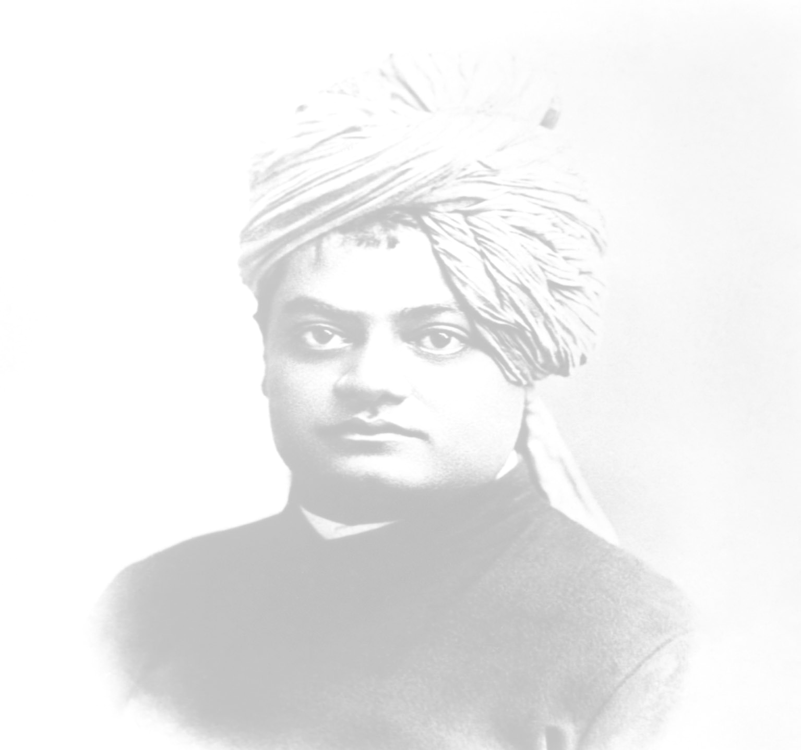
Venue: L-15, Lecture Hall Complex, IIT Kanpur

Day 1: Enlightened Citizenship & the Indian Society

Day 2: Karma Yoga- Swami Vivekananda's Doctrine Revisited on his 150th Birth Anniversary

About the Speaker:
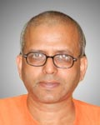
Swami Tyagarupananda is an eminent scholar and an excellent orator of the Ramakrishna Order. He is the Principal of the Ramkrishna Mission Vidyamandira, the residential college at Belur Math, Howrah, West Bengal, since 2005. He earned his PhD. degree in Economics from the Calcutta University in 1993. He has delivered many lectures at several renowned institutes and government organizations. In addition to classes in economics he conducts regular classes on the Indian religious texts for brahmacharins.

All are invited
Tea will be served before each talk

