CapFinLoan
Low-Level Design (LLD)

CapFinLoan Low Level Design (LLD)
Version: 2.0
Project: CapFinLoan
Architecture Style: Microservices + API Gateway + Event-Driven Integration
1. System Overview
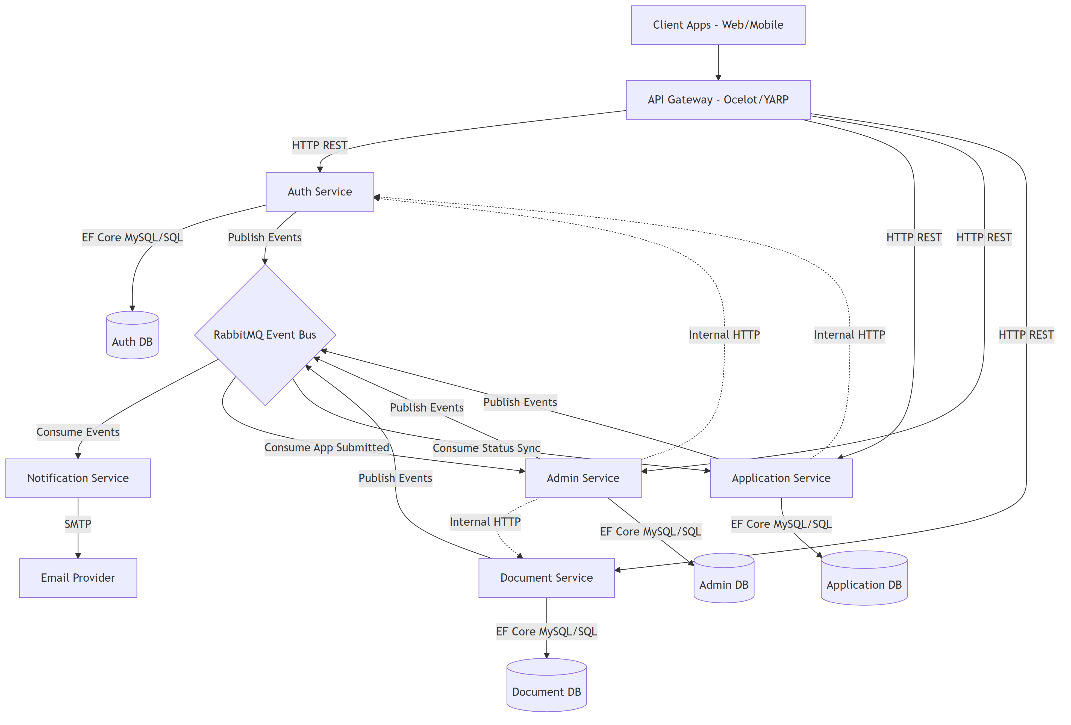
System Architecture
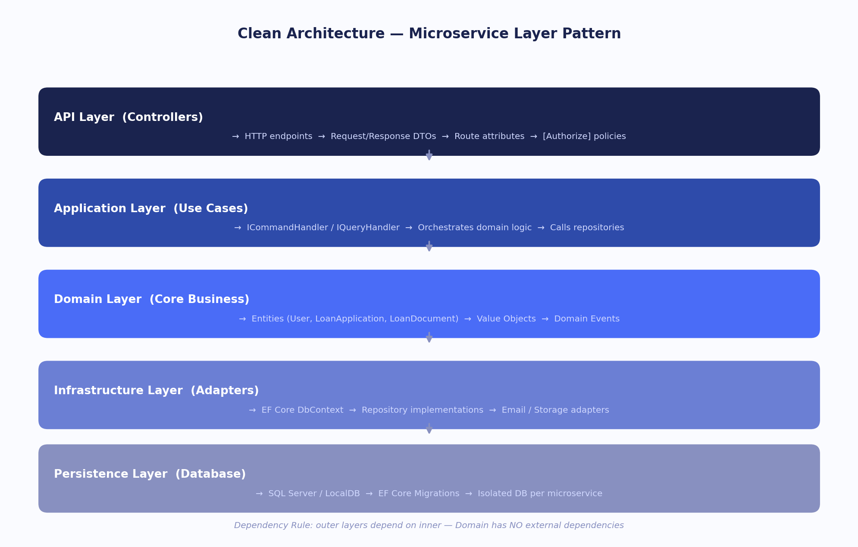
Clean Architecture Layers
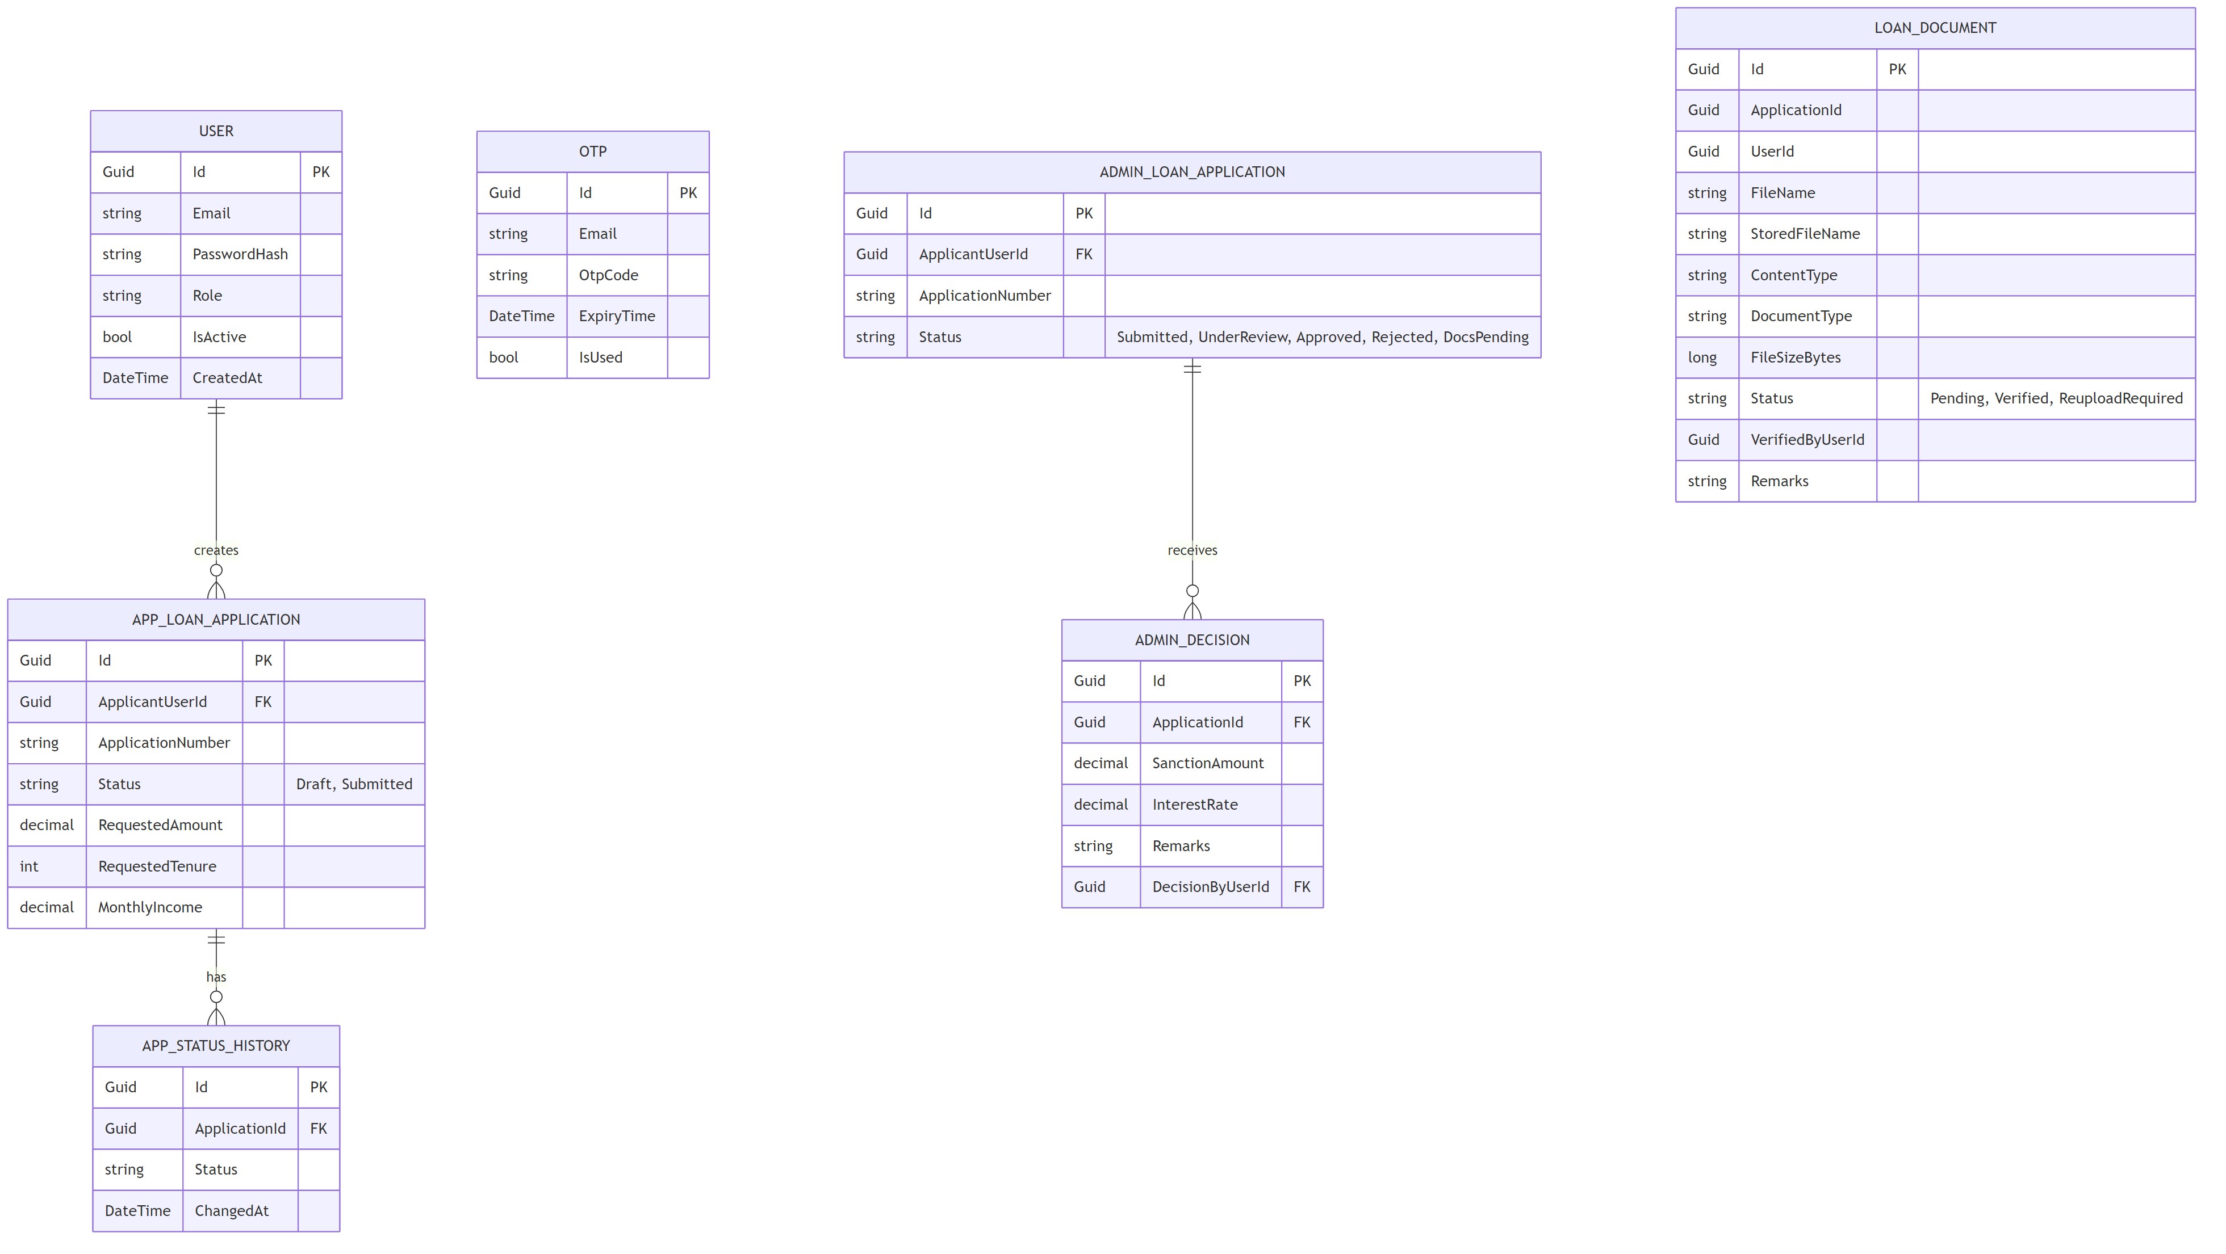
Database Entity Relationship Diagram
CapFinLoan is a financial loan processing platform built with a microservices backend and an Angular SPA frontend. The platform supports applicant onboarding, loan application creation, document verification, admin decisioning, wallet-based payment/disbursal flows, notification dispatch, and chatbot-assisted interactions.
The solution is designed for bounded service ownership, asynchronous integration through messaging, and centralized external access via API Gateway.
1.1 Architecture Summary
Component | Technology | Responsibility
Frontend SPA | Angular 21 | Applicant/Admin UI, route guards, interceptors, wallet and chatbot UI integrations
API Gateway | Ocelot + SwaggerForOcelot | Single external entry point, route mapping, CORS, swagger aggregation
Auth Service | ASP.NET Core (.NET 10) | Registration, login, JWT issuance, OTP and role claims
Application Service | ASP.NET Core (.NET 10) | Loan lifecycle, profile, EMI estimation, wallet operations
Document Service | ASP.NET Core (.NET 10) | Applicant document upload, retrieval, verification workflows
Admin Service | ASP.NET Core (.NET 10) | Admin queue, review, status transitions, dashboards, reporting
Notification Service | ASP.NET Core (.NET 10) | Event-driven email notifications and alerting
Chatbot Service | FastAPI + Groq SDK | Conversation orchestration, admin Q&A, applicant guided assistance
SQL Server | SQL Server 2022 | Service-isolated relational data stores
RabbitMQ | rabbitmq:3-management + MassTransit | Domain event transport across microservices
Docker Compose | Docker | Local and integration environment orchestration

1.2 Cross-Cutting Concerns
- Authentication and Authorization
- JWT bearer token issued by Auth Service and validated across services.
- Role-based route access in frontend (APPLICANT and ADMIN).
- Error Handling
- Global exception middleware pattern in backend services with service-specific custom exception mapping.
- Service Boundaries
- Each microservice owns its own DB schema and persistence layer.
- Event-Driven Integration
- RabbitMQ used for asynchronous propagation of business events.
- Observability
- Structured service logs and container health checks via Docker compose.
2. Shared Contracts Library and Shared Conventions
CapFinLoan follows shared conventions for cross-service communication, response shape, and event names to avoid tight runtime coupling.
2.1 Common Response DTOs
- Standard API response wrappers and error payloads are used for consistency between frontend and backend.
- Validation and business rule failures are surfaced with stable error codes where required by UI flows (example: wallet insufficiency scenarios).
2.2 Domain Events (RabbitMQ Messages)
Representative event patterns used across services:
- User registration related events (Auth to downstream consumers).
- Application submission and status change events (Application/Admin to Notification and other consumers).
- Document verification updates (Document to dependent services and notification pipeline).
- Operational notification events for email dispatch and alerts.
2.3 Exception Hierarchy and Error Codes
- Services expose business exceptions with HTTP status alignment.
- Wallet-sensitive operations use explicit insufficient balance exceptions so frontend can provide actionable guidance.
2.4 Constants and Shared Rules
- Domain constants include statuses, document types, wallet entry types, and transition rules.
- Shared naming conventions are used for event routing keys and service contracts.
3. API Gateway (Ocelot)
Gateway service acts as a central ingress for frontend and external clients.
3.1 Route Table (ocelot.json)
Current upstream-downstream route groups:
- /gateway/auth/{everything} -> Auth Service (/api/auth/{everything})
- /gateway/applications/{everything} -> Application Service (/api/applications/{everything})
- /gateway/documents/{everything} -> Document Service (/api/documents/{everything})
- /gateway/admin/{everything} -> Admin Service (/api/admin/{everything})
- /gateway/chat and /gateway/chat/{everything} -> Chatbot Service
- /gateway/api/{everything} -> internal API forwarding route
3.2 CORS Policy
- CORS is enabled in gateway and downstream services according to allowed frontend origins.
- Chatbot service also applies its own CORS origin allowlist for direct interactions.
3.3 Swagger Aggregation
- Ocelot swagger endpoints aggregate service docs for Auth, Application, Document, and Admin APIs.
- This supports a single discovery surface for API consumers and QA.
4. Auth Service
4.1 Data Models
Core entities generally include:
- User entity (identity, email, role, security metadata)
- OTP and verification records
- Authentication and token metadata structures
4.2 API Endpoints
Typical endpoint groups:
- Registration and OTP verification
- Login with JWT generation
- Role-aware identity retrieval
- OAuth related flows where configured
4.3 Service Layer
Key responsibilities:
- Credential validation and hashing rules
- JWT token issuance with issuer/audience/key alignment
- OTP generation and validation logic
- User profile bootstrap for downstream services
- Event publishing for user lifecycle milestones
5. Application Service
Application Service is the core business service for applicant lifecycle and wallet logic.
5.1 Data Models
Core aggregates and entities include:
- Loan application aggregate (draft to final decision states)
- Personal details and employment details
- Loan details (amount, tenure, purpose, remarks)
- Wallet summary/ledger entities and wallet entry types
5.2 API Endpoints
Major endpoint groups:
- Profile read/update for applicant onboarding completeness
- Application draft create and update
- Submit application and status retrieval
- My applications listing and detailed status timeline
- Wallet summary/config endpoints
- Wallet top-up and admin wallet operations
5.3 Business Rules and Calculation Logic
- EMI estimate workflow for applicant decision support.
- Submission guardrails including wallet fee deductions.
- State transitions with validation (Draft -> Submitted -> UnderReview -> Approved/Rejected/etc.).
- Balance validation with explicit insufficient-wallet exceptions for both applicant submission fee and admin disbursal checks.
5.4 Service Layer
Representative components:
- Application orchestration service for lifecycle transitions
- Wallet service for debit/credit operations and transaction history
- Domain validation and transition guards
- Repository abstraction and persistence transaction management
- RabbitMQ event publishing for downstream notification/reporting
6. Document Service
Document Service handles applicant document operations and verification status.
6.1 Data Models
Core entities:
- Loan document metadata (type, owner, app reference)
- Document status and remarks
- File storage path and upload audit fields
6.2 Document Status Lifecycle
Typical states:
- Uploaded/Pending
- Verified
- ReuploadRequired
6.3 Conflict Guards and Validation
- Prevent invalid replacement/verification actions when application is in restricted terminal states.
- Validate document type and ownership before updates.
6.4 API Endpoints
Major endpoint groups:
- Upload or replace document
- Fetch my documents
- Fetch application-linked documents
- Admin verification/reupload remark actions
- Internal admin listing endpoints where configured
6.5 Service Layer
- File handling and metadata persistence
- Business validation against application state
- Event production for verification updates and notifications
- Integration contracts for admin/document queue visibility
7. Admin Service
Admin Service provides review, approval/rejection actions, dashboards, and report functions.
7.1 Data Models
Representative model groups:
- Admin-facing application projections
- Decision metadata (remarks, sanction amount, interest rate)
- Operational and reporting DTOs
7.2 API Endpoints
Key endpoint groups:
- Queue and dashboard retrieval
- Application review details
- Status transition actions (approve/reject/docs pending/under review)
- Reports and exports where configured
7.3 Service Layer
- Decision orchestration and validation pipeline
- Aggregation services for queue and dashboard
- Integration with document/application context
- Audit and reporting support components
- Event publishing to Notification Service
8. Frontend (Angular 21 SPA)
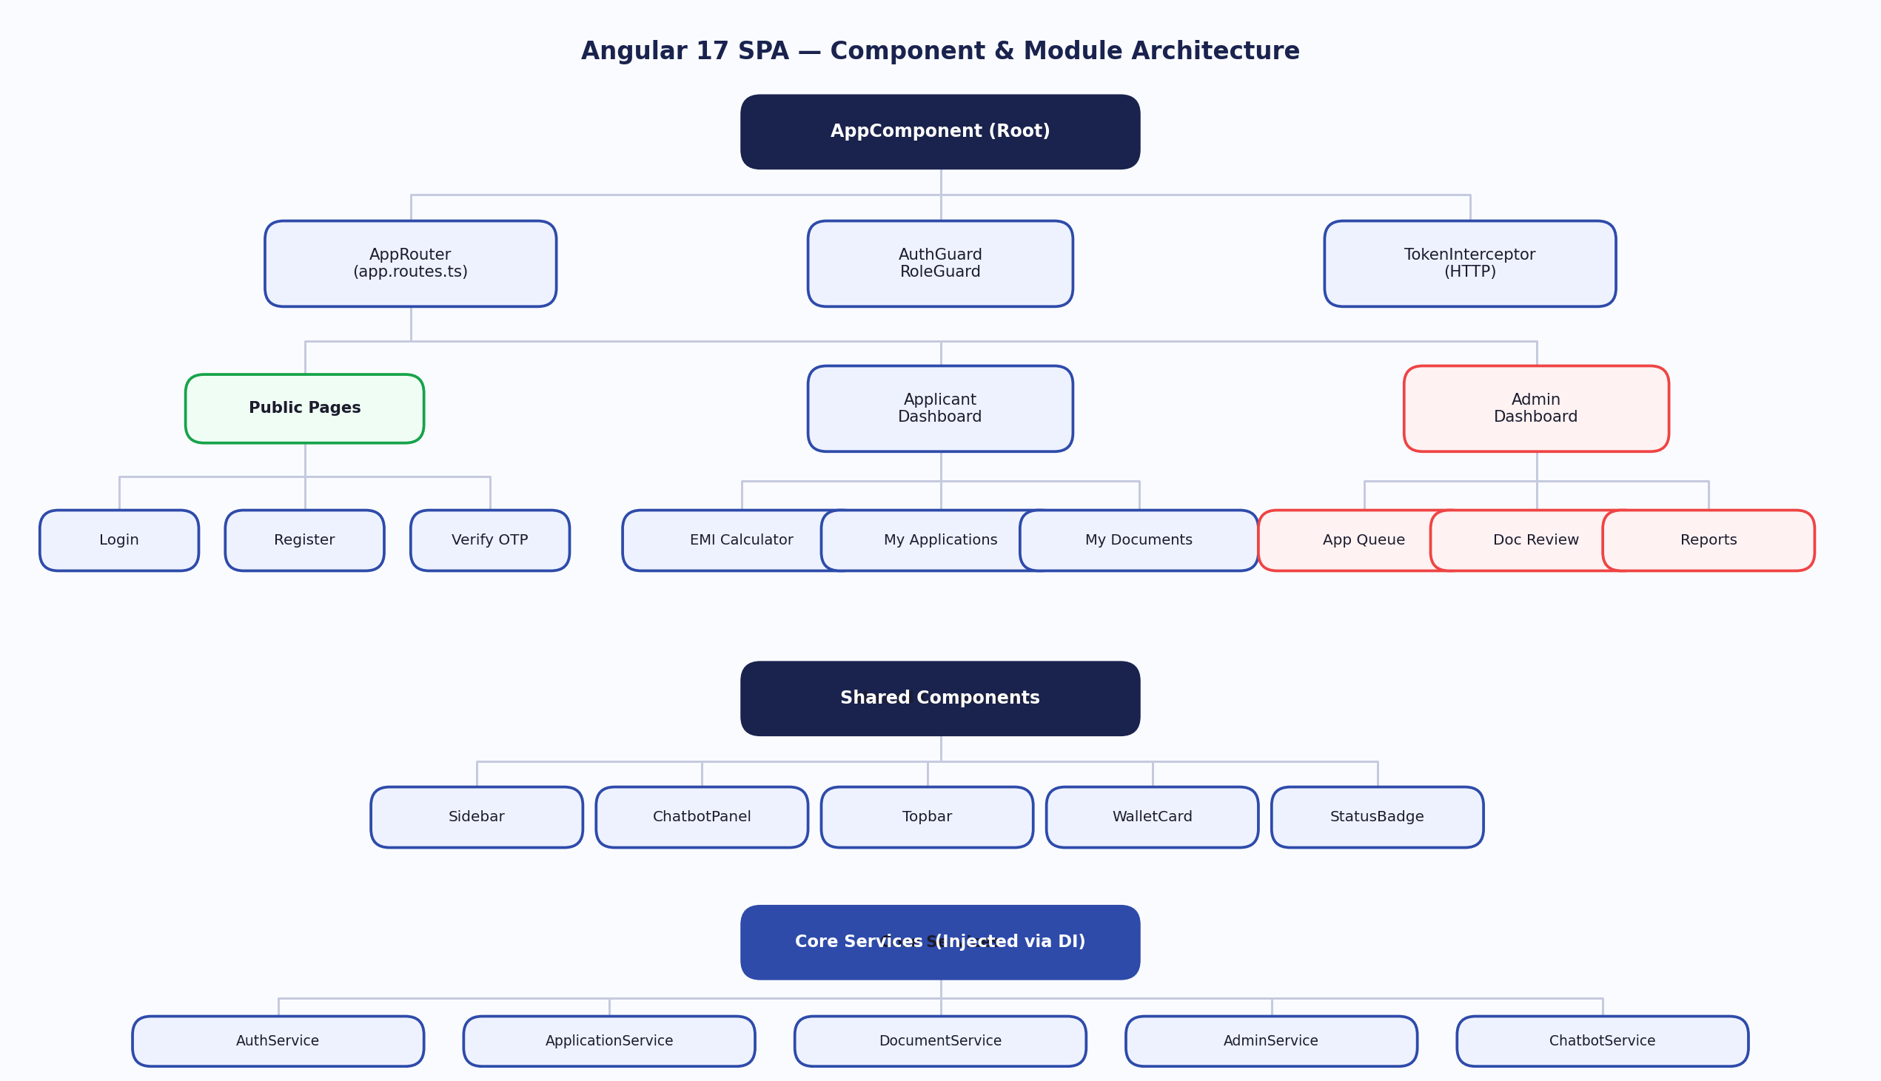
Angular Component Architecture
8.1 Application Bootstrap (app.config.ts)
- Uses standalone configuration style.
- Provides router, HTTP client with fetch, and interceptor chain.
- Enables global error listeners, hydration, and animations.
8.2 Route Table (app.routes.ts)
Primary route groups:
- Public pages (landing)
- Auth pages (login, signup)
- Applicant area:
- dashboard, apply, applications, track status, documents, profile, wallet
- Admin area:
- queue, documents, application review, reports, users, wallet
8.3 Route Guards
- authGuard ensures authenticated access.
- roleGuard enforces APPLICANT or ADMIN route-level authorization.
8.4 HTTP Interceptors
- authInterceptor attaches JWT bearer token automatically.
- errorInterceptor centralizes API error handling behavior.
8.5 Core Services
Representative frontend service responsibilities:
- Auth API integration and token/session handling
- Application and wallet APIs
- Document APIs
- Admin queue and decision APIs
- Chatbot API integration through gateway routes
8.6 Pages and Components
Notable feature modules and pages:
- Applicant apply flow with review and submission checks
- Applicant and admin wallet pages with transaction visualization and top-up flows
- Admin application review and document moderation pages
- Shared layouts, sidebar/navigation, status badges, toast/error states
9. Key Data Flows
9.1 User Registration and OTP Verification
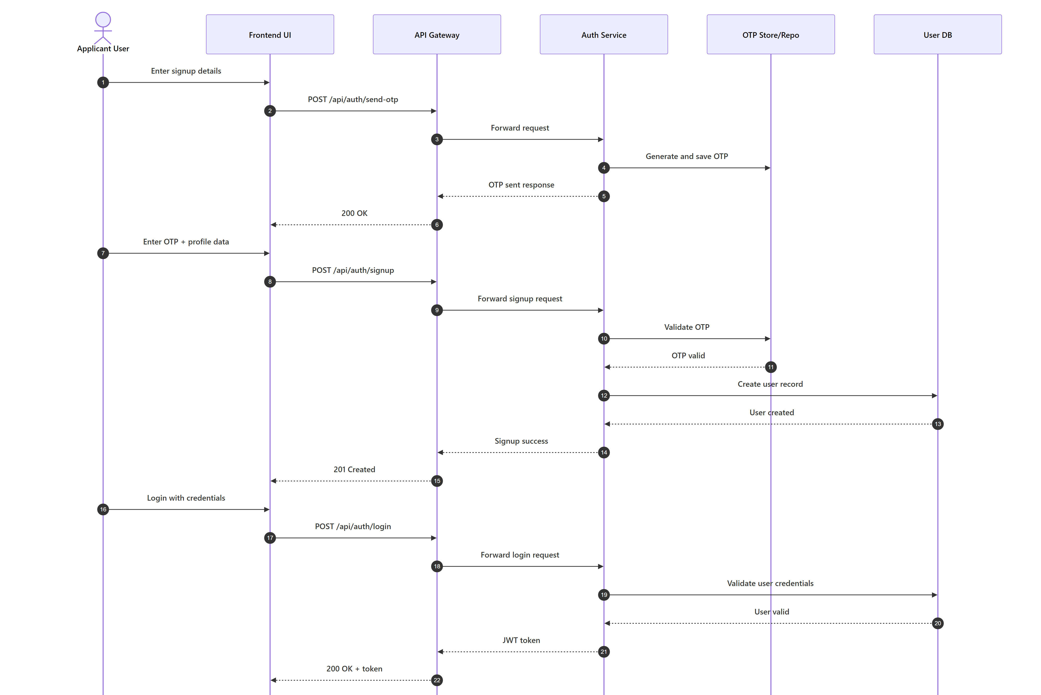
OTP Sign-up and Login
- 1. User registers through Auth API.
- 2. OTP is generated and delivered.
- 3. Verification confirms account activation.
- 4. Auth emits registration-related events for downstream consumers.
9.2 Login and JWT Token Flow
- 1. User logs in with credentials.
- 2. Auth returns JWT containing identity and role claims.
- 3. Frontend stores token and attaches it through authInterceptor.
- 4. Backend services validate token independently.
9.3 Loan Application and Draft Flow
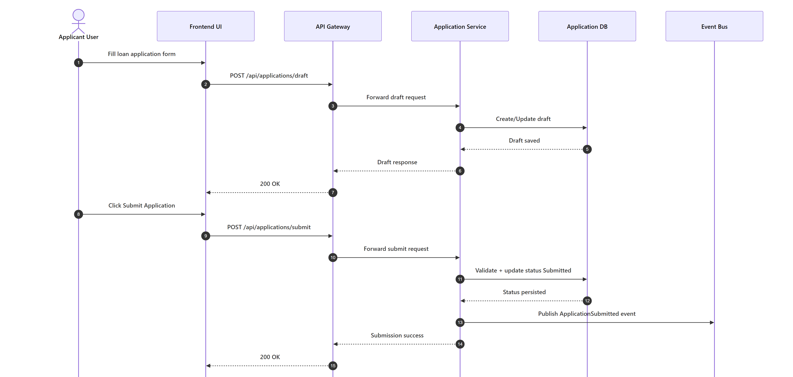
Application Submit Flow
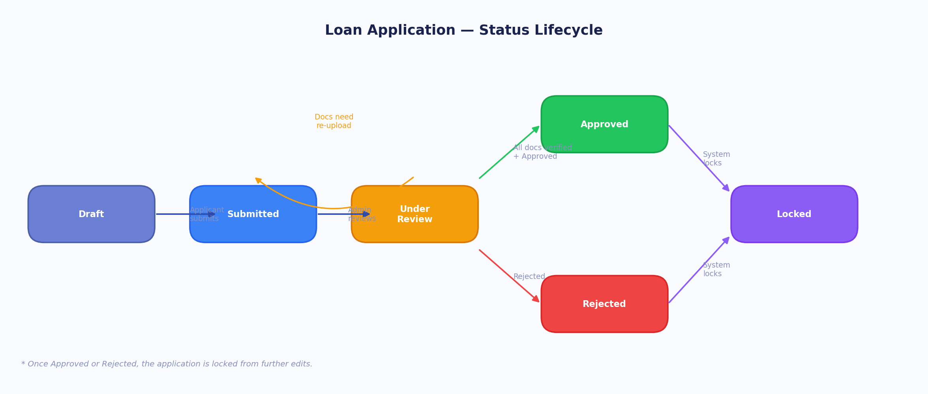
Application Status Lifecycle
- 1. Applicant creates/updates draft.
- 2. Profile and employment details are validated.
- 3. Loan details are saved with state Draft.
- 4. Applicant can continue with documents and status tracking.
9.4 Submission Fee and Wallet Validation Flow
- 1. Applicant attempts submit.
- 2. Application Service validates wallet balance against configured submission fee.
- 3. If sufficient, fee is debited and application transitions to Submitted.
- 4. If insufficient, service returns explicit wallet error code and frontend keeps draft state with top-up guidance.
9.5 Admin Review, Disbursal Guard, and Document Lifecycle
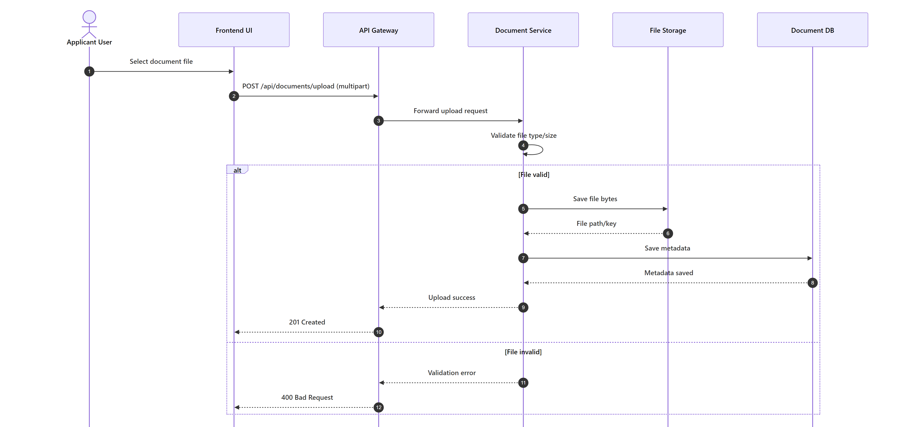
Document Upload Flow
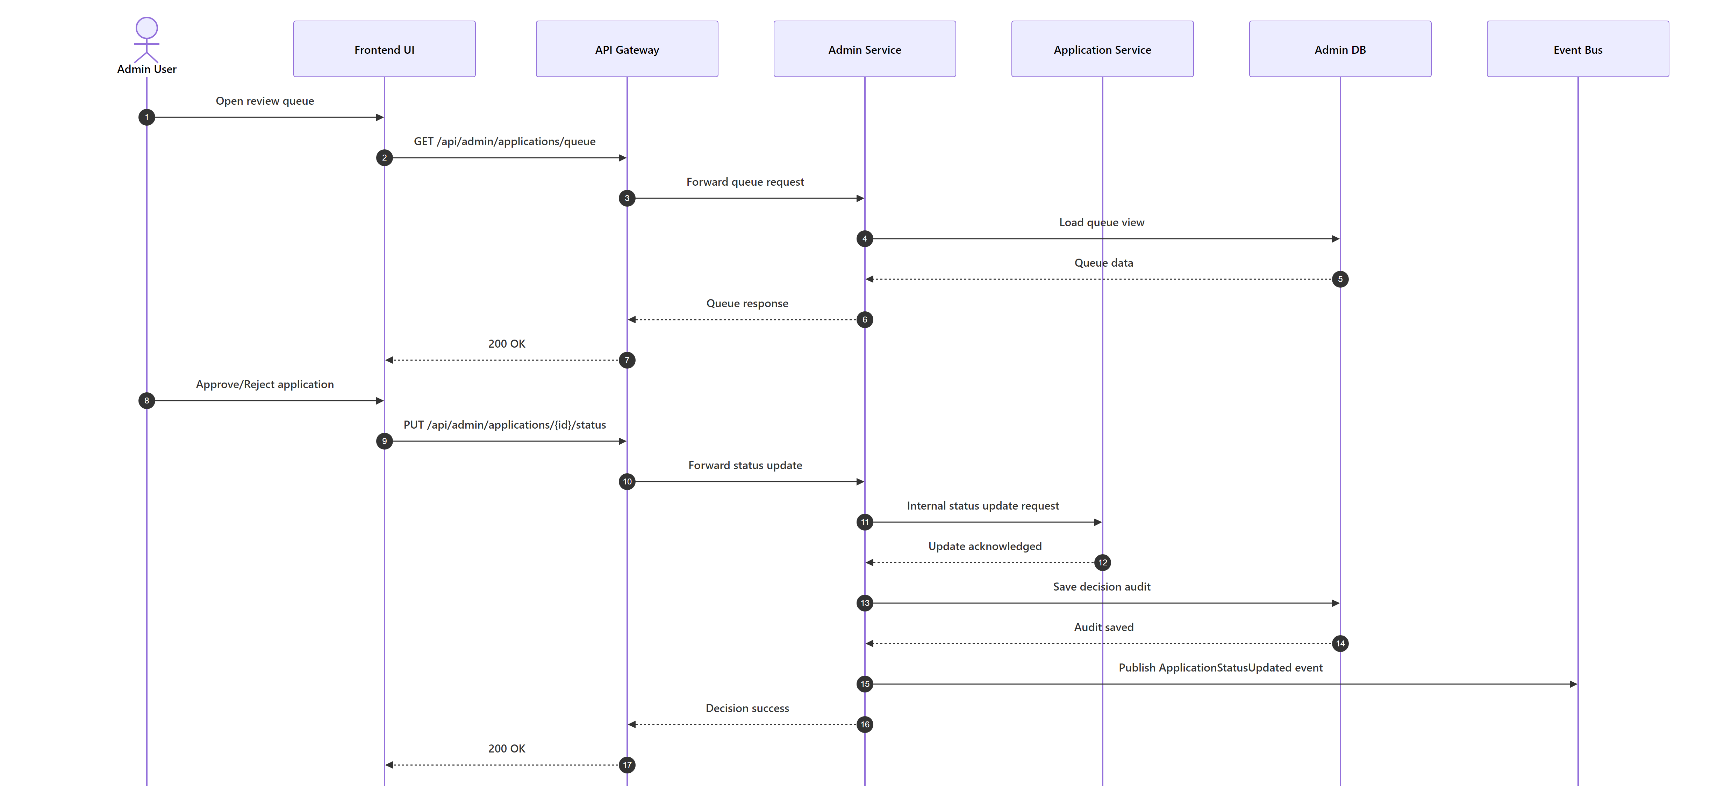
Admin Review and Decision Flow
- 1. Admin opens review queue and document states.
- 2. Admin verifies docs and progresses application decisions.
- 3. Before approval/disbursal, wallet sufficiency is validated.
- 4. Status and decision remarks are persisted.
- 5. Events trigger notification workflows.
9.6 Chatbot-Assisted Interaction Flow
- 1. Frontend sends chat message via gateway to chatbot service.
- 2. Chatbot validates JWT and loads user session context.
- 3. Applicant conversations follow deterministic orchestration.
- 4. Admin conversations use Groq model with hydrated admin context snapshots.
- 5. Chat response includes reply text, optional action, and quick replies.
10. Infrastructure and Configuration
10.1 Docker Compose Services
Compose stack includes:
- sqlserver
- rabbitmq
- auth-service
- application-service
- document-service
- admin-service
- notification-service
- api-gateway
- chatbot-service
- frontend
10.2 Database Configuration per Service
Service-isolated databases on SQL Server:
- CapFinLoan_AuthDb
- CapFinLoan_ApplicationDb
- CapFinLoan_DocumentDb
- CapFinLoan_AdminDb
10.3 JWT Configuration (Shared Across Services)
- Shared key, issuer, and audience across auth and consuming services.
- Token expiry and validation rules standardized through environment variables.
10.4 RabbitMQ and MassTransit Configuration
- RabbitMQ host/credentials injected per service.
- Services use event-based integration for decoupled workflows.
10.5 Logging, Health Checks, and Runtime
- Container health checks configured for critical services.
- Service startup order controlled with depends_on and health conditions.
- Notification and chatbot services are part of runtime health envelope.
11. Unit Test Projects and Quality Strategy
11.1 Backend Testing Framework
- .NET test projects validate domain rules, services, and integration boundaries.
- Focus areas: status transitions, wallet rules, validation middleware, event consumers.
11.2 Frontend and Chatbot Testing Framework
- Angular tests cover routing, guards, component behavior, and service integrations.
- Chatbot service includes Python unit tests for orchestrator state transitions and payload correctness.
12. Security Considerations
- JWT-based authentication and role segregation across endpoints and routes.
- Input validation for all state-changing APIs.
- File upload guardrails for document workflows.
- Business rule protections on wallet debit/disbursal operations.
- Environment-secret driven runtime configuration.
- Recommendation: enforce strict issuer/audience verification and secure secret rotation in all environments.
Appendix A: Solution Structure Snapshot
- CapFinLoan.Backend
- AuthService
- ApplicationService
- DocumentService
- AdminService
- NotificationService
- ApiGateway
- CapFinLoan.Frontend
- ChatbotService
- Documentation
- Docs
- Files
- docker-compose.yml
Appendix B: Notes on Alignment with SmartSure Template
This document intentionally follows the same section hierarchy pattern used by SmartSure LLD:
- 1. System Overview
- 2. Shared Contracts
- 3. API Gateway
- 4. Identity/Auth Service
- 5. Core Domain Service
- 6. Document/Claim-style Service
- 7. Admin Service
- 8. Frontend
- 9. Key Data Flows
- 10. Infrastructure
- 11. Testing
- 12. Security
The content has been adapted to CapFinLoan-specific services, wallet flows, and chatbot integration.

