CapFinLoan
Financial Loan Management System
Low-Level Design (LLD)
Backend: ASP.NET Core 6 Microservices | Frontend: Angular 21
Version 1.0 | May 2026 | Complete & Authoritative

1. System Overview
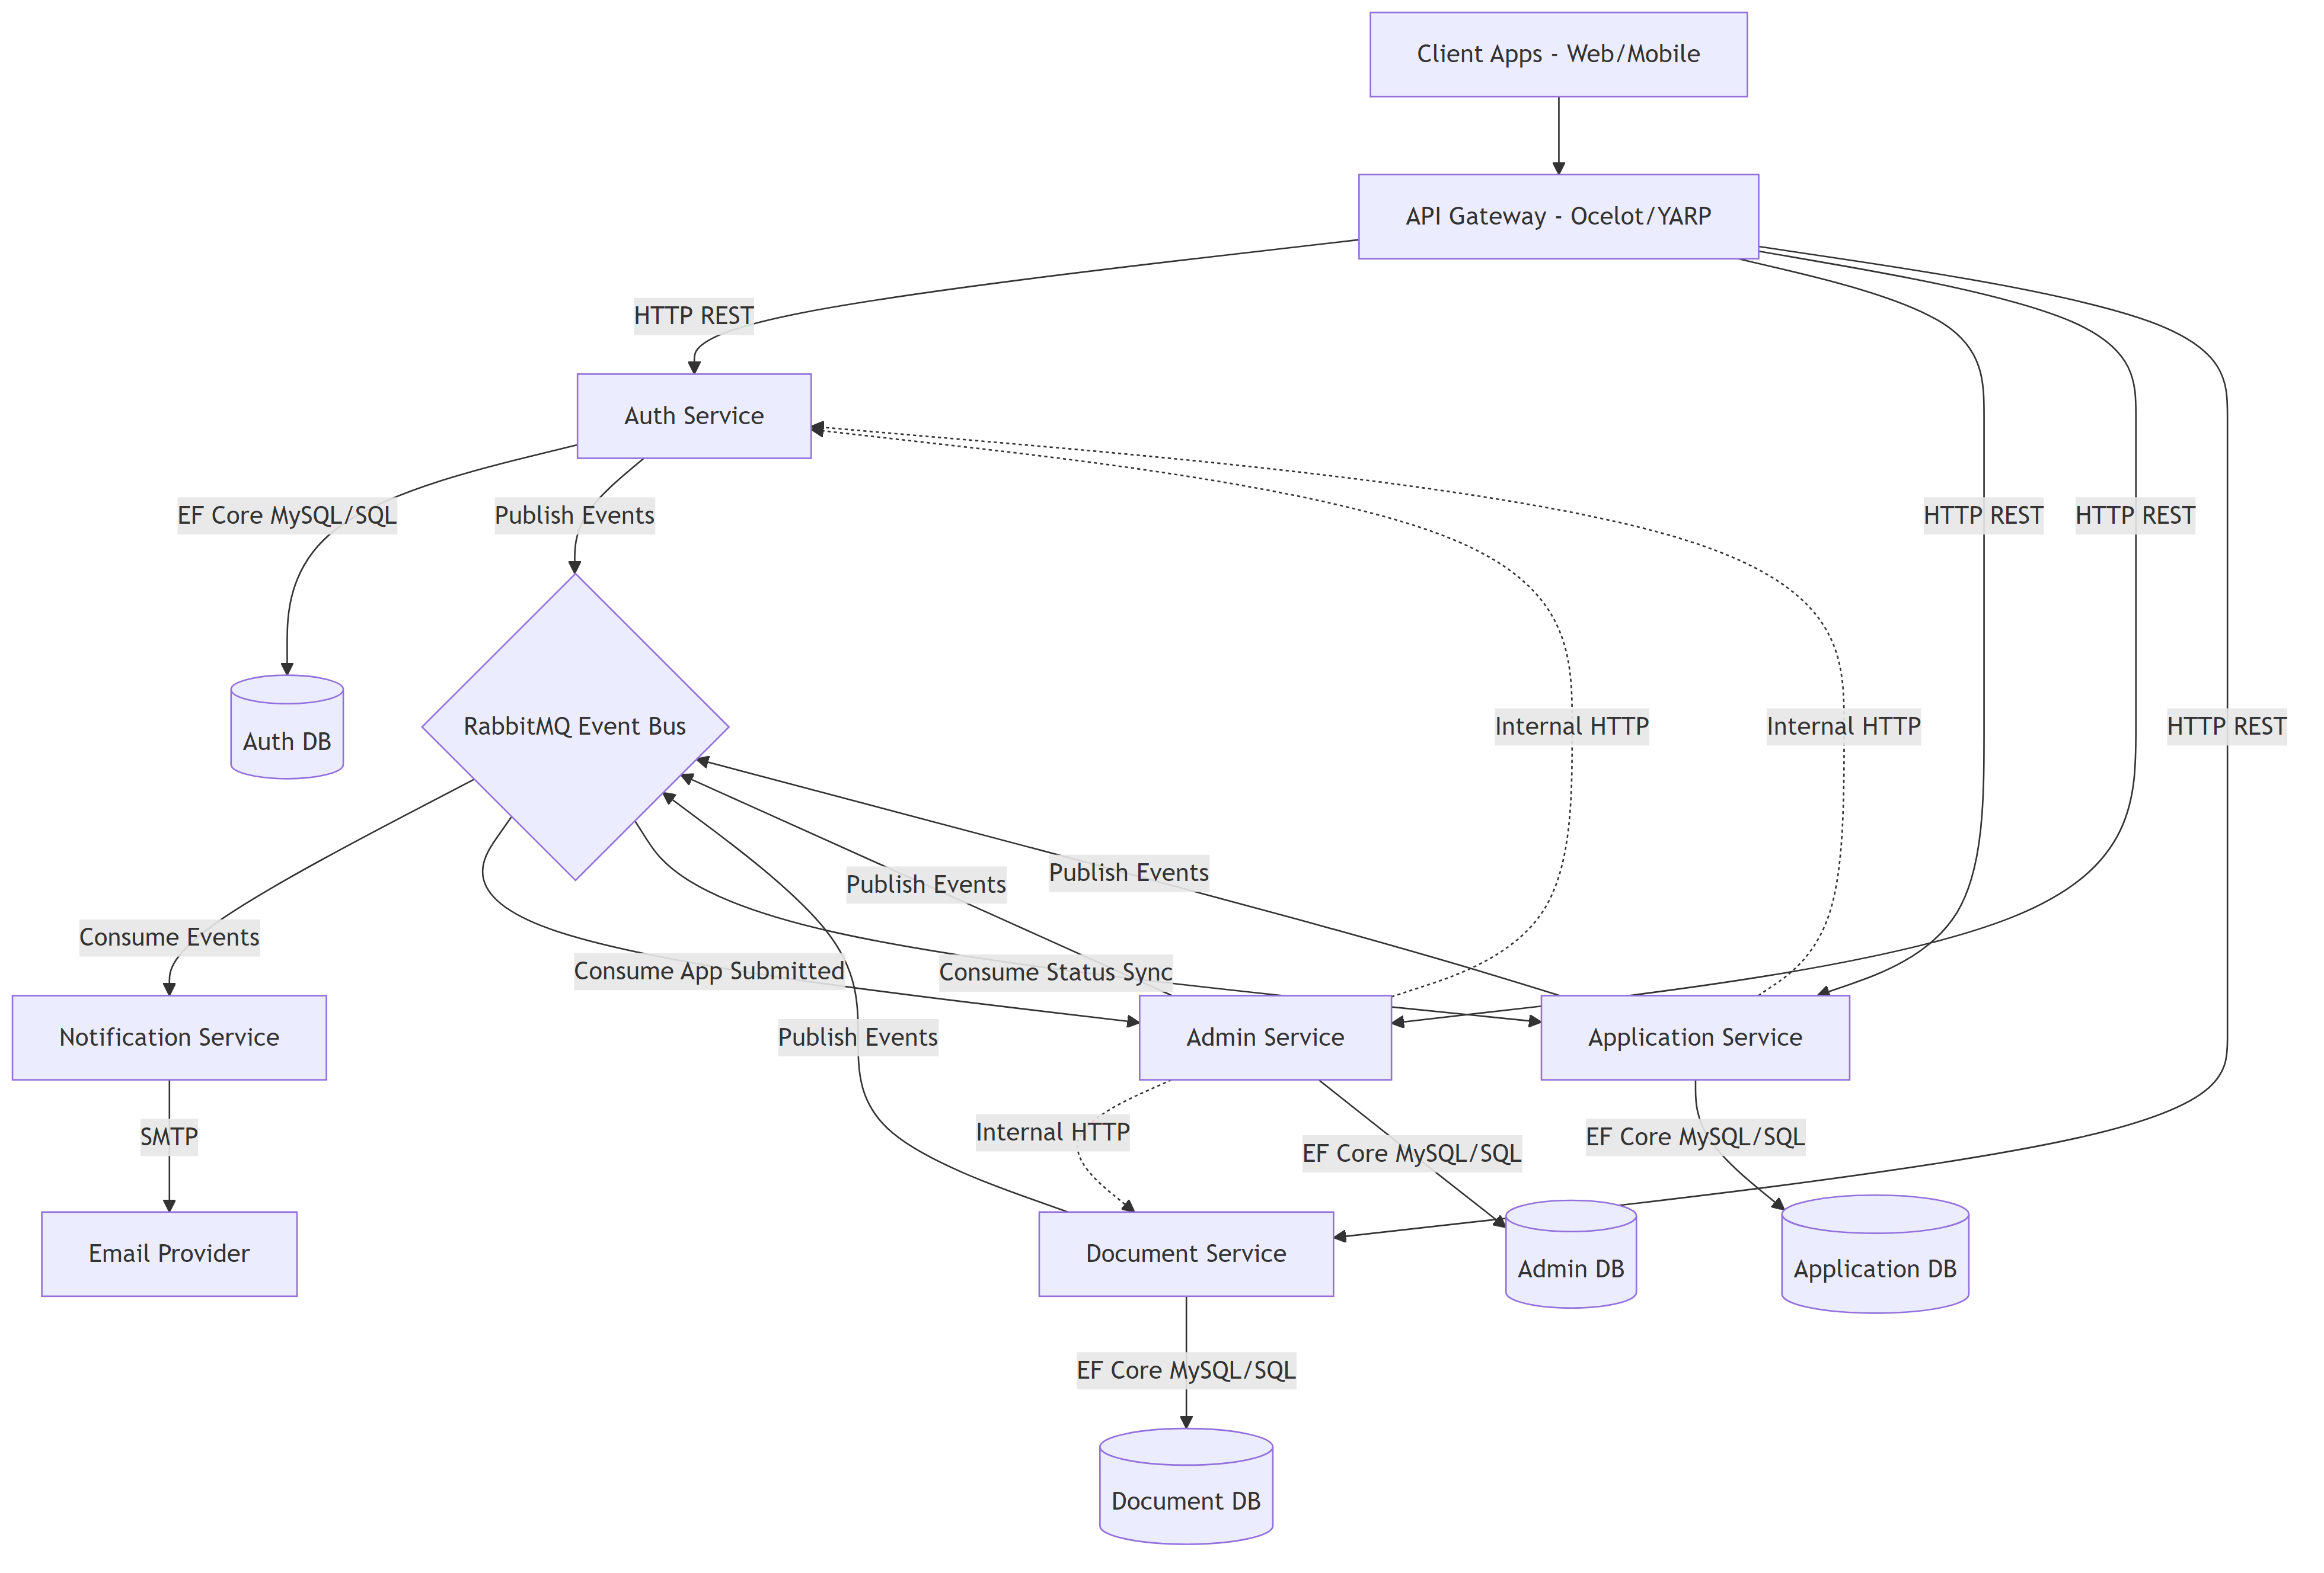
System Architecture
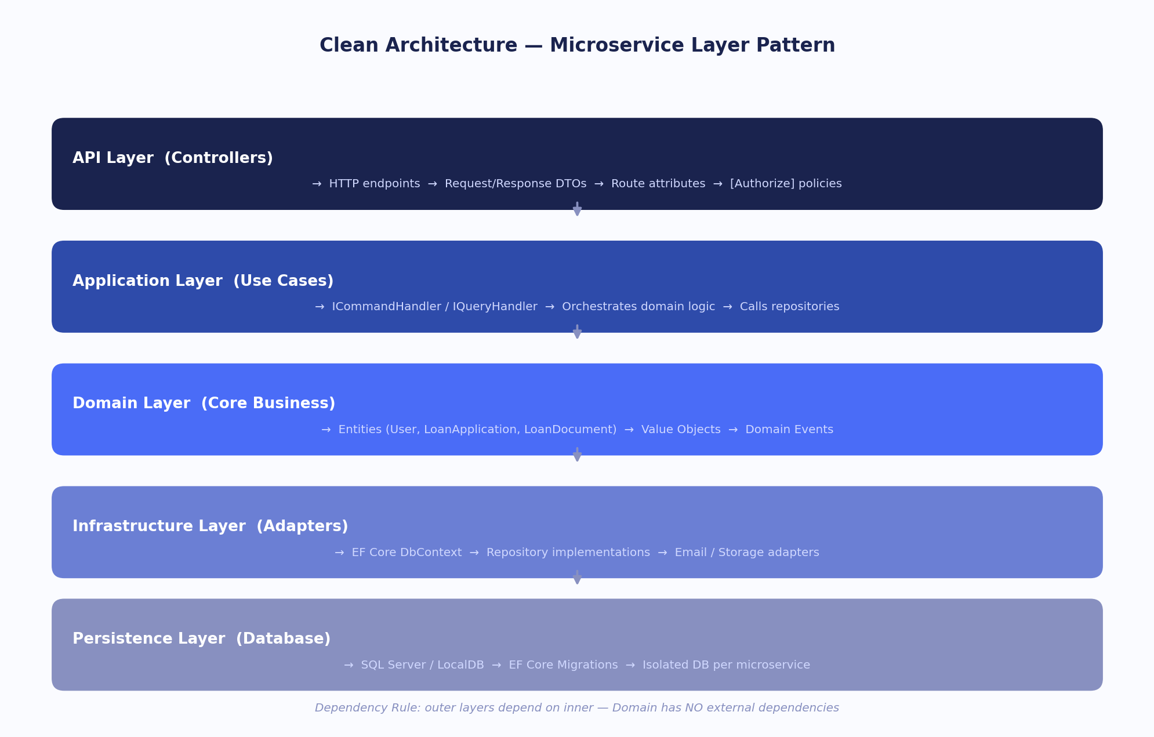
Clean Architecture Layers
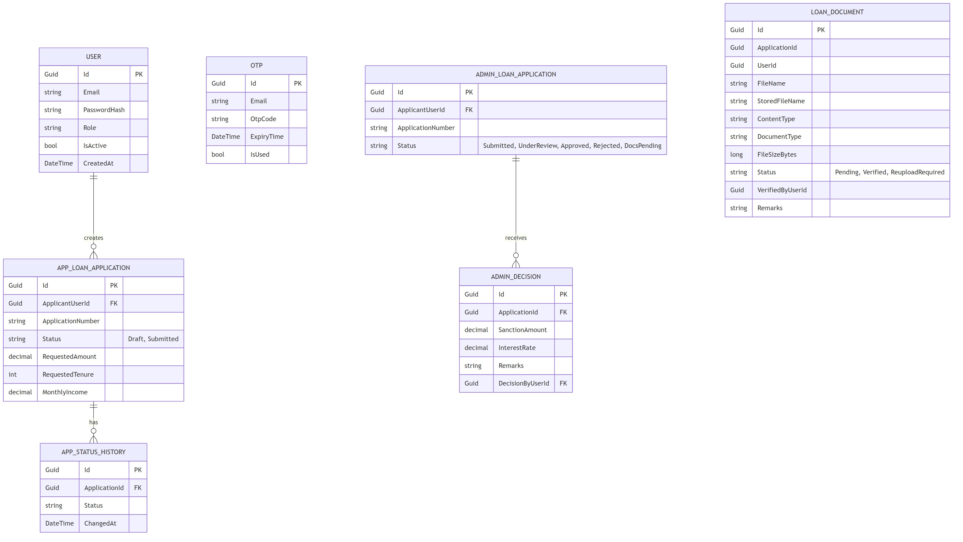
Database Entity Relationship Diagram
CapFinLoan is a full-stack loan management platform composed of five ASP.NET Core 10 backend microservices, one FastAPI chatbot service, and an Angular 21 SPA frontend, all fronted by an Ocelot API Gateway.
Each domain service owns its own SQL Server database schema. Inter-service asynchronous communication uses RabbitMQ with MassTransit. Authentication is JWT bearer based, and each service validates JWT independently using shared issuer, audience, and signing key configuration.
1.1 Architecture Summary
Component | Technology | Port | Responsibility
Angular SPA | Angular 21 / TypeScript | 4200 | Applicant and Admin UI, guarded routes, wallet UI, chatbot UI integration
API Gateway | Ocelot + SwaggerForOcelot | 5020 | Single API ingress, route forwarding, CORS, aggregated swagger
Auth Service | ASP.NET Core 10 + Identity | 5021 | Signup/login, OTP, JWT generation, admin user management
Application Service | ASP.NET Core 10 + EF Core | 5022 | Applicant profile, loan drafts/submission, status history, wallet and payment orchestration
Document Service | ASP.NET Core 10 + EF Core | 5023 | Document upload, replace, link, download, verification lifecycle
Admin Service | ASP.NET Core 10 + EF Core | 5024 | Queue/dashboard, decision updates, user and document admin proxy APIs
Notification Service | ASP.NET Core 10 + MassTransit | 5025 | Email notifications and failure signaling consumers
Chatbot Service | FastAPI + Groq SDK | 5026 | JWT-aware chat orchestration, applicant guided flow, admin AI summaries
RabbitMQ | rabbitmq:3-management | 5673 / 15673 | Event bus and consumer queues
SQL Server | mssql/server:2022-latest | 1433 | Isolated service databases

1.2 Cross-Cutting Concerns
- Authentication: JWT bearer across services, roles APPLICANT and ADMIN.
- Error Handling: global exception middleware in each .NET API service.
- Eventing: MassTransit with service-specific endpoint naming formatters.
- Configuration: appsettings + environment variables + DotNetEnv for local env loading.
- Persistence pattern: clean layering with Domain, Application, Infrastructure, Persistence projects.
2. Shared Contracts Library (CapFinLoan.Messaging.Contracts)
The shared contracts project provides strongly typed event contracts consumed by multiple services.
2.1 Common Response DTOs
Service APIs primarily return typed JSON DTOs and domain-specific payloads. Error responses are standardized through middleware and service exceptions.
2.2 Domain Events (RabbitMQ Messages)
Event | Key Fields | Typical Publisher to Consumers
UserRegisteredEvent | UserId, Email, FullName, Role, RegisteredAtUtc | Auth -> Application, Notification
ApplicationSubmittedEvent | ApplicationId, ApplicantUserId, ApplicationNumber, RequestedAmount | Application -> Admin, Notification
ApplicationStatusChangedEvent | ApplicationId, PreviousStatus, NewStatus, ChangedByUserId | Admin or Application sync -> Notification, Application/Admin sync consumers
ApplicationStatusRolledBackEvent | ApplicationId, PreviousStatus, RolledBackFromStatus, Remarks | Admin rollback flow -> Notification/consumers
StatusSyncFailedEvent | ApplicationId, AttemptedStatus, FailureReason | Application -> Admin compensation consumer
DocumentVerifiedEvent | DocumentId, ApplicationId, IsVerified, Remarks, VerifiedByUserId | Document -> Admin, Application, Notification
LoanApprovedEvent | ApplicationId, SanctionAmount, ApprovedByUserId | Admin/Application process -> Notification
LoanRejectedEvent | ApplicationId, ApplicantName, Remarks, RejectedByUserId | Admin/Application process -> Notification
OtpSendEvent | Email, OtpCode, Purpose, ExpiresAtUtc | Auth -> Notification
NotificationFailedEvent | ApplicationId, NotificationType, FailureReason | Notification -> Admin consumer for ops visibility

2.3 Exception Hierarchy
Each service has an ApplicationServiceException-style pattern with specific derived exceptions. Notable wallet-specific exception:
- InsufficientWalletBalanceException with HTTP 402 and error code INSUFFICIENT_WALLET_BALANCE.
2.4 Constants
Representative constants:
- Application statuses: Draft, Submitted, Docs Pending, Docs Verified, Under Review, Approved, Rejected, Closed.
- Wallet owner types: Applicant, Admin.
- Wallet directions: Credit, Debit.
- Wallet entry types: TopUp, ApplicationFee, LoanDisbursal, LoanRepayment, Compensation, Withdrawal.
- Document status enum: Pending, UnderReview, Verified, ReuploadRequired.
3. API Gateway (Ocelot)
Port: 5020 | Technology: Ocelot + SwaggerForOcelot
The gateway performs route forwarding and swagger aggregation. JWT validation remains in downstream services.
3.1 Route Table (ocelot.json)
Upstream Path | Downstream Path | Downstream Service | Methods
/gateway/auth/{everything} | /api/auth/{everything} | Auth (5021 local / 8080 docker) | GET, POST, PUT, DELETE
/gateway/applications/{everything} | /api/applications/{everything} | Application (5022 / 8080) | GET, POST, PUT, DELETE
/gateway/documents/{everything} | /api/documents/{everything} | Document (5023 / 8080) | GET, POST, PUT, DELETE
/gateway/admin/{everything} | /api/admin/{everything} | Admin (5024 / 8080) | GET, POST, PUT, DELETE
/gateway/chat | /chat | Chatbot (5026 / 8000) | POST
/gateway/chat/{everything} | /{everything} | Chatbot (5026 / 8000) | GET, POST, DELETE
/gateway/api/{everything} | /api/{everything} | Gateway self route | GET, POST, PUT, DELETE

3.2 CORS Policy
Gateway currently allows any origin, any method, and any header through default policy.
3.3 Swagger Aggregation
Gateway aggregates swagger docs for:
- Auth Service
- Application Service
- Document Service
- Admin Service
4. Auth Service
Port: 5021 | Route prefix: api/auth and api/internal/users
4.1 Data Models
Primary entity:
- ApplicationUser (IdentityUser<Guid>) with Name, IsActive, CreatedAtUtc, UpdatedAtUtc.
Supporting entity:
- EmailVerificationOtp with Email, OtpCode, ExpiresAtUtc, IsUsed.
4.2 API Endpoints
Verb | Path | Auth | Description
POST | /api/auth/signup | None | Applicant signup initiation
POST | /api/auth/signup-admin | None | Admin signup initiation
POST | /api/auth/send-otp?email= | None | Send signup OTP
POST | /api/auth/forgot-password/send-otp?email= | None | Send forgot password OTP
POST | /api/auth/verify-otp-signup | None | Verify OTP and complete applicant signup
POST | /api/auth/verify-otp-signup-admin | None | Verify OTP and complete admin signup
POST | /api/auth/login | None | Credentials login and JWT issuance
POST | /api/auth/google-login | None | Google ID token login
POST | /api/auth/forgot-password/reset | None | OTP-based password reset
GET | /api/internal/users | Admin | List users for admin panel
GET | /api/internal/users/{id}/notification-info | Internal key (anonymous endpoint with key check) | Notification profile lookup
PUT | /api/internal/users/{id}/status | Admin | Activate/deactivate user

4.3 Service Layer
- AuthService: signup, OTP verification, login, password reset, user status operations.
- JwtTokenGenerator: token creation with issuer, audience, key.
- OtpRepository and Otp flow: OTP persistence and expiry validation.
- RabbitMqEventPublisher: publishes user and OTP-related events.
5. Application Service
Port: 5022 | Route prefix: api/applications
5.1 Data Models
Core entities:
- LoanApplication
- ApplicationStatusHistory
- ApplicantProfile
- WalletAccount
- WalletLedgerEntry
- PaymentOrder
5.2 API Endpoints
Verb | Path | Auth | Description
GET | /api/applications/profile | Applicant | Get applicant profile
PUT | /api/applications/profile | Applicant | Save applicant profile
GET | /api/applications/my | Authenticated | List current user applications
GET | /api/applications/{id} | Authenticated | Get application by id
POST | /api/applications | Applicant | Create draft application
PUT | /api/applications/{id} | Applicant | Update draft application
POST | /api/applications/{id}/submit | Applicant | Submit draft application
GET | /api/applications/{id}/status | Authenticated | Get current status and timeline
DELETE | /api/applications/{id} | Applicant | Delete draft
GET | /api/applications/wallet/summary | Applicant | Applicant wallet summary
GET | /api/applications/wallet/ledger?take= | Applicant | Applicant wallet ledger
POST | /api/applications/wallet/topup/create-order | Applicant | Create applicant topup order
POST | /api/applications/wallet/topup/verify | Applicant | Verify applicant topup payment
POST | /api/applications/wallet/withdraw | Applicant | Applicant withdraw operation
GET | /api/applications/wallet/config | Applicant | Wallet configuration including application fee
GET | /api/applications/wallet/admin/summary | Admin | Admin wallet summary
POST | /api/applications/wallet/admin/topup/create-order | Admin | Create admin topup order
POST | /api/applications/wallet/admin/topup/verify | Admin | Verify admin topup payment

5.3 Core Logic: Loan, Wallet, and EMI
- Draft -> submit lifecycle with validation and ownership checks.
- Profile completeness and status timeline support.
- Wallet fee deduction on submission.
- Admin disbursal balance checks.
- Explicit insufficient wallet handling via dedicated custom exception.
5.4 Service Layer
- LoanApplicationService for profile/application lifecycle operations.
- WalletService for account summary, ledger, topup verification, and debit/credit logic.
- Repositories for profile, loan, and wallet persistence.
- MassTransit consumers:
- ApplicationStatusChangedConsumer
- UserRegisteredConsumer
- DocumentVerifiedConsumer
6. Document Service
Port: 5023 | Route prefixes: api/documents and api/internal/documents
6.1 Data Models
Primary model:
- LoanDocument: file metadata, document type, status enum, verification metadata, timestamps.
6.2 Document Lifecycle
Status | Meaning
Pending | Uploaded and waiting for review
UnderReview | Being reviewed by admin
Verified | Accepted by admin
ReuploadRequired | Rejected and requires fresh upload

6.3 Validation and Guards
- Ownership checks for applicant-only operations.
- Role checks for admin-only verification endpoints.
- Replace/link/download constraints and status updates are service enforced.
6.4 API Endpoints
Verb | Path | Auth | Description
POST | /api/documents/upload | Applicant | Upload document by application and type
GET | /api/documents/application/{applicationId} | Authenticated | List docs for application
GET | /api/documents/my | Authenticated | List current user docs
GET | /api/documents/{id} | Authenticated | Get doc metadata
PUT | /api/documents/{id} | Applicant | Replace uploaded file
POST | /api/documents/{id}/link | Applicant | Link existing document to another application
GET | /api/documents/{id}/download | Applicant | Download/view own document
PUT | /api/internal/documents/{id}/verify | Admin | Verify or reject document
GET | /api/internal/documents/application/{applicationId} | Admin | List docs for application
GET | /api/internal/documents/all?status= | Admin | List all docs with optional filter
GET | /api/internal/documents/{id}/download | Admin | Download any document

6.5 Service Layer
- DocumentService combines document repository and application-state integration.
- Local file storage implementation under wwwroot/uploads.
- TokenForwardingHandler used in internal service-to-service calls.
7. Admin Service
Port: 5024 | Route prefixes: api/admin/applications, api/admin/documents, api/admin/users
7.1 Data Models
Primary entities:
- LoanApplication (admin projection)
- ApplicationStatusHistory
- Decision (sanction amount, interest rate, remarks, decision status)
7.2 API Endpoints
Verb | Path | Auth | Description
GET | /api/admin/applications | Admin | Review queue with optional status filter
GET | /api/admin/applications/dashboard | Admin | Dashboard metrics
GET | /api/admin/applications/{id} | Admin | Application details
PUT | /api/admin/applications/{id}/status | Admin | Update status with review payload
GET | /api/admin/documents/application/{applicationId} | Admin | Proxy fetch docs for application
GET | /api/admin/documents?status= | Admin | Proxy fetch all docs
GET | /api/admin/documents/{id}/download | Admin | Proxy download document
PUT | /api/admin/documents/{id}/verify | Admin | Proxy verify document
GET | /api/admin/users | Admin | Proxy fetch users from auth service
PUT | /api/admin/users/{id}/status | Admin | Proxy update user status

7.3 Service Layer
- AdminLoanApplicationService for queue, dashboard, decision updates.
- Internal HTTP clients for AuthServiceClient and DocumentServiceClient.
- Event publisher and consumers for cross-service synchronization.
- MassTransit consumers:
- ApplicationSubmittedConsumer
- DocumentVerifiedConsumer
- StatusSyncFailedConsumer
- NotificationFailedConsumer
8. Frontend (Angular 21 SPA)
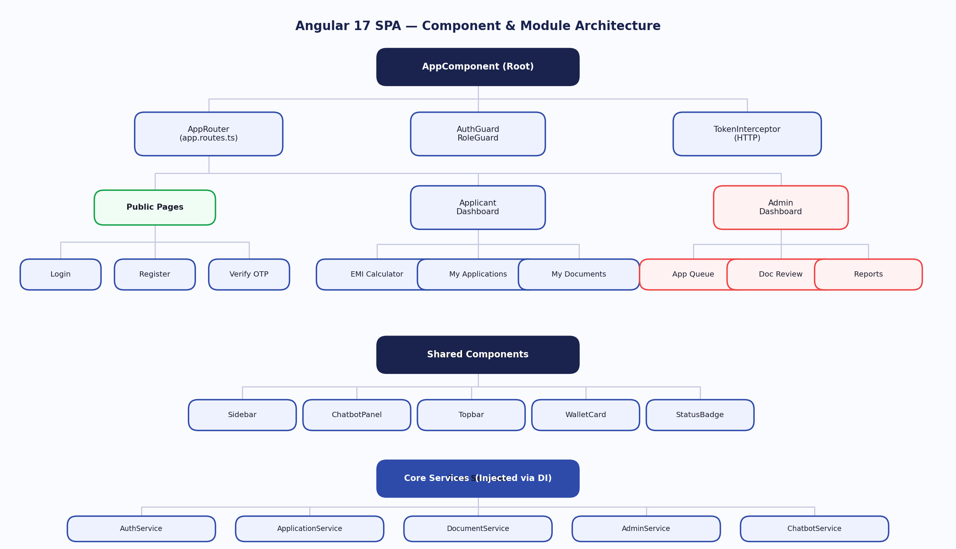
Angular Component Architecture
8.1 Application Bootstrap (app.config.ts)
- Router provider with standalone routes.
- HttpClient with fetch backend and interceptor chain.
- Interceptors: authInterceptor and errorInterceptor.
- Browser hydration and animations enabled.
8.2 Route Table (app.routes.ts)
Route | Area | Guard | Description
/ | Public | None | Landing page
/login | Public | None | Login page
/signup | Public | None | Signup page
/applicant/dashboard | Applicant | authGuard + roleGuard(APPLICANT) | Applicant dashboard
/applicant/apply and /applicant/apply/{id} | Applicant | authGuard + roleGuard(APPLICANT) | Loan apply/edit flow
/applicant/applications | Applicant | authGuard + roleGuard(APPLICANT) | My applications list
/applicant/applications/{id} | Applicant | authGuard + roleGuard(APPLICANT) | Application detail
/applicant/applications/{id}/status | Applicant | authGuard + roleGuard(APPLICANT) | Status tracking
/applicant/applications/{id}/documents | Applicant | authGuard + roleGuard(APPLICANT) | App-specific documents
/applicant/documents | Applicant | authGuard + roleGuard(APPLICANT) | My documents
/applicant/profile | Applicant | authGuard + roleGuard(APPLICANT) | Profile
/applicant/wallet | Applicant | authGuard + roleGuard(APPLICANT) | Applicant wallet
/admin/queue | Admin | authGuard + roleGuard(ADMIN) | Admin queue
/admin/documents | Admin | authGuard + roleGuard(ADMIN) | Admin documents
/admin/applications/{id} | Admin | authGuard + roleGuard(ADMIN) | Admin review screen
/admin/reports | Admin | authGuard + roleGuard(ADMIN) | Reports
/admin/users | Admin | authGuard + roleGuard(ADMIN) | User management
/admin/wallet | Admin | authGuard + roleGuard(ADMIN) | Admin wallet

8.3 Route Guards
- authGuard: checks authentication/token state.
- roleGuard(role): enforces required role for route tree.
8.4 HTTP Interceptors
- authInterceptor: appends bearer token to API requests.
- errorInterceptor: centralized frontend handling for API error payloads.
8.5 Core Services
- AuthService: login/signup/token/user state.
- ApplicationService: profile, applications, wallet, status timeline.
- DocumentService: upload/list/replace/link/download operations.
- AdminService: queue, decision updates, admin-specific orchestration.
- Chat integration: gateway route based chatbot API usage.
8.6 Key Pages and Components
- Applicant pages: dashboard, apply-loan, my-applications, track-status, documents, wallet, profile.
- Admin pages: queue, documents, application-review, users, reports, wallet.
- Shared shell: layouts, sidebar, badges, cards, and reusable tables/forms.
9. Key Data Flows
9.1 Signup and OTP Verification
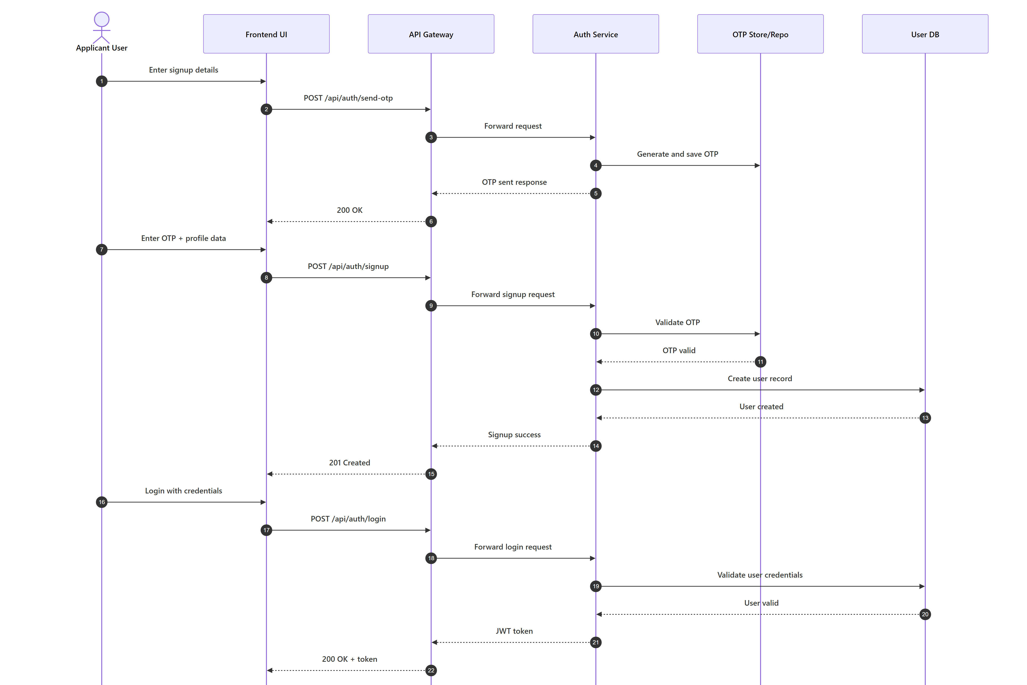
OTP Sign-up and Login
- 1. User starts signup.
- 2. Auth service sends OTP and stores verification state.
- 3. User verifies OTP.
- 4. Account is activated and downstream user-registration event is emitted.
9.2 Login and JWT Propagation
- 1. User logs in.
- 2. Auth service issues JWT.
- 3. Frontend stores token and sends through auth interceptor.
- 4. Downstream services validate token and role claims.
9.3 Applicant Draft and Submission Flow
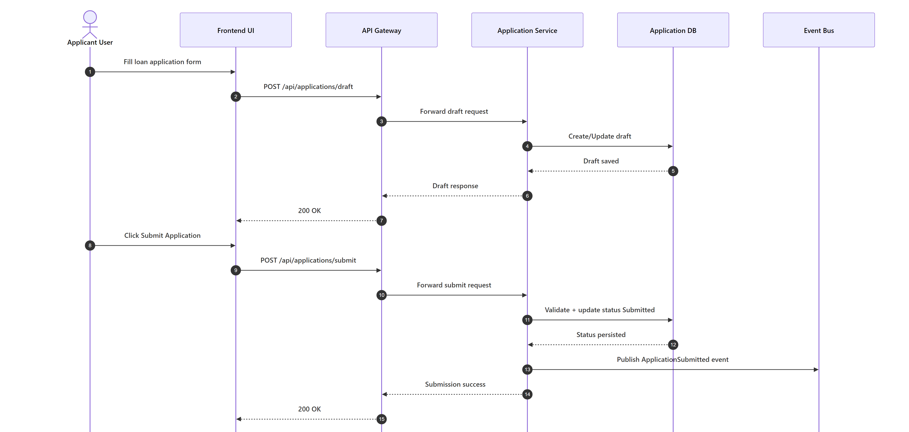
Application Submit Flow
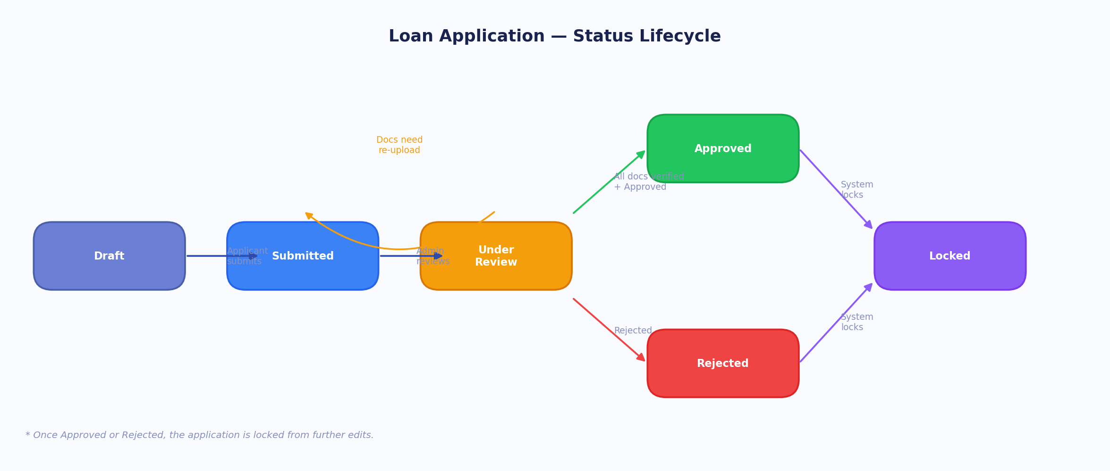
Application Status Lifecycle
- 1. Applicant saves profile and draft application.
- 2. Applicant uploads required documents.
- 3. Submit endpoint validates and transitions draft to submitted.
- 4. ApplicationSubmittedEvent is emitted for admin and notification flows.
9.4 Wallet Fee and Balance Validation Flow
- 1. Applicant submits loan application.
- 2. Application fee debit is attempted from applicant wallet.
- 3. If insufficient balance, service raises INSUFFICIENT_WALLET_BALANCE (HTTP 402).
- 4. Frontend keeps application as draft and asks user to top up wallet.
9.5 Admin Review and Disbursal Guard
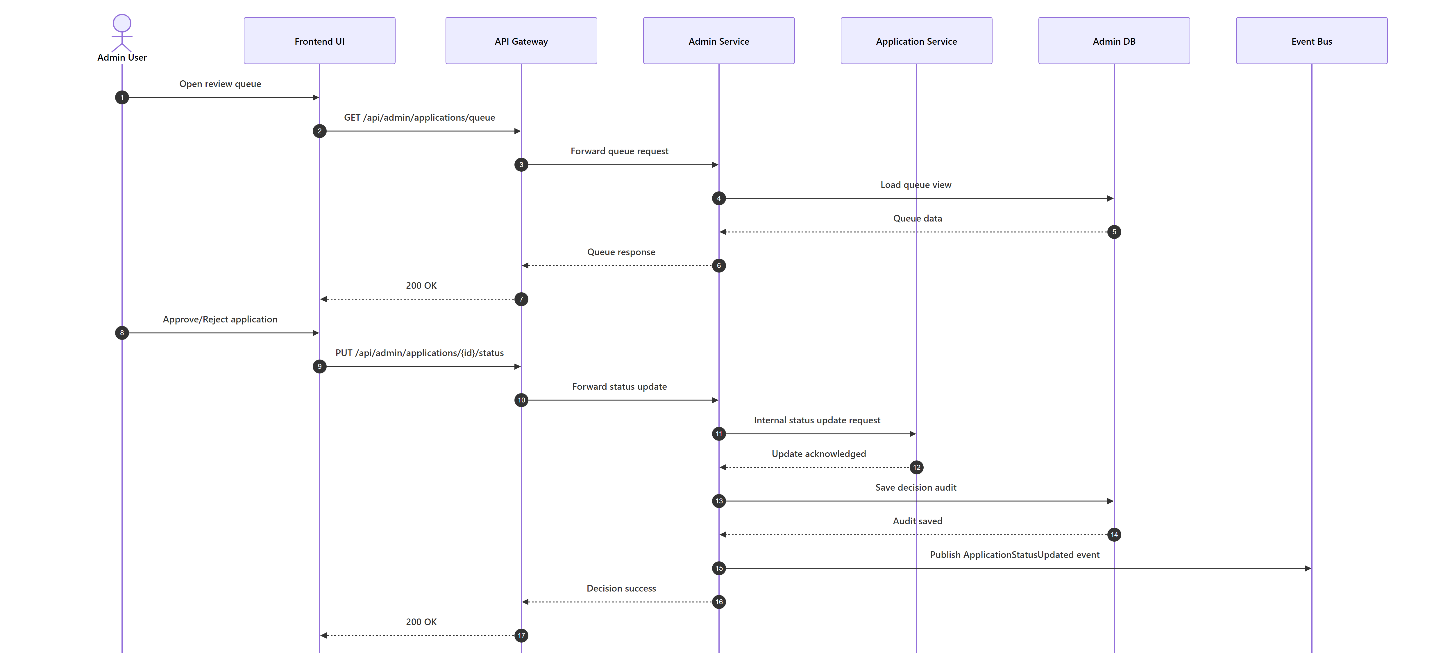
Admin Review and Decision Flow
- 1. Admin opens queue and application details.
- 2. Admin updates status and decision fields.
- 3. Admin wallet sufficiency is validated before disbursal operations.
- 4. Status updates are synchronized and status-change events are emitted.
9.6 Document Verification Flow
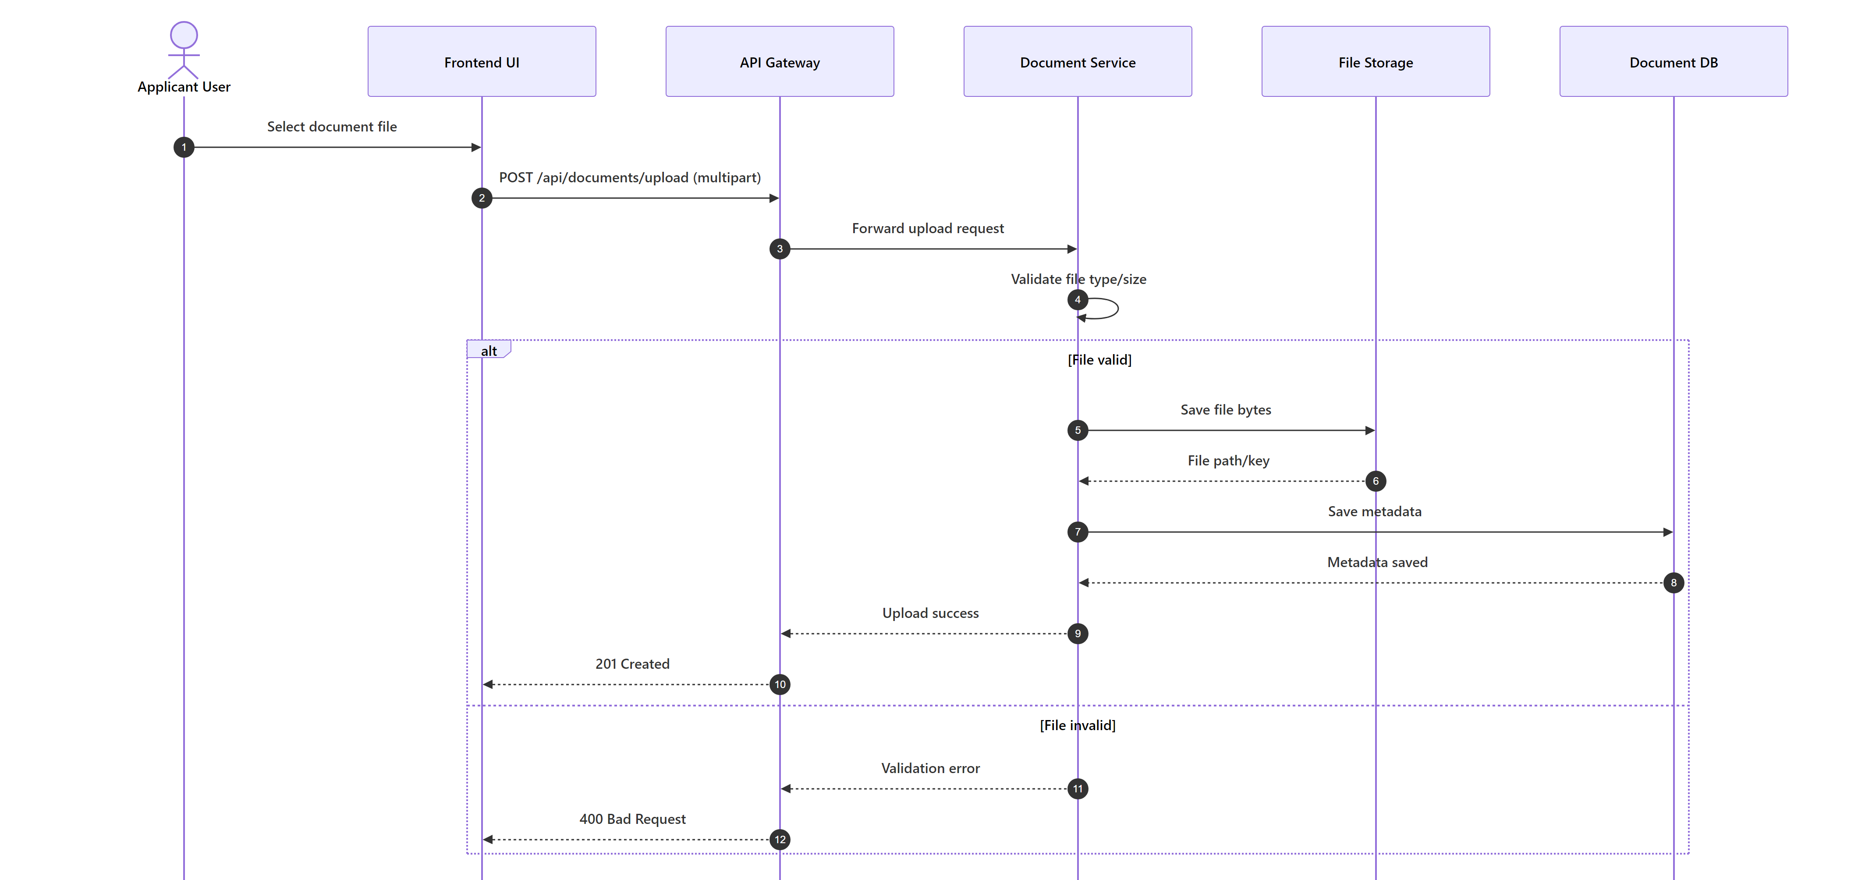
Document Upload Flow
- 1. Applicant uploads/replaces document.
- 2. Admin verifies or requests reupload.
- 3. DocumentVerifiedEvent is emitted.
- 4. Application/admin/notification consumers react to status changes.
9.7 Chatbot Flow
- 1. Frontend calls gateway chat route.
- 2. Chatbot validates JWT and loads or creates session context.
- 3. Applicant flow: deterministic guided orchestration.
- 4. Admin flow: LLM summary response over preloaded admin context.
10. Infrastructure and Configuration
10.1 Docker Compose Services
Service | Container Port | Host Port | Notes
sqlserver | 1433 | 1433 | Persistent volume sqlserver_data
rabbitmq | 5672 / 15672 | 5673 / 15673 | Management UI exposed
auth-service | 8080 | 5021 | JWT + identity APIs
application-service | 8080 | 5022 | Loan + wallet APIs
document-service | 8080 | 5023 | Upload/verification APIs
admin-service | 8080 | 5024 | Admin APIs
notification-service | 8080 | 5025 | Event consumer + email
api-gateway | 8080 | 5020 | Ocelot entry point
chatbot-service | 8000 | 5026 | FastAPI chatbot
frontend | 4200 | 4200 | Angular UI

10.2 Database Configuration per Service
Service | Connection String Database
Auth Service | CapFinLoan_AuthDb
Application Service | CapFinLoan_ApplicationDb
Document Service | CapFinLoan_DocumentDb
Admin Service | CapFinLoan_AdminDb

10.3 JWT Configuration
Shared keys used across services:
- Jwt:Key
- Jwt:Issuer
- Jwt:Audience
- Jwt:ExpiryMinutes
10.4 RabbitMQ and MassTransit
- RabbitMQ host, username, password configured per service.
- Kebab-case endpoint naming formatters scoped by service prefixes.
- ConfigureEndpoints automatically wires consumers to queues.
10.5 Runtime Health and Startup
- Docker compose health checks for SQL, RabbitMQ, and API services.
- Service startup depends on health of dependencies.
- APIs run schema migrations on startup in service Program.cs.
11. Unit Test Projects
Test Project
CapFinLoan.Auth.UnitTests
CapFinLoan.Application.UnitTests
CapFinLoan.Document.UnitTests
CapFinLoan.Admin.UnitTests
CapFinLoan.Notification.UnitTests
ChatbotService tests/test_orchestrator.py

11.1 Backend Testing Framework
- .NET test projects validate service logic, exception behavior, and domain transitions.
- Messaging and orchestration paths are validated at service layer boundaries.
11.2 Frontend and Chatbot Testing
- Frontend test config present at tsconfig.spec.json.
- Chatbot has orchestrator unit tests covering guided conversation and payload construction.
12. Security Considerations
- Password handling through ASP.NET Identity in Auth service.
- JWT validated independently in each API service.
- Role-based authorization annotations on controllers and routes.
- Admin-only internal endpoints protected via role constraints.
- Internal notification lookup endpoint additionally guarded by X-Internal-Api-Key.
- Document upload/download paths enforce user ownership or admin role checks.
- Wallet operations enforce server-side balance checks and exception-safe debits.

