

SCHOOL OF COMPUTER SCIENCE AND ENGINEERING

PROJECT: CREATING a WEBPAGE

TOPIC: PROPERTY WEBSITE

COURSE TITLE: INTERNET PROGRAMMING

COURSE CODE: CSE326

Submitted to: Mr. SANDEEP KUMAR [28953]

Submitted by: YESWANTH YAIKUNTAM [12222952, 29]

SANKET YELUGOTLA [12223854,53]

VICCKY TIWARY [12217090, 04]

INTRODUCTION

This project was about making a webpage for a property website. The property webpage has been named Sky Heights . To make this webpage we used different computer languages like HTML and CSS to make it eye-catching.

TECHNOLOGIES USED:

Computer languages like HTML and CSS have been used to make the webpage.

* HTML [Hyper Text Markup Language]

Hyper Text Markup Language, a standardized system for tagging text files to achieve font, colour, graphic, and hyperlink effects on World Wide Web pages. This language is for documents designed to be displayed in a web browser. It can be assisted by technologies such as Cascading Style

Sheets and scripting languages such as JavaScript.

*The whole webpage has been designed with HTML as a base and the creativity and designing has been done using CSS.*

* CSS [Cascading Style Sheets]

Cascading Style Sheets is a style sheet language used for describing the presentation of a document written in a markup language such as HTML or XML. CSS is a cornerstone technology of the World Wide Web, alongside HTML and JavaScript.

*Both internal and inline CSS have been used in the project.*

FEATURES OF THE PROJECT:

The main features in the webpage are:

→ Name of the property website in the web browser tab done using HTML.

This helps making the webpage look more authentic.

→ Scrolling motion

Done using CSS, for the HTML element.

Clicking sections like ‘Home’, ‘About’, ‘Menu’ etc. will make the page scroll down to the respective section in the webpage. This will make it effortless and easy to reach the destination-section.

● Other features

→ Login and Signup pages are made on different HTML pages.

→ User is given description on easy of using the website as intro.

→Sections are divided for buying and selling the houses separately.

→ Gallery

Created using HTML and CSS.

The images have been layered out on the page. On hovering over the images and they zoom-in a little while moving the cursor over them.

→Blocks

On hovering over the text boxes, they change colour and turn another colour while focusing on them.

CODE USED:

Property.html

<!DOCTYPE html>

<html lang="en">

<head>

    <meta charset="UTF-8">

    <meta http-equiv="X-UA-Compatible" content="IE=edge">

    <meta name="viewport" content="width=device-width, initial-scale=1.0">

    <title>Property Website</title>

    <link rel="shortcut icon" href="./pics/favicon.png" type="image/x-icon">

    <link rel="stylesheet" href="style.css">

</head>

<body>

    <header>

        <a href="#"><img src="./pics/sky heights copy.png" alt="logo-home"></a>

        <ul id="ulhead">

            <li><a href="propertylog.html">Login</a></li>

            <li><a href="propertysign.html">Signup</a></li>

        </ul>

    </header>

    <div id="d1">

        <ul id='ul1'>

            <li><a href="#pg">Buy</a></li>

            <li><a href="#pg1">Rent</a></li>

            <li><a href="">Sell</a></li>

            <li style="width:150px ;"><a href="">Contact Us</a></li>

            <li style="width:225px ;"><a href="">Post Property for Free</a></li>

        </ul>

    </div>

    <div id='back'>

        <div id="intro">

            <p id="p1"> Welcome to skyheights!</p>

            <p id="p2"> Select your Location, Property type and Budget to continue </p>

        </div>

        <div id="info">

            <center>

                <form>

                    <select class="select" id="b3">

                        <option value="Select">Location</option>

                        <option value="Phagwara"> Phagwara</option>

                        <option value="Jalandhar"> Jalandhar</option>

                        <option value="Delhi"> Delhi</option>

                        <option value="Mumbai"> Mumbai</option>

                    </select>

                    <select id="b2">

                        <option value="Property Type">Property Type</option>

                        <option value="Individual">2BHK</option>

                        <option value="Individual 3BHK house">3BHK</option>

                        <option value="Individual 4BHK house">Individual 4BHK house</option>

                        <option value="Apartment">Apartment</option>

                    </select>

                    <select id="b1">

                        <option value="Budget">Budget</option>

                        <option value="Below 10lakhs">Below 10lakhs</option>

                        <option value="Below 20 lakhs">Below 20 lakhs</option>

                        <option value="Below 30 lakhs">Below 30 lakhs</option>

                    </select>

                    <input id="search" type="button" value='search'>

                </form>

            </center>

        </div>

    </div>

    <section class="services" id="services">

        <h1 style="font-size: 35px;" id="p2"> Our Services </h1>

        <div class="box-container">

            <div class="box">

                <img src="./pics/s-1.png" alt="">

                <h3>Buying Home</h3>

                <p>There are many residential formats to choose from - Residential plot, apartments, single floors,

                    independent houses and multi-storey flats.

                    If you have the required finances, ready-to-move-in is the ideal option for an end-user. </p>

                <a href="#" class="btn">Learn more</a>

            </div>

            <div class="box">

                <img src="./pics/s-2.png" alt="">

                <h3>Renting Home</h3>

                <p>Before renting a home there are plenty of factors to consider such as location, type of house,

                    number of bedrooms needed, your budget and the location of this house. Once you figure all these

                    things out, you can start the search process.</p>

                <a href="#" class="btn">Learn more</a>

            </div>

            <div class="box">

                <img src="./pics/s-3.png" alt="">

                <h3>Selling Home</h3>

                <p>It is important to know the market before you decide to sell your house. Examine the prevailing

                    real estate market trends. The right time to sell your property is when you get the price you

                    want for your property.</p>

                <a href="#" class="btn">Learn more</a>

            </div>

        </div>

    </section>

    <div id="gallery10">

        <p id="pg"> <small> Top </small> <br> Projects</p>

        <div id="gallery1" class="gallery">

            <div id="block">

                <img src="./pics/apartment.jpg" alt="apartment">

                <p class="para" id="para">Naval Apartments </p>

                <p class="para"> &#8377 25 lakhs</p>

                <p id="para2">

                    <ion-icon name="location-outline"></ion-icon> Visakhapatnam

                </p>

            </div>

            <div id="block">

                <img src="./pics/img2.png" alt="apartment">

                <p class="para" id="para">Neo Imperial </p>

                <p class="para"> &#8377 52 lakhs</p>

                <p id="para2">

                    <ion-icon name="location-outline"></ion-icon> Indore

                </p>

            </div>

            <div id="block">

                <img src="./pics/img3.png" alt="apartment">

                <p class="para" id="para">Phoenix </p>

                <p class="para"> &#8377 2.9 Crores</p>

                <p id="para2">

                    <ion-icon name="location-outline"></ion-icon> Hyderabad

                </p>

            </div>

            <div id="block">

                <img src="./pics/img4.png" alt="apartment">

                <p class="para" id="para">Hill Top House </p>

                <p class="para"> &#8377 2 Crores</p>

                <p id="para2">

                    <ion-icon name="location-outline"></ion-icon> Darjeeling

                </p>

            </div>

        </div>

        <div id="gallery2" class="gallery">

            <div id="block">

                <img src="./pics/img5.png" alt="apartment">

                <p class="para" id="para">Urbania Trinity </p>

                <p class="para"> &#8377 30 lakhs</p>

                <p id="para2">

                    <ion-icon name="location-outline"></ion-icon> Mumbai

                </p>

            </div>

            <div id="block">

                <img src="./pics/img6.png" alt="apartment">

                <p class="para" id="para">Metropolis </p>

                <p class="para"> &#8377 3 Crores</p>

                <p id="para2">

                    <ion-icon name="location-outline"></ion-icon> Delhi

                </p>

            </div>

            <div id="block">

                <img src="./pics/img7.png" alt="apartment">

                <p class="para" id="para">Omkar Bhavan</p>

                <p class="para"> &#8377 32 lakhs</p>

                <p id="para2">

                    <ion-icon name="location-outline"></ion-icon> kolkata

                </p>

            </div>

            <div id="block">

                <img src="./pics/img8.png" alt="apartment">

                <p class="para" id="para">Hari Township </p>

                <p class="para"> &#8377 25 lakhs</p>

                <p id="para2">

                    <ion-icon name="location-outline"></ion-icon> Bengaluru

                </p>

            </div>

        </div>

        <p id="pg1"> <small style="font-size: 25px;"> Homes </small> <br>For rent </p>

        <div id="gallery3" class="gallery">

            <div id="block">

                <img src="./pics/rent1" alt="apartment">

                <p class="para" id="para">Trinity Houses</p>

                <p class="para"> &#8377 25,000/Mo</p>

                <p id="para2">

                    <ion-icon name="location-outline"></ion-icon> Delhi

                </p>

            </div>

            <div id="block">

                <img src="./pics/rent2.jpg" alt="apartment">

                <p class="para" id="para">Modern Apartments </p>

                <p class="para"> &#8377 40,000/Mo</p>

                <p id="para2">

                    <ion-icon name="location-outline"></ion-icon> Phagwara

                </p>

            </div>

            <div id="block">

                <img src="./pics/rent3.jpg" alt="apartment">

                <p class="para" id="para">SS Apartments</p>

                <p class="para"> &#8377 44,000/Mo</p>

                <p id="para2">

                    <ion-icon name="location-outline"></ion-icon> Goa

                </p>

            </div>

            <div id="block">

                <img src="./pics/rent4.jpg" alt="apartment">

                <p class="para" id="para">Goa Venture </p>

                <p class="para"> &#8377 50,250/Mo</p>

                <p id="para2">

                    <ion-icon name="location-outline"></ion-icon> Goa

                </p>

            </div>

        </div>

        <div id="gallery4" class="gallery">

            <div id="block">

                <img src="./pics/img5.png" alt="apartment">

                <p class="para" id="para">Smart Apartments </p>

                <p class="para"> &#8377 40,000/Mo</p>

                <p id="para2">

                    <ion-icon name="location-outline"></ion-icon> Noida

                </p>

            </div>

            <div id="block">

                <img src="./pics/img6.png" alt="apartment">

                <p class="para" id="para">Golkuldam Aoartments </p>

                <p class="para"> &#8377 20,000/Mo</p>

                <p id="para2">

                    <ion-icon name="location-outline"></ion-icon> Indore

                </p>

            </div>

            <div id="block">

                <img src="./pics/img7.png" alt="apartment">

                <p class="para" id="para">Surya heights</p>

                <p class="para"> &#8377 32 lakhs</p>

                <p id="para2">

                    <ion-icon name="location-outline"></ion-icon> kolkata

                </p>

            </div>

            <div id="block">

                <img src="./pics/img8.png" alt="apartment">

                <p class="para" id="para">Mahaver Enclave </p>

                <p class="para"> &#8377 25 lakhs</p>

                <p id="para2">

                    <ion-icon name="location-outline"></ion-icon> Bengaluru

                </p>

            </div>

        </div>

        <div>

            <p id="p1">

                What makes us prefered choice.

        </div>

        <div id="choice">

            <div>

                <img src="./pics/apartment.jpg" alt="apartment">

                <p>Maximum choice</p>

            </div>

            <div>

                <img src="./pics/trust.png" alt="apartment">

                <p>Buyers trust</p>

            </div>

            <div>

                <img src="./pics/prefer.png" alt="apartment">

                <p>Sellers prefer Us</p>

            </div>

            <div>

                <img src="./pics/expert-option.png" alt="apartment">

                <p>Expert Guidance</p>

            </div>

            </p>

        </div>

        <div id="cities">

            <p id="p1">Top cities in India</p>

            <div id="cities1">

                <div><img src="./pics/vizag.jpg" alt="vizag">

                    <p>Vizag</p>

                </div>

                <div><img src="./pics/delhi.jpg" alt="delhi">

                    <p>Delhi</p>

                </div>

                <div><img src="./pics/mumbai.jpg" alt="">

                    <p>Mumbai</p>

                </div>

                <div><img src="./pics/kolkata.jpg" alt="">

                    <p>kolkata</p>

                </div>

                <div><img src="./pics/bengaluru.jpg" alt="">

                    <p>bengaluru</p>

                </div>

                <div><img src="./pics/chennai.jpg" alt="">

                    <p>chennai</p>

                </div>

                <div><img src="./pics/hyderabad.jpg" alt="">

                    <p>hyderabad</p>

                </div>

            </div>

        </div>

        <div id="foot">

            <div id="about">

                <p id="h1"> About Us</p>

                <p id="h2">Skyheights is a fast growing real estate website among the various property sites in India.

                    It'sestablished to help you Buy, Rent, Sell Property in India. Hundreds of new real estate projects

                    in

                    India

                    having new and resale properties for sale are being added every month in our database. You can find

                    vast

                    number of residential and commercial property options on our website including Independent House,

                    Villas,

                    Residential Land, Factory, Agricultural Land, Farm House, Studio Apartment, Showrooms, Business/IT

                    Park,

                    etc. We offer variety of possible tools and options to advertise your property for rent or sell, to

                    help

                    you

                    take profitable decisions for your property by connecting you with the realtors.

            </div>

            <div id="contact">

                <p id="h3">Stay in Touch</p>

                <p style="padding-bottom:0;" id="h4">

                    <ion-icon id="bion" name="location-outline"></ion-icon>LPU BH:6

                </p>

                <p id="h4">

                    <ion-icon id="bion" name="call"></ion-icon>9550572255 <br>

                    <ion-icon id="bion" name="call"></ion-icon>8008385927

                </p>

                <p id="h3">Social Media</p>

                <p id="social">

                    <a target="_blank" href="https://www.facebook.com">

                        <ion-icon id="bion" class="icon" name="logo-facebook"></ion-icon>

                    </a>

                    <a target="_blank" href="https://www.instagram.com">

                        <ion-icon id="bion" name="logo-instagram"></ion-icon>

                    </a>

                    <a target="_blank" href="https://twitter.com/?lang=en-in">

                        <ion-icon id="bion" name="logo-twitter"></ion-icon>

                    </a>

                    <a target="_blank" href="https://web.whatsapp.com">

                        <ion-icon id="bion" name="logo-whatsapp"></ion-icon>

                    </a>

                </p>

            </div>

        </div>

        <script type="module" src="https://unpkg.com/ionicons@5.5.2/dist/ionicons/ionicons.esm.js"></script>

        <script nomodule src="https://unpkg.com/ionicons@5.5.2/dist/ionicons/ionicons.js"></script>

</body>

</html>

style.css

* {

    margin: 0;

    padding: 0%;

    box-sizing: border-box;

    font-family: Helvetica, Arial, sans-serif;

}

html {

    scroll-behavior: smooth;

}

header img {

    height: 35px;

}

header {

    background-color: rgb(3, 101, 133);

    margin-top: 0;

    display: flex;

    font-size: 30px;

    color: White;

    padding-left: 148px;

    padding-top: 6px;

    font-family: Helvetica, Arial, sans-serif;

    height: 48px;

}

#ulhead {

    margin-left: 800px;

    font-family: Arial, Helvetica, sans-serif;

    padding-top: 3px;

}

#ulhead li {

    margin-left: 20px;

    font-size: 15px;

    width: 75px;

    height: 30px;

    text-align: center;

    line-height: 30px;

    list-style: none;

    float: left;

    border: 1px solid white;

    border-radius: 50px;

    background-color: white;

    color: rgb(3, 101, 133);

}

#ulhead li a {

    text-decoration: none;

    display: block;

}

#d1 {

    height: 50px;

    border-bottom: 1px solid black;

}

#ul1 li {

    border: 1px solid black;

    float: left;

    list-style: none;

    text-align: center;

    background-color: rgb(182, 221, 235);

    margin-right: 30px;

    width: 100px;

    line-height: 30px;

    border-radius: 10px;

    font-size: 20px;

    transition: transform ease-in-out 0.3s;

}

#ul1 li:hover {

    background-color: rgb(135, 202, 226);

    transform: scale(1.1);

}

#ul1 li a {

    text-decoration: none;

    color: #1f0c0c;

    display: block;

}

#ul1 {

    padding-top: 7px;

    padding-left: 150px;

}

#intro {

    padding-top: 20px;

    font-size: 20px;

    text-align: center;

}

#intro #p1 {

    color: #2a54ed;

    font-size: 30px;

    font-weight: 600;

    padding-bottom: 20px;

    padding-top: 20px;

}

#intro #p2 ,.services #p2{

    text-align: center;

    font-family: 'Lato', sans-serif;

    font-size: 30px;

    font-weight: 700;

    color: #4b4b4b;

    padding-bottom: 20px;

}

#back {

    background-image: url('./pics/home-banner.jpg');

    width: 100%;

    background-size: cover;

    height: 500px;

}

#info {

    background-color: aliceblue;

    border: 1px solid black;

    border-radius: 40px;

    padding: 10px;

    margin-left: 400px;

    margin-right: 400px;

    margin-top: 20px;

}

select, #search {

    font-size: 20px;

    width: auto;

    height: 40px;

    text-align: center;

    border: none;

}

#search {

    font-size: 20px;

    width: 125px;

    height: 40px;

    text-align: center;

    border: none;

    border-radius: 100px;

    background-color: rgb(3, 101, 133);

    color: white;

    padding: 5px;

}

#search:hover {

    background-color: rgb(3, 79, 104);

}

#gallery10 {

    padding-top: 20px;

}

#gallery10 #pg ,#pg1{

    margin-left: 80px;

    color: #827f7b;

    font-size: 35px;

    font-weight: 600;

    text-transform: uppercase;

}

.gallery img {

    border-radius: 5px;

    border-bottom-left-radius: 0;

    border-bottom-right-radius: 0;

    width: 275px;

    height: 150px;

}

.gallery {

    padding-top: 20px;

    display: flex;

    width: 300px;

    height: auto;

    margin-left: 80px;

}

.gallery div{

    border: 1px solid rgb(153, 153, 153);

    border-radius: 5px;

    margin-left: 50px;

    height: 230px;

    transition: transform ease-in-out 0.3s;

}

.gallery div:hover {

    transform: scale(1.1);

}

.gallery p {

    padding-left: 25px;

    text-align: left;

    margin-top: 10px;

}

.para{

    font-size: 15px;

    font-weight: 600;

}

#para2{

    font-size: 15px;

    color: #949494;

    font-weight: 600;

}

#para {

    width: 175px ;

    padding-right: 20px;

    float: left;

}

#p1 {

    font-size: 30px;

    text-align: center;

    padding-top: 50px;

    padding-bottom: 50px;

    font-weight: 600;

}

#choice {

    padding-top: 30px;

    display: flex;

    margin-left: 200px;

}

#choice div {

    margin-right: 50px;

}

#choice img {

    border-radius: 10px;

    width: 175px;

    height: 150px;

    margin-left: 50px;

    transition: transform ease-in-out 0.3s;

}

#choice p {

    padding-top: 20px;

    text-align: center;

    margin-left: 50px;

    color: red;

}

#cities {

    background-color: rgb(193, 242, 242);

    width: 100%;

    padding-top: 70px;

    margin-top: 30px;

}

#cities1 {

    padding-top: 20px;

    padding-bottom: 50px;

    display: flex;

    width: 100%;

}

#cities p {

    padding-top: 5px;

    text-align: center;

    font-size: 250x;

}

#cities #p1 {

    text-align: center;

    font-size: 30px;

}

#cities div {

    padding-left: 90px;

}

#cities1 img {

    height: 85px;

    width: 85px;

    border-radius: 100%;

    transition: transform ease-in-out 0.3s;

}

#cities img:hover {

    transform: scale(1.1);

}

#foot {

    background-color:#000;

    height: 325px;

    width: 100%;

    padding: 50px;

    display: flex;

}

#about {

    width: 70%px;

    margin-left: 25px;

}

#foot #h1 {

    padding-top: 30px;

    text-align: center;

    color: white;

    font-size: 20px;

}

#foot p {

    padding: 10px;

    font-size: 16px;

    color:#7a7a7a;

}

#contact {

    margin-left: 100px;

    width: 100%;

    padding-top: 20px;

}

#foot #h3 {

    color: white;

}

#bion {

    padding-right: 10px;

    color: #7a7a7a;

}

/* box */

.services .box-container{

    display: flex;

    gap:2rem;

    margin-left: 150px;

    margin-bottom: 10px;

}

.services .box-container .box{

    width: 350px;

    border-radius: .5rem;

    background:#fff;

    box-shadow: 0 .5rem 1rem rgba(0,0,0,.1);

    border:.1rem solid rgba(0,0,0,.2);

    text-align: center;

    padding:2rem;

    margin-right: 50px;

}

.services .box-container .box h3{

    font-size: 2rem;

    color:#333;

}

.services .box-container .box p{

    color:#666;

    padding:.5rem;

}

.btn {

    margin-top: 10px;

    display: inline-block;

    padding: 10px;

    border-radius: .5rem;

    font-size: 1.3rem;

    color: #333;

    color: white;

    background: rgb(3, 101, 133);

}

.box a {

    text-decoration: none;

}

.services {

    margin-top: 50px;

}

.btn:hover {

    background-color: rgb(3, 79, 104)/*rgb(177, 0, 0)*/;

}

Propertylog.html

<!DOCTYPE html>

<html lang="en">

<head>

    <meta charset="UTF-8">

    <meta http-equiv="X-UA-Compatible" content="IE=edge">

    <meta name="viewport" content="width=device-width, initial-scale=1.0">

    <title>login page</title>

    <link rel="shortcut icon" href="./pics/favicon.png" type="image/x-icon">

    <link rel="stylesheet" href="stylelog.css">

</head>

<body>

    <header>

        <a href="#"><img src="./pics/sky heights copy.png" alt="logo-home"></a>

    </header>

    <div id="max">

        <div id="login">

            <div>

                <p id="p1">Login</p>

            </div>

            <div><input type="text" placeholder="Username"></div>

            <div><input type="password" placeholder="Password"></div>

            <div><a href="property.html"><input type="button" value='submit'></a></div>

        </div>

        <div id="signup">

            <p id="p2">

                Don't have an account? <a href="propertysign.html" target="_blank">Signup</a>

            </p>

        </div>

    </div>

</body>

</html>

Propertysign.html

<!DOCTYPE html>

<html lang="en">

<head>

    <meta charset="UTF-8">

    <meta http-equiv="X-UA-Compatible" content="IE=edge">

    <meta name="viewport" content="width=device-width, initial-scale=1.0">

    <title>signup page</title>

    <link rel="shortcut icon" href="./pics/favicon.png" type="image/x-icon">

    <link rel="stylesheet" href="stylelog.css">

    <style>

        #max{

            margin-top: 125px;

        }

    </style>

</head>

<body>

    <header>

        <a href="#"><img src="./pics/sky heights copy.png" alt="logo-home"></a>

    </header>

    <div id="max">

        <div id="login">

            <div>

                <p id="p1">Sign up</p>

            </div>

            <div><input type="text" placeholder="Full name"></div>

            <div><input type="text" placeholder="Location"></div>

            <div><input type="text" placeholder="Type"></div>

            <div><input type="password" placeholder="Password"></div>

            <div><input type="password" placeholder="Enter password again"></div>

            <div><a href="property.html"><input type="button" value='submit'></a></div>

        </div>

        <div id="signup">

            <p id="p2">

                Already have an account? <a href="propertylog.html" target="_blank">Login</a>

            </p>

        </div>

    </div>

</body>

</html>

stylelog.css

*{

    margin:0;

    padding:0%;

    box-sizing: border-box;

    font-family:Helvetica,Arial,sans-serif;

}

body {

    background-color:rgb(237, 247, 247);

}

header img{

    height: 35px;

}

header {

    background-color:rgb(3, 101, 133)/*rgb(209, 45, 45) */;

    font-size: 30px;

    padding-left: 148px;

    padding-top: 6px;

    font-family:Helvetica,Arial,sans-serif;

    height: 48px;

}

#max {

    margin-top: 200px;

    background-color: white;

    margin-left: 575px;

    margin-right: 575px;

}

#login , #signup {

    border: 1px solid rgb(195, 190, 190);

    /* outline: 1px solid black; */

    /* background-color: aqua; */

    margin-bottom: 10px;

    border-radius: 5px;

    padding-top: 40px;

    padding-bottom: 25px;

    text-align: center;

}

#signup {

    font-size: 14px;

    padding-top: 25px;

}

#login #p1 {

    font-size: 30px;

    margin-bottom: 30px;

}

#login input{

    text-align: center;

    height: 40px;

    font-size: 15px;

    border: 1px solid rgb(195, 190, 190);

    border-radius: 5px;

}

#login input[type=text] , input[type=password] {

    margin-bottom:5px;

    width: 250px;

}

#login input[type=button] {

    margin-top: 10px;

    border-radius: 20px;

    border: none;

    background-color:rgb(3, 101, 133) ;

    color: white;

    height: 35px;

    width: 100px;

}

#login input[type=button]:hover {

    background-color: rgb(3, 79, 104);

}

#login input::placeholder{

    text-align: center;

}

#signup a {

    text-decoration: none;

}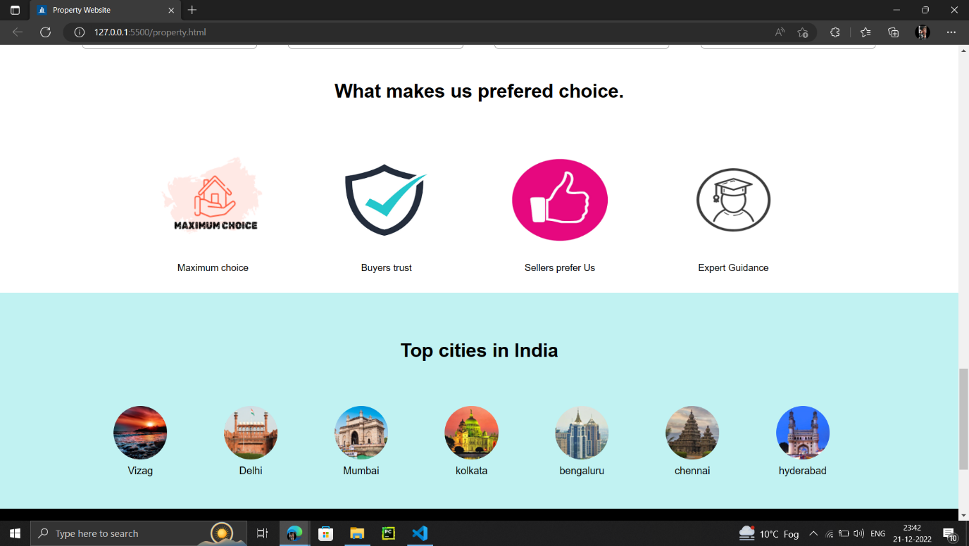

Gallery of the Project

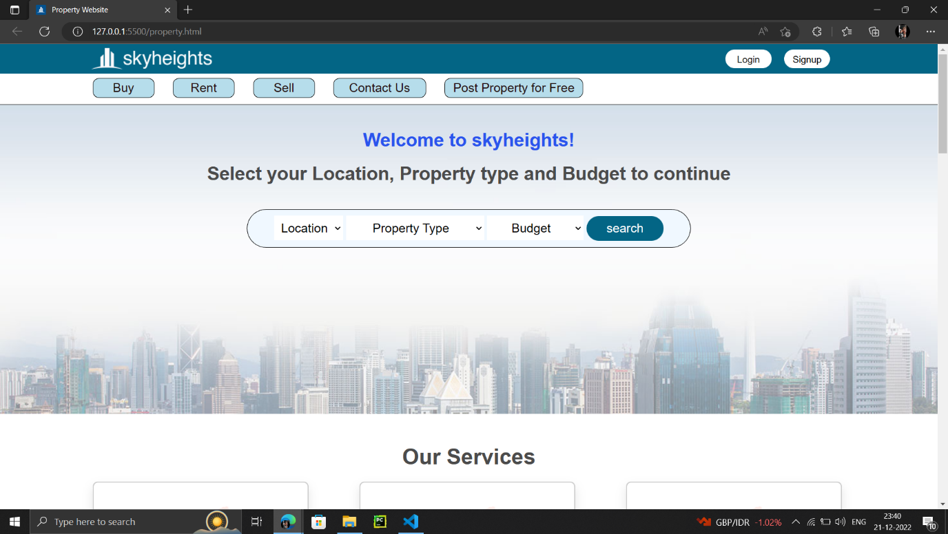

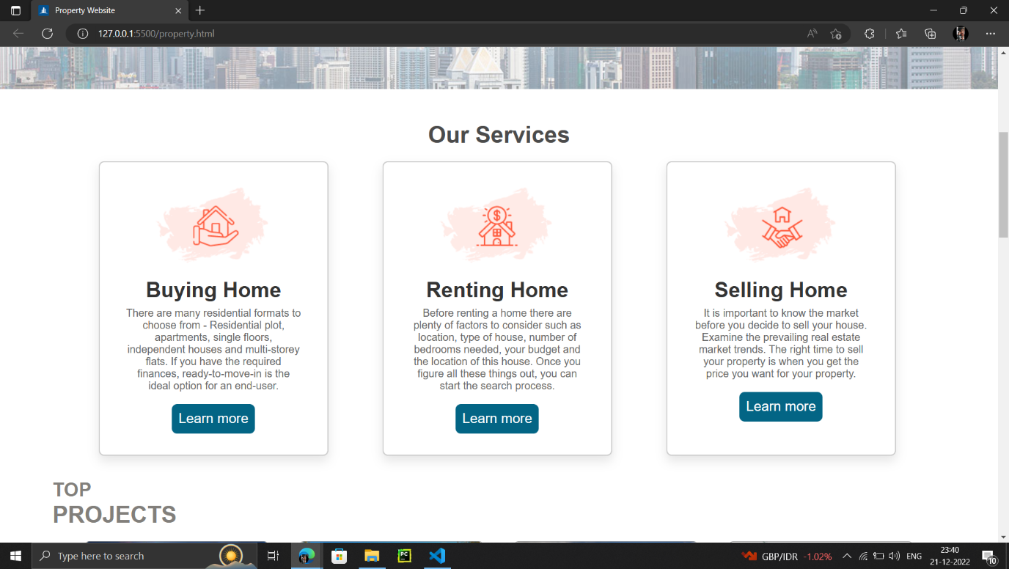

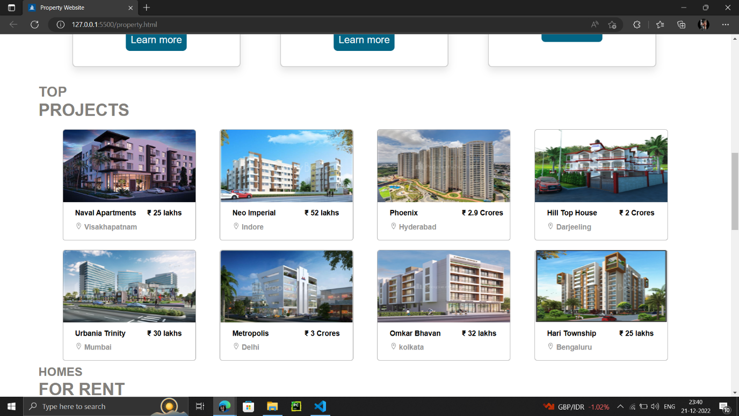

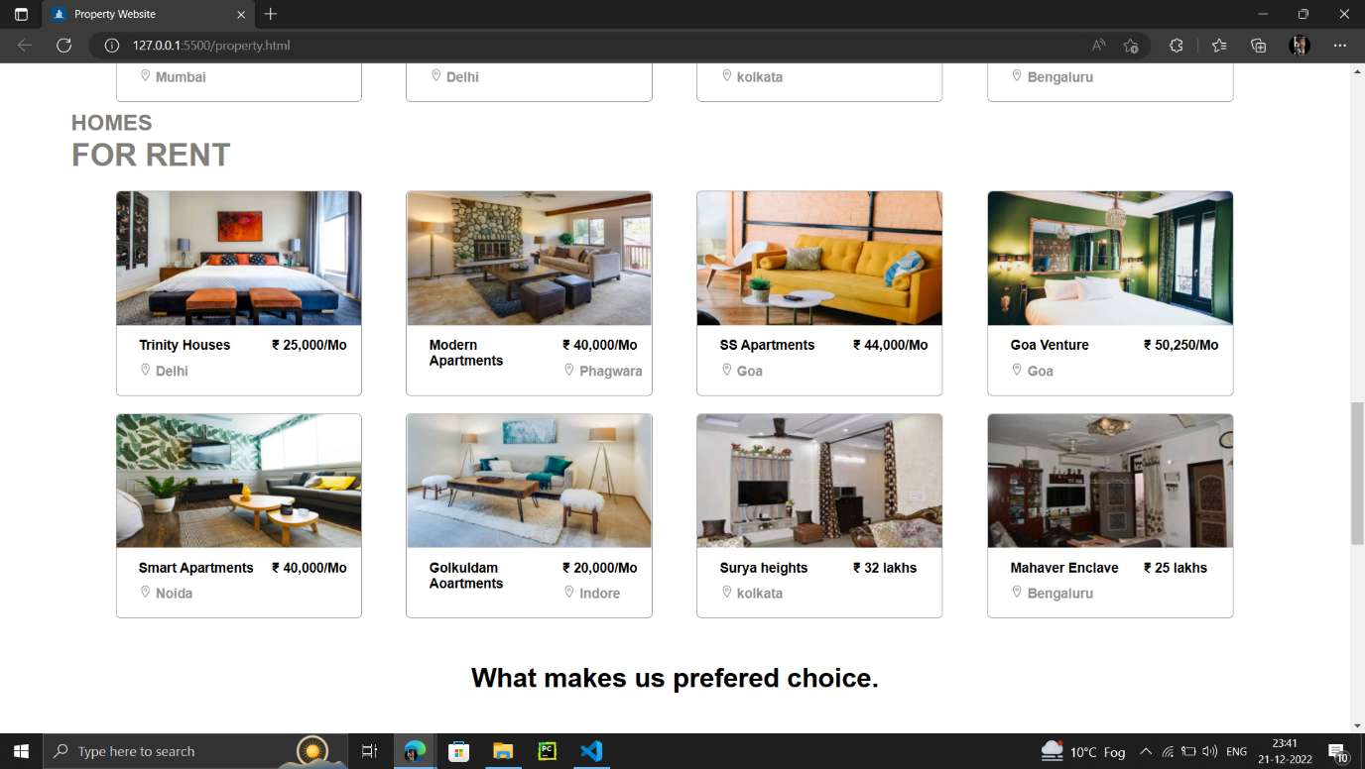



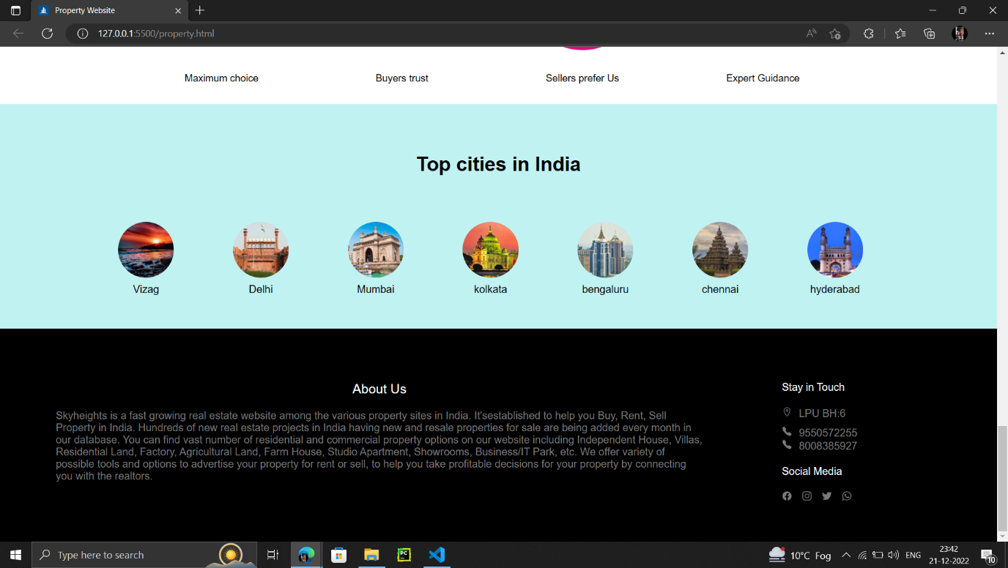

FLOW OF THE PROJECT

1. First of all, we researched on the topic of Property.
   1. Checked out different websites of different Property.
   2. Got an idea about how the webpage should look like and how it should be designed.
   3. Used those websites for reference and coded for the same.
2. What we did after this :-
   1. We divided the work based on our skills.
3. Hence, the project was finally wrapped up!

CONCLUSION

Overall, the webpage is made to-the-point and customer-friendly. We learned the different ways in which CSS can be used in designing the webpage. This project helped in making us understand the way in which the languages like HTML and CSS are used in making webpages. It also helped in overcoming the problems faced while coding.

And it helped in improving our report writing skills, communication and team work. It was a really wonderful learning experience.

REFERENCES

HTML References: [https://www.w3schools.com](https://www.w3schools.com/howto/tryit.asp?filename=tryhow_js_scroll_to_top)

* Website taken for primary reference:

[www.magicbricks.com](http://www.magicbricks.com) , www.propertybazar.com

* Other sites taken for content-reference:

[www.github.com](http://www.github.com) , www.ionicons.com