**Sanket Suryawanshi – code.sanket@gmail.com**

**Network Intrusion Detection System (NIDS) - Analysis & Findings Report**

**Dataset Used:** CICIDS2017 (or similar public intrusion detection dataset)  
 **Objective:** To classify network traffic into **Normal** or **Attack** categories using **Machine Learning**.

**Step 1: Data Preprocessing & Cleaning**

**Dataset Overview:**

* The dataset consists of categorical and numerical features related to network traffic.
* Important features: totalSourceBytes, totalDestinationBytes, sourcePort, destinationPort, protocolName, etc.
* The target variable is Label (Normal/Attack).

**Initial Data Analysis & Cleaning**

Removed unnecessary columns:

* Non-numeric & redundant features like appName, protocolName, startDateTime, stopDateTime.  
  Handled missing values & normalized numerical features.  
  Encoded categorical labels (Normal = 0, Attack = 1).

**Step 2: Feature Selection & Correlation Analysis**

**Feature Correlation Heatmap**

*This heatmap shows the relationships between different numerical features.*

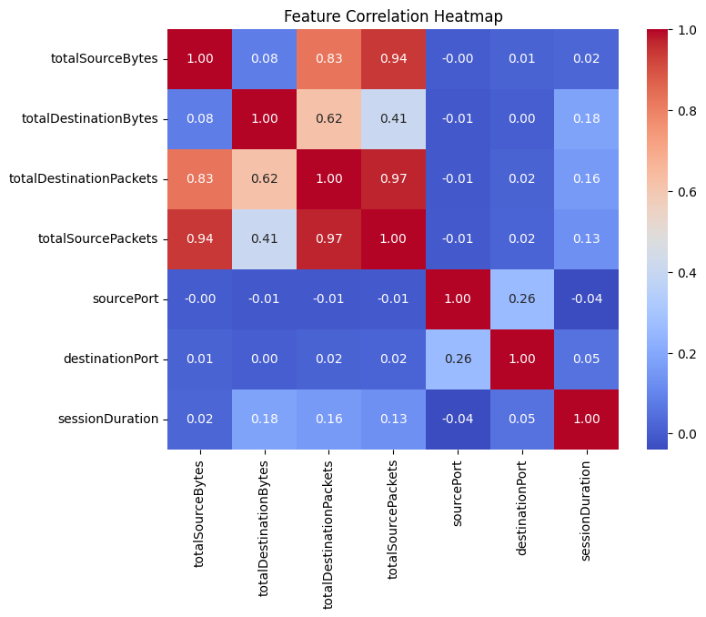

**Key Observations:**

✔ **Highly Correlated Features**

* totalSourcePackets & totalDestinationPackets (**0.97**)
* totalSourceBytes & totalSourcePackets (**0.94**)
* totalDestinationPackets & totalSourceBytes (**0.83**)

✔ **Low Correlation Features**

* sourcePort, destinationPort, and sessionDuration show weak correlations with other features.

✔ **Negative Correlation**

* sessionDuration & sourcePort have a slight negative correlation.

**Action Taken:**  
 **Feature selection applied** : Highly correlated features reduced to prevent redundancy.

**Step 3: Model Training & Performance Evaluation**

**Model 1: Random Forest Classifier**

**Feature Importance (Random Forest)**

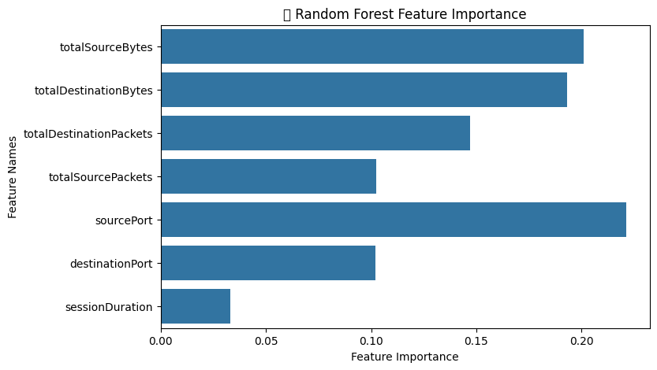

**Classification Report (Random Forest)**

| **Class** | **Precision** | **Recall** | **F1-Score** | **Support** |
| --- | --- | --- | --- | --- |
| **Attack** | 0.98 | 0.97 | 0.98 | 755 |
| **Normal** | 1.00 | 1.00 | 1.00 | 33,521 |
| **Accuracy** | - | - | **1.00** | 34,276 |
| **Macro Avg** | 0.99 | 0.99 | 0.99 | 34,276 |
| **Weighted Avg** | 1.00 | 1.00 | 1.00 | 34,276 |

Random Forest Accuracy:99.91%

**Confusion Matrix - Random Forest**  
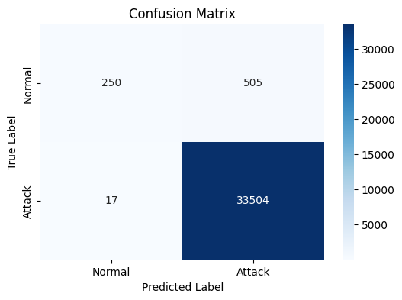

**Interpretation:**  
 **High Accuracy (99.91%)** : Model performs exceptionally well in classifying normal vs. attack traffic.  
 **Misclassifications**:

* 505 false positives (Normal classified as Attack).
* 17 false negatives (Attack classified as Normal).  
  **Feature Importance Ranking:**
* totalSourceBytes & sourcePort are most significant.
* sessionDuration contributes the least.

**Model 2: Artificial Neural Network (ANN)**

**Classification Report (ANN)**

| **Class** | **Precision** | **Recall** | **F1-Score** | **Support** |
| --- | --- | --- | --- | --- |
| **0** (Normal) | 0.94 | 0.33 | 0.49 | 755 |
| **1** (Attack) | 0.99 | 1.00 | 0.99 | 33,521 |
| **Accuracy** | - | - | **0.98** | 34,276 |
| **Macro Avg** | 0.96 | 0.67 | 0.74 | 34,276 |
| **Weighted Avg** | 0.98 | 0.98 | 0.98 | 34,276 |

**ANN Accuracy:** **98.0%**

**Interpretation:**  
 ANN has high accuracy (98%) but struggles with detecting **minority class (Normal traffic)**.  
 Recall for **Normal traffic is only 33%**, meaning the model fails to identify a significant portion of normal traffic.

**Step 4: Final Comparison & Conclusion**

| **Model** | **Accuracy** | **Precision** | **Recall** | **F1-Score** | **Observations** |
| --- | --- | --- | --- | --- | --- |
| **Random Forest** | **99.91%** | **1.00 (Normal), 0.98 (Attack)** | **1.00 (Normal), 0.97 (Attack)** | **1.00 (Normal), 0.98 (Attack)** | **Performs best, high recall, minimal false negatives** |
| **ANN** | **98.0%** | **0.99 (Attack), 0.94 (Normal)** | **1.00 (Attack), 0.33 (Normal)** | **0.99 (Attack), 0.49 (Normal)** | **Struggles with minority class (Normal traffic)** |

**Final Observations & Recommendations**

**Best Model:** **Random Forest (99.91% Accuracy)**  
 **Key Issues with ANN:**

* Fails to detect **Normal traffic effectively**.
* Neural networks might require **more fine-tuning (hyperparameter optimization, more layers, different activation functions)**.

**Feature Importance & Optimization:**

* Some features like sessionDuration were **less important**, which could be removed for model optimization.

**Final Takeaways**

**Random Forest is the best model for this dataset** due to its high accuracy & recall.  
**Feature selection & correlation analysis helped in optimizing the dataset**.  
**ANN struggled due to class imbalance**, requiring further optimization.  
**Further work should focus on class imbalance handling & model efficiency improvement**.