CYCLING PERCEPTION STUDY · STATISTICAL MODELLING REPORT
Modelling Cyclists’ Perceptions of Overall Cycling Quality with Ordered Probability Models
Evidence from a survey of Toronto bicycle owners: model specification, selection and elasticities
21 September 2026
Executive summary
This report investigates how cyclists rate the overall quality of cycling routes and facilities in Toronto. Because the rating is an ordered five-category response, ordered logit and ordered probit models were estimated on 207 unique survey respondents and compared. The refined ordered logit was selected: it retains four of 23 candidate variables, fits as well as the full model (likelihood-ratio test p = 0.890), has the lowest BIC (644.0) and a lower AIC (617.4) than the full model, and gives the same conclusions as the probit link.
Perceived quality is higher for cyclists whose workplace offers bike parking, and lower for cyclists in households with more work commuters by bike, for university graduates, and for those living farther from the nearest bike lane. Elasticities show that a 10% increase in distance to the nearest bike lane raises the probability of the poorest rating by 1.7% and lowers the probability of the best rating by 2.1%. The model’s explanatory power is modest (McFadden R² = 0.032), so the results describe associations, not causes.

1. Introduction

1.1 Background and motivation
Cities invest heavily in cycling routes, off-street paths and bike parking, but the success of that investment depends on how riders themselves experience the system. Perceived quality shapes satisfaction, the willingness to keep cycling and support for further investment. Perceptions are collected in surveys as ordered ratings (for example, from “excellent” to “poor”). Such responses have a natural ranking but no meaningful distance between categories, so they should not be analysed with ordinary least squares. Ordered probability models are the standard tool for this kind of data (McCullagh, 1980; Greene, 2018).
This report uses a survey of bicycle owners in the city of Toronto. Each respondent rated the overall quality of the cycling routes and facilities available to residents and also supplied information on their household, cycling habits, access to facilities, socio-economic profile and neighbourhood.

1.2 Objectives
The study has one modelling task: to explain and predict a cyclist’s rating of the overall quality of cycling in the city. Its specific objectives are to:
- formulate ordered probit and ordered logit models of the overall quality rating and justify the explanatory variables considered;
- select the best model specification from the alternatives, using statistical criteria and diagnostic tests;
- interpret the selected model, in particular through the elasticities of the category probabilities with respect to each explanatory variable; and
- draw out the practical implications for cycling policy and state the limitations of the evidence.

1.3 Parts of the work
The work is organised in four connected parts, summarised in Table 1.
Table 1. Parts of the work
Part | What was done | Section
Data and preparation | Audited the survey file; removed duplicate records; treated an outlier and a sparsely populated rating category; recoded categorical variables into interpretable dummies. | 1.4
Model formulation | Specified the ordered response framework (logit and probit links) and a set of 23 candidate explanatory variables with reasoned expectations. | 2
Specification selection | Estimated four candidate models (full and refined, logit and probit); compared them on likelihood-based criteria, tested proportional odds and checked robustness. | 3
Interpretation | Computed odds ratios, marginal effects and elasticities of the category probabilities with simulated confidence intervals. | 4

1.4 Data
The data come from the sheet “Final” of CyclingPerceptionData.xlsx: 243 records and 31 variables with no missing values. All respondents own at least one bicycle. Table 2 lists the data issues found and how each was handled. Category definitions for the coded socio-economic variables were taken from comments embedded in the workbook’s header row; the “Variables” sheet documents only a few fields.
Table 2. Data audit and treatment
Issue found | Treatment | Reason
36 exact duplicate rows (one respondent ID appears 20 times) | Removed, leaving 207 unique respondents | Duplicates overweight individuals and overstate precision
One record reports 101 household trips for errands/friends (next largest is 5) | Capped at 5 | Almost certainly a keying error; would dominate the coefficient
Rating category 6 has only 2 respondents | Merged into the worst category | A category this small cannot support its own threshold
Ownership variable is constant (all = 1) | Excluded | No variation, no information
Rating scale direction not documented | Assumed 1 = Excellent … 5 = Poor; recoded so that 5 = best | Makes coefficients read as “higher = better quality”

After cleaning, the dependent variable is concentrated in the middle of the scale: 20% of respondents give the poorest rating (1), 29% rate 2, 29% rate 3, 14% rate 4 and 7% give the best rating (5) (Figure 1). Only 14 respondents fall in the best category, which limits precision at the upper end of the scale.
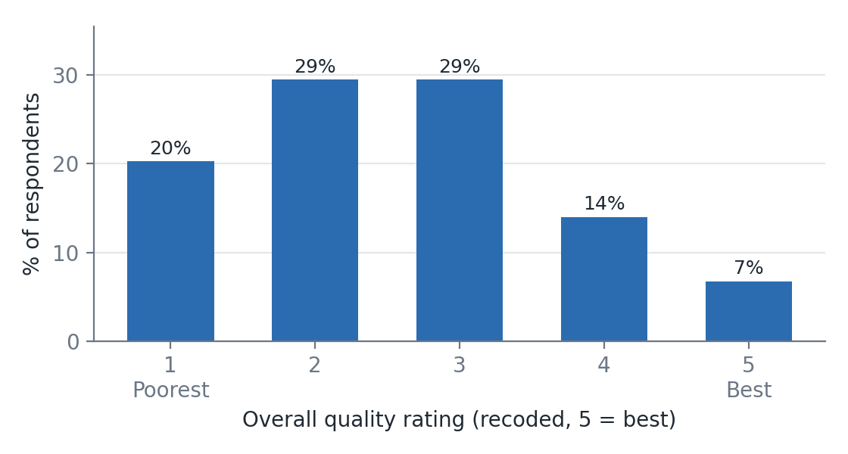
Figure 1. Distribution of the overall quality rating (n = 207)

2. Model Formulation and Justification of Variables

2.1 The modelling task and why an ordered model
The dependent variable, Quality, takes five ordered values, 1 (poorest) to 5 (best). Treating it as continuous assumes equal spacing between categories, and an unordered model such as multinomial logit discards the ranking and needs many more parameters. The ordered probability model respects the ranking with a single set of coefficients and a small number of thresholds, which suits a sample of about 200 respondents.

2.2 Model formulation
Each respondent i has an unobserved (latent) perception of quality, y, that depends linearly on the explanatory variables x*:
y*ᵢ = x′ᵢβ + εᵢ
The observed rating is the category in which the latent perception falls relative to four estimated thresholds, μ₁ < μ₂ < μ₃ < μ₄:
yᵢ = k if μₖ₋₁ < y*ᵢ ≤ μₖ , k = 1,…,5, μ₀ = −∞, μ₅ = +∞
With error distribution function F, the probability of each rating is:
P(yᵢ = k) = F(μₖ − x′ᵢβ) − F(μₖ₋₁ − x′ᵢβ)
The ordered logit takes F to be the logistic distribution, F(z) = 1/(1 + e⁻ᶻ); the ordered probit takes the standard normal, Φ(z). The parameters (β and the thresholds) are estimated by maximum likelihood:
ln L = Σᵢ Σₖ 1[yᵢ = k] · ln[ F(μₖ − x′ᵢβ) − F(μₖ₋₁ − x′ᵢβ) ]
No intercept is included because the thresholds absorb it, and the error variance is fixed (π²/3 for logit, 1 for probit) for identification. A positive β_j shifts respondents towards better ratings. In the logit, exp(β_j) is the proportional odds ratio: the multiplicative change in the odds of a rating above any given category when x_j rises by one unit. Logit and probit coefficients differ in scale (logit ≈ 1.6–1.8 × probit) but should agree in sign and significance.

2.3 Explanatory variables and their justification
Twenty-three candidate variables were built from the survey, grouped in six blocks. They were chosen on behavioural grounds, not from a statistical search, so that every variable has a stated rationale. Where theory gives no clear direction the expected sign is shown as “±”. Descriptive statistics are in Appendix A.
Table 3. Candidate explanatory variables, expected sign and rationale
Block | Variables | Exp. sign | Rationale
Cyclist | Male | ± | Safety concerns and route preferences differ by gender; direction on overall rating unclear.
 | Age (per 10 years) | ± | Older riders may ride less intensively and be less critical, or be more safety-sensitive.
Household | Bikes owned; adults (15+); children present | ± | Larger, family households have different trip needs and exposure to risk.
Cycling use | Household cyclists biking for work / for school / for errands & friends / recreationally | ± | Frequent, purposeful riders depend on the network and hold higher standards; the count of users measures exposure.
Access and facilities | Car available all the time | − | Rely less on cycling, so may perceive the system as less adequate for daily needs (or hold lower expectations).
 | Bike parking at work | + | Secure end-of-trip facilities directly improve the cycling experience.
 | Minutes to nearest major path; to nearest bike lane | − | Poorer access to infrastructure should lower the perceived quality of the system.
Housing and tenure | Years in neighbourhood; home owner; detached home | ± | Long-term residents know the network better; tenure and dwelling type proxy for location and lifestyle.
Socio-economic | University graduate; income band; student; retired | ± | Education and income shape expectations of public services; students and retirees have distinct travel patterns.
Neighbourhood | Bike-network density (km/km²); population density; bike km per 1,000 residents | + / ± | A denser, more extensive network should be perceived as higher quality; population density controls for urban form.

Three modelling choices are worth noting. Categorical survey fields were converted to dummies for the most interpretable contrast (for example, “university graduate” combines the two highest education codes). The three neighbourhood measures are constant within each of the 99 neighbourhoods, so they are estimated from between-neighbourhood variation only. Finally, the ratings of on-street lanes, off-street paths and parking were deliberately excluded: they are answered in the same question block as the overall rating and are strongly correlated with it (r ≈ 0.63 with the on-street item), so including them would absorb the effects of interest and create endogeneity.
Multicollinearity is not a concern: the largest variance inflation factor is 3.26 (Bike km per '000 residents), well below the usual threshold of 5–10.

3. Selection of the Best Model Specification

3.1 Candidate specifications and criteria
Four specifications were estimated on the same sample: the full 23-variable model and a refined model, each with a logit and a probit link. The refined model was obtained by backward elimination: the least significant variable is removed one at a time until every remaining variable has p ≤ 0.10. The criteria were:
- Likelihood-based fit: log-likelihood, AIC and BIC (lower is better; BIC penalises extra parameters most), and McFadden’s pseudo-R² relative to a thresholds-only model.
- Likelihood-ratio (LR) tests: of the refined against the full model, and of each model against the null.
- Behavioural plausibility and parsimony: signs consistent with the rationale in Table 3, and a specification the sample can support.
- Validity and robustness: the proportional-odds (Brant) test, neighbourhood-clustered standard errors and sensitivity to data-cleaning choices.

3.2 Comparison of candidate models
Table 4. Model comparison (N = 207; thresholds-only log-likelihood = −310.8)
Model | Slope parameters | Log-lik. | AIC | BIC | McFadden R² | Adj. R²
Full logit | 23 | −294.8 | 643.5 | 733.5 | 0.052 | −0.022
Full probit | 23 | −296.0 | 645.9 | 735.9 | 0.048 | −0.026
Refined logit | 4 | −300.7 | 617.4 | 644.0 | 0.032 | 0.020
Refined probit | 4 | −301.2 | 618.4 | 645.1 | 0.031 | 0.018
The selected model is shaded. Adjusted R² subtracts the number of slope parameters from the log-likelihood.
Logit versus probit. The two links are nearly indistinguishable: the AIC difference is 2.4 for the full models and 1.0 for the refined models, both in favour of logit, and the same four variables are significant at 5% under both links. Logit coefficients are about 1.7 times the probit ones, as theory predicts. Since the fit is equivalent, the logit is preferred because its coefficients translate into odds ratios.
Full versus refined. The refined model drops 19 variables without a significant loss of fit: the LR statistic is χ²(19) = 11.88 (p = 0.890). The full model has a slightly higher log-likelihood, as any larger model must, but a worse AIC (643.5 vs 617.4) and BIC (733.5 vs 644.0). Its adjusted McFadden R² is negative (−0.022), which is a sign of over-fitting with about 200 observations, while that of the refined model is 0.020. The refined model is also significantly better than the null: χ²(4) = 20.1, p < 0.001.

3.3 Selected specification
The selected model is the refined ordered logit with the four explanatory variables below. Section 3.4 reports its estimates, and section 3.5 shows that it is robust and satisfies the proportional-odds assumption.

3.4 Final model estimates
Table 5. Final model: refined ordered logit
Variable | Coef. (β) | Std. err. | z | p-value | Odds ratio (95% CI) | p, clustered
Household cyclists biking for work | −0.477 | 0.172 | −2.77 | 0.006 *** | 0.62 (0.44, 0.87) | <0.001
Bike parking at work (1 = yes) | +0.531 | 0.258 | 2.06 | 0.039 ** | 1.70 (1.03, 2.82) | 0.051
University graduate (1 = yes) | −0.649 | 0.256 | −2.53 | 0.011 ** | 0.52 (0.32, 0.86) | 0.017
Minutes to nearest bike lane | −0.022 | 0.009 | −2.44 | 0.015 ** | 0.98 (0.96, 1.00) | 0.002
* p<0.01, p<0.05, * p<0.10. The last column re-computes p-values with standard errors clustered by neighbourhood (99 clusters).
Table 6. Estimated thresholds (latent scale)
Threshold | μ₁ (1|2) | μ₂ (2|3) | μ₃ (3|4) | μ₄ (4|5)
Estimate | −2.08 | −0.61 | 0.83 | 2.14
Std. error | 0.31 | 0.27 | 0.28 | 0.36

Interpretation of the coefficients. All four estimates have the expected or plausible sign. Each additional household cyclist who bikes to work multiplies the odds of a better overall rating by 0.62 (a 38% reduction). Having bike parking at work raises those odds by a factor of 1.70. University graduates have odds 48% lower than other respondents, and each additional minute from the nearest bike lane lowers the odds by 2.1%. The work-commuter and university effects are best read as evidence of higher expectations among the most dependent and most educated users, not as evidence that facilities are objectively worse for them.

3.5 Goodness of fit, diagnostics and robustness
- Fit. McFadden R² = 0.032; the model assigns the modal category correctly for 34% of respondents, against 29% for always guessing the most common rating, and 84% of predictions fall within one category of the reported rating. Explanatory power is therefore modest, which is typical of perception data where individual attitudes dominate.
- Proportional odds (Brant test). The omnibus test does not reject a single set of slopes across the four category splits (χ²(12) = 12.1, p = 0.437). Individually, no variable violates the assumption at 5%; university graduate is borderline (p = 0.054), and the top split rests on only 14 respondents.
- Clustered standard errors. Respondents in the same neighbourhood share the same network. With neighbourhood-clustered errors, three variables stay significant at 5%; bike parking at work moves to p = 0.051 (borderline).
- Sensitivity. The sign of every retained coefficient is unchanged across the alternatives in Table 7. Bike parking at work is the least secure result: it is insignificant if duplicate records are retained and only weakly significant when the two rating-6 respondents are dropped.
Table 7. Robustness of the four retained coefficients (ordered logit unless stated)
Variant | N | Work trips | Parking at work | Univ. graduate | Min. to bike lane
Baseline (logit) | 207 | −0.48*** | +0.53** | −0.65** | −0.02**
Probit link | 207 | −0.31*** | +0.32** | −0.35** | −0.01**
Keep duplicate rows | 243 | −0.56*** | +0.33 | −0.46* | −0.02**
Drop rating-6 respondents | 205 | −0.51*** | +0.49* | −0.67*** | −0.02**
Keep errand outlier (full model) | 207 | −0.58*** | +0.57** | −0.68** | −0.02**
Full 23-variable model | 207 | −0.56*** | +0.57** | −0.63** | −0.02**
* p<0.01, p<0.05, * p<0.10. The “errand outlier” and “full model” rows re-estimate the 23-variable model; probit coefficients are on a smaller scale.

4. Elasticities of the Independent Variables

4.1 Why elasticities, and how they are computed
In an ordered model the coefficient β_j has no direct effect on any single category probability: raising x_j moves probability mass between categories, increasing the extreme ones and shifting the middle ones in a way that depends on where the respondent starts. Elasticities give the change in each category’s probability in proportional terms, which is unit-free and comparable across variables. They are computed for the selected model as follows.
- Continuous and count variables (household work cyclists; minutes to the nearest bike lane): the aggregate point elasticity of the probability of rating k, evaluated at the sample mean of x_j:
E(k, x_j) = [ ∂P̄ₖ / ∂x_j ] · ( x̄_j / P̄ₖ ), ∂Pₖ/∂x_j = β_j [ f(μₖ₋₁ − x′β) − f(μₖ − x′β) ]
where P̄ₖ is the sample-average predicted probability and f the logistic density. It is interpreted as the % change in P(rating = k) for a 1% change in x_j.
- Dummy variables (parking at work; university graduate): a point elasticity is undefined, so the arc (pseudo-) elasticity is used, the % change in P(rating = k) when the dummy switches from 0 to 1 for everyone in the sample.
- An elasticity of the expected rating, E[rating] = Σ k·P(k), summarises the overall shift on the 1–5 scale.
Ninety-five percent confidence intervals come from 4,000 draws from the estimated joint distribution of the coefficients and thresholds (Krinsky and Robb, 1986). Elasticities are proportional to the base probability, so they look larger for rarely chosen categories (for example the best rating, with an average probability of 6.7%) even when the absolute change in probability is small; marginal effects in section 4.4 give the absolute view.

4.2 Results
Table 8. Elasticities of category probabilities and of the expected rating (95% confidence interval below)
Variable | P(1) Poorest | P(2) | P(3) | P(4) | P(5) Best | E[rating]
Household cyclists biking for work (mean 0.6) | +0.22  (+0.07, +0.36) | +0.08  (+0.02, +0.14) | −0.08  (−0.14, −0.02) | −0.20  (−0.33, −0.06) | −0.27  (−0.45, −0.08) | −0.07  (−0.11, −0.02)
Bike parking at work † | −33%  (−54%, −3%) | −13%  (−25%, −1%) | +15%  (1%, 35%) | +45%  (2%, 105%) | +63%  (3%, 158%) | +13%  (1%, 27%)
University graduate † | +65%  (12%, 142%) | +21%  (4%, 45%) | −15%  (−27%, −4%) | −36%  (−55%, −10%) | −45%  (−65%, −13%) | −14%  (−23%, −3%)
Minutes to nearest bike lane (mean 10.7) | +0.17  (+0.03, +0.30) | +0.06  (+0.01, +0.12) | −0.06  (−0.11, −0.01) | −0.16  (−0.28, −0.03) | −0.21  (−0.37, −0.04) | −0.05  (−0.10, −0.01)
† Dummy variables: % change in probability when the variable moves from 0 to 1 (arc elasticity). All other rows: point elasticity at the sample mean. Base probabilities: P(1) = 20.2%, P(2) = 29.9%, P(3) = 29.6%, P(4) = 13.7%, P(5) = 6.7%; mean expected rating = 2.57.
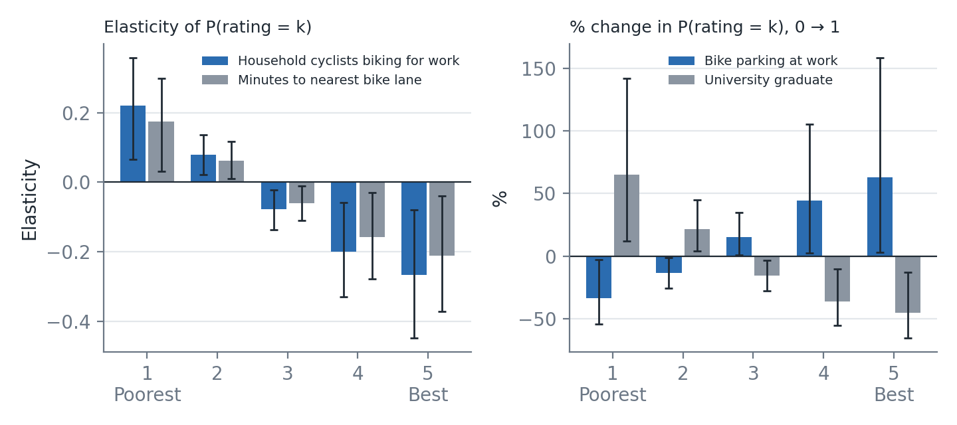
Figure 2. Elasticities by rating category with 95% confidence intervals: continuous variables (left) and dummy variables (right)

4.3 Interpretation
Direction of the effects. For every variable the elasticities have the same pattern: a factor that lowers perceived quality raises the probability of the two poorest ratings (1–2) and lowers the probability of ratings 3 to 5. The largest proportional changes occur at the two ends of the scale, where the base probabilities are smallest, and the middle category changes least. A factor that raises quality does the reverse.
Household cyclists biking for work (mean 0.61). The elasticity of the poorest rating is +0.22 (95% CI +0.07 to +0.36) and that of the best rating is −0.27 (−0.45 to −0.08). A 10% increase in the number of work cyclists raises the probability of the poorest rating by about 2.2% and lowers that of the best rating by about 2.7%. All intervals exclude zero. In absolute terms, one more work cyclist raises the probability of the poorest rating by 8.2 percentage points (pp) and lowers that of the best by 2.4 pp.
Minutes to the nearest bike lane (mean 10.7 minutes). Elasticities are +0.17 for the poorest rating and −0.21 for the best rating. A 10% longer trip to the nearest lane (about one minute at the mean) therefore raises the probability of the poorest rating by 1.7% and lowers that of the best rating by 2.1%. A further 10 minutes raises the probability of the poorest rating by 3.5 pp (Figure 3, left). Access is the one variable that policy can change directly.
Bike parking at work (dummy). Employer-provided parking is associated with a 33% lower probability of the poorest rating and a 63% higher probability of the best rating (95% CI 3% to 158%). The large relative change in the top category reflects its small base (6.7%): in absolute terms the best-rating probability rises by 4.1 pp. The interval is wide and the effect is the least robust in the study.
University graduate (dummy). Graduates have a 65% higher probability of the poorest rating and a 45% lower probability of the best rating; the poorest-rating probability is 11.6 pp higher.
Overall shift. The elasticities of the expected rating are small (−0.07 for work cyclists, −0.05 for distance to the nearest lane, +13% for parking and −14% for education). The variables move respondents between categories, especially at the extremes, but the average score changes little. This is consistent with the low R² and with the finding that most personal and neighbourhood characteristics have no independent effect.
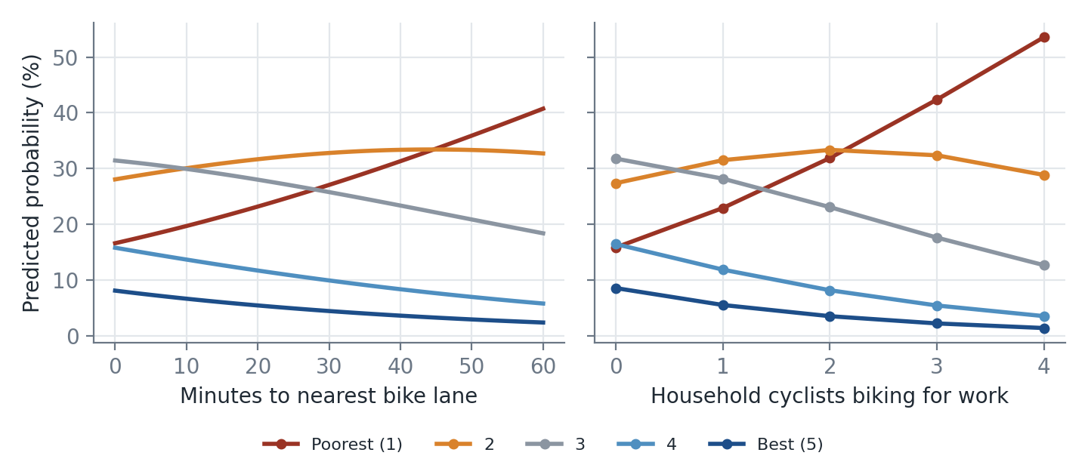
Figure 3. Predicted probability of each rating as the two non-binary variables change (other variables at their sample values)

4.4 Absolute change in probabilities (marginal effects)
Table 9. Average change in the probability of each rating, in percentage points (95% interval below)
Variable (change) | P(1) Poorest | P(2) | P(3) | P(4) | P(5) Best
Household cyclists biking for work (+1) | +8.2  (+2.2, +14.6) | +2.8  (+0.7, +4.5) | −4.5  (−8.0, −1.1) | −4.0  (−6.7, −1.2) | −2.4  (−4.5, −0.7)
Bike parking at work (0 → 1) | −7.0  (−12.1, −0.3) | −5.2  (−10.2, −0.2) | +2.8  (0.0, +4.6) | +5.3  (+0.2, +10.3) | +4.1  (+0.1, +10.4)
University graduate (0 → 1) | +11.6  (+2.4, +21.9) | +3.1  (+0.2, +4.9) | −6.4  (−11.6, −1.3) | −5.3  (−8.7, −1.3) | −3.1  (−5.6, −0.8)
Minutes to nearest bike lane (+10 min) | +3.5  (+0.6, +6.6) | +1.5  (+0.3, +2.8) | −1.9  (−3.6, −0.3) | −1.9  (−3.6, −0.3) | −1.2  (−2.5, −0.2)
Household work cyclists: +1 person. Minutes to nearest lane: +10 minutes. Intervals from 5,000 coefficient draws.

4.5 Policy implications
- Targets for improvement. Households that commute by bike are more critical of the system; the routes and connections they use daily are the most likely places to gain from investment.
- Access to the network matters. Longer distance to the nearest bike lane is associated with a worse overall rating; extending the network to under-served areas should raise perceived quality.
- Workplace parking. Bike parking at work is associated with better ratings, so employer or city programmes for end-of-trip facilities look worthwhile, subject to the caveat on robustness.
- Managing expectations. University graduates rate the system lower; satisfaction targets should account for the composition of the user base.

5. Conclusions and Limitations
Ordered logit and probit models of overall cycling quality gave the same answers, and the refined ordered logit was chosen as the best specification on parsimony, fit criteria, the LR test, the Brant test and robustness checks. Four variables explain perceived quality: bike parking at work (positive), and household work cycling, university education and distance to the nearest bike lane (all negative). The elasticities show that these variables shift probability mainly between the poorest and best categories, and that the size of the shift is proportionally largest for the rarely chosen top category.
The evidence has limits that should be stated alongside the findings:
- Modest explanatory power (McFadden R² = 0.032); most variation in ratings is due to factors not measured.
- Association, not causation. The data are a cross-section; work cyclists may simply be more exposed to, and more critical of, the network.
- Selection effects. Variables were chosen by backward elimination, so p-values are somewhat optimistic; robustness checks and clustered errors partly address this.
- Small sample and sparse categories. Only 207 respondents from 99 neighbourhoods (median two per neighbourhood), and 14 in the top category.
- Assumptions to verify. The rating direction (1 = Excellent), the merging of code 6, the interpretation of the “biking for work” count and the codes for workplace parking come from headers and comments, not full documentation.
Extending the model to a random-effects or multilevel ordered specification for neighbourhoods, and adding the facility-specific ratings as a second-stage analysis, would be natural next steps.

References
Greene, W. H. (2018). Econometric Analysis (8th ed.). Pearson.
Brant, R. (1990). Assessing proportionality in the proportional odds model for ordinal logistic regression. Biometrics, 46(4), 1171–1178.
Krinsky, I., & Robb, A. L. (1986). On approximating the statistical properties of elasticities. Review of Economics and Statistics, 68(4), 715–719.
McCullagh, P. (1980). Regression models for ordinal data. Journal of the Royal Statistical Society: Series B, 42(2), 109–142.
McFadden, D. (1974). Conditional logit analysis of qualitative choice behavior. In P. Zarembka (Ed.), Frontiers in Econometrics (pp. 105–142). Academic Press.

Appendix A. Descriptive statistics of candidate variables
Table A1. Analysis sample (N = 207)
Variable | Mean | Std. dev. | Min | Max
Male (1 = male) | 0.51 | 0.50 | 0.00 | 1.00
Age (per 10 years) | 4.44 | 1.47 | 2.00 | 8.40
Number of bikes owned | 2.41 | 1.22 | 1.00 | 5.00
Adults (15+) in household | 2.59 | 1.11 | 1.00 | 6.00
Children in household (1 = yes) | 0.66 | 0.47 | 0.00 | 1.00
Household cyclists biking for work | 0.61 | 0.74 | 0.00 | 4.00
Household cyclists biking for school | 0.31 | 0.57 | 0.00 | 3.00
Household cyclists biking for errands/friends | 1.34 | 0.81 | 0.00 | 5.00
Household recreational cyclists | 1.74 | 0.93 | 0.00 | 5.00
Car available all the time (1 = yes) | 0.51 | 0.50 | 0.00 | 1.00
Bike parking at work (1 = yes) | 0.51 | 0.50 | 0.00 | 1.00
Years in neighbourhood (1-5 band) | 3.60 | 1.32 | 1.00 | 5.00
Owns home (1 = yes) | 0.66 | 0.48 | 0.00 | 1.00
Detached/semi-detached home | 0.53 | 0.50 | 0.00 | 1.00
University graduate (1 = yes) | 0.57 | 0.50 | 0.00 | 1.00
Income band (1-7) | 4.38 | 2.13 | 1.00 | 7.00
Student (1 = yes) | 0.10 | 0.30 | 0.00 | 1.00
Retired (1 = yes) | 0.09 | 0.29 | 0.00 | 1.00
Minutes to major bike path | 9.34 | 8.87 | 0.00 | 60.00
Minutes to nearest bike lane | 10.66 | 14.15 | 0.00 | 120.00
Bike-network density (km/km2) | 1.49 | 0.86 | 0.06 | 4.53
Population density ('000/km2) | 6.18 | 4.78 | 1.18 | 40.69
Bike km per '000 residents | 0.33 | 0.26 | 0.01 | 1.24

Appendix B. Full 23-variable models
Table B1. Full ordered logit and ordered probit estimates
Variable | Logit β | Logit p | Probit β | Probit p
Male (1 = male) | +0.062 | 0.819 | +0.008 | 0.961
Age (per 10 years) | −0.016 | 0.895 | −0.005 | 0.947
Number of bikes owned | −0.012 | 0.934 | −0.027 | 0.761
Adults (15+) in household | +0.006 | 0.969 | −0.017 | 0.843
Children in household (1 = yes) | +0.420 | 0.184 | +0.205 | 0.266
Household cyclists biking for work | −0.564*** | 0.004 | −0.344*** | 0.004
Household cyclists biking for school | +0.095 | 0.695 | +0.039 | 0.784
Household cyclists biking for errands/friends | −0.275 | 0.118 | −0.146 | 0.172
Household recreational cyclists | +0.154 | 0.420 | +0.106 | 0.361
Car available all the time (1 = yes) | −0.205 | 0.491 | −0.125 | 0.474
Bike parking at work (1 = yes) | +0.572** | 0.038 | +0.360** | 0.026
Years in neighbourhood (1-5 band) | −0.185 | 0.114 | −0.082 | 0.236
Owns home (1 = yes) | +0.020 | 0.955 | +0.013 | 0.951
Detached/semi-detached home | −0.109 | 0.743 | −0.036 | 0.856
University graduate (1 = yes) | −0.630** | 0.039 | −0.342** | 0.048
Income band (1-7) | −0.020 | 0.804 | −0.010 | 0.834
Student (1 = yes) | −0.727 | 0.118 | −0.428 | 0.132
Retired (1 = yes) | −0.122 | 0.834 | −0.129 | 0.710
Minutes to major bike path | −0.010 | 0.528 | −0.008 | 0.419
Minutes to nearest bike lane | −0.023** | 0.027 | −0.013** | 0.040
Bike-network density (km/km2) | −0.148 | 0.539 | −0.103 | 0.458
Population density ('000/km2) | −0.002 | 0.957 | −0.001 | 0.960
Bike km per '000 residents | +0.555 | 0.507 | +0.325 | 0.522
* p<0.01, p<0.05, * p<0.10. Variables were removed in the following order (p-value at removal): Adults (15+) in household (0.97); Population density ('000/km2) (0.96); Owns home (1 = yes) (0.94); Number of bikes owned (0.95); Age (per 10 years) (0.89); Male (1 = male) (0.83); Income band (1-7) (0.78); Retired (1 = yes) (0.77); Detached/semi-detached home (0.68); Household cyclists biking for school (0.69); Minutes to major bike path (0.50); Bike-network density (km/km2) (0.45); Bike km per '000 residents (0.57); Car available all the time (1 = yes) (0.48); Household recreational cyclists (0.29); Household cyclists biking for errands/friends (0.18); Student (1 = yes) (0.13); Children in household (1 = yes) (0.19); Years in neighbourhood (1-5 band) (0.11).

Appendix C. Brant test of proportional odds
Table C1. Wald tests of equal slopes across the four cumulative splits, and the slope in each split
Variable | χ² (df = 3) | p-value | y > 1 | y > 2 | y > 3 | y > 4
Household cyclists biking for work | 1.76 | 0.624 | −0.45 | −0.63 | −0.45 | −0.92
Bike parking at work (1 = yes) | 0.78 | 0.855 | +0.58 | +0.59 | +0.64 | +0.22
University graduate (1 = yes) | 7.63 | 0.054 | −0.91 | −0.98 | −0.24 | +0.60
Minutes to nearest bike lane | 1.45 | 0.694 | −0.02 | −0.03 | −0.03 | −0.01
Omnibus (df = 12) | 12.10 | 0.437

