CYCLING PERCEPTION STUDY · STATISTICAL MODELLING REPORT
Modelling Cyclists’ Perceptions of Overall Cycling Quality with an Ordered Logit Model
Evidence from a survey of Toronto bicycle owners: model formulation, specification selection and elasticities
22 September 2026
Executive summary
This report investigates how cyclists rate the overall quality of cycling routes and facilities in Toronto. Because the rating is an ordered five-category response, an ordered logit model was estimated on 207 unique survey respondents. The refined specification, obtained by backward elimination from 22 candidate variables, was selected: it retains 4 variables, fits as well as the full model (likelihood-ratio test p = 0.888), and improves on the full model's AIC (620.9 vs 645.8) and BIC (647.6 vs 732.4).
Perceived quality is higher for cyclists whose workplace offers bike parking, and lower for cyclists in households with more work commuters by bike, more household cyclists biking for errands and to see friends, and those living farther from the nearest bike lane. Elasticities show that a 10% increase in distance to the nearest bike lane raises the probability of the poorest rating by about 1.6% and lowers the probability of the best rating by about 1.9%. The model's explanatory power is modest (McFadden R² = 0.027), so the results describe associations, not causes.

1. Introduction

1.1 Background and motivation
Cities invest heavily in cycling routes, off-street paths and bike parking, but the success of that investment depends on how riders themselves experience the system. Perceived quality shapes satisfaction, the willingness to keep cycling and support for further investment. Perceptions are collected in surveys as ordered ratings (for example, from "excellent" to "poor"). Such responses have a natural ranking but no meaningful distance between categories, so they should not be analysed with ordinary least squares. Ordered probability models — ordered logit or ordered probit — are the standard tool for this kind of data (McCullagh, 1980; Greene, 2018). This report uses the ordered logit: it fits data of this kind as well as the probit alternative, and its coefficients translate directly into proportional odds ratios, which are easier to communicate than probit index-scale coefficients.
This report uses a survey of bicycle owners in the city of Toronto. Each respondent rated the overall quality of the cycling routes and facilities available to residents and also supplied information on their household, cycling habits, access to facilities, socio-economic profile and neighbourhood.

1.2 Objectives
The study has one modelling task: to explain and predict a cyclist’s rating of the overall quality of cycling in the city. Its specific objectives are to:
- formulate an ordered logit model of the overall quality rating and justify the explanatory variables considered;
- select the best model specification from the alternatives, using statistical criteria and diagnostic tests;
- interpret the selected model, in particular through the elasticities of the category probabilities with respect to each explanatory variable; and
- draw out the practical implications for cycling policy and state the limitations of the evidence.

1.3 Parts of the work
The work is organised in four connected parts, summarised in Table 1.
Table 1. Parts of the work
Part | What was done | Section
Data and preparation | Audited the survey file; removed duplicate records; treated an outlier and a sparsely populated rating category; recoded categorical variables into interpretable dummies. | 1.4
Model formulation | Specified the ordered logit framework and a set of 22 candidate explanatory variables with reasoned expectations. | 2
Specification selection | Estimated the full and a backward-eliminated refined model; compared them on likelihood-based criteria, tested proportional odds and checked robustness. | 3
Interpretation | Computed odds ratios, marginal effects and elasticities of the category probabilities with simulated confidence intervals. | 4

1.4 Data
The data come from the sheet "Final" of CyclingPerceptionData.xlsx: 243 records and 31 variables with no missing values. All respondents own at least one bicycle. Table 2 lists the data issues found and how each was handled. Category definitions for the coded socio-economic variables were taken from comments embedded in the workbook's header row; the "Variables" sheet documents only a few fields.
Table 2. Data audit and treatment
Issue found | Treatment | Reason
36 exact duplicate rows (one respondent ID appears 20 times) | Removed, leaving 207 unique respondents | Duplicates overweight individuals and overstate precision
One record reports 101 household trips for errands/friends (next largest is 5) | Capped at 5 | Almost certainly a keying error; would dominate the coefficient
Rating category 6 has only 2 respondents | Merged into the worst category | A category this small cannot support its own threshold
Ownership variable is constant (all = 1) | Excluded | No variation, no information
Rating scale direction not documented | Assumed 1 = Excellent … 5 = Poor; recoded so that 5 = best | Makes coefficients read as "higher = better quality"

After cleaning, the dependent variable is concentrated in the middle of the scale: 20% of respondents give the poorest rating (1), 29% rate 2, 29% rate 3, 14% rate 4 and 7% give the best rating (5) (Figure 1). Only 14 respondents fall in the best category, which limits precision at the upper end of the scale.
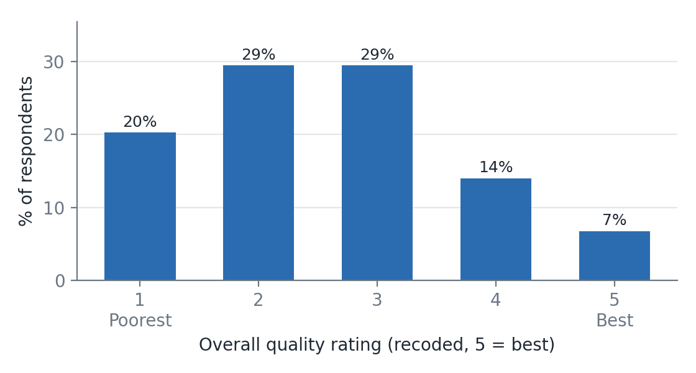
Figure 1. Distribution of the overall quality rating (n = 207)

2. Model Formulation and Justification of Variables

2.1 The modelling task and why an ordered model
The dependent variable, Quality, takes five ordered values, 1 (poorest) to 5 (best). Treating it as continuous assumes equal spacing between categories, and an unordered model such as multinomial logit discards the ranking and needs many more parameters. The ordered logit respects the ranking with a single set of coefficients and a small number of thresholds, which suits a sample of about 200 respondents.

2.2 Model formulation
Each respondent i has an unobserved (latent) perception of quality, y, that depends linearly on the explanatory variables x*:
y*ᵢ = x′ᵢβ + εᵢ , εᵢ ~ Logistic(0, π²/3)
The observed rating is the category in which the latent perception falls relative to four estimated thresholds, μ₁ < μ₂ < μ₃ < μ₄:
yᵢ = k if μₖ₋₁ < y*ᵢ ≤ μₖ , k = 1,…,5, μ₀ = −∞, μ₅ = +∞
With Λ the standard logistic cumulative distribution function, Λ(z) = 1/(1 + e⁻ᶻ), the probability of each rating is:
P(yᵢ = k) = Λ(μₖ − x′ᵢβ) − Λ(μₖ₋₁ − x′ᵢβ)
The parameters (β and the thresholds) are estimated by maximum likelihood:
ln L = Σᵢ Σₖ 1[yᵢ = k] · ln[ Λ(μₖ − x′ᵢβ) − Λ(μₖ₋₁ − x′ᵢβ) ]
No intercept is included because the thresholds absorb it, and the error variance is fixed (π²/3) for identification. A positive β_j shifts respondents towards better ratings. Because Λ is logistic, exp(β_j) is the proportional odds ratio: the multiplicative change in the odds of a rating above any given category when x_j rises by one unit. This proportional-odds property — the same β for every cut-point — is an assumption of the model, and is tested directly in §3.5.

2.3 Explanatory variables and their justification
Twenty-two candidate variables were built from the survey, grouped in six blocks. They were chosen on behavioural grounds, not from a statistical search, so that every variable has a stated rationale. Where theory gives no clear direction the expected sign is shown as "±". Descriptive statistics are in Appendix A.
Table 3. Candidate explanatory variables, expected sign and rationale
Block | Variables | Exp. sign | Rationale
Cyclist | Male | ± | Safety concerns and route preferences differ by gender; direction on overall rating unclear.
 | Age (per 10 years) | ± | Older riders may ride less intensively and be less critical, or be more safety-sensitive.
Household | Bikes owned; adults (15+); children present | ± | Larger, family households have different trip needs and exposure to risk.
Cycling use | Household cyclists biking for work / for school / for errands & friends / recreationally | ± | Frequent, purposeful riders depend on the network and hold higher standards; the count of users measures exposure.
Access and facilities | Car available all the time | − | Rely less on cycling, so may perceive the system as less adequate for daily needs (or hold lower expectations).
 | Bike parking at work | + | Secure end-of-trip facilities directly improve the cycling experience.
 | Minutes to nearest major path; to nearest bike lane | − | Poorer access to infrastructure should lower the perceived quality of the system.
Housing and tenure | Years in neighbourhood; home owner; detached home | ± | Long-term residents know the network better; tenure and dwelling type proxy for location and lifestyle.
Socio-economic | Income band; student; retired | ± | Income shapes expectations of public services; students and retirees have distinct travel patterns.
Neighbourhood | Bike-network density (km/km²); population density; bike km per 1,000 residents | + / ± | A denser, more extensive network should be perceived as higher quality; population density controls for urban form.

Three modelling choices are worth noting. Categorical survey fields were converted to dummies for the most interpretable contrast. The three neighbourhood measures are constant within each of the 99 neighbourhoods, so they are estimated from between-neighbourhood variation only. Finally, the ratings of on-street lanes, off-street paths and parking were deliberately excluded: they are answered in the same question block as the overall rating and are strongly correlated with it (r ≈ 0.63 with the on-street item), so including them would absorb the effects of interest and create endogeneity. An education dummy (university graduate) considered at an earlier stage of the analysis was also excluded from the candidate set, so it plays no part in the results below.
Multicollinearity is not a concern: the largest variance inflation factor is 3.25 (Bike km per '000 residents), well below the usual threshold of 5–10.

3. Selection of the Best Model Specification

3.1 Candidate specifications and criteria
Two nested specifications were estimated on the same sample and the same ordered-logit link: the full 22-variable model and a refined model obtained by backward elimination, removing the least significant variable one at a time until every remaining variable has p ≤ 0.10. The criteria for preferring one over the other were:
- Likelihood-based fit: log-likelihood, AIC and BIC (lower is better; BIC penalises extra parameters most), and McFadden’s pseudo-R² relative to a thresholds-only model.
- Likelihood-ratio (LR) test: of the refined against the full model, and of each model against the null.
- Behavioural plausibility and parsimony: signs consistent with the rationale in Table 3, and a specification the sample can support.
- Validity and robustness: the proportional-odds (Brant) test, neighbourhood-clustered standard errors and sensitivity to data-cleaning choices.

3.2 Comparison of candidate models
Table 4. Model comparison (N = 207; thresholds-only log-likelihood = −310.8)
Model | Slope parameters | Log-lik. | AIC | BIC | McFadden R² | Adj. R²
Full logit | 22 | −296.9 | 645.8 | 732.4 | 0.045 | −0.026
Refined logit | 4 | −302.5 | 620.9 | 647.6 | 0.027 | 0.014
The selected model is shaded. Adjusted R² subtracts the number of slope parameters from the log-likelihood.
Full versus refined. The refined model drops 18 variables without a significant loss of fit: the LR statistic is χ²(18) = 11.15 (p = 0.888). The full model has a slightly higher log-likelihood, as any larger model must, but a worse AIC (645.8 vs 620.9) and BIC (732.4 vs 647.6). Its adjusted McFadden R² is negative (−0.026), a sign of over-fitting with about 200 observations, while that of the refined model is 0.014. The refined model is also significantly better than the null: χ²(4) = 16.6, p = 0.002.

3.3 Selected specification
The selected model is the refined ordered logit with the four explanatory variables below. Section 3.4 reports its estimates, and section 3.5 shows that it is robust and satisfies the proportional-odds assumption.

3.4 Final model estimates
Table 5. Final model: refined ordered logit
Variable | Coef. (β) | Std. err. | z | p-value | Odds ratio (95% CI) | p, clustered
Household cyclists biking for work | −0.410 | 0.176 | −2.33 | 0.020 ** | 0.66 (0.47, 0.94) | 0.005
Household cyclists biking for errands/friends | −0.271 | 0.158 | −1.72 | 0.086 * | 0.76 (0.56, 1.04) | 0.084
Bike parking at work (1 = yes) | +0.518 | 0.259 | 2.00 | 0.045 ** | 1.68 (1.01, 2.79) | 0.056
Minutes to nearest bike lane | −0.020 | 0.009 | −2.20 | 0.027 ** | 0.98 (0.96, 1.00) | 0.006
*** p<0.01, ** p<0.05, * p<0.10. The last column re-computes p-values with standard errors clustered by neighbourhood (99 clusters).
Table 6. Estimated thresholds (latent scale)
Threshold | μ₁ (1|2) | μ₂ (2|3) | μ₃ (3|4) | μ₄ (4|5)
Estimate | −2.01 | −0.57 | 0.85 | 2.17
Std. error | 0.34 | 0.30 | 0.32 | 0.39

Interpretation of the coefficients. Every retained estimate has the expected or a plausible sign. Each additional household cyclist who bikes to work multiplies the odds of a better overall rating by 0.66 (a 34% reduction). Each additional household cyclist biking for errands or to see friends multiplies the odds by 0.76 (a 24% reduction, significant at 10% but not at 5%). Having bike parking at work raises the odds of a better rating by a factor of 1.68, and each additional minute from the nearest bike lane lowers the odds by 1.9%. The work- and errand-trip effects are best read as evidence of higher expectations, or more exposure to the network's weak points, among the most frequent users — not as evidence that facilities are objectively worse for them.

3.5 Goodness of fit, diagnostics and robustness
- Fit. McFadden R² = 0.027; the model assigns the modal category correctly for 29% of respondents, against 29% for always guessing the most common rating, and 80% of predictions fall within one category of the reported rating. Explanatory power is therefore modest, which is typical of perception data where individual attitudes dominate.
- Proportional odds (Brant test). The omnibus test does not reject a single set of slopes across the four category splits (χ²(12) = 8.2, p = 0.767). No individual variable violates the assumption at 5% (Appendix C); the top split rests on only 14 respondents, so it is estimated imprecisely.
- Clustered standard errors. Respondents in the same neighbourhood share the same network. With neighbourhood-clustered errors, the variables that lose significance at 5% are: bike parking at work.
- Sensitivity. The sign of every retained coefficient is unchanged across the alternatives in Table 7.
Table 7. Robustness of the four retained coefficients
Variant | N | Household cyclists biking for work | Household cyclists biking for errands/friends | Bike parking at work | Minutes to nearest bike lane
Baseline | 207 | −0.41** | −0.27* | +0.52** | −0.02**
Keep duplicate rows | 243 | −0.52*** | −0.08 | +0.36 | −0.02*
Drop rating-6 respondents | 205 | −0.44** | −0.29* | +0.47* | −0.02**
Keep errand outlier (101) | 207 | −0.46*** | −0.01 | +0.54** | −0.02**
Full 22-variable model | 207 | −0.54*** | −0.33* | +0.60** | −0.02**
*** p<0.01, ** p<0.05, * p<0.10. The "errand outlier" and "full model" rows re-estimate under the stated data change; "full model" re-estimates the 22-variable specification.

4. Elasticities of the Independent Variables

4.1 Why elasticities, and how they are computed
In an ordered model the coefficient β_j has no direct effect on any single category probability: raising x_j moves probability mass between categories, increasing the extreme ones and shifting the middle ones in a way that depends on where the respondent starts. Elasticities give the change in each category’s probability in proportional terms, which is unit-free and comparable across variables. They are computed for the selected model as follows.
- Continuous and count variables (household work cyclists; household errand/friend cyclists; minutes to the nearest bike lane): the aggregate point elasticity of the probability of rating k, evaluated at the sample mean of x_j:
E(k, x_j) = [ ∂P̄ₖ / ∂x_j ] · ( x̄_j / P̄ₖ ), ∂Pₖ/∂x_j = β_j [ λ(μₖ₋₁ − x′β) − λ(μₖ − x′β) ]
where P̄ₖ is the sample-average predicted probability and λ the logistic density. It is interpreted as the % change in P(rating = k) for a 1% change in x_j.
- Dummy variables (parking at work): a point elasticity is undefined, so the arc (pseudo-) elasticity is used, the % change in P(rating = k) when the dummy switches from 0 to 1 for everyone in the sample.
- An elasticity of the expected rating, E[rating] = Σ k·P(k), summarises the overall shift on the 1–5 scale.
Ninety-five percent confidence intervals come from 4,000 draws from the estimated joint distribution of the coefficients and thresholds (Krinsky and Robb, 1986). Elasticities are proportional to the base probability, so they look larger for rarely chosen categories (for example the best rating, with an average probability of 6.7%) even when the absolute change in probability is small; marginal effects in section 4.4 give the absolute view.

4.2 Results
Table 8. Elasticities of category probabilities and of the expected rating (95% confidence interval below)
Variable | P(1) Poorest | P(2) | P(3) | P(4) | P(5) Best | E[rating]
Household cyclists biking for work (mean 0.6) | +0.19  (+0.03, +0.33) | +0.07  (+0.01, +0.13) | −0.06  (−0.12, −0.01) | −0.17  (−0.31, −0.03) | −0.23  (−0.42, −0.04) | −0.06  (−0.11, −0.01)
Household cyclists biking for errands/friends (mean 1.3) | +0.27  (−0.04, +0.56) | +0.10  (−0.01, +0.23) | −0.09  (−0.20, +0.01) | −0.25  (−0.53, +0.03) | −0.33  (−0.70, +0.04) | −0.09  (−0.18, +0.01)
Bike parking at work † | −33%  (−54%, −1%) | −14%  (−26%, 0%) | +15%  (0%, 34%) | +44%  (1%, 106%) | +61%  (1%, 157%) | +13%  (0%, 27%)
Minutes to nearest bike lane (mean 10.7) | +0.16  (+0.02, +0.28) | +0.06  (+0.01, +0.12) | −0.05  (−0.11, −0.01) | −0.15  (−0.27, −0.02) | −0.19  (−0.36, −0.03) | −0.05  (−0.09, −0.01)
† Dummy variable: % change in probability when the variable moves from 0 to 1 (arc elasticity). Other rows: point elasticity at the sample mean. Base probabilities: P(1) = 20.1%, P(2) = 29.4%, P(3) = 29.8%, P(4) = 14.0%, P(5) = 6.7%; mean expected rating = 2.58.
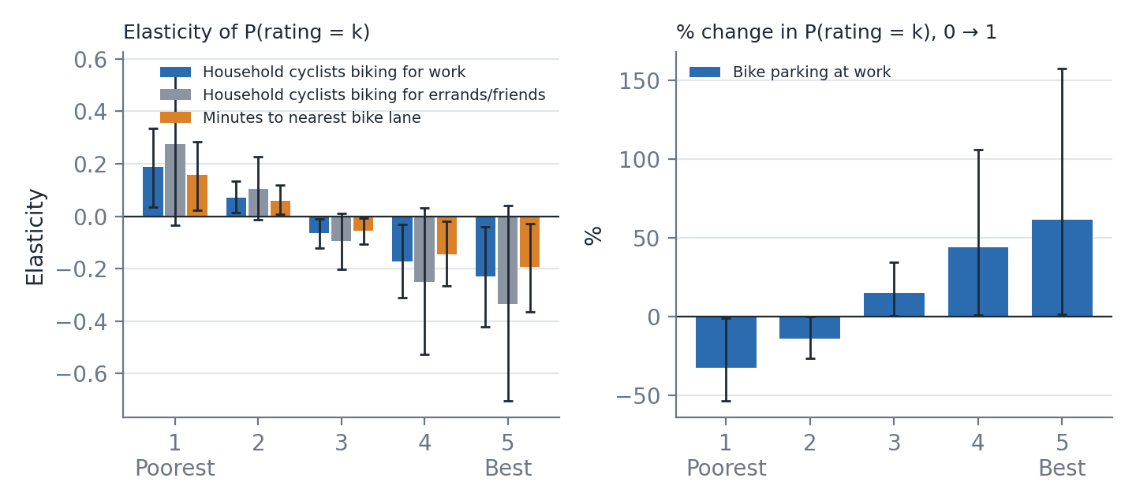
Figure 2. Elasticities by rating category with 95% confidence intervals: continuous variables (left) and the parking dummy (right)

4.3 Interpretation
Direction of the effects. For every variable the elasticities have the same pattern: a factor that lowers perceived quality raises the probability of the two poorest ratings (1–2) and lowers the probability of ratings 3 to 5. The largest proportional changes occur at the two ends of the scale, where the base probabilities are smallest, and the middle category changes least. A factor that raises quality does the reverse.
Household cyclists biking for work (mean 0.61). The elasticity of the poorest rating is +0.19 (95% CI +0.03 to +0.33) and that of the best rating is −0.23 (−0.42 to −0.04). A 10% increase in the number of work cyclists raises the probability of the poorest rating by about 1.9% and lowers that of the best rating by about 2.3%. In absolute terms, one more work cyclist raises the probability of the poorest rating by 6.9 percentage points (pp) and lowers that of the best by 2.1 pp.
Household cyclists biking for errands/friends (mean 1.34). Elasticities are +0.27 for the poorest rating and −0.33 for the best rating; the confidence interval for the best-rating elasticity (−0.70 to +0.04) is wide and close to zero, consistent with this variable's borderline significance (p = 0.086) in Table 5.
Minutes to the nearest bike lane (mean 10.7 minutes). Elasticities are +0.16 for the poorest rating and −0.19 for the best rating. A 10% longer trip to the nearest lane (about one minute at the mean) raises the probability of the poorest rating by 1.6% and lowers that of the best rating by 1.9%. A further 10 minutes raises the probability of the poorest rating by 3.2 pp (Figure 3, left). Access is the one variable in this model that policy can change directly.
Bike parking at work (dummy). Employer-provided parking is associated with a 33% lower probability of the poorest rating and a 61% higher probability of the best rating (95% CI 1% to 157%). The large relative change in the top category reflects its small base (6.7%): in absolute terms the best-rating probability rises by 4.0 pp.
Overall shift. The elasticities of the expected rating are small (−0.06 for work cyclists, −0.09 for errand cyclists, −0.05 for distance to the nearest lane and +13% for parking). The variables move respondents between categories, especially at the extremes, but the average score changes little. This is consistent with the low R² and with the finding that most personal and neighbourhood characteristics have no independent effect.
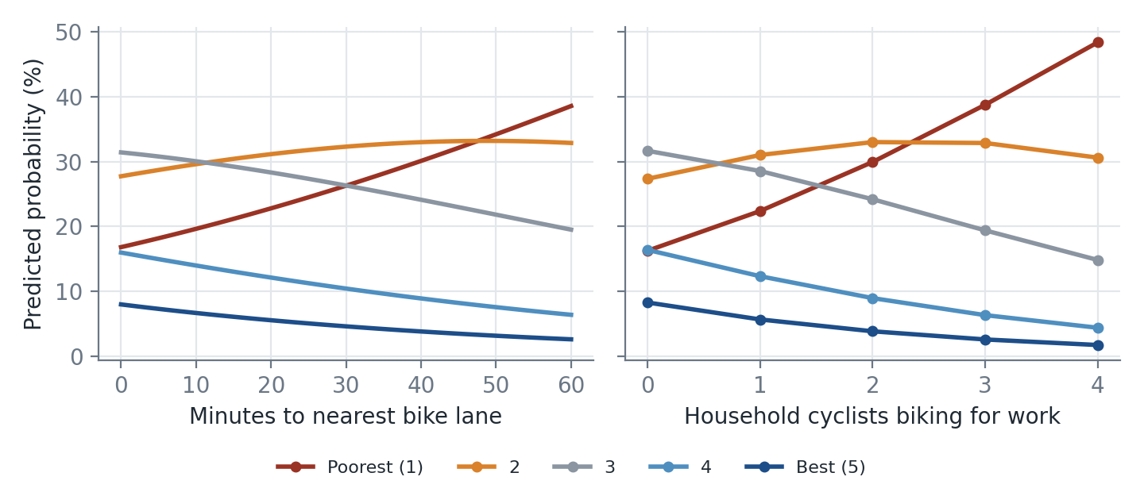
Figure 3. Predicted probability of each rating as two of the retained variables change (other variables at their sample values)

4.4 Absolute change in probabilities (marginal effects)
Table 9. Average change in the probability of each rating, in percentage points (95% interval below)
Variable (change) | P(1) Poorest | P(2) | P(3) | P(4) | P(5) Best
Household cyclists biking for work (+1) | +6.9  (+0.8, +13.4) | +2.7  (+0.4, +4.6) | −3.8  (−7.3, −0.4) | −3.7  (−6.6, −0.5) | −2.1  (−4.1, −0.3)
Household cyclists biking for errands/friends (+1) | +4.4  (−0.5, +10.2) | +2.0  (−0.3, +3.7) | −2.4  (−5.6, +0.3) | −2.5  (−5.2, +0.4) | −1.5  (−3.3, +0.2)
Bike parking at work (0 → 1) | −6.8  (−11.9, −0.1) | −5.2  (−10.4, −0.1) | +2.6  (−0.3, +4.5) | +5.4  (+0.1, +10.6) | +4.0  (+0.1, +10.4)
Minutes to nearest bike lane (+10 min) | +3.2  (+0.3, +6.1) | +1.5  (+0.2, +2.8) | −1.7  (−3.4, −0.1) | −1.8  (−3.5, −0.2) | −1.1  (−2.3, −0.1)
Household work / errand cyclists: +1 person. Minutes to nearest lane: +10 minutes. Intervals from 5,000 coefficient draws.

4.5 Policy implications
- Targets for improvement. Households that commute or run errands by bike are more critical of the system; the routes and connections they use daily are the most likely places to gain from investment.
- Access to the network matters. Longer distance to the nearest bike lane is associated with a worse overall rating; extending the network to under-served areas should raise perceived quality.
- Workplace parking. Bike parking at work is associated with better ratings, so employer or city programmes for end-of-trip facilities look worthwhile.

5. Conclusions and Limitations
An ordered logit model of overall cycling quality was formulated from 22 candidate variables spanning cyclist, household, access, housing, socio-economic and neighbourhood characteristics. Backward elimination and likelihood-based criteria selected a refined four-variable specification, which passes the Brant test for proportional odds and is robust to the data-cleaning choices tested. The model shows that perceived quality is higher where bike parking at work is available, and lower for households with more frequent work and errand cycling and for those living farther from the nearest bike lane. Elasticities show that these variables shift probability mainly between the poorest and best categories, and that the size of the shift is proportionally largest for the rarely chosen top category.
The evidence has limits that should be stated alongside the findings:
- Modest explanatory power (McFadden R² = 0.027); most variation in ratings is due to factors not measured.
- Association, not causation. The data are a cross-section; work and errand cyclists may simply be more exposed to, and more critical of, the network.
- Selection effects. Variables were chosen by backward elimination, so p-values are somewhat optimistic; robustness checks and clustered errors partly address this.
- Small sample and sparse categories. Only 207 respondents from 99 neighbourhoods (median two per neighbourhood), and 14 in the top category.
- Assumptions to verify. The rating direction (1 = Excellent), the merging of code 6, the interpretation of the "biking for work"/"biking for errands" counts and the codes for workplace parking come from headers and comments, not full documentation.
Extending the model to a random-effects or multilevel ordered specification for neighbourhoods, and adding the facility-specific ratings as a second-stage analysis, would be natural next steps.

References
Greene, W. H. (2018). Econometric Analysis (8th ed.). Pearson.
Brant, R. (1990). Assessing proportionality in the proportional odds model for ordinal logistic regression. Biometrics, 46(4), 1171–1178.
Krinsky, I., & Robb, A. L. (1986). On approximating the statistical properties of elasticities. Review of Economics and Statistics, 68(4), 715–719.
McCullagh, P. (1980). Regression models for ordinal data. Journal of the Royal Statistical Society: Series B, 42(2), 109–142.
McFadden, D. (1974). Conditional logit analysis of qualitative choice behavior. In P. Zarembka (Ed.), Frontiers in Econometrics (pp. 105–142). Academic Press.

Appendix A. Descriptive statistics of candidate variables
Table A1. Analysis sample (N = 207)
Variable | Mean | Std. dev. | Min | Max
Male (1 = male) | 0.51 | 0.50 | 0.00 | 1.00
Age (per 10 years) | 4.44 | 1.47 | 2.00 | 8.40
Number of bikes owned | 2.41 | 1.22 | 1.00 | 5.00
Adults (15+) in household | 2.59 | 1.11 | 1.00 | 6.00
Children in household (1 = yes) | 0.66 | 0.47 | 0.00 | 1.00
Household cyclists biking for work | 0.61 | 0.74 | 0.00 | 4.00
Household cyclists biking for school | 0.31 | 0.57 | 0.00 | 3.00
Household cyclists biking for errands/friends | 1.34 | 0.81 | 0.00 | 5.00
Household recreational cyclists | 1.74 | 0.93 | 0.00 | 5.00
Car available all the time (1 = yes) | 0.51 | 0.50 | 0.00 | 1.00
Bike parking at work (1 = yes) | 0.51 | 0.50 | 0.00 | 1.00
Years in neighbourhood (1-5 band) | 3.60 | 1.32 | 1.00 | 5.00
Owns home (1 = yes) | 0.66 | 0.48 | 0.00 | 1.00
Detached/semi-detached home | 0.53 | 0.50 | 0.00 | 1.00
Income band (1-7) | 4.38 | 2.13 | 1.00 | 7.00
Student (1 = yes) | 0.10 | 0.30 | 0.00 | 1.00
Retired (1 = yes) | 0.09 | 0.29 | 0.00 | 1.00
Minutes to major bike path | 9.34 | 8.87 | 0.00 | 60.00
Minutes to nearest bike lane | 10.66 | 14.15 | 0.00 | 120.00
Bike-network density (km/km2) | 1.49 | 0.86 | 0.06 | 4.53
Population density ('000/km2) | 6.18 | 4.78 | 1.18 | 40.69
Bike km per '000 residents | 0.33 | 0.26 | 0.01 | 1.24

Appendix B. Full 22-variable model
Table B1. Full ordered logit estimates
Variable | β | Std. err. | z | p-value
Male (1 = male) | +0.054 | 0.270 | 0.20 | 0.842
Age (per 10 years) | −0.037 | 0.121 | −0.31 | 0.756
Number of bikes owned | +0.032 | 0.145 | 0.22 | 0.825
Adults (15+) in household | +0.029 | 0.145 | 0.20 | 0.840
Children in household (1 = yes) | +0.420 | 0.315 | 1.33 | 0.183
Household cyclists biking for work | −0.542*** | 0.195 | −2.78 | 0.005
Household cyclists biking for school | +0.118 | 0.243 | 0.49 | 0.627
Household cyclists biking for errands/friends | −0.329* | 0.173 | −1.90 | 0.057
Household recreational cyclists | +0.115 | 0.190 | 0.61 | 0.542
Car available all the time (1 = yes) | −0.245 | 0.297 | −0.83 | 0.409
Bike parking at work (1 = yes) | +0.599** | 0.275 | 2.18 | 0.029
Years in neighbourhood (1-5 band) | −0.129 | 0.113 | −1.14 | 0.256
Owns home (1 = yes) | +0.002 | 0.360 | 0.00 | 0.997
Detached/semi-detached home | −0.210 | 0.328 | −0.64 | 0.522
Income band (1-7) | −0.066 | 0.077 | −0.85 | 0.393
Student (1 = yes) | −0.702 | 0.463 | −1.52 | 0.129
Retired (1 = yes) | −0.163 | 0.587 | −0.28 | 0.782
Minutes to major bike path | −0.011 | 0.016 | −0.71 | 0.478
Minutes to nearest bike lane | −0.021** | 0.010 | −2.05 | 0.040
Bike-network density (km/km2) | −0.197 | 0.242 | −0.81 | 0.416
Population density ('000/km2) | +0.001 | 0.034 | 0.03 | 0.972
Bike km per '000 residents | +0.714 | 0.837 | 0.85 | 0.394
*** p<0.01, ** p<0.05, * p<0.10. Variables were removed in the following order (p-value at removal): Owns home (1 = yes) (1.00); Population density ('000/km2) (0.97); Adults (15+) in household (0.84); Male (1 = male) (0.85); Number of bikes owned (0.79); Age (per 10 years) (0.75); Household cyclists biking for school (0.60); Detached/semi-detached home (0.53); Retired (1 = yes) (0.53); Minutes to major bike path (0.43); Car available all the time (1 = yes) (0.37); Household recreational cyclists (0.37); Bike-network density (km/km2) (0.28); Bike km per '000 residents (0.48); Years in neighbourhood (1-5 band) (0.21); Student (1 = yes) (0.24); Income band (1-7) (0.26); Children in household (1 = yes) (0.19).

Appendix C. Brant test of proportional odds
Table C1. Wald tests of equal slopes across the four cumulative splits, and the slope in each split
Variable | χ² (df = 3) | p-value | y > 1 | y > 2 | y > 3 | y > 4
Household cyclists biking for work | 1.73 | 0.630 | −0.32 | −0.51 | −0.44 | −0.95
Household cyclists biking for errands/friends | 3.17 | 0.367 | −0.27 | −0.30 | −0.43 | +0.06
Bike parking at work (1 = yes) | 0.82 | 0.845 | +0.54 | +0.55 | +0.63 | +0.20
Minutes to nearest bike lane | 1.80 | 0.615 | −0.02 | −0.02 | −0.03 | −0.01
Omnibus (df = 12) | 8.23 | 0.767

