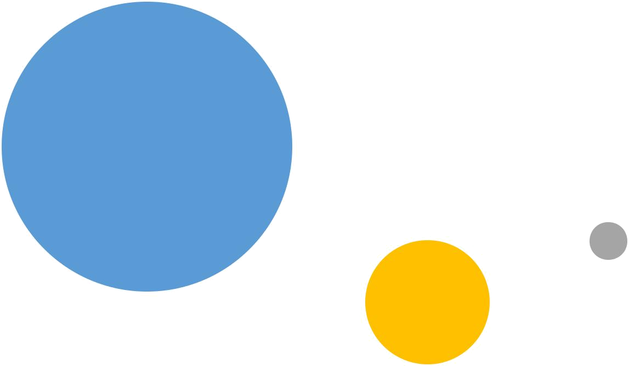

Data Science Capstone

North York, Toronto


Sankhadeep Dutta

- The Brazilian tourism agency plans to organize their first trip to Toronto in Canada, and they plan to start with the city of North York.

To create the best itinerary for your clients, the travel agency is looking for which districts near North York visit, for that, he had commissioned an analysis of characteristics and the most relevant places in these neighborhoods. Mainly, the tourism agency focuses on hotels, restaurants, parks, shops, places, squares, etc.

- Question: So, what are the characteristics of the neighborhoods neighboring North York and what places should the Brazilian tourism agency visit to provide the best tour to its clients?

Introduction / Business Problem

- To solve this problem, I'll first get the data on the neighborhoods of North York (Toronto): Borough, Latitude, Longitude. This data is available on Wikipedia, so with a simple script, I was able to access the data in tabular format. Below is the example of this dataframe.

- The second step, with the help of the API of Foursquare, got the information of the best places of the neighborhood and its neighbors. With a new dataframe with the complete information, you're all set to cluster the entire dataset.

Data description

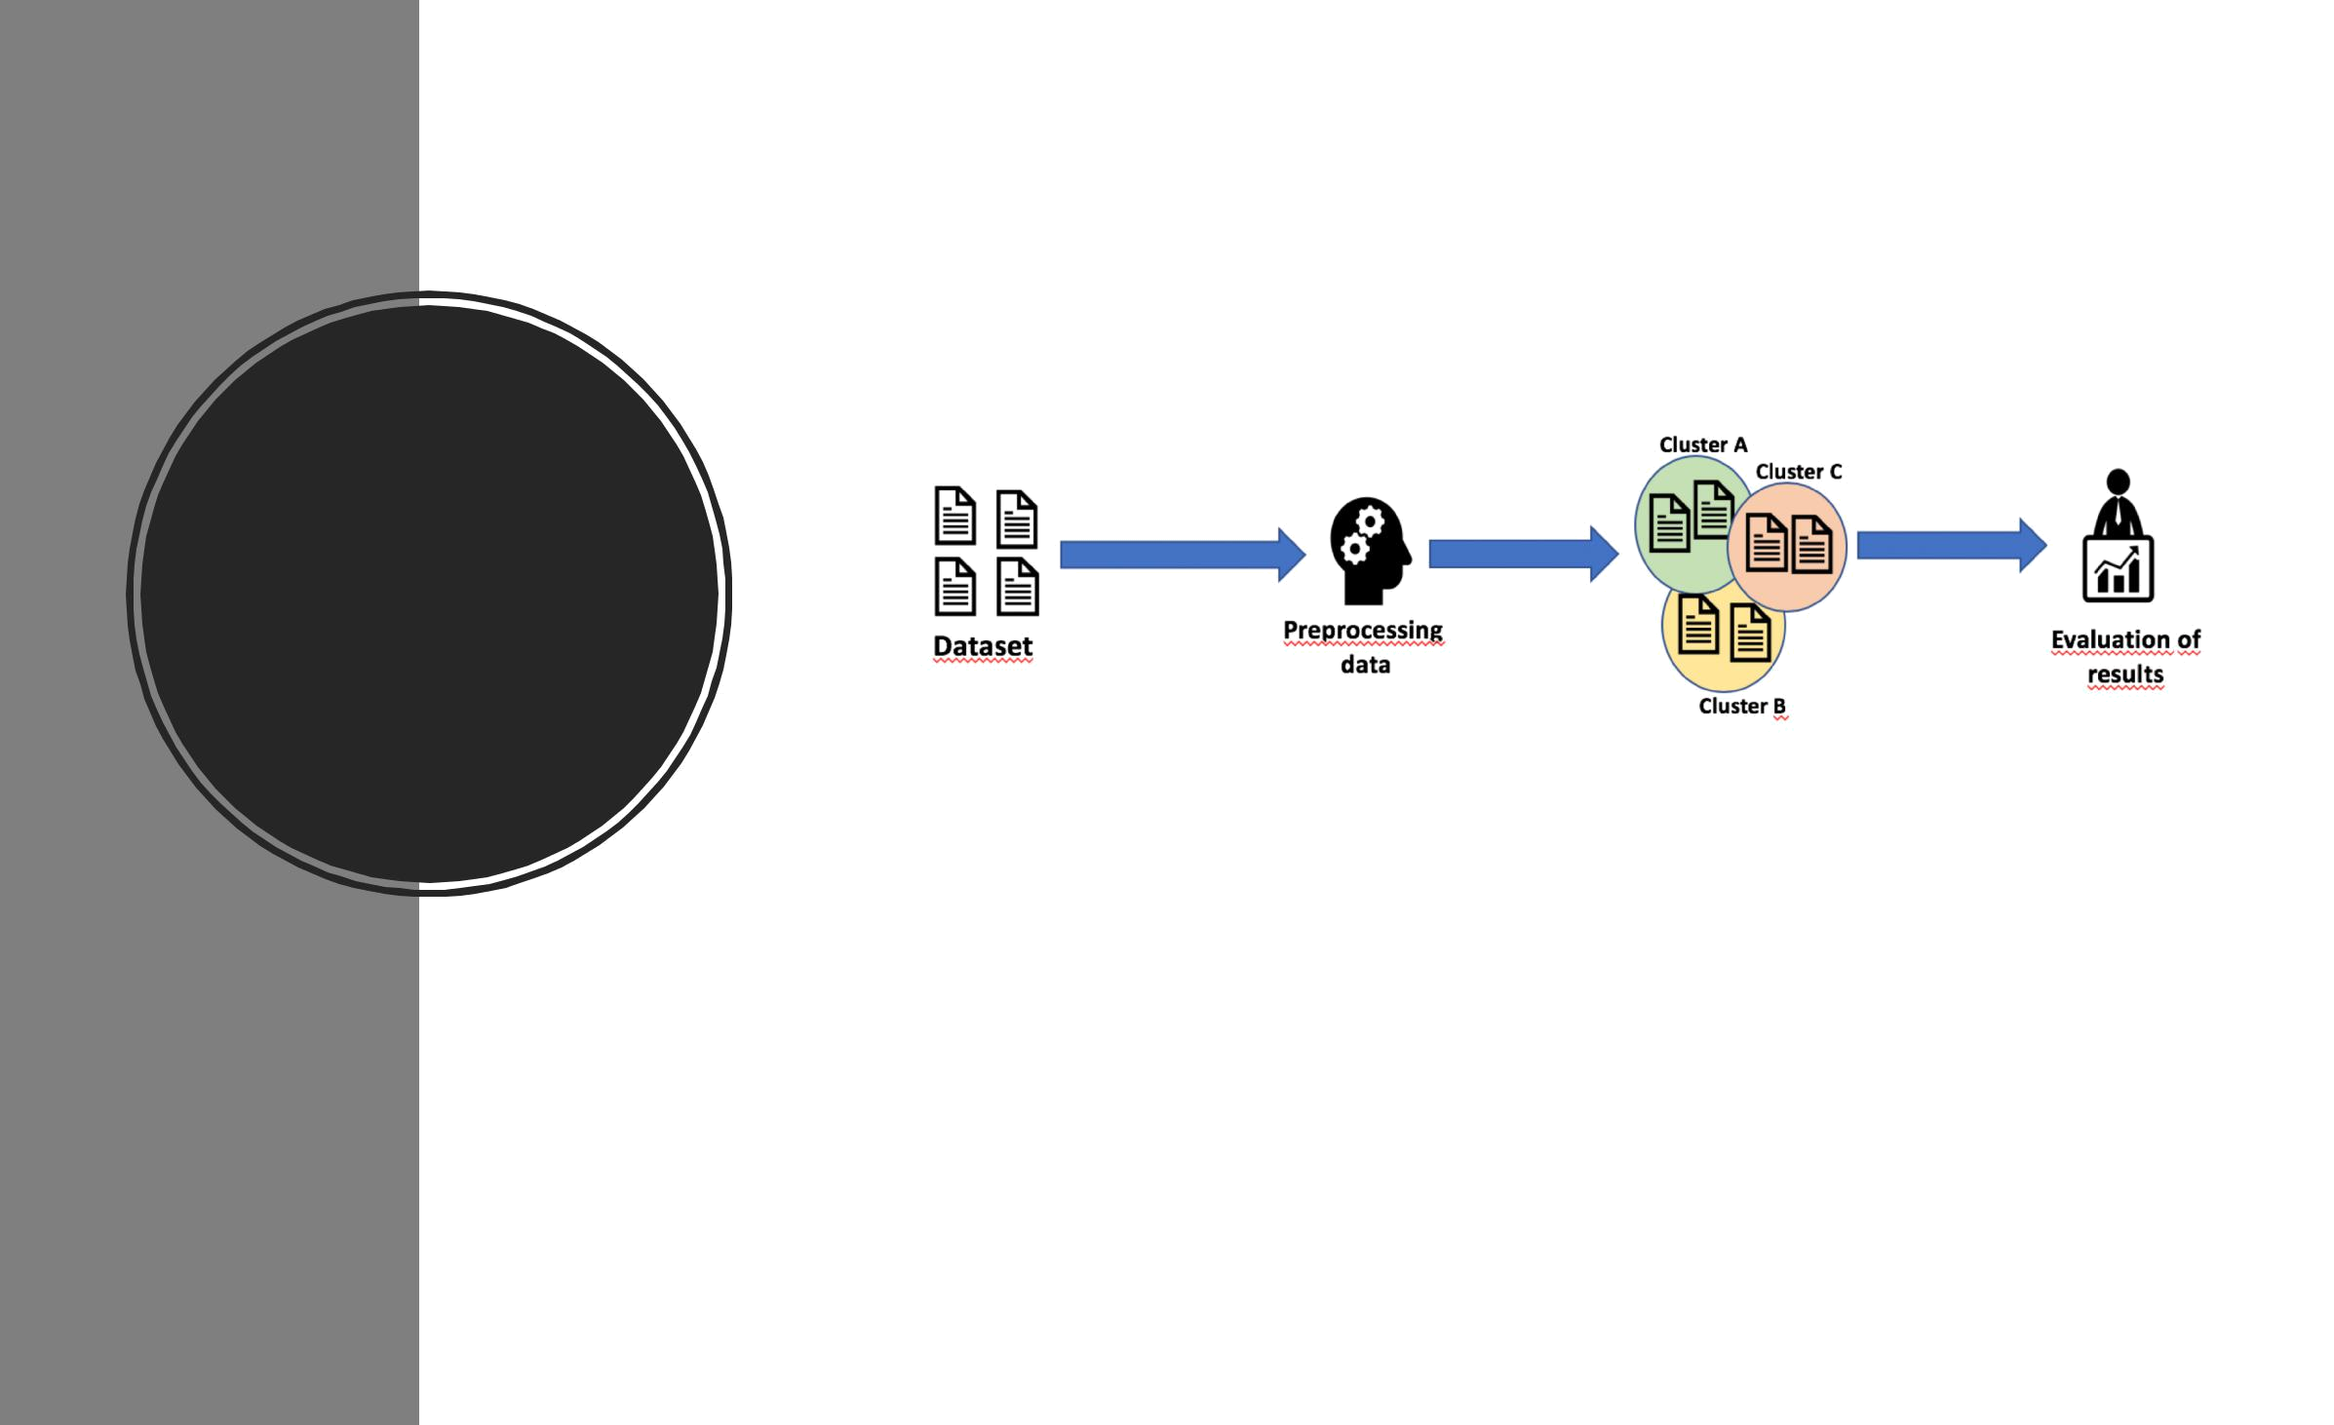

Methodology

- This section describes what steps have been taken during project development. Here you will find pictures about the workflow, maps, explanations of procedures performed and other relevant information.
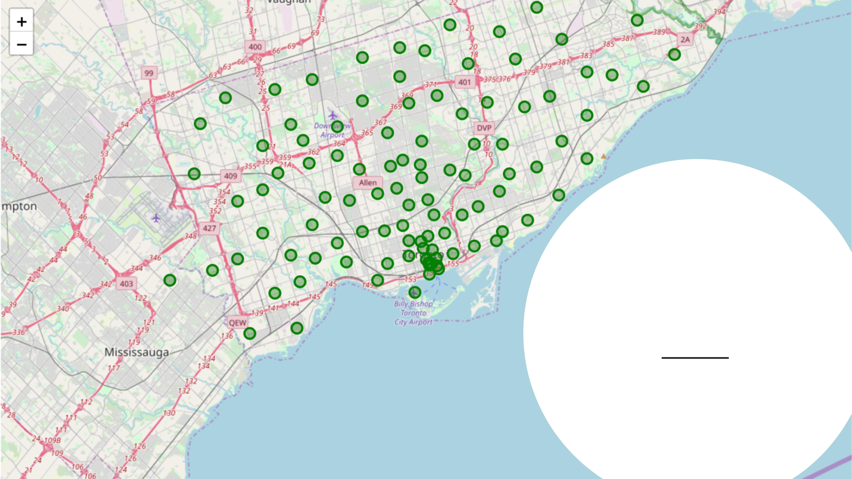

Toronto's
neighborhoods

A map was built with the previous dataframe and now it

is possible to see Toronto's neighborhoods .

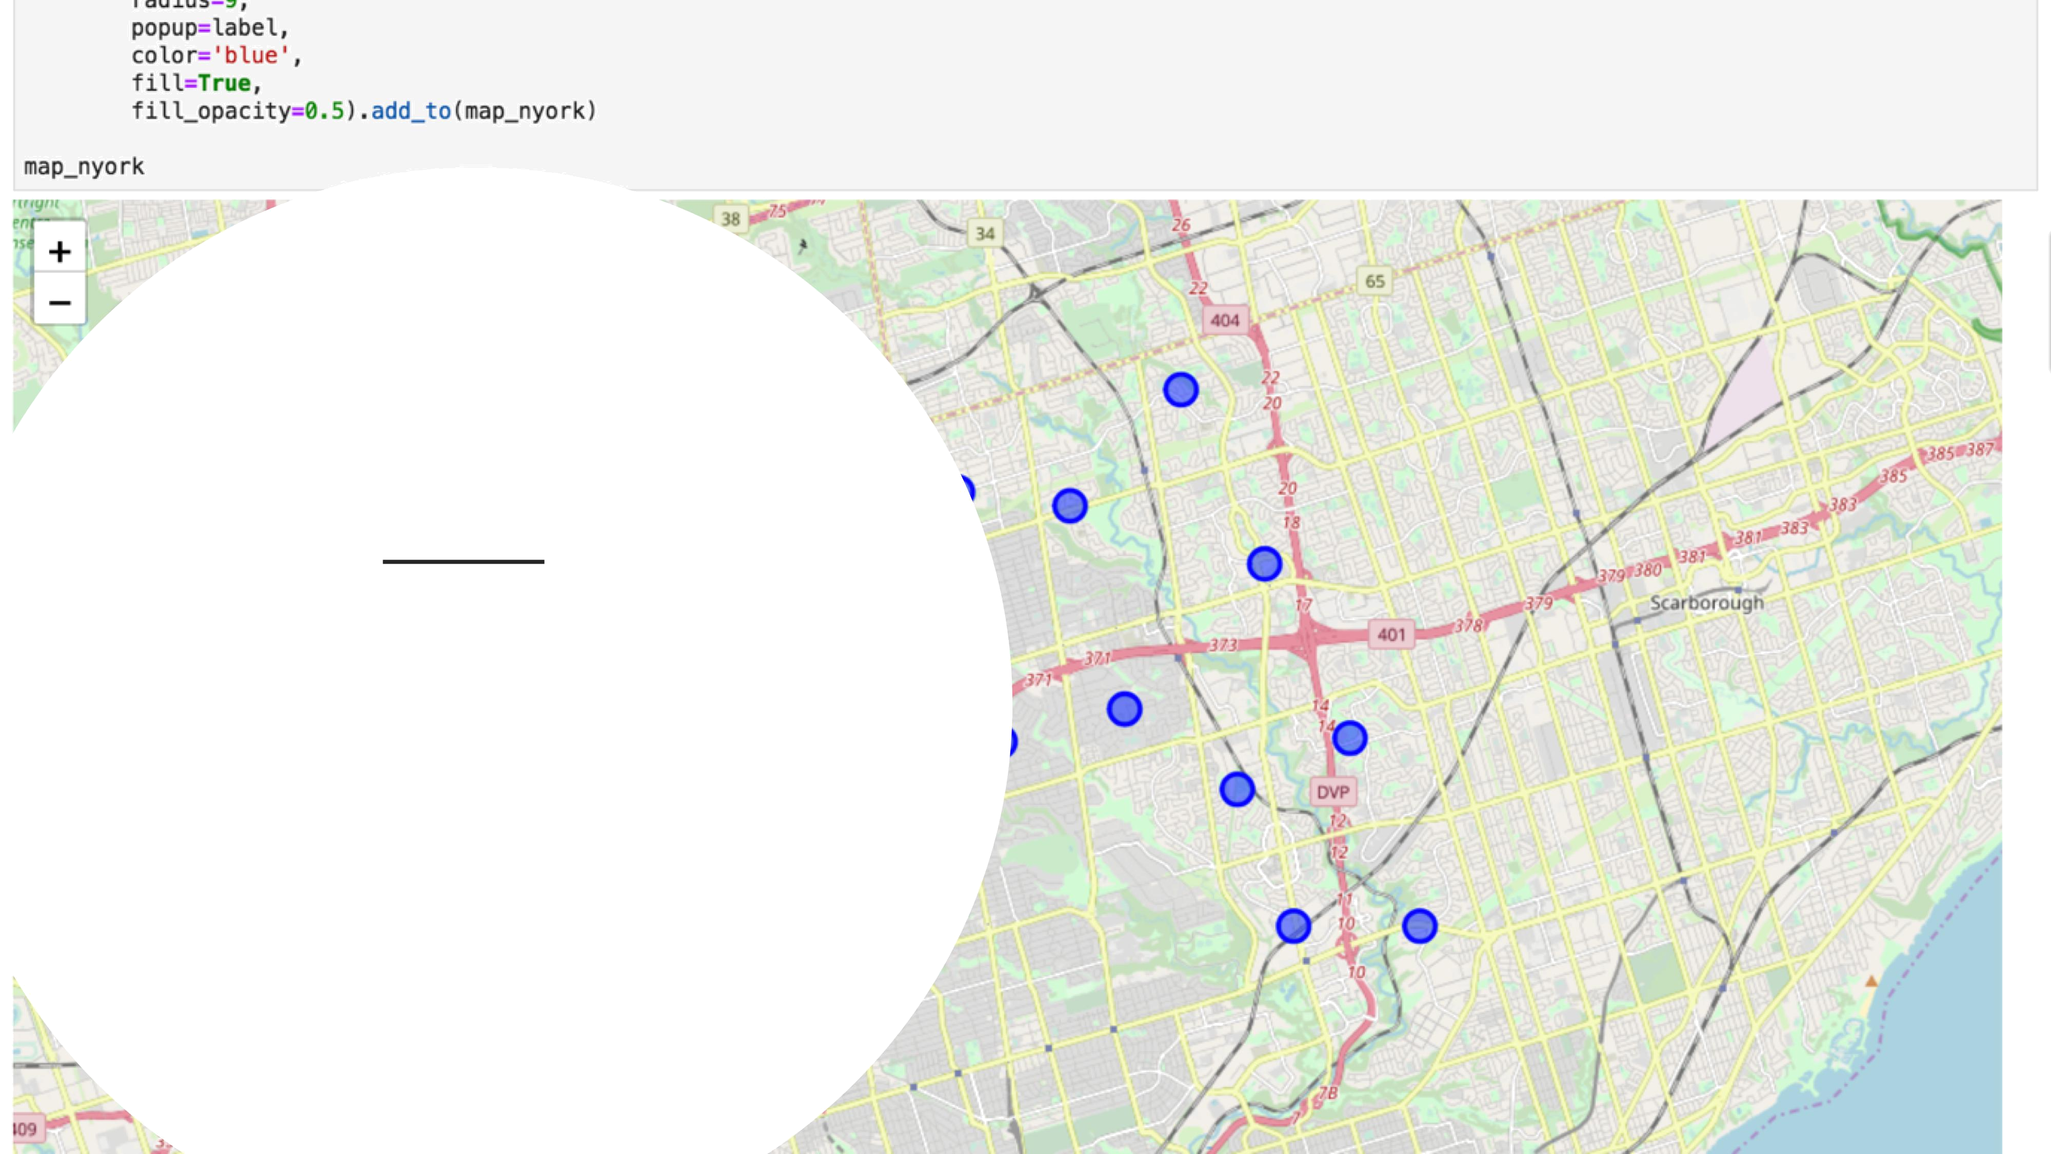

North York and its
neighborhoods

Below is a map of the city of North York and its
neighborhoods, using the libraries: folium and
pygeo
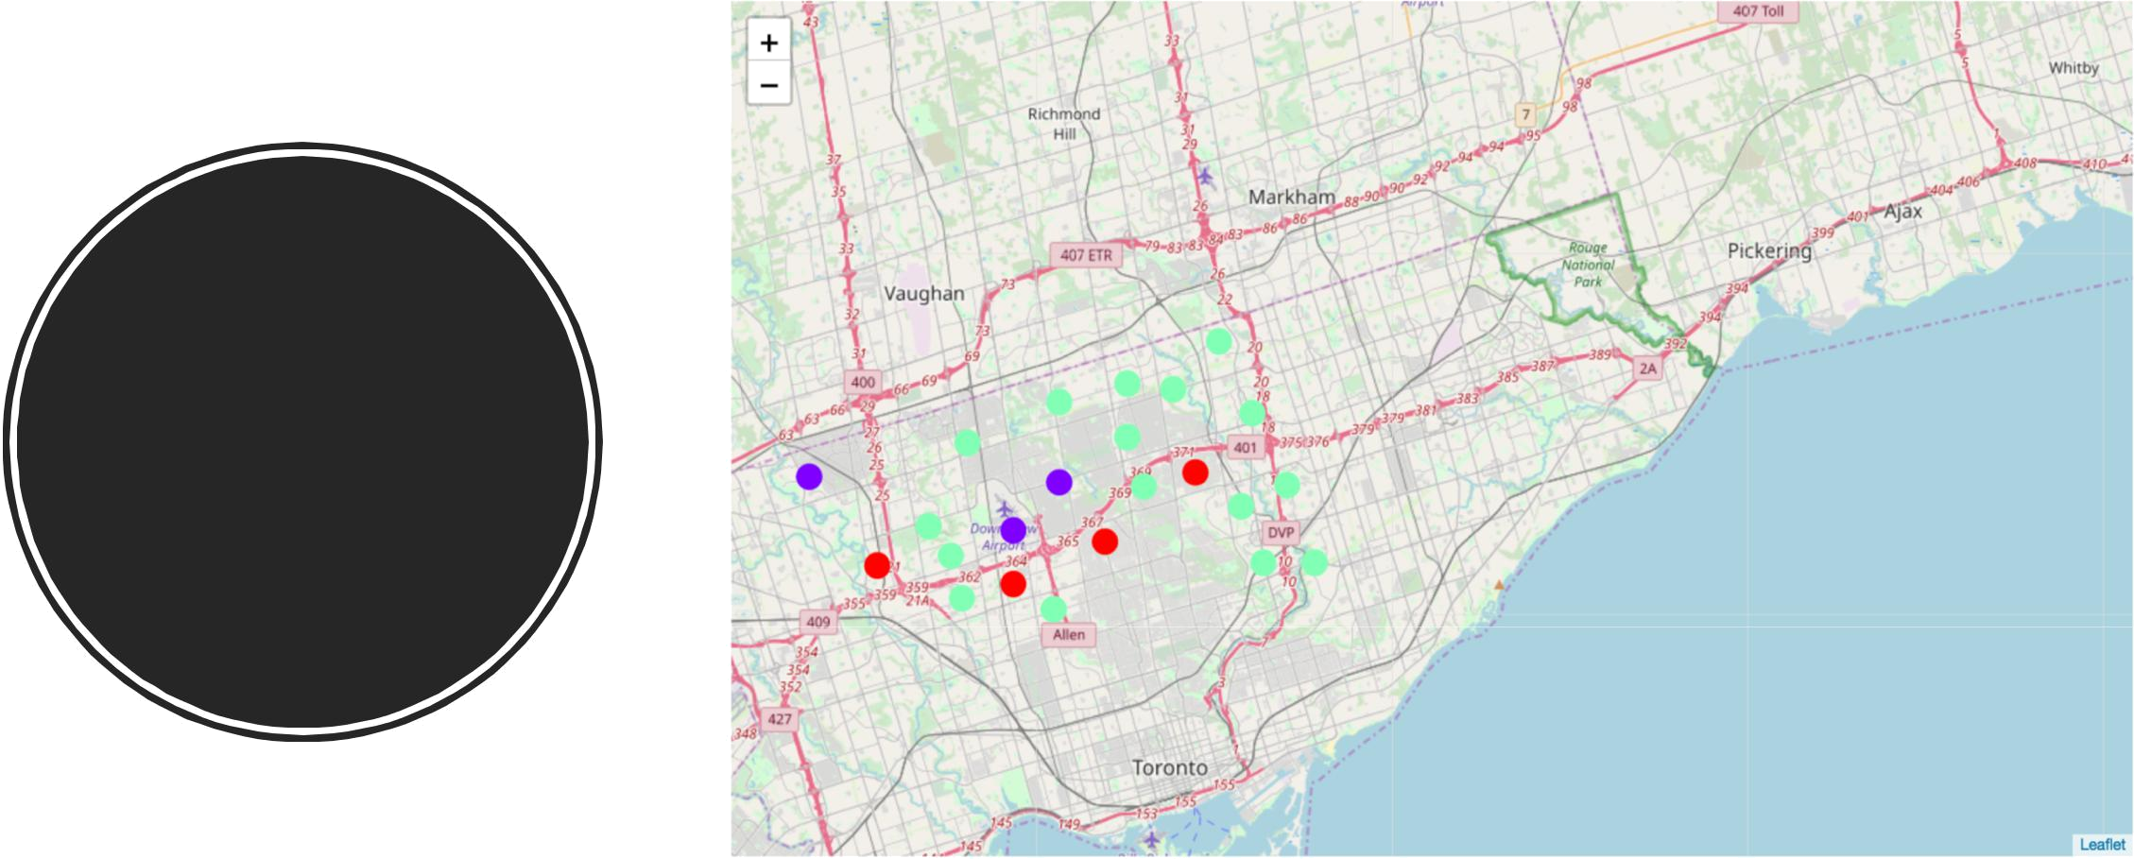

Results

- Below, the map plotted with clusters generated by Kmeans. We can notice the similarity of several neighborhoods with regard to the category of venues
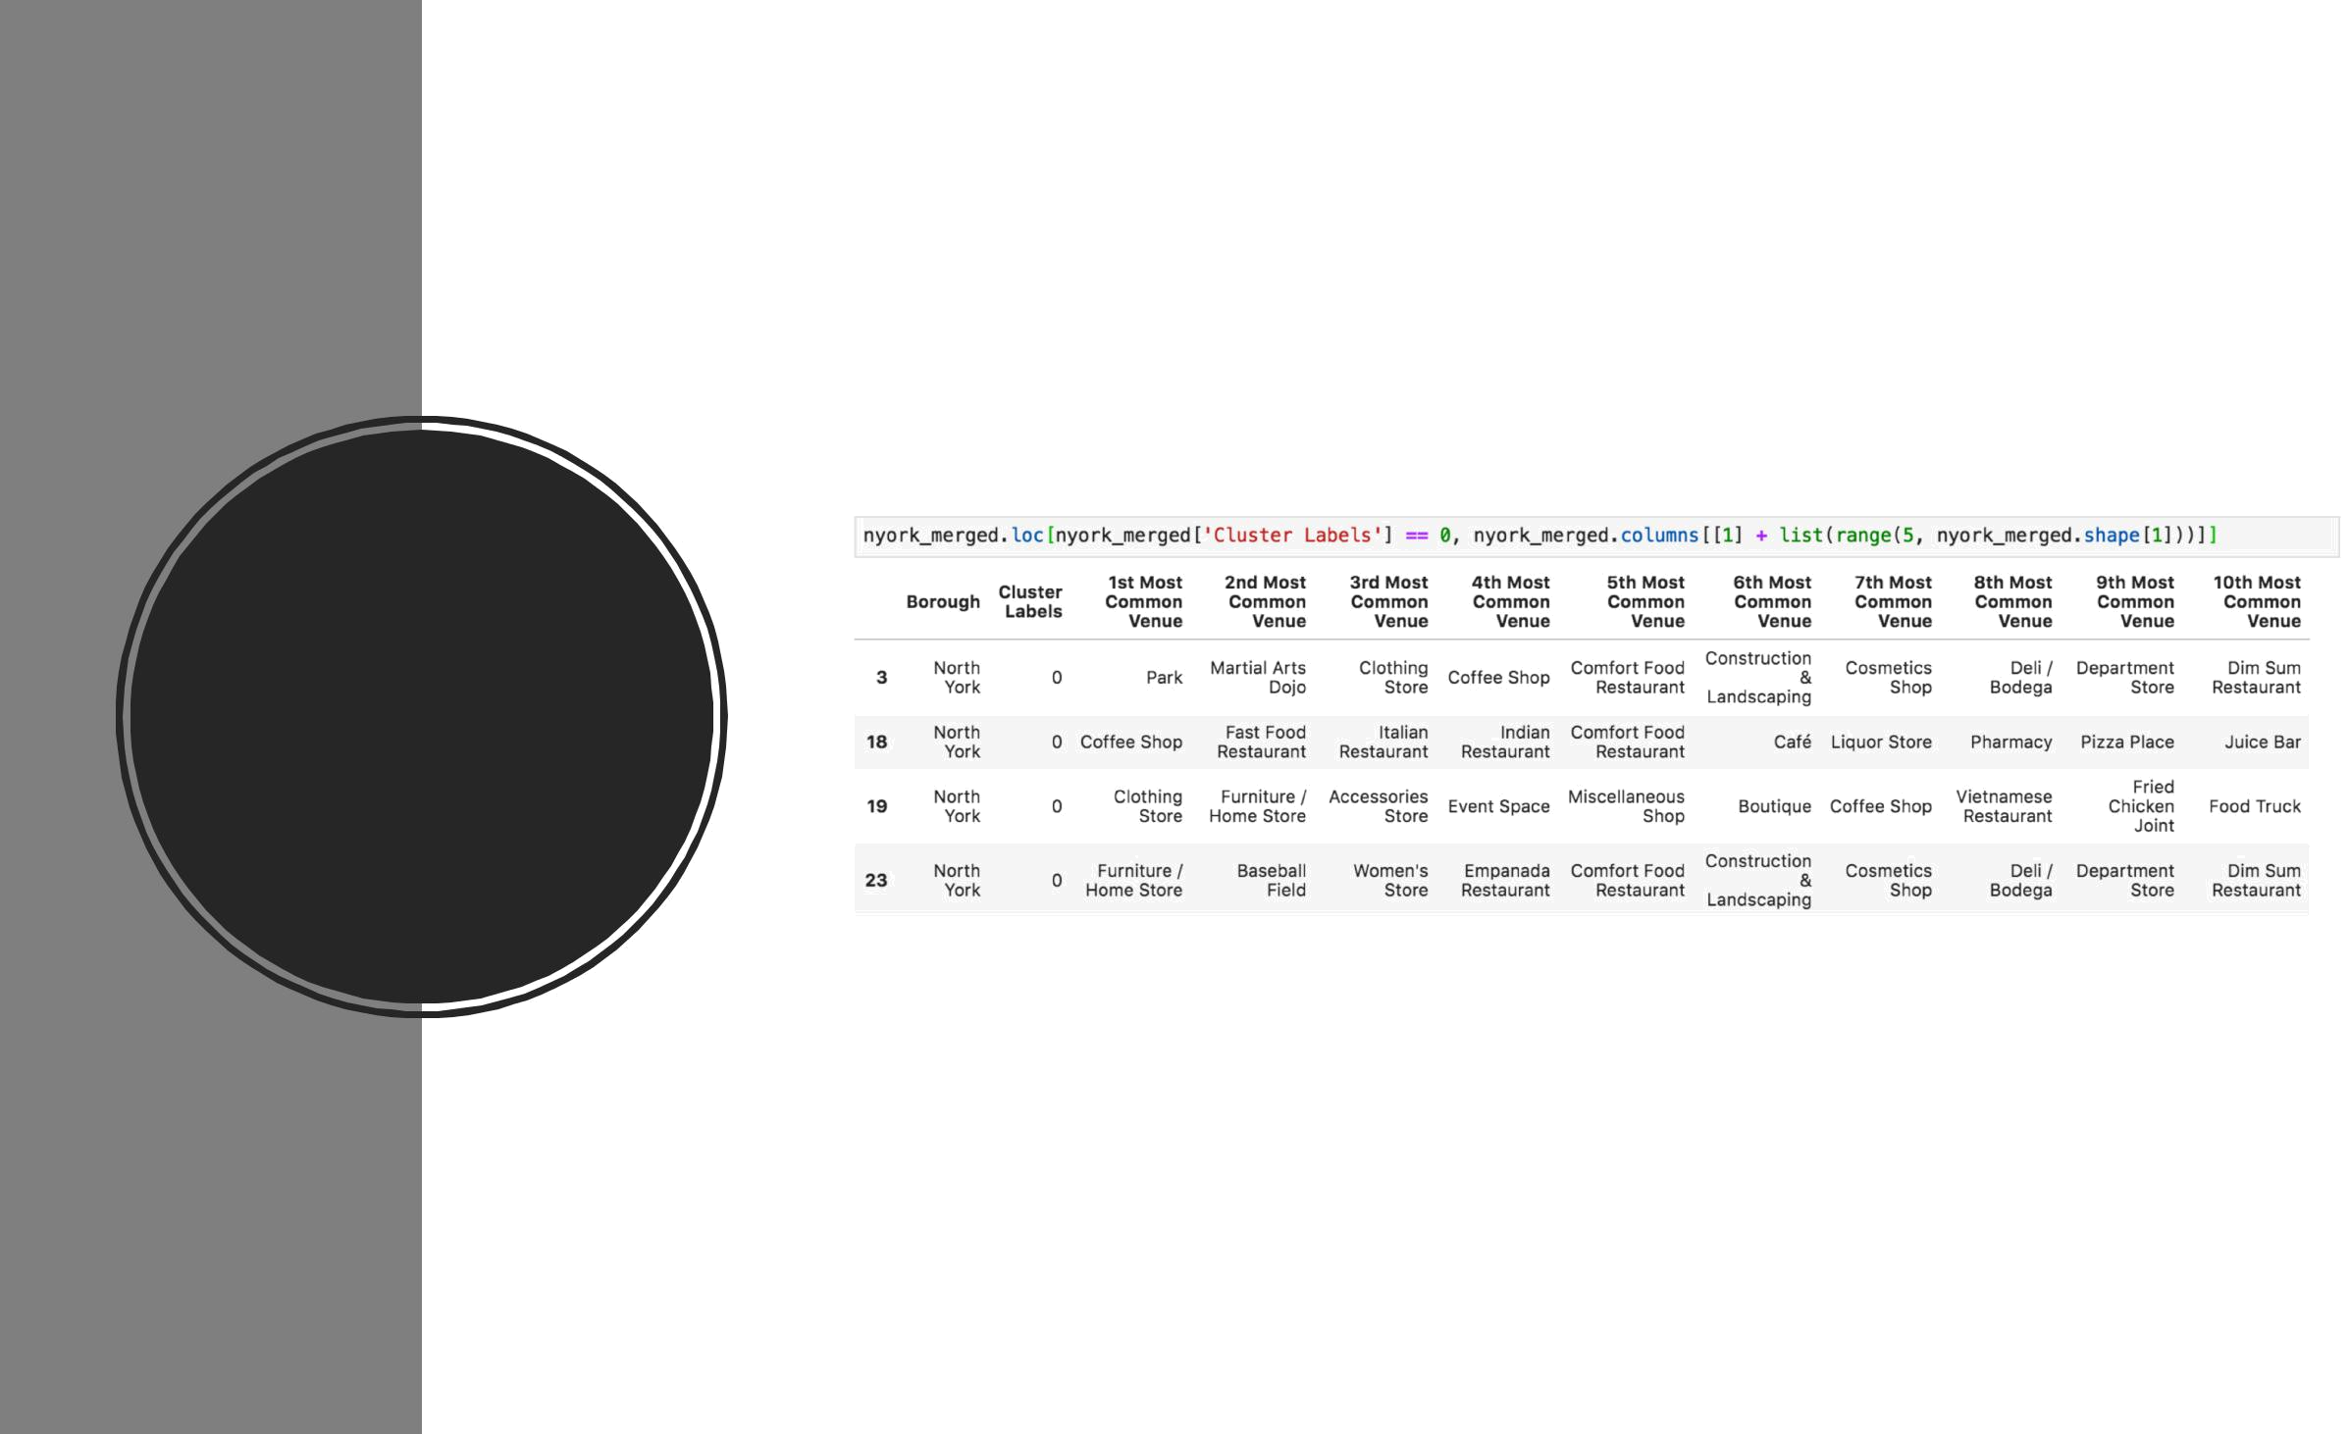

Cluster label
0
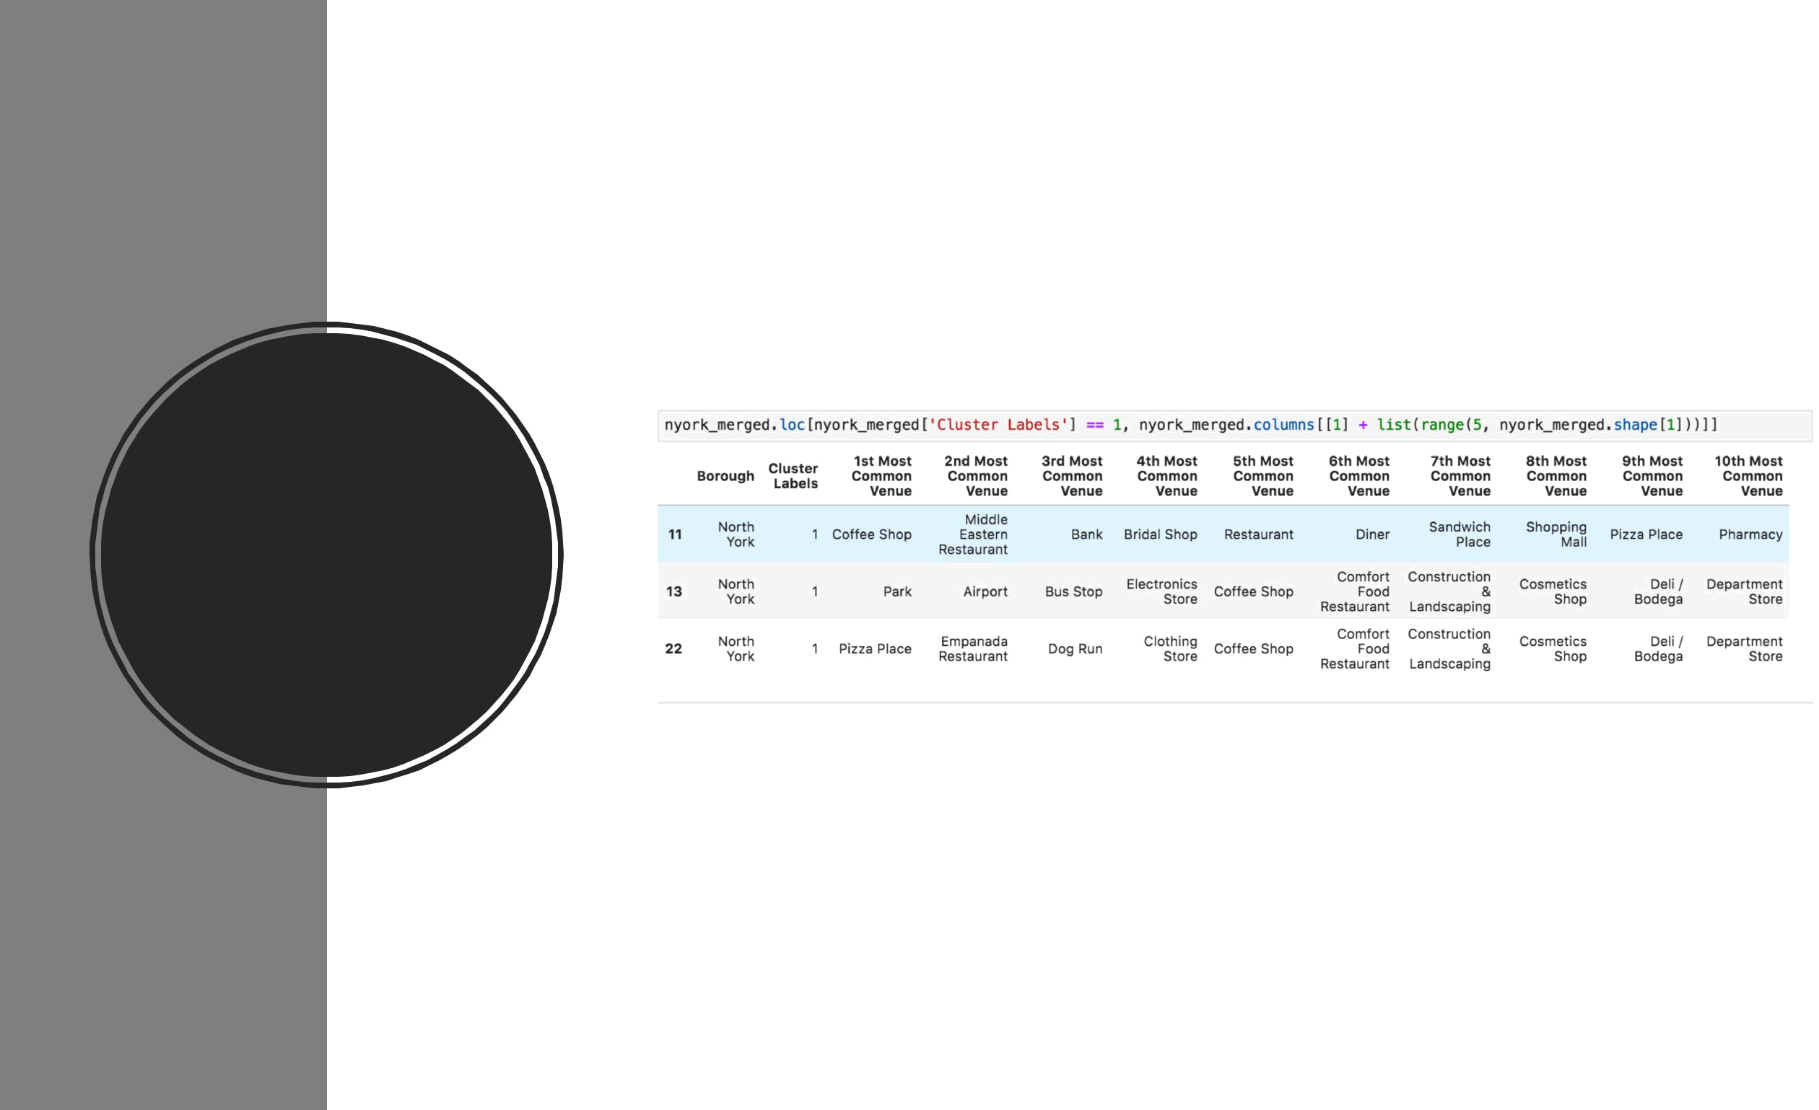

Cluster label
1
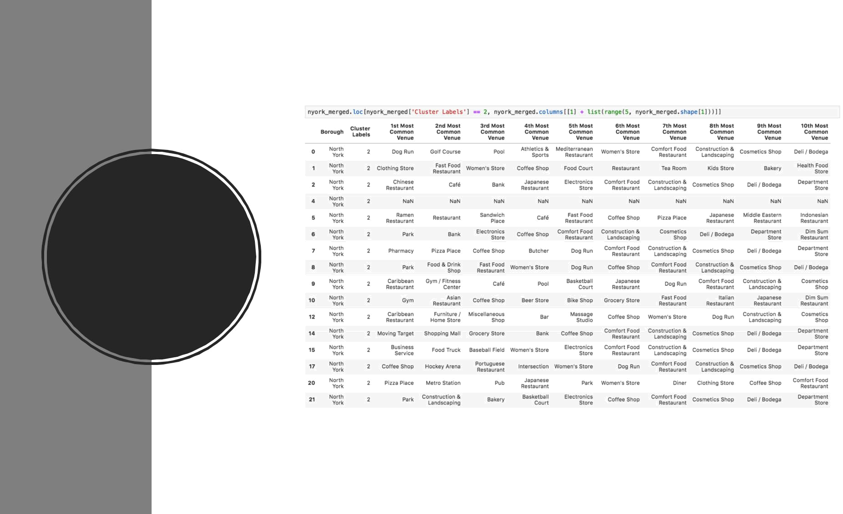

Cluster label
2
- The main challenge of data science applications is certainly data manipulation. We need to get data from different sources, which are not always friendly and easy to manipulate.

- When the data preparation step is unsuccessful, we need to choose the appropriate technique to be applied. The word is to experiment and analyze options.

- Finally, the challenge of a data scientist is to organize the chronology of facts and tell the story. In the course, we learned that the data scientist, in addition to the various skills, need to be able to tell the story and persuade the person involved in the project.

Discussion

- This project analyzed data from different sources and was able to obtain results for the client. The applied process also proved that with a more comprehensive database, we could extrapolate the Toronto boundaries and get insightful insights from other places as well.

- The challenge always ends up being: the data. It is not always possible to get them easily. But with deep research and the curiosity of a data scientist who wants to solve the customer's problem, the sky may be the limit.

Conclusion

