PROJECT REPORT
on
AgriMind
Smart Farm & Marketplace Management System
BATCH-2024

Project Mentor | Student Name & ID
____________________________ | 1. Aryan Chandel (2411981124)  2. Chetna (2411981170)

Department of Computer Science and Engineering
Chitkara University Himachal Pradesh

CERTIFICATE
This is to certify that the project report entitled “AgriMind – Smart Farm & Marketplace Management System” has been prepared by Aryan Chandel (2411981124) and Chetna (2411981170), Batch-2024, Department of Computer Science and Engineering, Chitkara University Himachal Pradesh, as part of their academic project work.
The report presents the design, frontend implementation, system architecture, data model, functional modules, testing approach and planned backend integration of the AgriMind platform.

Project Mentor | Project Team
____________________________ | Aryan Chandel  Chetna

ACKNOWLEDGEMENT
We would like to express our sincere gratitude to the Department of Computer Science and Engineering, Chitkara University Himachal Pradesh, for providing the academic environment and resources required to develop this project.
We are thankful to our project mentor and faculty members for their guidance and feedback during the development of AgriMind. We also acknowledge the use of React, Vite, React Router, JavaScript and modern web-development practices that helped us structure the application into reusable modules.
Finally, we thank our peers and everyone who contributed feedback during the development and testing of the user interface.

TABLE OF CONTENTS
Section | Title
1. | Introduction
1.1 | Objective
1.2 | Technology Stack
2. | Project Description
2.1 | Problem Background
2.2 | Proposed Solution
2.3 | Functional Requirements
2.4 | Non-Functional Requirements
2.5 | Constraints and Assumptions
3. | System Architecture & Design
3.1 | High-Level System Architecture
3.2 | Detailed System Design
3.3 | Module / Process Design
3.4 | UI/UX and Responsive Design
4. | Database Design
4.1 | Conceptual Database Schema
4.2 | Relationships
5. | Data Flow Diagrams (DFD)
5.1 | Level 0 DFD
5.2 | Level 1 DFD
6. | Features Implemented
7. | Screenshots
8. | Testing & Validation
9. | Limitations & Future Enhancements
10. | Conclusion
11. | Appendix

SUSTAINABLE DEVELOPMENT GOALS
AgriMind is designed as a digital platform that connects farm management with agricultural commerce. The project can be related to the following Sustainable Development Goals (SDGs):
SDG | Contribution of AgriMind
SDG 2 – Zero Hunger | Supports digital organization of farming activities and can contribute to improved agricultural productivity.
SDG 8 – Decent Work and Economic Growth | Provides a digital marketplace workflow intended to support direct farmer-to-buyer commerce.
SDG 9 – Industry, Innovation and Infrastructure | Uses modern web technologies to create a structured digital platform for agricultural services.
SDG 12 – Responsible Consumption and Production | Digitized farm, crop and inventory records can support more organized resource and stock management.
SDG 15 – Life on Land | Provides a foundation for future sustainable-farming and environmental decision-support features.

1. Introduction
Agriculture is one of the most important sectors of the economy, yet many farming activities continue to depend on manual records, disconnected information and separate channels for selling agricultural products. AgriMind – Smart Farm & Marketplace Management System is designed to bring these activities into a single web-based platform.
The current project milestone focuses on a structured React frontend with separate Farmer and Buyer experiences. The Farmer portal includes dashboard analytics, farm management, crop management, inventory, product listings, market-rate information and order management. The Buyer portal provides marketplace browsing, product details and cart functionality.
The application is being developed with a MERN-oriented architecture. The present implementation provides the frontend workflow and interface foundation, while Node.js, Express.js, MongoDB/MongoDB Atlas and secure authentication are planned for the next integration stage.

1.1 Objective
• Develop a user-friendly digital platform for managing farm-related information.
• Digitize farm, crop and inventory records to reduce dependence on manual records.
• Allow farmers to list agricultural products for direct sale to buyers.
• Provide buyers with a marketplace-style interface for discovering agricultural products.
• Provide dashboards that make important farm and sales information easy to understand.
• Create a scalable foundation that can later be connected to REST APIs and persistent database services.

1.2 Technology Stack
Technology / Tool | Purpose
React.js | Frontend user interface and reusable components
Vite | Frontend development and build tooling
JavaScript | Application logic and state handling
HTML5 | Page structure and semantic content
CSS3 / Custom CSS | Responsive layout and visual styling in the current frontend
React Router | Navigation between application pages
Node.js + Express.js | Planned backend and REST API layer
MongoDB / MongoDB Atlas | Planned persistent application database
JWT + bcrypt.js | Planned authentication and password protection
Git / GitHub / VS Code | Version control and development environment

2. Project Description
AgriMind combines smart farm record management with an agricultural marketplace. At the start of the application, the user can select a Farmer or Buyer role. The Farmer side is intended to operate as a farm-management and seller portal, while the Buyer side follows a marketplace-oriented experience.
The project is organized into modular screens so that farm information, crop records, stock, marketplace products and orders can be managed without forcing every workflow into one overloaded page.

2.1 Problem Background
• Farm information can be difficult to organize when records are maintained manually or across separate files.
• Crop production, stored stock and sold quantities may be difficult to track consistently without a structured record system.
• Farmers often need a separate mechanism for presenting products to potential buyers.
• Buyers need a simple interface for discovering agricultural products and managing selected items.
• Disconnected workflows make it harder to obtain a single overview of farm, inventory and marketplace activity.

2.2 Proposed Solution
AgriMind proposes a unified browser-based platform in which Farmer users can manage farms, crops, inventory, products and orders, while Buyer users can browse products, inspect product information and use a cart workflow. The design separates role-specific navigation while maintaining a common application identity.

2.3 Functional Requirements
ID | Requirement | Primary Role
FR-01 | Select Farmer or Buyer role and access the corresponding workflow. | All users
FR-02 | Register and log in through the authentication interface. | All users
FR-03 | Create, edit and delete farm records. | Farmer
FR-04 | Add and manage crop records with production and stock information. | Farmer
FR-05 | Track produced, stored and sold quantities through inventory workflow. | Farmer
FR-06 | Create and manage marketplace product listings. | Farmer
FR-07 | Search/filter market-rate demonstration data. | Farmer
FR-08 | View incoming orders and progress order status in the frontend workflow. | Farmer
FR-09 | Browse agricultural products and view product details. | Buyer
FR-10 | Add marketplace products to a cart and retain cart state in the browser. | Buyer

2.4 Non-Functional Requirements
• Usability: important actions should be visible through dashboards and clear navigation.
• Responsiveness: the interface should remain usable across desktop, tablet and mobile layouts.
• Maintainability: pages and reusable UI patterns should be separated by responsibility.
• Scalability: the frontend should provide a foundation for future API and database integration.
• Consistency: role-specific screens should use a common visual language and navigation structure.

2.5 Constraints and Assumptions
The current milestone is primarily a frontend implementation. Several records and workflows use local or temporary state for demonstration. Backend APIs, persistent MongoDB storage and production authentication are treated as the next integration stage. Market-rate values are demonstration data and are not presented as a verified government data feed.

3. System Architecture & Design

3.1 High-Level System Architecture
AgriMind follows a planned client-server architecture. The React frontend handles presentation, navigation, forms and dashboard interactions. In the final architecture, the frontend will communicate with a Node.js and Express.js backend through REST APIs. The backend will apply application logic and communicate with MongoDB/MongoDB Atlas for persistent records.
Layer | Main Components | Responsibility
Presentation | React.js, React Router, CSS | Screens, forms, dashboards, navigation and responsive UI
Application | Node.js, Express.js, REST APIs | Authentication, business rules, CRUD operations and request handling
Data | MongoDB / MongoDB Atlas | Persistent users, farms, crops, products and orders
Security | JWT, bcrypt.js | Planned authentication, authorization and password protection

3.2 Detailed System Design
Module | Current Role in Project
Authentication | Frontend role selection, registration and login interface; backend authentication is pending.
Farmer Dashboard | Displays farm statistics, recent orders, crop stock and quick actions.
Farm Management | CRUD-style frontend management of farm name, location, area, soil, irrigation and crops grown.
Crop Management | Add/delete crop records, validate production and stock values, and calculate summaries.
Inventory | Track produced, stored and sold quantities and identify low-stock conditions.
My Products | Create, edit, activate/deactivate and delete marketplace product listings.
Government / Market Rates | Frontend demonstration with search and category/location filters.
Farmer Orders | Display incoming orders, buyer information, filters, details and frontend status progression.
Buyer Marketplace | Buyer dashboard, product details and cart workflow.

3.3 Module / Process Design
• Farmer → Authentication → Farmer Dashboard → Farm / Crop / Inventory Management → My Products → Farmer Orders
• Buyer → Authentication → Buyer Dashboard → Product Details → Cart
• Application → Planned REST API → Business Logic → MongoDB / MongoDB Atlas

3.4 UI/UX and Responsive Design
The interface uses a custom CSS design system with dashboard cards, grid/flex layouts, navigation sidebars, status indicators, forms and responsive breakpoints. The visual language uses agricultural green tones, light neutral backgrounds and compact cards to keep operational information easy to scan.

SYSTEM ARCHITECTURE OVERVIEW
FARMER / BUYER
↓
REACT + VITE + REACT ROUTER
↓
REST API (NODE.JS + EXPRESS.JS)
↓
MONGODB / MONGODB ATLAS
↘
FUTURE MEDIA / SERVICES
The current implementation reaches the frontend stage of this architecture. The backend and database layers are documented as the planned final integration path rather than being claimed as completed functionality.

4. Database Design

4.1 Conceptual Database Schema
The planned database uses MongoDB as a document-oriented database. Mongoose is intended to provide application-level data models and references. The major conceptual data domains are:
Data Domain | Purpose
Users | Stores account identity, role and authentication-related information.
Farm Information | Stores farm name, location, area, soil, irrigation and crop-related information.
Crops | Stores crop details including production, stored quantity, sold quantity and dates.
Inventory | Supports stock-related records and low-stock calculations.
Products / Listings | Stores marketplace product information such as name, category, price, quantity, unit and location.
Orders | Stores buyer order information and seller-side order status.
Market Rates | Supports market-rate information used by the frontend demonstration.

4.2 Relationships
• A Farmer/Seller account is associated with farm-management information.
• A Farmer/Seller can create and manage multiple crop and product records.
• Marketplace listings created by a Farmer/Seller are presented to Buyer users.
• Orders connect marketplace products with buyer-side and farmer-side workflows.
• Application records are intended to be persisted through MongoDB using Mongoose models.
• Authentication and authorization data will be linked to user roles in the final backend implementation.

5. Data Flow Diagrams (DFD)

5.1 Level 0 DFD (Context Level)
At context level, AgriMind is treated as a single system interacting primarily with Farmer/Seller and Buyer users. Farmers provide farm, crop, inventory, product and order-management actions. Buyers provide marketplace and cart-related actions. The system returns authentication results, stored-record responses, marketplace information and order-related information.
External Entity | Input to AgriMind | Output from AgriMind
Farmer / Seller | Login details, farm data, crop data, product/listing data, management actions | Dashboard information, saved records, listing status, order information
Buyer | Login details, marketplace requests, product selections, cart actions | Product information, availability, product details, cart responses

5.2 Level 1 DFD
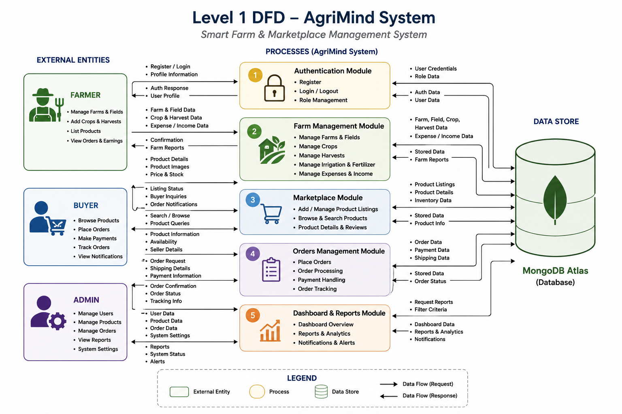
Figure 1: Level 1 DFD – AgriMind System
The Level 1 DFD divides the platform into authentication, farm management, marketplace, order management and dashboard/reporting processes. It also represents the intended connection to MongoDB as the data store.

6. Features Implemented
The current milestone primarily demonstrates the frontend workflow and user interface. The modules use local or temporary state where backend persistence is not yet connected.
Feature | Description | Status
Role Selection | User chooses Farmer or Buyer at the entry point. | Implemented
Registration / Login UI | Forms with role-aware navigation and validation. | Implemented
Farmer Dashboard | Statistics, recent orders, crop stock and quick actions. | Implemented
Farm Management | Add, edit and delete farm records with farm details. | Implemented
Crop Management | Add/delete crops, validation and production/stock summaries. | Implemented
Inventory Management | Track produced, stored and sold quantities and low-stock status. | Implemented
My Products | Add, edit, activate/deactivate and delete marketplace listings. | Implemented
Market Rates | Search and filter demonstration data. | Frontend demo
Farmer Orders | Incoming-order cards, buyer/delivery information and status progression. | Frontend
Buyer Dashboard | Marketplace-oriented buyer experience. | Frontend
Product Details | Dedicated product detail route and presentation. | Frontend
Buyer Cart | Cart workflow using browser localStorage in the current prototype. | Frontend

7. Screenshots
The following screenshots document the current frontend milestone and illustrate the implemented user interface.
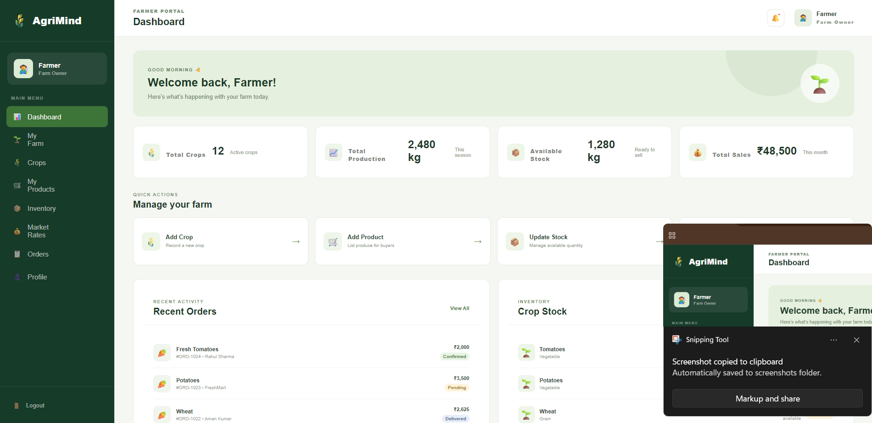
Figure 2: AgriMind Farmer Dashboard

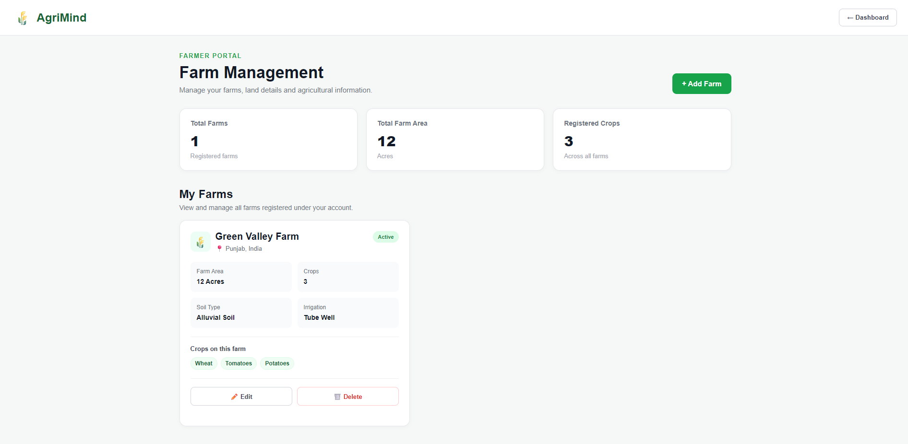
Figure 3: AgriMind Farm Management

ADDITIONAL APPLICATION SCREENS
[ SCREENSHOT PLACEHOLDER ]
Figure 4: Crop Management screen – latest application screenshot
[ SCREENSHOT PLACEHOLDER ]
Figure 5: Inventory Management screen – latest application screenshot
[ SCREENSHOT PLACEHOLDER ]
Figure 6: My Products screen – latest application screenshot
[ SCREENSHOT PLACEHOLDER ]
Figure 7: Farmer Orders screen – latest application screenshot
[ SCREENSHOT PLACEHOLDER ]
Figure 8: Buyer Dashboard / Marketplace screen – latest application screenshot

8. Testing & Validation
Testing at the current milestone focuses on frontend navigation, form validation, local state behaviour, responsive layout and role-specific workflows.

8.1 Validation Dimensions
Test Area | Validation Performed | Expected Result
Navigation | Open public, farmer and buyer routes. | Correct page loads for each route.
Role Selection | Select Farmer and Buyer at login. | Corresponding workflow is presented.
Farm Form | Add/edit/delete farm information. | Record updates in current frontend state.
Crop Validation | Enter production, stored and sold quantities and dates. | Invalid relationships are rejected and summaries update.
Inventory | Update stored quantity and calculate stock/sold information. | Stock-related values remain consistent within prototype.
Product Listing | Create, edit, activate/deactivate and remove a product. | Marketplace listing state updates correctly.
Market Rates | Search and filter demonstration rate records. | Matching records are displayed.
Orders | Filter orders and progress status. | Order card/status reflects selected frontend state.
Cart | Add/remove items and refresh browser. | Cart state remains available through localStorage in current prototype.
Responsive UI | Resize to desktop, tablet and mobile widths. | Layout adapts using CSS grid/flex and media queries.

Backend API, persistent database operations and production authentication should be tested separately after their integration is completed.

9. Limitations & Future Enhancements

9.1 Current Limitations
• The current milestone is primarily a frontend implementation.
• Backend Node.js and Express.js integration is pending.
• MongoDB / MongoDB Atlas persistence is planned and not yet connected to the current frontend workflow.
• Authentication security features such as JWT and bcrypt are planned for the backend stage.
• Market-rate values are demonstration data and are not connected to a verified government API.
• Several screens use temporary/local state rather than shared persistent records.
• The current buyer cart uses browser localStorage for prototype persistence.
• Production deployment, monitoring and large-scale security hardening remain future work.

9.2 Planned Enhancements
• Connect all modules to Node.js and Express.js REST APIs.
• Integrate MongoDB / MongoDB Atlas for persistent farm, crop, inventory, product and order data.
• Implement JWT-based authentication and bcrypt-based password protection.
• Integrate AI-assisted crop, farm or marketplace recommendations.
• Add weather and environmental data integration.
• Introduce notifications for important farm and marketplace events.
• Add advanced analytics and visual dashboards for farm and marketplace performance.
• Expand buyer-seller communication with structured messaging or inquiry workflows.
• Add multilingual support and mobile-focused access.
• Enhance marketplace discovery through stronger search, filtering and recommendation features.

10. Conclusion
AgriMind – Smart Farm & Marketplace Management System establishes a digital foundation for combining farm management with an agricultural marketplace. The current milestone demonstrates a structured React frontend with separate Farmer and Buyer experiences and connected navigation across the major modules.
The Farmer-side interface includes dashboard analytics, farm management, crop management, inventory, marketplace product listings, market-rate demonstration and order management. The Buyer-side foundation includes the buyer dashboard, product details and cart functionality.
The modular structure provides a clear path toward backend integration. Connecting the current frontend with Node.js, Express.js and MongoDB will allow farms, crops, inventory, products and orders to use shared persistent records.
Overall, AgriMind demonstrates how modern web technologies can be organized into a practical platform for agricultural management and digital commerce while leaving a clear foundation for future intelligent, analytical and mobile capabilities.

11. Appendix

11.1 Project Information
Item | Details
Project Title | AgriMind – Smart Farm & Marketplace Management System
Batch | 2024
Students | Aryan Chandel (2411981124), Chetna (2411981170)
Department | Department of Computer Science and Engineering
University | Chitkara University Himachal Pradesh
Current Development Stage | Frontend / React application milestone
Frontend | React, Vite, JavaScript, React Router, custom CSS
Backend | Node.js / Express.js – planned integration
Database | MongoDB / MongoDB Atlas – planned integration
Authentication | JWT / bcrypt.js – planned integration
Repository | To be inserted from the final project repository
Live Application | To be inserted from the deployed application URL

11.2 Current Navigation Map
User Type | Navigation / Flow
Public | Home → Login / Register
Farmer | Login → Farmer Dashboard → Farm Management / Crop Management / Inventory / My Products / Market Rates / Farmer Orders
Buyer | Login → Buyer Dashboard → Product Details → Cart

11.3 Project Resources
• Frontend source code and page components developed for the AgriMind application.
• React Router route configuration for public, farmer and buyer workflows.
• Custom CSS design system and responsive layouts.
• Planned REST API and MongoDB architecture for the next development stage.
Note: Repository and live-application links have intentionally not been fabricated. They should be inserted from the actual final project repository and deployment.

END OF REPORT
AgriMind
Smart Farm & Marketplace Management System

