

OOAD LAB

WEEK-6

NAME:J.BHANU DATE: /1/26
ROLL NUMBER: 23R21A6785 BRANCH: CSD-B
Problem Statement: Design a UML Analysis Class Diagram for the ATM Withdraw Cash Use case showing Boundary, Control, and Entity classes and their interaction with the Bank.
Use Case Diagram :
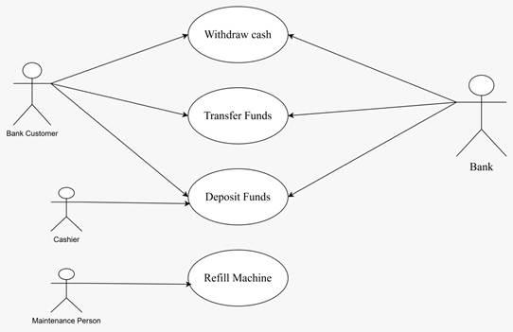

Sequence diagram :
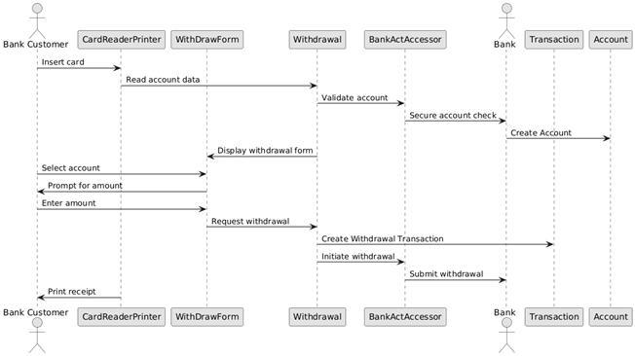
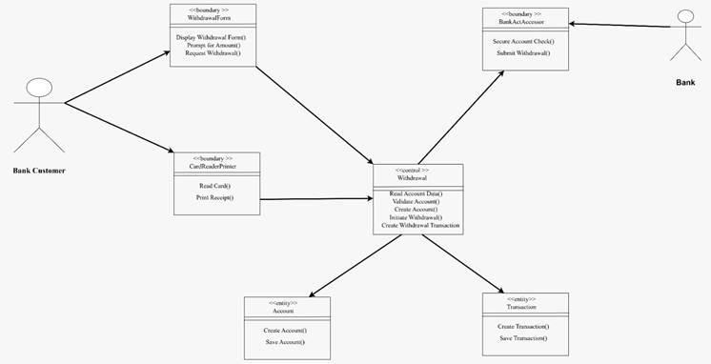
3. COMMUNICATIONS DIAGRAM
ANALYSIS OF CLASSES
