***Importing set of libraries***

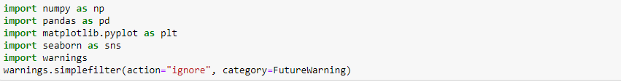

Reading the csv file which we have downloaded and placing the path below in order to display the dataset.



head() displays the first 5 rows of the dataset

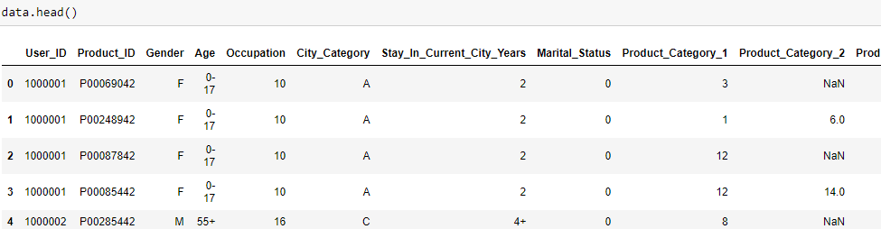

***shape attribute in pandas is used to get the shape of a DataFrame***

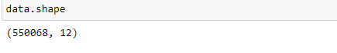

***info() is used to print the information of a DataFrame***

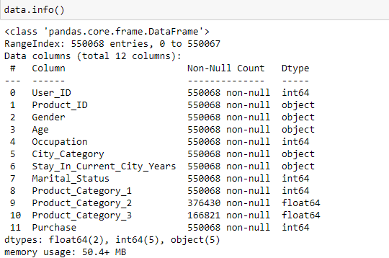

Checking whether if we have any null values in the dataset

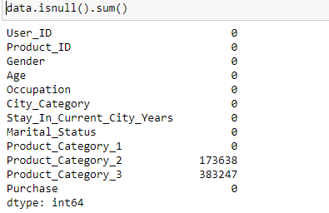

Checking null values in percentage for the dataset

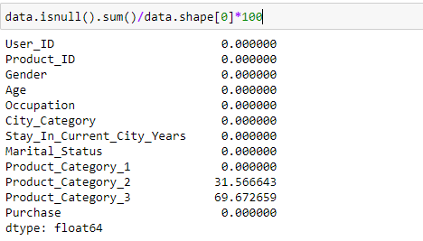

***Checking unique values in the elements***

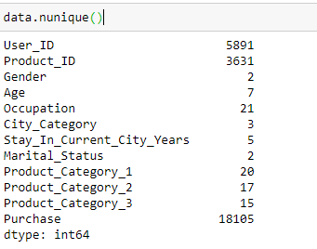

***Histogram (histplot()) is used to display the distribution of the data and shows the values of your data in series***

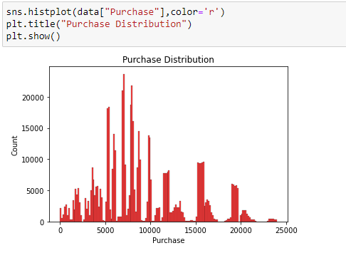

***(boxplot()) is used to display the groups of the numerical in the form quartiles***

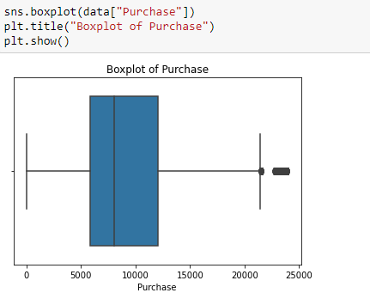

***Skewness of the data which is present in the given axis of the dataframe, it denotes an asymmetric distribution***

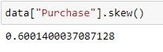

***Kurtosis is another method which is used when the data are heavy outliers or light – tailed to normal distribution***

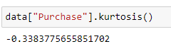

Describe() gives the entire details of the dataset

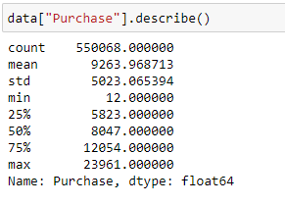

***Countplot is used to display the counts of the observations in each category i.e for female and male***

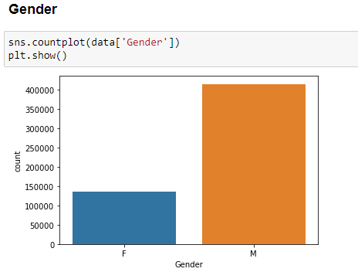

***Displaying the percentage of purchase which were made by both male and female***

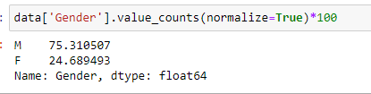

***Groupby is used for gender category so that it can separate the data into groups and mean() is used to get the average of the purchases.***

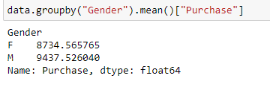

***Countplot is used to display the counts of the observations in each category i.e for married and unmarried***

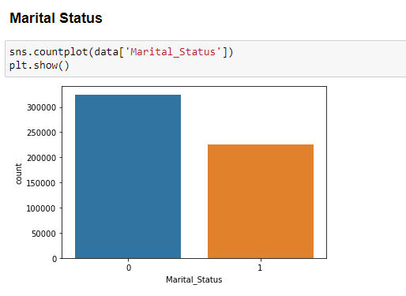

***Groupby is used for marital_status so that it can separate the data into groups and mean() is used to get the average of the purchases made by unmarried and married people***

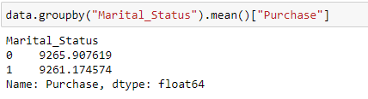

***Plotting a graph for the grouped data of marital_status and mean of purchases***

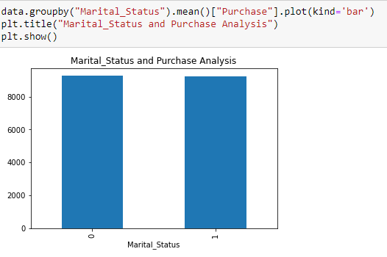

***Countplot is used to display the counts of the observations in each category i.e for occupation data***

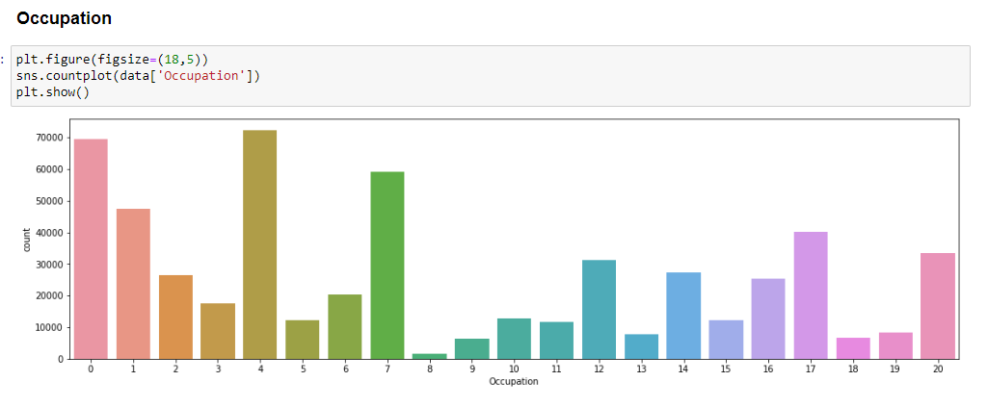

***Groupby is used for occupation data so that it can separate the data into groups and mean() is used to get the average of the purchase of each occupation***

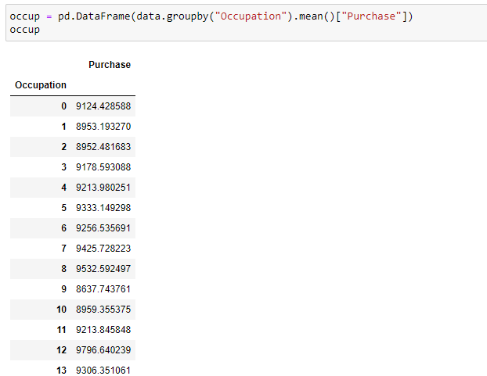

***Plotting a graph for the grouped data of occupation and mean of purchases***

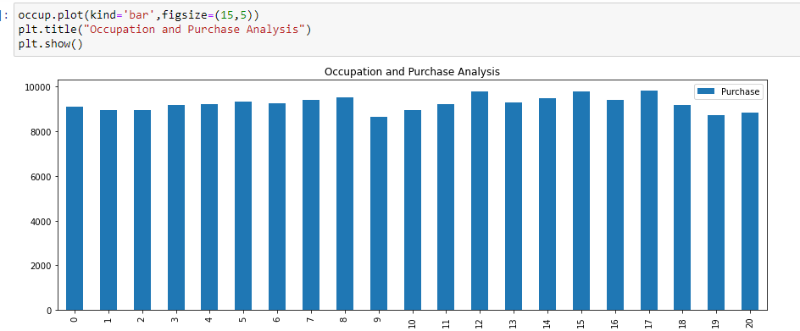

***Countplot is used to display the counts of the observations in each category i.e for City_Category data***

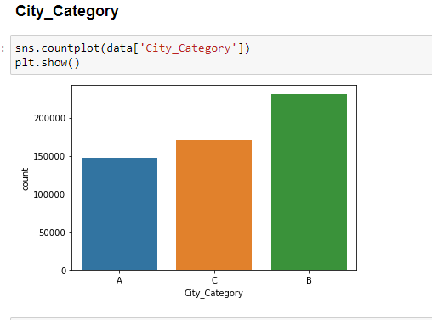

***Groupby is used for city_category data so that it can separate the data into groups and mean() is used to get the average of the purchase***

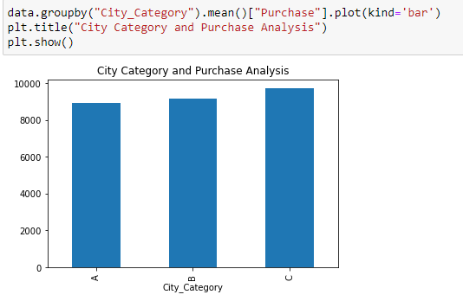

***Countplot is used to display the counts of the observations in each category i.e for stay_in_current_city_years.***

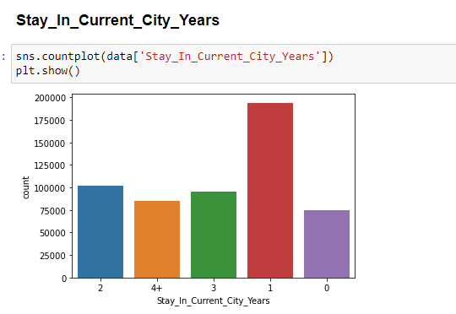

***Groupby is used for Stay_In_Current_City_Years data so that it can separate the data into groups and mean() is used to get the average of the purchase***

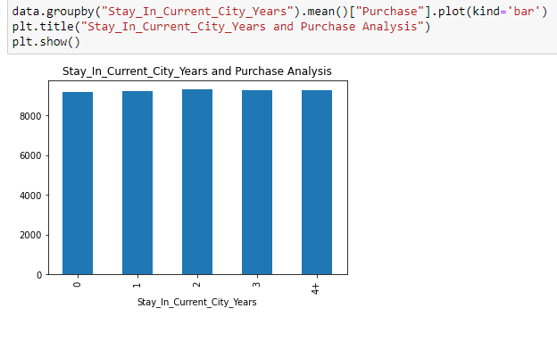

***Countplot is used to display the counts of the observations in each category i.e for diff age groups***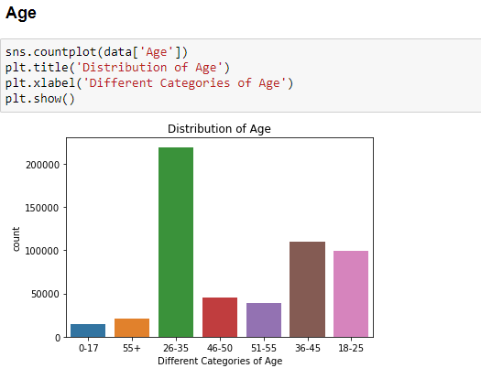

***Groupby is used for Age data so that it can separate the data into groups and mean() is used to get the average of the purchase***

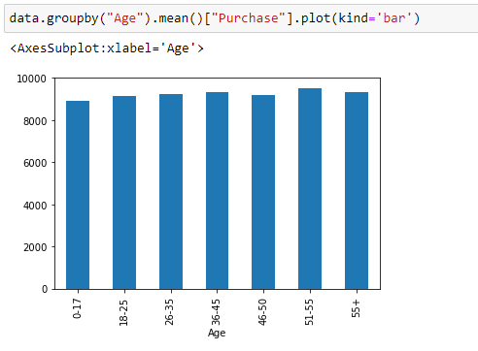

***Groupby is used for Age data so that it can separate the data into groups and sum() is used to get the sum of the purchase of the items***

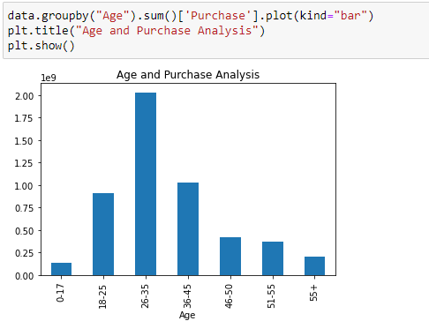

***Countplot is used to display the counts of the observations in each category i.e for product_category_1***

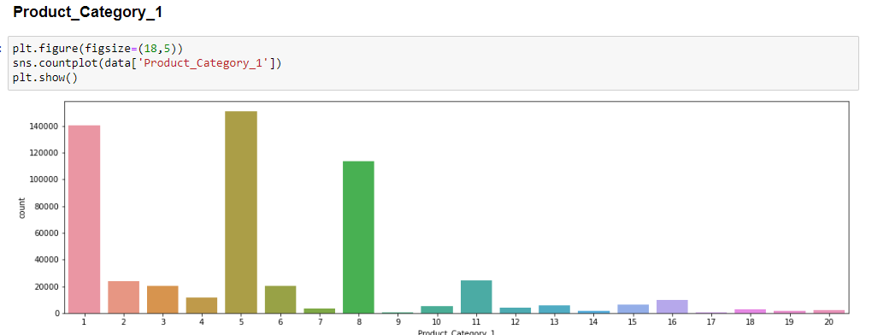

***Groupby is used for product_category_1 data so that it can separate the data into groups and mean() is used to get the average of the purchase***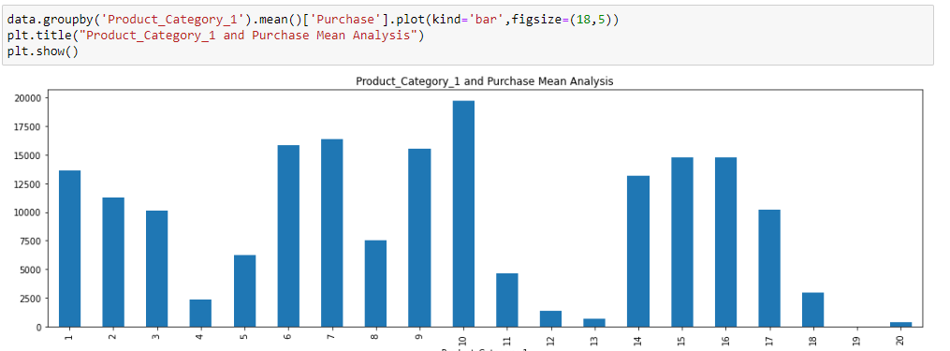

***Groupby is used for product_category_1 data so that it can separate the data into groups and mean() is used to get the sum of the purchase of the item***

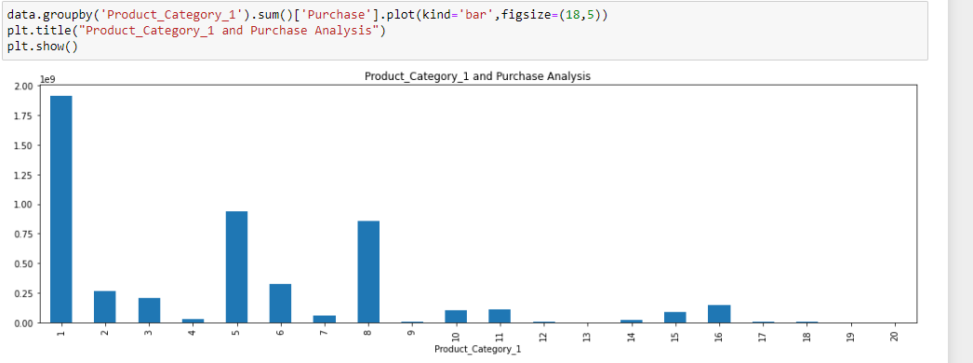

***Countplot is used to display the counts of the observations in each category i.e for product_category_2***

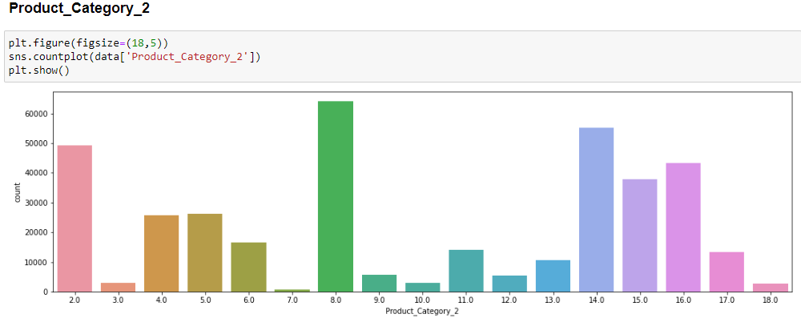

***Countplot is used to display the counts of the observations in each category i.e for product_category_3***

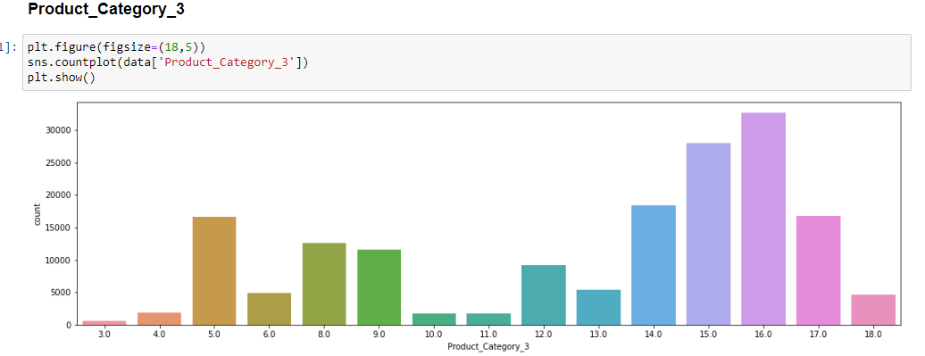

***corr() is used to find the correlation of each columns in the DataFrame. Nan values were automatically ignored.***

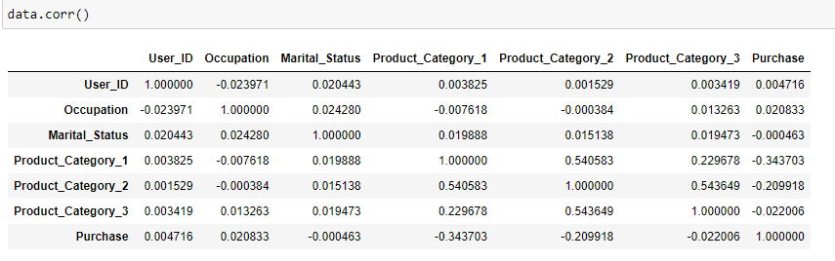

***HeatMap is used to display the correlation between the different variables in a matrix from ranging from -1 to +1. It displays the various shades of colour of each value.***

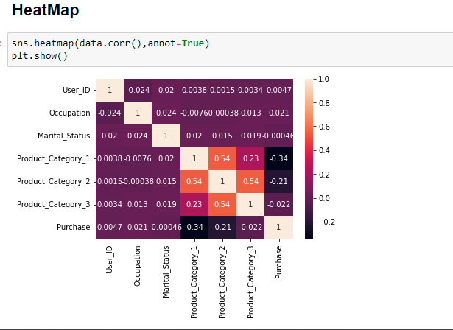

***Displaying the labels of each column below***

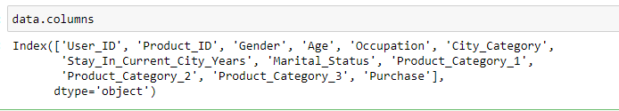

***copy() is used to create a copies of the list***



Head() displays the first 5 rows of the dataset

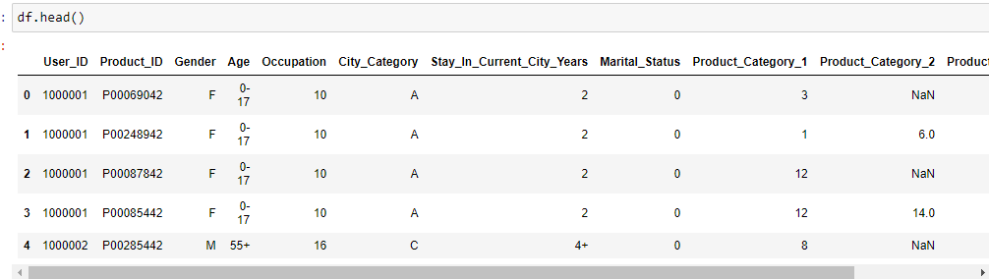

***Get_dummies is used for manipulating the data***



***Encoding the variables i.e converting set of labels into numeric form and displaying them using head() so that top five data is displayed***

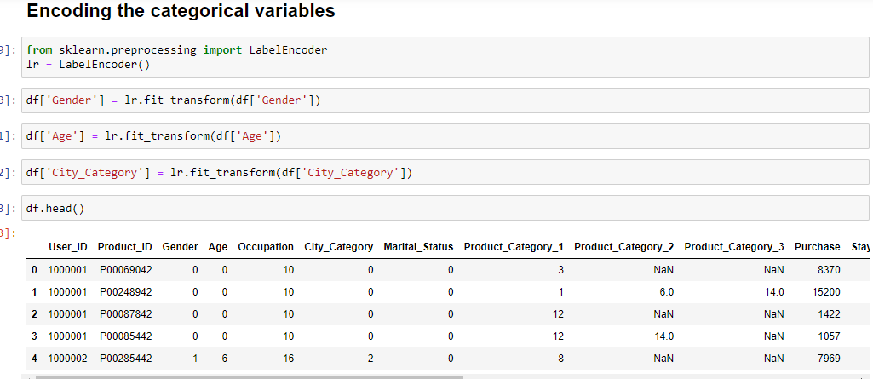

***fillna() is used to replace the values which are NULL with a specified value and isnull() is used to check whether any null values are present or not***

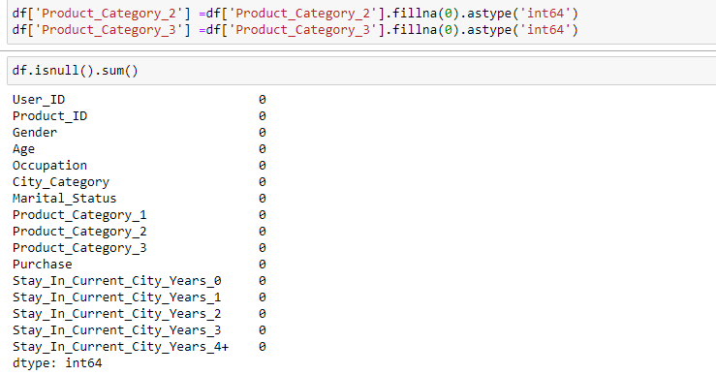

***info() is used to print the information of a DataFrame***

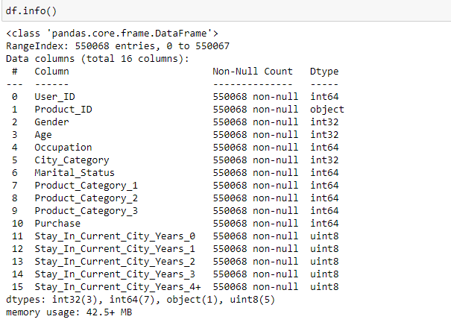

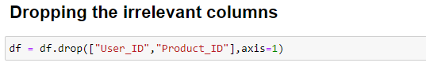

***Splitting data into dependent and independent variables i.e train and test***

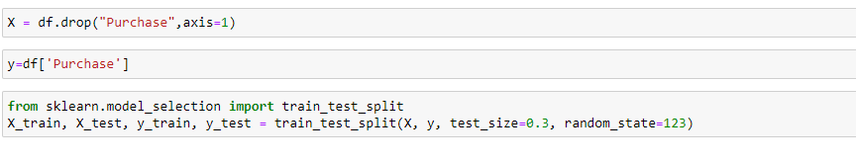

***A random forest regressor that fits a set of classification decision trees to different samples of data set and used to improve the accuracy of the predictions.***

***Creating and regressor object called RFregressor.***

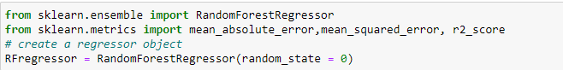

***Fit() is used to take the training data as set of parameters and perform set of calculations on the input data***

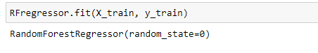

***Declaring a variable as rf_y_pred and using predict() is to predict the values of the data.***

***MAE(mean_absolute_error) is used to calculate the summation of the absolute difference between the predicted value and the true value***

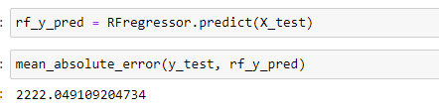

***MSE(mean_sqaured_error) is used to calculate the average of the square difference between the predicted value and the true value***

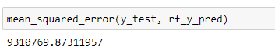

***R2_score in regression means the proportion of variance of true variable which is explained by estimated variable***

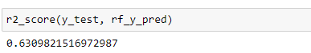

***RMSE means square rooting the value of MSE***

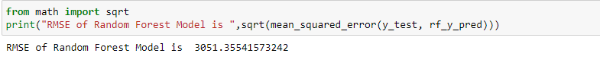

***Installing xgboost in order to perform xgboost regressor***

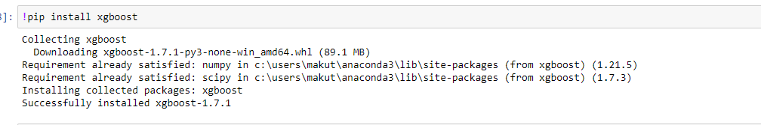

***XGBOOST means eXtreme Gradient Boosting which layout parallel tree boosting.***

***Declaring a variable and initialising the variables with some values and Fit() is used to take the training data as set of parameters and perform set of calculations on the input data***

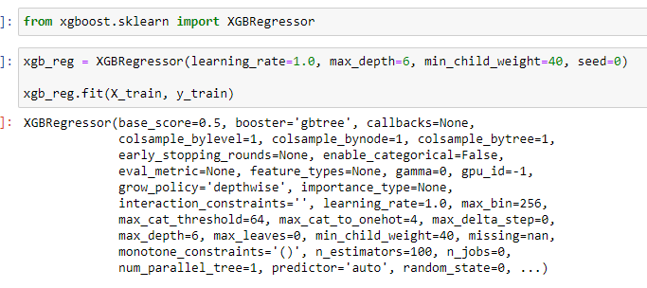

***Declaring a variable as xgb_y_pred and using predict() is to predict the values of the data.***

***MAE(mean_absolute_error) is used to calculate the summation of the absolute difference between the predicted value and the true value***

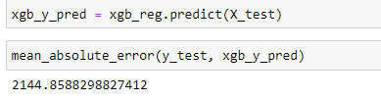

***MSE(mean_sqaured_error) is used to calculate the average of the square difference between the predicted value and the true value***

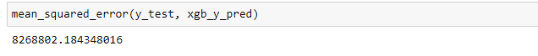

***R2_score in regression means the proportion of variance of true variable which is explained by estimated variable***



***RMSE means square rooting the value of MSE***

