ELEC 3300 Project Summary Sheet
This is a ONE Page Summary Sheet, Content more than 1 page will be deleted.
All the fonts used in this Sheet should be in Times New Roman at 12 points

Group Number | 2
Project Title | Smart Ventilator
Name of Student 1 | Sankalp Khanna
Name of Student 2 | Wang Foon Lee

Please attach ONE photo of your project here

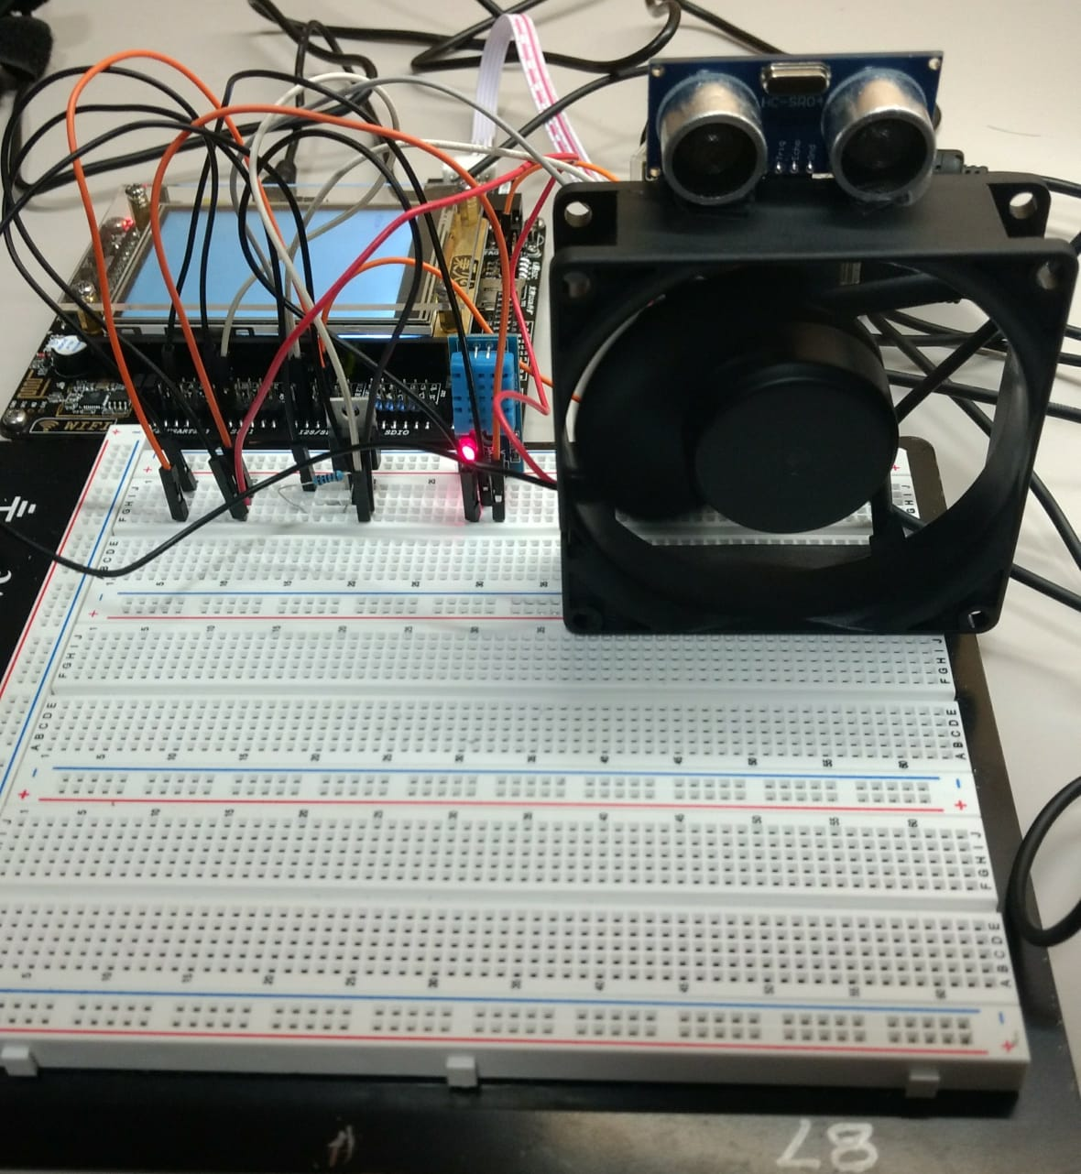

Please list the functions of your project in point form

- Uses an UV sensor (HC-SR04) to detect human presence.
- Uses DHT11 to detect room temperature and humidity.
- Switches fan on and sets speed based on human presence and room temperature.
- Displays room temperature, humidity and distance of human from sensor on the LCD screen.

