**OWN CLOUD SERVER**

**Problem Statement:**

Creating Own Cloud server in Ubuntu using the services of ownCloud.After struggling to reach mainstream status in the technology world for years, utility computing may yet arrive in the coming quarters. This time around, however, it will be known as cloud computing. And when cloud computing does cross the chasm into mainstream adoption, it will be powered by Ubuntu.

**Description:**

The term cloud computing borrows much from the utility and grid technologies that preceded it. Cloud computing describes the availability of off-premise services traditionally pictured as a cloud in architectural diagrams, hence the name - which themselves may be composed of a variety of hardware and software services.

Linux is the natural technology for enabling cloud computing: it’s modular, it’s performant, it’s power efficient, it scales, it’s open source, and it’s ubiquitous. And, as the platform upon which the largest cloud infrastructures in the world have been built, Linux - unlike other available operating systems - has little left to prove as a component of cloud infrastructures, be they public or private. “Every time you use Google, you’re using a machine running the Linux kernel,” as Google’s Chris DiBona has said.

**Setup And Configuration :**

*Steps:*

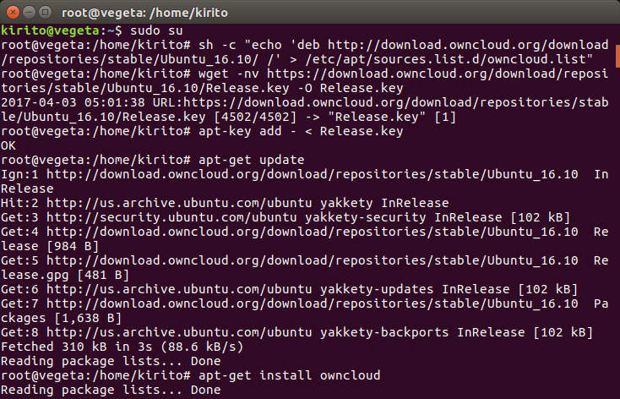

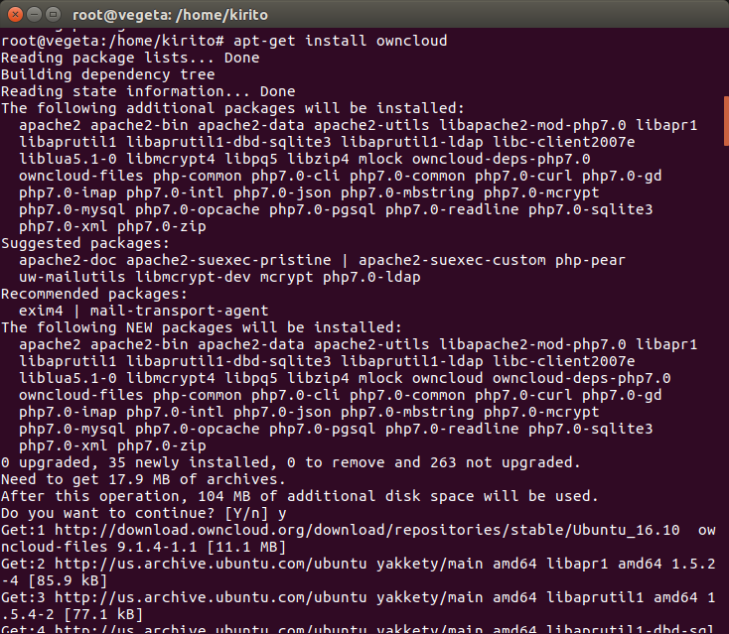

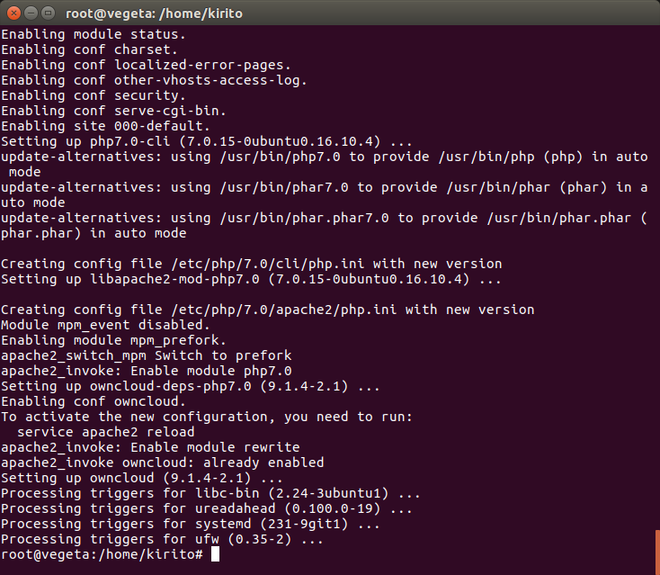

*Configurations:*

