**SIGNAL PROCESSING LABORATORY RECORD (EE314)**

**Name**: Sasank Sah

**Scholar Id**: 1913142

**Sec**: B

**Semester**: 5th

**Guided By**:

Dr. TAPAN PRADHAN.

Dr. AVADH PATI.

ELECTRICAL ENGINEERING DEPARTMENT, NIT SILCHAR.

|  |  |  |  |  |  |
| --- | --- | --- | --- | --- | --- |
| SL NO. | NAME OF EXPERIMENT | PAGE NO. | DATE OF EXPERIMENT | DATE OF SUBMISSION | REMARKS |
| 1 | GENERATION OF BASIC SIGNALS USING MATLAB | 3-9 | 07/09/2021 | 16/09/2021 |  |
| 2 | VERIFICATION OF SAMPLING THEOREM AND ALIASING | 3-10 | 16/09/2021 | 22/09/2021 |  |
| 3 | LINEAR AND CICULAR CONVOLUTION | 3-9 | 23/09/2021 | 29/09/2021 |  |
|  |  |  |  |  |  |
|  |  |  |  |  |  |
|  |  |  |  |  |  |
|  |  |  |  |  |  |
|  |  |  |  |  |  |
|  |  |  |  |  |  |
|  |  |  |  |  |  |
|  |  |  |  |  |  |
|  |  |  |  |  |  |
|  |  |  |  |  |  |
|  |  |  |  |  |  |

**INDEX**

**EXP NO : 03**

**TITLE: LINEAR AND CIRCULAR CONVOLUTION**

**Date :23/09/2021**

**Objective:**

To generate linear and circular convolution of given sequences using MATLAB

**Hardware and Software required:**

Computer

MATLAB R2021a

**Theory:**

**Circular Convolution:**

The Circular convolution, also known as cyclic convolution, of two periodic functions occurs when one of them is convolved in the normal way with a periodic summation of the other function. Circular convolution is only defined for finite length functions (usually equal in length), continuous or discrete in time. In circular convolution, it is as if the finite length functions repeat in time, periodically. Because the input functions are now periodic, the convolved output is also periodic.

Circular convolution sum can be calculated using the formula:

**Linear Convolution:**

Convolution is the process used to find the response of a Linear Time Invariant system to a given input, assuming we already know the impulse response of that system. In case of continuous-time signals, we can find the system response using the Convolution Integral, while in case of discrete-time systems; the response can be calculated using the Convolution Sum.

**Program:**

%LINEAR CONVOLUTION

x=[1 1 1 1];

h=[1 1 1 1];

y=conv(x,h);

disp(y);

subplot(3,1,1);

stem(x);

xlabel('sequence');

ylabel('amplitude x(n)');

title('Linear Convolution');

subplot(3,1,2);

stem(h);

xlabel('sequence');

ylabel('amplitude h(n)');

subplot(3,1,3);

stem(y);

xlabel('sequence');

ylabel('amplitude y(n)');

**OUTPUT:**

%CIRCULAR CONVOLUTION

clc;

clear all;

N=4;

x=[1,2,2,0];

h=[1,2,3,4];

n=0;

disp('The result of circular convolution is');

for m=1:N;

sum=0;

for k=1:N;

if((m-k)>=0)

n=m-k+1;

else

n=m-k+N+1;

end

sum=sum+x(k)*h(n);

end

disp(sum);

end

**OUTPUT:**

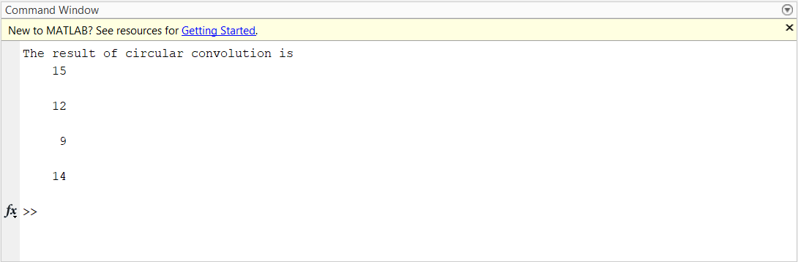

%Assignment 1

N=4;

x=[1 2 2 0];

h=[1 2 3 4];

c=cconv (x, h, N);

disp(c);

**OUTPUT:**



%Assignment 2

%Linear Convolution function

function y=convu(x, h)

L1=length(x);

L2=length(h);

Ny=L1+L2-1;

y = zeros(1,Ny);

for i = 1:L1

for k = 1:L2

y(i+k-1) = y(i+k-1) + h(k)*x(i);

end

end

%%Linear Convolution using matlab function

clc

clear all;

x=[1 1 1 1];

h=[1 1 1 1];

disp("Result of convolution is: ");

y=convu(x,h);

disp(y);

subplot(3,1,1);

stem(x);

xlabel('sequence');

ylabel('amplitude x(n)');

title('Linear Convolution');

subplot(3,1,2);

stem(h);

xlabel('sequence');

ylabel('amplitude h(n)');

subplot(3,1,3);

stem(y);

xlabel('sequence');

ylabel('amplitude y(n)');

**OUTPUT:**

%Assignment 3

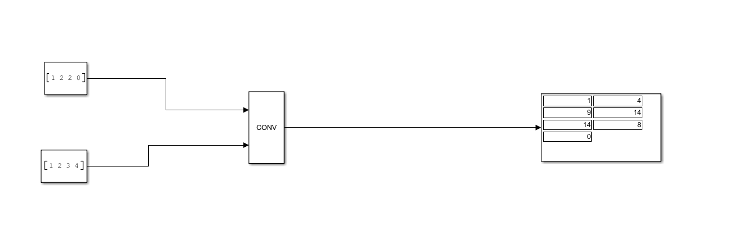

**Result and Discussion:**

In this experiment we learned to perform Linear and Circular Convolution both using .m file and Simulink. We also plotted the result in the graph as well.

**Conclusion:**

Linear and Circular Convolution was performed using .m file and Simulink successfully and conv and convc function was used for performing the same.