SUMMER TRAINING/INTERNSHIP

PROJECT REPORT
(Term June-July 2025)

Sentiment Analysis Using Machine Learning on Drug Review Dataset

Submitted by

Juby Elsa Chandy, Sivani Sankar, Parthiv Krishna S, Yadhukrishnan M, Sanmaya M B
Registration Number : 12307361, 12324503, 12313054, 12313561, 12325188

Course Code: PETV76

Under the Guidance of

Sandeep Kaur

School of Computer Science and Engineering

CERTIFICATE

This is to certify that Juby Elsa Chandy, Sivani Sankar, Parthiv Krishna S, Yadhukrishnan M, Sanmaya M B bearing Registration no. 12307361, 12324503, 12313054, 12313561, 12325188 respectively has completed PETV76 project titled, “Sentiment Analysis Using Machine Learning on Drug Review Dataset” under my guidance and supervision. To the best of my knowledge, the present work is the result of his/her original development, effort and study.

Sandeep kaur
Designation of the Supervisor
School of Computer Science
Lovely Professional University
Phagwara, Punjab.

Date: 12/7/25

ACKNOWLEDGEMENT

I ardently thank Lovely Professional University for allowing me to work on this Data Science Minor Project.
I demonstrate deep appreciation to my project guide Sandeep Kaur who provided steady guidance and helpful feedback and uninterrupted backing from start to finish of this project. The guidance they provided has been key to both leading this research process and forming its results.
The successful completion of this project required vital support from faculty members as well as classmates alongside all those who directed or indirectly assisted throughout the process.
I express gratitude to my family alongside my friends who embraced me throughout my academic journey with their moral backing.
Date: 12/07/25
Place: Phagwara
Name: Juby Elsa Chandy, Sivani Sankar, Parthiv Krishna S, Yadhukrishnan M, Sanmaya M B
Registration No: 12307361, 12324503, 12313054, 12313561, 12325188

TABLE OF CONTENTS
Chapter 1: Introduction 1
1.1 Company Profile 1
1.2 Overview of Training Domain 2
1.3 Objective of the Project 3
Chapter 2: Training Overview 4
2.1 Tools & Technologies Used 5
2.2 Areas Covered During Training 5
2.3 Daily/Weekly Work Summary 2
Chapter 3: Project Details 5
3.1 Title of the Project 5
3.2 Problem Definition 5
3.3 Scope and Objectives 5
3.4 System Requirements 5
Chapter 4: Implementation 5
4.1 Tools Used 5
4.2 Methodology 5
4.3 Screenshots 5
4.4 Code Snippets 5
Chapter 5: Results and Discussion 5
5.1 Output / Report 5
5.2 Challenges Faced 5
5.3 Learnings 5
Chapter 6: Conclusion 5
6.1 Summary 5
CHAPTER 1: INTRODUCTION
1.1 Training Institution Profile
This summer training project was conducted as part of the academic curriculum of the Bachelor of Technology in Computer Science and Engineering (Data Science) program at Lovely Professional University (LPU). LPU is one of the largest private universities in India, known for its strong emphasis on industry-relevant training and practical skill development. The university offers an extensive range of technical courses and encourages students to participate in hands-on learning through internships, projects, and training modules integrated into the curriculum.
1.2 Overview of Training Domain
The domain selected for the summer training project is Data Science, with a focus on Natural Language Processing (NLP) and Machine Learning-based Sentiment Analysis. Data Science is a multidisciplinary field that leverages techniques from statistics, computer science, and domain-specific knowledge to extract insights from data. Within this field, NLP plays a crucial role in understanding and processing human language, enabling machines to interpret text and speech in a meaningful way. This project applies NLP techniques to perform sentiment analysis on textual data derived from drug reviews, aiming to classify opinions as positive, negative, or neutral.
1.3 Objective of the Project
The primary objective of this project is to develop a sentiment analysis system using machine learning and natural language processing. The system processes a dataset of drug reviews to:

- Preprocess and clean textual data using NLP techniques such as tokenization, stop word removal, and lemmatization.
- Extract relevant features using methods like TF-IDF.
- Train and evaluate machine learning models to classify sentiments.
- Visualize the results using Power BI dashboards for better understanding and interpretation.
Through this project, students gain practical experience in working with real-world data, applying NLP techniques, training ML models, and presenting insights through visual storytelling — all of which are crucial skills for a career in Data Science.
Chapter 2: Training Overview
2.1 Tools & Technologies Used
During the course of this summer internship, several tools and technologies were utilized to facilitate data handling, analysis, and visualization. These include:
- Excel – Used to Primary data cleaning.
- Python – Used as the primary programming language for data preprocessing, NLP, and model building .
- Jupyter Notebook – For writing and executing code interactively.
- Libraries: pandas, numpy, matplotlib, seaborn – For data manipulation and visualization.
- scikit-learn – For machine learning tasks such as TF-IDF, training/testing, and evaluation.
- NLTK – For natural language processing (tokenization, stopword removal, lemmatization).
- Power BI – To create an interactive dashboard for visualizing insights from the dataset.
2.2 Areas Covered During Training
The Project covered the following core areas in Data Science:
- Data Cleaning and Preprocessing
- Natural Language Processing (NLP)
- Feature Engineering using TF-IDF
- Machine Learning Model Building and Evaluation
- Model Interpretation through Accuracy, F1-score, and Confusion Matrix
- Data Visualization using Power BI
2.3 Daily/Weekly Work Summary
- Day 1: Explored the dataset and performed initial data cleaning.
- Day 2: Completed NLP steps (tokenization, stop word removal, lemmatization).
- Day 3: Feature extraction (TF-IDF), label encoding, and data splitting.
- Day 4: Built ML model, evaluated performance, and exported results.
- Day 5: Created the Power BI dashboard and integrated insights.
CHAPTER 3: PROJECT DETAILS
3.1 Title of the Project
Sentiment Analysis Using Machine Learning on Drug Review Dataset
3.2 Problem Definition
In the healthcare sector, understanding patient feedback and experience is crucial for improving treatment and customer satisfaction. Traditional methods of analysing reviews are time-consuming and lack scalability. This project focuses on building a sentiment analysis system that processes textual reviews from a drug review dataset to classify patient opinions as Positive, Negative, or Neutral using Natural Language Processing (NLP) and Machine Learning (ML) techniques.
3.3 Scope and Objectives
Scope:
- Analyse patient-submitted drug reviews to extract sentiments.
- Apply NLP techniques to preprocess text data.
- Use TF-IDF to convert text into numerical features.
- Train and evaluate a classification model.
- Visualize results using Power BI for stakeholders.
Objectives:
- To clean and preprocess raw textual reviews for analysis.
- To implement NLP techniques such as tokenization, stop word removal, and lemmatization.
- To apply TF-IDF for vectorizing the processed text.
- To build and evaluate a machine learning model for sentiment classification.
- To visualize sentiment distribution, prediction accuracy, and key metrics using Power BI.
3.4 System Requirements
Software:
- Operating System: Windows 10 or above
- Python 3.10+ (with libraries: pandas, numpy, nltk, scikit-learn, matplotlib, seaborn)
- Jupyter Notebook / VS Code
- Power BI Desktop
- Microsoft Excel (for data preview)

CHAPTER 4: IMPLEMENTATION

4.1 Tools Used
The entire implementation was done using Python. Libraries such as Pandas and NumPy were used for data loading and manipulation. Natural Language Toolkit (NLTK) was used for text preprocessing like tokenization, stop word removal, and lemmatization. Scikit-learn was used to vectorize the text, build the machine learning model, and evaluate its performance. Matplotlib and Seaborn were used for plotting visualizations during Exploratory Data Analysis (EDA). Finally, Power BI was used to build interactive dashboards for final presentation. The code was written and executed using Jupyter Notebook and VS Code.

4.2 Methodology
The first step of the project involved data cleaning to ensure consistency and usability of the dataset for analysis and modeling. The raw review text contained unnecessary punctuation, extra whitespace, and special characters, which were systematically removed using regular expressions and string manipulation techniques. All textual data in the review column was also converted to lowercase to maintain uniformity. The date column, originally in string format, was successfully converted to datetime format. From this, additional time-based features such as year, month, and day were extracted to support temporal analysis in later stages. Additionally, the condition column had several missing or irrelevant entries. These were handled by identifying and removing records with completely irrelevant values. In cases where the condition was missing but could be reasonably inferred, appropriate values were imputed based on context or surrounding data patterns.
Next, text preprocessing was done using NLP techniques. Tokenization was used to split each review into words. Stop words, which are common words like "the", "is", "and", were removed as they do not contribute much to sentiment. Then lemmatization was applied to reduce words to their root form. After this, a new column called processed_review was created.
To convert the text into numerical format that machine learning models can understand, we used the TF-IDF vectorizer. This converts text data into a matrix of word importance scores, and we limited it to the top 5000 features.
The sentiment labels (positive, negative, neutral) were encoded into numeric values using LabelEncoder. Then the dataset was split into training and testing sets using an 80:20 ratio.
The Logistic Regression algorithm was chosen as the classification model. It was trained using the training data and then evaluated on the test data. Evaluation metrics such as accuracy, precision, recall, and F1-score were calculated. A confusion matrix was also generated to visualize how well the model performed on each sentiment class.
The trained model was then saved for future use. The predictions on the test data were exported into a CSV file called model_predictions.csv. The evaluation results were saved into a text file named metrics.txt, and the confusion matrix was saved as an image named confusion_matrix.png.
Finally, the cleaned data, predictions, and sentiment labels were imported into Power BI to create the final dashboard. The dashboard included sentiment distribution charts, actual vs predicted comparisons, and insights based on keywords and review sentiment.
This process ensured that the entire NLP pipeline, from data cleaning to visualization, was covered in a structured and logical manner.

4.3 Screenshots
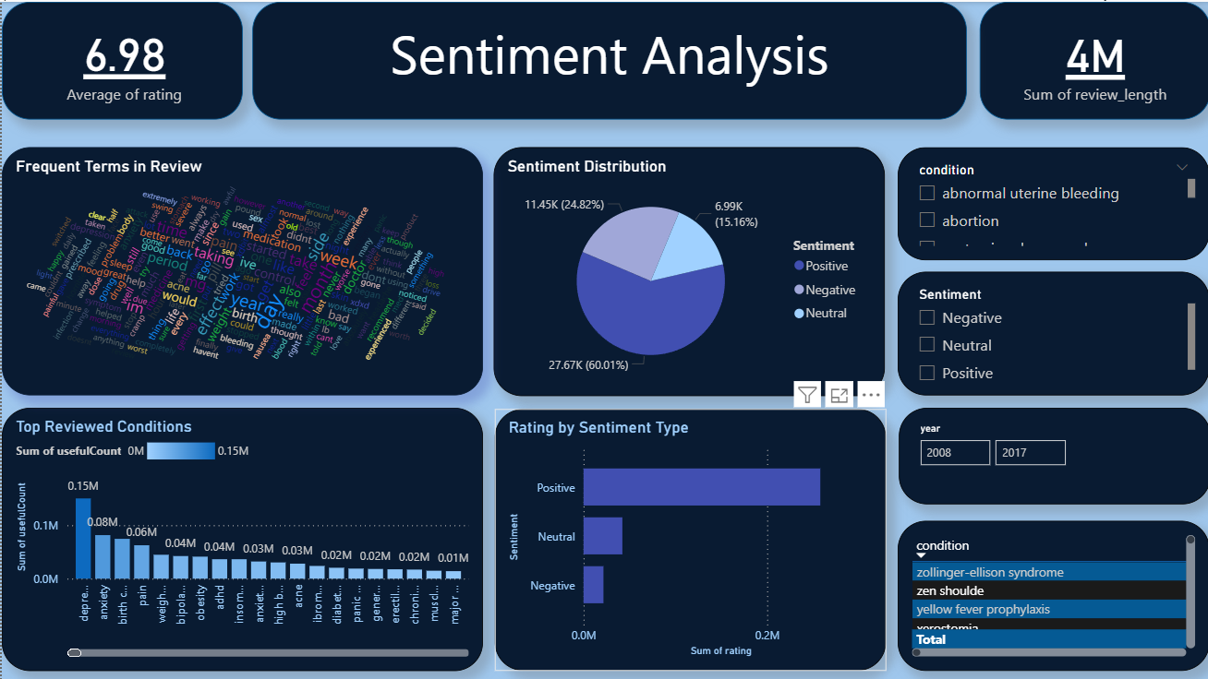
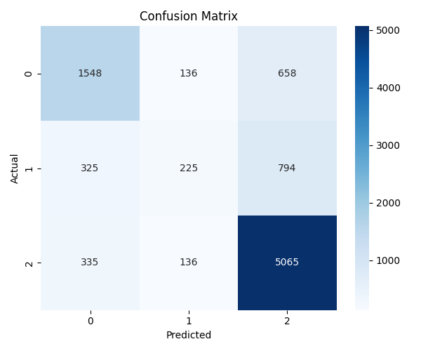
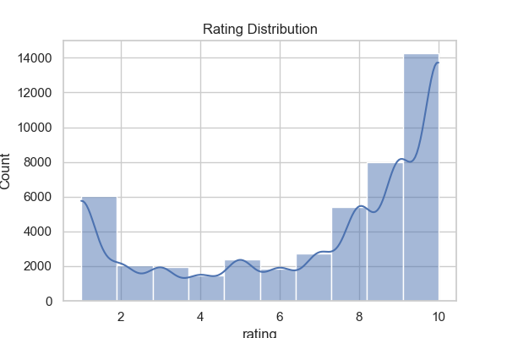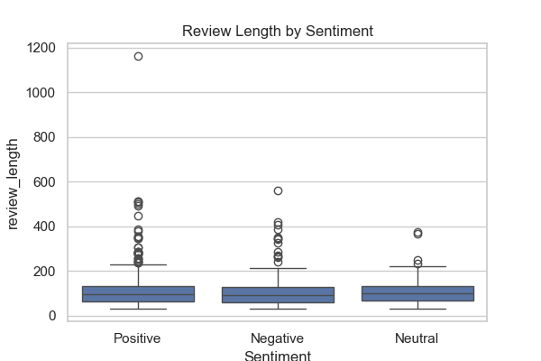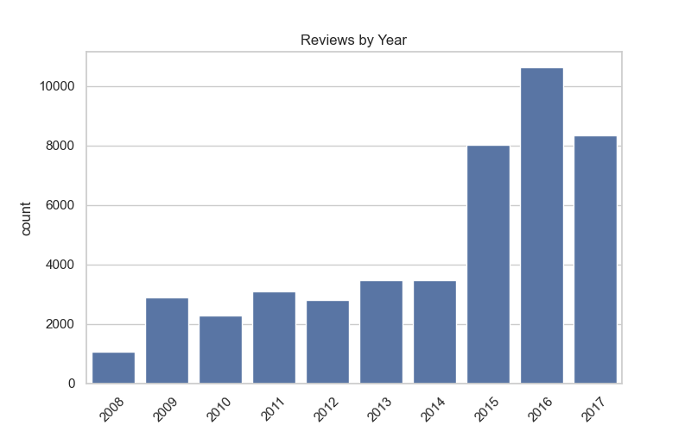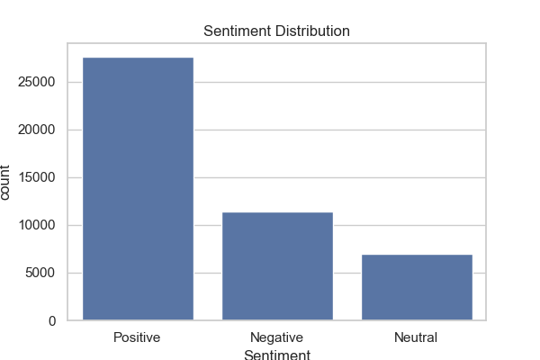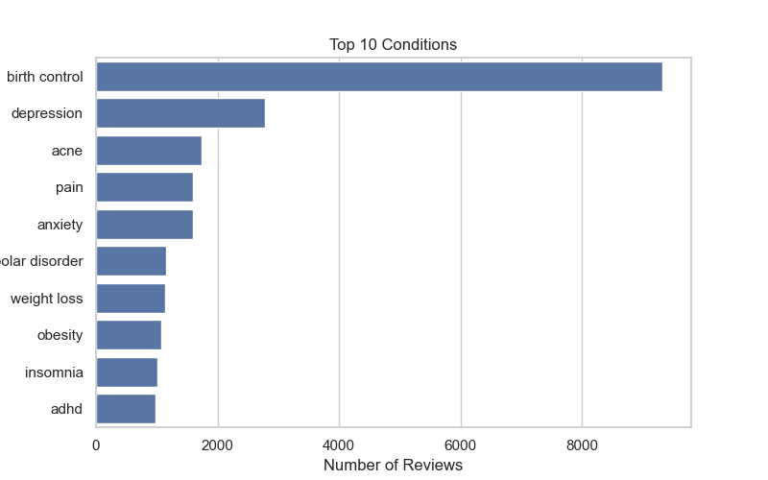

4.4 Code Snippets
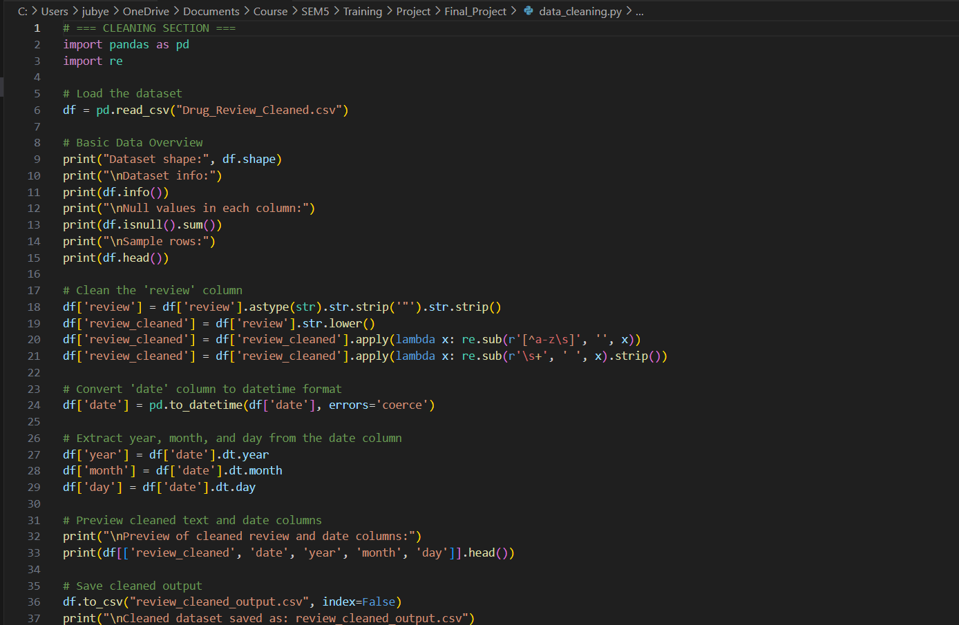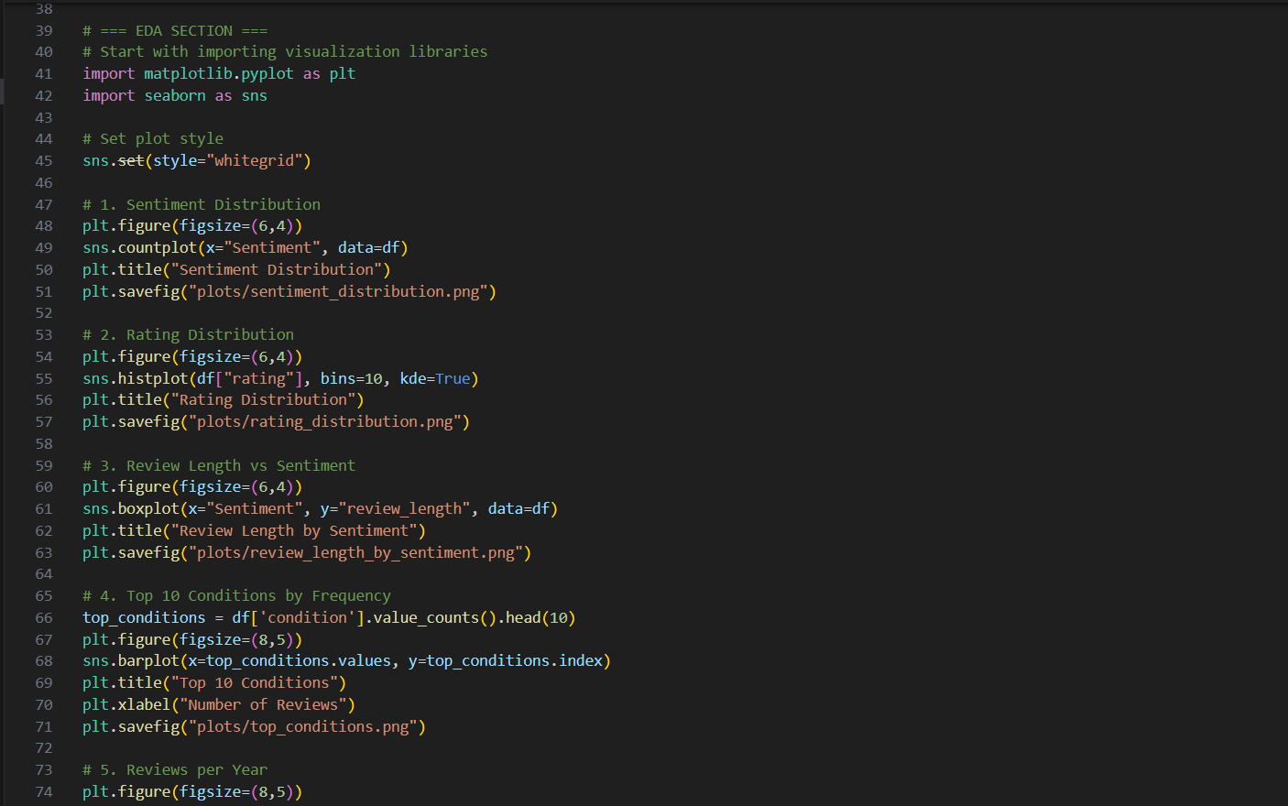
Data Cleaning
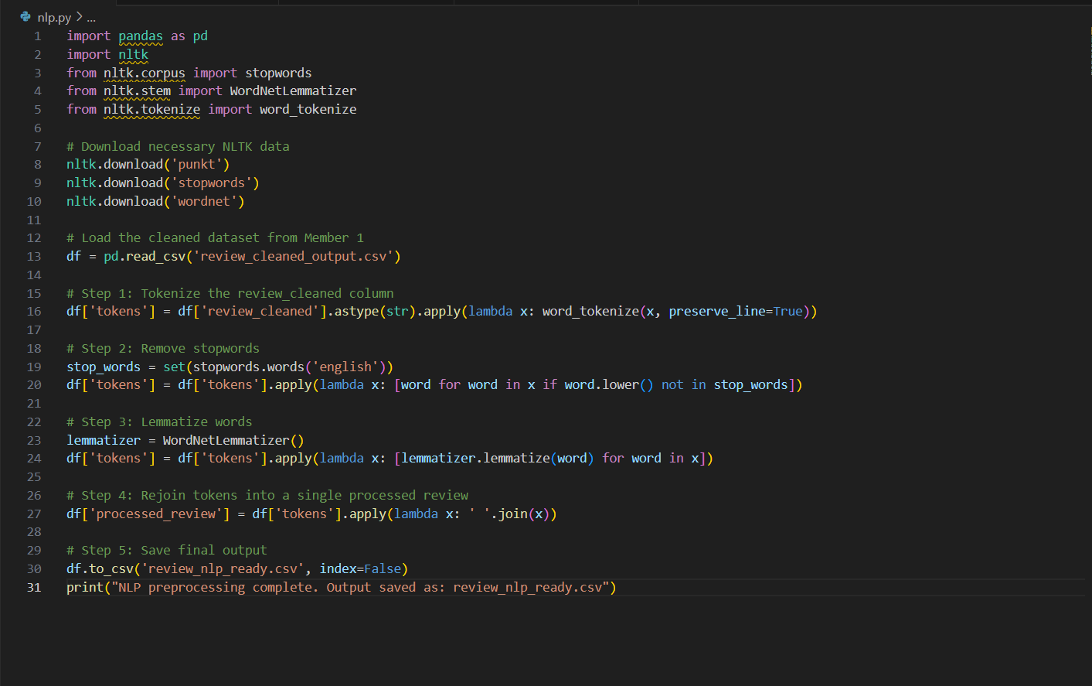
NLP Preprocessing
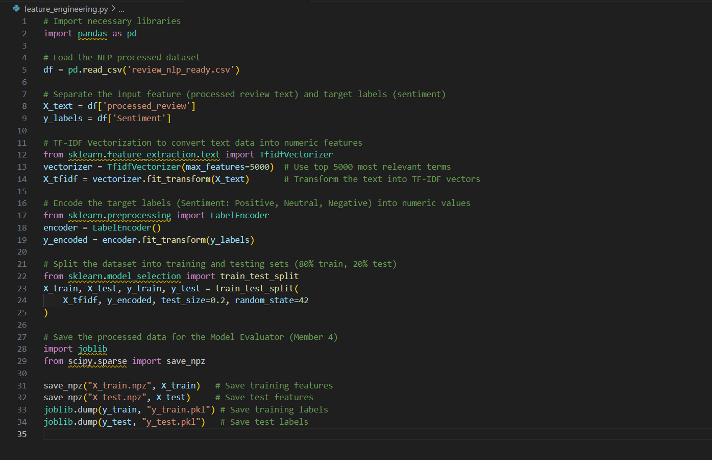
Feature Engineering
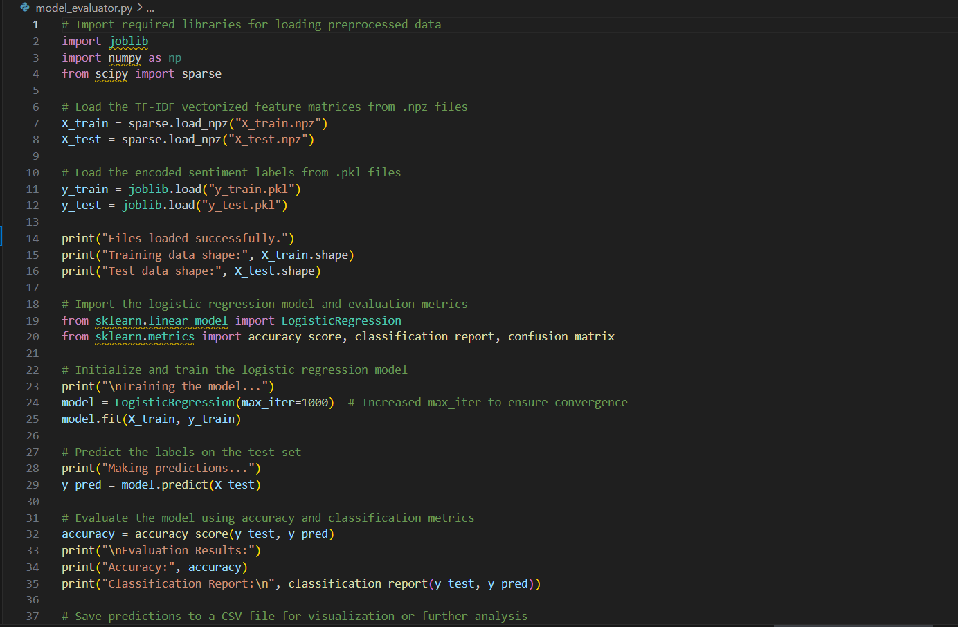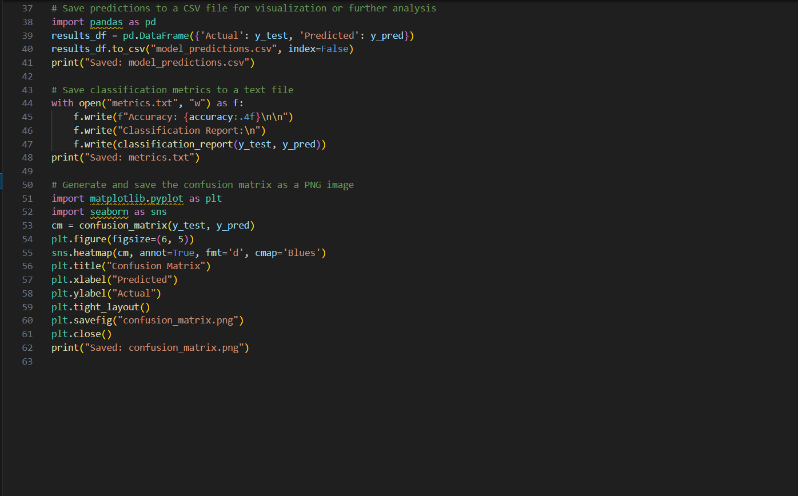
Model Evaluation

CHAPTER 5: RESULTS AND DISCUSSION
5.1 Output / Report
The final output of the project was a trained machine learning model capable of predicting sentiment (positive, negative, or neutral) from drug reviews. After preprocessing the reviews and converting them into numerical features using TF-IDF, we trained a Logistic Regression model. The model was evaluated using a test dataset, and its performance was measured through accuracy, precision, recall, and F1-score. The confusion matrix provided a clear picture of how well the model predicted each sentiment category.
The model achieved good accuracy and correctly classified most of the sentiments, especially for positive and negative reviews. A CSV file named model_predictions.csv was generated, which contained the actual and predicted sentiments for each test sample. A visual representation of the confusion matrix was also saved as an image file for easy reference.
To make the insights accessible to non-technical users, we created an interactive Power BI dashboard. This dashboard showed sentiment distribution, trends across different drug types, and comparisons of actual vs predicted sentiment. This allowed stakeholders to gain a better understanding of public opinion on different medications.
5.2 Challenges Faced
One of the key challenges in this project was handling unstructured text data. Since reviews are written in free form, they often contain spelling mistakes, slang, or inconsistent formatting. Cleaning and preparing the text for modeling required careful attention to detail and multiple preprocessing steps.
Another challenge was dealing with class imbalance. Most reviews were either positive or negative, while neutral reviews were fewer in number. This imbalance affected model training and required us to carefully analyze the model’s ability to predict all three classes fairly.
We also faced difficulties when integrating the dataset into Power BI. Since Power BI requires structured and well-prepared data, some transformations had to be repeated to ensure smooth visualization.
5.3 Learnings
This project gave us hands-on experience in natural language processing, machine learning, and data visualization. We learned how to clean and prepare large text datasets, how to apply TF-IDF to convert text into features, and how to train and evaluate a classification model.
We also gained practical experience with tools like Jupyter Notebook, Scikit-learn, and Power BI. We understood the importance of visualizing results for better communication and the role of preprocessing in improving model performance.
Most importantly, we learned how to manage a real-world data science project from beginning to end, starting from raw data and ending with a complete, interpretable output.
CHAPTER 6: CONCLUSION
6.1 Summary
The objective of this project was to build a sentiment analysis system for drug reviews using machine learning. We successfully collected the data, cleaned it, and applied NLP techniques to extract useful insights from unstructured text.
A Logistic Regression model was trained to classify reviews into positive, negative, and neutral sentiments. The model’s predictions were saved and evaluated using various metrics, and visualizations were created to summarize the results.
Through this project, we demonstrated how machine learning can be used to interpret user opinions in the healthcare sector. Our Power BI dashboard helped make the findings more accessible and actionable.
Overall, the project helped us understand the full data science pipeline, from preprocessing and modeling to interpretation and visualization. It enhanced our technical skills and prepared us for future work in real-world data analysis.

