**AIWR**

**ASSIGNMENT - 02**

**Movie** **Recommender** **System**

**Team Members:**

|  |  |
| --- | --- |
| **Name** | **SRN** |
| Sanmat Sanjayakumar Payagoudar | PES1UG20CS385 |
| Shamith V S | PES1UG20CS390 |
| Monisha N | PES1UG21CS820 |
| Sumukha S S | PES1UG21CS833 |

**SECTION 1 : PROBLEM STATEMENT**

The goal is to create a system for reliably recommending movies to users based on their viewing interests, viewing history, and other pertinent information like movie ratings and reviews. The system should be able to offer tailored movie suggestions that take into consideration each user's distinct preferences and interests as well as their demographics and behavioral tendencies. By providing pertinent and interesting movie suggestions that boost user engagement and happiness with the site, the aim is to enhance the user experience

**SECTION 2 : INTRODUCTION**

A personalized movie recommendation system proposes films to viewers based on their prior viewing habits, movie reviews, and other pertinent information. In order to generate personalized recommendations that are catered to each user's particular interests and preferences, the system employs algorithms to analyze a user's watching history, demographic traits, and behavioral patterns.

Systems for making movie recommendations are crucial for streaming video services like Netflix, Hulu, and Amazon Prime Video. It can be difficult for people to find films or TV episodes they want to watch on these platforms because they have such a large selection. A recommendation system makes it easier for users to access pertinent material fast, enhancing their platform engagement.

There are several applications for movie recommendation algorithms in the real world. For instance, in the entertainment sector, production companies can recommend movie scripts that are expected to perform well at the box office using recommendation systems. Additionally, movie theatres can make movie suggestions to patrons based on their location, movie preferences, and other pertinent variables using recommendation algorithms. By recommending instructive films or documentaries to students based on their interests, movie recommendation systems in the educational sector might enhance the learning process.

Generally speaking, movie recommendation systems are crucial for giving users tailored recommendations, enhancing the user experience, and raising user engagement and happiness with the platform.

**SECTION 3 : DATASET DESCRIPTION**

The data for this assignment is gathered from grouplens. It is a IMDB movie dataset.

Link to dataset:

<https://grouplens.org/datasets/movielens/100k/>

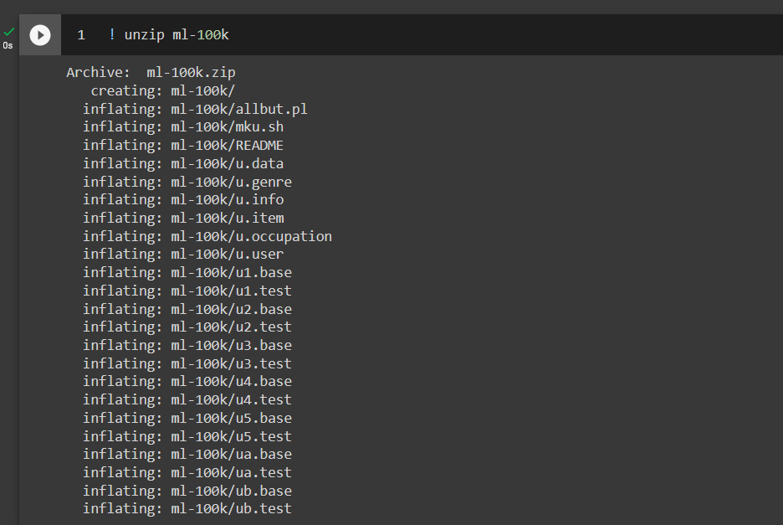

**Summary of the Dataset:**

A well-known benchmark dataset for recommender systems, the MovieLens 100K dataset is frequently used for developing and testing different machine learning algorithms.

The dataset consists of 100,000 ratings (from 1 to 5 stars) for 1,682 films from 943 individuals. Along with demographic data on users (such as age, gender, and occupation), it also contains details about the movie genres. The MovieLens users who volunteered to take part in the data collection process provided the evaluations between January 1995 and October 1998.

The dataset is made available in a number of different formats, including a CSV file that contains user ratings, a second file for user data, and a third file for movie data. The dataset also includes a README file that contains comprehensive information about the dataset, its application, and the data collection procedure.

Overall, the MovieLens 100K dataset is a useful tool for researchers and professionals working in the field of recommender systems. It can be applied to many different tasks, such as developing and assessing recommendation algorithms, analysing user behaviour, and examining the connection between demographics and movie preferences.

**SECTION 4 : EDA**

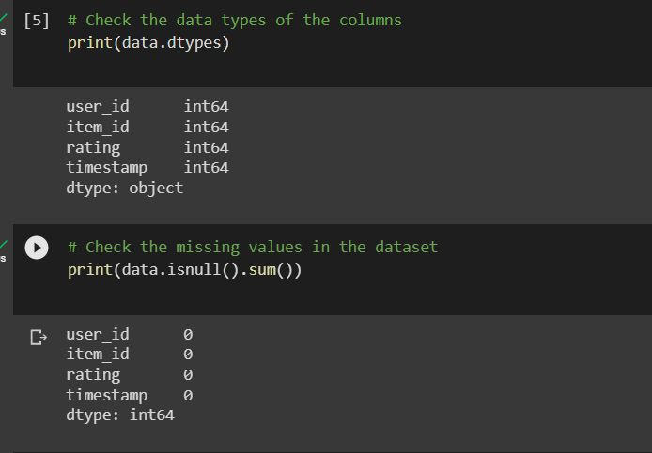

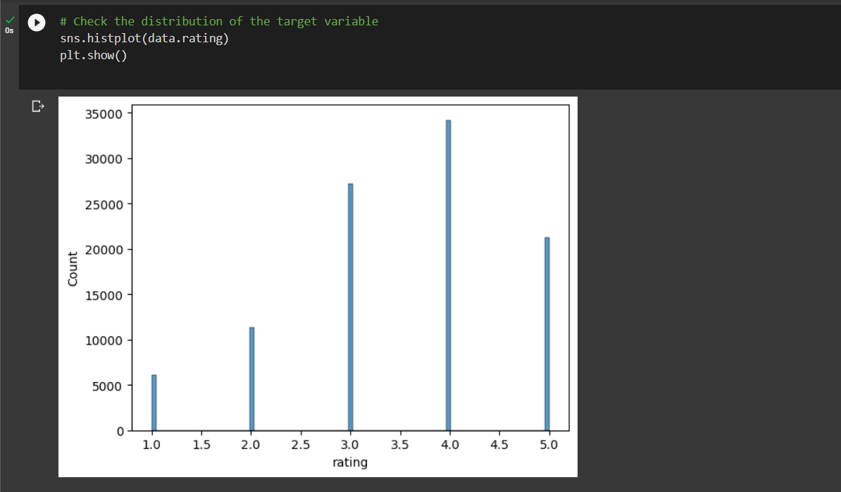

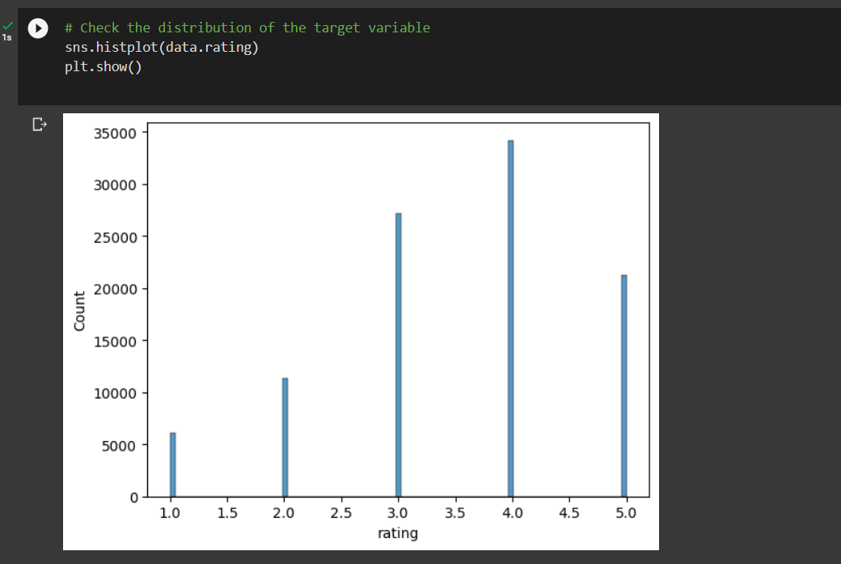

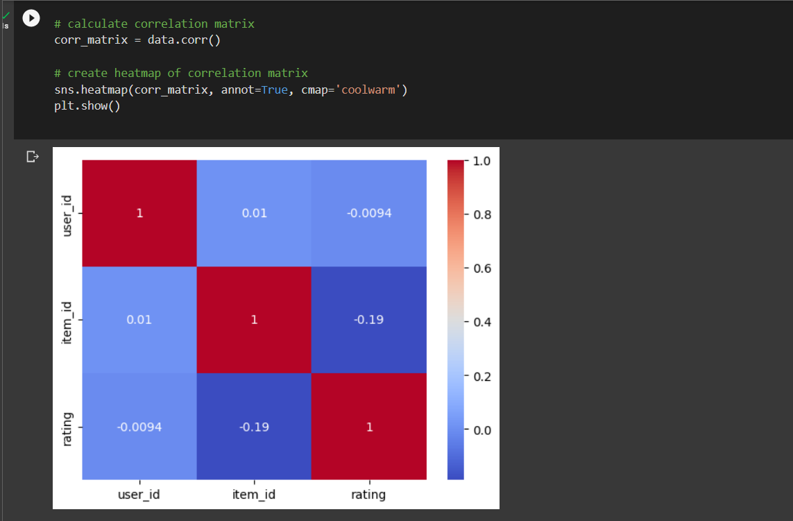

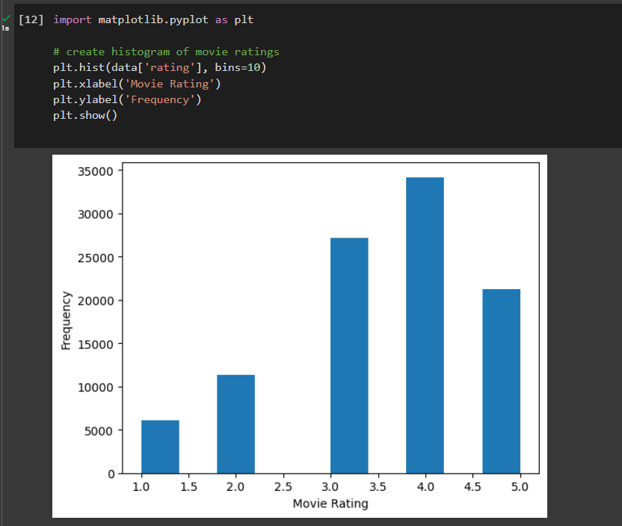

**SECTION 5 : PRE PROCESSING OF DATA**

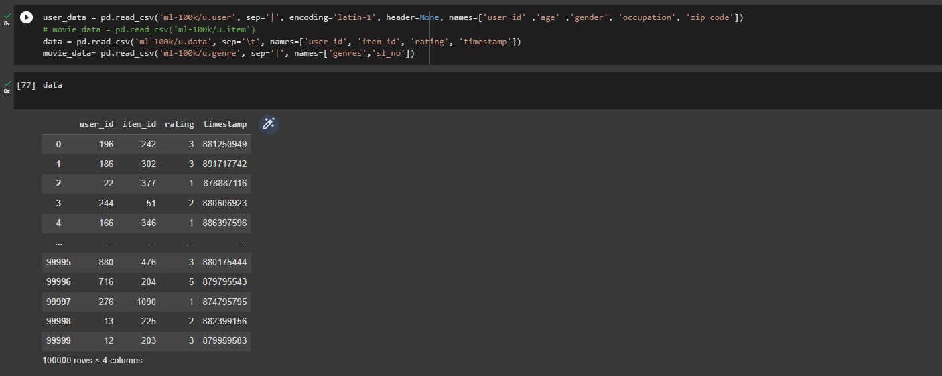

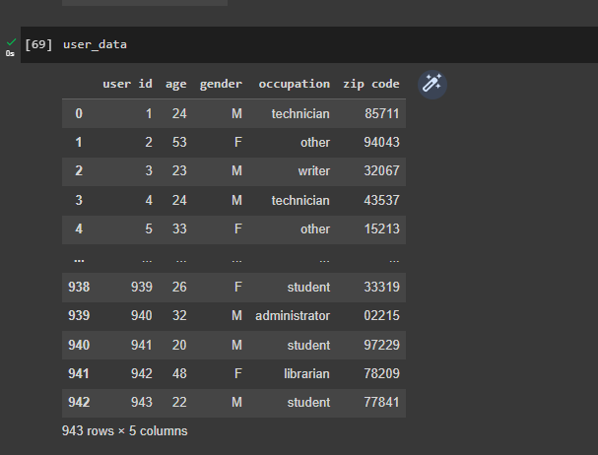

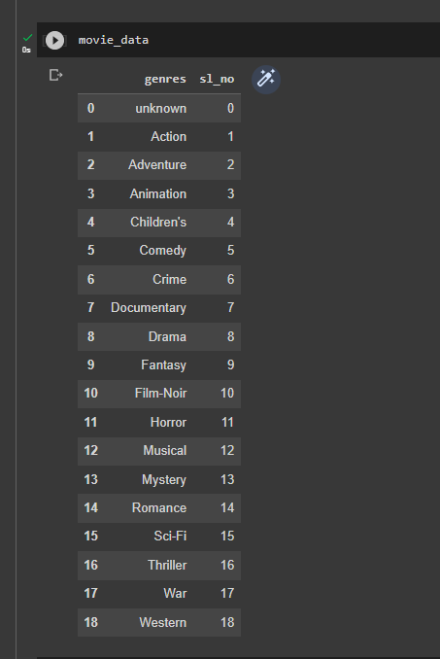

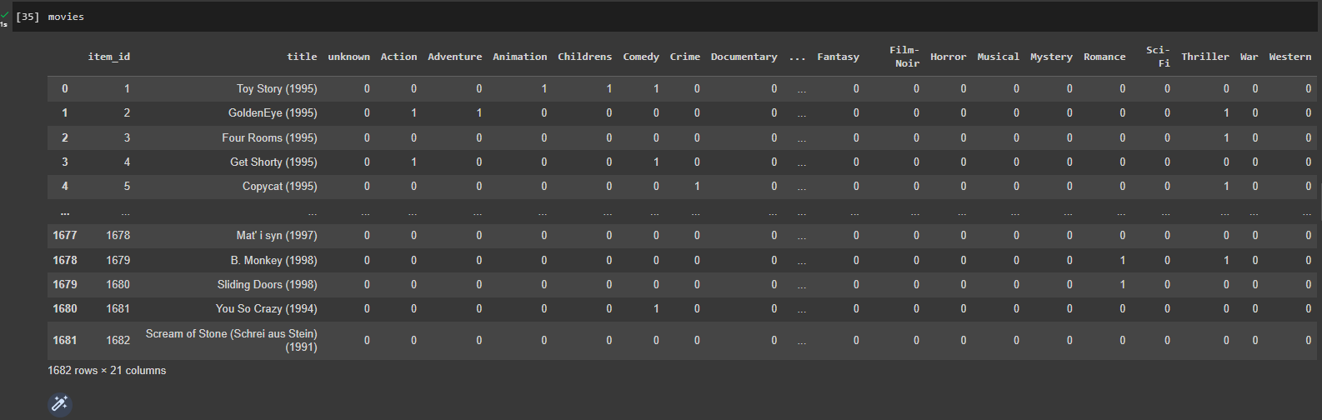

**SECTION 6 : USING COLLABARATIVE FILTERING**

**Collaborative filtering analysis :**

A well-liked recommendation system called collaborative filtering uses user behaviour analysis to produce tailored recommendations. EDA approaches can be used to spot patterns in user behaviour, such as the films that people tend to watch together most often or the genres that appeal to different age groups.

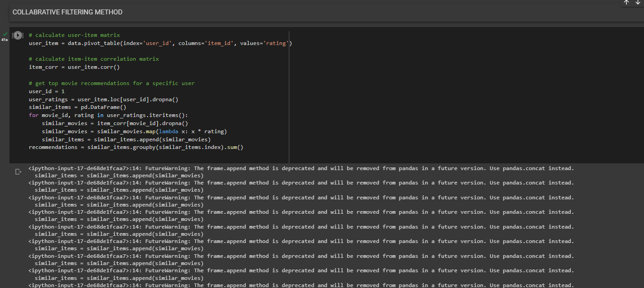

**OUTPUT :**

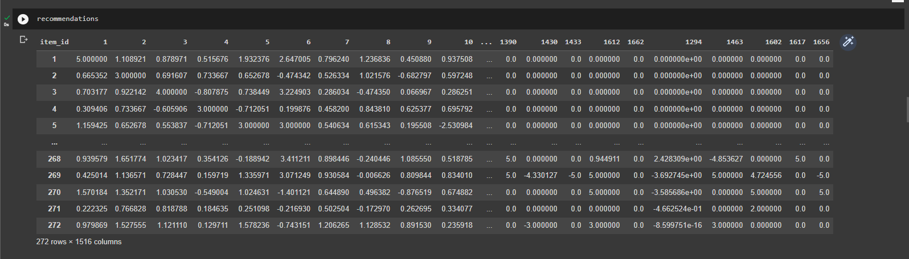

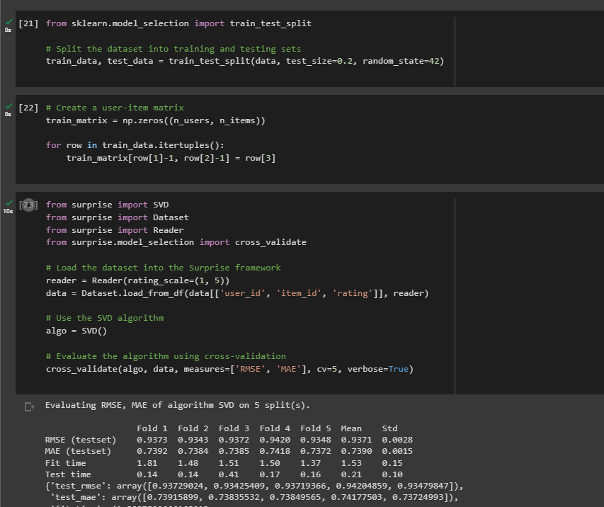

**COSINE SIMILARITY :**

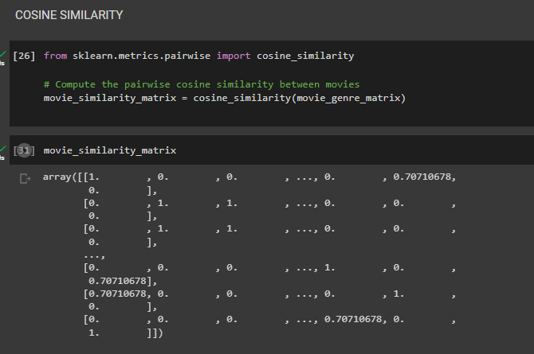

**SECTION 7 : CONTENT BASED**

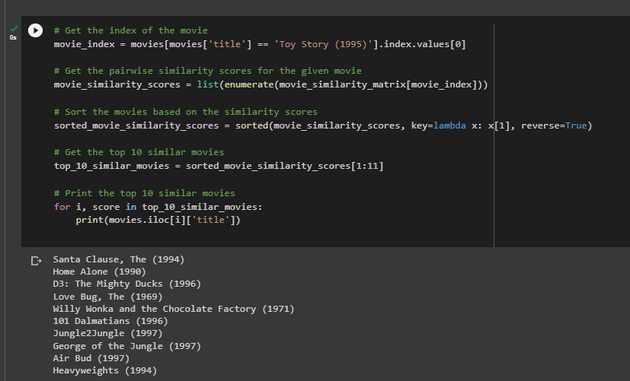

**ANALYSIS OF MODEL :**

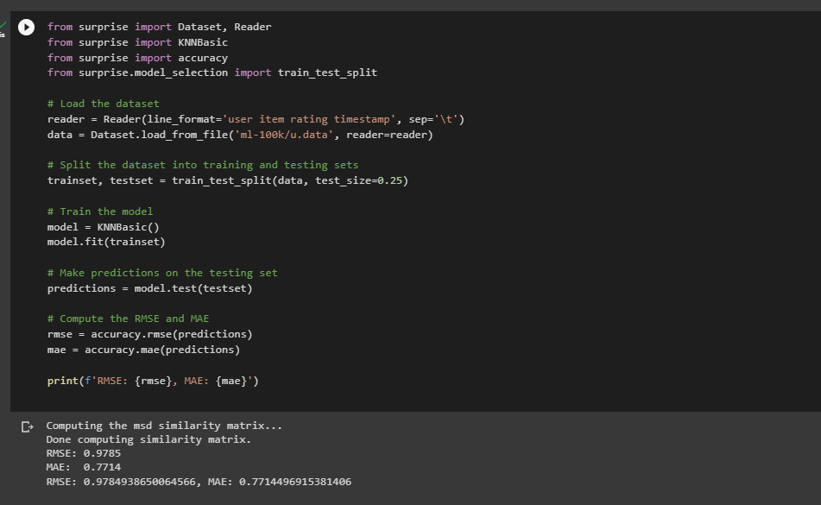

**PREDICTIONS :**

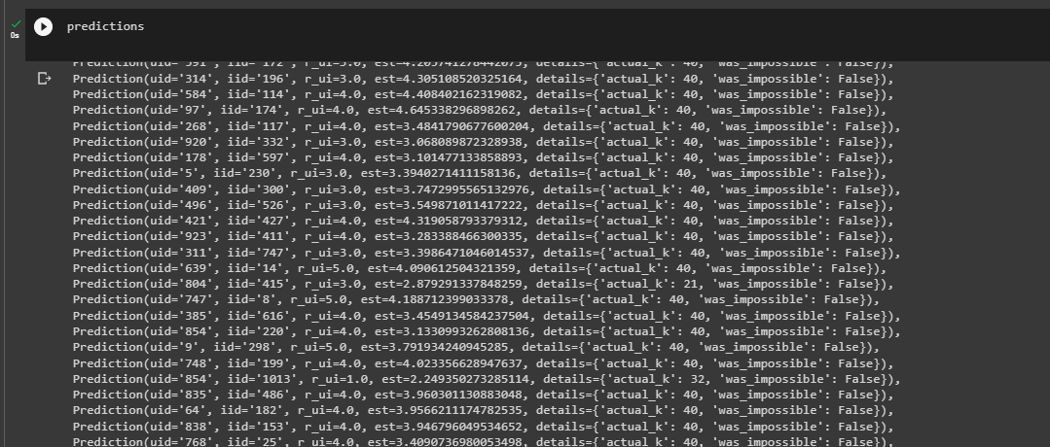

**HYBRID RECOMMENDOR :**

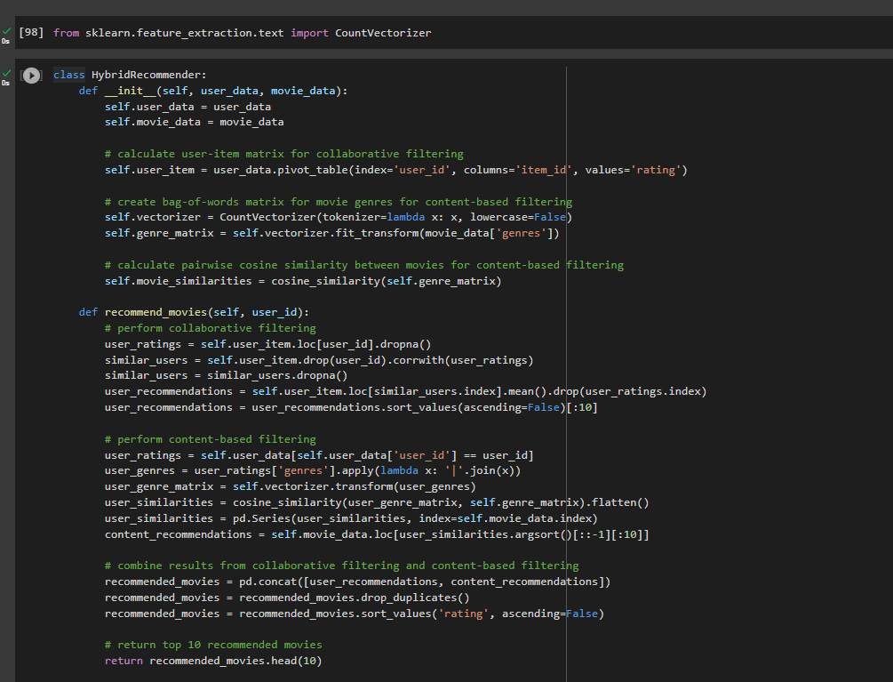

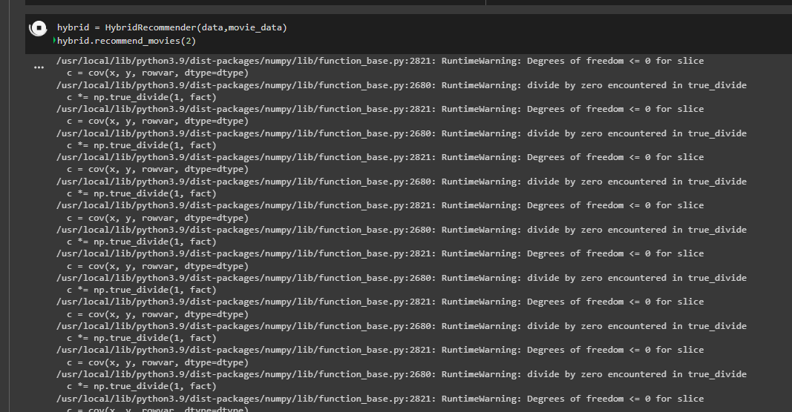

**CONCLUSION:**

In conclusion, a movie recommendation system is a crucial tool for giving customers tailored movie suggestions based on their viewing interests and history. Collaborative filtering, content-based filtering, and hybrid recommender systems—which integrate both methods—are a few examples of different recommender system kinds. Each of these strategies has benefits and drawbacks.

A common strategy for recommending films is collaborative filtering, which makes use of user behaviour data. It operates by identifying user similarities and recommending films that those users have seen and highly rated. On the other side, content-based filtering suggests films based on their qualities and characteristics, such as their genre, actors, and directors.

For more precise and varied recommendations, hybrid recommender systems integrate collaborative and content-based filtering. They can get beyond each method's drawbacks and offer a better overall suggestion experience.

To create a movie recommendation system, a variety of tools and packages are available, including Surprise, LightFM, and TensorFlow. These tools offer a quick and scalable solution to install various recommender system types and assess their effectiveness.

Movie streaming services like Netflix, Amazon Prime Video, and Hulu frequently use movie recommender systems to offer their subscribers individualised movie recommendations. They can boost user experience overall, raise revenue, and improve user engagement and retention.

The movie recommendation system is an effective tool that may offer users personalised and pertinent movie choices. We can create accurate and efficient recommendation systems that give viewers a better movie-watching experience by utilising the advantages of various methodologies.