**CLOUD** **COMPUTING**

**Assignment** – **3**

Name : Sanmat Sanjayakumar Payagoudar

SRN : PES1UG20CS385

Section : G

Lab 1 - Introduction to Amazon S3 :

1c: Display new-report.png after making it publicly accessible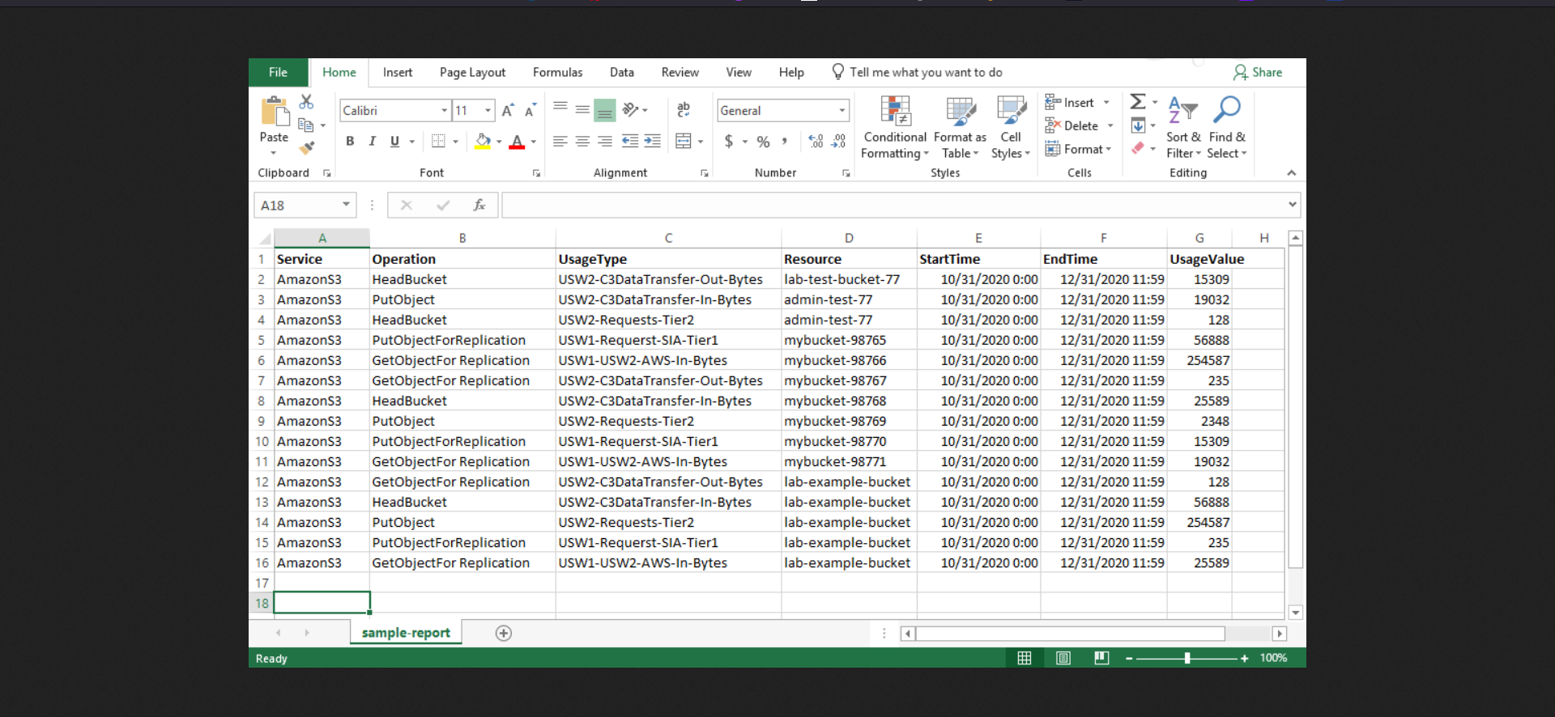

1f: Display sample-file.txt after updating policy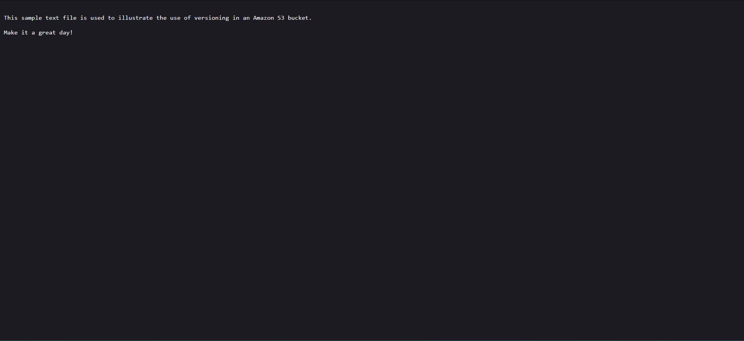

Lab 7 - Hosting a Static Website Using Amazon Simple Storage Service (Amazon S3) :

2a: Enabled static website option selected under “Edit static website hosting”

2c: Uploaded objects (index.html, script.js, style.css)

