**CLOUD COMPUTING**

**ASSIGNMENT – 4**

Name : Sanmat Sanjayakumar Payagoudar

SRN : PES1UG20CS385

Section : G

**TASK A: Installing Zookeeper**

1a: Screenshot of Zookeeper Server having started.

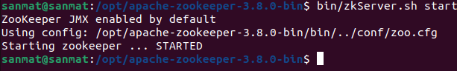

**TASK B: Getting Familiar with Zookeeper CLI**

2a: Screenshot of Listing of the created ZNodes

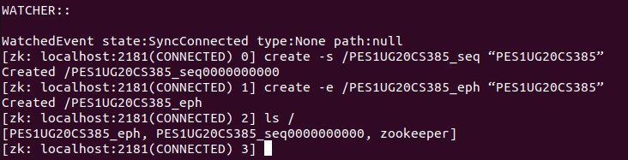

2b: Screenshot of Listing of the deleted ephemeral node

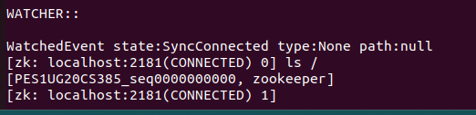

2c: Screenshot of Data and Metadata associated with the created sequential znode.

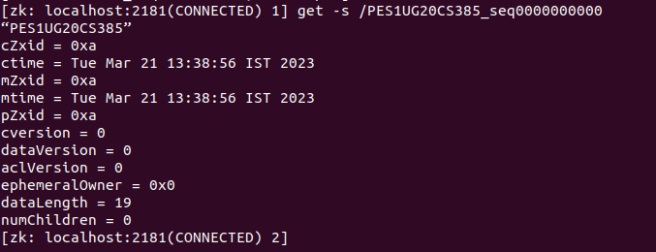

2d: Screenshot of Listing of all the children nodes

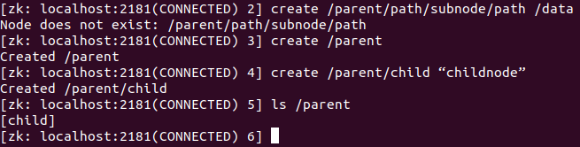

**TASK B: Naive Leader Election with Zookeeper CLI - Understanding the Algorithm**

3a: Screenshot of each of the clients listing all the znodes

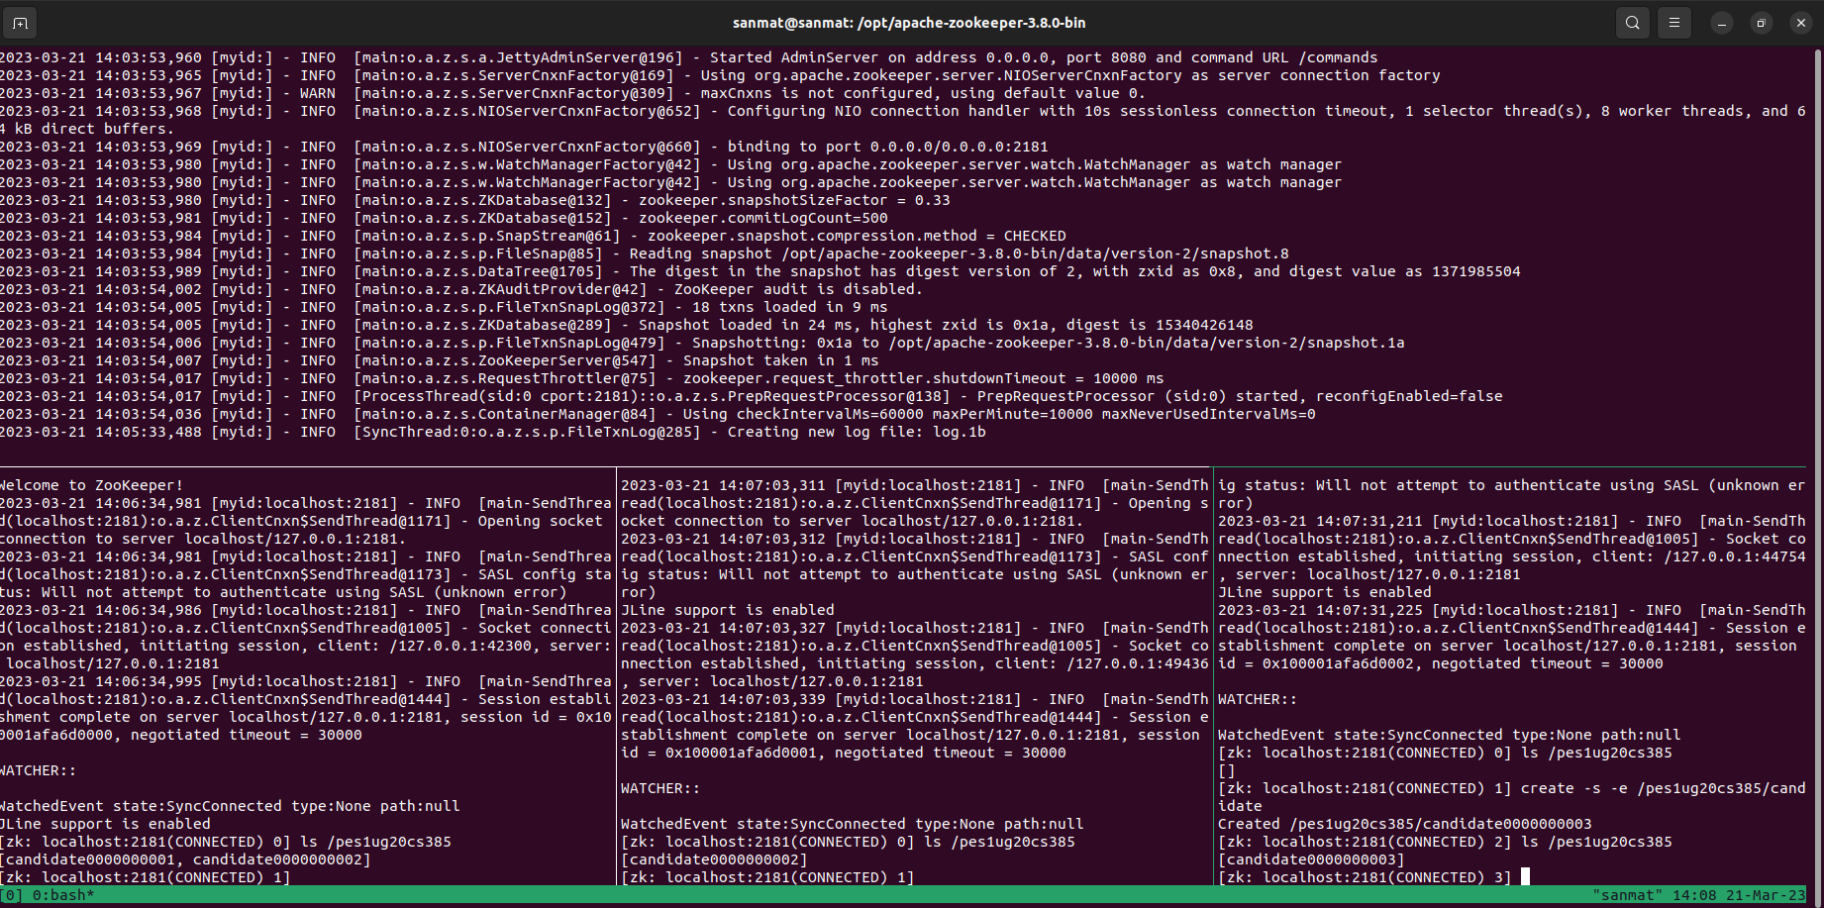

3b: Screenshot of the Watched Event and the Zookeeper Server logs.

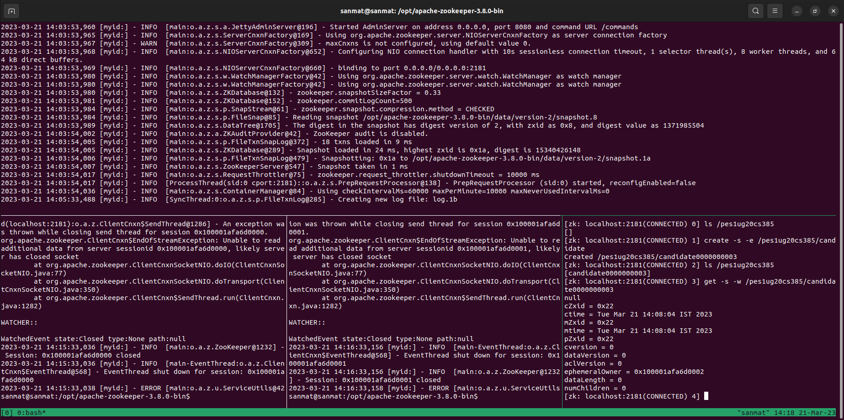

3c: Screenshot of the old leader coming back and having a new sequence number.

