**CLOUD COMPUTING**

**LAB – 2**

Name : Sanmat Sanjayakumar Payagoudar

SRN : PES1UG20CS385

Section : G

**1a)** Screenshot of running docker hello-world.

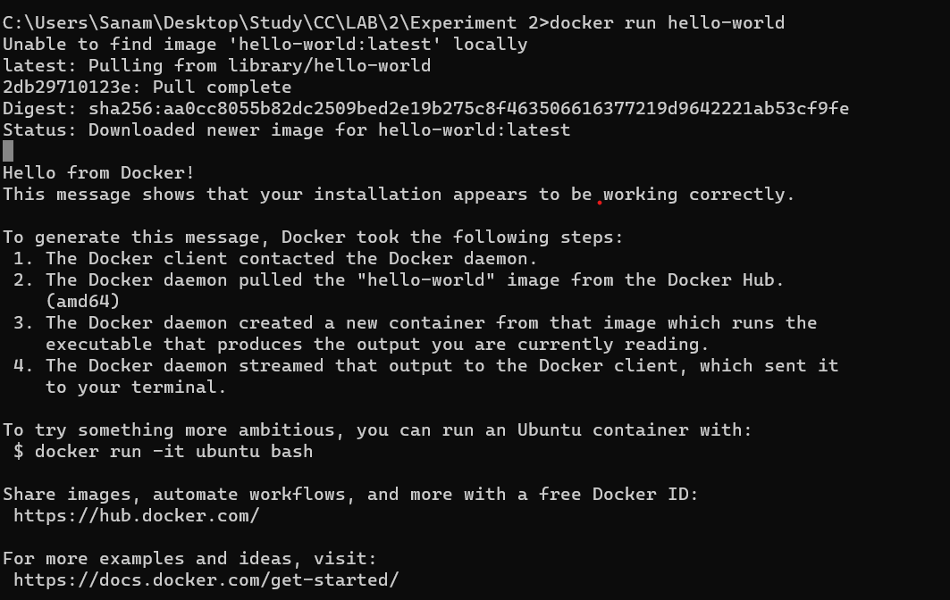

**2a)** Screenshot of C Program successfully run inside the container.



**2b)** Screenshot of the image pushed to Dockerhub.

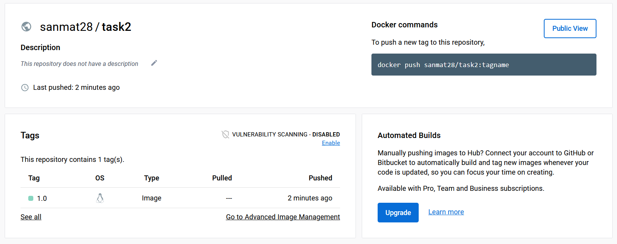

**3a)** Screenshot of docker container running nginx.

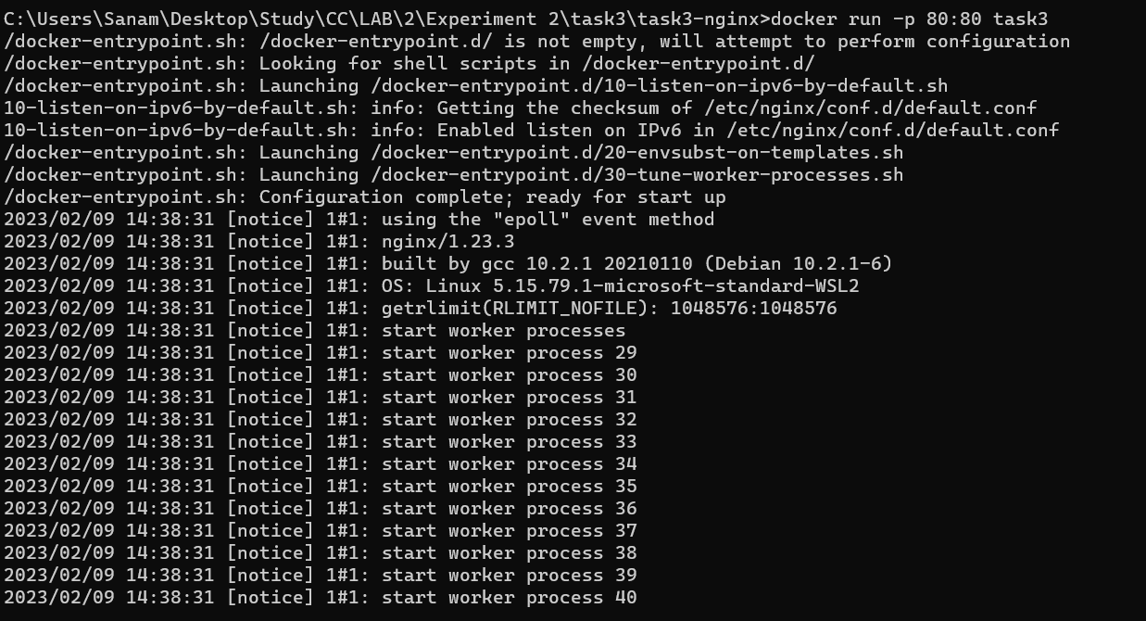

**3b)** Sample.html showing the web page on the browser.

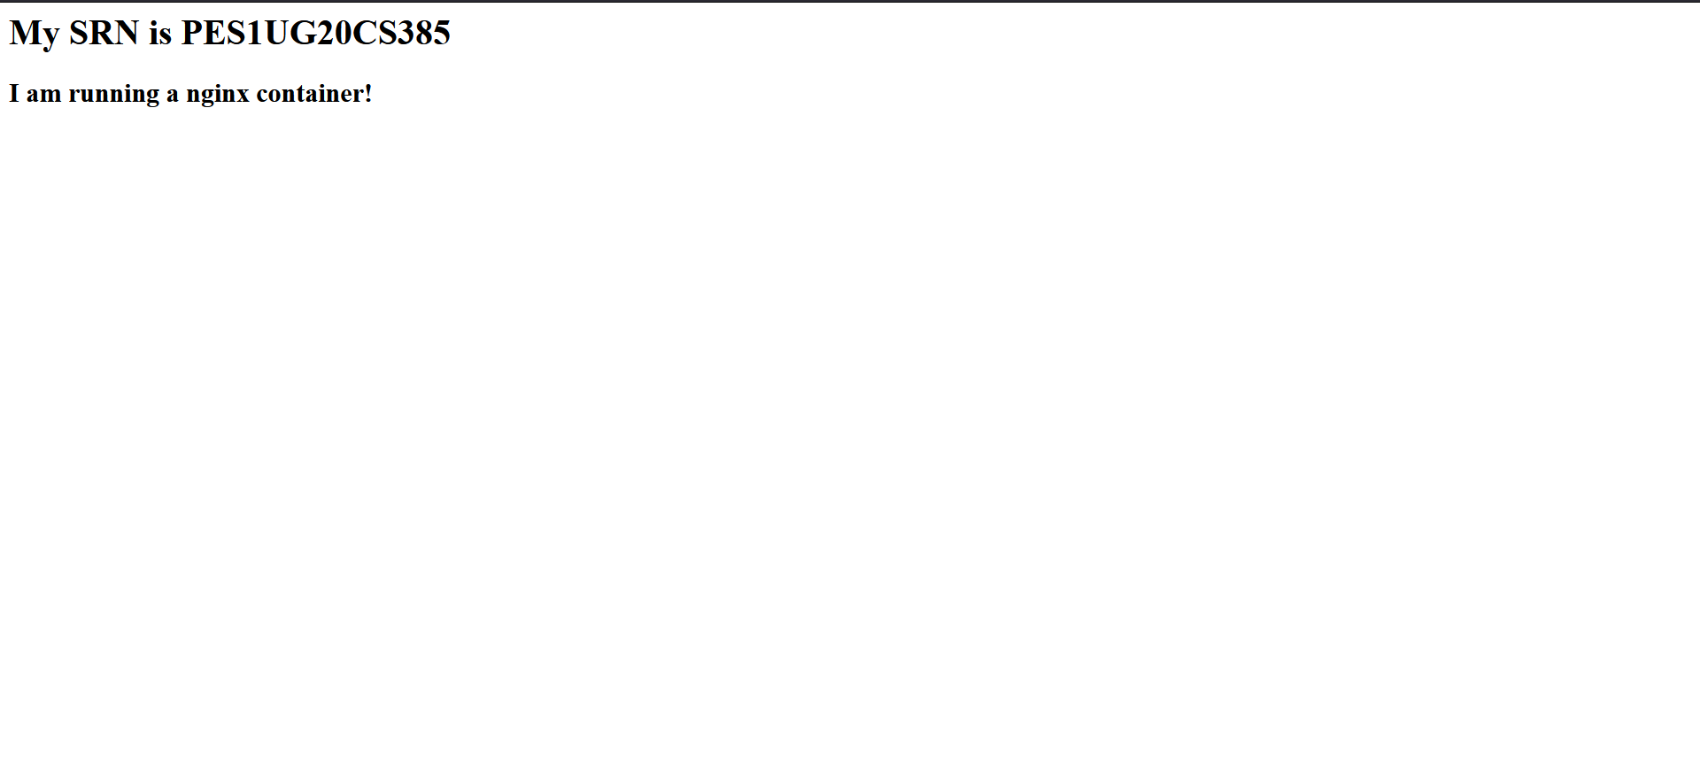

**3c)** Screenshot of python application successfully writing and reading from the MongoDB database

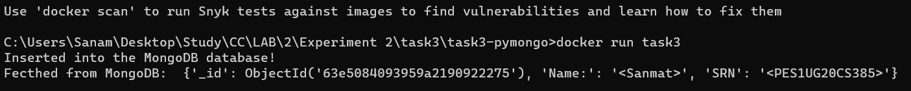

**3d)** Screenshot showing mongodb being run within the network(docker command has to be clearly highlighted)



**3e)** Screenshot showing python file being run within the network and successfully writing and reading from MongoDB (docker command has to be clearly highlighted)

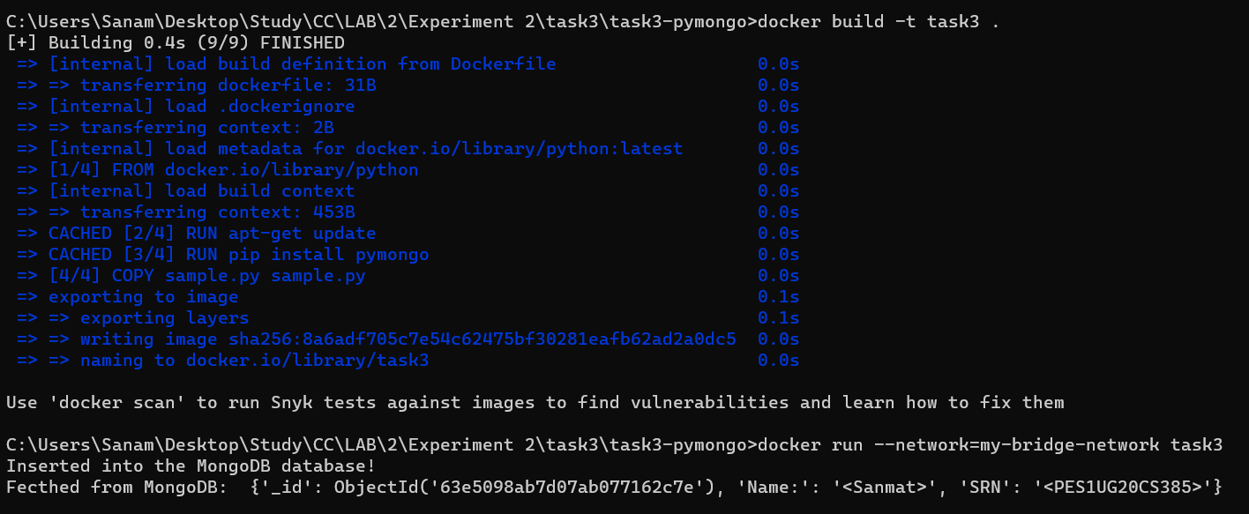

**4a)** Screenshot of python-mongodb application running as a docker-compose application(logs of the application)

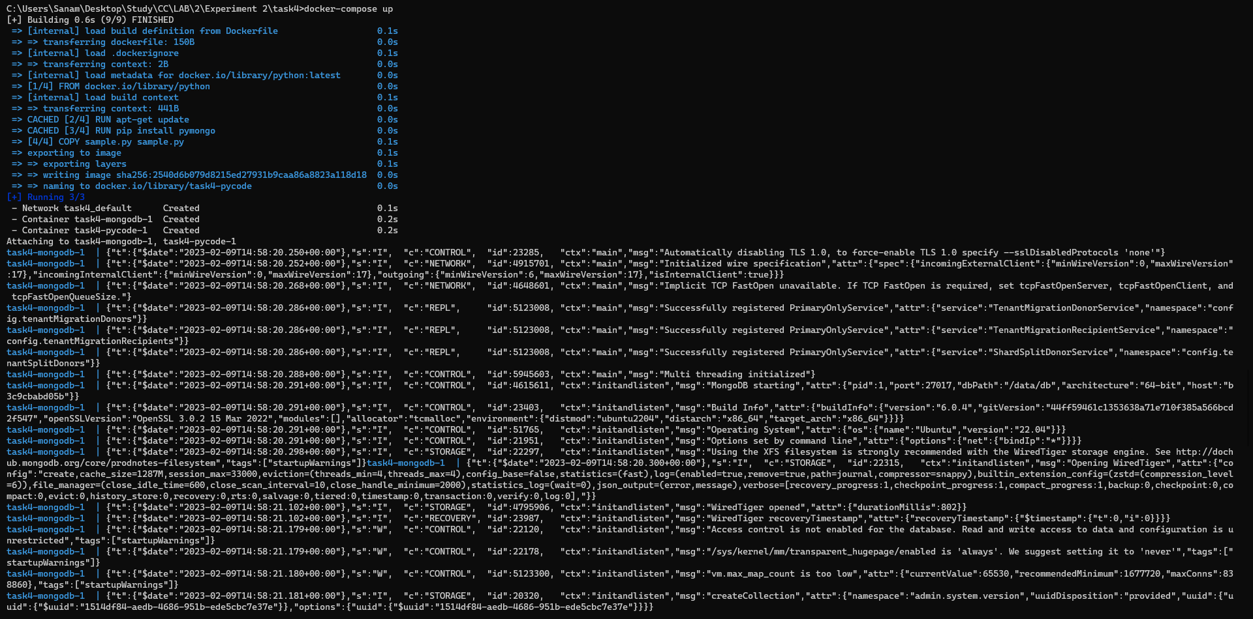

**4b)** Screenshot of 3 python application writes and reads from MongoDB after scaling the python application.

