**CLOUD** **COMPUTING**

**EXPERIMENT** – **3**

**DynamoDB**

Name : Sanmat Sanjayakumar Payagoudar

SRN : PES1UG20CS385

Section : G

1a: Creation of table

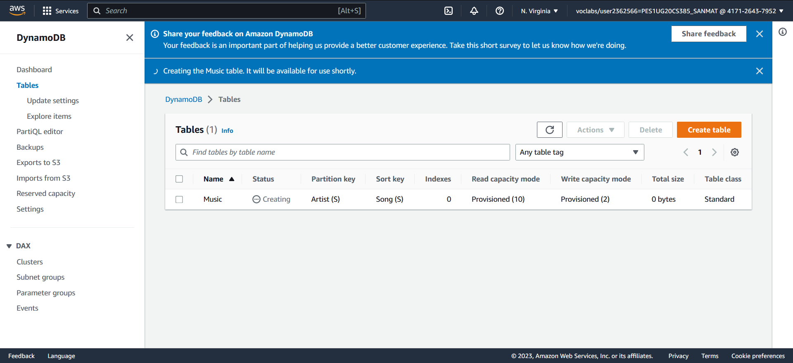

2a: Show the inserted entries in table

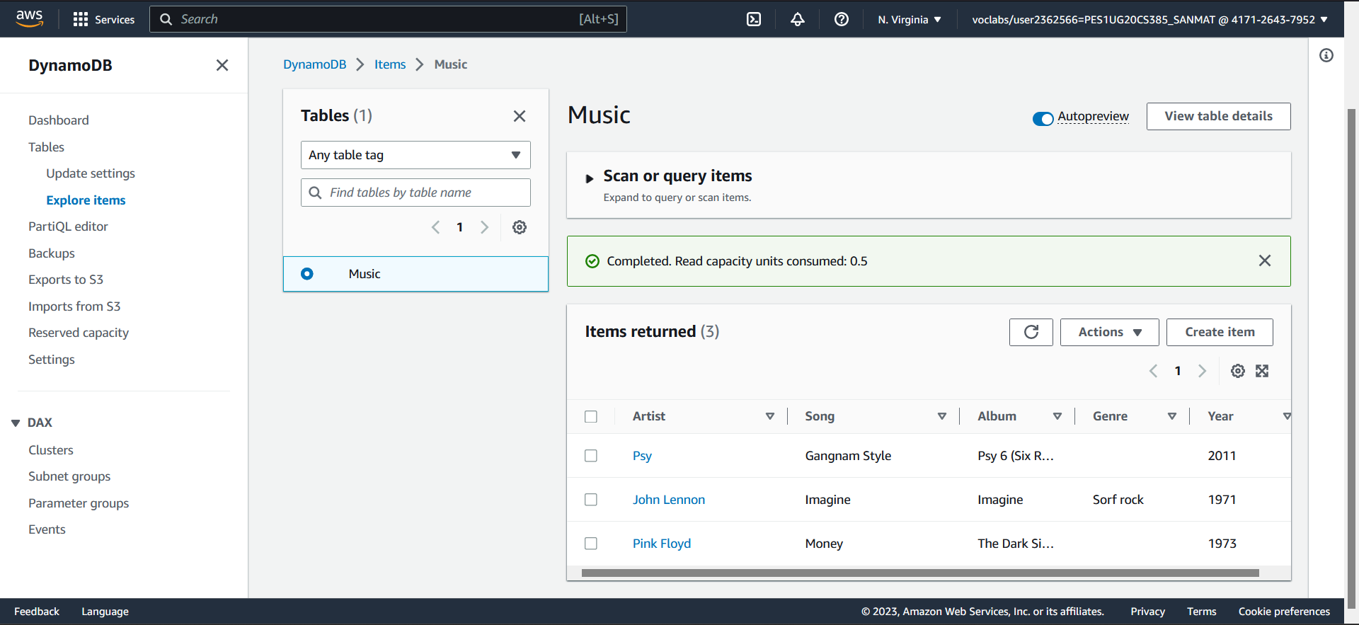

3a: Show the entries post update

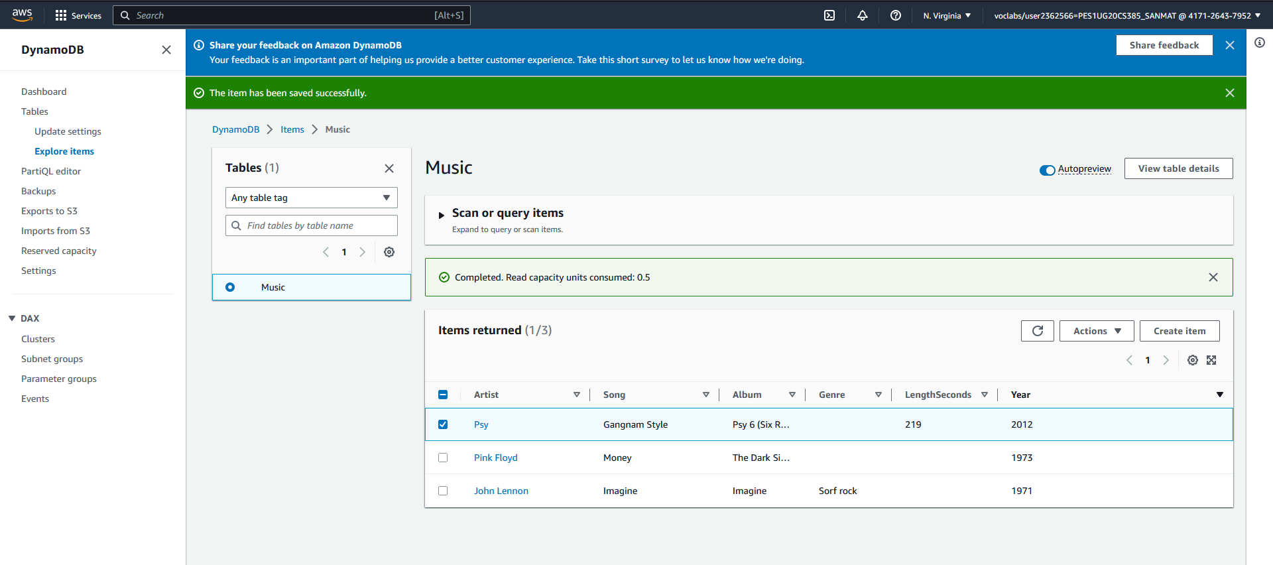

4a: Result of the query Artist (Partition key): Psy, Song (Sort key): Equal to Gangnam Style

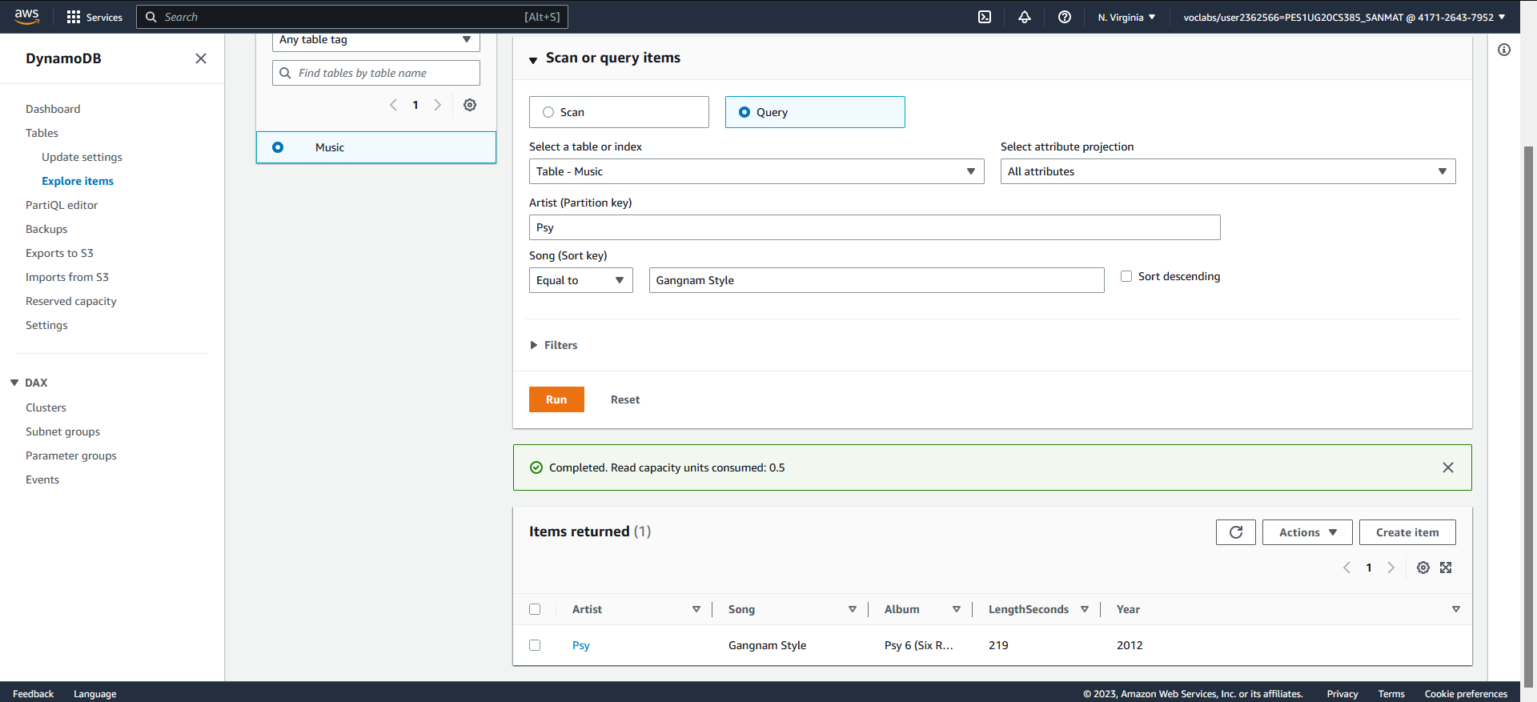

4b: Result of Scan filter

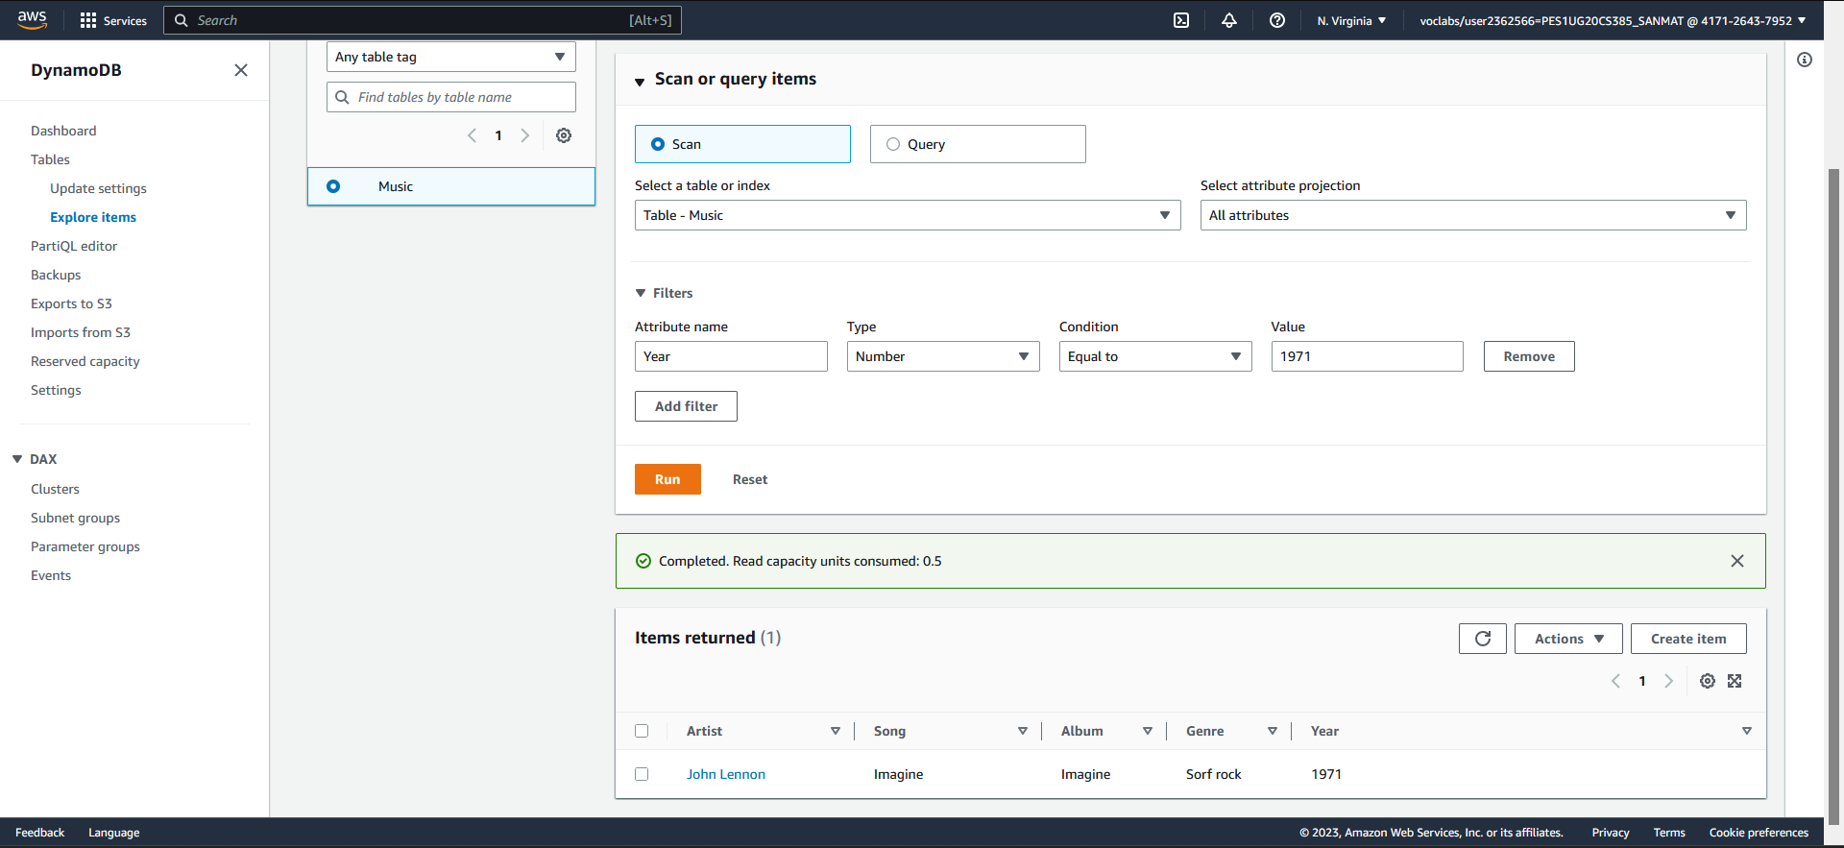

5a: Data after deletion of an item from the table

