**CLOUD** **COMPUTING**

**LAB** **EXPERIMENT** – **4**

NAME: Sanmat Sanjayakumar Payagoudar

SRN : PES1UG20CS385

SECTION : G

1a: Pyenv installed and local Python version changed to 3.6.8.

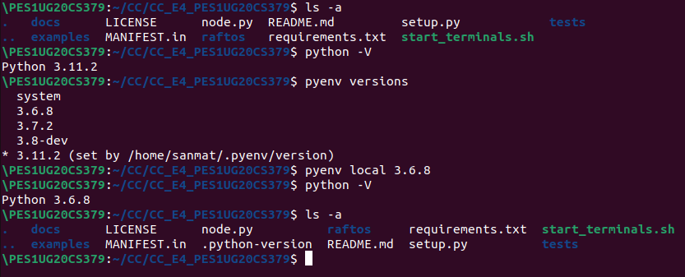

2a: Initial leader election has occurred, and first value has replicated.

Leader : node 2.

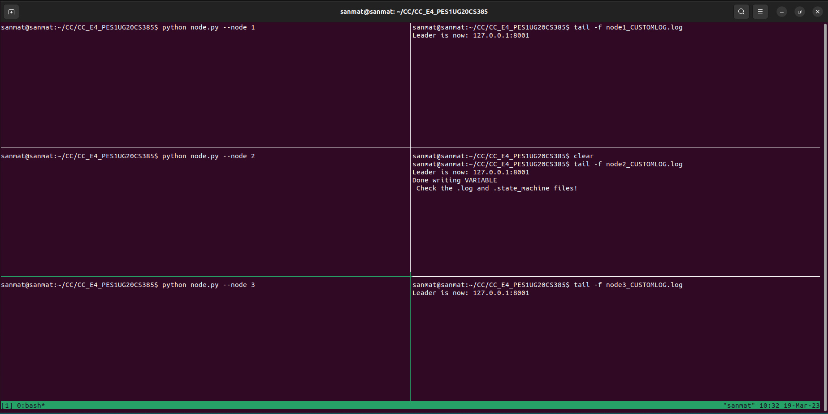

2b: Leader crashed, new leader elected, and second value replicated.

New leader : node 1.

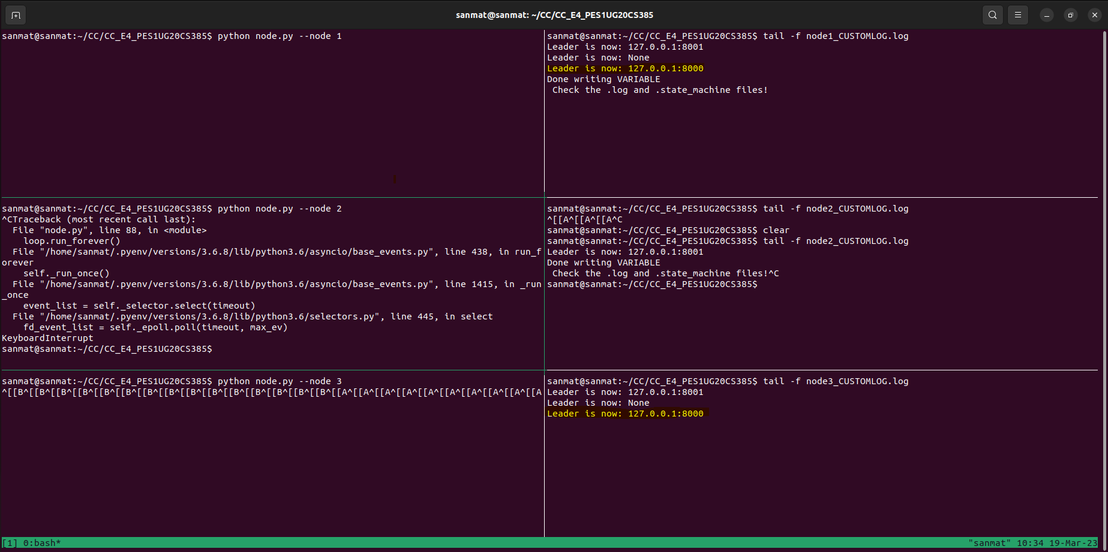

2c: Old leader comes back online, but becomes a follower instead and updates its old state to its new state.

node 2 comes back online, but becomes a follower instead.

