**CLOUD** **COMPUTING**

**LAB** **EXPERIMENT** – **5**

Name : Sanmat Sanjayakumar Payagoudar

SRN : PES1UG20CS385

Section : G

1. user-1 added to the S3-Support Group.

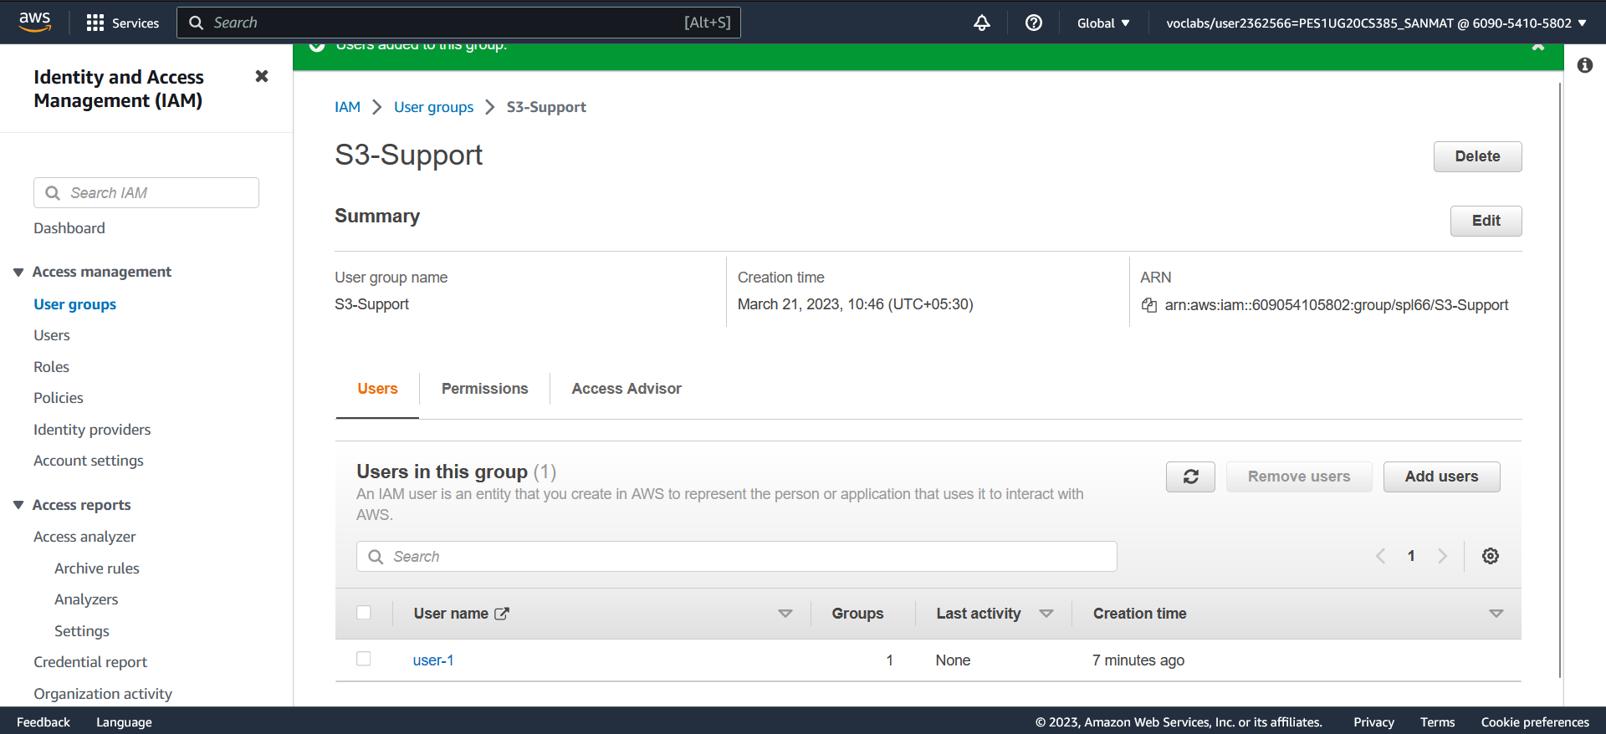

1. user-2 added to the EC2-Support Group.

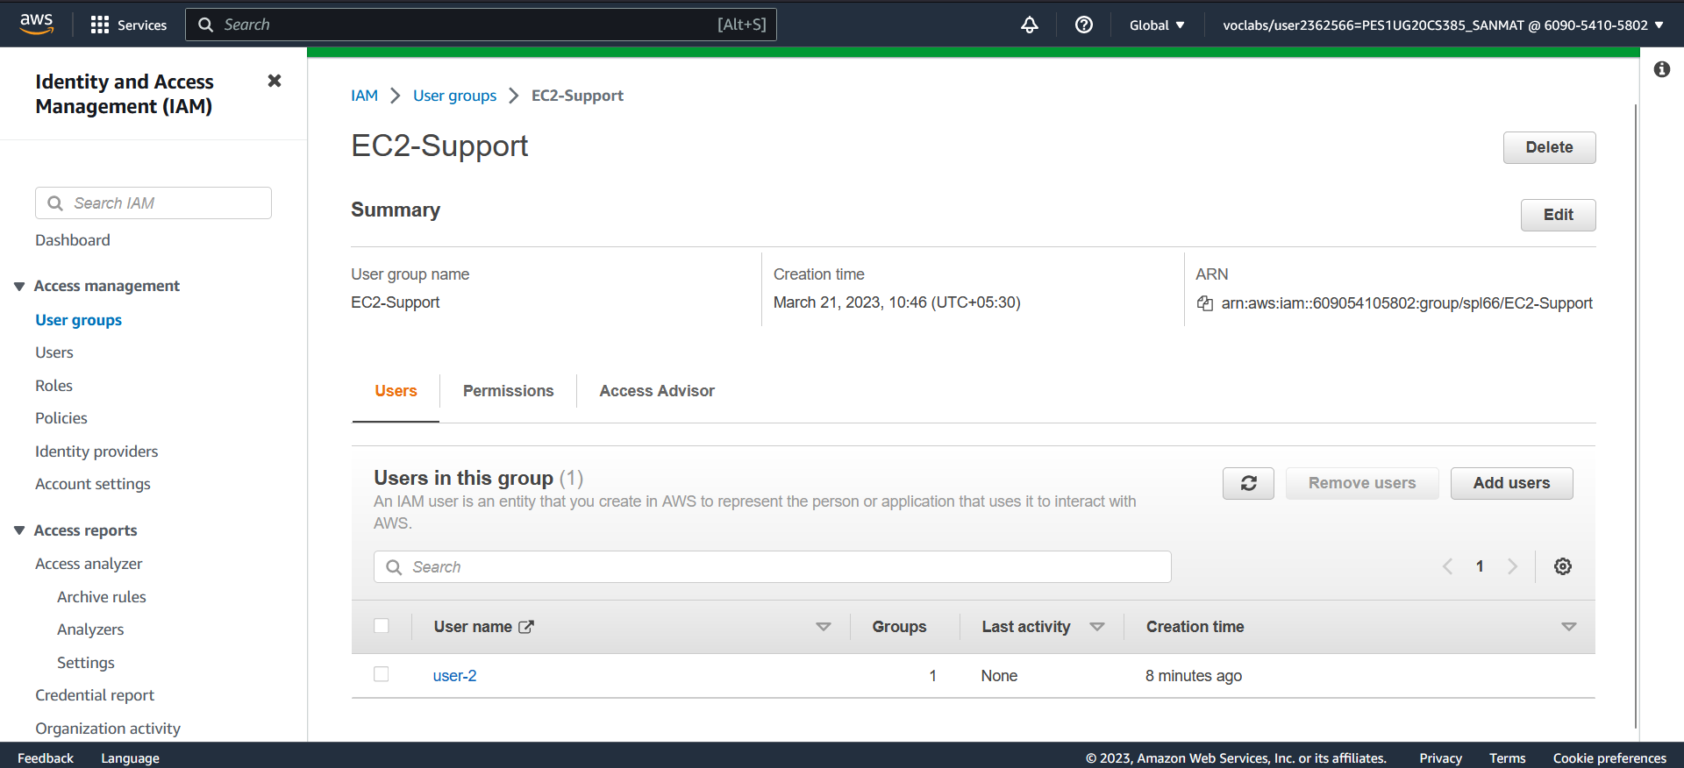

1. user-3 added to the EC2-Admin Group.

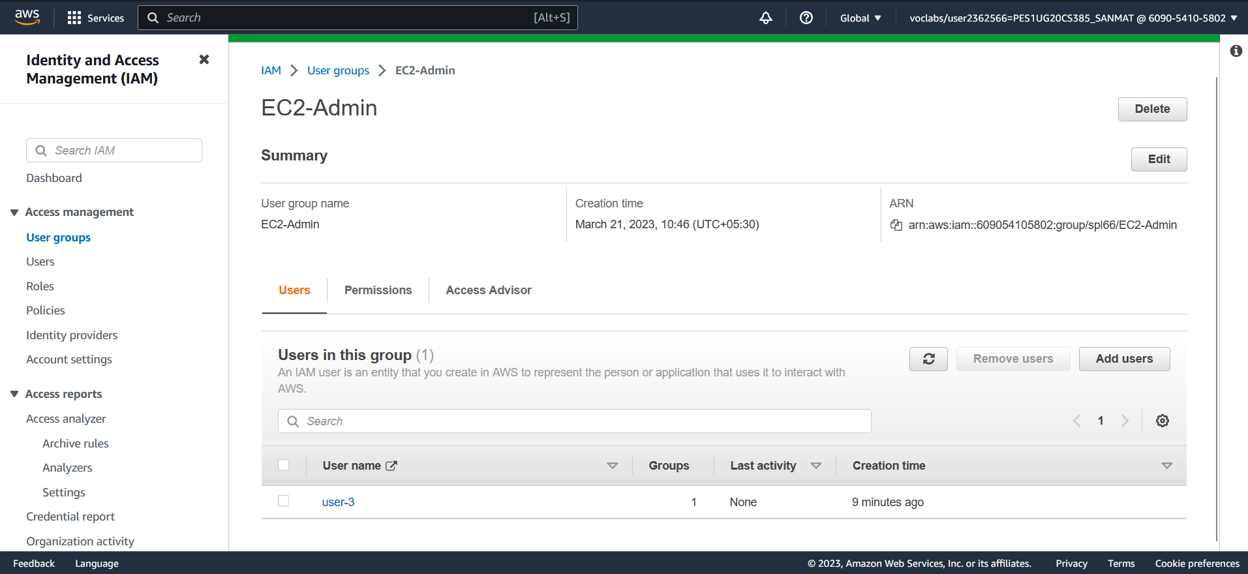

1. View S3 buckets with user-1 role.

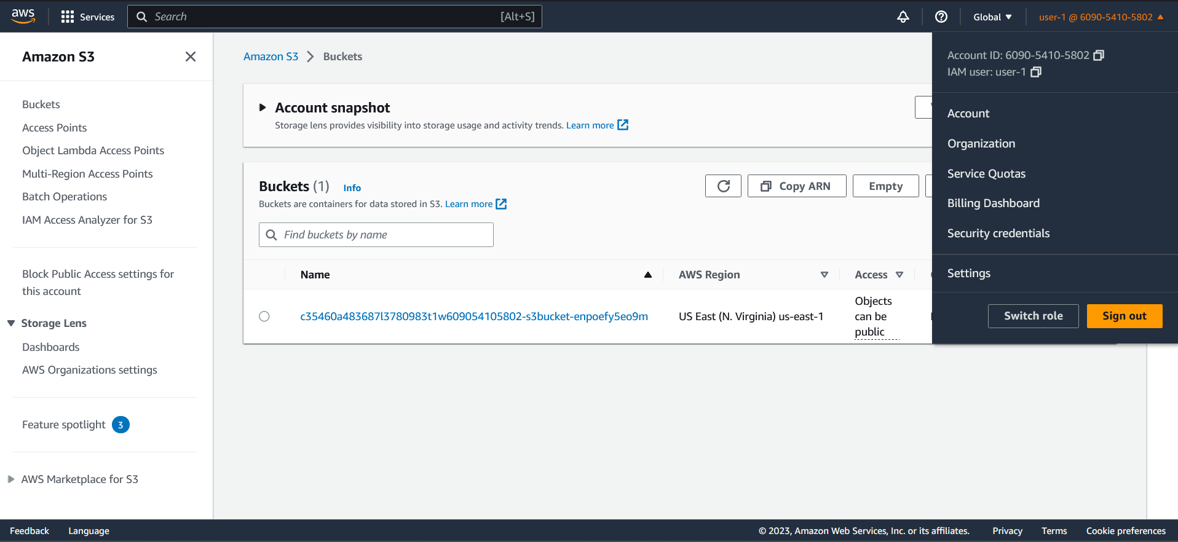

1. EC2 instance dashboard with user-1 role (Not authorized).

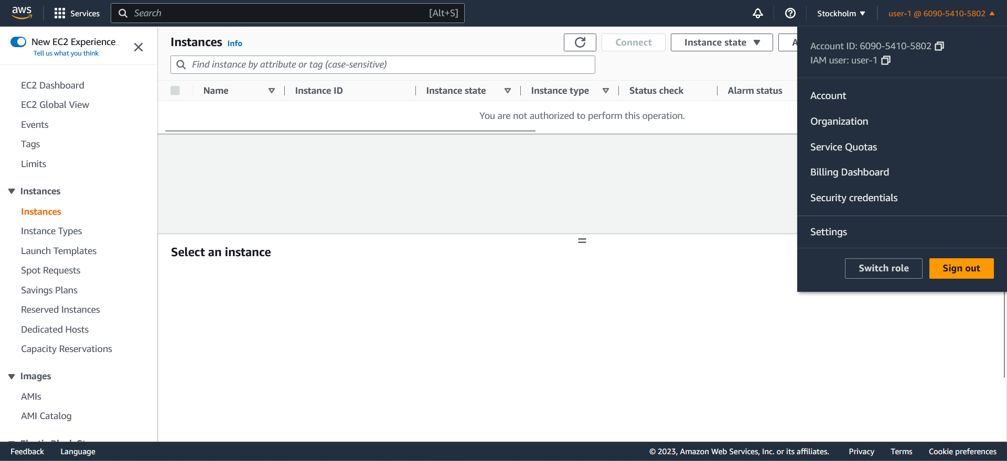

1. Failure message when instance stopped with user-2 role.

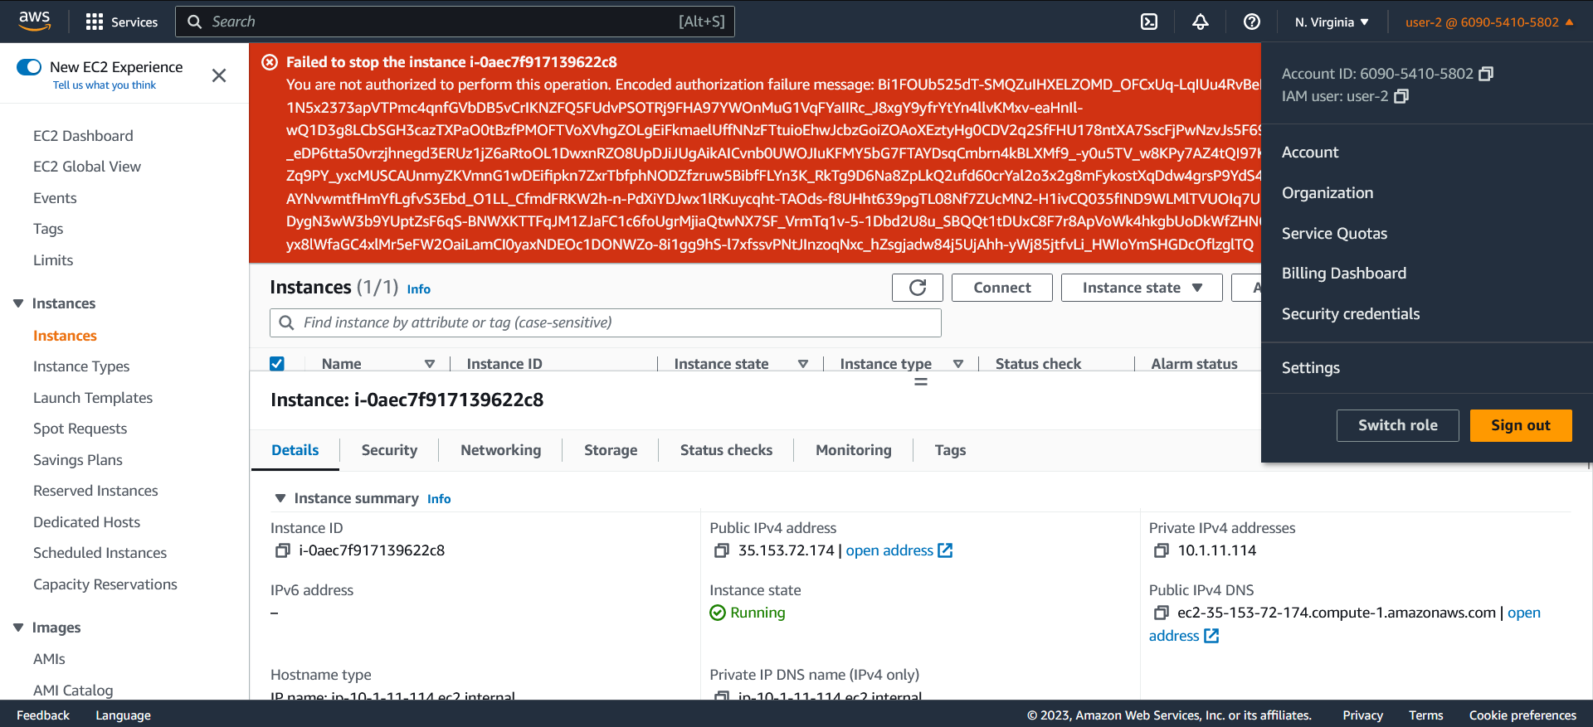

1. Successful stoppage of E2 instance with user-3 role.

