DBMS

LAB-1

NAME : SANMAT SANJAYAKUMAR PAYAGOUDAR

SRN : PES1UG20CS385

**TASK 1 :** Identify all entities in the problem domain. Draw weak and strong entities with proper notations. Show attributes for each entity and denote composite, multivalued and derived attributes.

**1.jpg :**

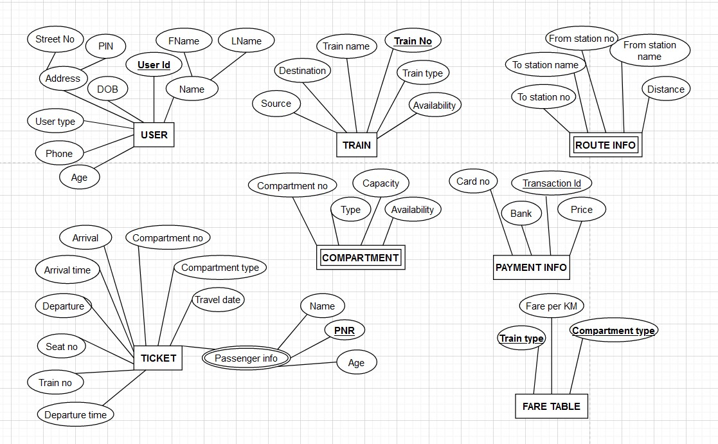

**TAKS 2 :** Identify all relationships between the entities. Mark the cardinality ratios, structural constraints, total participations, identifying relationships with proper notations.

**2.jpg :**

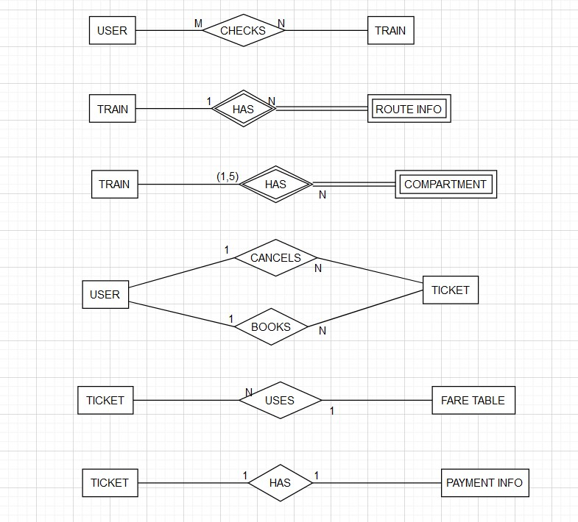

**TASK 3 :** Draw the ER Diagrams connecting all entities and relationships

**3.jpg**

