DBMS

LAB – 10

**NAME :** SANMAT SANJAYAKUMAR PAYAGOUDAR

**SRN :** PES1UG20CS385

1. **Screenshot of database with the table - ‘train’ before populating it.**

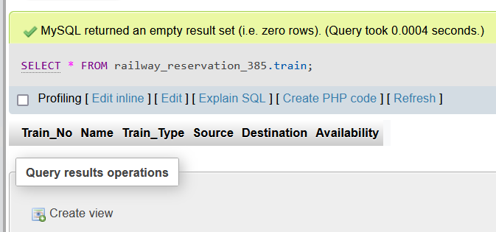

1. **Screenshot of the User Interface.**

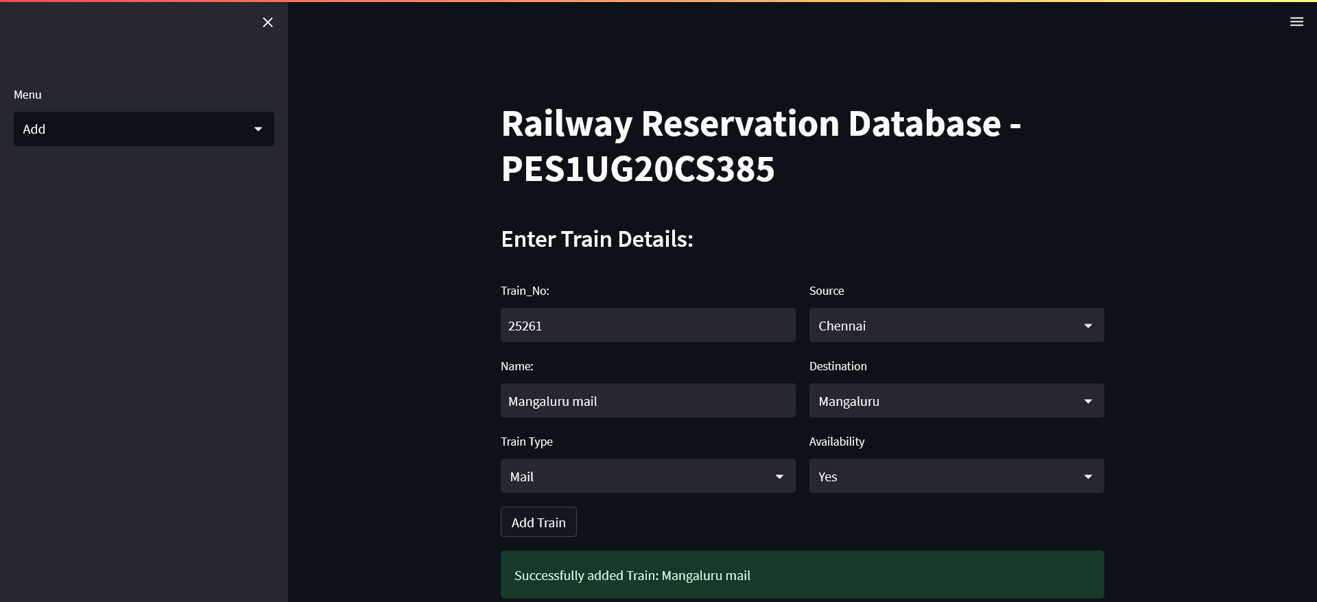

1. **Screenshot of the 3 records in the train table from MySQL WorkBench.**

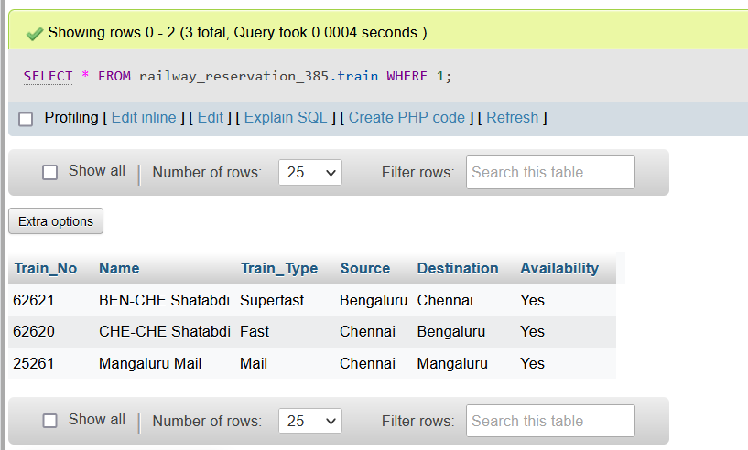

1. **Screenshot of the same 3 records visualised in the User Interface.**

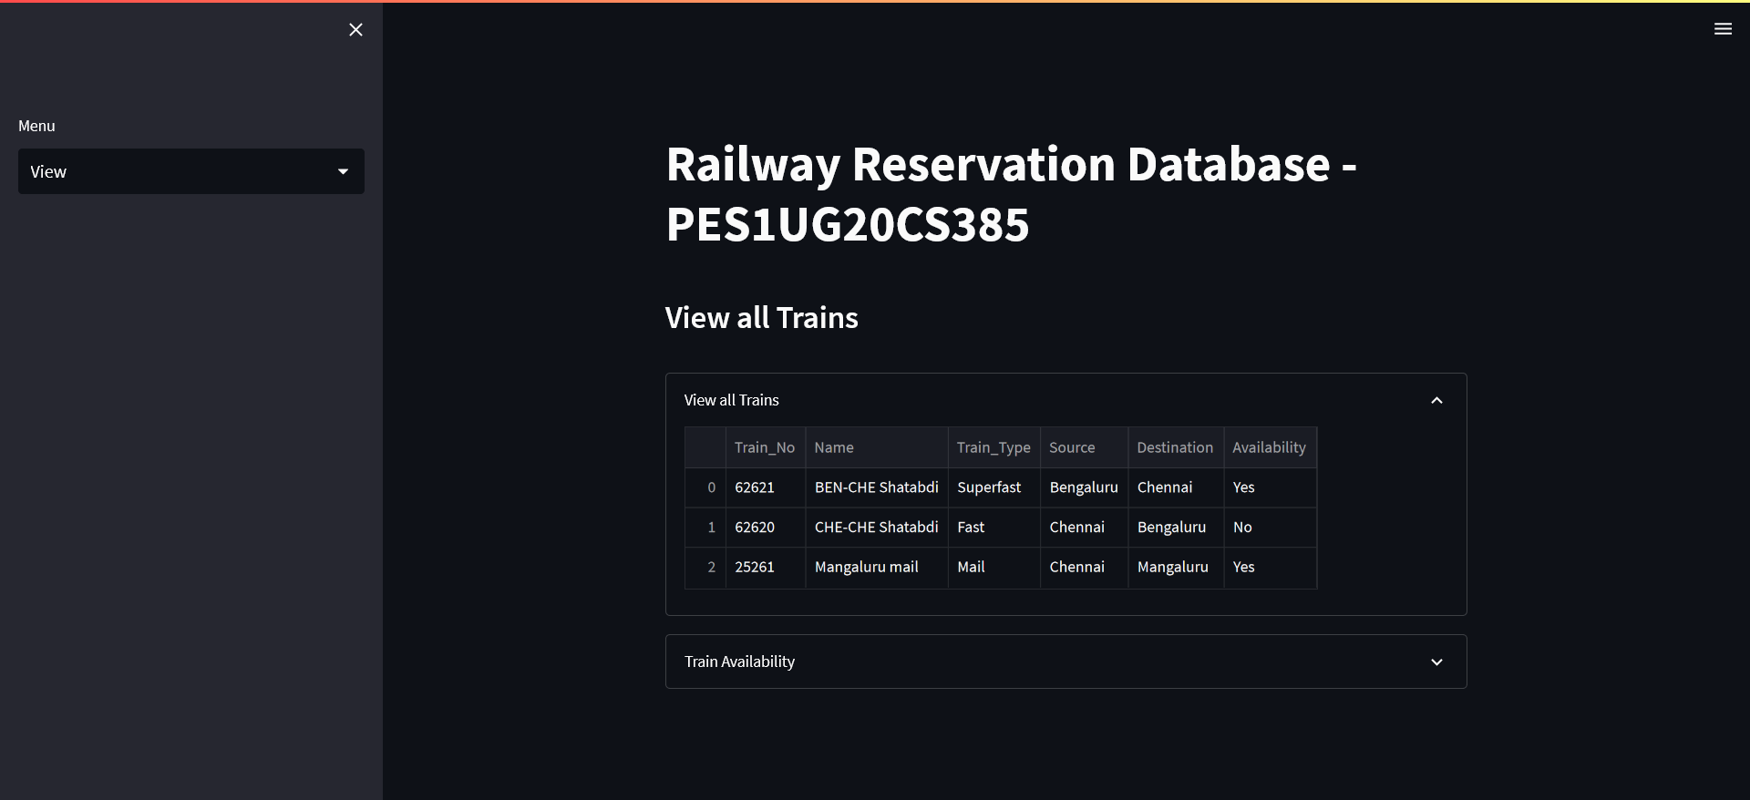

1. **Screenshot of Updated Train_No 62620 in the User-Interface.**

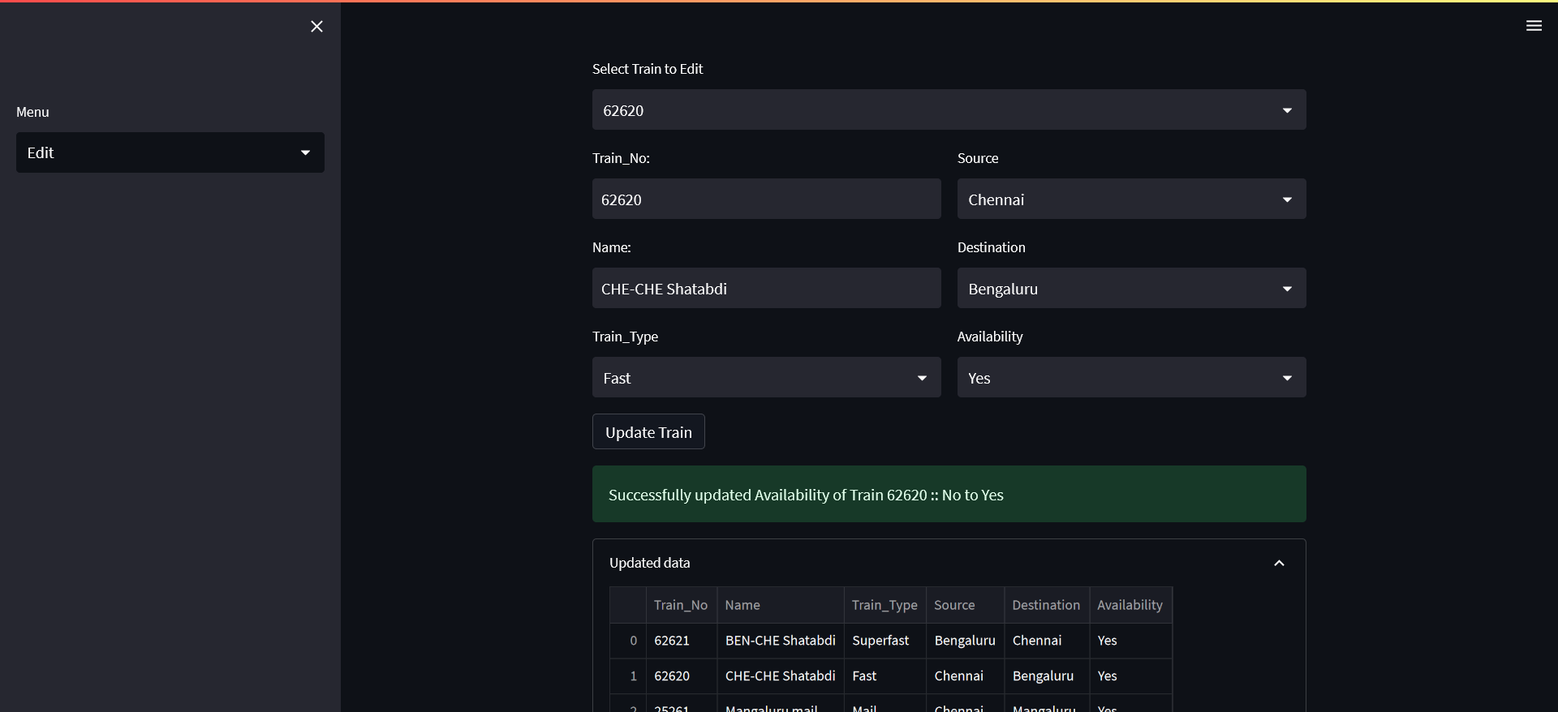

1. **Screenshot of User-Interface after the Train_No 25261 has been deleted.**

