**DBMS**

**LAB – 3**

**DDL – COMMANDS**

**NAME :** **SANMAT SANJAYAKUMAR PAYAGOUDAR**

**SRN :** **PES1UG20CS385**

1. **PK and FK Constraints for all applicable Relations :**

**CODE :**

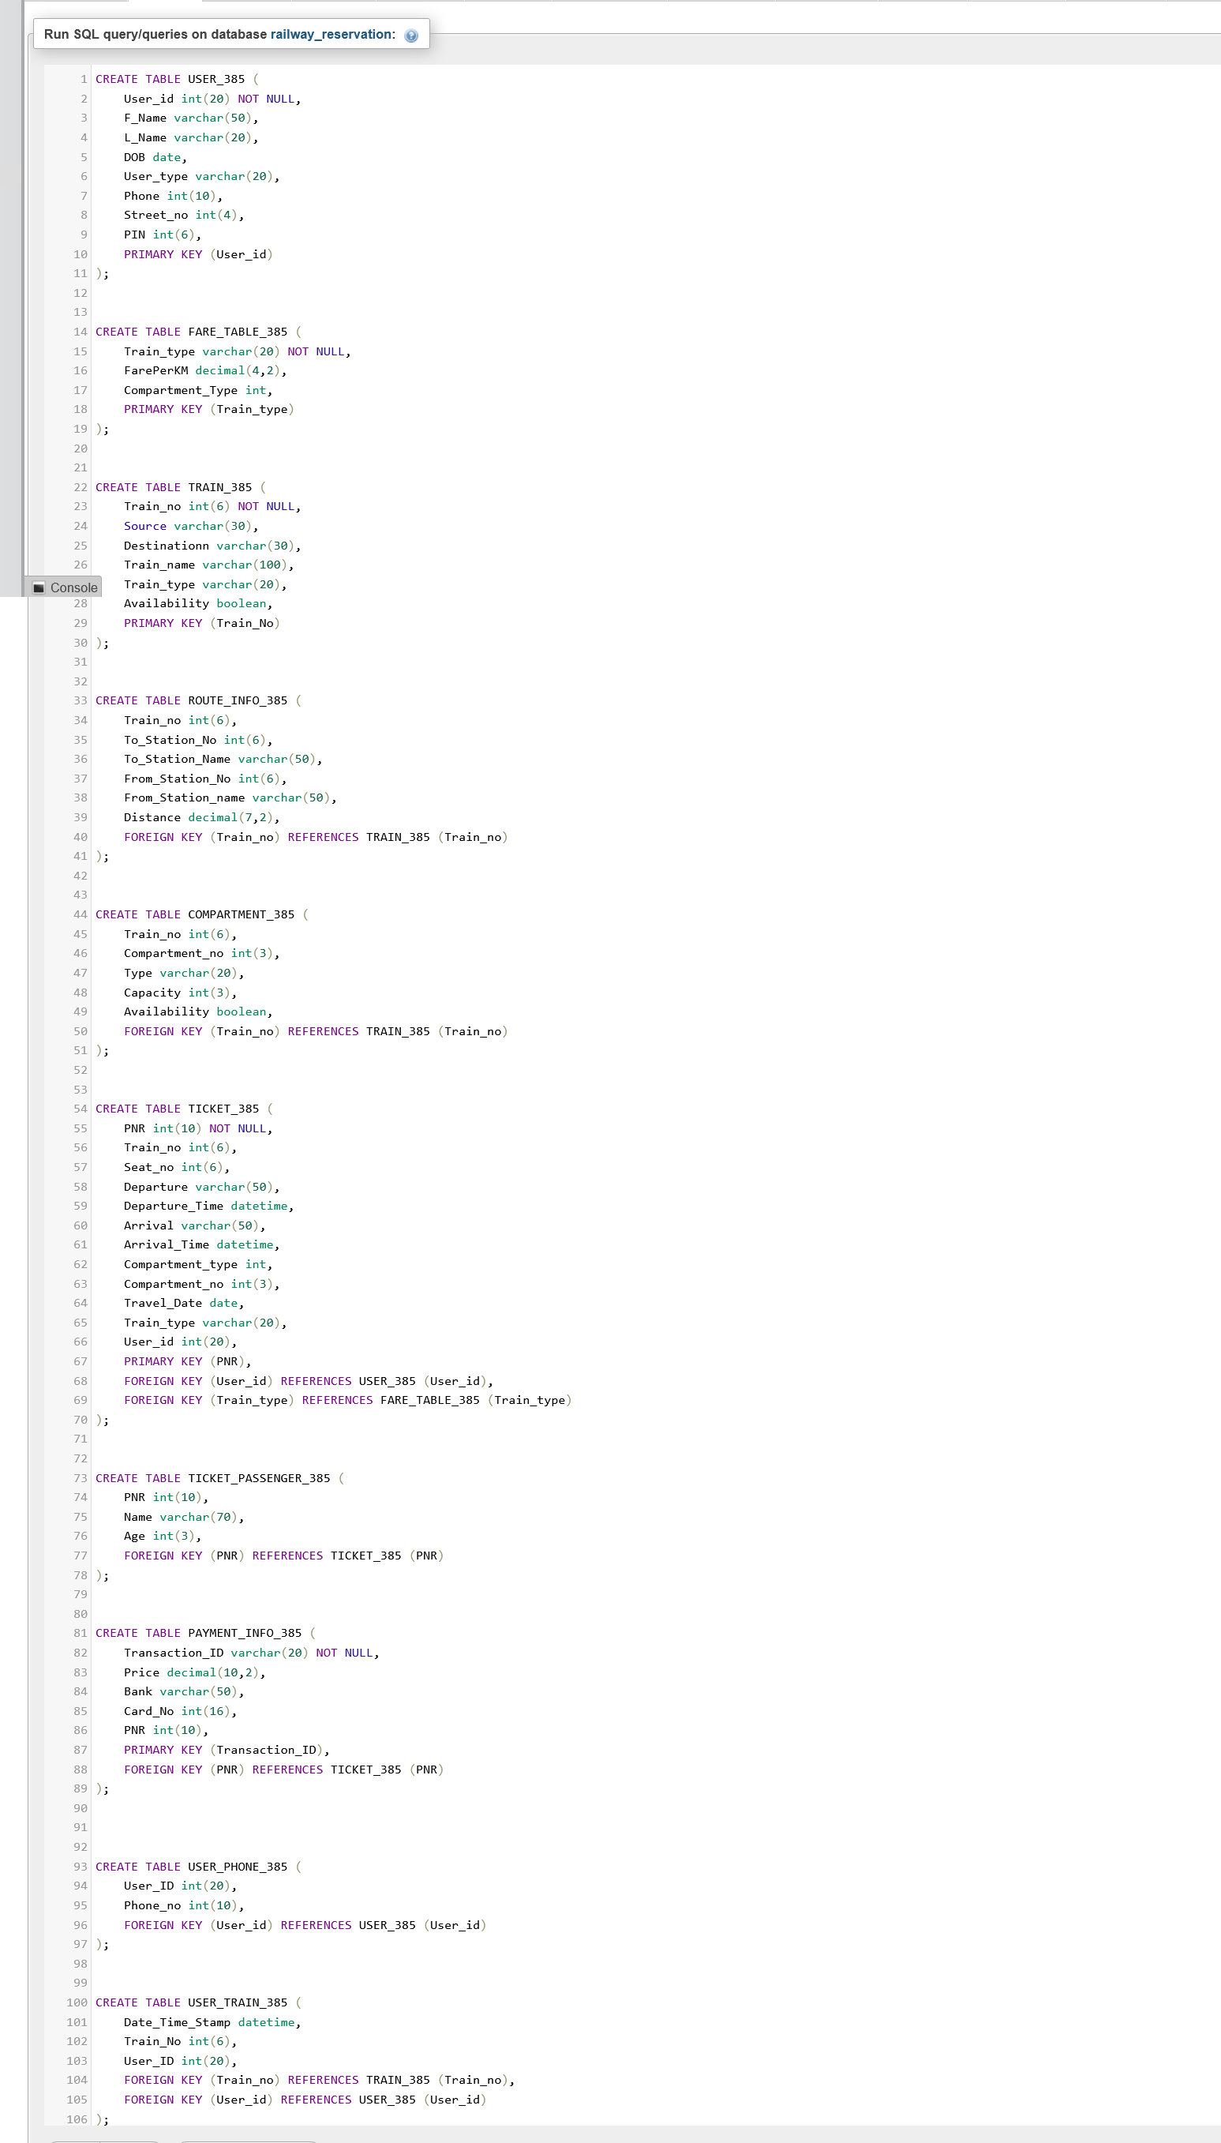

**OUTPUT :**

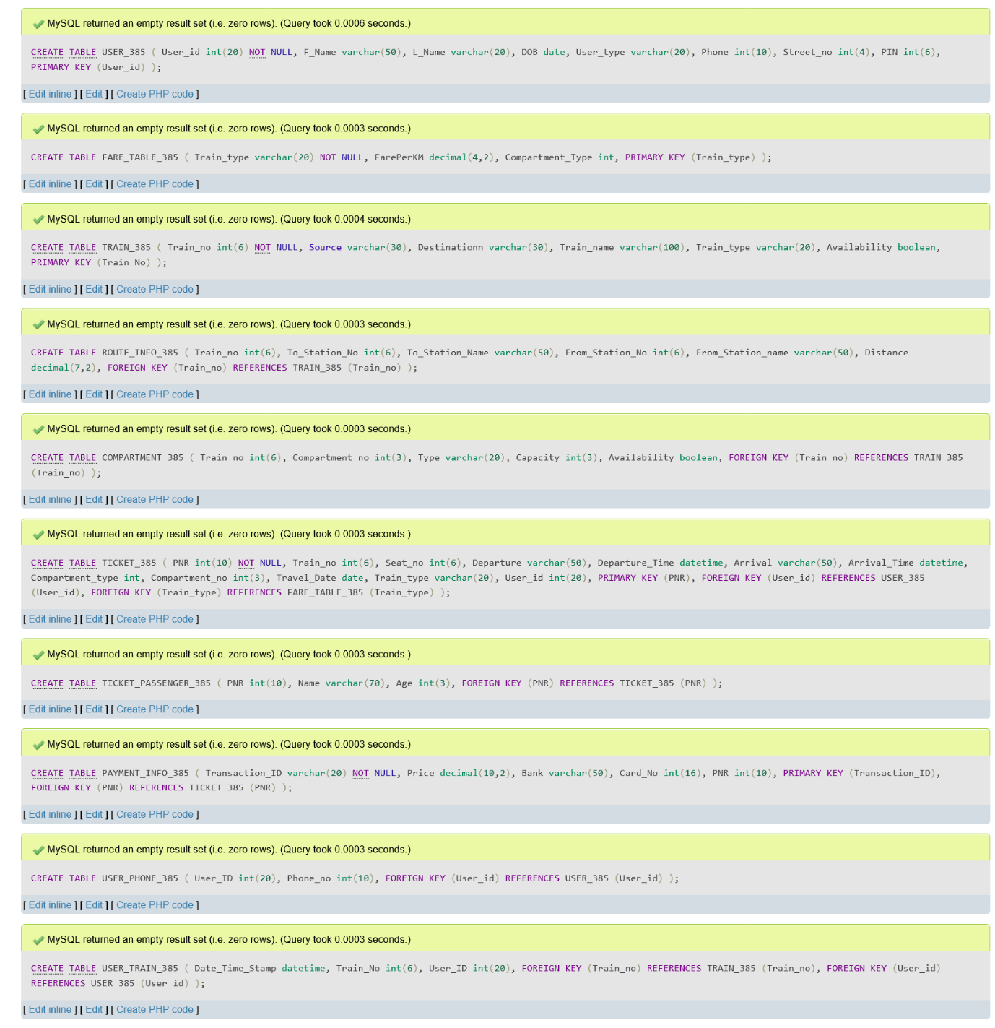

1. **Adding NOT NULL Constraints :**

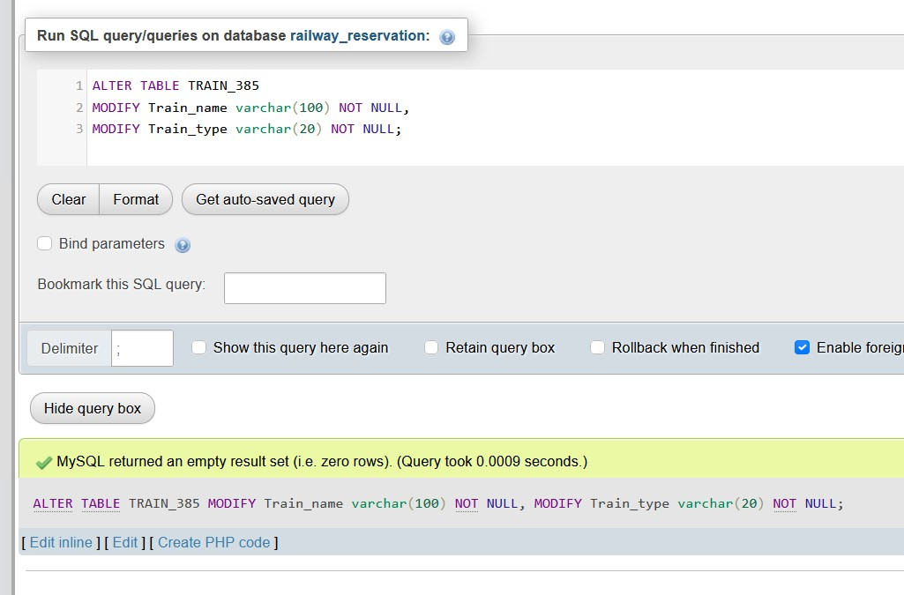

1. **Adding DEFAULT Constraints :**

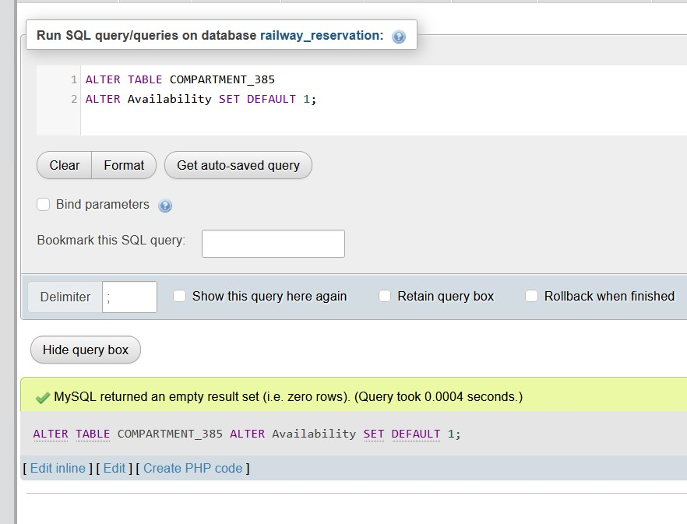

1. **Adding UNIQUE Constraints :**

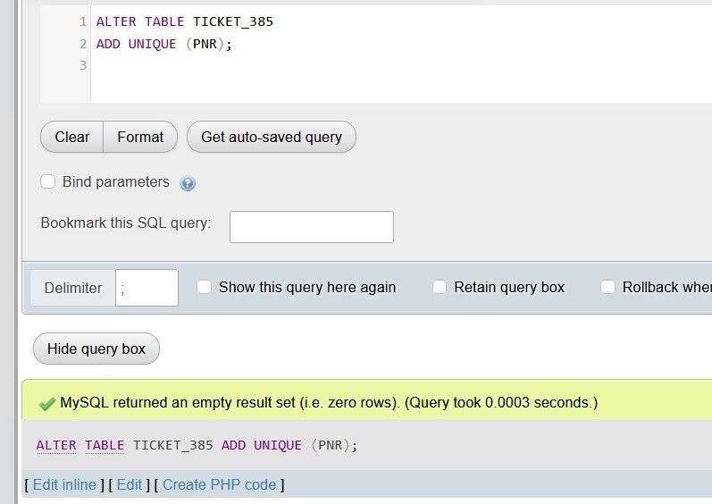

1. **Adding CHECK Constraints :**

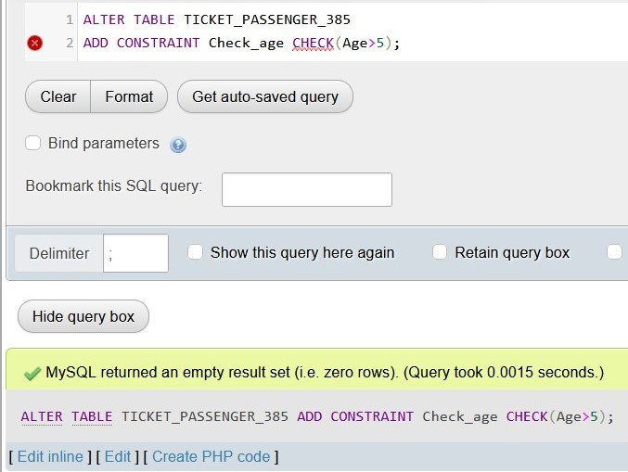

1. **RENAMING TABLE :**

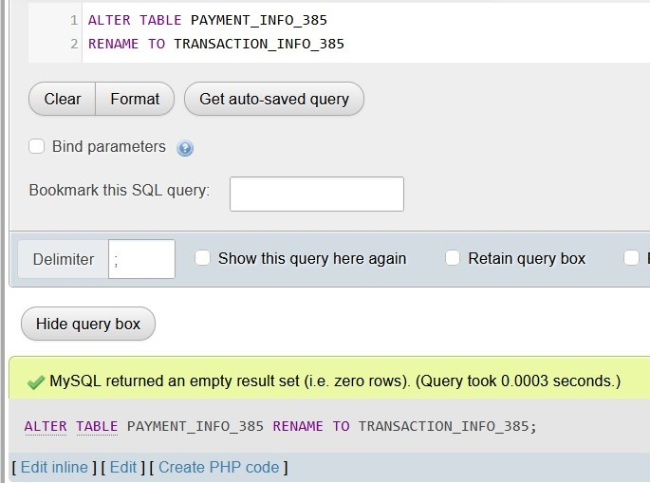

1. **Creating a VIEW :**

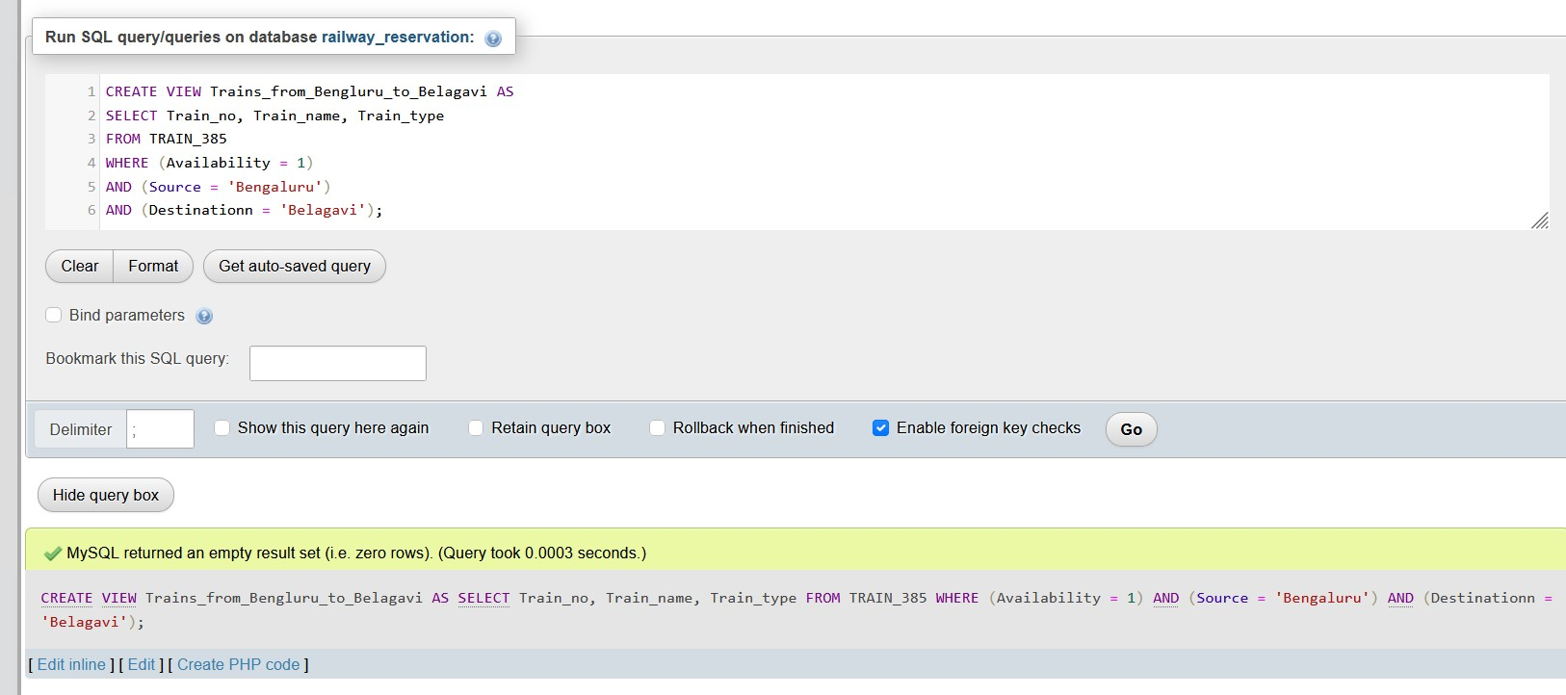

1. **DROP and TRUNCATE commands :**

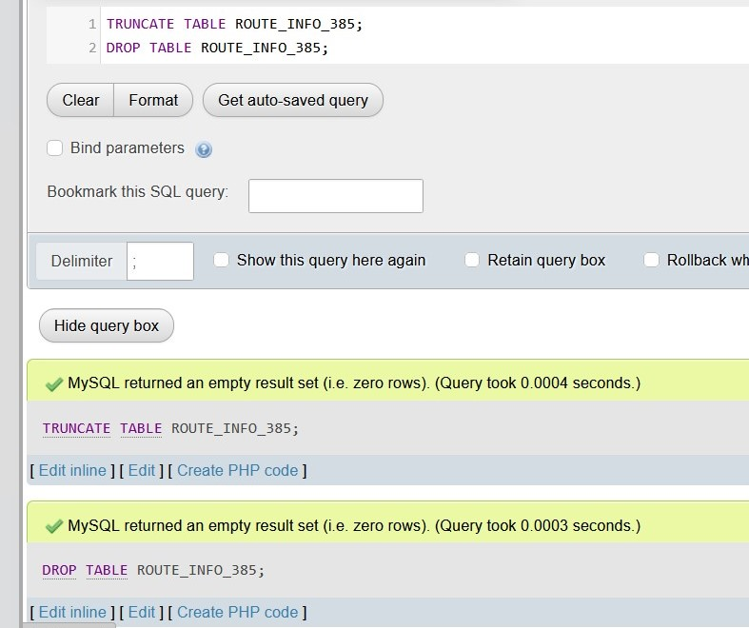

1. **Database when only TRUNCATE is done :**

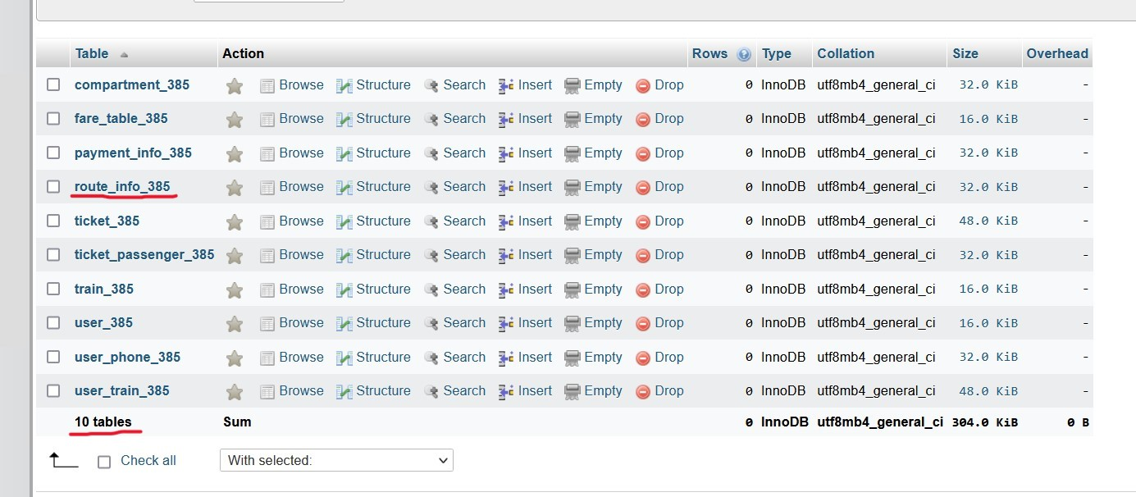

1. **Database when DROP is done :**

