DBMS

LAB – 4

NAME : Sanmat Sanjayakumar Payagoudar

SRN : PES1UG20CS385

TASK – 1

1. A. Inserting values into TRAIN_385 table using load command.

Code :

LOAD DATA INFILE "C:\\xampp\\mysql\\data\\My_DB\\Data_Railway_Reservation_Train.csv" INTO TABLE TRAIN_385

COLUMNS TERMINATED BY ','

OPTIONALLY ENCLOSED BY '"'

ESCAPED BY '"'

LINES TERMINATED BY '\n'

IGNORE 1 LINES;

Output :

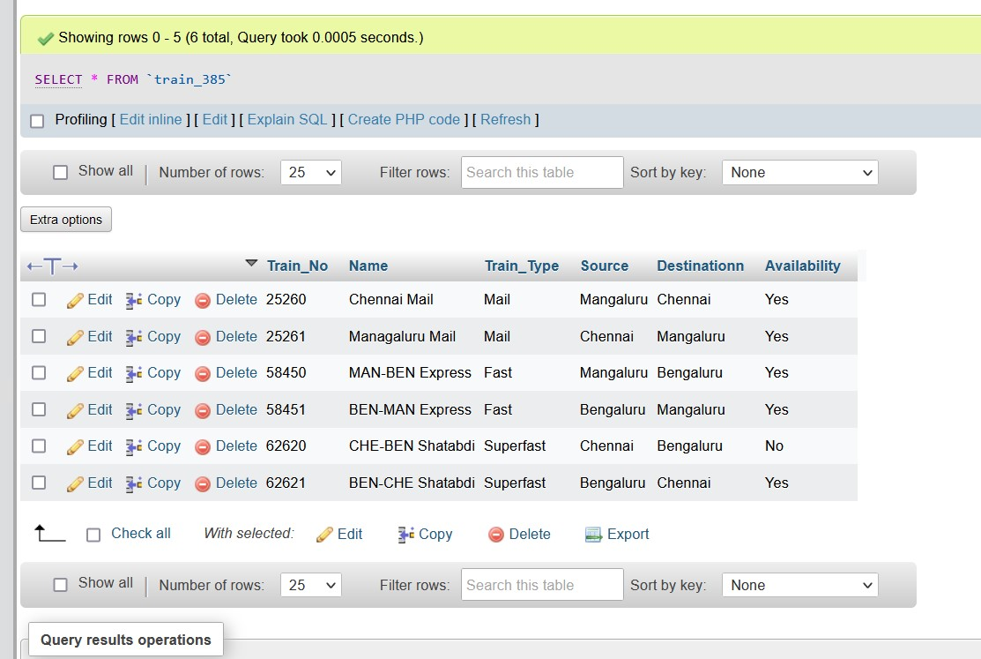

B. Using INSERT INTO USER_385 command.

Code :

INSERT INTO USER_385 (User_ID, User_Type, FName, LName, Age, DOB, PinCode, Street) VALUES

('USR_001', 'PSGR',   'Ajit',   'Ullal',    NULL,   1971-01-01, 560001, '10 Janpath'),

('USR_002', 'PSGR', 'Muhammed',     'Ali',  NULL,   09-10-2000, 560003, '10 Downing'),

('USR_003', 'PSGR', 'Sai Deepak',   'Reddy',    NULL,   12-12-1996, 600001, '14 Kailsh Marg'),

('USR_004', 'PSGR', 'Rudra',    'Agarwal',  NULL,   13-12-1996, 600042, '5 Lohia Garden'),

('USR_005', 'PSGR', 'Rahul',    'Khanna',   NULL,   14-12-1997, 600067, '1 Pink Street'),

('USR_006', 'PSGR', 'Nirmala',  'Seturaman',    NULL,   15-12-1998, 560105, '3 Blue Avenue'),

('USR_007', 'PSGR', 'Smriti',   'Irani',    NULL,   16-12-1999, 575014, '4 Banyan Avenie'),

('USR_008', 'PSGR', 'Ajit', 'Sethi',    NULL,   14-04-1966, 575001, '6 Poes Garden'),

('USR_009', 'PSGR', 'Arjun',    'Allu', NULL,   08-04-1967, 575020, '7 Dhamaka street'),

('USR_010', 'PSGR', 'Samanta',  'Prabhu',   NULL,   14-04-1968, 600042, '8 Clone Colony'),

('USR_011', 'PSGR', 'Kiran',    'Bedi', NULL,   14-04-1969, 560003, '56 Brigade Road'),

('USR_012', 'PSGR', 'Rahul',    'Gandhi',   NULL,   08-04-1970, 475001, 'Mirza road'),

('USR_013', 'PSGR', 'Rashkit',  'Shetty',   NULL,   14-04-1971, 560009, 'JC Road'),

('USR_014', 'PSGR', 'Rishi',    'Sunak',    NULL,   14-04-1972, 600034, 'Anna Sali'),

('USR_015', 'PSGR', 'Vedavalli',    'Srinath',  NULL,   14-04-1973, 560054, 'Church Street Bangalore'),

('USR_016', 'PSGR', 'Subbu',    'Saravana', NULL,   14-04-1974, 600043, 'American Street'),

('USR_017', 'PSGR', 'Sheela',   'Dixit',    NULL,   08-04-1975, 560048, 'Kasturba Road'),

('USR_018', 'PSGR', 'Margaret', 'Alva', NULL,   14-04-1976, 560008, 'New BEL Road'),

('USR_019', 'PSGR', 'Arun', 'Kumar',    NULL,   14-04-1977, 600046, 'Mint Street'),

('USR_020', 'PSGR', 'Anshu',    'Bhardwaj', NULL,   14-04-1978, 575001, 'KSR Road'),

('USR_021', 'PSGR', 'Suma', 'Sampat',   NULL,   08-04-1979, 560012, 'Old Airport Road Bangalore'),

('USR_022', 'PSGR', 'Srihari',  'Udupa',    NULL,   14-04-1980, 560015, 'Suranjan Das Road'),

('USR_023', 'PSGR', 'Satish',   'Kotian',   NULL,   14-04-1981, 600044, 'T Nagar'),

('USR_024', 'PSGR', 'Shradha',  'Nayar',    NULL,   08-04-1982, 560006, 'M G Road Bangalore'),

('USR_025', 'PSGR', 'Manisha',  'Solanki',  NULL,   08-04-1983, 575030, 'M G Road'),

('USR_026', 'PSGR', 'Bharti',   'Devgan',   NULL,   14-04-1984, 560059, 'NAL Wind Tunnel Road'),

('USR_027', 'PSGR', 'Roopa',    'Ram    ',NULL, 14-04-1985, 575023, 'Bunder Road'),

('USR_028', 'PSGR', 'Pallavi',  'Ram',  NULL,   08-04-1986, 560044, 'Lavelle Road'),

('USR_029', 'PSGR', 'Ravi', 'Naik', NULL,   14-04-1987, 600045, 'Thiru V ka Salai'),

('USR_030', 'PSGR', 'Virat',    'Murthy',   NULL,   14-04-1988, 575011, 'Bejai New Road'),

('ADM_001', 'ADMIN',    'Narendra',     'Modi', NULL,   14-04-1989, 600047, 'Old Jail Road'),

('ADM_002', 'ADMIN',    'Droupadi', 'Murmu',    NULL,   14-04-1990, 640012, 'High Street'),

('ADM_003', 'ADMIN',    'Manmohan',     'Singh',    NULL,   08-04-1991, 575003, 'Pumpwell Road');

Output :

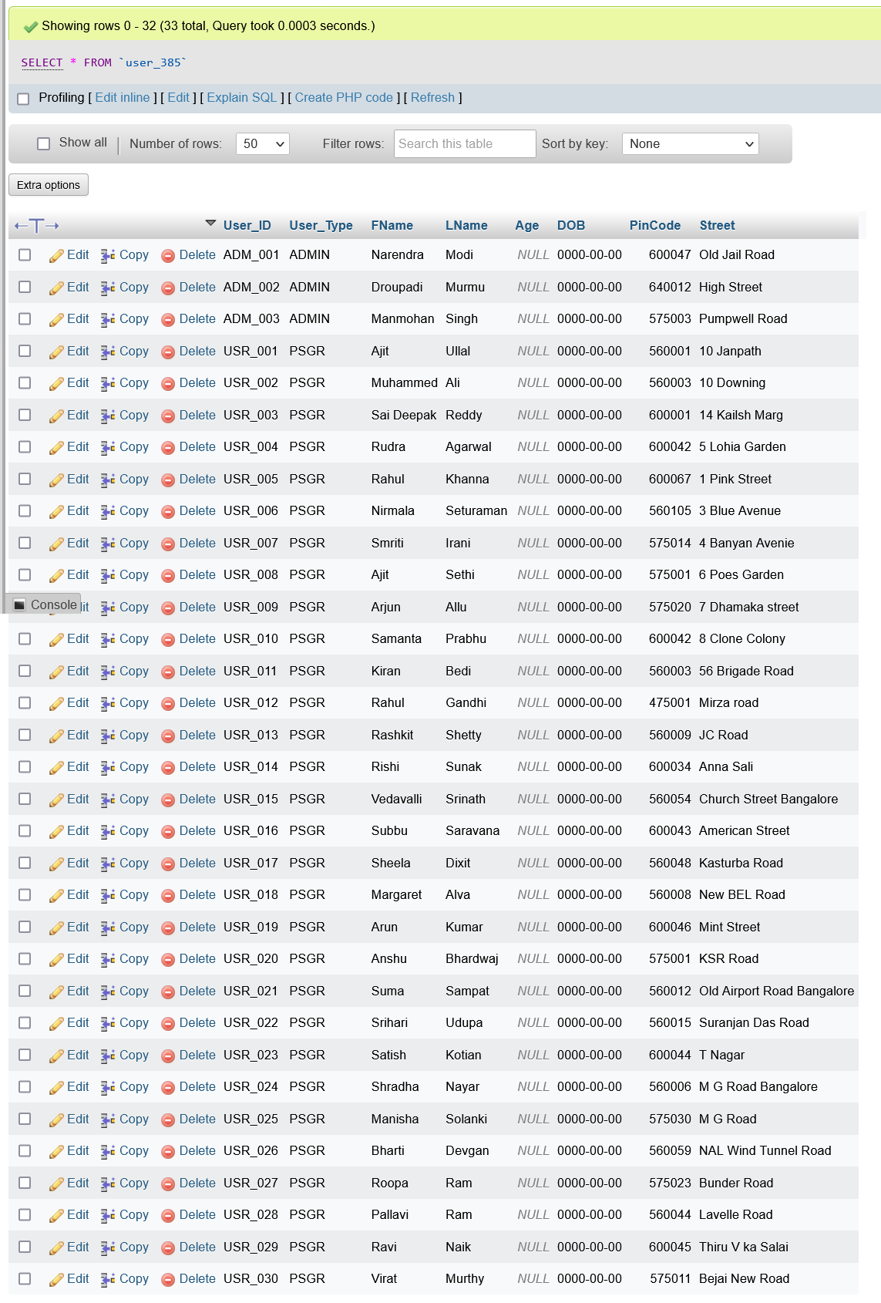

C. FARE_TABLE_385 table using IMPORT.

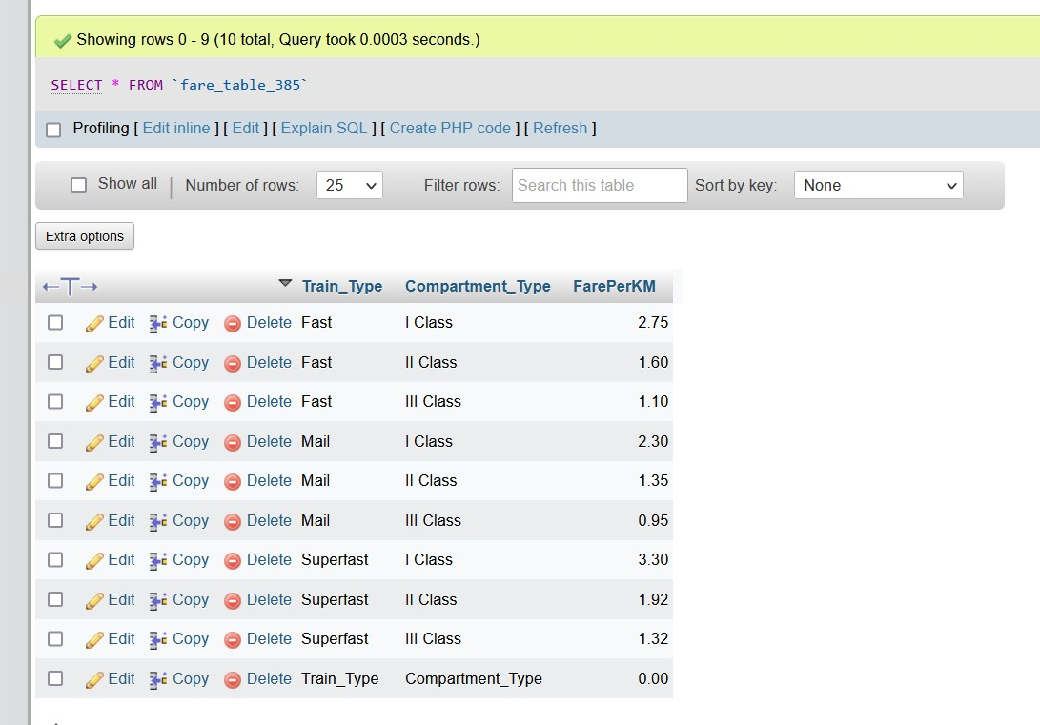

1. Calculate and update age in USER_385 table.

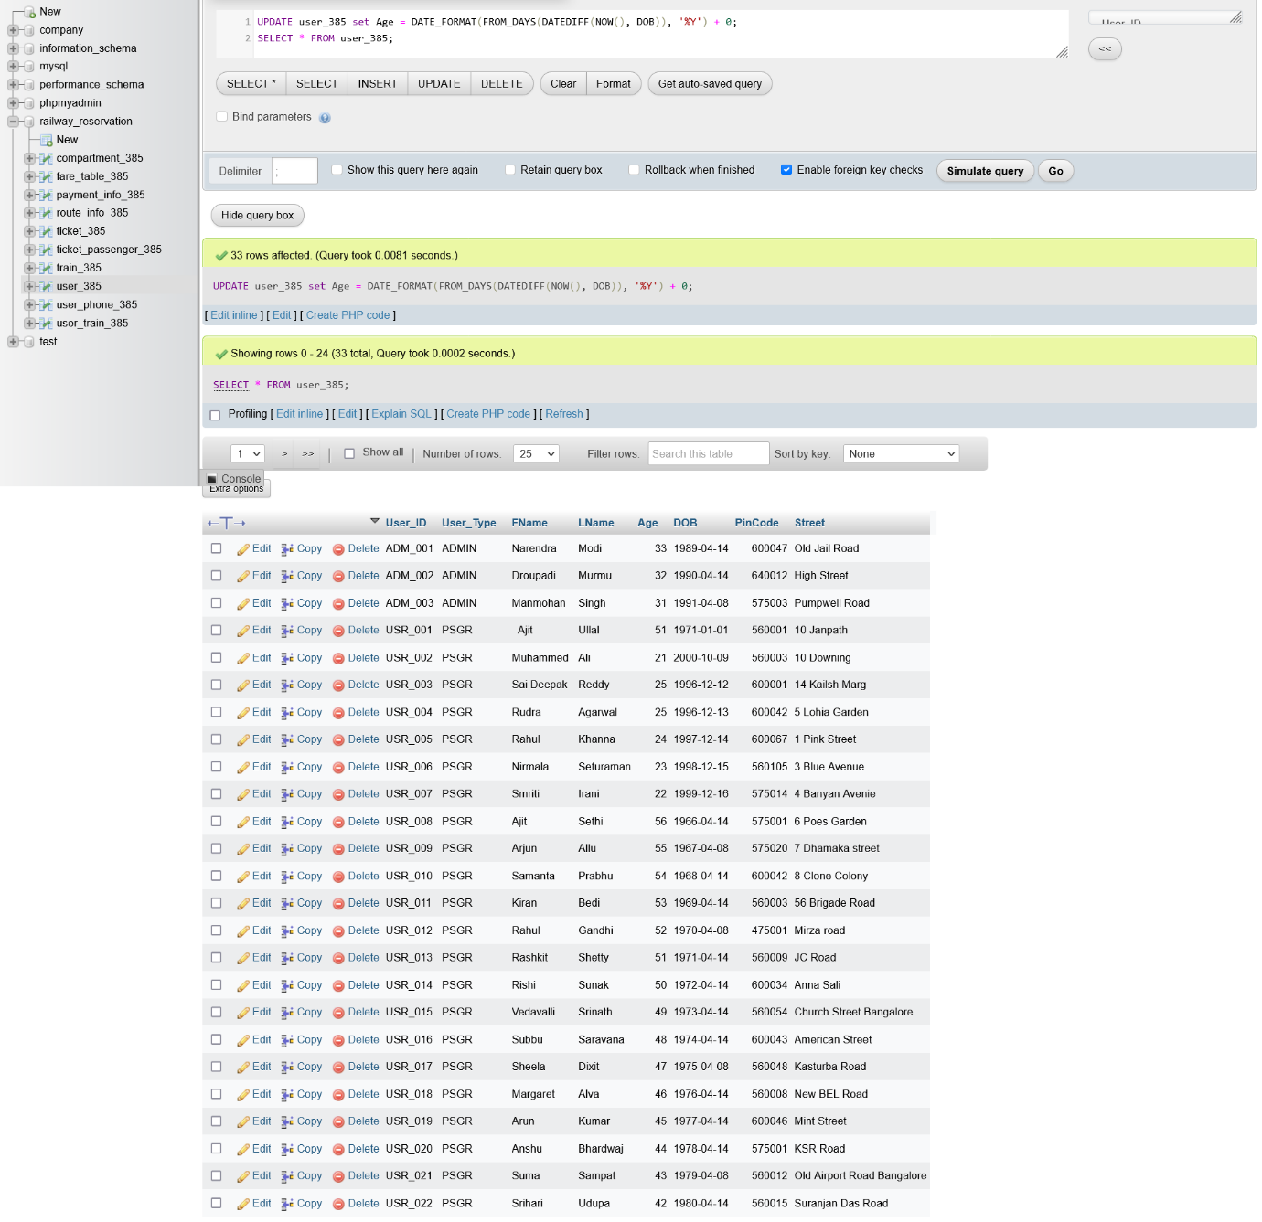

1. Display all the route information whose distance falls in a range from 70 to 150 km.

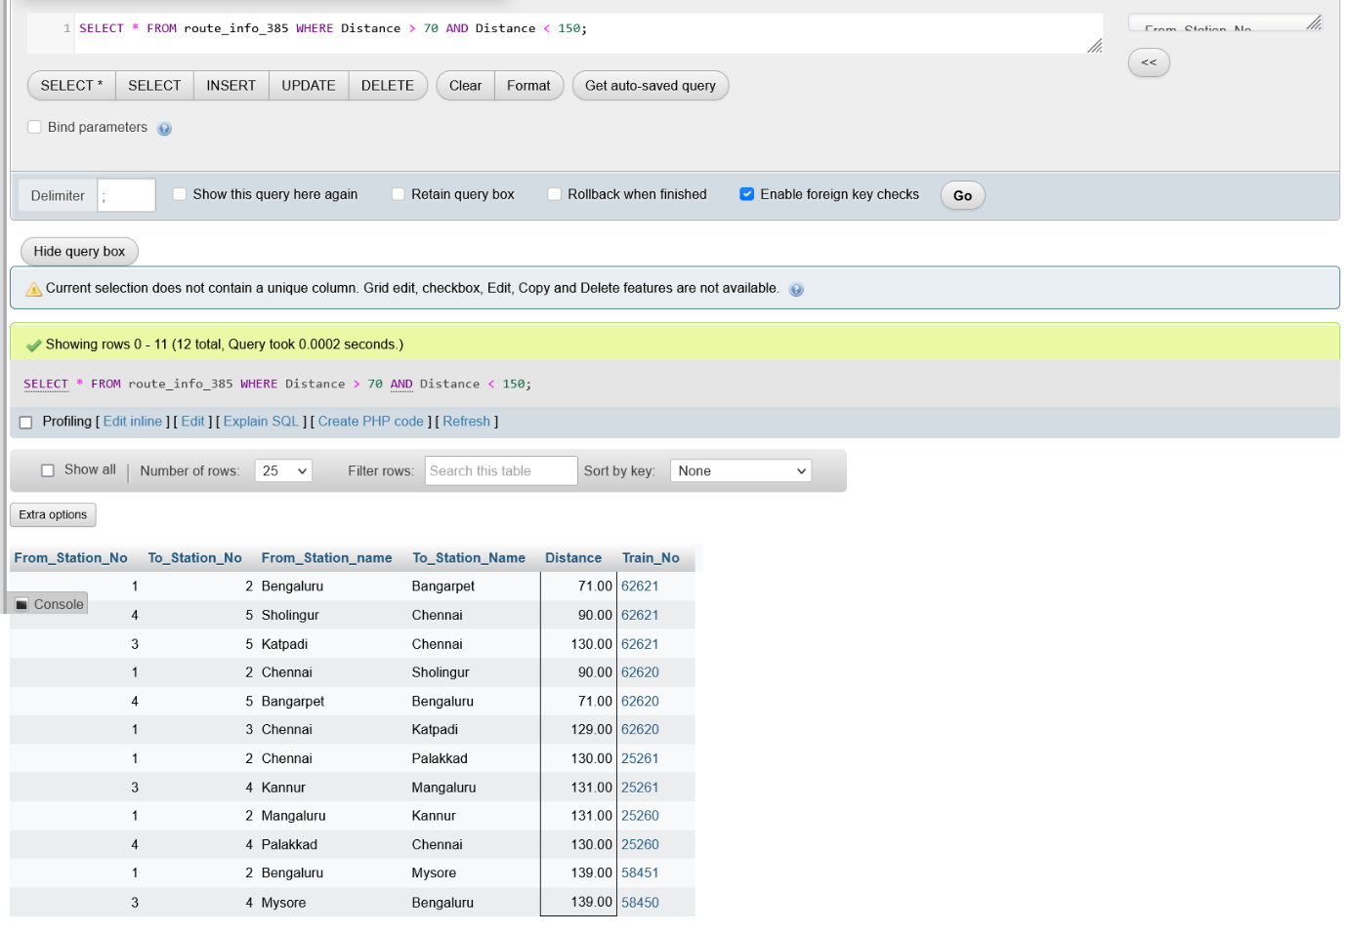

1. Display the train route information which are run between Chennai and Sholingur.

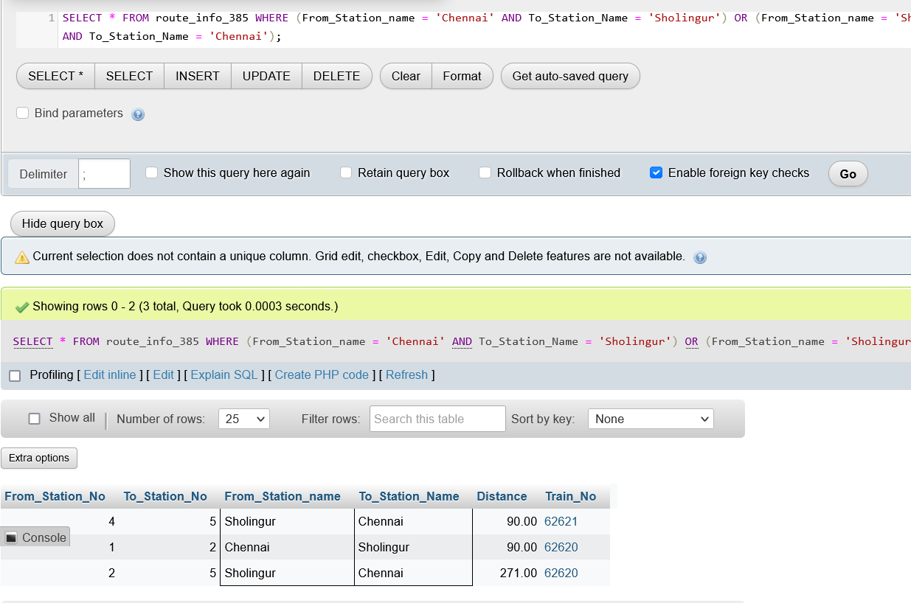

1. Display the train details whose type is not mail.

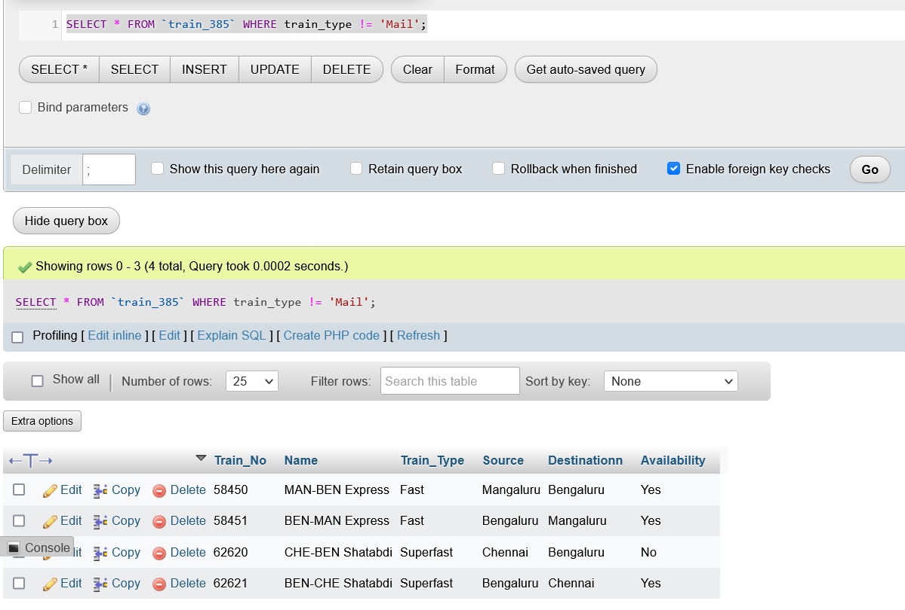

1. Display the train name which goes to Chennai from Bangalore.

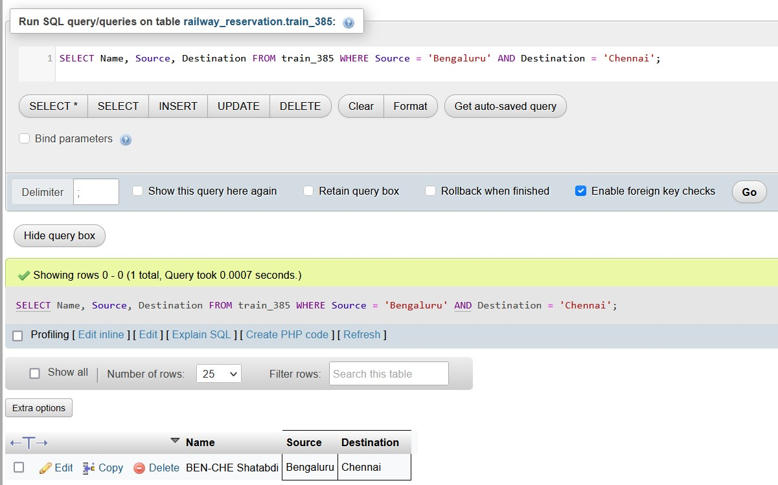

1. Display the list of trains starting from Chennai after 8:00.

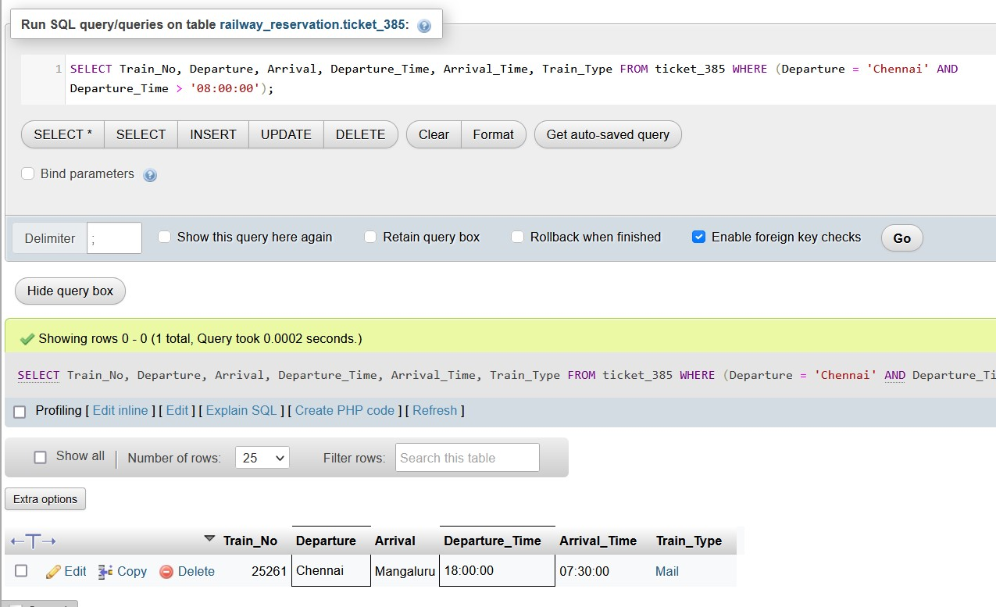

1. Display the list of users who are born between 1980 to 1990.

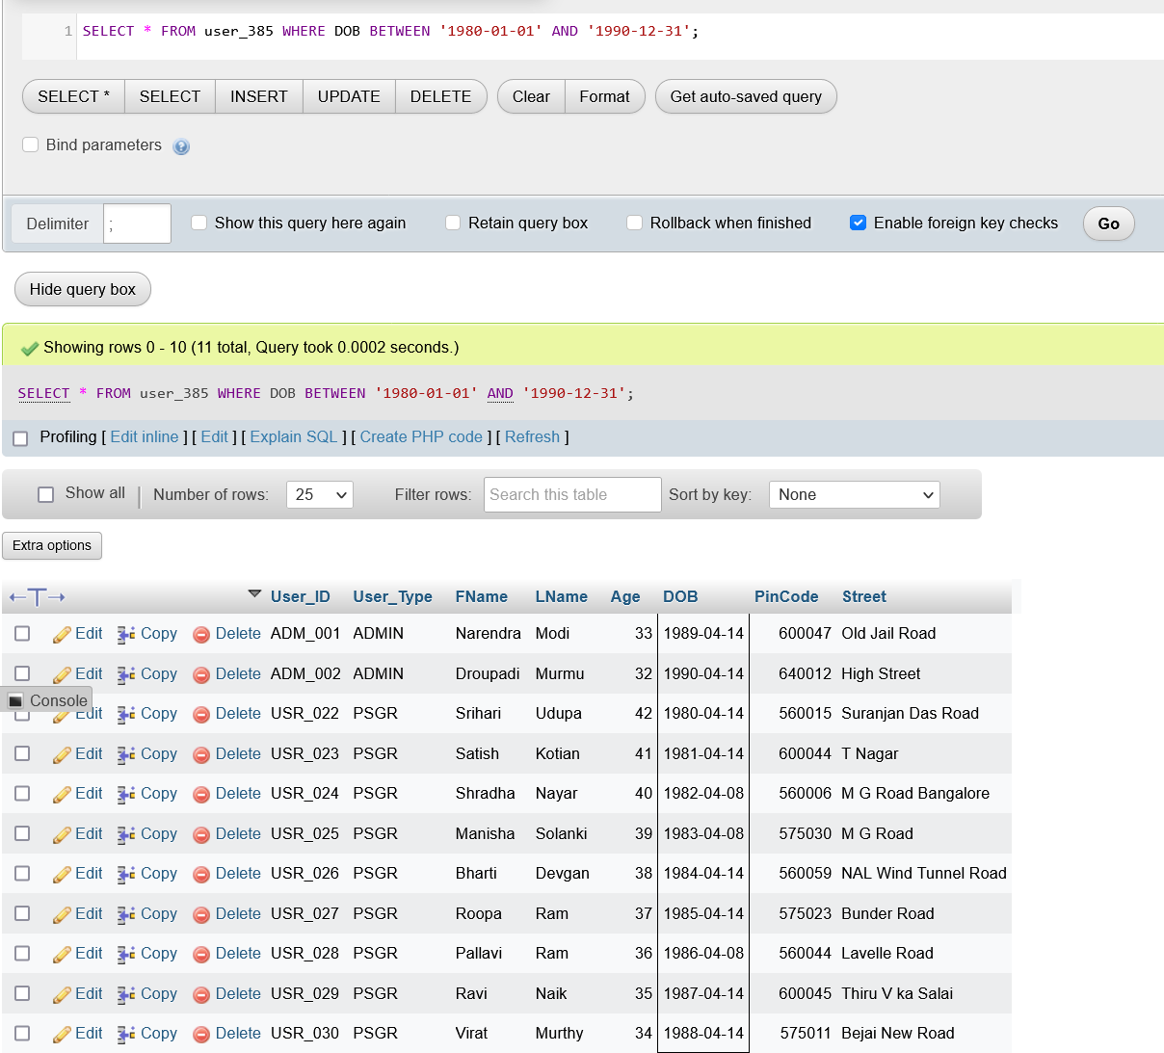

1. Display the train users whose name starts with the letter ‘S’

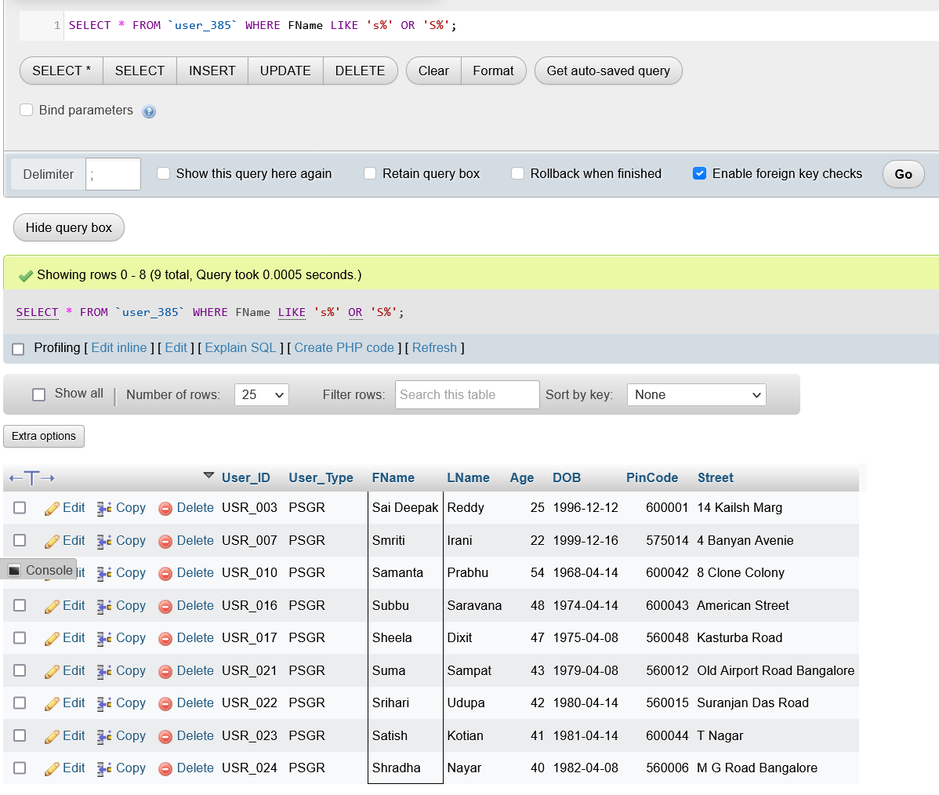

1. Find the availability of I Class compartment of the train number 62621

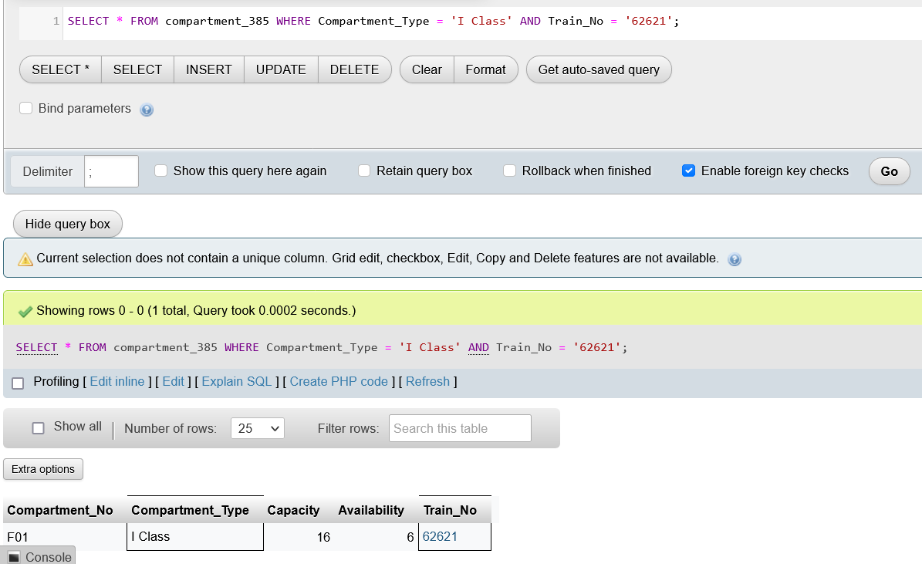

1. Find the PNR and Transaction ID of the users who made payment via Union Bank.

