DBMS

LAB – 4

NAME : Sanmat Sanjayakumar Payagoudar

SRN : PES1UG20CS385

TASK – 2

1. Grant privileges on different tables to users and observe the effect.

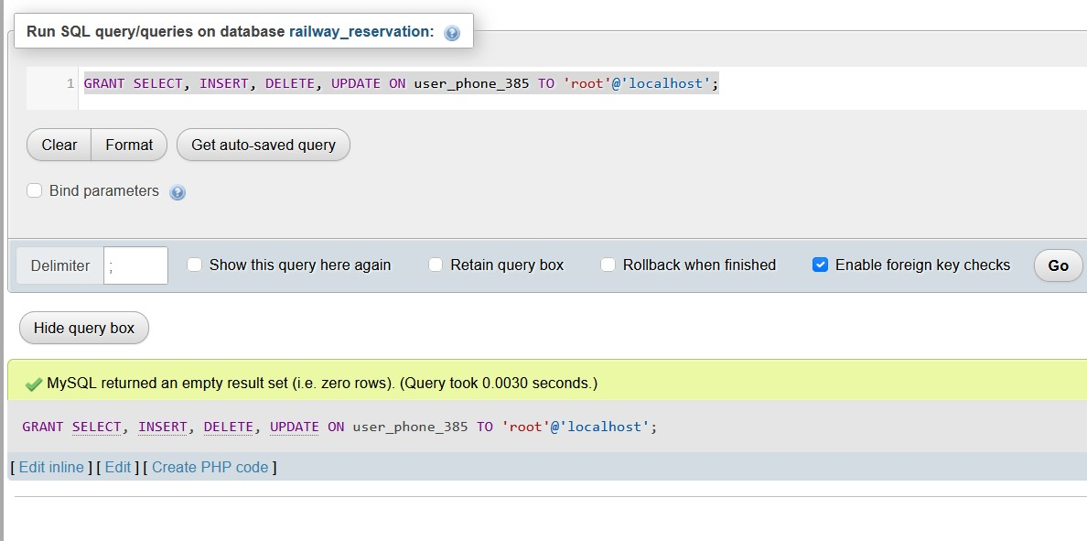

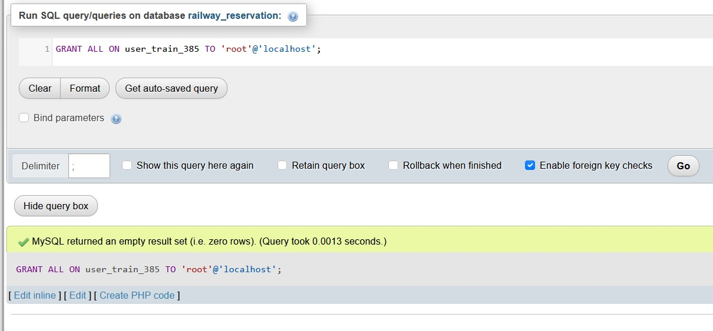

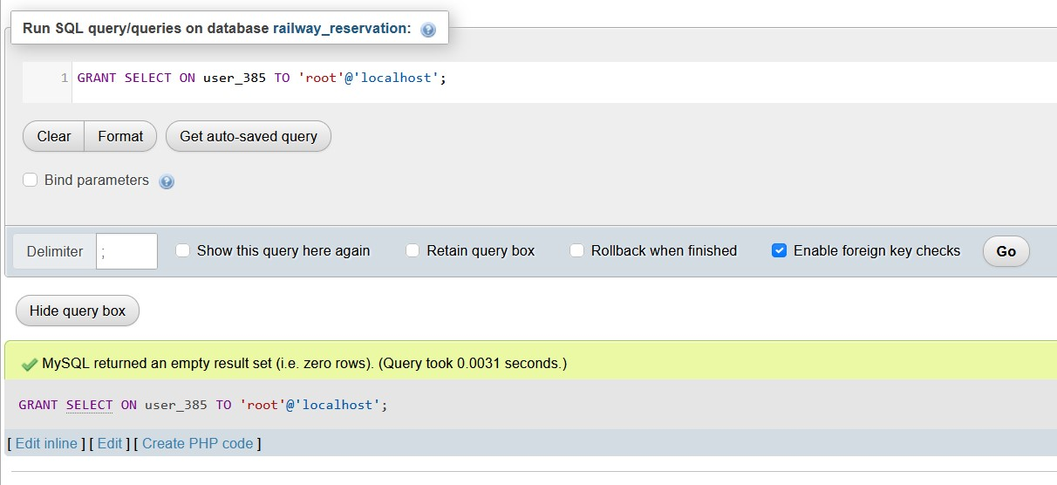

1. Revoke UPDATE & DELETE privileges on any tables and observe the effect if any  
   deletion/updation is performed

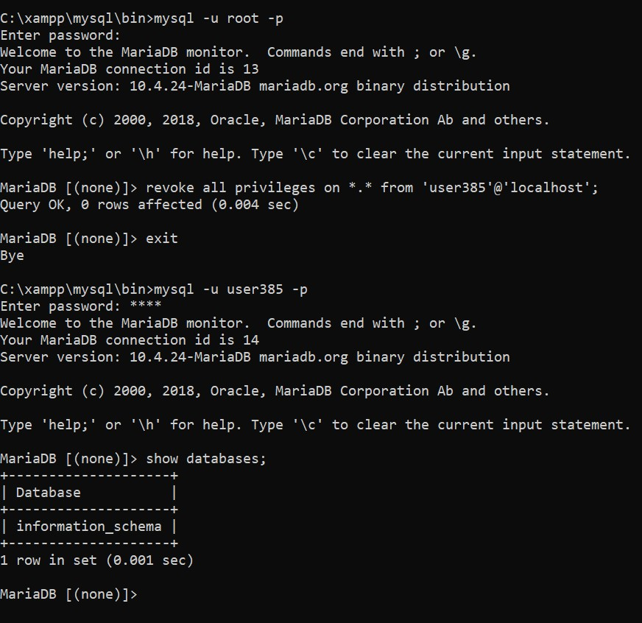

1. Create different save points and perform some insert/update/delete operations. Observethe effect of commit & rollback operations and release any created savepoints.

