DBMS

LAB – 6

**NAME :** SANMAT SANJAYAKUMAR PAYAGOUDAR

**SRN :** PES1UG20CS385

1. Query :

select Train_No, AVG(Distance) from route_info_385 GROUP BY Train_No;

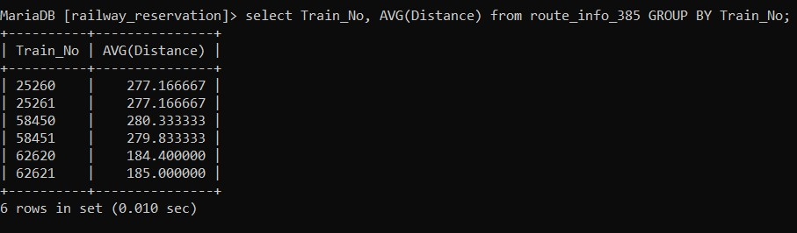

1. Query :

select Train_No, AVG(Distance) from route_info_385 GROUP BY Train_No ORDER BY AVG(Distance) DESC;

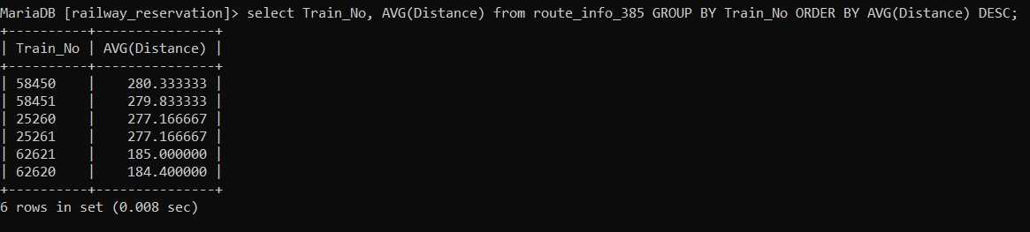

1. Query :

select Train_No, SUM(Distance) from route_info_385 GROUP BY Train_No ORDER BY AVG(Distance) DESC;

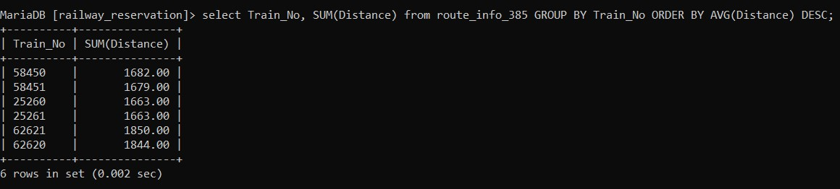

1. Query :

**MAX**

select Train_No, MAX(total_avai) AS Max_Avai FROM (select SUM(compartment_385.Availability) AS total_avai, Train_No from compartment_385 group by Train_No) AS Total_Availability;

**MIN**

select Train_No, MIN(total_avai) AS Max_Avai FROM (select SUM(compartment_385.Availability) AS total_avai, Train_No from compartment_385 group by Train_No) AS Total_Availability;

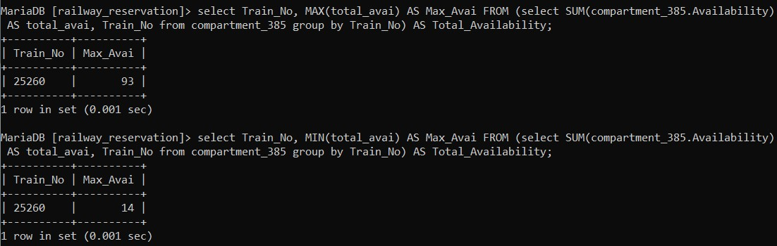

1. Query :

select User_ID, Phone_No from user_phone_385 where User_ID IN ('ADM_001', 'USR_006', 'USR_010');

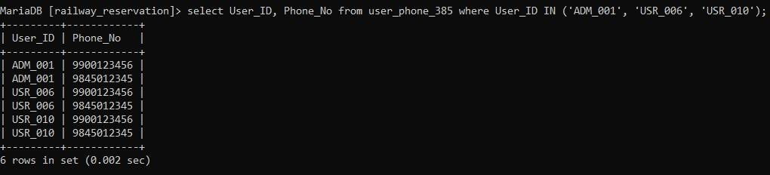

1. Query :

select Train_Type, AVG(FarePerKM) AS Avg_Fare from fare_table_385 GROUP BY Train_Type ORDER BY Avg_Fare DESC;

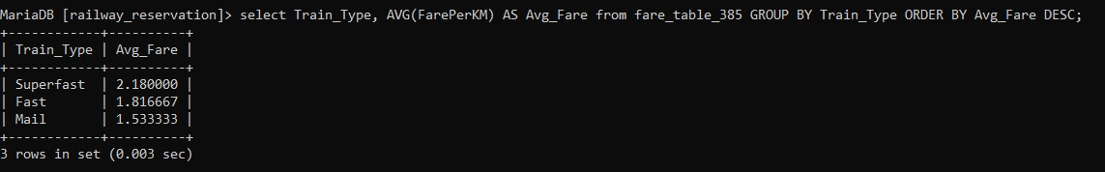

1. Query :

select * from user_385 where Age = (select MAX(Age) AS Age from user_385);

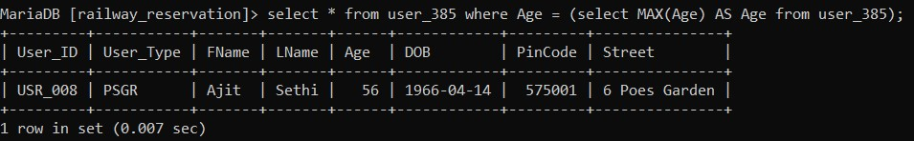

1. Query :

select COUNT(Name) FROM ticket_passenger_385 where Name LIKE '%Ullal';

