DBMS

LAB – 7

**NAME :** SANMAT SANJAYAKUMAR PAYAGOUDAR

**SRN :** PES1UG20CS385

1. **Find the list of passengers (user_id, user_type First name and last name) who have traveled from Bengaluru to Chennai during the month of Oct 2021 and Aug 2022**

**Query :**

SELECT T1.User_ID,

    T2.User_Type,

    T2.FName,

    T2.LName

FROM ticket_385 T1

    JOIN user_385 T2 ON T1.User_ID = T2.User_ID

WHERE T1.Travel_Date BETWEEN '2021-10-01' AND '2021-10-31'

    AND T1.Departure = 'Bengaluru'

    AND T1.Arrival = 'Chennai'

UNION

(

    SELECT T3.User_ID,

        T4.User_Type,

        T4.FName,

        T4.LName

    FROM ticket_385 T3

        JOIN user_385 T4 ON T3.User_ID = T4.User_ID

    WHERE T3.Travel_Date BETWEEN '2022-08-01' AND '2022-08-31'

        AND T3.Departure = 'Bengaluru'

        AND T3.Arrival = 'Chennai'

);

**OUTPUT :**

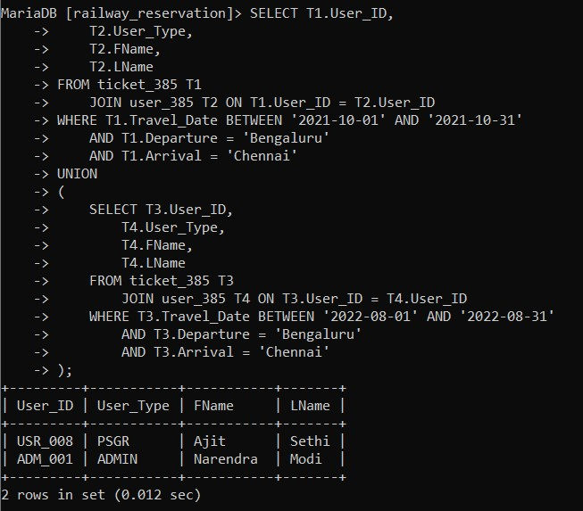

1. **Find the list of passengers (user_id, user_type First name and last name) who have traveled from Bengaluru to Chennai during the month of Oct 2021 and also during Aug 2022**

**Query :**

SELECT T1.User_ID,

    T2.User_Type,

    T2.FName,

    T2.LName

FROM ticket_385 T1

    JOIN user_385 T2 ON T1.User_ID = T2.User_ID

WHERE T1.Travel_Date BETWEEN '2021-10-01' AND '2021-10-31'

    AND T1.Departure = 'Bengaluru'

    AND T1.Arrival = 'Chennai'

INTERSECT

(

    SELECT T3.User_ID,

        T4.User_Type,

        T4.FName,

        T4.LName

    FROM ticket_385 T3

        JOIN user_385 T4 ON T3.User_ID = T4.User_ID

    WHERE T3.Travel_Date BETWEEN '2022-08-01' AND '2022-08-31'

        AND T3.Departure = 'Bengaluru'

        AND T3.Arrival = 'Chennai'

);

**OUTPUT :**

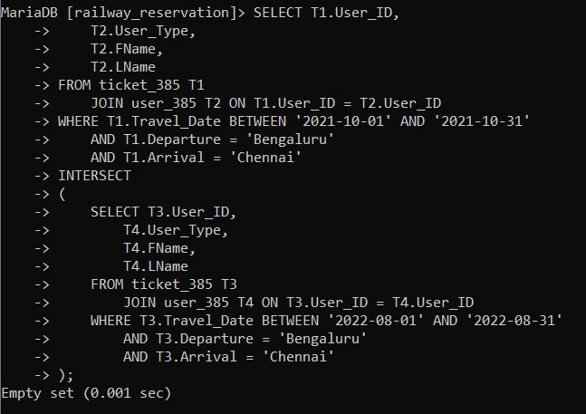

1. **Find the list of passengers (user_id, user_type First name and last name) who have traveled from Bengaluru to Chennai during the month of Aug 2022 and not in Oct 2021**

**Query :**

SELECT T1.User_ID,

    T2.User_Type,

    T2.FName,

    T2.LName

FROM ticket_385 T1

    JOIN user_385 T2 ON T1.User_ID = T2.User_ID

WHERE T1.Travel_Date BETWEEN '2022-08-01' AND '2022-08-31'

    AND T1.Departure = 'Bengaluru'

    AND T1.Arrival = 'Chennai'

EXCEPT(

        SELECT T3.User_ID,

            T4.User_Type,

            T4.FName,

            T4.LName

        FROM ticket_385 T3

            JOIN user_385 T4 ON T3.User_ID = T4.User_ID

        WHERE T3.Travel_Date BETWEEN '2021-10-01' AND '2021-10-31'

            AND T3.Departure = 'Bengaluru'

            AND T3.Arrival = 'Chennai'

    );

**OUTPUT :**

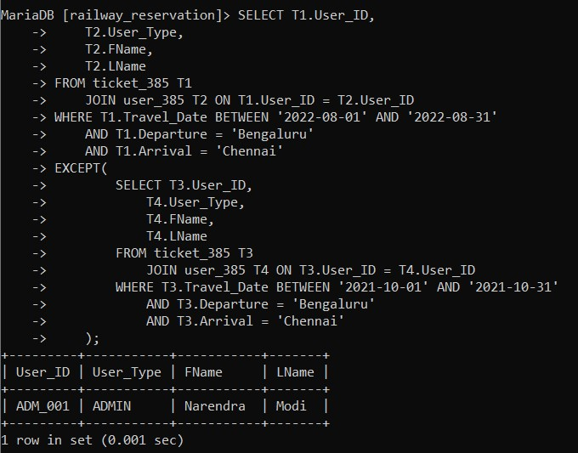

1. **Find the list of passengers (user_id, user_type, First name and last name) who have traveled from Bengaluru to Chennai and returned to Bengaluru within a week.**

**Query :**

SELECT T1.User_ID,

    T2.User_Type,

    T2.FName,

    T2.LName

FROM ticket_385 T1

    JOIN user_385 T2 ON T1.User_ID = T2.User_ID

WHERE T1.Departure = 'Bengaluru'

    AND T1.Arrival = 'Chennai'

    AND EXISTS(

        SELECT T3.User_ID,

            T4.User_Type,

            T4.FName,

            T4.LName

        FROM ticket_385 T3

            JOIN user_385 T4 ON T3.User_ID = T4.User_ID

        WHERE T3.User_ID = T1.User_ID

            AND T3.Arrival = 'Bengaluru'

            AND DATEDIFF(T3.Travel_Date, T1.Travel_Date) < 8

    );

**OUTPUT :**

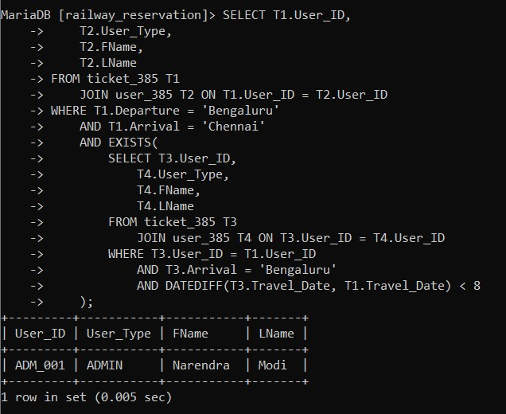

1. **Find the list of passengers (user_id, user_type, First name and last name) who have traveled from Bengaluru to Chennai and did not return to Bengaluru (in other words, only one way travel from Bengaluru to Chennai)**

**Query :**

SELECT T1.User_ID,

    T2.User_Type,

    T2.FName,

    T2.LName

FROM ticket_385 T1

    JOIN user_385 T2 ON T1.User_ID = T2.User_ID

WHERE T1.Departure = 'Bengaluru'

    AND T1.Arrival = 'Chennai'

    AND NOT EXISTS(

        SELECT T3.User_ID,

            T4.User_Type,

            T4.FName,

            T4.LName

        FROM ticket_385 T3

            JOIN user_385 T4 ON T3.User_ID = T4.User_ID

        WHERE T3.User_ID = T1.User_ID

            AND T3.Arrival = 'Bengaluru'

            AND T3.Travel_Date >= T1.Travel_Date

    );

**OUTPUT :**

