DBMS

LAB – 8

**NAME :** SANMAT SANJAYAKUMAR PAYAGOUDAR

**SRN :** PES1UG20CS385

1. **Write a function to find the number of tickets booked by a customer. If no of tickets is more than 3 for the current month then display error message as “cannot purchase tickets current limit is over”.**

**Query :**

DELIMITER $$

CREATE FUNCTION count_tickets(ticket_385 int)

RETURNS VARCHAR(50)

DETERMINISTIC

BEGIN

DECLARE VALUE varchar(50);

IF ticket_385 > 3 then

set VALUE="Cannot purchase tickets Current limit is over";

    ELSE

set VALUE ="Can Purchase ticket_385";

    end if;

    return value;

END$$

DELIMITER ;

with t as (Select user_id, count(pnr) as count from ticket_385 group by user_id )

select user_id, count_tickets(count) as Validate, count as ticket_purchased from t;

**OUTPUT :**

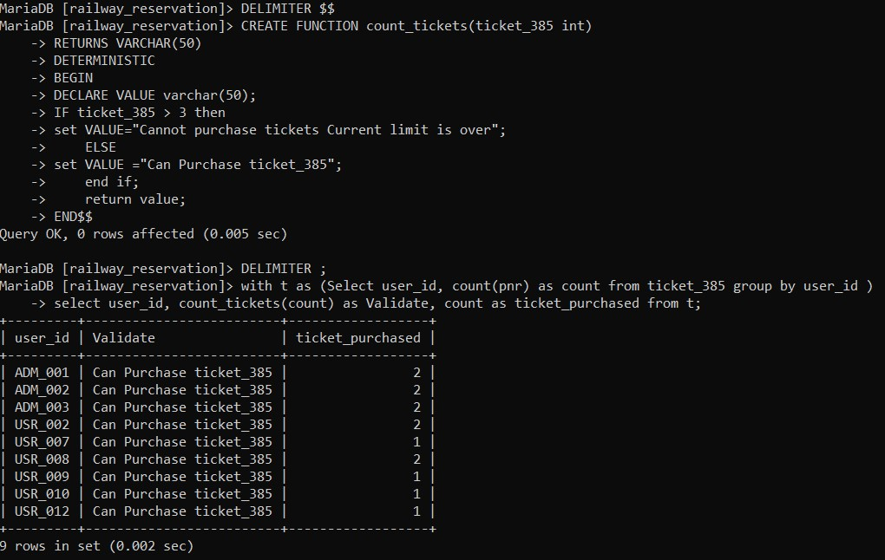

1. **Write a stored procedure to calculate the age of the customer when the date of birth is given. Update the column named age in the customer table.**

**Query :**

DELIMITER $$

CREATE procedure age_updation(

IN UID varchar(30),IN DB date, OUT msg varchar(30))

BEGIN

DECLARE age int;

IF DB>sysdate() THEN

    set msg= 'Invalid DoB';

ELSE

    update user_385

    set Age=(datediff(sysdate(),DB))/365

    where User_ID= UID;

    update user_385

    set DOB=DB

    where User_ID=UID;

    set msg=' Age updated Successfully';

END IF;

END$$

DELIMITER ;

CALL age_updation('ADM_003','1991-04-08',@A);

SELECT @A;

select * from user_385 where User_ID='ADM_003';

**OUTPUT :**

