HTML:

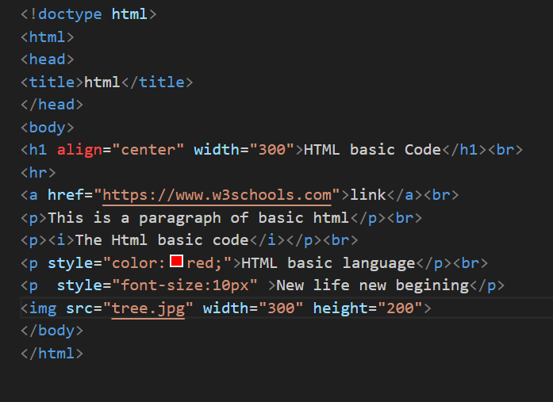

OUTPUT:

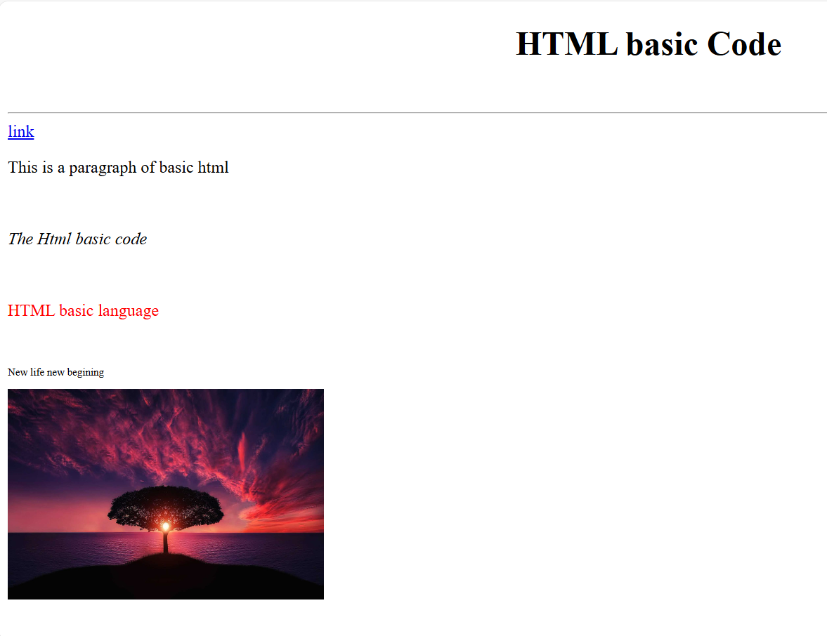

LEET CODE:

1.

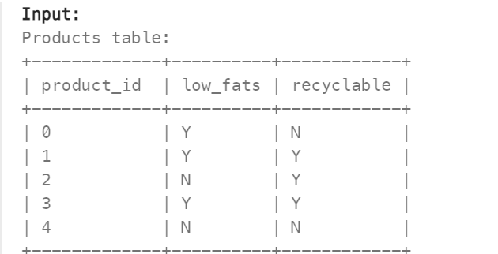

Write a solution to find the ids of products that are both low fat and recyclable.

Code:

select product_id from products where low_fats='Y' and recyclable='Y';

OUTPUT:

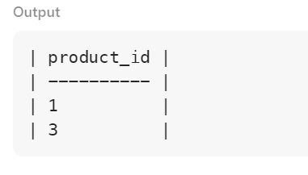

2.

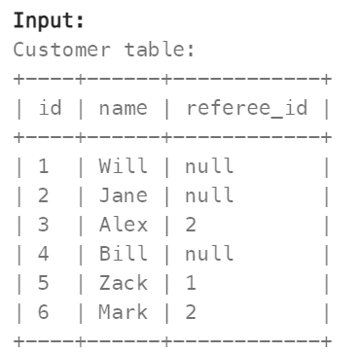

Find the names of the customer that are **not referred by** the customer with id = 2.

CODE:

select name from Customer where referee_id!=2 or referee_id is null;

OUTPUT:

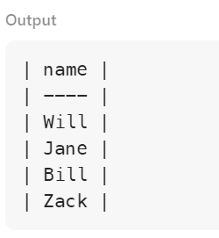

3.

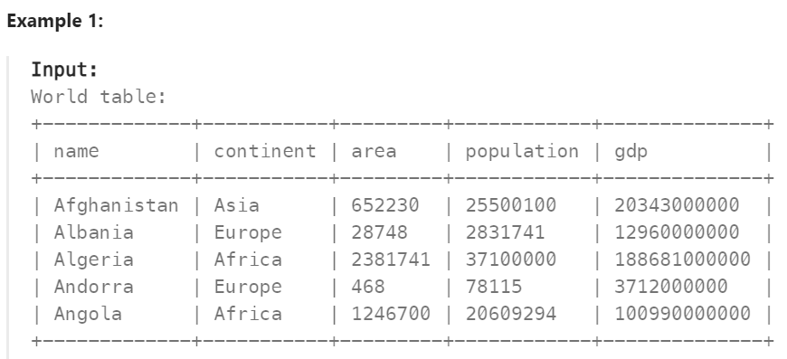

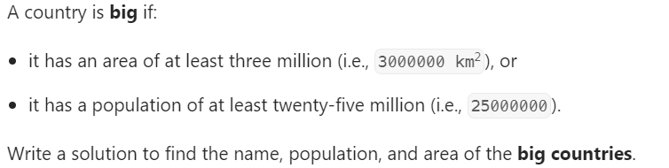

CODE:

select name,population,area from World where area>3000000 or population>25000000;

OUTPUT:

