**To see databases**

show databases;

**To create database**

create database databasename

**show table**

show tables;

**ddl commands**

**create**

create table tablename(columnname datatype,columnname datatype);

**drop**

drop database

drop database databasename;

drop table

drop table product;

drop column name

**alter**

alter table product drop column amount;

**rename table**

rename table tablename to newtablename

eg:

rename table product to products

**truncate**

truncate table table_name;

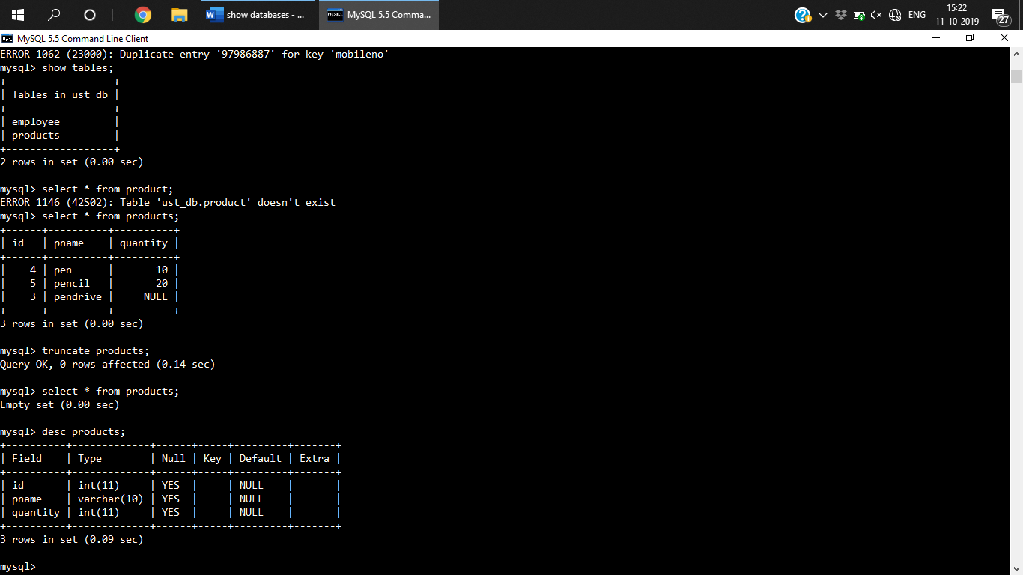

**DML**

1. **INSERT**

**1st Way of inserting data**

Insert into tablename (columnName1, columnname2, …... , columnnamen) values (value1,value2….valuen)

**Eg:**

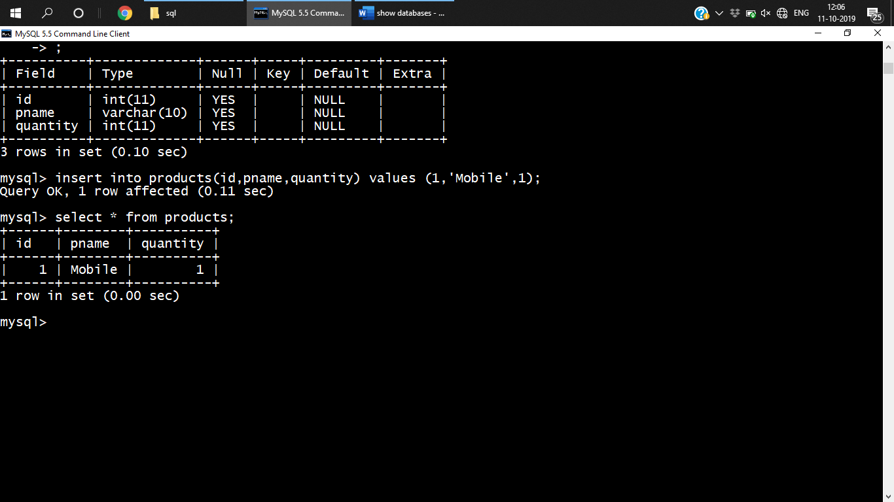

**2nd way of inserting data**

Insert into tablename values (value1,value2….valuen);

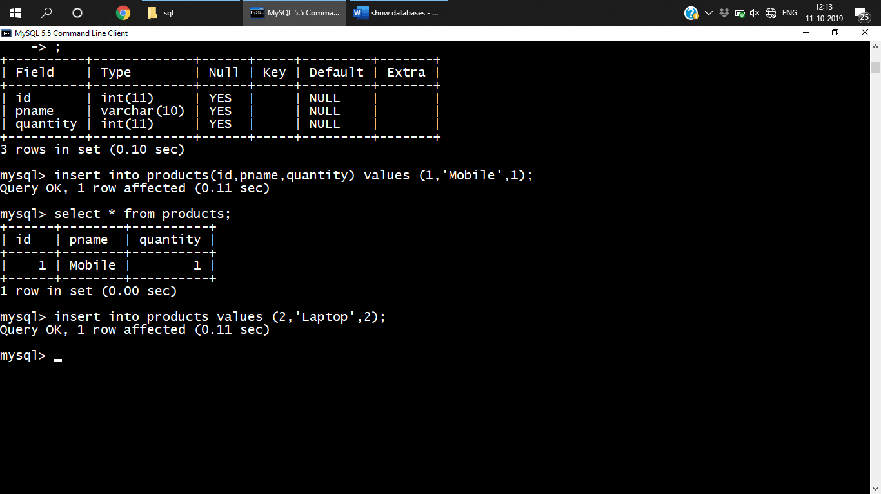

**3rd way Inserting data in to few columns**

Insert into tablename (columnName1, columnname2,) values (value1,value2)

Eg:

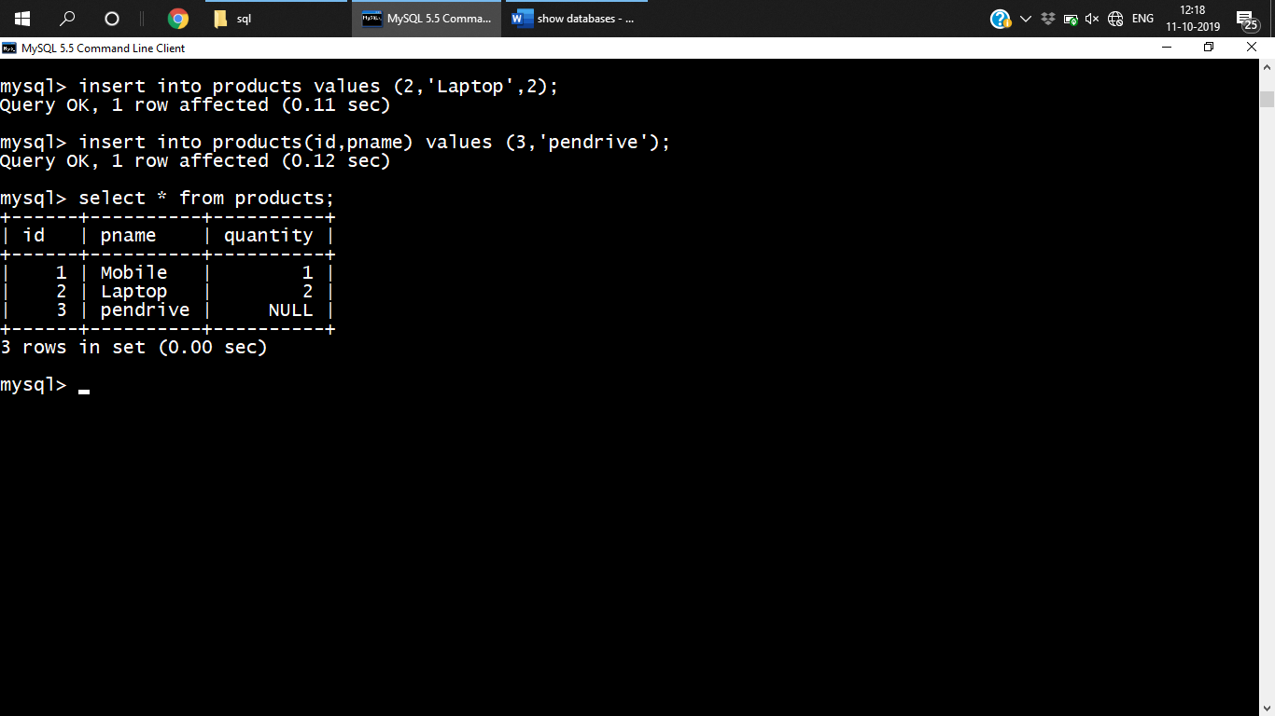

**4th way Inserting multiple records at a time**

Insert into tablename (columnName1, columnname2, …... , columnnamen) values (value1,value2….valuen),

(value1,value2….valuen), (value1,value2….valuen);

Eg:

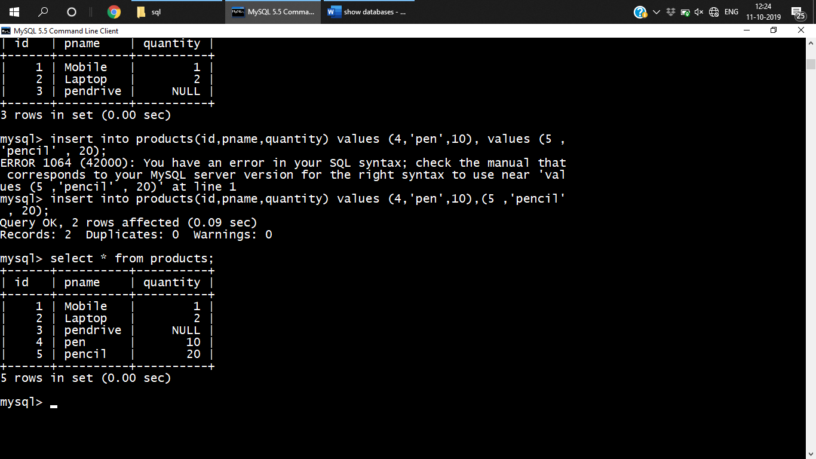

1. **UPDATE**

Update tablename set columnname = values;

**Eg :**

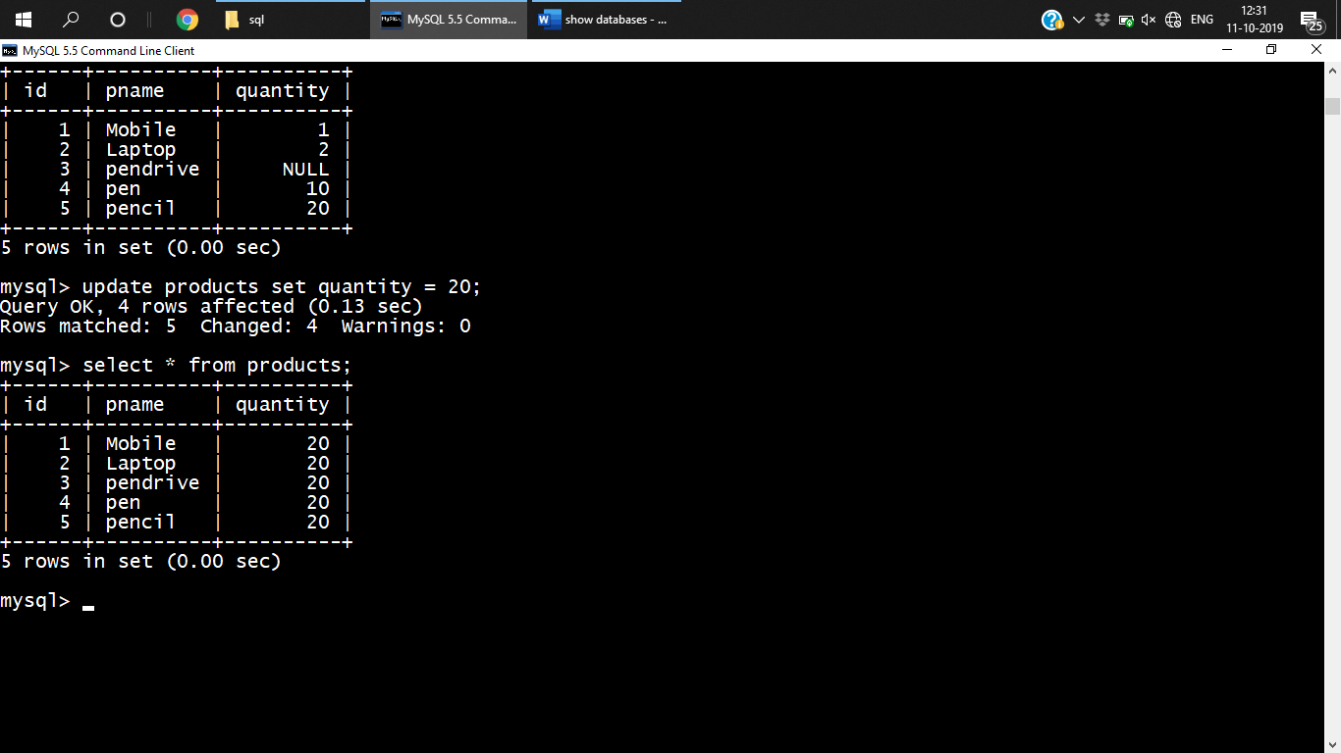

1. **Delete**

Delete from tablename;

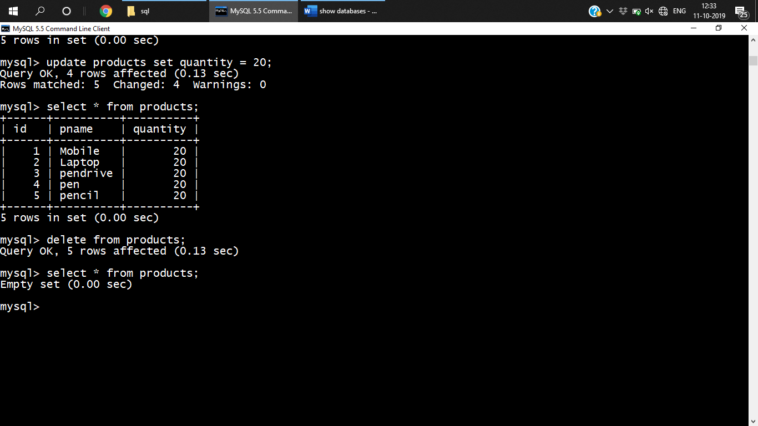

**DQL**

DQL is used to retrieve data from database.

**Select**

**3 ways of retrieval**

***Projection***

Retrieving column form table

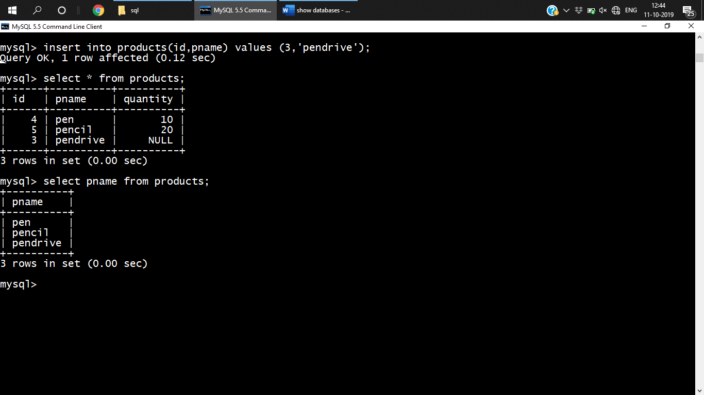

Select colName form tablename;

***Selection***

Retrieving both row and column data

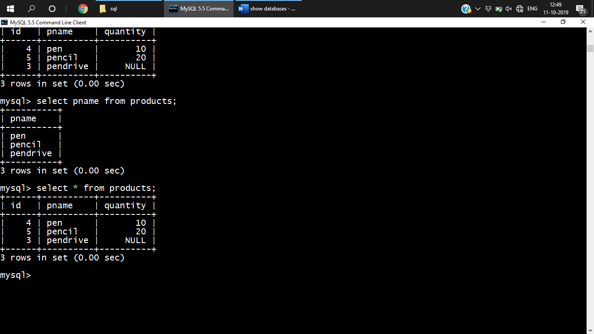

***Joins***

**Constraints**

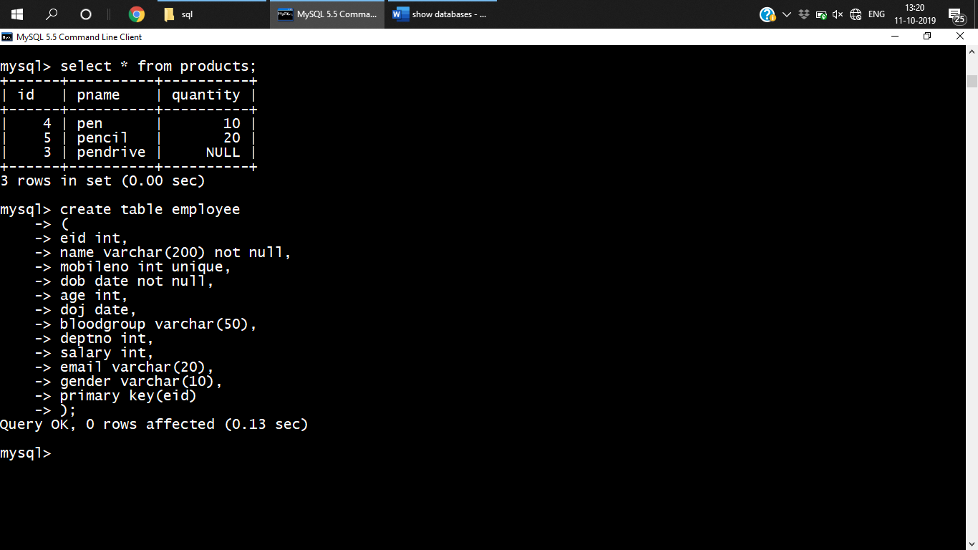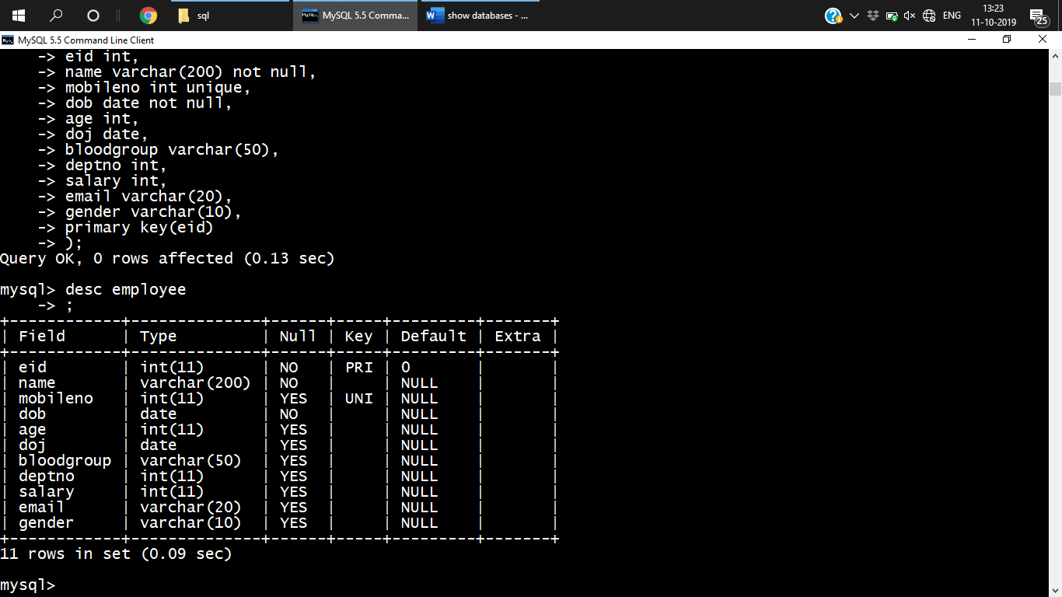

**Distinct**

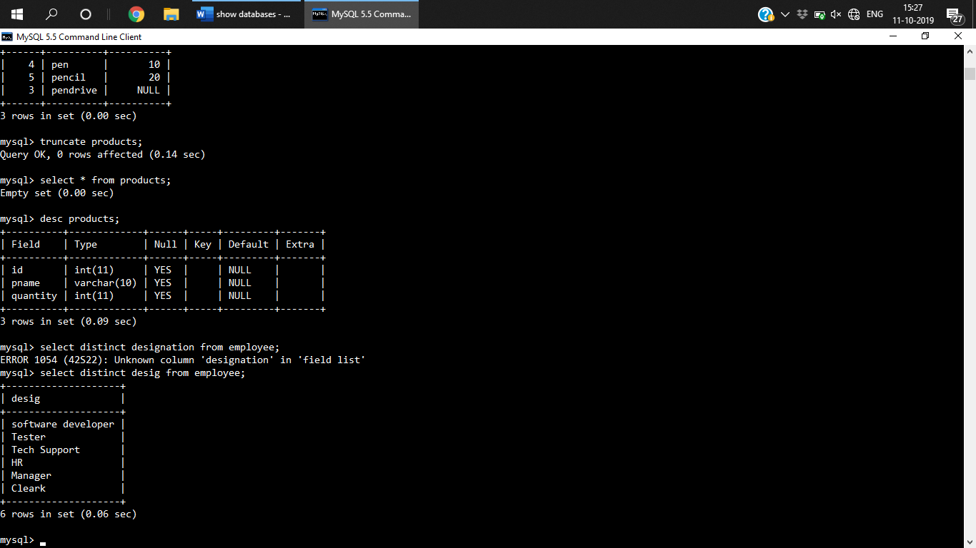Select distinct colName from tablename;

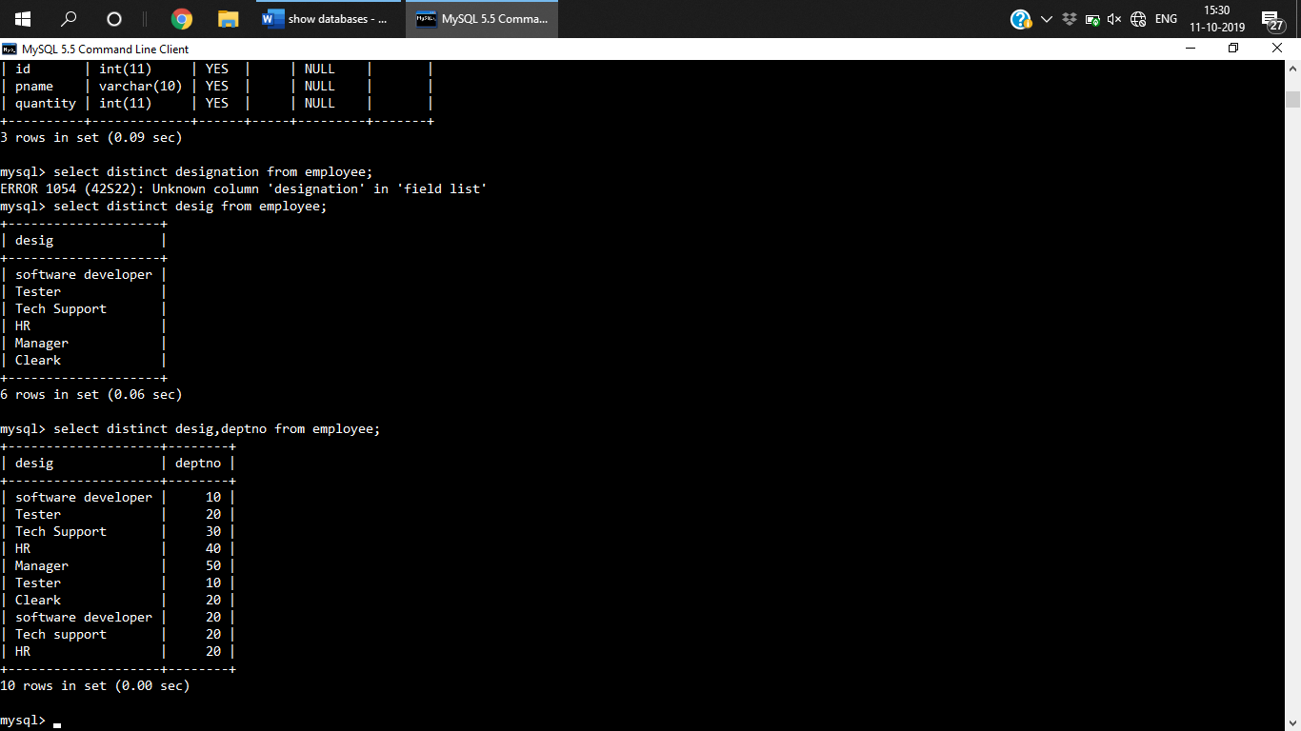

**Alias**

This is the temporary name foe the table

Select colname as aliasname from tablename ;

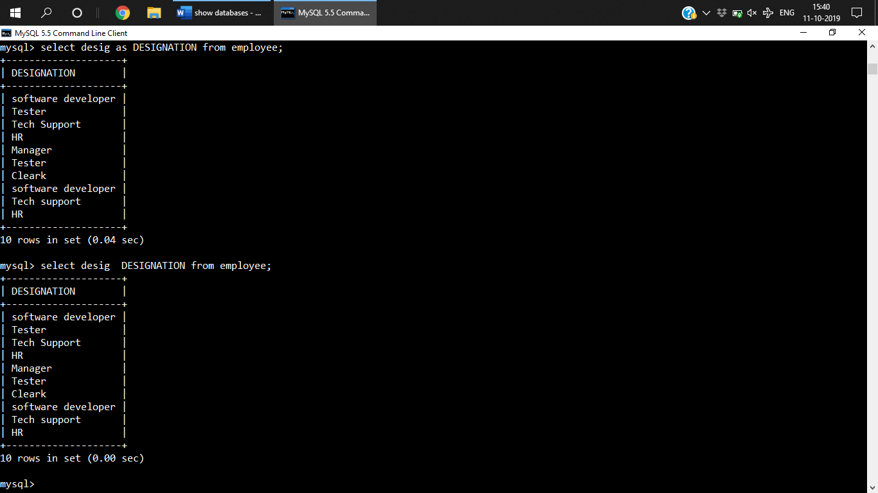 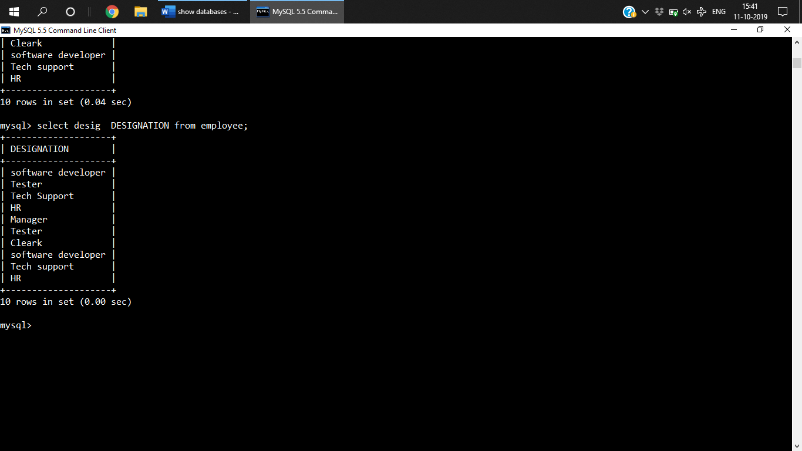

**where clause**

Used with update, delete, select

retrieves/manipulate records based on some condition

filter the data

syntax:

select * from tablename where condition;

eg

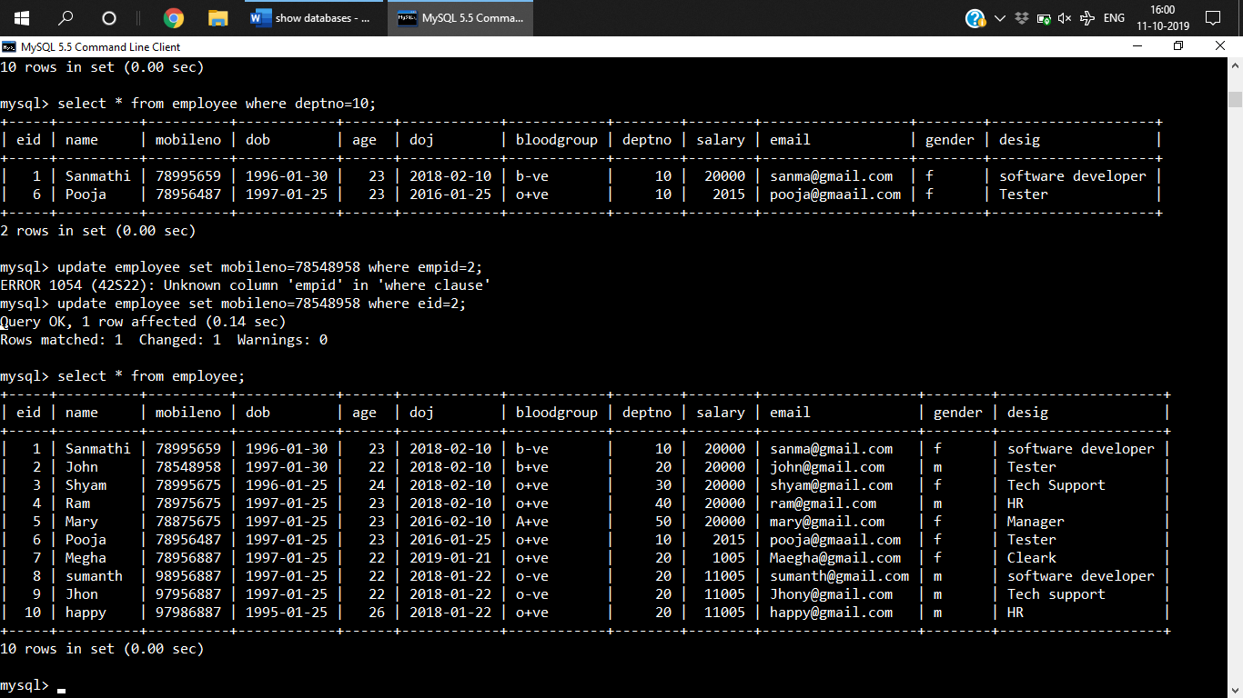

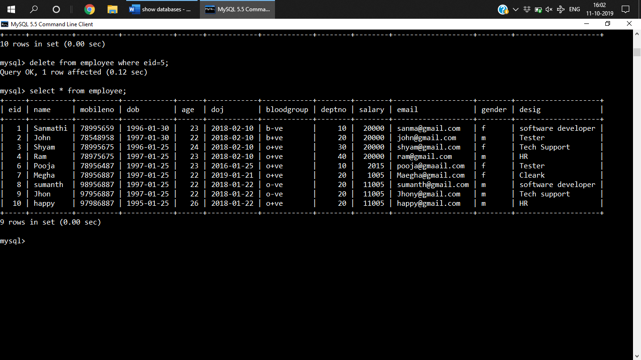

**Where clause order of execution**

1. From
2. Where
3. Select

**Expression**

* Column name
* Literals –3 types- number , character (sal+’sanmathi’), date(‘YYYY – MM -dd’ )

Eg: sal+5000 , sal+’sanmathi’

***Q) WAQ Query to display salary of employee incremented by 50000***

mysql> select salary+5000 as Salary from employee;

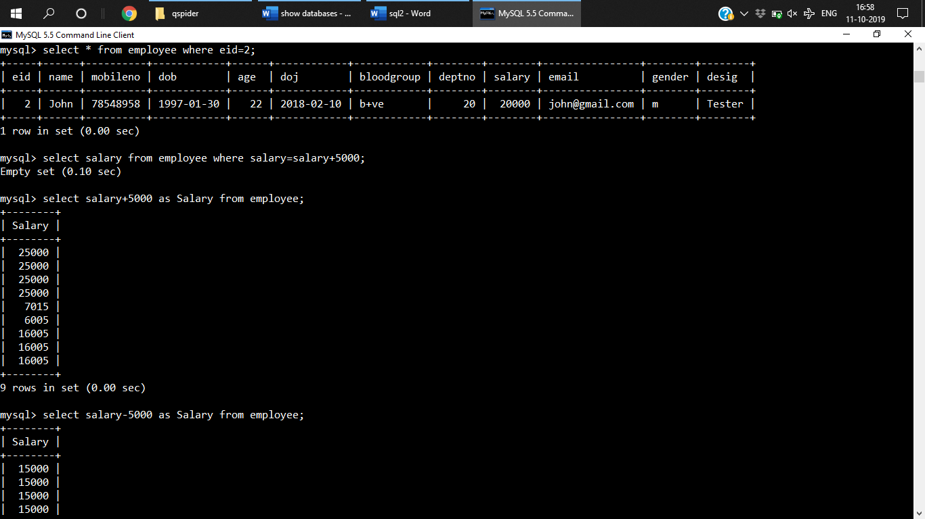

select salary-5000 as Salary from employee;

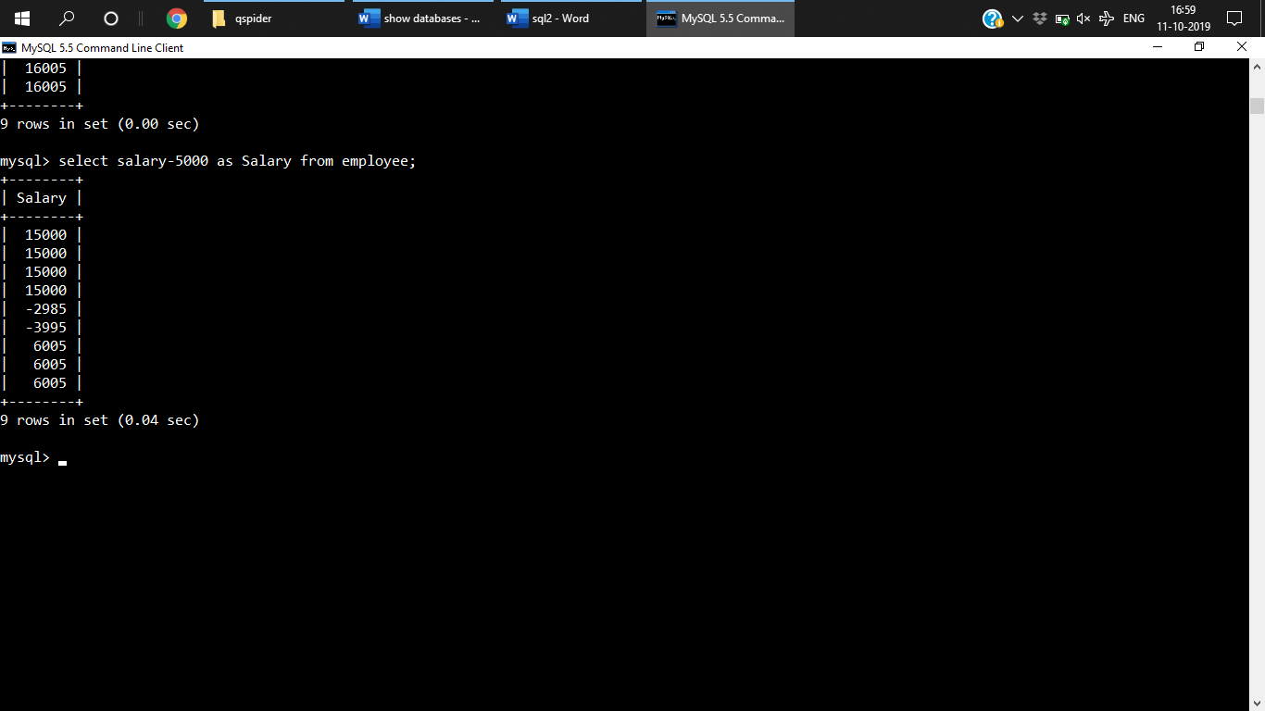

***Q) to select annual salary***

select salary*12 as Salary from employee;

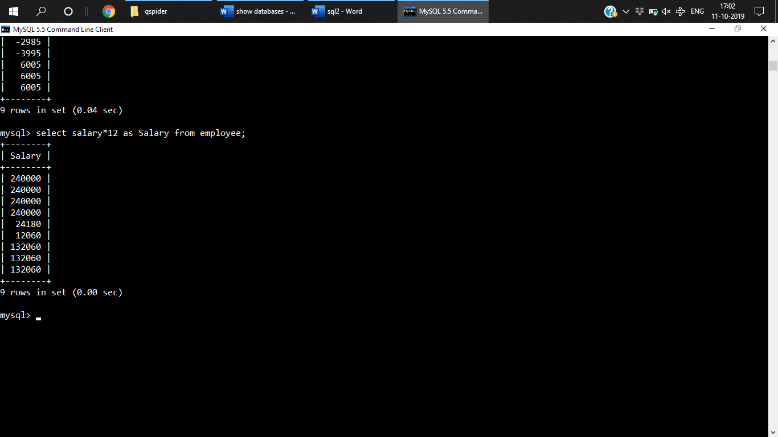

***Q)Salary for one day***

select salary/30 as Salary from employee;

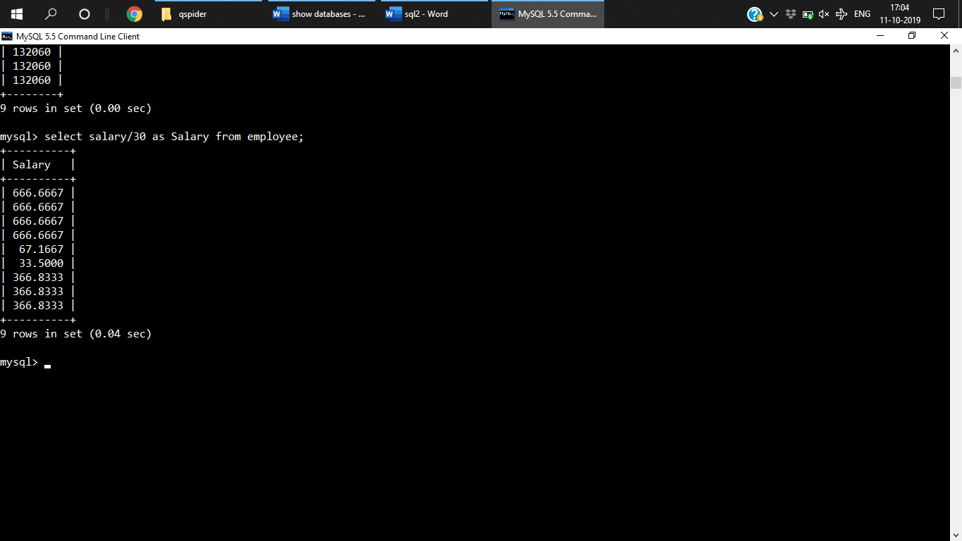

Comparison op

***Q) WAQ To display the result from the employee table whose desig is Software developer***

select * from employee where desig='software developer';

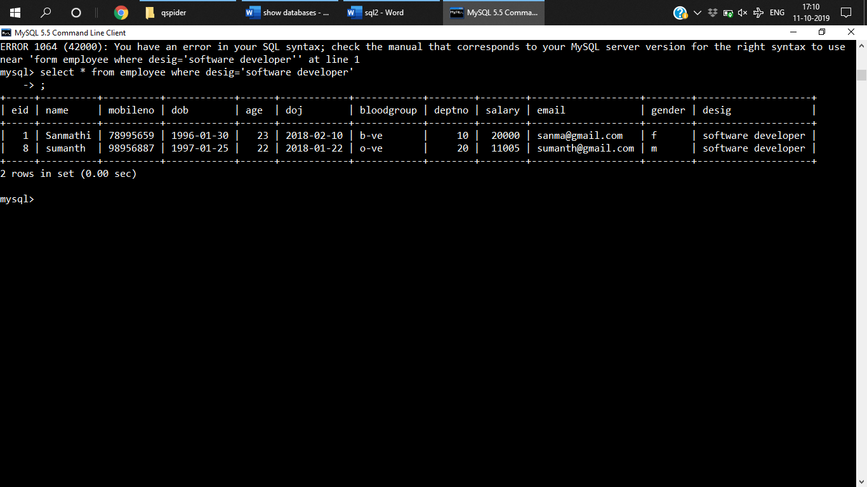

***Q) WAQ to display all the details of employee excluding who is working in dept no 20***

select * from employee where deptno!=20;

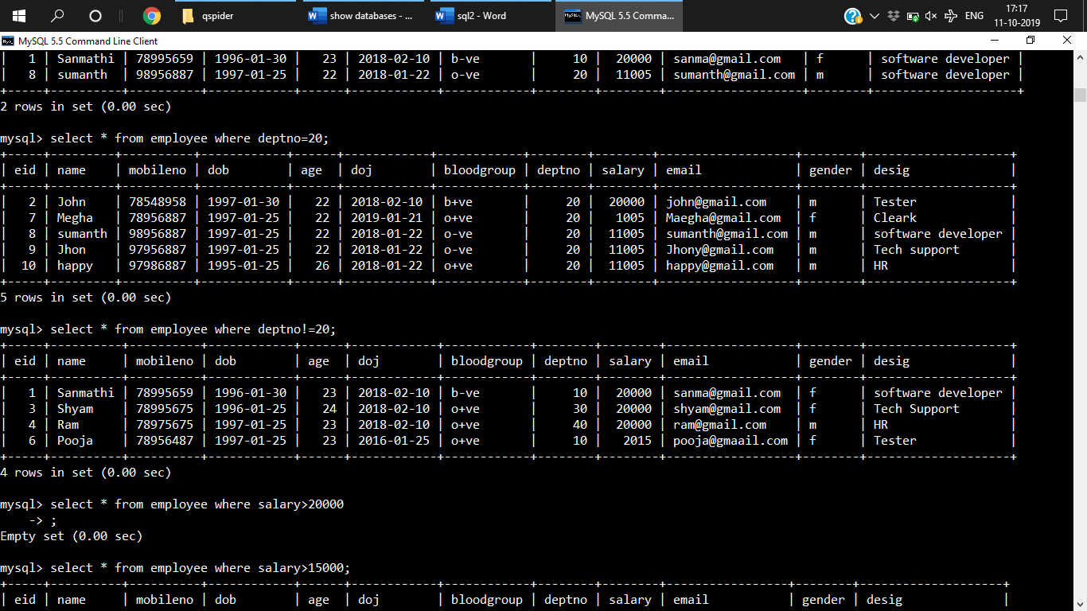

**Q) *WAQ to display record of employee whose sal >15000***

***select * from employee where salary>15000;***

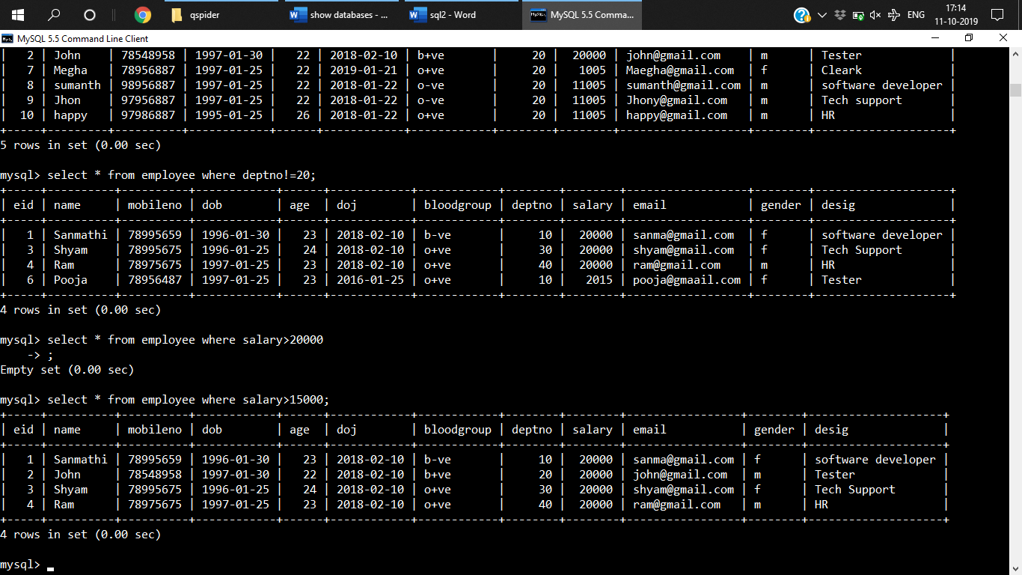

***Q)Whose age is less than 30***

select * from employee where age<30;

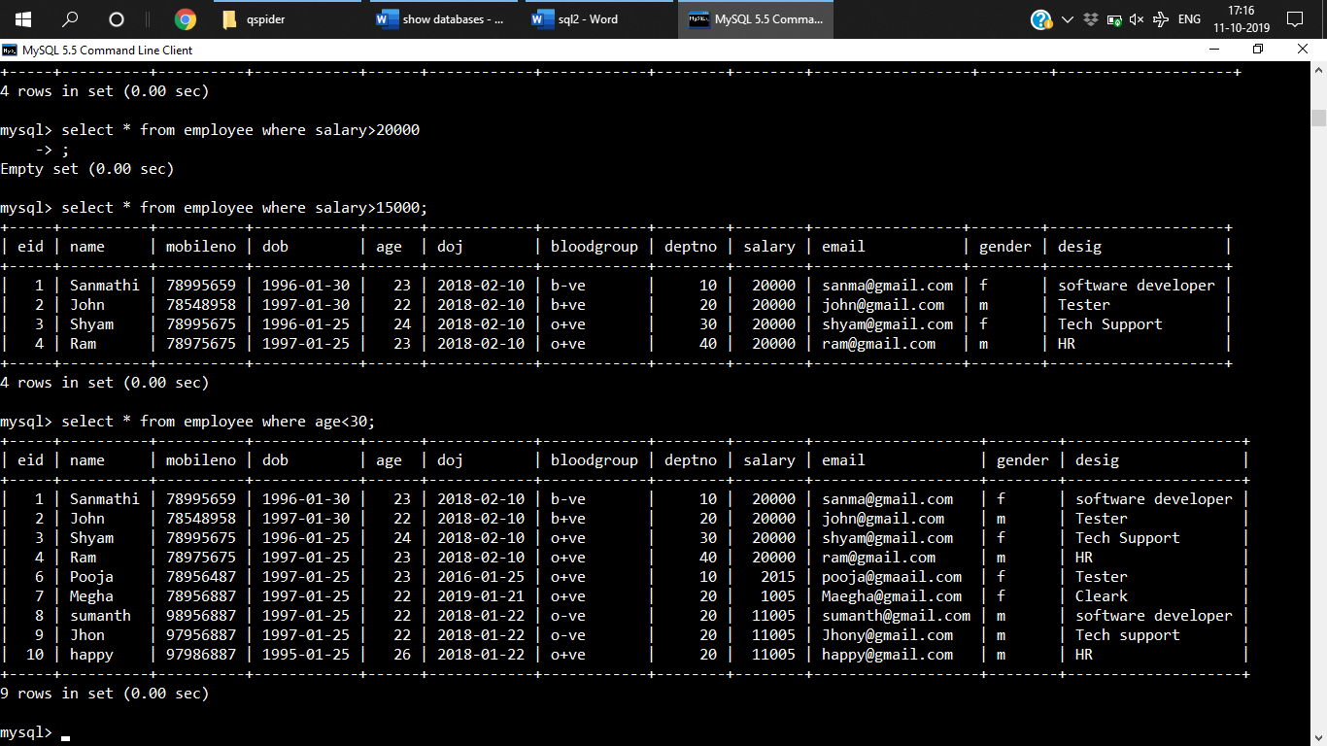

***Q) WAQTD Name sal emailed mobileno whose name=22 or greater than 22***

select * from employee where age>=22;

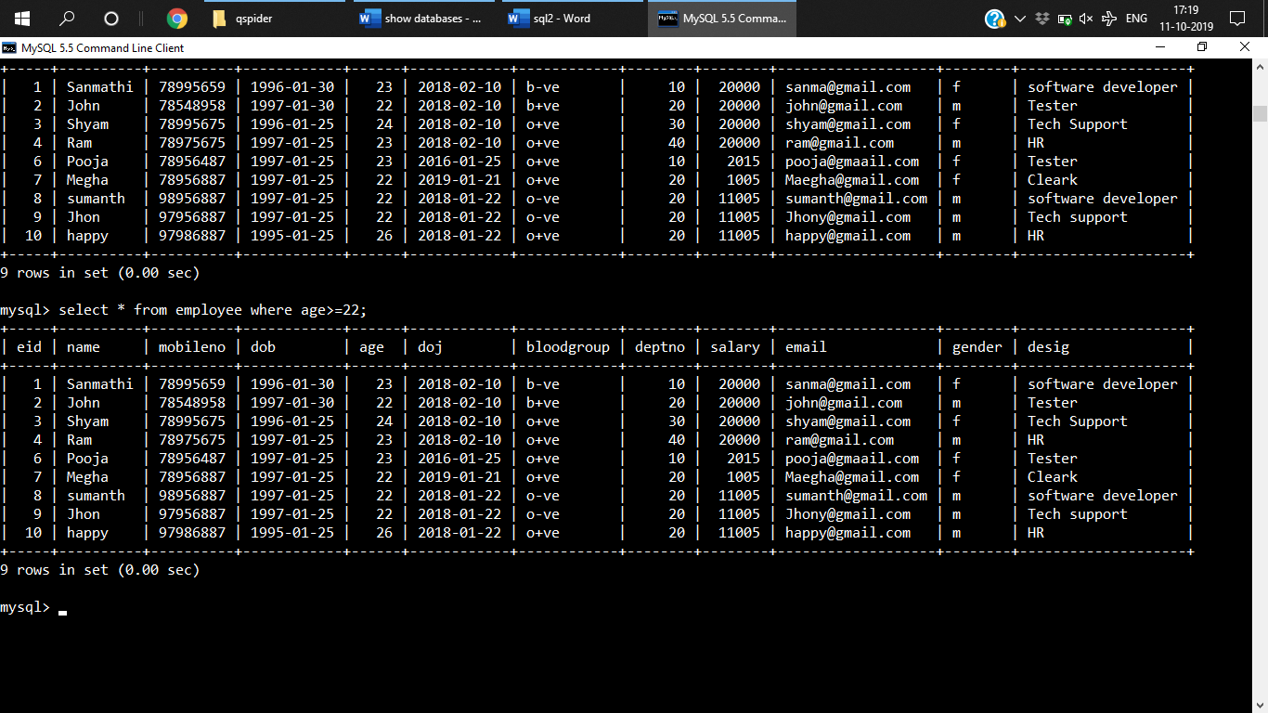

***Q) WQTD whose sal<=180000***

select * from employee where salary<=18000;

***Logical Operator***

***And operator***

Select * from tablename where condition1 and condition 2;

***OR***

Select * from tablename where condition1 or condition 2;

***Not***

Select * from tablename where not condition ;

***Q)WAQTD all the employee details who is working in dept no***

***20 as well as sal is >25000***

select * from employee where deptno=20 and salary>15000;

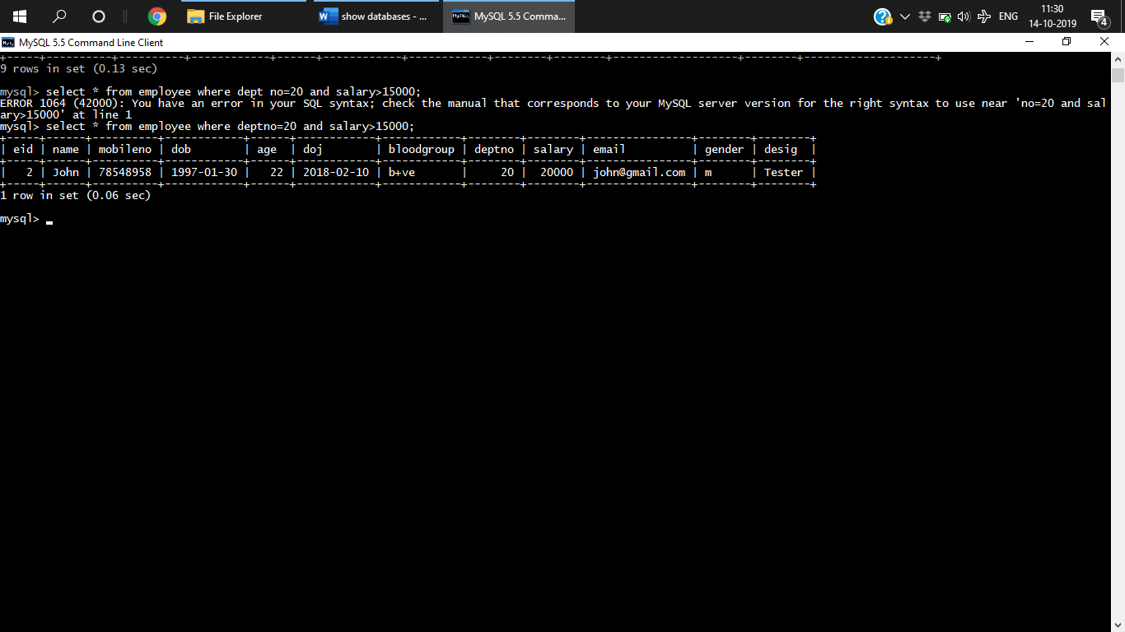

**Q)**WAQ***TD name ,salary from the employee table who is working in deptno 10 and 20***

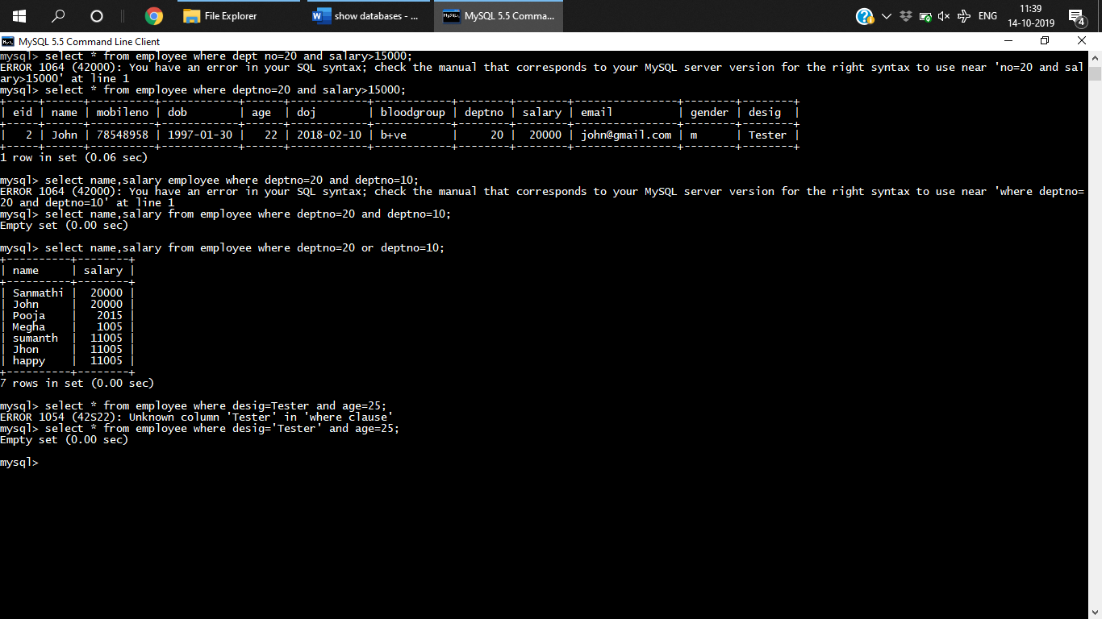

***Q)WAQTD employee details whose desig=tester and age =25***

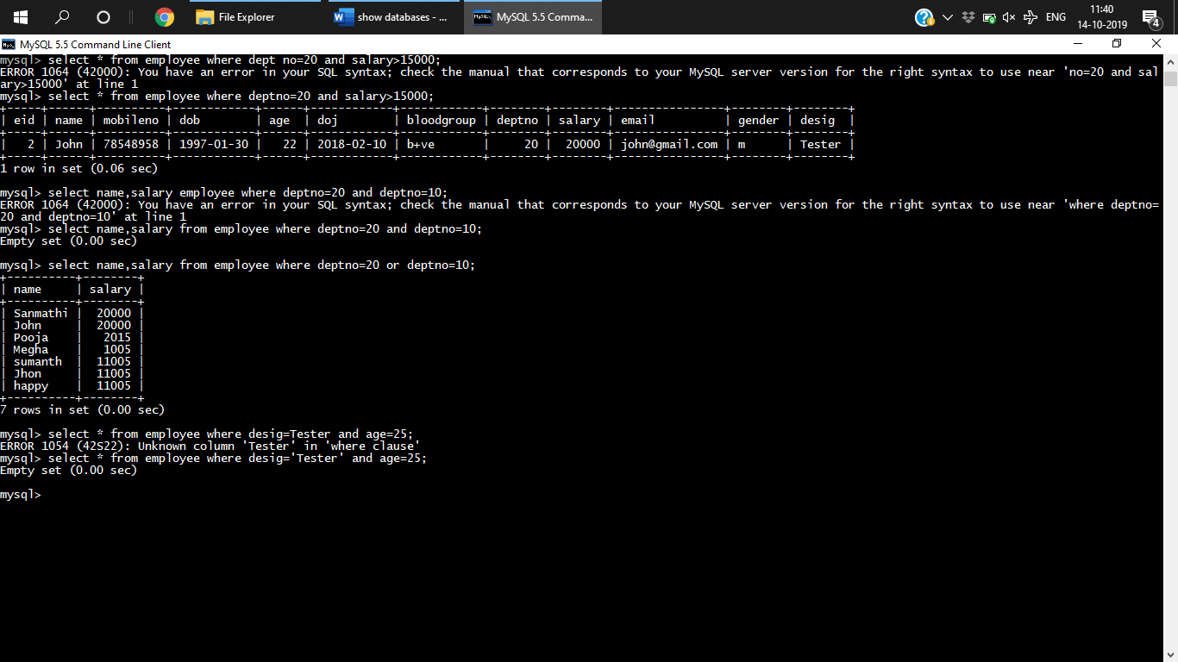

***Q)WAQ to display all the record of the employee who is working as a Tester or having sal more than 15000***

select * from employee where desig='Tester' or salary>15000;

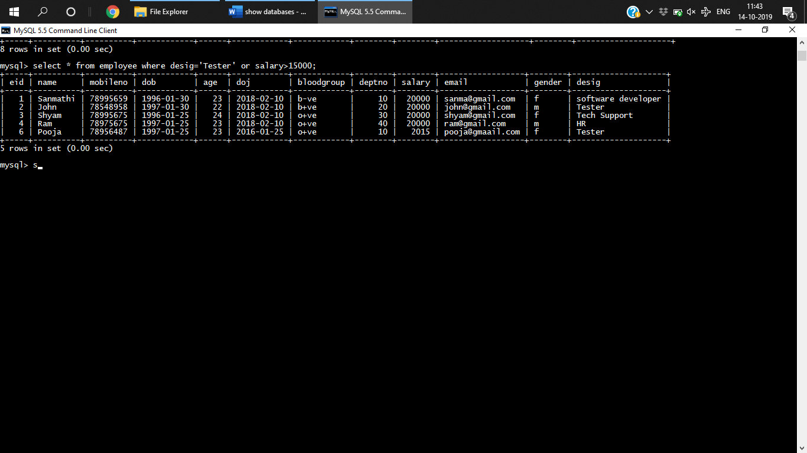

**Q)**WAQTD ***name sal age form employee who is working in deptno 10 or 20 or 50***

select name,salary,age from employee where deptno=20 or deptno=10 or deptno=50;

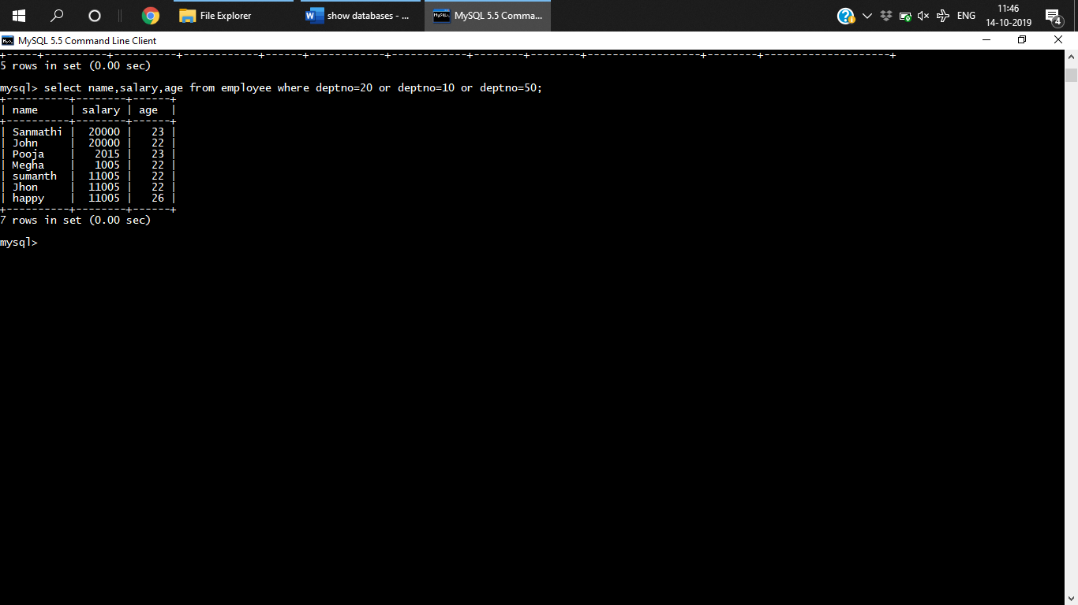

**Q)**WAQTD ***name sal age form employee who is working in deptno 10 or 40 or 80***

select name,salary,age from employee where deptno=20 or deptno=10 or deptno=50;

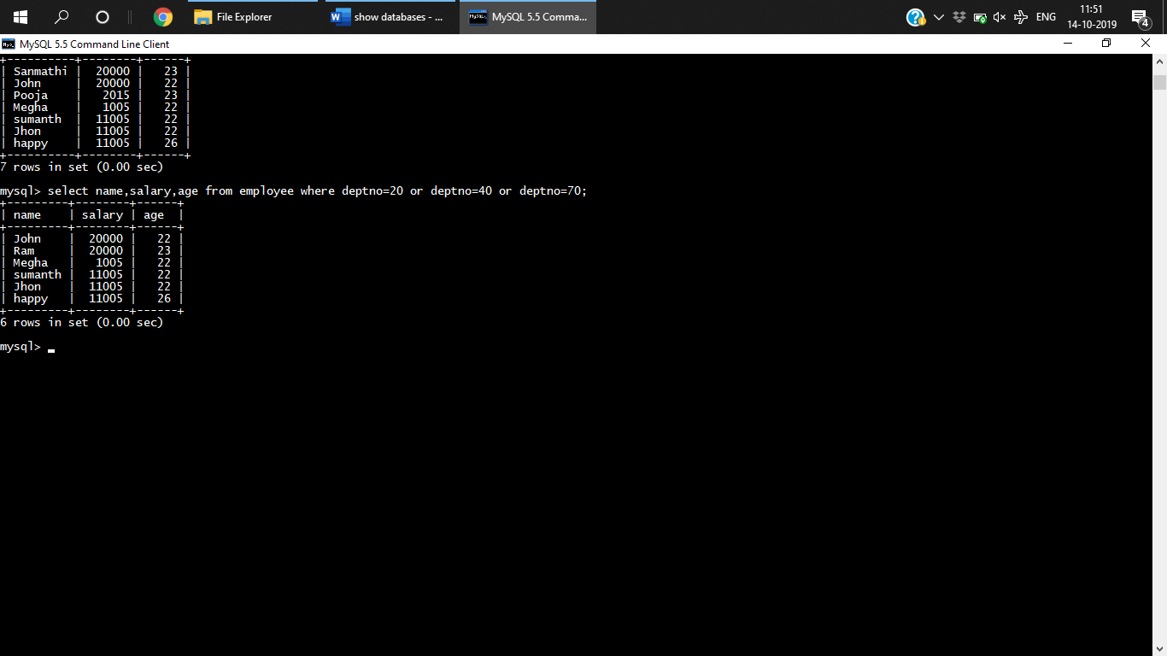

**Q)WQTD whose age>25 and bloodgroup=b+ve**

mysql> select * from employee where age>25 and bloodgroup='b+ve';

Empty set (0.00 sec)

***Q)WAQTD all record excluding tester***

select * from employee where not desig='tester';

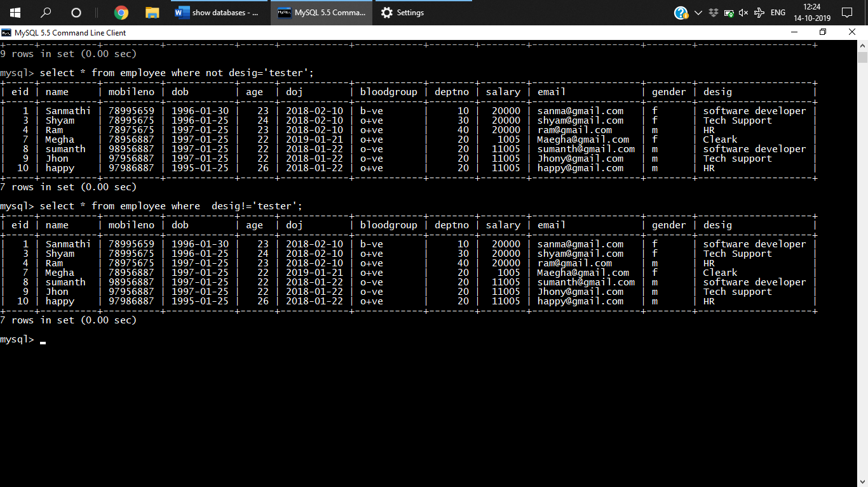

Q***)WAQTD name of all the employee who is working as HR or tester and sal>40000***

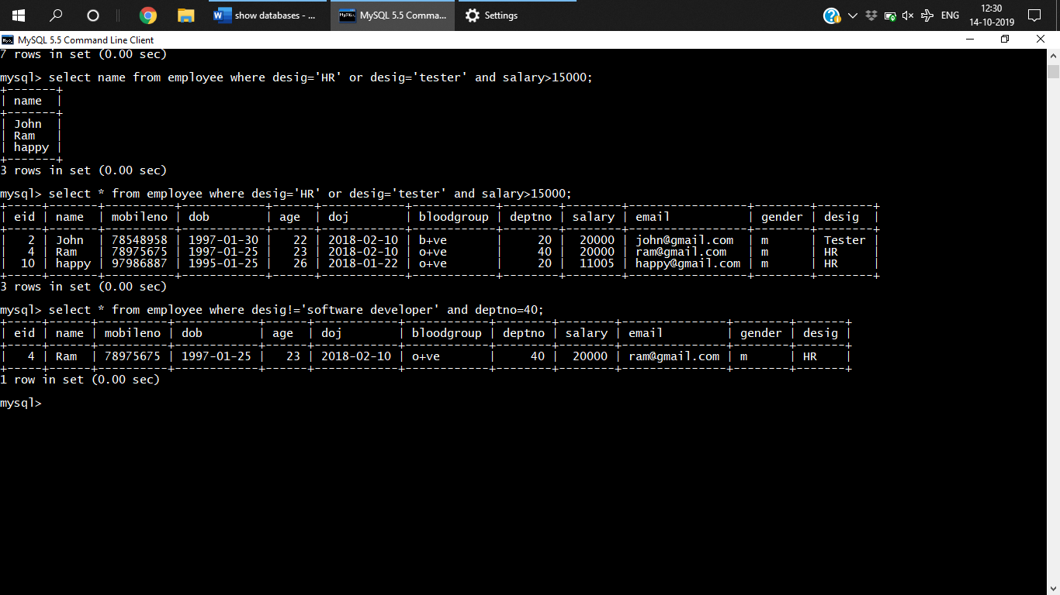

***Q) WAQ to display all employee excluding sw developer who have been working in dept no 40***



ORDER of execution

Not

And

Or

***Q)WAQ to display all the software developer who is working for dept no 10 or 40***

select * from employee where desig='software developer' and (deptno=10 or deptno=40);

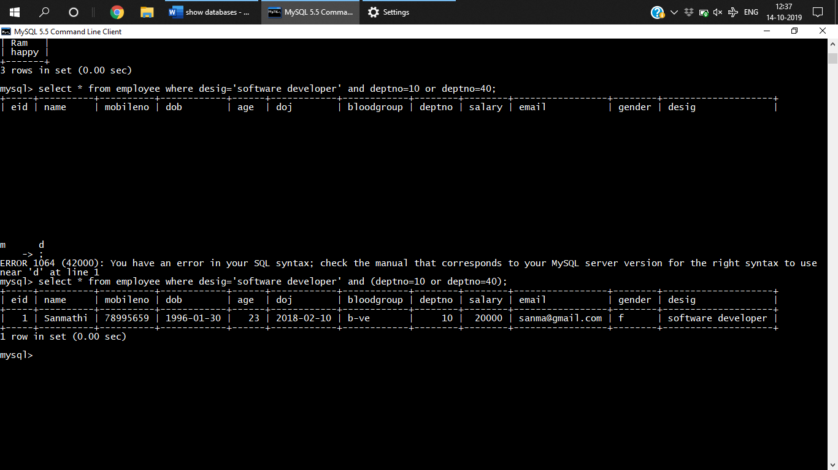

**Special operator**

**1.IN-**It is used to evaluating multiple values.

Syntax

Select * from table name where column_name in(list of values);

Select * from employee employee where dept no In(10,20,70,80)

***Q)WAQTD all details of employee who is working in 40, 50, 70***

select * from employee where deptno in(40,50,70,80);

**Q)WAQTD name of all the employees who is working as a tester HR cleark**

select * from employee where desig in('HR','Tester','admin');

***Q) WAQTD details of tester admin sd who are working in deptno 20 or 30 and sal is greater than 400000***

select * from employee where desig in('software developer','Tester','admin') and deptno in(20,30) and salary>40000;

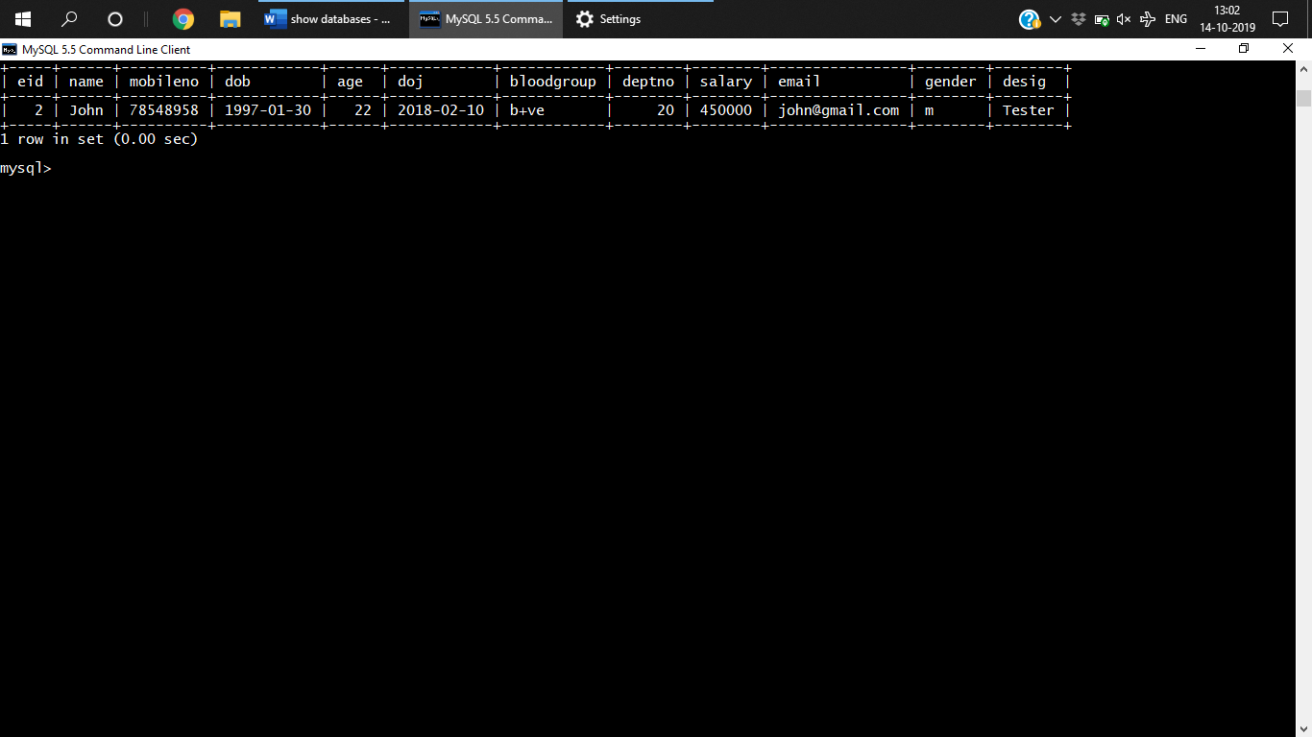

**2. NOT IN:**

To exclude multiple values,

Select * from table name where col_name not in(values1,v2)

***Q ) WAQTD all details excluding who is working a tester admin HR***

select * from employee where desig not in('HR','Tester','admin');

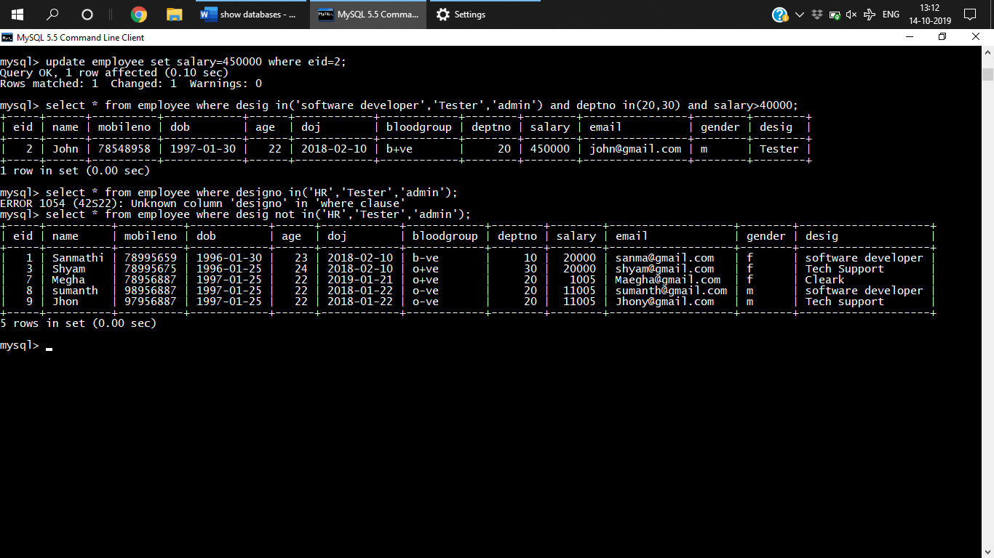

***Q) WAQTD all the record of employee whose age is 20 25 30 40***

***Exclude all the detail of tester and SD***

select * from employee where age in(20,25,30,40) and desig not in('Tester','software developer');

Empty set (0.00 sec)

**3.BETWEEN**

Used for searching based on range of values

Select * from tablename where colname between value1 and value 2;

**Q)WAQTD all the details of the employee whose age is btwn 20 to 30**

select * from employee where age between 20 and 30;

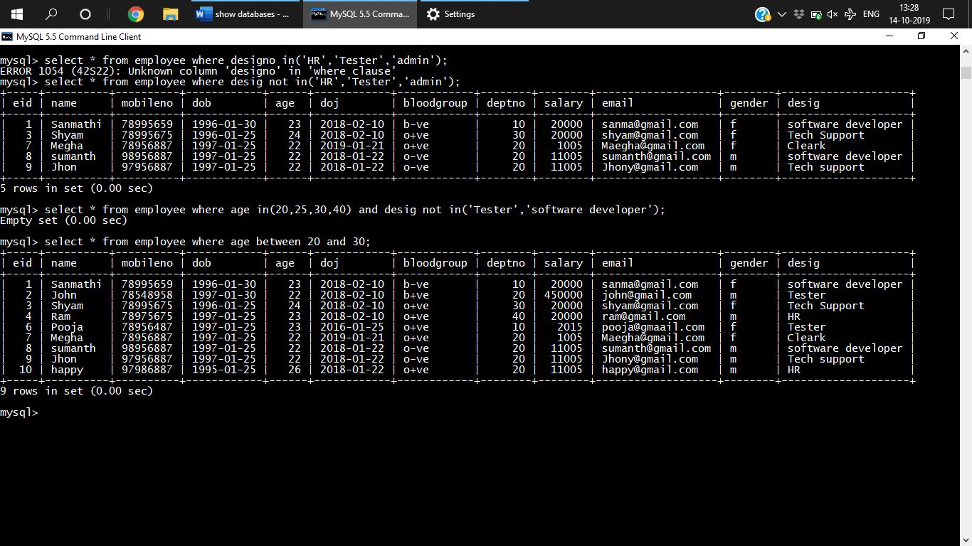

***Q) WAQTD who where hired during 2017***

select * from employee where doj between '2017-01-01' and '2017-12-31';

Empty set (0.00 sec)

**4.NOT BETWEEN**

**Q) WAQTD All record of employee excluding whose sal is in the range of 25000-30000**

select * from employee where salary not between 250000 and 300000;

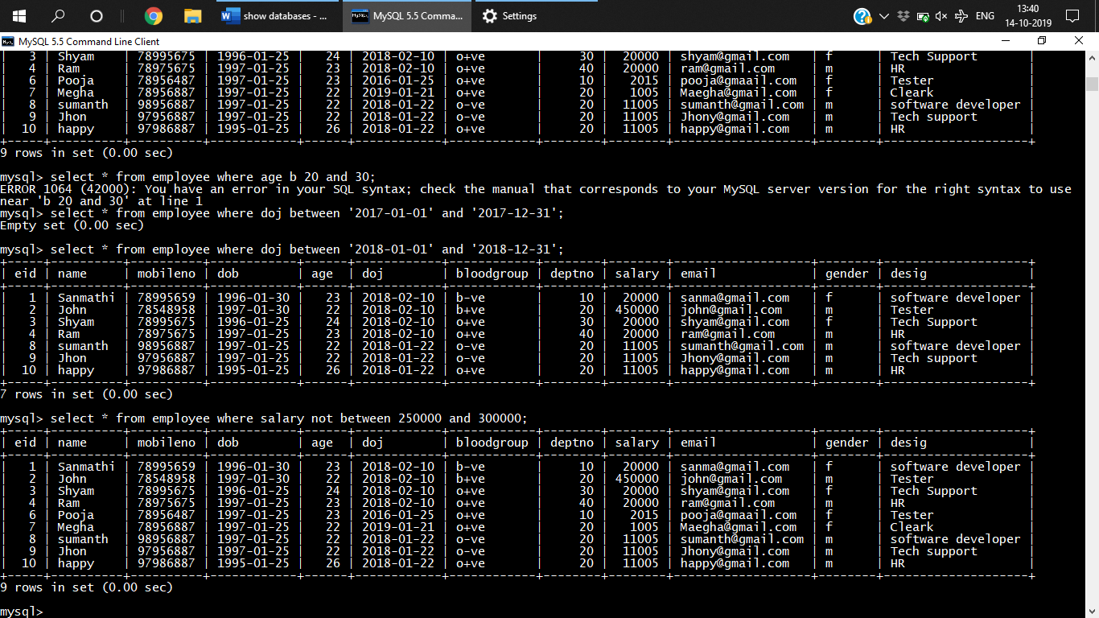

1. **Is**

is used to compare with null value

Select * from the table where col_name is null

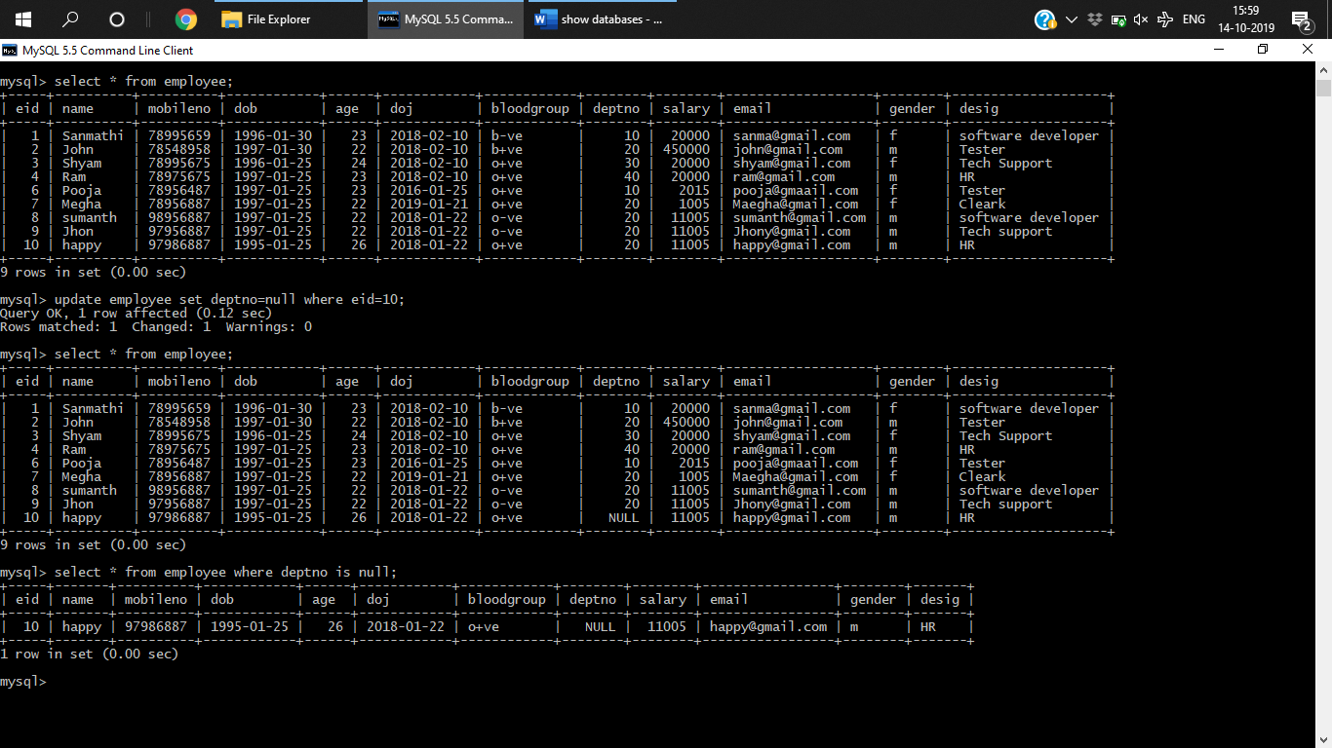

1. **Not null**

is used to compare with null value

Select * from the table where col_name is null

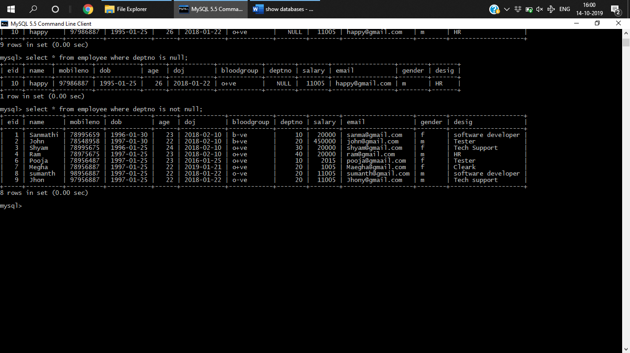

1. **Like**

**Used to perform pattern matching**

**Ordinary 0 to 9 or a-z**

**Special**

**(%)-matches 0 to n characters**

**_-exactly one character**

**Select * from table_name where col_name like ‘%/_’;**

**Q) WAQTD all the detail of employee whose name start with a**

select * from employee where name like 'a%';

select * from employee where name like 'j%';

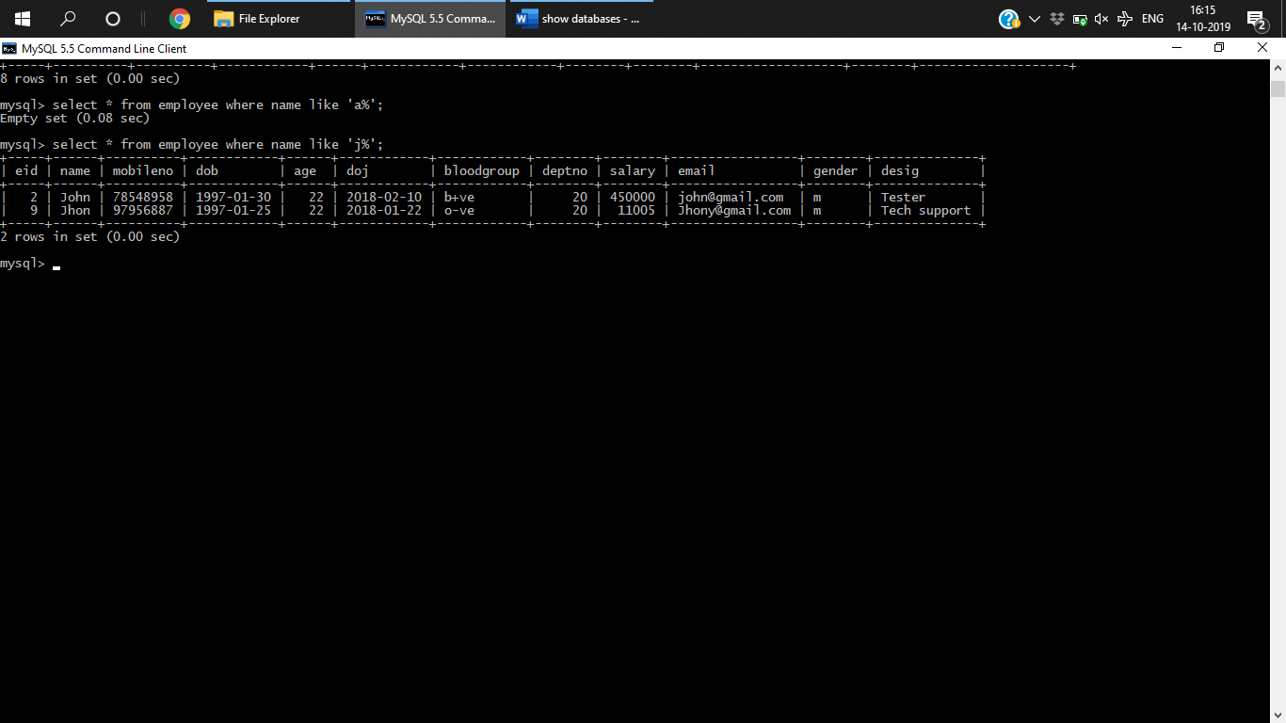

**Q) name of employee whose second chatacter is i**

select * from employee where name like '_i%';

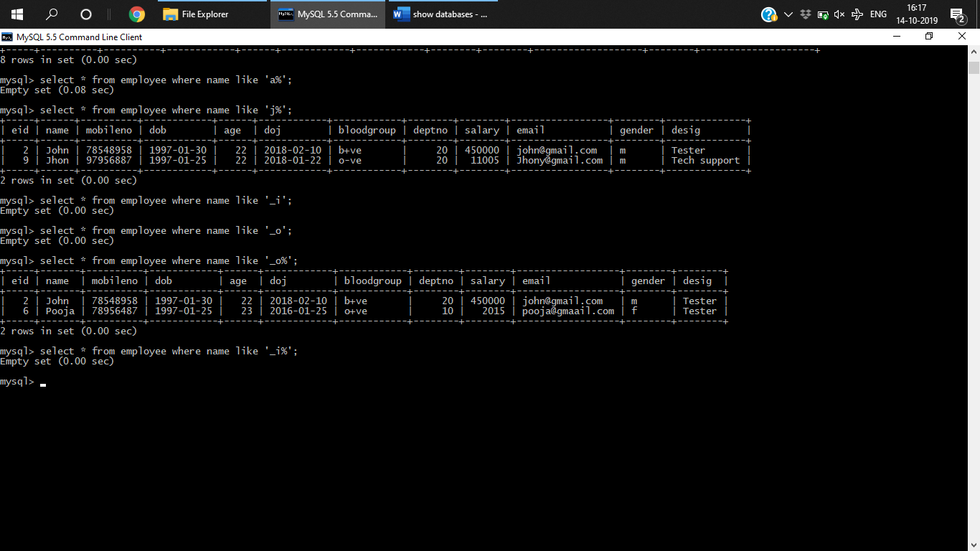

**Q) WAQ to display the name of the employee which has atlest 2 l in their name**

select * from employee where name like '%l%l%';

Empty set (0.00 sec)

**Q) WAQTD name of the employee whose name start with s and end with p**

select * from employee where name like 's%p';

Empty set (0.00 sec)

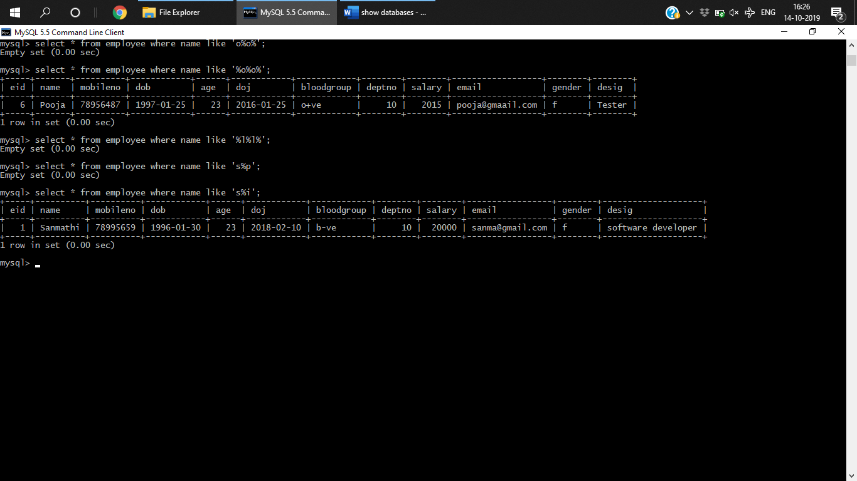

**Q)WAQTD all the record of the employee if the employee name begins with a or s**

select * from employee where name like 's%' or name like 'a%';

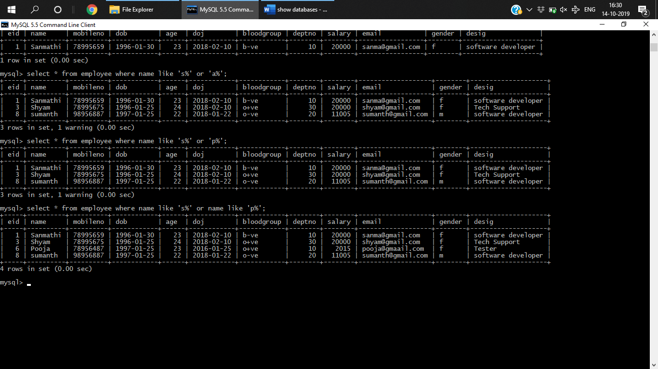

**Q)WAQTD ename sal who is working in deptno 10 20 30 and job desig starts with s**

select name, salary from employee where deptno in(10,20,30) and desig like 's%';

**Functions:**

* Single row(scalar) -single I/p single output
* Multirow or aggregate function - n input one output

i/p i/p

O/p

Single row Multirow

**Multirow functions.**

*AVG()-*Returns Average value

*select avg(salary) from employee;*

*COUNT()-*counts no of rows

*select count(*) from employee;*

*Max()-*returns max value

*select max(salary) from employee;*

*Min()-*returns min value

*select min(salary) from employee;*

*Sum()-*returns sum

*select sum(salary) from employee;*

**ORDER BY**

**Used to sort result set in asc or desc order**

**Select** col1,cil2 **FROM** table_name **ORDER BY** col1 **asc|desc**

* Order of execution

From

Where

Select

Order by

***Q) WAQTD all the result of the employee with sal in desc order***

*select * from employee order by salary desc;*

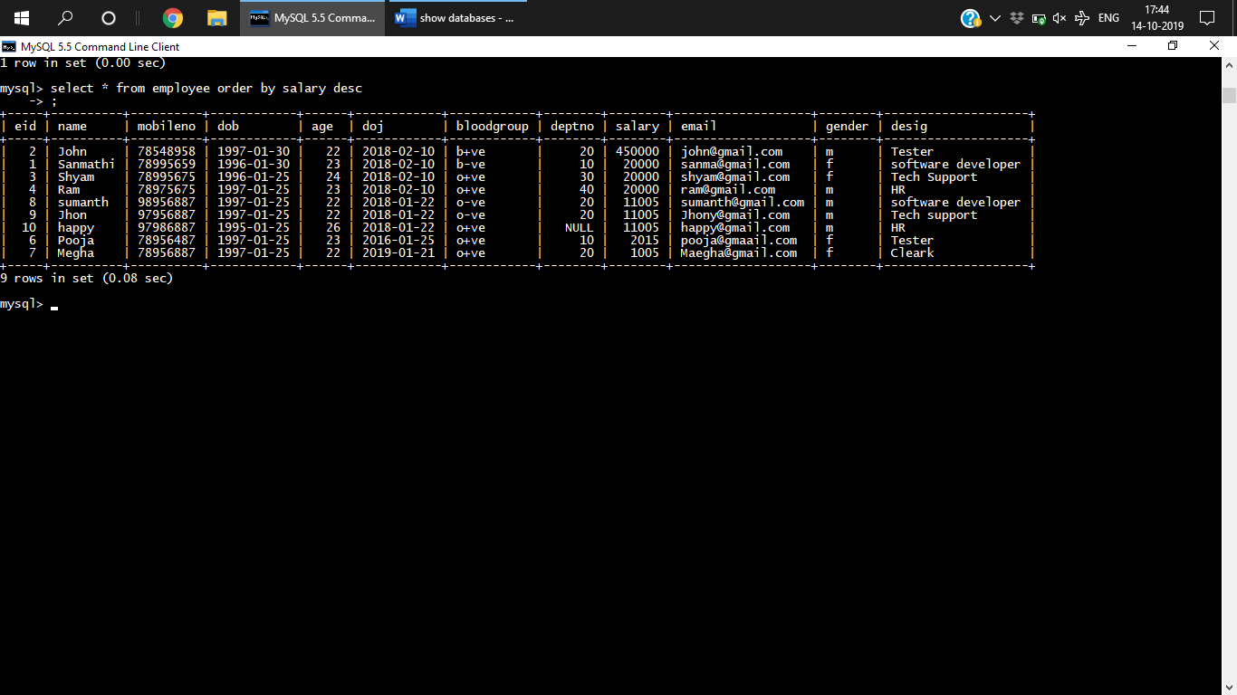

* **Subquery**

**SINGLEROW**

***Q) WAQTD all the record of the employee whose dOj is equal to Sanmathi***

select * from employee where doj =(select doj from employee where name='sanmathi');

***Q)WAQTD second max sal from employee***

select max(salary) from employee where salary <(select max(salary) from employee);

**MULTIROW**

**Q) WAQTD name of the employee who is working in a location which has atleast one a in the location**

select name from employee where deptno in(select deptno from dept where location like '%a%');

**Q)WAQ*TD to display all the records of the employee who is working in admin operations developments***  
select * from employee where deptno in(select deptno from dept where dname in('admin' , 'operations','development'));

**GROUP BY**

**Q)WAQTD the max sal for each dept**

select max(salary) from employee group by deptno;

**Q) WAQTD highest sal given to HR in each department**

select max(salary) from employee where desig='HR' group by deptno;

**HAVING clause**

Select * from tablename where condition groupby colname having condition

From, where , group by , having , select , orderby

**Q) WAQTD deptno which has atleast 2 employee;**

select deptno, count(*) from employee group by deptno having count(*)>=2;

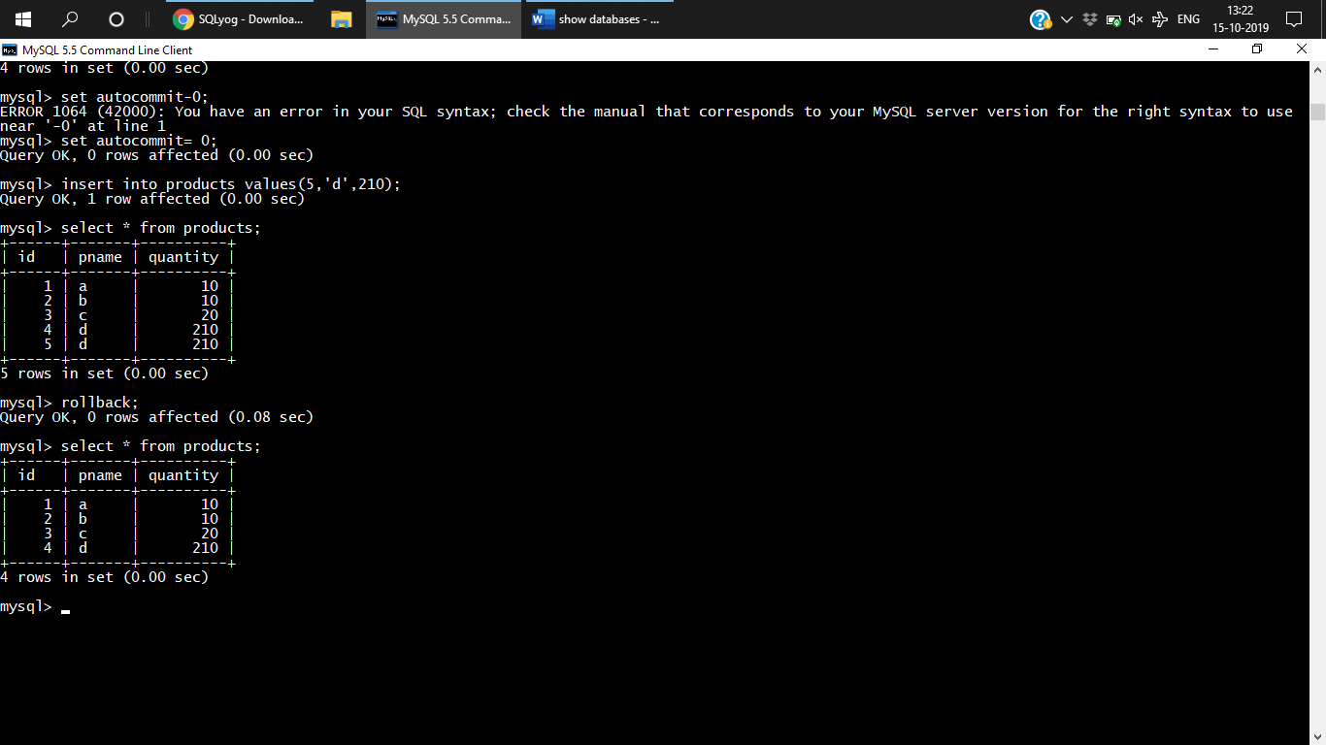

After commit if we try to rollback its not possible to rollback.

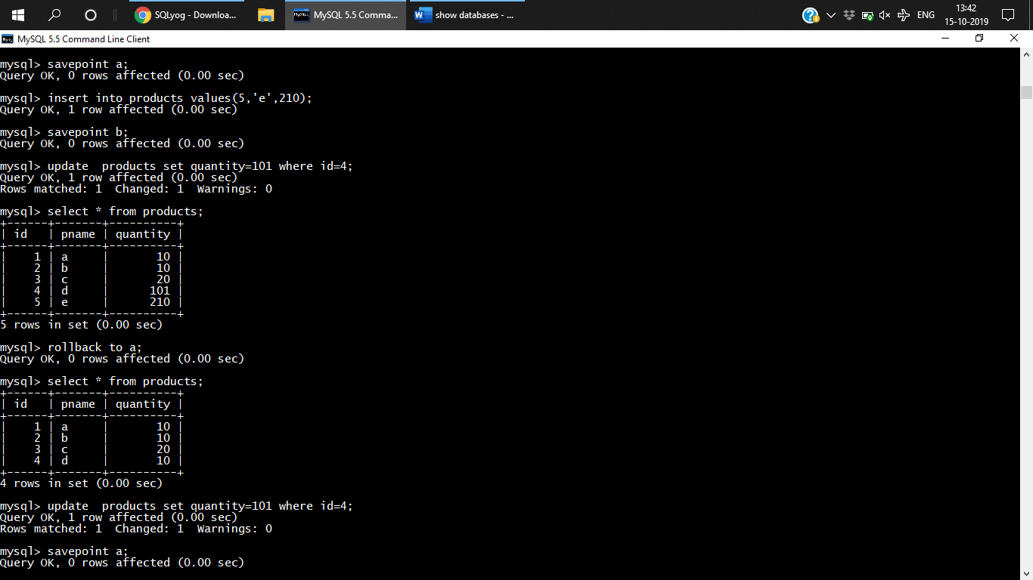

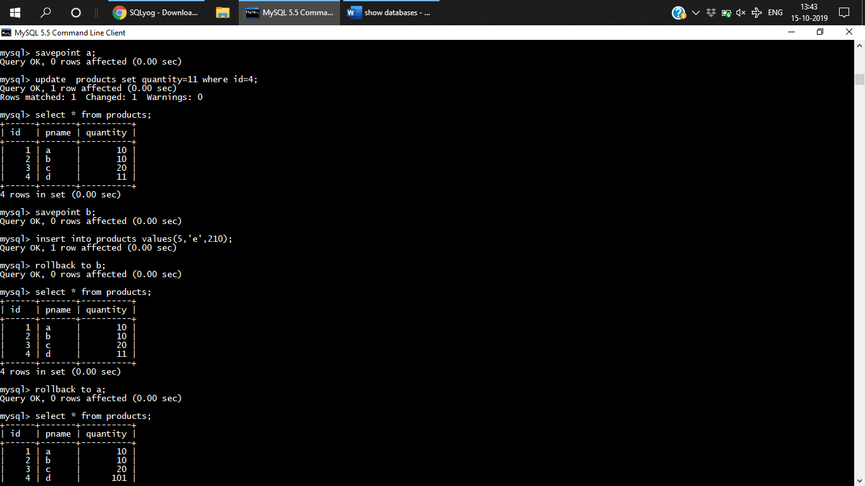

**JOINS**

**CROSS JOIN:**

**Syntax**

**Select * from tablename1 cross join tablename 2;(INSI)**

**Select * from tablename1, tablename2;(ORACLE)**

select * from products cross join dept;

**INNER JOIN**

select * from table1 inner join tbale2 on join condition;

select * from employee e inner join dept d on e.deptno=d.deptno(INSI);

Select * from table name1,tablename2 where joincondition;(oracle)

**LEFT OUTER JOIN**

select * from employee e **left outer join** dept d on e.deptno=d.deptno;

select * from employee e **right outer join** dept d on e.deptno=d.deptno;

select * from employee e left outer join dept d on e.deptno=d.deptno **union** select * from employee e right outer join dept d on e.deptno=d.deptno;

select * from employee **natural join** dept ;