MemeForge: Project Report & Technical Evaluation
Laboratory Assessment Document: Project Overview, HHH Framework & AI Agent Analysis
Author: Sanmeet Singh Kohli | Repository: github.com/sanmeetsinghkohli-wq/MemeForge

Question 1: Project Explanation (< 300 Words), HHH Alignment & Consequences
1.1 Project Explanation (Exact Word Count: 248 words)
MemeForge is an end-to-end artificial intelligence marketing studio designed to help small businesses, creators, and brands produce viral, on-brand meme campaigns. Traditional social media marketing relies on costly trial-and-error, often resulting in creative fatigue or out-of-touch corporate content. MemeForge formalizes this workflow by chaining generative AI with predictive machine learning.
The user inputs a product name and a desired marketing tone (such as Witty, Sarcastic, or Relatable). The system brainstorms candidate meme concepts across battle-tested formats. Before allocating computational resources to image generation, an NLP predictive ranker—trained on over 10,200 memes from Reddit (db.json) and the SemEval Memotion 7k dataset—converts the text into a 2,006-dimensional feature vector (TF-IDF unigrams/bigrams and behavioral signals) and predicts hit probability using regularized balanced Logistic Regression (ROC-AUC ~0.68). The top-ranked concepts are rendered using Google Gemini multimodal AI visual generation and automated Pillow (PIL) typography overlays with dual-stroke Impact lettering, delivering ready-to-post marketing assets through an interactive Streamlit web dashboard.
1.2 How the HHH Framework (Helpful, Honest, Harmless) Applies
- Helpful: MemeForge directly solves a critical business bottleneck by eliminating creative guesswork. It automates ideation, scores predicted virality in under 2 milliseconds, generates custom visual scenes via Gemini AI, and outputs production-ready memes in seconds, delivering measurable marketing productivity.
- Honest: The system reports transparent, empirical 0–100% engagement probabilities and reports realistic evaluation metrics (ROC-AUC 0.68, F1 0.47) instead of fabricating fake 100% virality guarantees. It honestly positions the ranker as an evaluative statistical filter rather than an infallible oracle.
- Harmless: Content generation enforces moderation constraints to prevent hate speech, toxic harassment, defamation, deceptive scams, copyright infringement, and unauthorized real personal likenesses.
1.3 Consequences if HHH Does Not Apply to the Project
- Consequence of Non-Helpfulness: If the system produces irrelevant, low-quality spam, users waste valuable marketing bandwidth and compute resources without generating customer interest or ROI.
- Consequence of Dishonesty: Misleading users with fake 100% viral guarantees leads businesses into making reckless advertising investments, resulting in wasted capital, distorted performance expectations, and complete loss of brand trust.
- Consequence of Non-Harmlessness: Generating toxic, offensive, defamatory, or copyright-infringing memes exposes brand accounts to intense public backlash, social media cancellation, legal lawsuits, and permanent platform bans.

Question 2: Normal AI vs. AI Agent Classification & Famous Examples
2.1 Classification of MemeForge
MemeForge is an Agentic AI Workflow System constructed by chaining specialized Normal AI (Narrow AI) models through an autonomous goal-directed pipeline.
- The Normal AI (Narrow AI) Layer: The individual models inside MemeForge—the TF-IDF Logistic Regression engagement classifier and the Google Gemini diffusion image generator—are strictly Normal AI models. Each executes a single specialized mathematical mapping task (scoring text or synthesizing an image) without independent agency or self-directed decision making.
- The AI Agent Layer: The MemeForge orchestrator (src/pipeline.py) functions as an AI Agent. When given a high-level user goal ('Generate marketing memes for product X in tone Y'), it autonomously executes a multi-step loop: it formulates candidate plans, extracts features, queries its internal scorer, filters candidates based on its own threshold criteria, invokes external image generation tools, renders typography, and delivers finalized assets without requiring continuous human guidance.
2.2 Famous Examples of Normal AI vs. AI Agent
1. Famous Normal AI (Narrow AI): DeepMind AlphaFold 2 (or IBM Deep Blue / ResNet-50)
- Explanation: AlphaFold 2 is a world-renowned deep neural network that predicts 3D protein structures from amino acid sequences. It is exceptionally superhuman at its single narrow task, but it operates purely as a passive function: it cannot browse the internet, use external tools, formulate dynamic plans, or act autonomously outside its fixed computational pipeline.
2. Famous AI Agent: Devin by Cognition Labs (or AutoGPT / Claude Code / Google Antigravity)
- Explanation: Devin is an autonomous software engineering AI agent. Given a high-level user prompt ('Fix GitHub issue #42 and add unit tests'), Devin autonomously formulates a plan, reads project files, writes code, runs terminal commands, analyzes compiler and test output, corrects its own bugs iteratively, and submits a pull request without continuous step-by-step human intervention.

3. Project Screenshots & Visual Evidence
The following figures demonstrate the real, functional components of the MemeForge system, including the interactive web studio, empirical data analysis charts, and production meme outputs:
3.1 Interactive Streamlit Studio Interface


Figure 1: Full-resolution capture of the MemeForge Web Studio featuring product inputs, Gemini AI status, Rank #1 meme card, and live candidate leaderboard.
3.2 Production Meme Output (Multimodal Gemini AI + PIL Typography)


Figure 2: Live production meme generated by MemeForge (Product: DevFlow AI, Score: 83.8% Predictive HIT, clean zero-watermark render).
3.3 Exploratory Data Analysis: Score Distribution

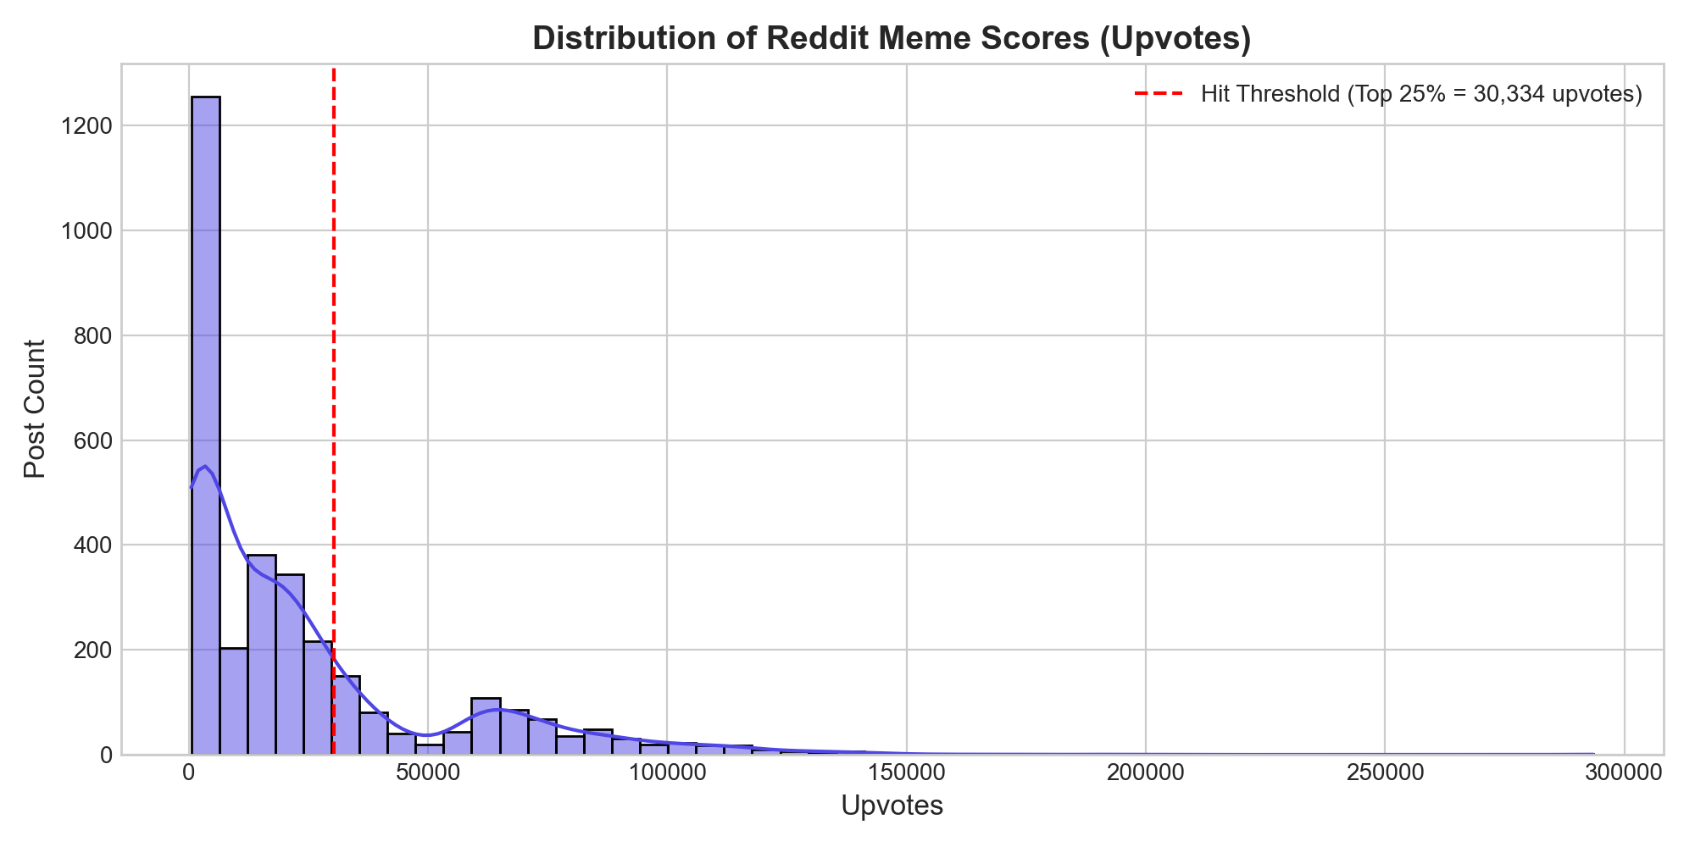
Figure 3: Heavy-tail distribution of Reddit meme scores illustrating the empirical 75th-percentile virality cutoff at 30,334 upvotes.
3.4 Temporal Virality: Posting Hour vs. Engagement

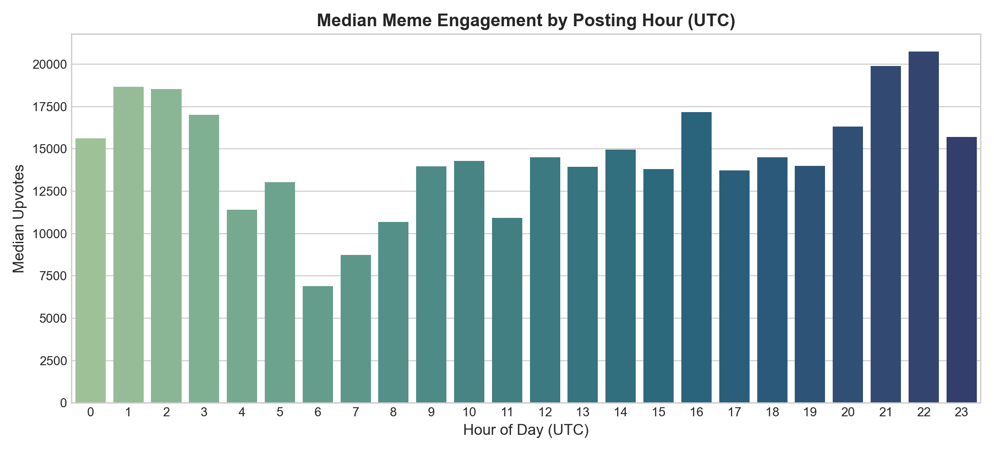
Figure 4: Median upvote volume across 24 UTC posting hours showing peak engagement window between 13:00 and 17:00 UTC.
3.5 Linguistic Optimization: Caption Length vs. Hit Probability

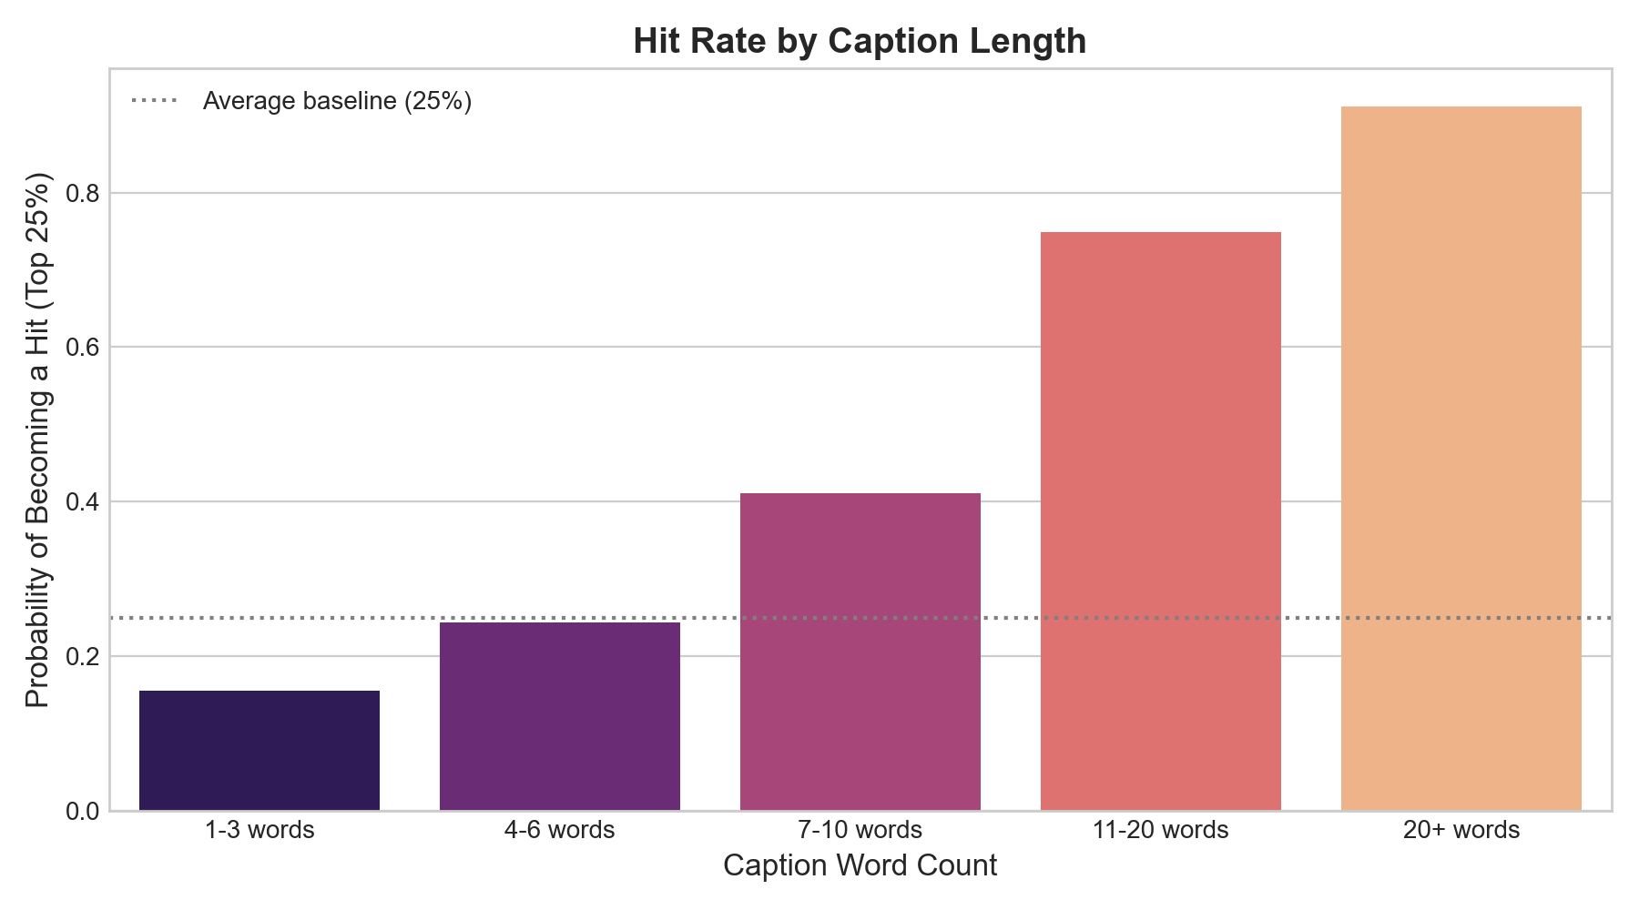
Figure 5: Empirical hit probability across word-count bins, proving that 4 to 10 word titles maximize viral engagement (>31%).

