Alfa: 192.168.56.112
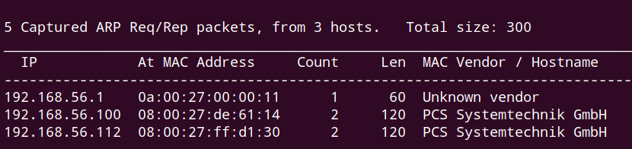

nmap tcp scan
tcp open port: 21, 80, 139, 445, 65111
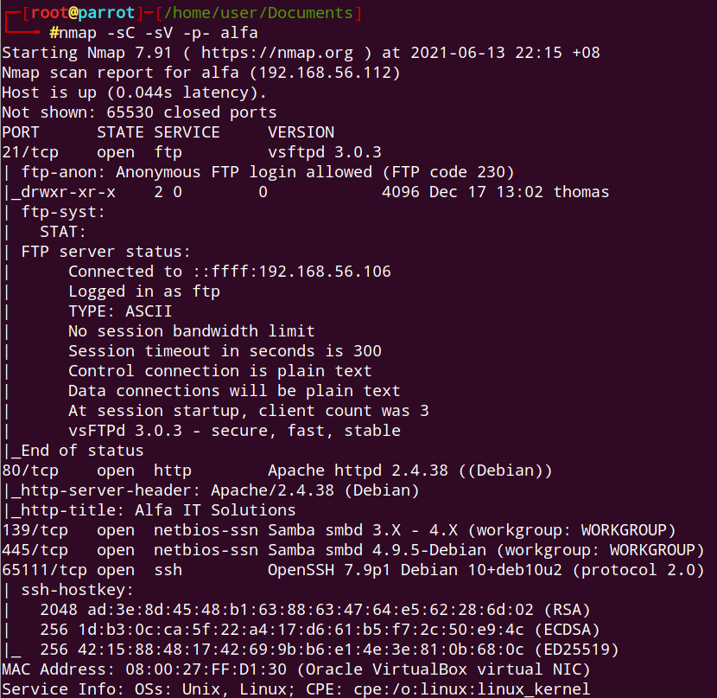

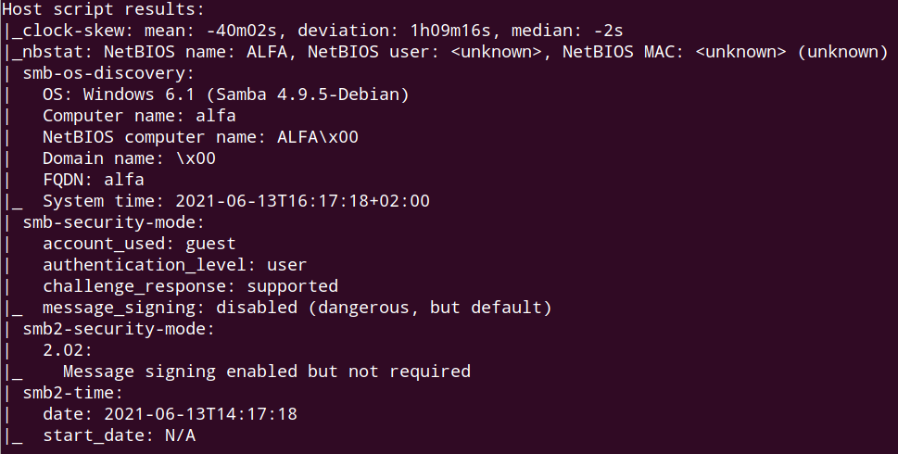

nmap udp scan:
nothing special
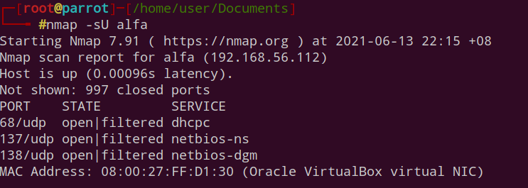

smb scan:
nothing interesting going on
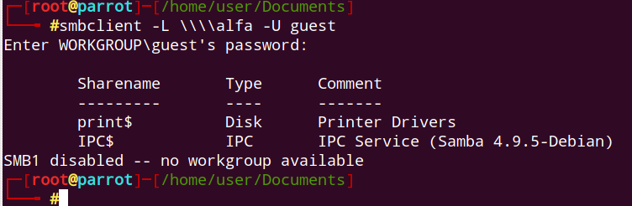

nikto scan:
nothing significant
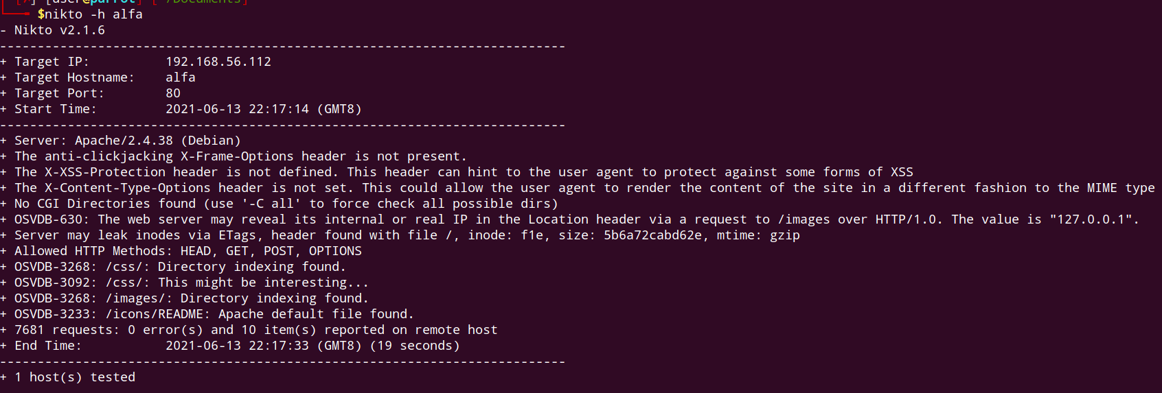

ffuf directory scan:
nothing interesting
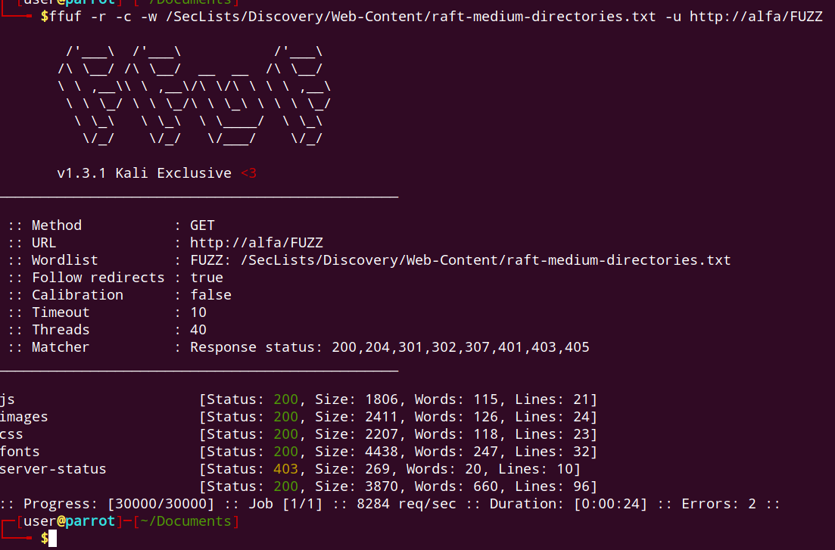

ffuf file scan:
robots.txt might be interesting
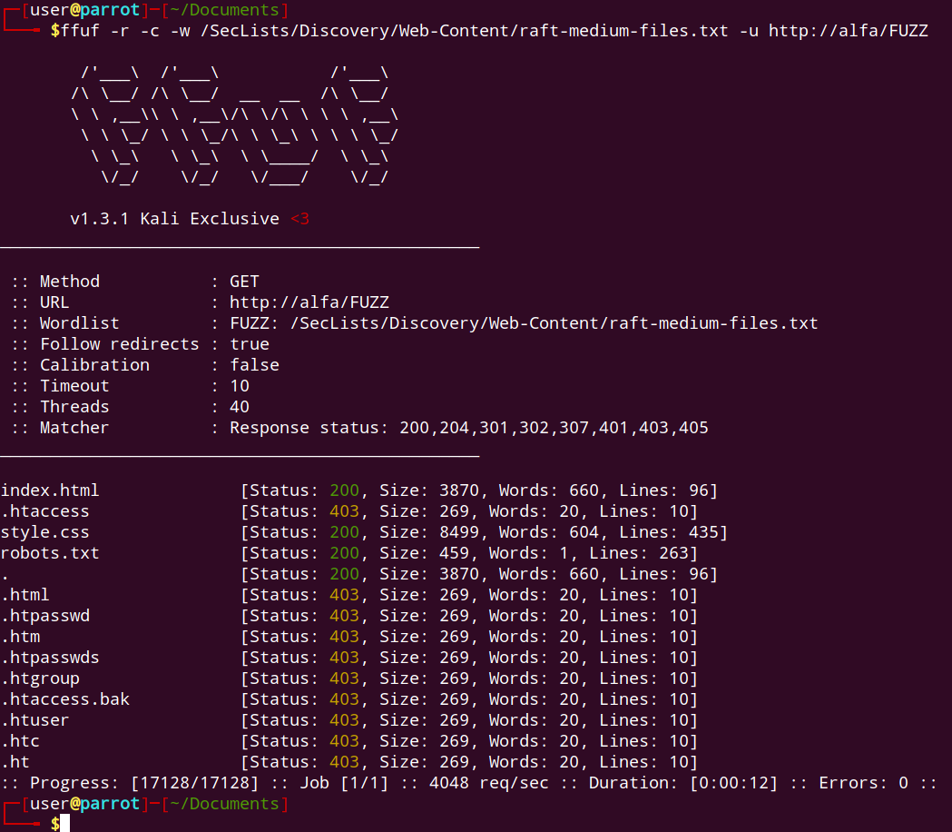

Promising directory:
/alfa-support
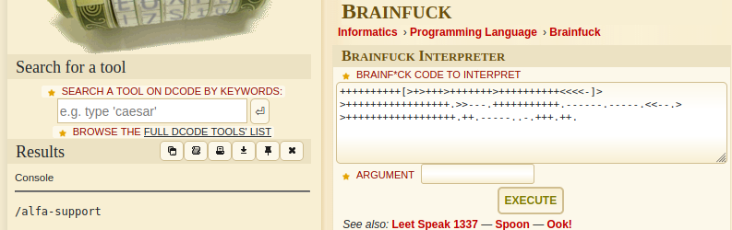

By enumerating ftp folders, we basically get the idea that thomas pet name is milo. So we need to use crunch to generate 3digit milo-xxx wordlist where xxx represent numbers.

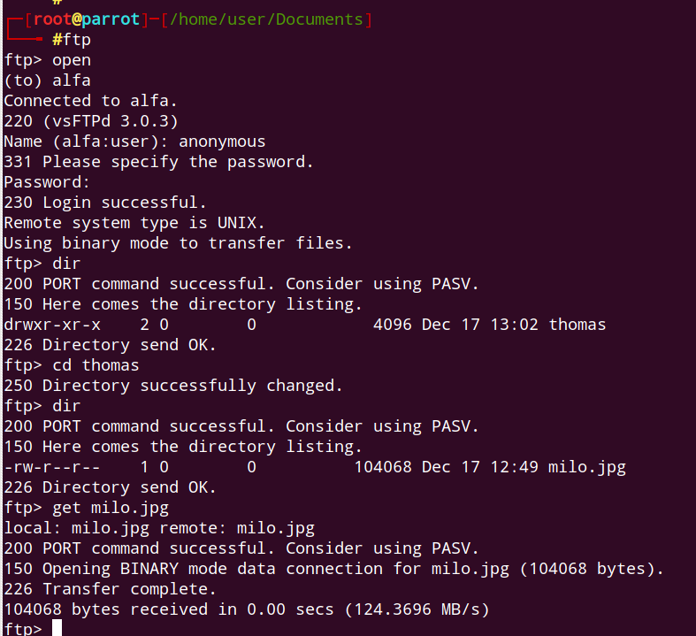

using crunch to generate dictionary:
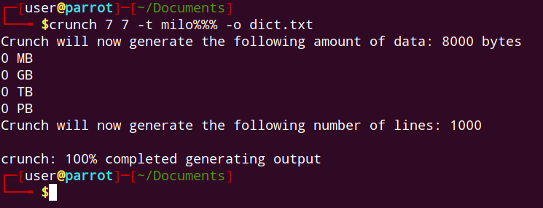

crunch 7 7 -t milo%%% -o dict.txt
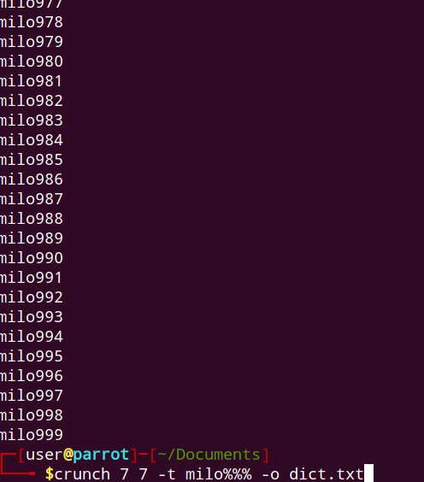

Brute force results:
ssh
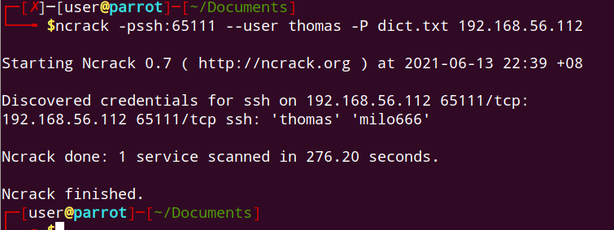

ftp

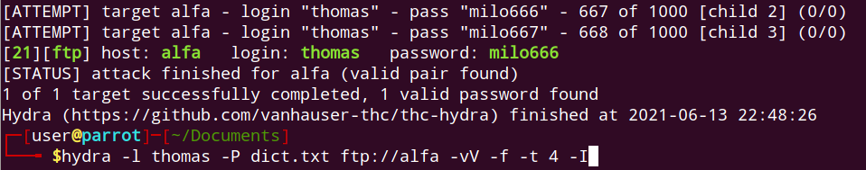

Initial foothold:
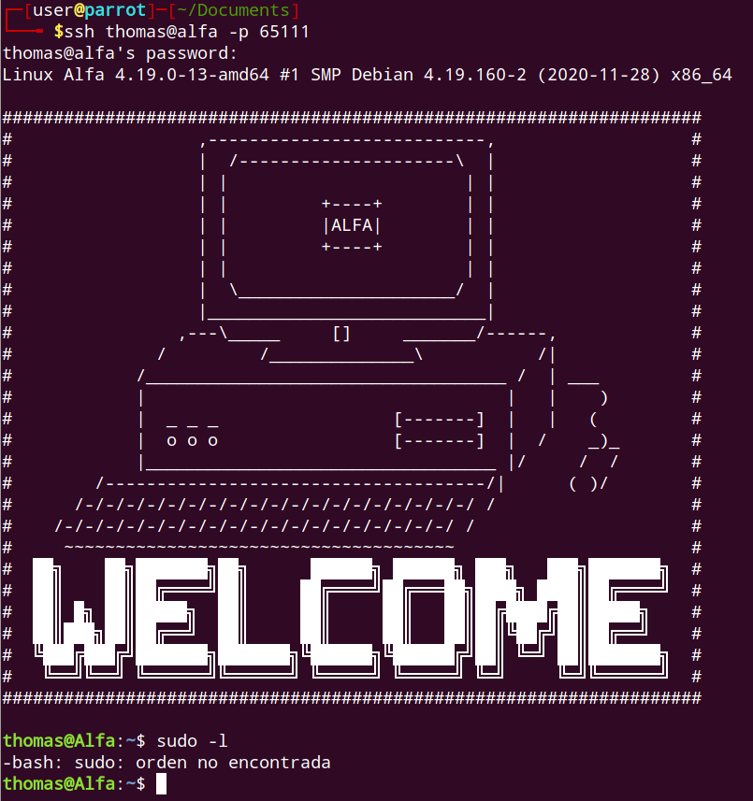

user flag:
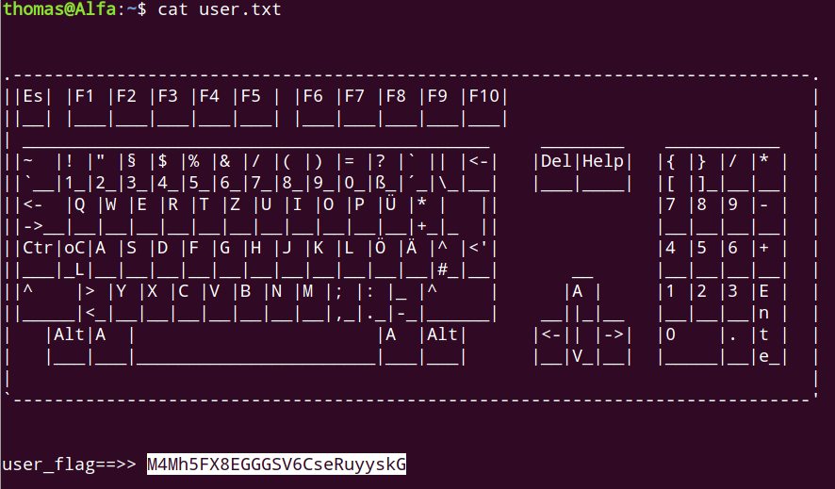

suspicious vnc process:
/usr/bin/Xtigervnc :1 -desktop Alfa:1 (root) -auth /root/.Xauthority -geometry 1900x1200 -depth 24 -rfbwait 30000 -rfbauth /root/.vnc/passwd -rfbport 5901 -pn -localhost -SecurityTypes VncAuth

Port forwarding vnc:
Remote port 5901(VNC) is forwarded to attacking machine local port 9000
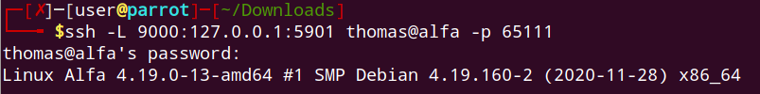

transfer vnc password file
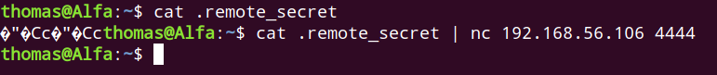

Initiate vnc to remote machine via localhost:
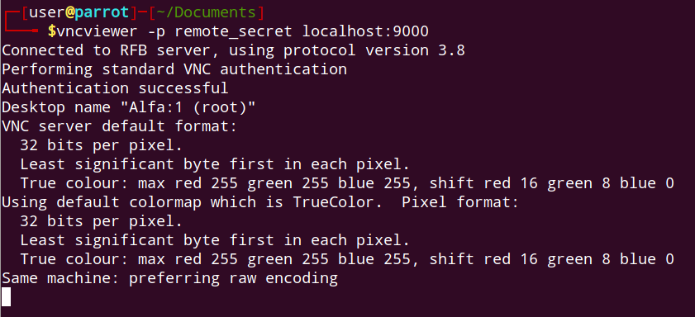

root flag:
