VM – Blogger

netdiscover scan:
Target VM IP = 192.168.56.110
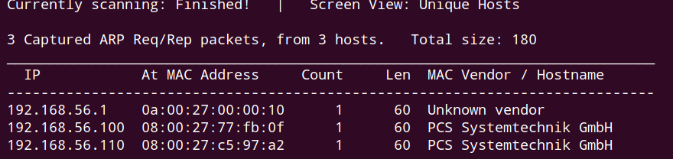

nmap scan:
TCP port – 22, 80
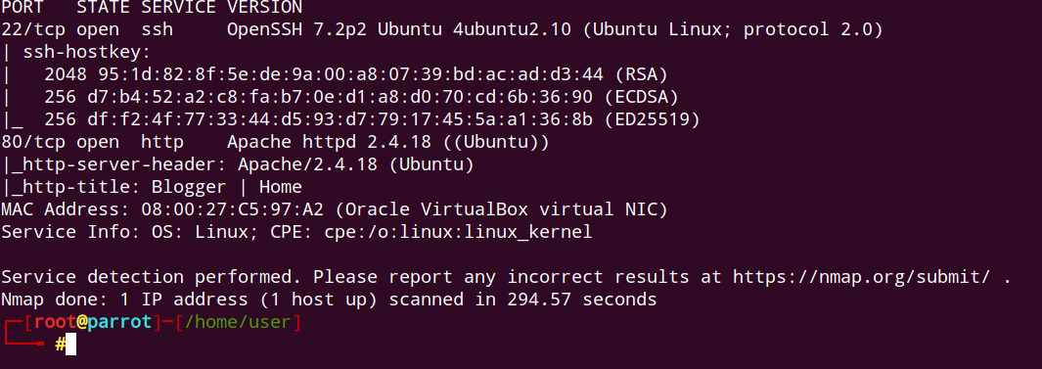

nmap udp scan:
nothing significant
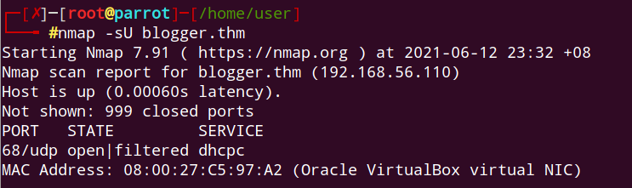

ssh brutefore not possible:
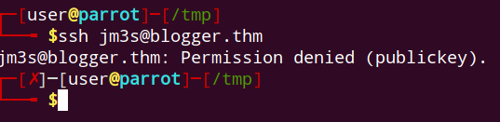

nikto scan:
nothing significant
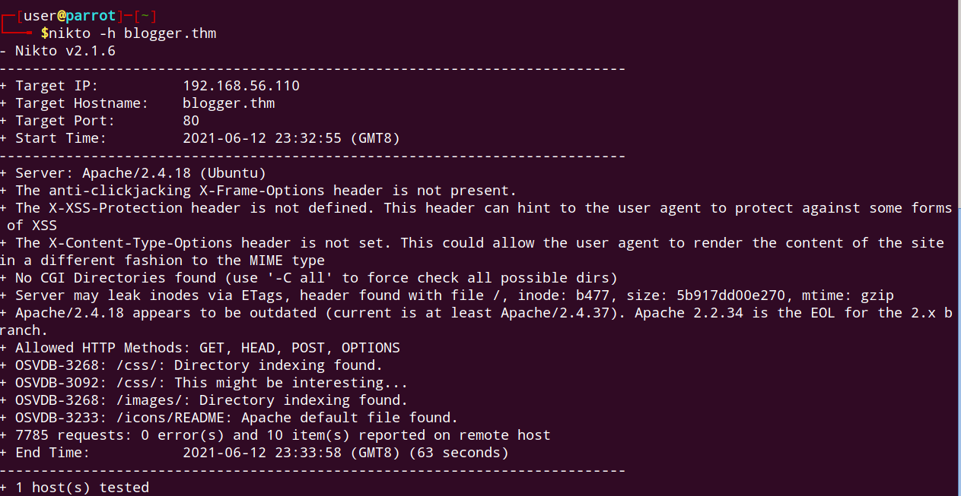

ffuf directory scan
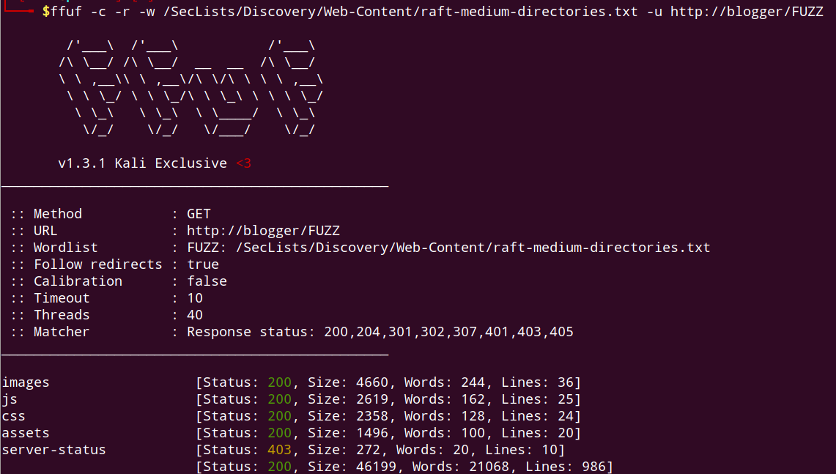

ffuf file scan
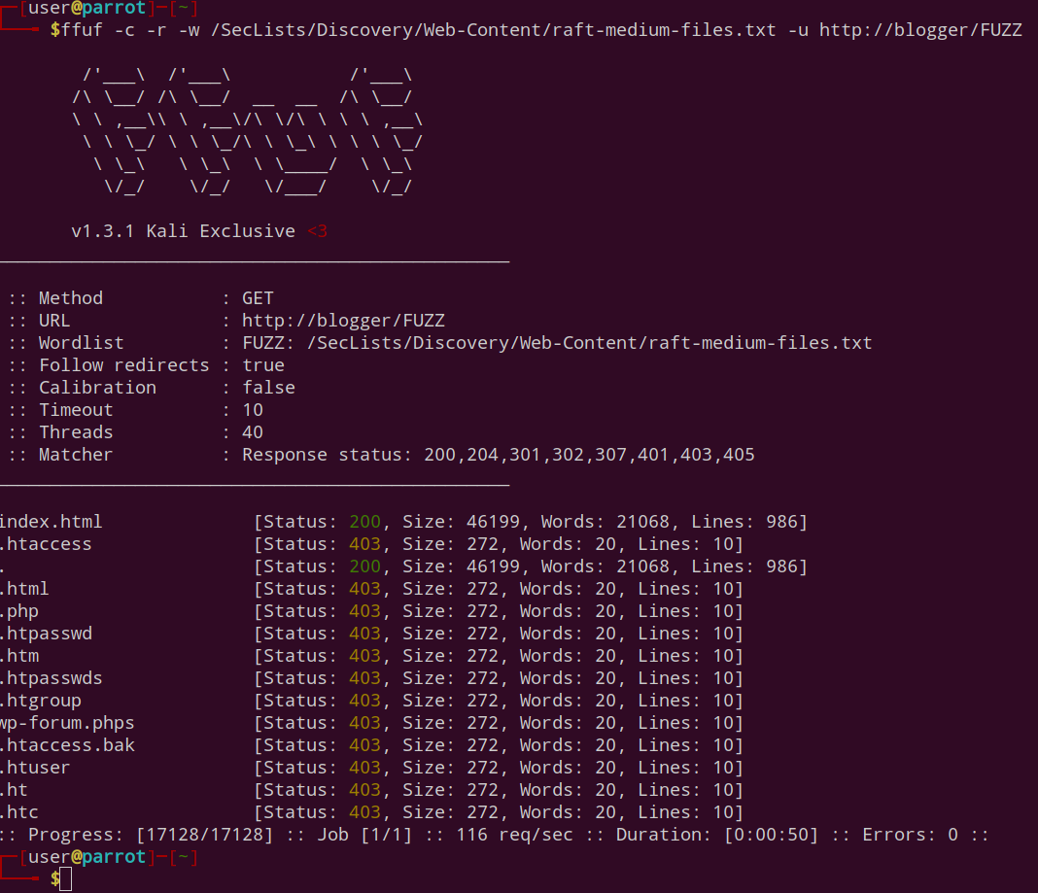

hidden subdirectory
http://blogger.thm/assets/fonts/blog/
Go to “/etc/hosts” , then point target machine ip to blogger.thm to allow webpage to display properly.

This hidden web subdirectory hosted a wordpress installation:
From the output, we can gather that:
1. Outdated wordpress software might be vulnerable to attacks
2. Upload directory accessible to public might mean that once shell is uploaded, triggering reverse shell is as easy as going to the correct directory and click the malicious php file.
3. The way in might be via bruteforcing user j@m3s or jm3s
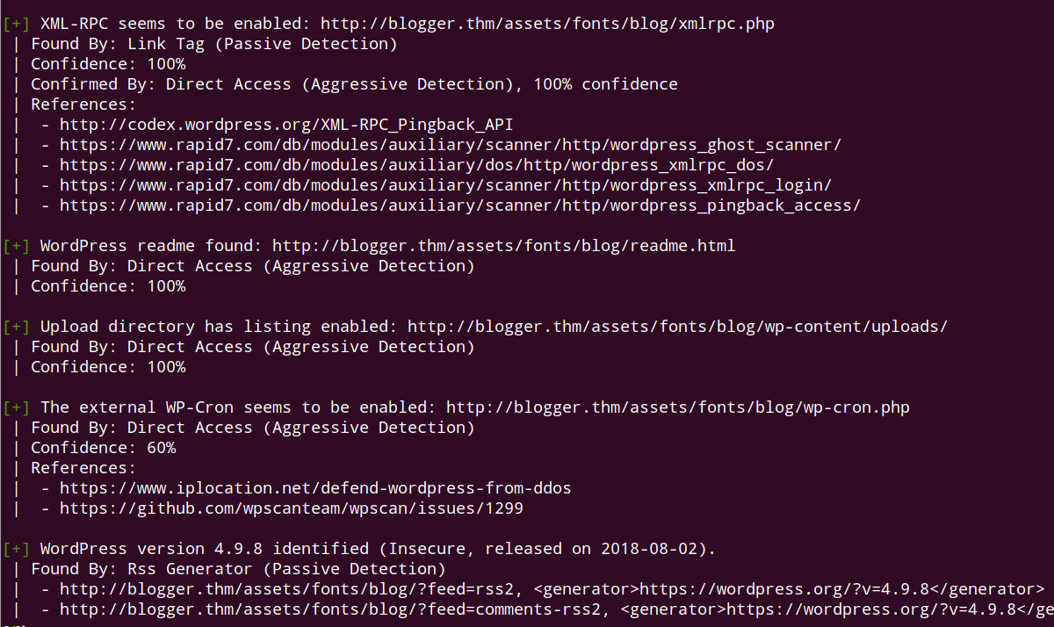

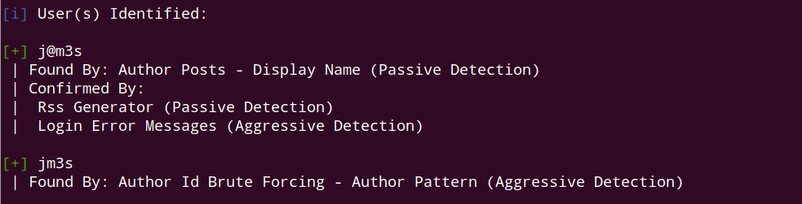

Bruteforce doesn’t yield anything.

Trying with wpscan enumerate vuln plugins
wpscan --url http://blogger.thm/assets/fonts/blog/ --api-token=cP8QzBevN0gbcqOrLFDOK8EanKWZwXsvupFGn4RRsO4 --plugins-detection mixed -e

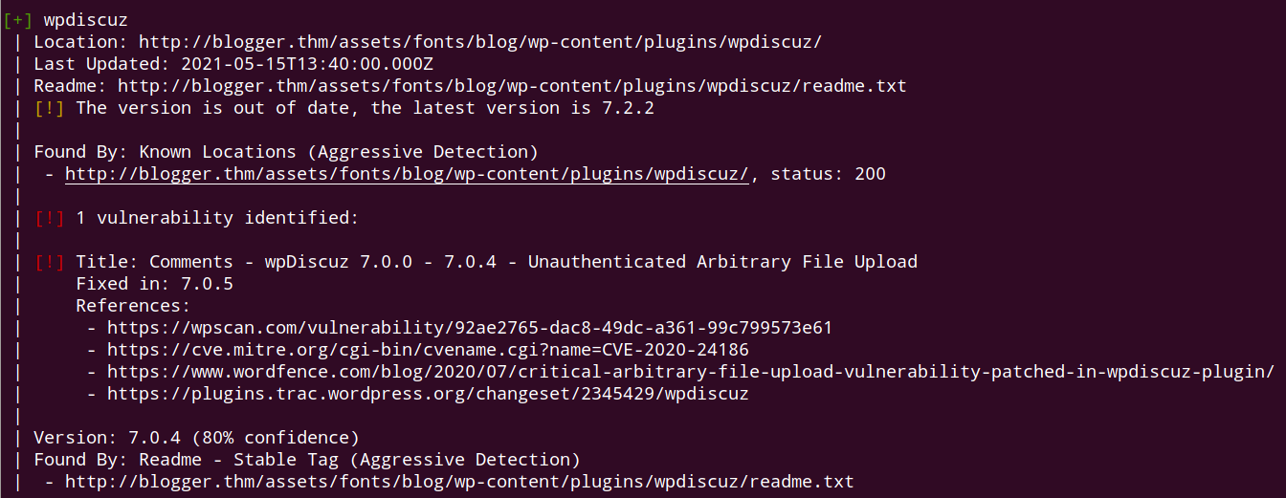

exploit for wpdiscuz available
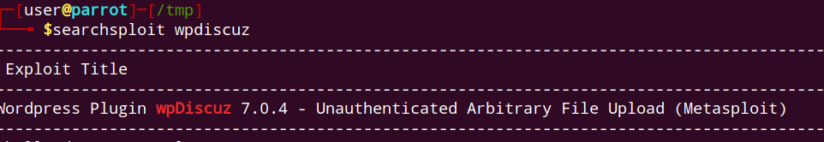

how to add metasploit from exploitdb:
https://www.hacknos.com/add-exploit-metasploit-from-exploit-db/

Configure settings in metasploit
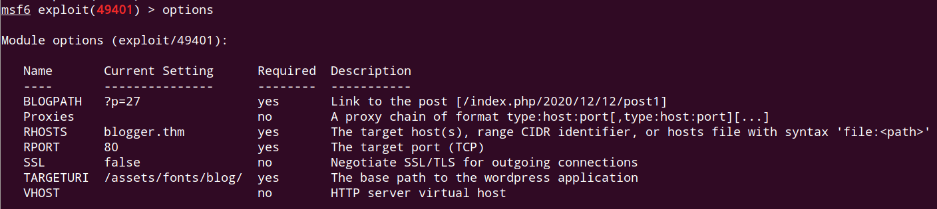

Initial foothold:
gather systeminfo
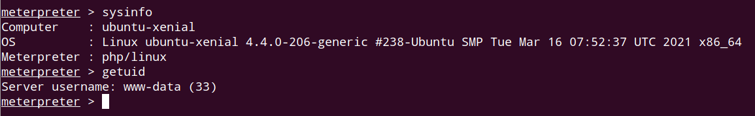

wp-config.php creds, might be useful:
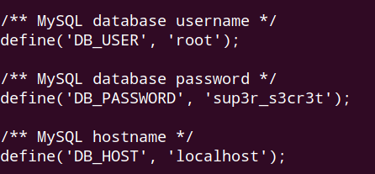

contents of passwd file
root, vagrant, ubuntu, james are able to be logged in to.
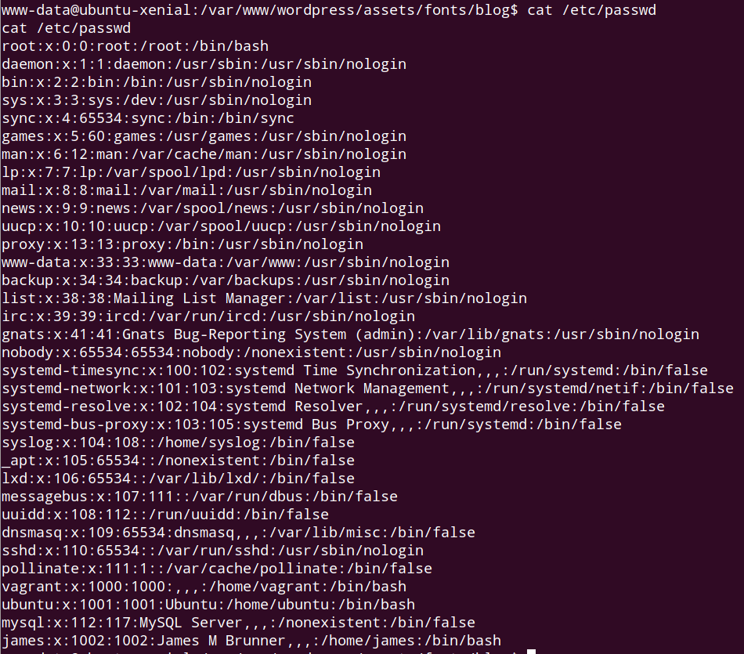

Crontab files has interesting entries.
Basically a script is run as root:
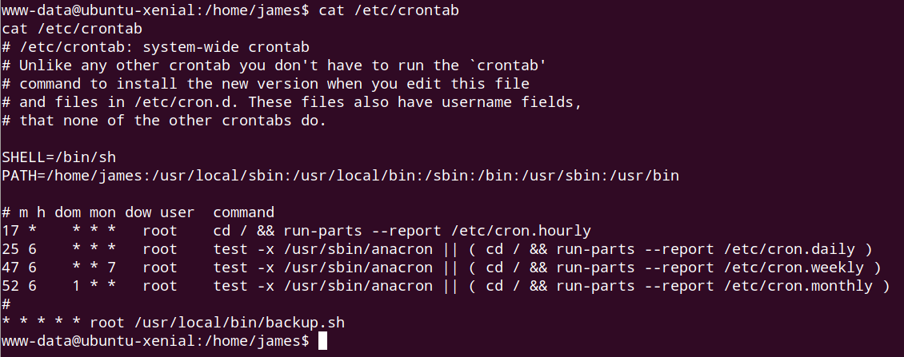

Every minute,, shell goes to james directory, make a backup and dump it at //tmp.
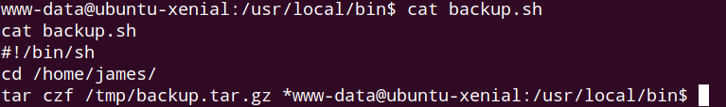

Unzip and untar file to get user flag
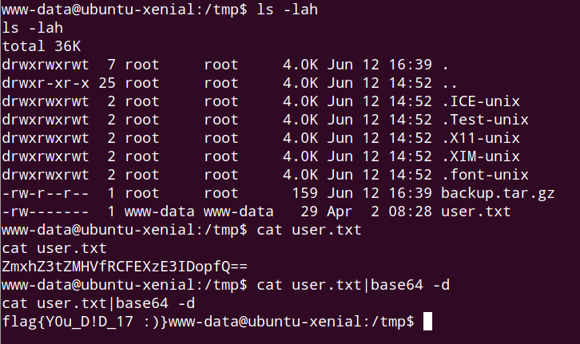

using weak credentials for user vagrant:
What we basically are going to do is that to use weak credentials for and do a horizontal escalation as vagrant. Then we escalate privilege to root.

