Dockerized Full-Stack AWS Deployment

Architecture Diagram A visual representation showing the logical flow: User Browser → Frontend (Nginx) → Backend (Node.js) → MySQL Database

EC2 Instance Running State A view of the AWS Console confirming the t2.micro instance is "Running" with the correct Security Group rules for ports 22, 80, and 3000 .
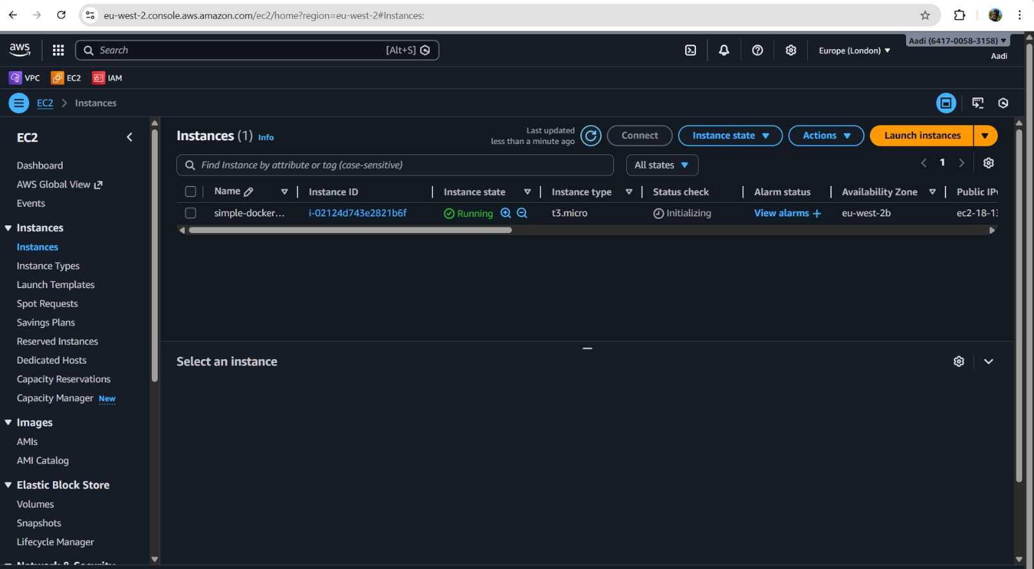
EC2 Terminal Login The terminal window showing a successful SSH connection to the Amazon Linux instance via the ec2-user@<public-ip> command

Docker Version Output The output of the docker --version command, confirming Docker is installed and the service is active on the EC2 instance.
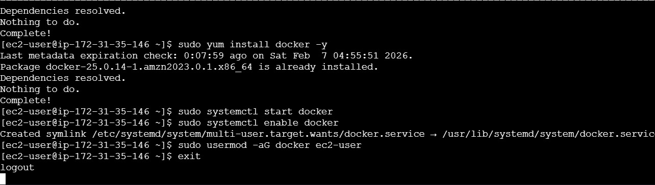

Displays the output of docker --version, confirming Docker version 25.0.14 is installed on the Amazon Linux 2023 environment.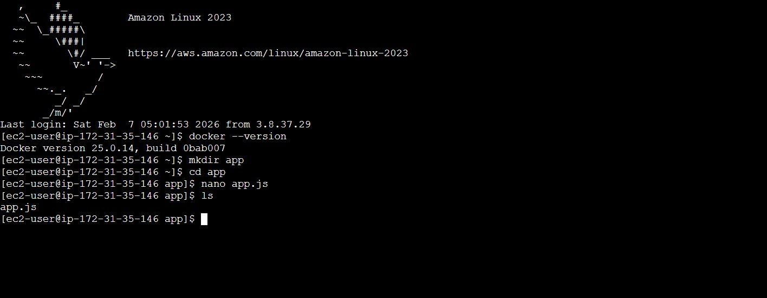

Shows the manual launch of a single container (simple-app) using docker run -d -p 80:3000 and verification via docker ps
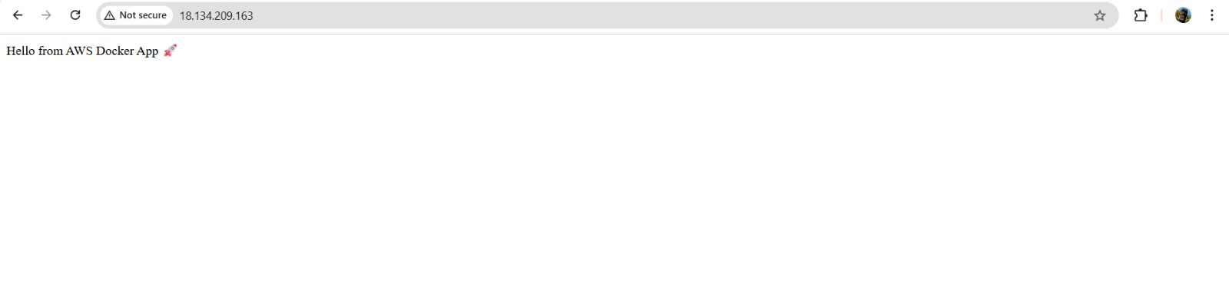

A terminal view showing the creation of the user-app directory and sub-folders backend and frontend. It lists the essential files: package.json, server.js, and dockerfile
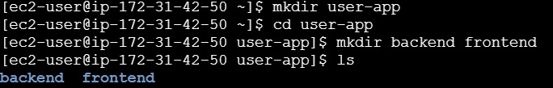

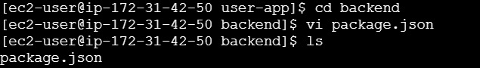

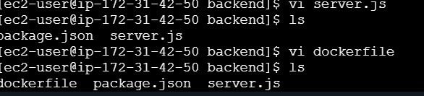

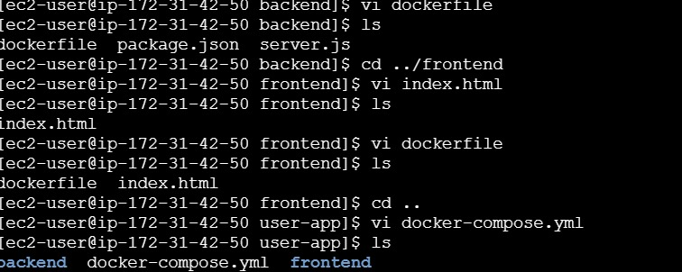

Directory tree showing server.js, package.json, and index.html alongside their respective Dockerfiles.
Success of Docker
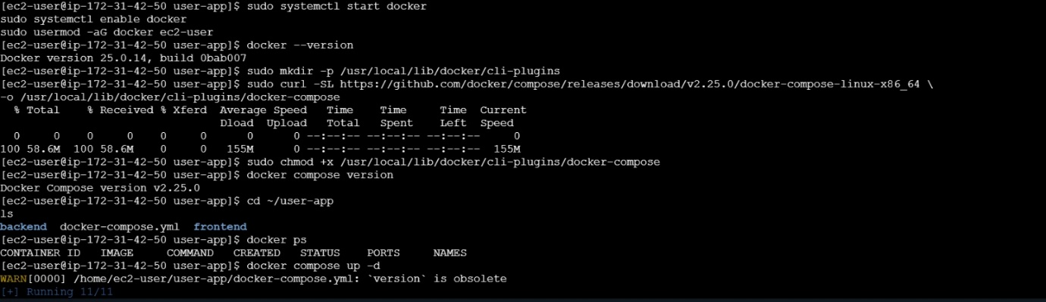
Execute docker compose up -d to build the images and start the containers in detached mode.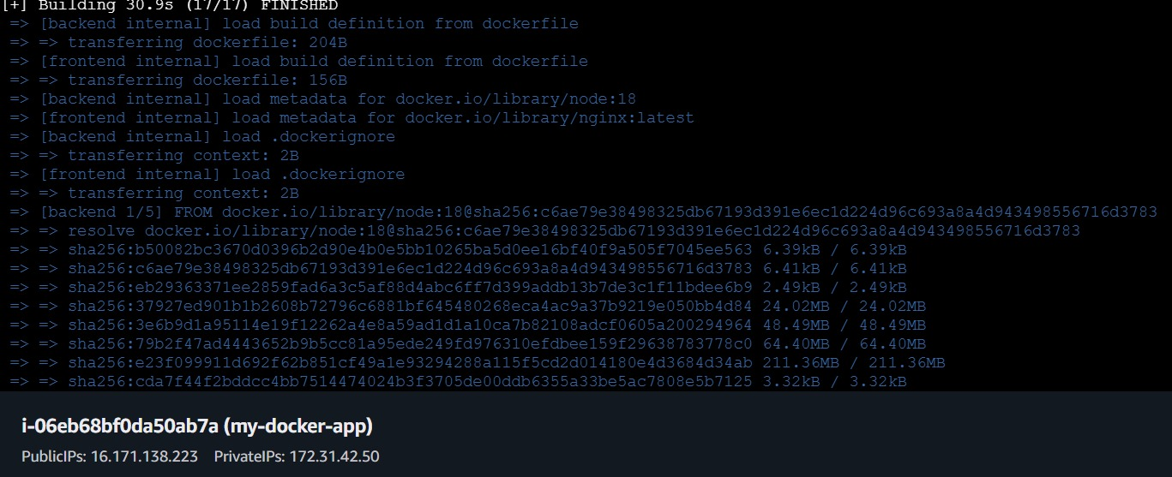
Access the MySQL container using docker exec and create the users table to store registration data
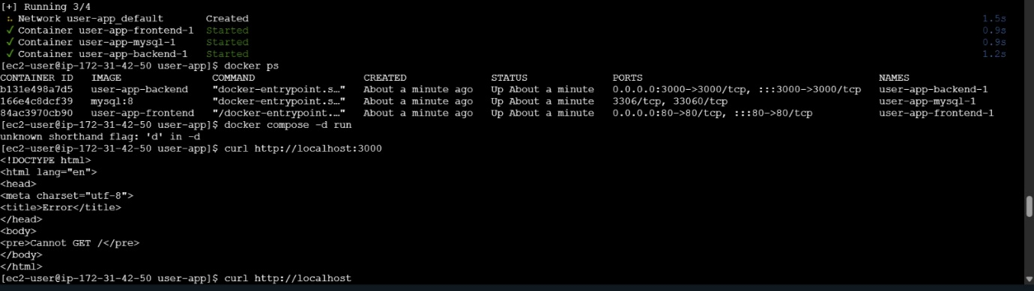
Confirmation of three active containers: frontend, backend, and mysql.

Logs showing Docker Compose being downloaded and configured with executable permissions.
Terminal output showing "Backend running on port 3000" and "DB Connected".

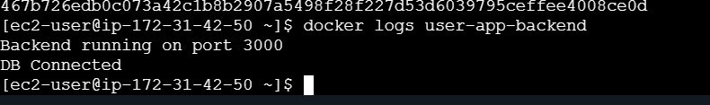

Successfully started mysql
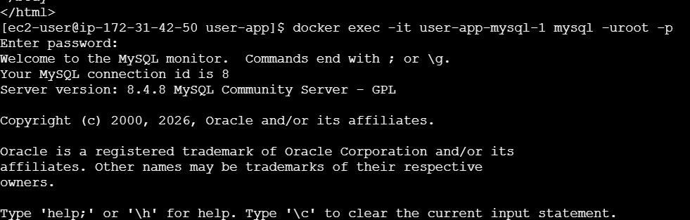

The successful execution of the CREATE TABLE command and insert records within the MySQL monitor.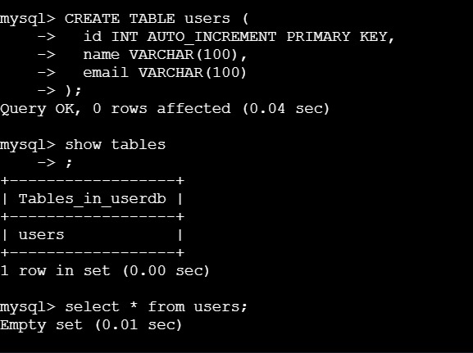
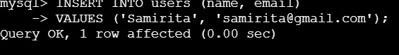

Configure an AWS Application Load Balancer (app-docker-alb) and a Target Group to route external HTTP traffic to your EC2 instance
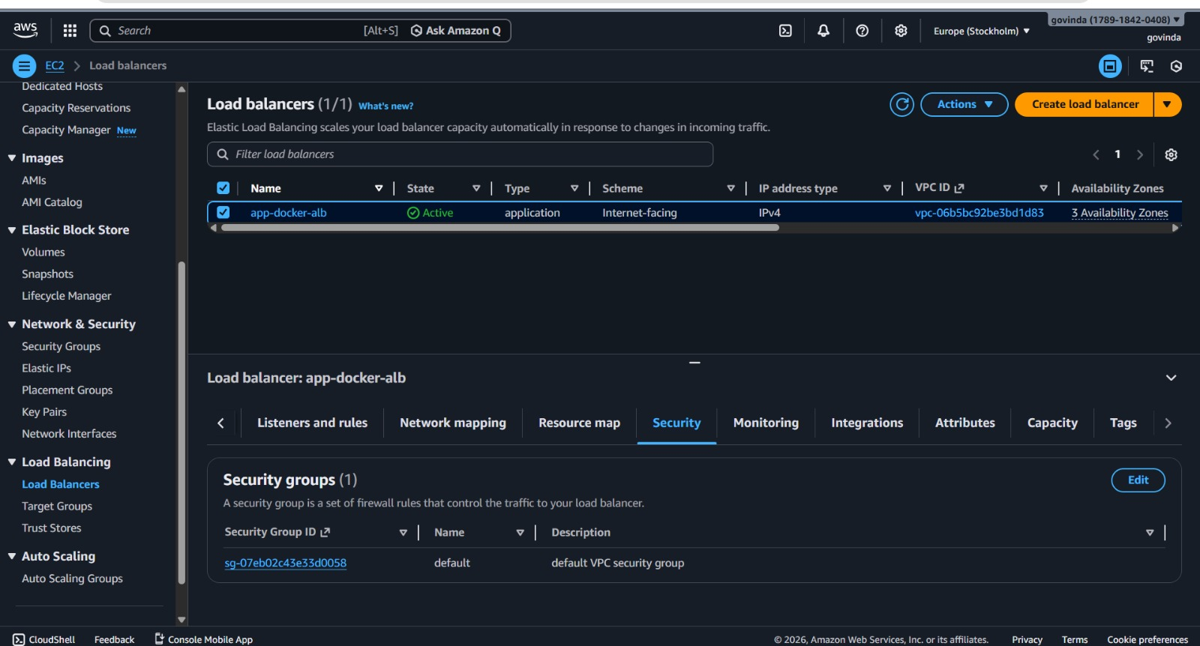

AWS Console view of the Load Balancer listeners and Target Group rules.
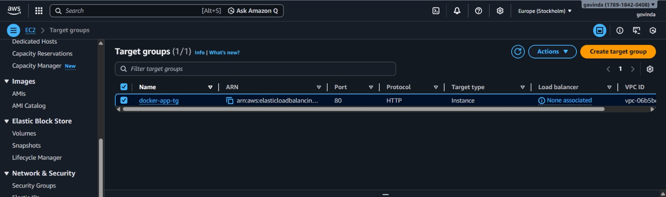

Access the application via the ALB DNS name in a web browser, submit a user registration form, and verify the record in the database
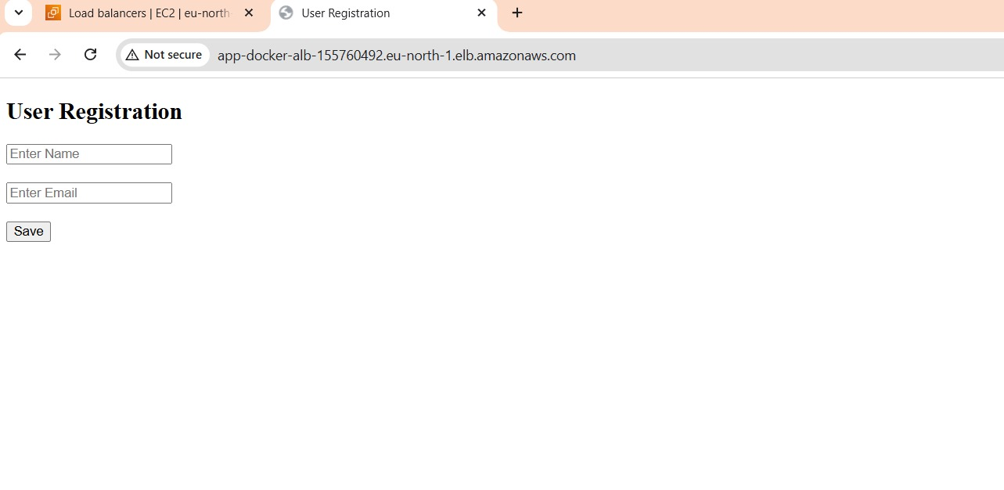

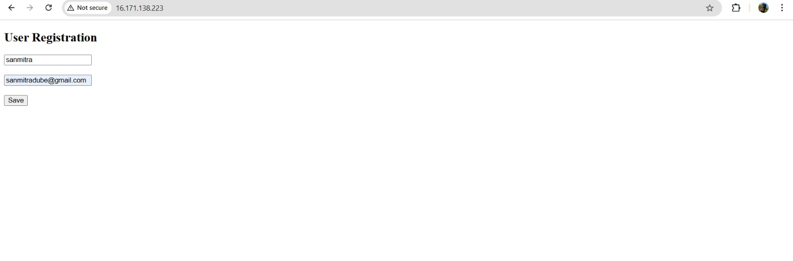

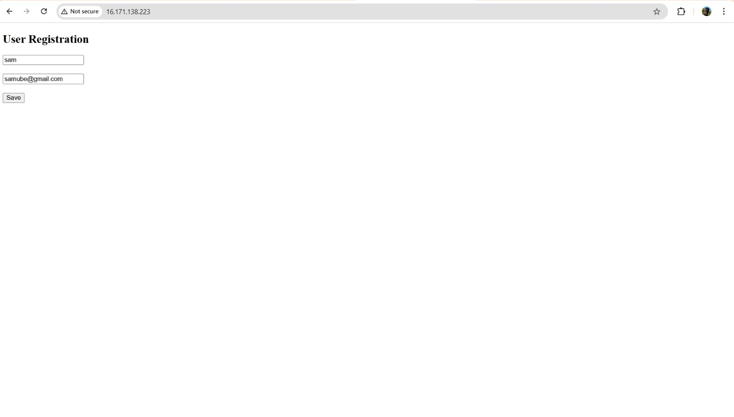
The final browser UI and a SELECT * FROM users; query showing the newly added data.
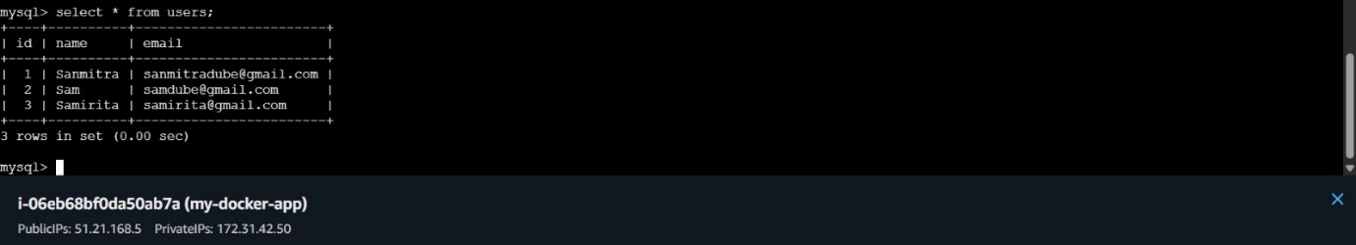

Summary of Results
This project focused on deploying a Dockerized full-stack application on AWS. An Amazon Linux EC2 instance was launched, Docker and Docker Compose were installed, and a multi-container architecture was created with Nginx (frontend), Node.js (backend), and MySQL (database). Containers were built and started using Docker Compose, the users table was created in MySQL, and backend connectivity was verified. An AWS Application Load Balancer was configured to route external traffic to the instance, enabling users to register through the web interface with data successfully stored in the database.

