**Image Recognition**

**with IBM Cloud Visual Recognition**

**Documentation:**

This comprehensive documentation outlines the design, development, and deployment of the Gender detection Image Recognition System. The objective of this system is to provide accurate detection of gender from images.

The core of the system lies in the model architecture, predominantly based on Convolutional Neural Networks (CNNs), with detailed descriptions of layers, hyperparameters, and activation functions.

Additionally, the document provides insights into future improvements, training materials, and procedures for regular testing and updates, ensuring the system's continued effectiveness. Comprehensive references and supplementary materials, along with sections for designated authorities' approval, further strengthen this invaluable resource.

**Technical Implementation:**.

Partitioning the data

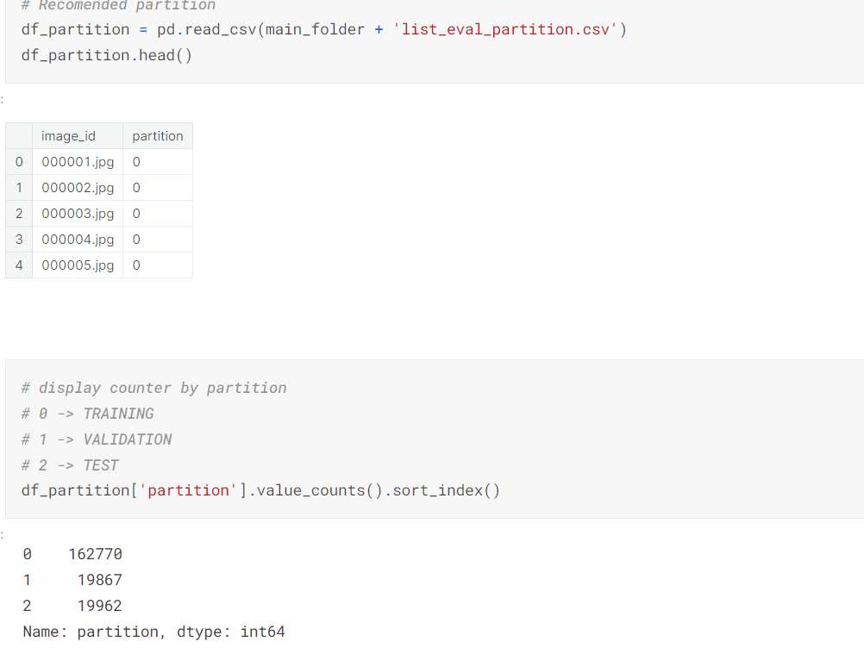

**Model Selection and Architecture:**

Choose an appropriate deep learning architecture, typically Convolutional Neural Networks (CNNs), known for their effectiveness in image recognition tasks.Design the model architecture with suitable layers, filters, and activation functions to capture intricate weather patterns.

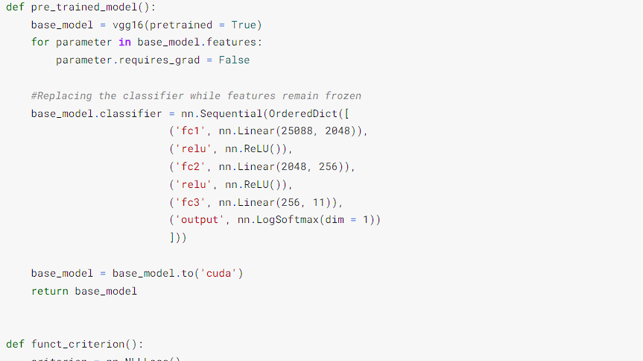

**Training and Validation:**

Split the dataset into training, validation, and test sets to train and evaluate the model's performance.Implement data pipelines for efficient data loading and processing during training.Define a loss function, commonly cross-entropy, and choose an optimization algorithm Train the model with various hyperparameters, such as learning rate, batch size, and the number of epochs.Monitor the validation metrics to prevent overfitting and adjust the model accordingly.

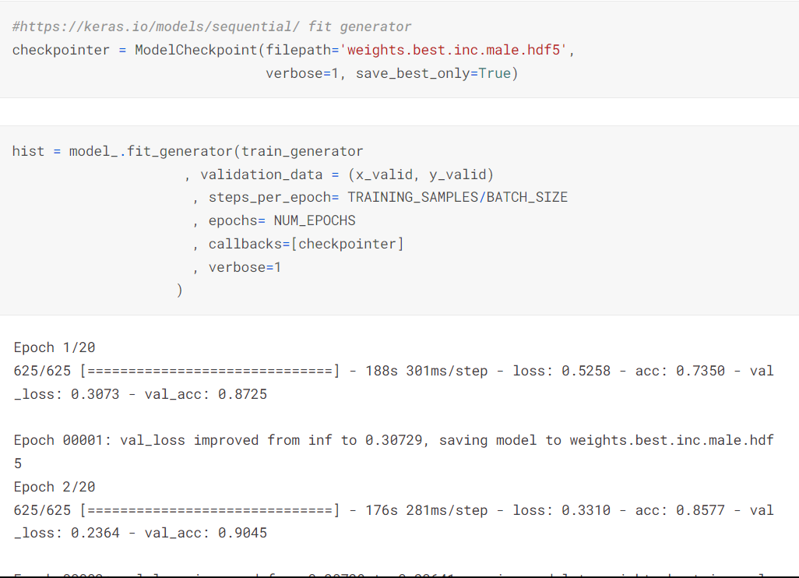

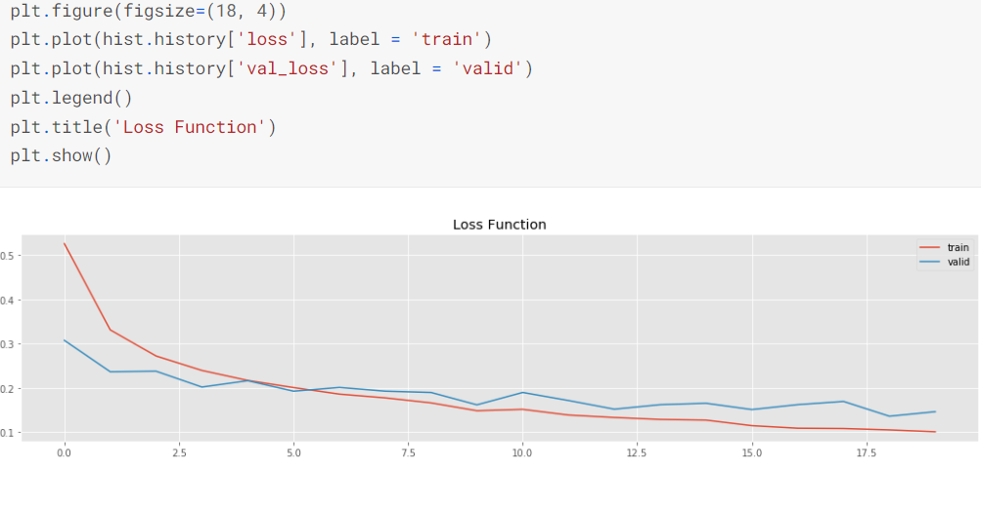

**Evaluation and Metrics:**

Evaluate the model's performance on a separate test dataset using appropriate evaluation metrics, including accuracy, precision, recall, F1-score, and confusion matrix.Monitor real-time processing speed (frames per second) to ensure responsiveness.

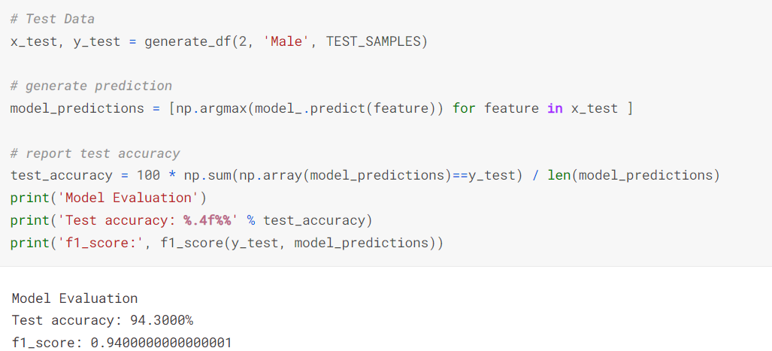

**Creating an web interface using html:**

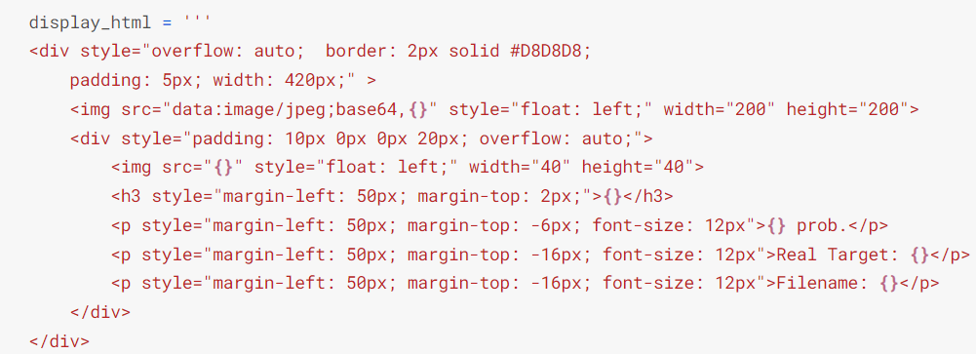

**Output of the project :**





**Conclusion:**

This project showcases the potential of Machine Learning in gender detection from images. The implemented CNN model demonstrates the feasibility of this application, and further refinements or expansions could lead to even more accurate and versatile gender recognition systems.