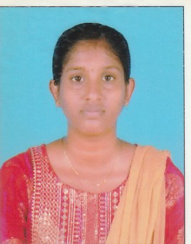RESUME

M.SANMUGAPRIYA

Mobile: 8610829357

E-Mail:priyamaruthai43@gmail.com

**OBJECTIVE:**

To be successful and eminent person in my discipline to serve my organization as well as my nation through my commitment and dedicated smart work.

**EDUCATIONAL QUALIFICATION:**

|  |  |  |  |  |
| --- | --- | --- | --- | --- |
| **Course** | **Institution** | Board/University | **Year Of Passed** | **Percentage** |
| B.Sc  (Computer Science) | Annai Women’s College Punnamchatram, Karur | Bharathidasan university | 2024 | 80% |
| Higher Secondary | Govt Hr.Sec.School,  Tharakampatti | State board | 2021 | 77% |
| S.S.L.C | Govt Hr.Sec.School,  Tharakampatti | State board | 2019 | 65% |

**SKILLS**

* JAVA
* Data Base
* Type Writing

**HOBBIES**

* Hearing Song

### PERSONAL DETAILS

Father’s Name : P.Maruthai

Date of Birth : 14.01.2004

Address : 1/32 East Street,

Tharakampatti (Po),

Karur (Dt) – 621 311

Languages known : Tamil & English

Gender : Female

Religion : Hindu

## Marital Status : Unmarried

# DECLARATION

I assure that the information furnished above is true to the best of my Knowledge.

Thanking You